In Vitro Callus Induction and Regeneration of Sugarcane variety Co0238 via Spindle Leaf Roll Segments

ABSTRACT
The sugarcane cultivar Co0238 was in vitro regenerated through callus culture using spindle leaf roll segments. Callus was induced on MS medium supplemented with 4 mg/L 2,4-D and 0.5 mg/L kinetin. Shoot regeneration was optimal on medium containing 5 mg/L NAA and 0.5 mg/L kinetin, while rooting was best on 5 mg/L NAA and 0.5 mg/L kinetin. The established protocol supported efficient regeneration and achieved a survival rate of 69.9% after hardening. This protocol can be effectively utilized for large-scale plant production and genetic improvement studies in sugarcane.
Keywords: Acclimatization, callus induction, shoot regeneration, survival frequency
1. INTRODUCTION
Plant regeneration systems are central to crop improvement as they enable clonal propagation, genetic transformation, and genome editing. Conventional propagation methods in vegetatively propagated crops such as sugarcane (Saccharum officinarum) are often constrained by pathogen transmission and variability in planting material. Tissue culture provides an effective alternative for generating uniform and disease-free plants. The first successful attempts in sugarcane were reported by Nickell (1964) and later by Heinz and Mee (1969) through callus-mediated regeneration. Since then, plantlets have been regenerated from diverse explants including immature leaf rolls (Soares et al., 2014), apical meristems (Ramgareeb et al., 2010), young leaves (Chengalrayan and Gallo-Meagher, 2001), and axillary buds (Vazquez Molina et al., 2005). However, regeneration efficiency is strongly influenced by genotype, explant source, and hormonal regime, making optimization essential for each cultivar.
The present study was undertaken to establish a protocol for callus induction, shoot regeneration, rooting, and acclimatization using spindle leaf roll segments of the sugarcane variety Co0238.

2. MATERIALS AND METHODS
2.1 Plant material
Sugarcane variety Co0238 were collected during January-February 2024 from the glasshouse of the School of Agricultural Biotechnology, Punjab Agricultural University, Ludhiana. Spindle leaf roll segments were used as explants for callus induction and regeneration. All in vitro experiments were conducted in the Tissue Culture and Genetic Transformation Laboratory of the same institute.
2.2 Explant source and pre-treatment
The apical tops of six month old, healthy sugarcane plant were selected as explants. A 10 cm long leaf roll was excised from the apical portion using secateur and divided into 2-3 segments. The leaf roll segments were carefully separated into individual layers using a sterile scalpel blade, immersed in Teepol solution for 15 seconds, and subsequently rinsed under running tap water for 15-20 minutes. The explants were then treated with 1% Bavistin solution for 1-2 hours on a rotary shaker (New Brunswick Scientific, USA) at 150 rpm for effective decontamination. This was followed by surface sterilization using 0.1% mercuric chloride for 5 minutes, as described by Sandhu et al (2016), and finally, the explants were rinsed three times with sterile distilled water to remove any traces of sterilants.
2.3 Callus induction
Spindle leaf roll segments excised from sugarcane plants were sliced into 0.5-1.0 cm and cultured aseptically on Murashige and Skoog (MS) medium supplemented with 4 mg/L 2,4-D + 0.5 mg/L kinetin and 8g/L agar and adjusted to pH 5.8. All procedures were carried out under sterile conditions in a laminar airflow cabinet. The spindle leaf segments were placed vertically in culture tubes, with alternate cuts made through the outer layers of the rolls to expose the internal tissue. Cultures were incubated at 25 ± 2 °C in complete darkness for 4-6 weeks, and subculturing was performed every 20 days to enhance callus proliferation.
2.4 Shoot and root regeneration
Callus tissues were transferred to MS medium containing 5 mg/L NAA + 0.5 mg/L kinetin for shoot induction. Medium was supplemented with 30 g/L sucrose and solidified with 8 g/L agar, with the pH adjusted to 5.8 prior to autoclaving. The regenerated shoots were subsequently cultured on rooting media having 5 mg/L NAA + 0.5 mg/L kinetin, also containing 30 g/L sucrose and 8 g/L agar at pH 5.8. The cultures were incubated in a growth chamber set at 25 ± 2 °C under a photoperiod regime of 16 h light and 8 h darkness.
2.5 Soil transfer and statistical evaluation
Regenerated plantlets were initially hardened on moist cotton soaked in water and maintained at 28 °C under a 16/8 h light/dark photoperiod for three days. Following this acclimatization phase, plantlets were transferred to transparent polybags containing a substrate mixture of three parts soil and one part cocopeat. The plants were maintained in a glasshouse and supplemented twice weekly with half-strength MS nutrient solution to support growth.
3. RESULTS AND DISCUSSION
3.1 Callus formation
Callus initiation was observed from spindle leaf rolls cultured on MS medium supplemented with 4.0 mg/L 2,4-D and 0.5 mg/L kinetin following 15 days of incubation in the dark at 25 ± 2 °C. Initial swelling of explants was visible after 15 days, and by 45 days a creamy white, friable callus mass had developed around the explants (Fig. 1). The treatment resulted in a callus induction frequency of 51.8% as described in table 1. This concentration of 2,4-D has been reported to induce callus in fewer days with larger size and at high induction frequency (Karim at al 2002, Kona 2018). Likewise, Jamil et al (2022) reported that 4.0 mg/L 2,4-D yielded an induction frequency of 84.7%. Low concentrations of cytokinins such as kinetin or BAP are known to enhance both the proliferation and quality of callus (Kaur and Gosal, 2009; Ramgareeb et al., 2010). Supporting this, Rao (2015) demonstrated that the combination of 3.5 mg/L 2,4-D with 0.5 mg/L BAP achieved a 100% induction frequency. The present findings therefore align with earlier reports, confirming that 4.0 mg/L 2,4-D in combination with 0.5 mg/L kinetin provides a highly suitable condition for callus induction in sugarcane.
Table 1: Callus induction from spindle leaf roll segments
Growth hormones | Spindles collected (No.) | Spindle leaf rolls cultured (No.) | Callus obtained (No.) | Callus obtained after subculture (No.)
4mg/L 2,4-D and 0.5mg/L Kinetin | 7 | 34 | 20 | 90
4mg/L 2,4-D and 0.5mg/L Kinetin | 11 | 54 | 28 | 160
4mg/L 2,4-D and 0.5mg/L Kinetin | 6 | 29 | 10 | 30
4mg/L 2,4-D and 0.5mg/L Kinetin | 4 | 18 | 12 | 50
4mg/L 2,4-D and 0.5mg/L Kinetin | 28 | 135 | 70 | 330
Callus induction frequency (%) |  |  | 51.8

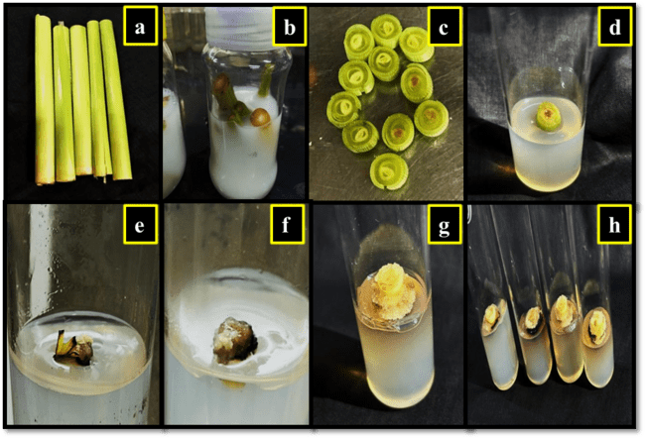
Fig 1: Callus induction from spindle leaf roll segment. a) spindle leaf rolls of sugarcane, b) Treatment of explant with bavistin (1%), c) Preparation of explant in aseptic conditions, d) Placement of explant on callus induction media, e) to f) explant showing swelling g) to h) Appearance of soft creamy friable covering around explant.
3.2 Shoot induction
Shoot regeneration was initiated after 30-40 days of culturing callus on MS medium supplemented with 5.0 mg/L NAA and 0.5 mg/L kinetin (Fig. 2). This treatment yielded a regeneration frequency of 41.5% (Table 2). Previous reports indicate that relatively low cytokinin concentrations are often more favorable for shoot proliferation. Rao (2015) observed that 1.0 mg/L kinetin enhanced multiple shoot induction, while Ather et al. (2009) noted that 1.0 mg/L BAP promoted a higher number of shoots. Similarly, Gopitha et al. (2010) reported a regeneration efficiency of 94% with 1.0 mg/L BAP combined with 0.5 mg/L NAA. These studies collectively suggest that reduced concentrations of auxins and cytokinins generally promote superior regeneration. The present findings demonstrate that a higher auxin level (5.0 mg/L NAA) in conjunction with a low cytokinin concentration (0.5 mg/L kinetin) also supports efficient shoot regeneration in sugarcane cv. Co0238, highlighting the genotype-dependent nature of regeneration responses.

Table 2: Shoot and root regeneration and survival of plantlets
Experiment No. | Growth hormone for shoot regeneration | Callus cultured on shooting media (No.) | Shoot regeneration (No.) | Growth hormone for root regeneration | Plants obtained including roots and shoots per calli (No.) | Surviving plantlets (No.)
1 | 5mg/L NAA and 0.5mg/L Kinetin | 10 | 0 | 5mg/L NAA and 0.5mg/L Kinetin | 0 | 0
2 | 5mg/L NAA and 0.5mg/L Kinetin | 15 | 4 | 5mg/L NAA and 0.5mg/L Kinetin | 35 | 20
3 | 5mg/L NAA and 0.5mg/L Kinetin | 30 | 17 | 5mg/L NAA and 0.5mg/L Kinetin | 105 | 76
4 | 5mg/L NAA and 0.5mg/L Kinetin | 25 | 15 | 5mg/L NAA and 0.5mg/L Kinetin | 70 | 41
5 | 5mg/L NAA and 0.5mg/L Kinetin | 10 | 3 | 5mg/L NAA and 0.5mg/L Kinetin | 10 | 4
6 | 5mg/L NAA and 0.5mg/L Kinetin | 20 | 15 | 5mg/L NAA and 0.5mg/L Kinetin | 95 | 55
7 | 5mg/L NAA and 0.5mg/L Kinetin | 30 | 22 | 5mg/L NAA and 0.5mg/L Kinetin | 130 | 91
8 | 5mg/L NAA and 0.5mg/L Kinetin | 50 | 27 | 5mg/L NAA and 0.5mg/L Kinetin | 184 | 150
9 | 5mg/L NAA and 0.5mg/L Kinetin | 20 | 11 | 5mg/L NAA and 0.5mg/L Kinetin | 74 | 53
10 | 5mg/L NAA and 0.5mg/L Kinetin | 40 | 23 | 5mg/L NAA and 0.5mg/L Kinetin | 140 | 100
11 | 5mg/L NAA and 0.5mg/L Kinetin | 20 | 0 | 5mg/L NAA and 0.5mg/L Kinetin | 0 | 0
12 | 5mg/L NAA and 0.5mg/L Kinetin | 10 | 0 | 5mg/L NAA and 0.5mg/L Kinetin | 0 | 0
13 | 5mg/L NAA and 0.5mg/L Kinetin | 25 | 0 | 5mg/L NAA and 0.5mg/L Kinetin | 0 | 0
14 | 5mg/L NAA and 0.5mg/L Kinetin | 25 | 0 | 5mg/L NAA and 0.5mg/L Kinetin | 0 | 0
Total | 5mg/L NAA and 0.5mg/L Kinetin | 330 | 137 | 5mg/L NAA and 0.5mg/L Kinetin | 843 | 590
Frequency (%) |  |  | 41.5 |  |  | 69.9

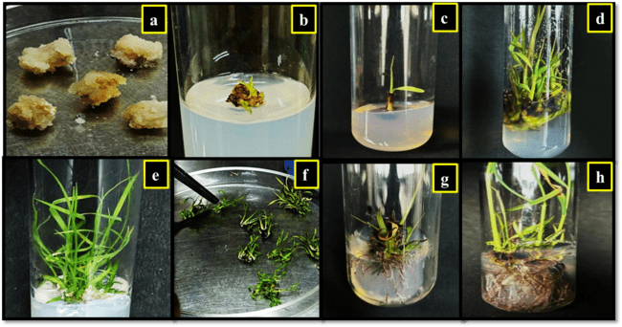
Fig 2: Shoot and root regeneration from callus. a) A creamy white friable callus, b) Green spots visible after 30-40 days, c) to f) Development of healthy green shoots , g) The pink purplish roots colour upon transfer to root induction media, h) Mature roots appearing white brownish after 30-45 days.
3.3 Root formation and survival frequency
Root induction was observed after 30-45 days of culturing regenerated shoots on MS medium containing 5.0 mg/L NAA and 0.5 mg/L kinetin (Fig. 2). The roots initially appeared thin with a purplish-pink coloration, later maturing into white to brown color. This treatment supported a rooting frequency of 83.9%. The well rooted shoots were transferred to moist cotton for 2-3 days for hardening. The plantlets first became feeble and withered after transferring to soil containing cocopeat but after 10-15 days the plants started to rejuvenate (Fig. 3). Out of 843 regenerated plantlets, 590 survived, representing a survival rate of 69.9% as described in Table 2. These observations are in agreement with earlier studies that highlight the pivotal role of auxins in root induction in sugarcane. Rao (2015) reported 100% rooting with 90% survival on MS medium containing 3.0 mg/L NAA, while Awan et al. (2019) achieved 92% rooting at the same concentration. Comparable findings have been reported by Gopitha et al. (2010), Mittal et al. (2013), and Behara and Sahoo (2009), where both NAA and IBA were shown to effectively promote root development. Consistent with these reports, the present study demonstrates that a combination of 5.0 mg/L NAA and 0.5 mg/L kinetin is highly effective for root induction, plantlet survival, and successful acclimatization in sugarcane variety Co0238.
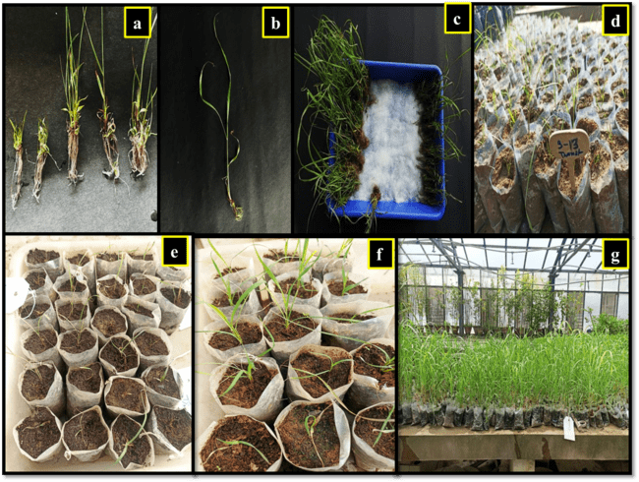
Fig 3: Hardening and transfer to soil. a) and b) The healthy well rooted shoots, c) Plantlets transferred on moist cotton for hardening, d) Plantlets transferred to soil in polybags, e) Plants looked withered after immediate exposure to the harsh environment conditions, f) Rejuvenated plants after 10-15 days in the glasshouse
4. CONCLUSION
The present study establishes an efficient regeneration system for sugarcane cultivar Co0238 using spindle leaf roll explants. The optimized auxin-cytokinin combinations supported reliable callus induction, shoot regeneration, root development, and acclimatization. This system provides a robust foundation for genetic transformation and large-scale clonal propagation of elite sugarcane cultivars.

REFERENCES
Ather, A., Khan, S., Rehman, A. & Nazir, M. (2009). Optimization of the protocols for callus induction, regeneration and acclimatization of sugarcane cv-Thatta-10. Pakistan Journal of Botony, 41, 815-820.
Awan, M.F., Iqbal, M.S., Sharif, M.N., Tabassum, B., Tariq, M., Murtaza, S., Ali, S., Raza, A,, Bukhari, S.A.R. & Nasir, I.A. (2019). Evaluation of genotypic and hormone mediated callus induction and regeneration in sugarcane (Saccharum officinarum L). Evaluation, 4, 70-76.
Behara, K.K. & Sahoo, S. (2009). Rapid in vitro micropropagation of sugarcane (Saccharum officinarum L. cv-Nayana) through callus culture. Nature and Science, 7, 1-10.
Chengalarayan, K. & Gallo-Meagher, M. (2001). Effect of various growth regulators on shoot regeneration studies in sugarcane variety CO-86032. Advances in Plant Sciences, 6, 649-651.
Gopitha, K., Bhavani, A.L. & Senthilmanickam, J. (2010). Effect of different auxins and cytokinins in callus induction, shoot, root regeneration in sugarcane. International Journal of Pharma and Bio Sciences, 1, 1-7.
Heinz, D.J. & Mee, G.W. (1969). Plant differentiation from callus tissues of Saccharum species. Crop Science, 9, 324-348.
Jamil, M.W., Ali, S.A., Sabir, W., Nasir, M., Irum, A., Khan, M.E., Naveed, M., Ullah, R., Nawaz, M.S., Saleem, S. & Khan, N.H. (2022). Optimization of protocol for callus formation and shoot development in sugarcane (Saccharum officinarum L.) cultivar CPF-248. Journal of Global Innovations in Agricultural and social Sciences, 10, 229-235.
Karim, M.Z., Alam, R., Baksha, R., Paul, S.K., Hossain, M.A. & Rahman, A.B.M.M. (2002). In vitro clonal propagation of sugarcane (Saccharum officinarum) variety ISD-31. Pakistan Journal of Biological Sciences, 5, 659-661.
Kaur, A. & Gosal, S.S. (2009). Desiccation of callus enhances somatic embryogenesis and subsequent shoot regeneration in sugarcane. Indian Journal of Biotechnology, 8, 332-334.
Kona, P. (2018). Effect of 2,4-D Emson in vitro regeneration in sugarcane cultivar, 2003V46. International Journal of Microbiology Research, 0975-5276.
Mittal, P., Devi, R. & Gosal, S.S. (2013). Direct plant regeneration from spindle leaf roll explants in sugarcane. Indian Journal of Ecology, 40, 67-70.
Nickell, L.G. (1964). Tissue and cell culture of sugarcane: Another research tool. Hawaiian Planters Record, 57, 223-229.
Ramgareeb, S., Snyman, S.J., Van Antwerpen, T. & Rutherford, R.S. (2010). Elimination of virus and rapid propagation of disease-free sugarcane (Saccharum spp cultivar NCo376) using apical meristem culture. Plant Cell, Tissue and Organ Culture, 100, 175-181.
Rao, A.S. (2015). Callus induction and organogenesis in sugarcane (Saccharum officinarum L.) var 93V297. International Letters of Natural Science, 48.
Sandhu, J.S., Kaur, M., Kaur, A. and Kalia, A. (2016). Single step direct transgenic plant regeneration from adventive embryos of agro-infected sugarcane (Saccharum spp) spindle leaf roll segments with assured genetic fidelity. Plant Cell, Tissue and Organ Culture, 125, 149-162.
Soares, R.R., Ferreira, M.E., Gamarano, M.C., Ribeiro, R.C., Sabino, V.M. & Pereira, B.M.H. (2014). The use of histological analysis for the detection of somatic embryos in sugarcane. African Journal of Biotechnology, 13, 762-767.
Vazquez Molina, D.E., De Los Santos, A., Lecona Guzman, K.A., Sumano Muniz, O., Velazquez Mendez, M., Rincon Rosales, R., Oliva Llaven, M.A., Dendooven, L. & Gutierrez-Miceli, F.A. (2005). Sugarcane buds as an efficient explant for plantlet regeneration. Biologia Plantarum, 49, 481-485.

