High-Throughput Root Dip Assay for Rapid Pathogenicity Testing of Ralstonia solanacearum in Tomato Seedlings

Abstract :
Ralstonia solanacearum, a devastating vascular pathogen of tomato, causes bacterial wilt leading to significant crop losses globally. Rapid and reliable screening methods are essential to assess the pathogenic potential of different isolates for resistance breeding and epidemiological studies. This study presents a high-throughput root dip inoculation assay to evaluate the virulence of R. solanacearum strain RsT-7 in tomato (cv. Sahoo and Aaryaman). Six distinct treatments involving bacterial broth, sterile water and bacterial suspension (OD₆₀₀ = 0.6) were compared in 6-7-day-old seedlings. Among all treatments, direct root exposure to bacterial suspension (S-1) resulted in 100% wilting within 48 hours post-inoculation, exhibiting rapid and consistent symptom development including turgor loss, drooping and seedling collapse. Other treatments involving broth or delayed suspension addition showed significantly lower wilt incidence (0–80%). The assay was successfully adapted to 30-day-old seedlings, which developed progressive wilting and stem collapse. Pathogen colonization was confirmed via ooze test and decreased lignification in vascular tissues was visualized using phloroglucinol staining. The results indicate that direct root dip in bacterial suspension is a reliable, reproducible and resource-efficient method for pathogenicity screening of R. solanacearum in tomato. This approach enables rapid disease assessment in early growth stages and can significantly accelerate screening pipelines in plant pathology research.
Keywords: Bacterial wilt, tomato, Ralstonia solanacearum, root dip assay, pathogenicity
- INTRODUCTION
Tomato (Solanum lycopersicum L.) stands as one of the most economically and nutritionally important horticultural crops globally. Valued for its culinary versatility, high content of antioxidants such as lycopene, vitamins (A, C and E) and dietary fiber, tomato is consumed fresh, cooked or processed into a wide range of food products. With increasing demand across global markets, tomato cultivation now spans over 5 million hectares, yielding approximately 190 million tonnes annually (FAOSTAT, 2023). China dominates global production, contributing nearly one-third of the total output, followed by India, the United States, Turkey and Egypt. In India, tomato occupies a central role in vegetable farming systems, covering close to 9,00,000 hectares with an annual production of over 21 million tonnes. The primary production belts include Andhra Pradesh, Madhya Pradesh, Karnataka, Maharashtra and Tamil Nadu, where both open-field and protected cultivation practices are employed depending on the season and market demand (Sankaran et al., 2024).
Despite its agronomic and economic significance, tomato production is severely threatened by a broad spectrum of biotic stresses, particularly diseases caused by fungi, viruses, nematodes and bacteria. Among these, bacterial wilt caused by Ralstonia solanacearum is one of the most destructive and intractable diseases affecting tomato in tropical and subtropical regions. This soilborne vascular pathogen invades the plant through the root system, colonizes the xylem and disrupts water transport, leading to sudden wilting, chlorosis and plant death. Bacterial wilt has been reported to cause yield losses ranging from 30% to 100%, depending on cultivar susceptibility, environmental conditions and inoculum density (Kumar et al., 2018; Devi et al., 2021). The disease is especially prevalent in warm, humid climates and poorly drained soils, where the pathogen can survive for long periods in water, soil and plant debris (Balamurugan et al., 2020).
Ralstonia solanacearum is a highly diverse and adaptable species complex comprising multiple phylotypes and sequevars, with a broad host range exceeding 250 plant species across 50 families (Mekonnen et al., 2022). It is included on the A2 list of quarantine pests by the European and Mediterranean Plant Protection Organization (EPPO) and has gained international attention due to its epidemic potential and persistence in asymptomatic hosts. In tomato, the pathogen’s aggressive colonization of xylem vessels, rapid systemic movement and ability to form protective biofilms render it particularly difficult to control through conventional chemical or cultural means (Zhang et al., 2022). The bacterium thrives under warm temperatures (28–35 °C) and high soil moisture, making it a recurrent problem in Indian tomato-growing regions during the rainy and post-rainy seasons (Ijaz et al., 2024; Subramanian, 2023).
Effective disease management strategies for bacterial wilt require early detection and accurate evaluation of pathogen virulence. For this, robust and reproducible pathogenicity assays are essential, particularly in breeding programs that aim to develop resistant cultivars and in studies evaluating biological control agents or plant defense inducers (Srinivasamurthy et al., 2014; Solanki & Khan, 2024). Traditional pathogenicity tests for R. solanacearum typically involve soil inoculation in pots, stem injection, or natural infestation under field conditions. However, these approaches are often time-consuming, require significant space and resources and are difficult to standardize across different laboratories. Moreover, these methods may introduce variability due to fluctuations in soil moisture, inoculum density or environmental conditions, making comparative assessment of virulence or resistance levels challenging (Konappa et al., 2018; Rout, 2015).
To overcome these limitations, efforts have been made to develop high-throughput, simplified assays that allow consistent, rapid and scalable evaluation of pathogenicity. Among these, a root dip inoculation method for early-stage tomato seedlings was proposed by Singh et al. (2018), offering a space-efficient and faster alternative to traditional pot assays. Their approach involves exposing 6–7-day-old tomato seedlings to a standardized bacterial suspension and monitoring symptom development under sterile conditions. However, despite its potential, this method has not been extensively validated across cultivars, exposure durations or inoculum formats (e.g., broth vs. suspension). Furthermore, questions remain regarding the physiological state of the bacteria at the time of inoculation and how that might influence infection efficiency (Heena et al., 2020).
Recent studies have highlighted the importance of biofilm formation, quorum sensing and xylem colonization in determining the virulence of R. solanacearum. For instance, melatonin-decorated silica nanoparticles were shown to significantly suppress bacterial wilt in tomato by modulating oxidative signaling and the rhizosphere microbiome, demonstrating the complexity of host-pathogen interactions and the need for precise inoculation assays (Ijaz et al., 2024). Similarly, biogenic resistance inducers like pipecolic acid have been found to alter tomato metabolomic profiles and enhance systemic acquired resistance against the pathogen (Sabharwal et al., 2025). Novel approaches such as biochar-based composites (Karanja et al., 2024) and virus-mediated CRISPR delivery (Peng et al., 2024) have also shown promise, reflecting the ongoing innovation in bacterial wilt management. These advancements underline the necessity for a reproducible and sensitive pathogenicity assay that can bridge molecular studies with phenotype-based disease screening.
Despite growing interest in R. solanacearum biology and control, there remains a significant methodological gap in standardizing pathogenicity assays that are rapid, cost-effective and suitable for both early-stage and mature seedlings. The lack of a universally accepted in vitro or greenhouse-based pathogenicity test hampers consistent evaluation of virulence traits, resistance sources and bioformulations under controlled conditions. Moreover, early disease detection systems capable of mimicking field infection without the spatial and temporal constraints of pot assays are urgently needed, especially in resource-limited settings.
The present study was undertaken with aim to develop and validate a rapid, high-throughput root dip inoculation method for assessing the pathogenicity of Ralstonia solanacearum in tomato under controlled conditions. By optimizing inoculation strategies and evaluating disease development across different seedling stages and cultivars, the approach offers a reliable and scalable alternative to traditional pathogenicity assays.
- Materials and Methods

2.1 Bacterial Culture and Inoculum Preparation
The Ralstonia solanacearum strain RsT-7 used in this study was obtained from the Pathogenomics Laboratory, Department of Plant Pathology, GKVK, University of Agricultural Sciences (UAS), Bangalore. This strain had been previously characterized for its virulence on solanaceous hosts. The bacterium was streaked on TZC (Triphenyl Tetrazolium Chloride) agar medium and incubated at 28 °C for 36 hours to obtain isolated virulent colonies (Plate 1). Colonies showing typical fluidal, irregular and pink-centred morphology were selected and transferred aseptically to 50 mL nutrient broth. The culture was incubated in a rotary shaker at 150 rpm for 36 hours at 28 °C to obtain actively growing cells.
For inoculum preparation, the broth culture was centrifuged at 5,000 rpm for 5 minutes at 4 °C. The pellet was washed twice with sterile distilled water to remove media residues and resuspended in sterile distilled water. The final bacterial concentration was adjusted to approximately 10⁸ colony-forming units (CFU)/mL using a spectrophotometer (OD₆₀₀ = 0.6), which served as the working suspension for pathogenicity assays.
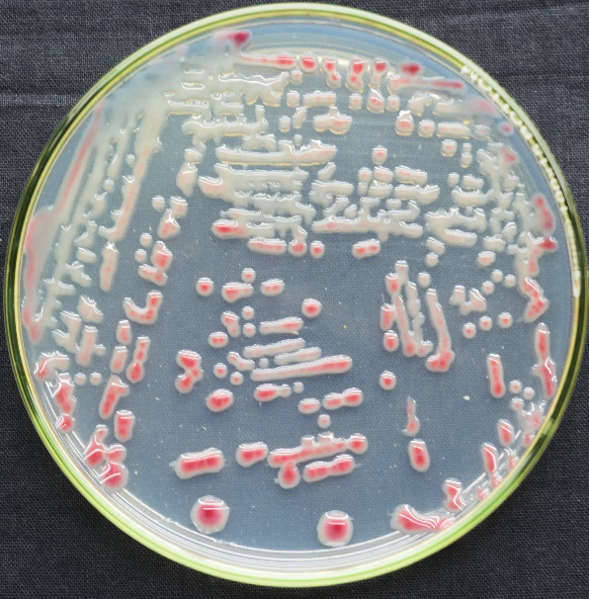
Plate 1. Ralstonia solanacearum (RST-7) cultural characters on TZC medium

2.2 Plant Material and Growth Conditions
Seeds of tomato cultivar ‘Sahoo’ were selected for early-stage assays. Seeds were surface sterilized by immersing them in 1% sodium hypochlorite solution for 1 minute followed by thoroughly rinsing five times with sterile distilled water. Sterilized seeds were soaked in sterile distilled water for 48 hours at ambient room temperature (25–30 °C) to promote uniform germination. Following soaking, seeds were placed on sterile tissue paper and cotton beds moistened with sterile distilled water in plastic trays. These were maintained in a growth chamber at 28 ± 2 °C, 75% relative humidity and a 12-hour light/12-hour dark photoperiod for 6–7 days, without the addition of nutrients. Germinated seedlings of uniform size were selected for inoculation.

2.3 Inoculation Treatments for 6–7-Day-Old Seedlings
To evaluate the effectiveness of various inoculation strategies, six treatments were designed using either bacterial broth or resuspended bacterial suspension, along with a sterile water control:
- B-1 (Broth Direct Dip): Seedling roots were directly immersed in R. solanacearum nutrient broth culture.
- B-2 (Broth Dip → Water Transfer): Roots were dipped in bacterial broth for 1–2 minutes, transferred to sterile 5.0 mL microcentrifuge tubes, left exposed to air for ~5 minutes and then overlaid with 2.5 mL sterile distilled water.
- B-3 (Water → Broth Addition): Seedling roots were first placed in 1.5 mL of sterile water in microfuge tubes, followed by the addition of 1.0 mL bacterial broth.
- S-1 (Suspension Direct Dip): Roots were directly immersed in sterile distilled water-based bacterial suspension (OD₆₀₀ = 0.6).
- S-2 (Suspension Dip → Water Transfer): Roots dipped in suspension for 1–2 minutes, air-exposed for ~5 minutes and then transferred to tubes containing 2.5 mL sterile water.
- S-3 (Water → Suspension Addition): Seedlings were placed in 1.5 mL water in tubes, followed by addition of 1.0 mL bacterial suspension.
Each treatment group consisted of 5 seedlings and all treatments were performed in triplicate. Seedlings were maintained under the same growth chamber conditions as described above. Sterile water-inoculated seedlings served as negative controls. Disease symptoms were monitored daily up to 3 days post-inoculation (dpi), with observations focused on wilting, turgor loss and seedling collapse.

2.4 Inoculation of 30-Day-Old Seedlings
To assess the robustness and scalability of the root dip method, pathogenicity assays were extended to 30-day-old tomato seedlings of cultivars ‘Sahoo’ and ‘Aaryaman’. Seedlings were gently uprooted from nursery trays and root systems were washed thoroughly with sterile distilled water to remove adhered soil particles.
Five seedlings had some of their roots were trimmed using sterile scissors to mimic natural wounding, while others were left intact. Roots were then directly immersed in freshly prepared R. solanacearum suspension (OD₆₀₀ = 0.6) for inoculation. Control seedlings were treated similarly but immersed in sterile distilled water. All seedlings were incubated under controlled growth chamber conditions.

2.5 Disease Evaluation
Wilting symptoms were recorded daily up to 3 dpi. Typical symptoms included drooping, chlorosis and collapse. The classical ooze test was used to confirm pathogen presence in infected stems.

2.6 Histochemical Lignin Staining
Tomato stems showing wilt symptoms were preserved in 70% ethanol. Thin transverse sections were prepared and subjected to Phloroglucinol-HCl (Wiesner) staining based on the method of Mitra & Loqué (2014):
- Prepare a 3% phloroglucinol solution by dissolving 0.3 g in 10 mL absolute ethanol. Mix 2 parts of this solution with 1 part concentrated HCl (37 N) to make Ph-HCl.
- Place stem sections in 1.0 mL of Ph-HCl in microcentrifuge tubes and cap immediately due to HCl’s corrosiveness.
- Gently pipette stained sections onto a microscope slide using a tip with a wide bore, mount with coverslip and observe under bright-field microscopy.
This method allowed visualization of reduced lignification in infected vascular tissues, indicating compromised structural defense.
- Results and Discussion

3.1 Efficacy of Inoculation Treatments in Young Seedlings
The high-throughput pathogenicity assay conducted on 6–7-day-old tomato seedlings revealed a clear hierarchy of disease severity among the six tested inoculation strategies. The S-1 treatment, which involved direct immersion of roots in bacterial suspension (OD₆₀₀ = 0.6), resulted in 100% wilting within 48 hours indicating a high level of pathogenic efficiency. In contrast, treatments involving broth (B-1, B-2, B-3) yielded minimal or no wilting symptoms (0–10%), suggesting a possible interference from nutrient-rich media in facilitating infection or influencing the bacterial virulence state (Plate 2). This observation is consistent with findings that nutrient deprivation or osmotic stress in bacterial suspension may upregulate virulence gene expression in R. solanacearum (Singh et al., 2018; Zhang et al., 2022).
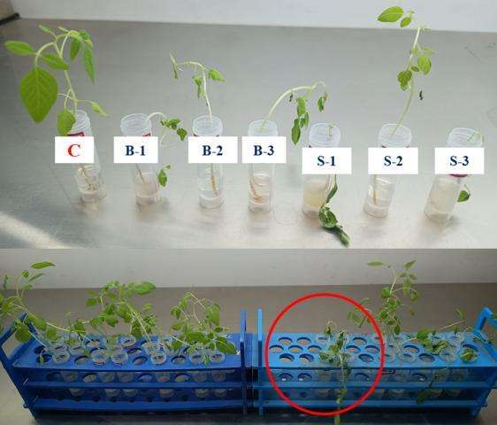
Interestingly, S-2 and S-3, which involved delayed or indirect exposure to the suspension, exhibited intermediate responses: S-2 produced 10% wilting, while S-3 showed up to 80% wilting, indicating that immediate and sustained contact with live bacterial cells is crucial for rapid pathogenesis. The wilting percentage of all the treatments is indicated in figure 1. These findings underscore the role of exposure timing and direct interaction with planktonic cells in disease initiation. The results diverge from earlier reports by Singh et al. (2018), who had identified S-2 as the most efficient treatment in their seedling-based assay. This discrepancy may be attributed to differences in bacterial strain aggressiveness, host cultivar susceptibility, or inoculum preparation protocols. While Singh et al. used strain F1C1 under microfuge-based systems, the present study employed RsT-7 in a sterile water-based root dip setup, which may better preserve virulence expression during host contact (Singh et al., 2018).
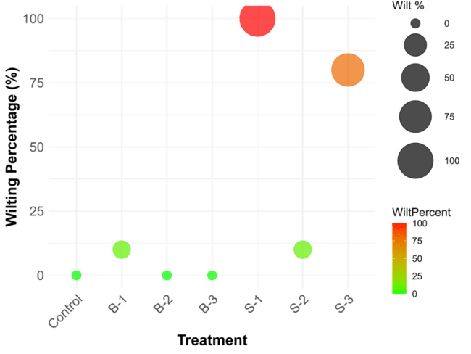
Plate 2. High throughput technique to prove pathogenicity in Tomato. (Where C: Water control, B-1: Broth, B-2: Broth dip-> water, B-3: Water + Broth, S-1: Bacterial Suspension, S-2: Suspension > water and S-3: Water + Suspension)
Fig. 1. Wilting percentage of different treatments on 6-7 days old seedlings

3.2 Validation in 30-Day-Old Tomato Seedlings
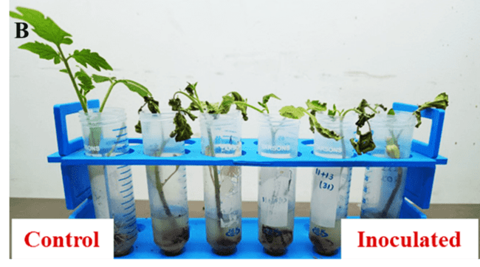
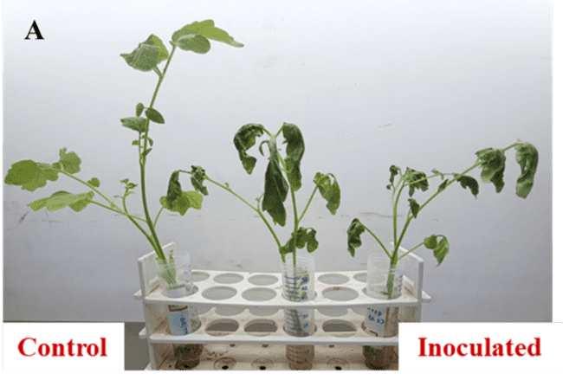
The adaptability of the root dip assay to older plants was successfully demonstrated using 30-day-old tomato seedlings from two cultivars, ‘Sahoo’ and ‘Aaryaman’. Following root immersion in the bacterial suspension, both cultivars showed clear wilting symptoms within 48–72 hours. In ‘Sahoo’, symptoms included chlorosis, drooping and gradual stem collapse, while ‘Aaryaman’ exhibited more severe wilting and rapid xylem discoloration (Plate 3A&B). Both cultivars showed cent per cent wilting (Fig. 2). These differences may reflect inherent genotypic variation in susceptibility to R. solanacearum, which has been reported in earlier studies comparing cultivar responses under greenhouse conditions (Mekonnen et al., 2022; Abo-Elyousr et al., 2021).
Plate 3. Wilting symptoms observes after 48 HPI in Sahoo (A) and Aaryaman (B) cultivars
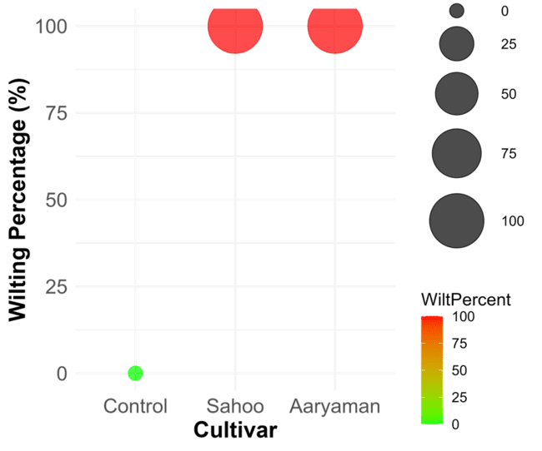
Fig. 2. Wilting percentage of Sahoo and Aaryaman cultivars (30 days old seedling)
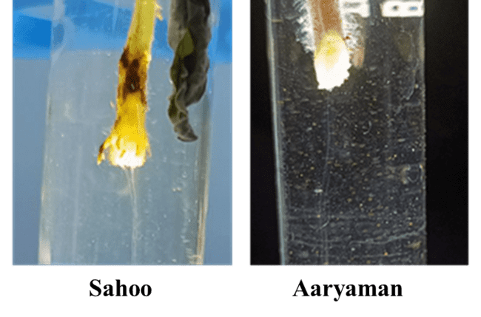
The presence of active pathogen colonization in infected plants was confirmed using the ooze test, which revealed typical bacterial streaming from cut stem sections (Plate 4). This classical diagnostic tool remains highly effective for confirming R. solanacearum presence during wilt assessment (Elphinstone, 2005). Notably, control plants treated with sterile water remained symptomless, validating the reliability of the experimental conditions and confirming that abiotic factors were not responsible for observed wilting.
Plate 4. Ooze test to confirm R. solanacearum colonization in Sahoo and Aaryaman cultivars
These results reinforce the scalability of the S-1 inoculation method and support its potential use across a range of growth stages, offering plant pathologists a unified and reproducible protocol for pathogenicity screening.

3.3 Histological Confirmation of Pathogen Impact
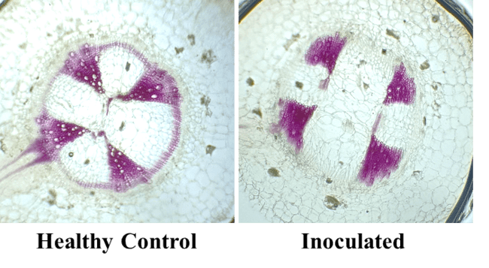
To gain anatomical insight into the host response, phloroglucinol-HCl staining was employed to assess lignin integrity in vascular tissues. In infected seedlings, a marked reduction in lignin staining was observed compared to controls, particularly in xylem regions (Plate 5). This supports the hypothesis that R. solanacearum disrupts vascular lignification to facilitate systemic movement within the host. Lignin degradation not only compromises the structural integrity of xylem vessels but also lowers host defense thresholds, accelerating symptom progression. Similar anatomical evidence has been reported in studies examining wilt progression in solanaceous hosts and in pathosystems involving vascular bacterial pathogens (Wang et al., 2023; Zhang et al., 2022).
Plate 5. Phloroglucinol-HCl staining to visualize lignification in Sahoo cultivar
This finding is particularly significant in light of R. solanacearum’s well-known ability to form biofilms within xylem vessels, a strategy that enhances colonization, protects against host defenses and ensures sustained pathogenicity under fluctuating environmental conditions (Khokhani et al., 2021). The consistent reduction in lignin across both seedling stages also implies that the physiological mechanisms underpinning wilt are activated early in the infection process, reinforcing the need for early detection and rapid pathogenicity assays.
Together, the integration of phenotypic (wilt scores), classical diagnostic (ooze test) and histological (lignin staining) assessments presents a comprehensive framework for evaluating R. solanacearum aggressiveness under laboratory conditions. Compared to traditional soil-based or stem-injection methods, the root dip assay described herein offers a more time-efficient, scalable and reproducible platform suitable for screening resistant germplasm, evaluating biocontrol agents and investigating strain-level pathogenic variability (Heena et al., 2020; Singh et al., 2018).
- CONCLUSION
The root dip assay proved to be a rapid and reproducible method for evaluating Ralstonia solanacearum pathogenicity in tomato. Direct root immersion reliably induced wilt, while ooze tests and lignin staining confirmed pathogen colonization and vascular damage. This standardized approach offers a practical alternative to traditional assays for resistance screening and virulence studies.
DISCLAIMER (ARTIFICIAL INTELLIGENCE)
Author(s) hereby declare that NO generative AI technologies such as Large Language Models (ChatGPT, COPILOT, etc.) and text-to-image generators have been used during the writing or editing of this manuscript.
COMPETING INTERESTS
Authors have declared that no competing interests exist
REFERENCES
Abo-Elyousr, K. A. M., Abdel-Hamid, A. M. & El-Mougy, N. S. (2021). Screening of tomato cultivars for resistance against bacterial wilt disease under greenhouse conditions. Egyptian Journal of Phytopathology, 49(1), 1–12.
Balamurugan, A., Muthamilan, M., Kamalakannan, A., Shanthi, A. & Arumugam, T. (2020). Characterization of Ralstonia solanacearum causing bacterial wilt disease of tomato in Coimbatore District of Tamil Nadu, India. International Journal of Current Microbiology and Applied Sciences, 9(2), 2975–2982.
Devi, U. P., Vineet, K. & Deshpande, K. S. (2021). Study of pathogenic traits of bacterial wilt-causing phytopathogens around Kanpur and Fatehpur regions, Uttar Pradesh, India. Journal of Applied Biology and Biotechnology, 9(5), 39–46.
Elphinstone, J. G. (2005). The current bacterial wilt situation: A global overview. In: Allen, C., Prior, P., & Hayward, A. C. (Eds.), Bacterial Wilt Disease and the Ralstonia solanacearum Species Complex (pp. 9–28). CABI Publishing.
FAOSTAT. (2023). World food and agriculture – Statistical yearbook 2023. Food and Agriculture Organization of the United Nations. Available at: https://openknowledge.fao.org/handle/20.500.14283/cc9413en
Heena, A., Dowarah, B. & Agarwala, N. (2020). A quick method for screening biocontrol efficacy of bacterial isolates against Ralstonia solanacearum in tomato. Bio-protocol, 10(22), e3829.
Ijaz, M., Lv, L., Ahmed, T., Noman, M., Manan, A., Ijaz, R., Shahid, M. S., Wang, D., Ondrašek, G. & Li, B. (2024). Immunomodulating melatonin-decorated silica nanoparticles suppress bacterial wilt (Ralstonia solanacearum) in tomato (Solanum lycopersicum L.) through fine-tuning of oxidative signaling and rhizosphere bacterial community. Journal of Nanobiotechnology, 22, 123–132.
Karanja, L. N., K’Owino, I. O., Wangila, P., Ramkat, R. C. & Odero, M. P. (2024). Evaluation of biochar plant extract composites from Solanum incanum fruits in controlling Ralstonia solanacearum-based bacterial wilt in tomato plants. International Research Journal of Pure and Applied Chemistry, 25, 89–97.
Khokhani, D., Lowe-Power, T. M., Tran, T. M. & Allen, C. (2021). A root inoculation method to study Ralstonia solanacearum pathogenicity in tomato seedlings. Phytopathology, 111(2), 295–303.
Konappa, N., Krishnamurthy, S., Siddaiah, C. N., Ramachandrappa, N. S. & Chowdappa, S. (2018). Evaluation of biological efficacy of Trichoderma asperellum against tomato bacterial wilt caused by Ralstonia solanacearum. Egyptian Journal of Biological Pest Control, 28(1), 1–10.
Kumar, S., Gowda, P. H. R., Saikia, B., Debbarma, J., Velmurugan, N. & Chikkaputtaiah, C. (2018). Screening of tomato genotypes against bacterial wilt (Ralstonia solanacearum) and validation of resistance-linked DNA markers. Australasian Plant Pathology, 47(5), 513–521.
Mekonnen, H., Kibret, M. & Assefa, F. (2022). Isolation and characterization of Ralstonia solanacearum causing wilt disease in tomato. Archives of Phytopathology and Plant Protection, 55(20), 2527–2542.
Mitra, P. P. & Loqué, D. (2014). Histochemical staining of Arabidopsis thaliana secondary cell wall elements. Journal of Visualized Experiments, 87, 51381.
Peng, S., Xu, Y., Qu, H., Nong, F., Shu, F., Yuan, G., Ruan, L. & Zheng, D. (2024). Trojan Horse virus delivering CRISPR-AsCas12f1 controls plant bacterial wilt caused by Ralstonia solanacearum. mBio, 15(3), 45–52.
Rout, P. P. (2015). Studies on the wilt disease complex in tomato (Solanum lycopersicum L.) and its management (Ph.D. thesis). Orissa University of Agriculture and Technology, India. 210 p.
Sabharwal, U., Kant, P., Choure, K., Subramanian, R. B., Joo, J. C. & Pandey, A. (2025). Investigating the effect of pipecolic acid on specialized metabolites involved in tomato plant defense mechanisms against Ralstonia solanacearum wilt pathogens. Analytica, 6(1), 1–12.
Sankaran, S. S. P., Murugan, M., Shanthi, M., Thiyagarajan, E., Kathithachalam, A., Karthikeyan, G., Gopal, A. V., Palanisamy, M., Manickam, R., Sotelo-Cardona, P., Oliva, R. & Ramasamy, S. (2024). Evaluation of integrated pest and disease management combinations against major insect pests and diseases of tomato in Tamil Nadu, India. Horticulturae, 10(7), 766–774.
Singh, N., Phukan, T., Sharma, P. L., Kabyashree, K., Barman, A., Kumar, R., Sonti, R. V., Genin, S. & Ray, S. K. (2018). An innovative root inoculation method to study Ralstonia solanacearum pathogenicity in tomato seedlings. Phytopathology, 108(4), 436–442.
Solanki, B. & Khan, M. S. (2024). Unveiling the efficacy of a bacterial antagonist in the management of tomato wilt disease caused by Ralstonia solanacearum. Research on Crops, 25(3), 102–110.
Srinivasamurthy, R., Singh, J. P. & Rai, A. K. (2014). Biological control of bacterial wilt disease-causing pathogens: A sustainable approach for increasing crop production. In: Biological Control of Plant Diseases (pp. 535–546). Springer.
Subramanian, R. B. (2023). Variation in defense enzymes in GT-2 and GAT-5 varieties of tomato during infection with bacterial wilt disease in Central Gujarat, India. Plant Stress, 100, 160–168.
Wang, Y., Zhang, J., Xu, J., Li, Y. & Zhao, H. (2023). Suppression of lignin biosynthesis during early infection by Ralstonia solanacearum promotes vascular colonization in tomato. Plant Physiology, 191(3), 1857–1872.
Zhang, L., Huang, Q. & Wang, L. (2022). Biofilm formation by Ralstonia solanacearum contributes to colonization and virulence in tomato xylem. Plant Pathology Journal, 38(5), 401–410.

