INSECT DIVERSITY ON LOW CHILLING APPLE VARIETIES IN HORTICULTURE EXPERIMENTAL FARM OF JORHAT, ASSAM

ABSTRACT-
A study on “diversity of insects on low chilling apple varieties viz. HRMN-99, Dorsett Golden and Anna” was carried out in the Horticulture Experimental Farm, Assam Agricultural University, Jorhat, India, during 2023-24. Based on taxonomic classification, the insect species were placed into 6 different orders, viz. Coleoptera, Hemiptera, Lepidoptera, Hymenoptera, Heteroptera and Aranea. Major insect pests recorded were woolly apple aphid (Eriosoma lanigerum), shot hole beetle and codling moth (Cydia pomonella) and the remaining 6 species were recorded as minor insect pests. Natural enemies observed were ladybird beetles, braconid wasps and lynx spider, while honey bees visited as pollinators. Also, the prevailing weather conditions of the experimental region, especially during flowering and fruiting stages and the insects recorded in response to particular intervals of time were presented along with the weather data. The findings obtained during the course of study will help understand the biodiversity of insect fauna associated with low chilling apple plants and therefore have implications for taxonomy and pest management in apple, particularly for the Jorhat region.

Keywords: Diversity, insect pests, natural enemies, pollinators and low chilling apple
1. INTRODUCTION-

Apple (Malus domestica) is one of the most important temperate fruit crops in the world and popularly known as the king of temperate fruits. Apple has grown worldwide, particularly in temperate regions, with loamy soil that is rich in organic matter, proper drainage and aeration facilities. Most of the apple varieties have the chilling requirement of 1000-1500 hr below 7° C. However, after the bud break, during the growth, long day hours with high light intensity, warm days (not hot days) viz.,12-15°C and cool nights (not freezing nights) viz., 7– 8°C, are favourable for the production of quality fruits. In India, the Kashmiri apples are famous for its unique flavour, taste, size, look and color. The ongoing research has developed various low-chilling apple varieties that are suitable for cultivation in the tropical and sub-tropical climatic conditions of the world. Low chilling varieties are those apple varieties that can be successfully cultivated in warm areas with around 200-300 hrs of chilling temperature (below 7ºC). Some of the Chilling Apple varieties are Anna, Tropical Beauty, Early Fuji, Tamma, Neomi, Parlin's Beauty, Golden Dorsett, HRMN-99, etc (Carter, 2007; Rai et al.,2015). Apple crops have been infested by a large number of insects, including both harmful and beneficial insects and some of them are very serious pests and need awareness to control them. The present study aimed to investigate the insects infesting the low chilling apple varieties, viz, HRMN-99, Dorsett Golden and Anna under Jorhat, Assam conditions.

2. MATERIALS AND METHODS-

The present study was conducted at the Experimental Farm, Department of Horticulture, Assam Agricultural University, Jorhat (located at 26˚45ʹ N latitude, 94˚12ʹ E longitude and at an altitude of 87 m above mean sea level) during the period of 2023-24 with three low-chilling apple varieties, viz. V1 (HRMN-99), V2 (Dorsett Golden) and V3 (Anna). Observation and collection of the insect pests and natural enemies were done weekly. The collected insects were differentiated as pests, beneficial insects and pollinators. The identification of a specimen was achieved by presenting subsequent appropriate diagnostic characters with the help of published keys (Srivastava, 2004; Atwal and Dhaliwal, 2010).

3. WEATHER DATA DURING FLOWERING AND FRUITING STAGES OF THE CROP
Table 1: Weather data during flowering and fruiting stages of the crop
 | Max T(ºC) | Min T(ºC) | RH (%) |  | RF(mm) | Rainy days | BSSH(hr) | WS(kmph)
 |  |  | I | II
February | 23.92 | 11.02 | 97.20 | 58.80 | 5.80 | 1.0 | 3.58 | 1.72
March | 27.64 | 14.46 | 94.00 | 54.00 | 10.82 | 1.0 | 4.80 | 2.20
April | 29.12 | 18.94 | 92.60 | 64.40 | 34.64 | 2.6 | 4.26 | 2.84
May | 30.96 | 21.56 | 89.60 | 66.80 | 53.22 | 2.2 | 4.80 | 2.46
June | 31.22 | 23.92 | 94.00 | 80.20 | 108.08 | 4.2 | 2.16 | 2.34
July | 33.12 | 24.86 | 92.80 | 73.40 | 79.34 | 3.6 | 4.66 | 2.60
August | 33.48 | 24.54 | 93.80 | 73.00 | 54.34 | 2.8 | 5.00 | 2.70
I = 6.13am | II = 1.13pm
-Insects (braconid wasp, lady bird beetle, handmaiden moth)
-Flowering and fruiting stage & insects (yellow tail tussock moth, honey bee, blue flea beetle, flea beetle, lynx spider)

-Fruit maturing stage & insects (shot hole beetle, codling moth)
-Insect (woolly apple aphid)

-Values of weather parameters

Weather parameters influence insect activity in a particular region, which further affects agricultural production. Changes in weather conditions may trigger major changes in the geographical distribution of insects, survival and population dynamics of insect pests, activity and abundance of natural enemies and efficacy of crop protection technologies. Insects are poikilothermic in nature and therefore they are highly sensitive to their surrounding climate, particularly the temperature (Devi et al.,2019). Due to sudden changes in the weather conditions, especially sudden increases in temperature or heavy rainfall, there are chances of an increase in the number of pest populations, outbreaks of pests and an increased number of generations per year (Devi et al.,2019). This, in turn, increases the chances of damage caused by insects, decreases crop yield, increases the cost of crop protection and thereby affects the economy. Since insects are cold-blooded organisms, i.e., their body temperature is approximately the same as that of the environment, therefore, temperature is considered one of the most important environmental factors that influence insect behaviour, development, as well as reproduction (Devi et al.,2019). Researchers have shown that increased temperature can profoundly affect insect development, survival rate, population size and geographic range. Temperature can also affect insect physiology and development directly or indirectly, as every species has a particular threshold of temperature above which development occurs and below which the development ceases (Devi et al.,2019). Precipitation, whether optimal, excessive, or insufficient, is a key variable affecting crop-pest interactions. Abnormally cool, wet conditions can also cause severe insect infestations. Some insects are sensitive to precipitation and are killed or removed from crops by heavy rains. Some studies revealed that the peak activity of the woolly apple aphid was observed during autumn months in Himachal Pradesh due to the provision of favourable environmental conditions (Thakur et al.,1992). It was observed that rainfall kept a significant check on the nymphal movement of woolly apple aphid, even under favourable conditions (Bharadwaj et al.,1995). The peak population of woolly apple aphid was observed during May-June in 1997; on the other hand, in 1998 highest population was observed in July. This fluctuation in the population of woolly apple aphid was mainly due to a decline in rainfall or the late occurrence of a rainy season (Sood et al.,2005). Temperature, moisture and photoperiod are the three known factors that affect the phenology of both plants and the pollinators (Devi et al.,2019). Many plants have reacted to increasing temperatures by earlier flowering (Miller et al.,2007). Insect-pollinated plants generally react more strongly to increased temperature than wind-pollinated plants and species that flower early in the season appear to be more sensitive (Miller et al.,2007). Natural enemies and the host insect population may respond differently to changes in temperature. Rising temperatures may also have a negative effect on delicate natural enemies such as Hymenopteran parasitoids and small predators (Devi et al.,2019). Weather parameters and their changing patterns also disturb the predator-prey and parasitoid-host interactions and even alter the balance between insect pests, natural enemies and host plants because of alteration in their synchrony (Evans et al.,2002). As shown in table 1, it could be concluded that as per the climatic condition of the experimental region, such values of weather parameters especially in terms of temperature, relative humidity, rainfall and rainy days corresponding to the presence of insects at that particular time and growth stage of the crop, could have probably affected the activity of the above mentioned insects and more specifically induces the activity of one of the major pest of apple i.e, wooly apple aphid and also shot hole beetle, which caused economic loss to the crop during the experiment.

4. RESULTS AND DISCUSSION-

In the present investigation, a total of 16 insect specimens were observed in the field. Of which 9 species of insect pests, 5 species of natural enemies and 2 species of pollinators were identified and documented (Table 2,3&4 and Fig. 1&2). Based on taxonomic classification, the insect species were placed in 6 different orders viz. Coleoptera (7), Hemiptera (1), Lepidoptera (3), Hymenoptera (2), Heteroptera (1) and Aranea (1). In the present investigations, coleopteran insects were found to be dominant among all the insects in the apple orchard and the results are similar to the findings of Biswas et al.(2020), who also reported the highest diversity of coleopterans in apple orchards of Meghalaya. The major insect pests recorded on low chilling apple during 2023-24 were apple woolly aphid (Eriosoma lanigerum), shot hole beetle and codling moth (Cydia pomonella) and minor insects recorded were green stink bug (Nezara viridula), handmaiden moth (Syntomoides imaon), flea beetle (Sphaeroderma testaceum), yellow tail tussock moth (Somena scintillans), blue flea beetle (Altica spp.) and ash weevil (Myllocerus spp.). The present investigation showed similarity with the results obtained by Gupta et al.(2016), who reported pale tussock moth (Calliteara pudibunda ) as a major insect pest in the apple orchards of Jammu region, India and Biswas et al.(2020), who reported tussock moth (Euproctis guttata ), handmaiden moth (Amata bicincta ), flea beetle (Arthrotus flavocincta) and stink Bug (Coridius chinensis) in the apple orchards of Meghalaya. Also, the results are similar to the findings of Khursheed et al.(2021), who reported woolly apple aphid (Eriosoma lanigerum), flea beetle (Altica spp.) and stink bug (Halyomorpha hayla) in the apple orchards of Kashmir valley and Wani et al.(2022), who recorded codling moth and woolly apple aphid in apple orchards of Jammu and Kashmir.

Natural enemies identified consist of the transverse ladybird beetle (Coccinella transversalis), 2 species of ladybird beetle (Micrapis discolor and Menochilus sexmaculatus), lynx spider (Oxyopes spp.) and braconid wasp (Apanteles spp.). These results conformed with the findings of Hradil et al.(2013), who reported the presence of coccinellid beetles in apple orchards. Similar findings for natural enemies were also reported by Biswas et al.(2020), who recorded ladybird beetle, coccinellid beetle and braconid wasp (Cotesia congregata ) in apple orchards of Meghalaya and Khursheed et al.(2021), who reported coccinellid beetles in the apple orchards of the Kashmir valley. Pollinators collected were 2 species of honey bee i.e, Apis cerana and Apis dorsata and the findings conformed with the results obtained by Raj et al.(2012) and Biswas et al.(2020), who reported honey bee as a major insect pollinator visiting apple flowers frequently.

Table 2 : Insect pests of apple recorded during 2023-24

Sl. No | Common name | Scientific name | Family | Order/  Sub-order | Feeding site | Status
1 | Green stink bug | Nezara viridula | Pentatomidae | Heteroptera | Leaf | Minor
2. | Apple wooly aphid | Eriosoma lanigerum | Aphididae | Hemiptera | Twigs,  bark,  fruits | Major
3. | Handmaiden moth | Syntomoides imaon (L .) | Erebidae | Lepidoptera | Leaf | Minor
4 | Flea beetle | Sphaeroderma testaceum | Chrysomelidae | Coleoptera | Leaf | Minor
5 | Yellow tail tussock moth | Somena scintillans | Erebidae | Lepidoptera | Leaf, buds,  flowers, fruits | Minor
6 | Blue flea beetle | Altica spp. | Chrysomelidae | Coleoptera | Leaf | Minor
7. | Ash weevil | Myllocerus spp. | Curculionidae | Coleoptera | Leaf and roots | Minor
8. | Shot hole beetle | unidentified | Curculionidae | Coleoptera | Bore inside the trunk | Major
9 | Codling moth | Cydia pomonella | Tortricidae | Lepidoptera | fruit | Major

Table 3 : Beneficial insects on apple recorded during 2023-24
Sl No. | Common name | Scientific name | Family | Order | Crop stage
1 | Transverse ladybird | Coccinella transversalis | Coccinellidae | Coleoptera | Flowering to maturity
2 | Ladybird beetle | Micrapis discolor | Coccinellidae | Coleoptera | Flowering to maturity
3 | Ladybird beetle | Menochilus sexmaculatus | Coccinellidae | Coleoptera | Flowering to maturity
4 | Lynx spider | Oxyopes spp. | Oxyopidae | Araneae | Vegetative to maturity
5 | Braconid wasp | Apanteles spp. | Braconidae | Hymenoptera | Fruiting stage

Table 4 : Pollinators on apple recorded during 2023-24
Sl No. | Common name | Scientific name | Family | Order | Crop stage
1 | Honey bee | Apis cerana | Apidae | Hymenoptera | Flowering
2 | Honey bee | Apis dorsata | Apidae | Hymenoptera | Flowering

Fig 1: Orders of insects recorded on the low chilling apple varieties

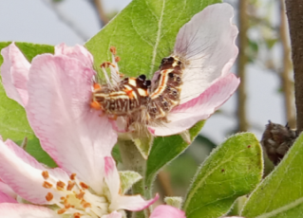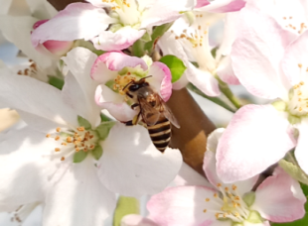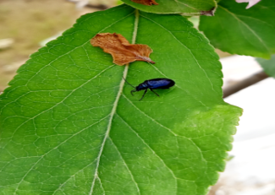
Yellow tail tussock moth (Somena scintillans)

Blue flea beetle (Altica sp.)

Honey bee (Apis cerana)

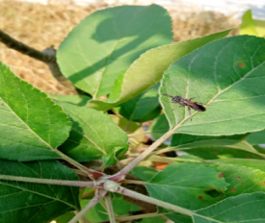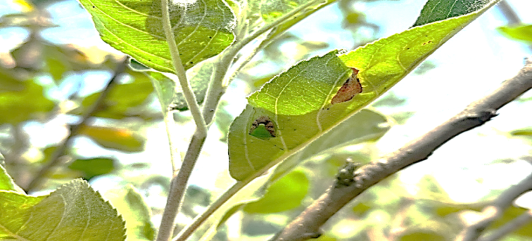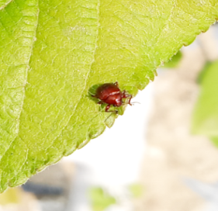
Flea beetle (Sphaeroderma testaceum)

Green stink bug (Nezara viridula )

Braconid wasp (Apanteles sp.)

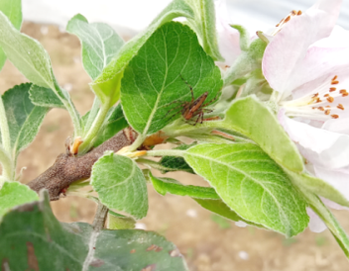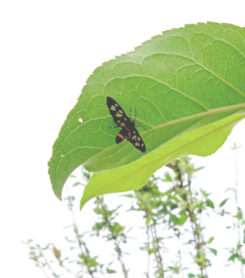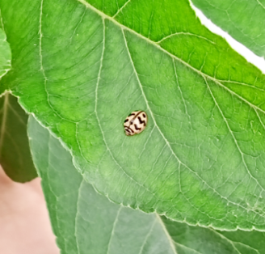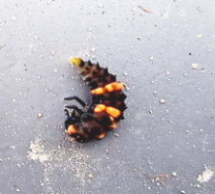
Transverse Lady bird beetle (Coccinella transversalis)
Lady bird beetle larva
Handmaiden moth (Syntomoides imaon (L .))

Lynx Spider (Oxyopes sp.)

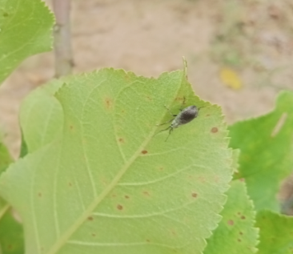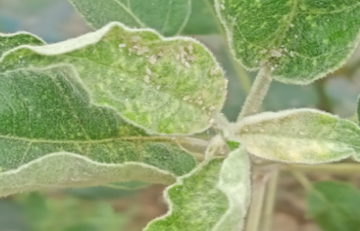
Ash weevil (Myllocerus sp.)

Apple wooly Aphid (Eriosoma lanigerum )

Shot hole borer

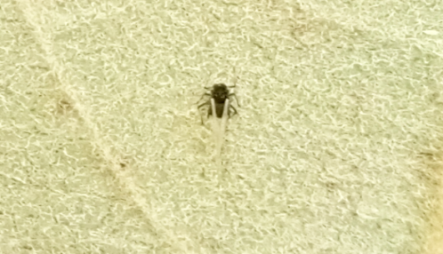
Apple wooly Aphid (a later stage) (Eriosoma lanigerum)

Fig 2: Insects recorded on low chilling apple varieties during 2023-24

5. CONCLUSION-

Through the present investigation, it is concluded that the low chilling apple varieties viz. HRMN-99, Dorsett Golden and Anna at the Horticulture Experimental Farm, Jorhat were infested by 16 species of insects during the year, 2023-24 and of which 9 species of insect pests viz. green stink bug, apple wooly aphid, handmaiden moth, flea beetle, yellow tail tussock moth, blue flea beetle, ash weevil, shot hole beetle and codling moth, 5 species of natural enemies viz. transverse ladybird beetle, 2 species of ladybird beetle, lynx spider and braconid wasp and 2 species of pollinators i.e, honey bee. Hence, additional studies can be performed to get a clear picture of insect pests associated with apple in this region and, therefore, implicating pest management strategies. Also, it is important to study the efficiency of some of the important natural enemies in order to reduce the use of chemical pesticides and conserve them, as well as the pollinators.

REFERENCES

Atwal, A.S. and Dhaliwal, G.S. (2010). Agricultural Pests of South Asia and their Management, Kalyani Publishers.

Bathari, M.; Taye, R.R.; Hazarika, B. and Gogoi, K. (2018). Diversity of insect pollinators on Litchi chinensis flower in the horticulture experimental farm of Jorhat district, Assam, India. J. Exp. Zool. India, 21(2):881-883.

Beaurepaire, A. L.; Webster, M. T. and Neumann, P. (2024). Population genetics for insect conservation and control. Conservation Science and Practice, 6(3), e13095.

Bhardwaj, S.; Chander, R. and Bhardwaj, S.P. (1995). Movement of woolly apple aphid (Eriosoma lanigerum) (Homoptera: Pemphigidae) on apple (Malus pumila) plant in relation to weather parameters. Indian Journal of Agricultural Science, 65:217-222.

Biswas, D.; Thakur, N.S.A.; Gogoi, J. and Nakambam, S. (2020). Study on the biodiversity of insects in apple in mid mid-hills of Meghalaya. Journal of Entomology and Zoology Studies, 8(3): 818-823.

Carter, K. (2007). Low Chill Apples. University of California Cooperative Extension Central Coast & South Region. http://ucce.ucdavis.edu/files/filelibrary/5764/33384.pdf.

Chowdhury, S.; Jennions, M.D.; Zalucki, M.P.; Maron, M.; Watson, J.E. and Fuller, R.A. (2023). Protected areas and the future of insect conservation. Trends in Ecology & Evolution, 38(1), 85- 95.

Devi, D.; Verma, S.C.; Sharma, P.L.; Sharma, H.K.; Gupta, N. and Thakur, P. (2019). Effect of climate change on insect pests of fruit crops and adaptation and mitigation strategies: A review. Journal of Entomology and Zoology Studies, 7(1): 507-512.

Evans, H.; Straw, N and Watt, A (2002). Climate change: implications for insect pests. Forestry Commission Bulletin, 125:99-118.

Gupta, R. and Pathania, P.C. (2016). Report on Lepidoptera pest diversity on apple plantations (Malus domestica) in Jammu province. Journal of Insect Science, 29(1):140-150.

Hradil, K.; Psota,V. and Stastna, P (2013). Species diversity of true bugs on apples in terms of plant protection. Plant Protection Science, 49(2):73-83.

Islam, N. and Modi, S (2021). Commercial Cultivation of Malus domestica and its Disease Management in Kashmir Valley. International Journal of Recent Advances in Multidisciplinary Topics, 2(9):74-75.

Khursheed, S.; Bhat, Z.A.; Rather, G.H.; Itoo, H.; Malik, A.R. and Pandit, BA. (2021). Occurrence of insect and mite pests and their natural enemies under high-density apple agro-ecosystems in Kashmir. Journal of Entomology and Zoology Studies, 9(1): 993-998.

Miller-Rushing, A.J.; Katsuki, T.; Primack, R.B.; Ishii, Y.; Lee, S.D. and Higuchi, H. (2007). Impact of global warming on a group of related species and their hybrids: cherry tree (Rosaceae) flowering at Mount Takao, Japan. American Journal of Botany, 94:1470-1478.

Nayak, S. B., Elango, K., & Rao, K. S. (2021). Insect biodiversity and their conservation for sustainable ecosystem functioning. Biological Diversity: Current Status and Conservation Policies, 1:304-314.

Outhwaite, C. L., McCann, P., & Newbold, T. (2022). Agriculture and climate change are reshaping insect biodiversity worldwide. Nature, 605(7908):97-102.

Rai, R.; Joshi, S.; Roy, S.; Singh, O.; Samir M. and Chandra A. 2015. Implications of Changing Climate on Productivity of Temperate Fruit Crops with Special Reference to Apple. J. Horti., 2:2.
Raj, H.; Mattu, V.K. and Thakur, M.L. (2012). Pollinator diversity and relative abundance of insect visitors on apple crop in Shimla hills of western Himalaya, India. International Journal of Science and Nature, 3(3):507-513.

Raven, P.H. and Wagner, D.L. (2021). Agricultural intensification and climate change are rapidly decreasing insect biodiversity. International Journal of Entomology Research, 5(1):15-17.

Sood, A. and Gupta, P.R. (2005). Studies on the seasonal abundance of woolly apple aphid and its natural enemies in the mid-hills of Himachal Pradesh. Acta Horticulture, 2:395-398.

Sollai, G. and Solari, P. (2022). An Overview of “Insect Biodiversity”. Diversity, 14(2):134.

Srivastava, K.P. (2004). Collection and Preservation of Insects and Classification and Considerations for Life Histories. In: A Text Book of Applied Entomology II, 36-64.

Thakur, J.R.; Dogra, G.S. and Gupta, P.R. (1992). Population trends and dispersal behaviour of woolly apple aphid, Eriosoma lanigerum (Haus.) In: Emerging Trends in Temperate Fruit Production in India. NHB Jach. Communication No. 1. National Horticulture Board, Gurgaon, India, 284-290.

Thangjam, R. and Vastrad, A.S. (2018), Studies on pest complex of sesame and their natural enemies in North Karnataka, India. Journal of Entomology and Zoology Studies, 6(6): 57-60.

Verma, R.C.; Waseem, M.A.; Sharma, N.; Bharathi, K.; Singh, S.; Anto Rashwin, A. and Singh, B.V. (2023). The role of insects in ecosystems: an in-depth review of entomological research. International Journal of Environment and Climate Change, 13(10):4340-4348.

Wani, S.D.; Majeed, M.; Kumar, G.; Jamali, M.M. and Mir, R.A. (2022). Studies on insect pests of apple in Kashmir and its integrated management approaches. Journal of Applied Entomologist, 2(4):01-08.

Webster, M.T.; Beaurepaire, A.; Neumann, P. and Stolle, E. (2023). Population genomics for insect conservation. Annual Review of Animal Biosciences, 11(1):115-140.

