Original Research Article
Soil-site suitability assessment for horticulture crops across different land use systems in Bada micro watershed (4D4F2j05) of Haveri district, Karnataka

ABSTRACT:
A research study was undertaken to evaluate the suitability of four land uses (forest, barren land, agriculture and horticulture) within the Bada micro watershed of Haveri district, situated in the Northern transition zone (Zone-8) of Karnataka. Utilizing base map in conjunction with satellite imagery total of eight profiles, two from each land use system were identified and assessed. Subsequently, the potential of these land use systems for the cultivation of key horticulture crops, namely chilli, tomato, coconut, mango, sapota and guava were assessed. The results indicated that across the forest, agriculture and horticulture land use systems suitability for crops was classified from moderately suitable (S2) to marginally suitable (S3). Whereas, the barren land use is not suitable (N) for mango, sapota and guava cultivation due to pronounced physical limitation that affecting rooting of crops. Conversely, the barren land exhibits marginal suitability (S3) for the production of chilli, tomato and coconut. These outcomes provides an essential baseline information for identifying specific soil constraints and support the formulation of sustainable crop production strategies within the study region.
KEYWORDS: Soil-site suitability; Bada micro watershed; Land use system
1. INTRODUCTION:
The world’s arable land is experiencing significant pressure, characterized by rapid urbanization, accelerated desertification and over exploitation driven by anthropogenic activities. The poor soil management practices across cultivated lands have resulted in increased soil erosion, diminished crop productivity and deterioration of soil quality (Pimentel and Burgess, 2013). As the sustainability of agricultural practices fundamentally depends on the effective utilization of land resources, there is a heightened focus on land evaluation to identify the most suitable land use alternatives. Land evaluation constitutes a systematic assessment of land suitability for specific purposes such as cultivation of crops. This process entails a comprehensive analysis of various factors including soil and topographical properties to inform sustainable and effective land use planning. The primary objective of land evaluation is to align the inherent characteristics of the land with the specific demands of intended uses, thereby optimizing productivity while concurrently mitigating adverse environmental effects. To evaluate the suitability and limitations of a specific piece of land for cultivation purposes, it is imperative to employ a scientific approach of land evaluation.
Land suitability evaluation is a critical component in land use planning, as it entails the assessment of land’s capacity to support various existing and potential uses (Sehgal, 1995). Soil properties and site characteristics are pivotal in categorizing land suitability into classes such as Highly Suitable (S1), Moderately Suitable (S2), Marginally Suitable (S3) and Not Suitable (N) for specific crops. This classification facilitates strategic planning aimed at expanding the cultivation area of the respective crop. Sharma et al. (2001) emphasized that analyzing the interplay between soil and site attributes alongside crop requirements forms the basis for determining soil suitability and formulating effective land use plans. The process of land evaluation comprises four key stages: (a) the characterization of existing soil, climatic and land use conditions; (b) the development of soil-site criteria based on crop requirements; (c) the comparison of crop requirements with prevailing soil and climate conditions; and (d) the final selection of the most appropriate crop as an alternative cropping strategy. Consequently, the assessment of soil-site suitability is essential for determining viable crop options within a specific region and its associated climatic context.
A land use system can be defined as the practices adopted on a particular tract of land, which substantially impacts soil fertility. Assessing the various land use systems for soil-site suitability is crucial for determining optimal management strategies to site specific conditions. The Bada micro watershed (4D4F2j05) with an area of 592.62 ha is situated in the Haveri district of Karnataka state was selected as a representative unit for evaluating soil-site suitability for horticulture crops across different land use systems.
2. MATERIALS AND METHODS
The research was carried out during the years 2024 to 2025 in the Bada micro watershed (4D4F2j05), located in the Haveri district of Karnataka state (Figure-1). Geographically, the micro watershed lies between 14˚ 55' 30" - 14˚ 58' 0" North latitudes and 75˚ 11' 45" and 75˚ 14' 0" East longitudes. The total area encompassed by the micro watershed is approximately 592.62 hectares. The study area is classified within the Northern Transition Zone (Agroclimatic Zone 8) of Karnataka state, characterized by an elevation range of 450 to 900 meters above mean sea level. The zone experiences an average annual rainfall varying between 620 and 1025 mm.
A preliminary survey of the entire micro watershed was conducted using a 1:7,920 scale base map in conjunction with satellite imagery. Total of four distinct land use systems were identified (Figure-2). Within each land use system, two representative soil profiles were selected for detailed examination and analysis. The morphological attributes of excavated soil profiles were systematically recorded and their physical and chemical properties were
Figure-1. Location of the study area
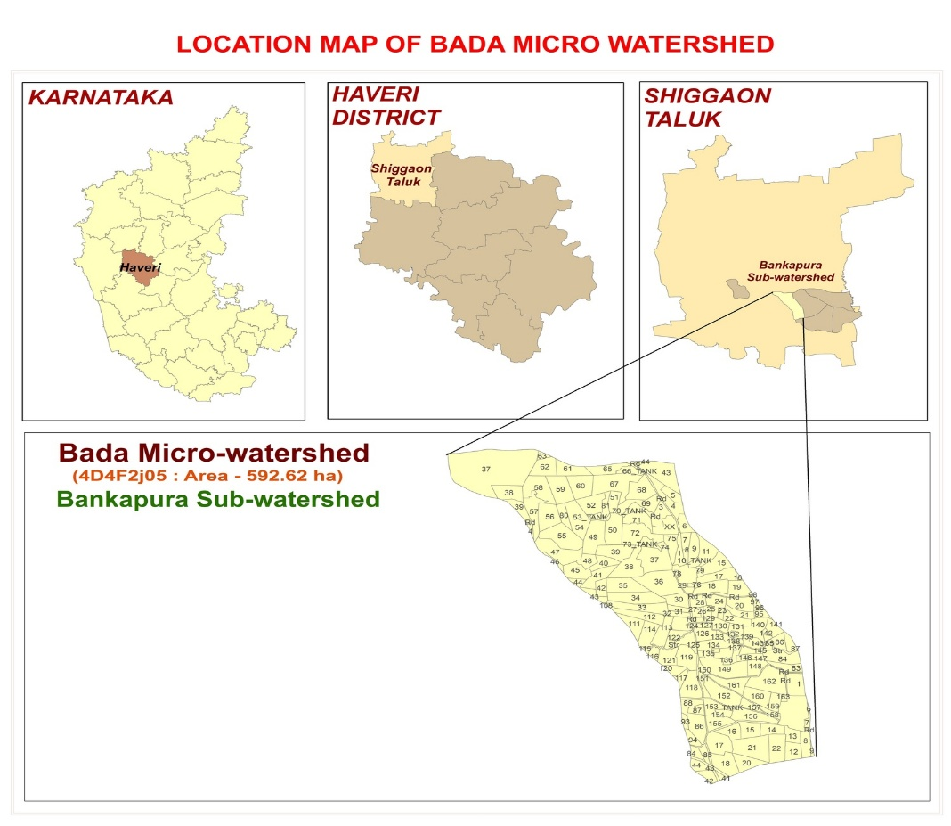

Figure-2. Land use systems of the Bada micro watershed
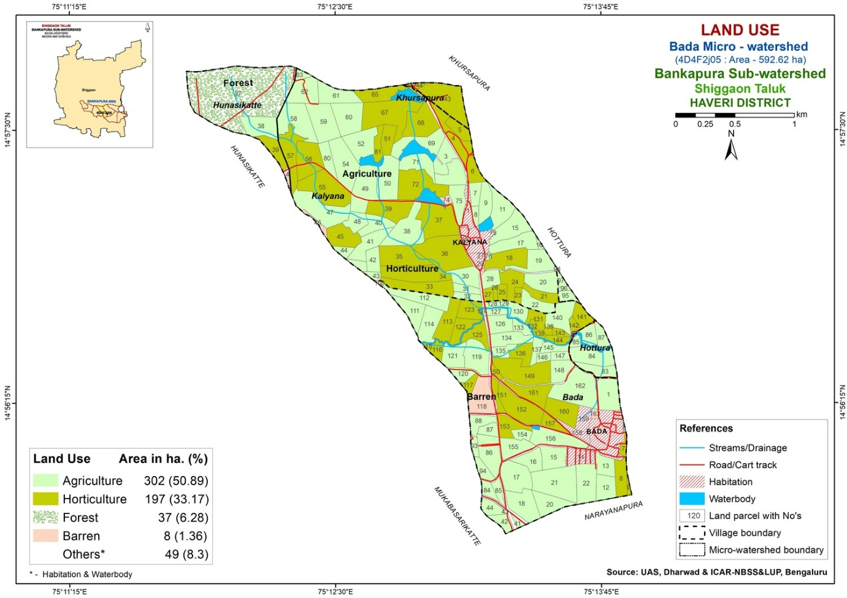
analyzed by employing standard procedures by following Keys to soil taxonomy (Anon., 2022).
Subsequent to comprehensive soil survey, crop suitability maps for major horticulture crops in the Bada micro watershed were generated across the land uses. This mapping was performed utilizing ArcGIS version 10.8.2. The assessment of crop suitability was employed using the limitation method, which considers both the quantity and intensity of limiting factors, as described by Naidu et al. (2006). The evaluation process comprises three distinct phases.
In the initial phase, data collection focused on a range of attributes as detailed in Table-1. Soil site characteristics categorized as oxygen availability to roots (soil drainage), nutrient availability (surface texture, soil pH, cation exchange capacity, base saturation, free calcium carbonate and organic carbon), rooting conditions (soil depth and coarse fragments), soil toxicity (salinity and sodicity) and erosion (slope). The study area was characterized by nearly level (agriculture) to gently sloping (barren land) slopes and had no history of flooding. Drainage conditions were identified as moderately well drained and the soil had a clay texture across all land uses.
In the second phase of the study, the landscape and soil requirements for six crops were derived from the NBSS and LUP manual by Naidu et al. (2006). The third phase involves assessing soil-site suitability by comparing landscape and soil characteristics with crop requirements, considering different suitability orders: Highly suitable (S1), Moderately suitable (S2), Marginally suitable (S3) and Not suitable (N) in accordance with FAO framework (Anon., 1976).
3. RESULTS AND DISCUSSION
The soil characteristics within the study region were evaluated in relation to the soil-site suitability criteria established for few horticultural crops grown in North Karnataka. Table-2 presents the assessment of soil-site suitability for major horticultural crops.
3.1 Chilli
Chilli (Capsicum annuum L.) is a widely cultivated and adaptable spice crop, recognized for its pungency and its unique flavour. It is extensively employed in culinary applications worldwide. In India, chilli cultivation is distributed across several states, with significant production concentrated in Andhra Pradesh, Maharashtra, Karnataka, Tamil Nadu and Gujarat. These regions offer favourable warm climatic conditions and soil properties suitable for chilli cultivation.
Table-1. Soil site characteristics of pedons under different land use systems for soil site suitability evaluation

Soil properties | Land use
Soil properties | Forest | Barren land | Agriculture | Horticulture
Oxygen availability to roots
Soil drainage | Moderately well | Moderately well | Moderately well | Moderately well
Nutrient availability
Surface texture | Clay | Clay | Clay | Clay
pH* | 6.43 | 8.39 | 7.68 | 7.31
CEC [cmol (p⁺) kg⁻¹)* | 56.97 | 16.34 | 46.95 | 48.21
BS (%)* | 53.16 | 77.20 | 86.07 | 81.80
Free CaCO₃ (g kg⁻¹)* | 1.29 | 4.33 | 3.56 | 2.64
OC (g kg⁻¹)* | 7.79 | 1.88 | 4.38 | 5.53
Rooting conditions
Soil Depth (cm)* | 103 | 85 | 135 | 105
Coarse fragments (%) | 15-35 | 35-60 | <15 | <15
Soil toxicity
Salinity - EC (1:2.5) (dS m⁻¹)* | 0.15 | 0.40 | 0.24 | 0.28
Sodicity - ESP (%)* | 3.14 | 2.89 | 4.28 | 5.25
Erosion
Slope (%) | 1-3 | 3-5 | 0-1 | 1-3
*Weighted average value of two profiles in respective land use

Table-2. Soil-site suitability classification for major horticulture crops in Bada micro watershed

Crop | Land use
Crop | Forest | Barren land | Agriculture | Horticulture
Chilli | S2gt | S3gn | S2nt | S2nt
Tomato | S2gt | S3g | S2nt | S2nt
Coconut | S2gt | S3gn | S3n | S2nt
Mango | S3gr | N | S2gnrt | S3r
Sapota | S3g | N | S2gnrt | S2grt
Guava | S3g | N | S2gnt | S2gt
Note: S1 – Suitable, S2 – Moderately suitable, S3 – Marginally suitable, N – Not suitable;
g – Gravelliness, l – Topography, n – Nutrient availability, r – Rooting condition, t – Texture.

This study evaluated the suitability of pedons across various land use systems for chilli cultivation, classifying them within the range of moderately suitable (S2) to marginally suitable (S3) (Figure-3). The findings indicated that pedons under forest land were categorized as suitability class S2, subclass S2gt, with principal limitations related to soil drainage, texture and gravelliness. Pedons under agricultural and horticultural land uses were also assigned to class S2, subclass S2nt, reflecting significant constraints including soil drainage, texture, pH and organic carbon content. Conversely, barren land pedons were classified as suitability class S3, subclass S3gn, primarily restricted by soil pH, organic carbon and gravelliness. Supporting these results, Narsaiah et al. (2020) reported that soils in the central and eastern regions of Warangal district, Telangana, exhibited marginal suitability (S3) for chilli cultivation. This marginal classification was mainly due to factors such as medium soil texture, slight variations in pedon depth and clay content, the presence or absence of coarse fragments and soil physical and fertility characteristics including pH and organic carbon levels.
Figure-3. Soil-site suitability map for chilli crop in Bada micro watershed
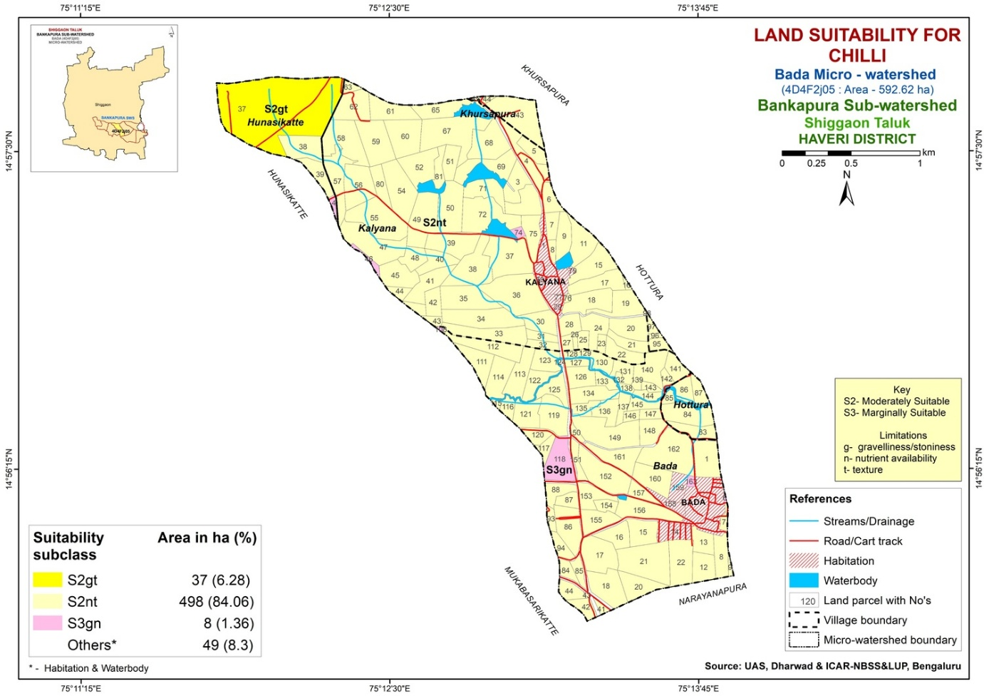

Figure-4. Soil-site suitability map for tomato crop in Bada micro watershed
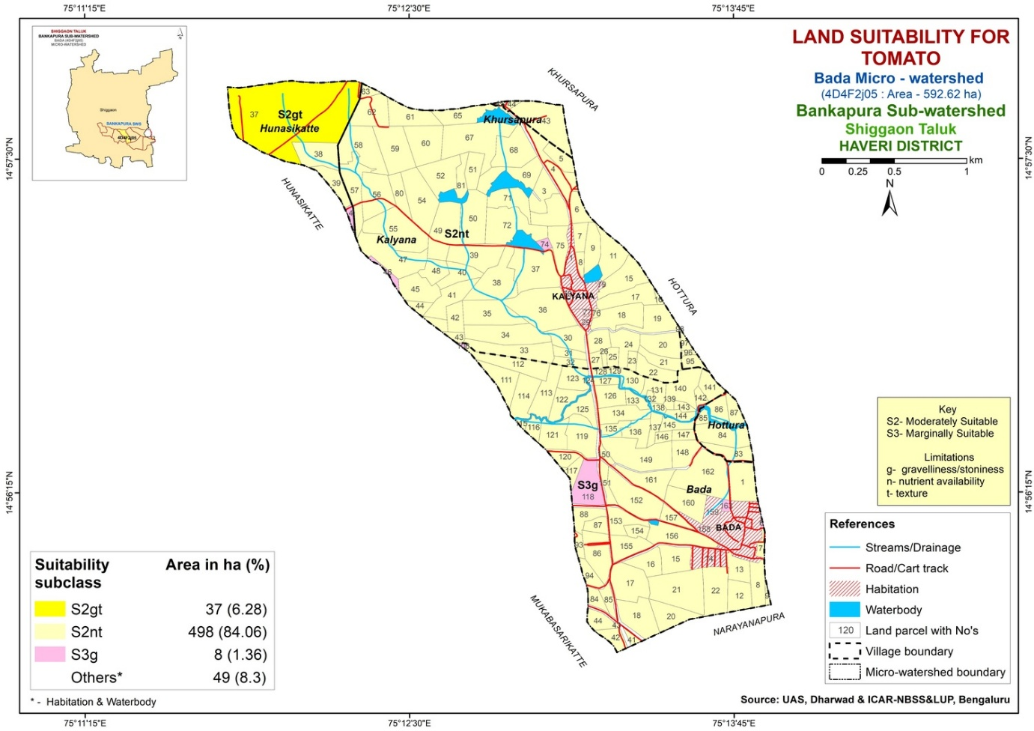
3.2 Tomato
Tomato (Solanum lycopersicum) represents a significant vegetable crop widely cultivated throughout India, fulfilling demands for both fresh consumption and processing. It is highly valued for its considerable nutritional value, notably its content of vitamin A and ascorbic acid. The cultivation of tomato is feasible across the majority of Indian states and demonstrates optimal growth in fertile loam soils characterized by a moderate sand fraction in the topsoil, which facilitates sufficient drainage and aeration.
An assessment of soil suitability for tomato cultivation across various land use systems indicated classifications ranging from moderately suitable (S2) to marginally suitable (S3) (Figure-4). Agricultural and horticultural lands were categorized under suitability class S2, subclass S2nt, with primary limiting factors identified as soil drainage, texture and pH. Forest land use was also assigned to class S2, subclass S2gt, where key constraints included soil drainage, texture and gravelliness. Barren lands fell into class S3, subclass S3g, predominantly limited by gravelliness. Yadav and Patil (2025) reported that the majority of the Ganjigatti sub-watershed was classified as moderately (S2) to marginally suitable (S3) for tomato cultivation, exhibiting moderate to severe limitations related to soil drainage, texture, depth and gravelliness.
3.3 Coconut
Coconut (Cocos nucifera L.) is a plantation crop primarily grown for its oil and edible products. It is chiefly cultivated in tropical coastal regions and island ecosystems. The coconut palm demonstrates adaptability to a wide range of soil types, encompassing coastal sandy and clay soils, lateritic, loamy, black, reclaimed marshy and coral soils. Optimal growth conditions necessitate a water table depth within three meters, effective soil drainage and the absence of a hard substratum within one meter of the soil surface.
A comprehensive evaluation of soil and its site characteristics across diverse land use systems was undertaken to ascertain their suitability for coconut cultivation. The suitability classifications ranged from moderately suitable (S2) to marginally suitable (S3) (Figure-5). Notably, forest and horticultural lands were categorized within the S2 class, with subclasses S2gt and S2nt, respectively. In both land use types, soil texture and drainage were identified as primary limiting factors, accompanied by gravelliness in forest soils and soil pH constraints in horticultural soils. Conversely, agricultural and barren lands were assigned to the S3 class, with subclasses S3n and S3gn, respectively, indicating soil pH and gravelliness as critical limiting
Figure-5. Soil-site suitability map for coconut crop in Bada micro watershed
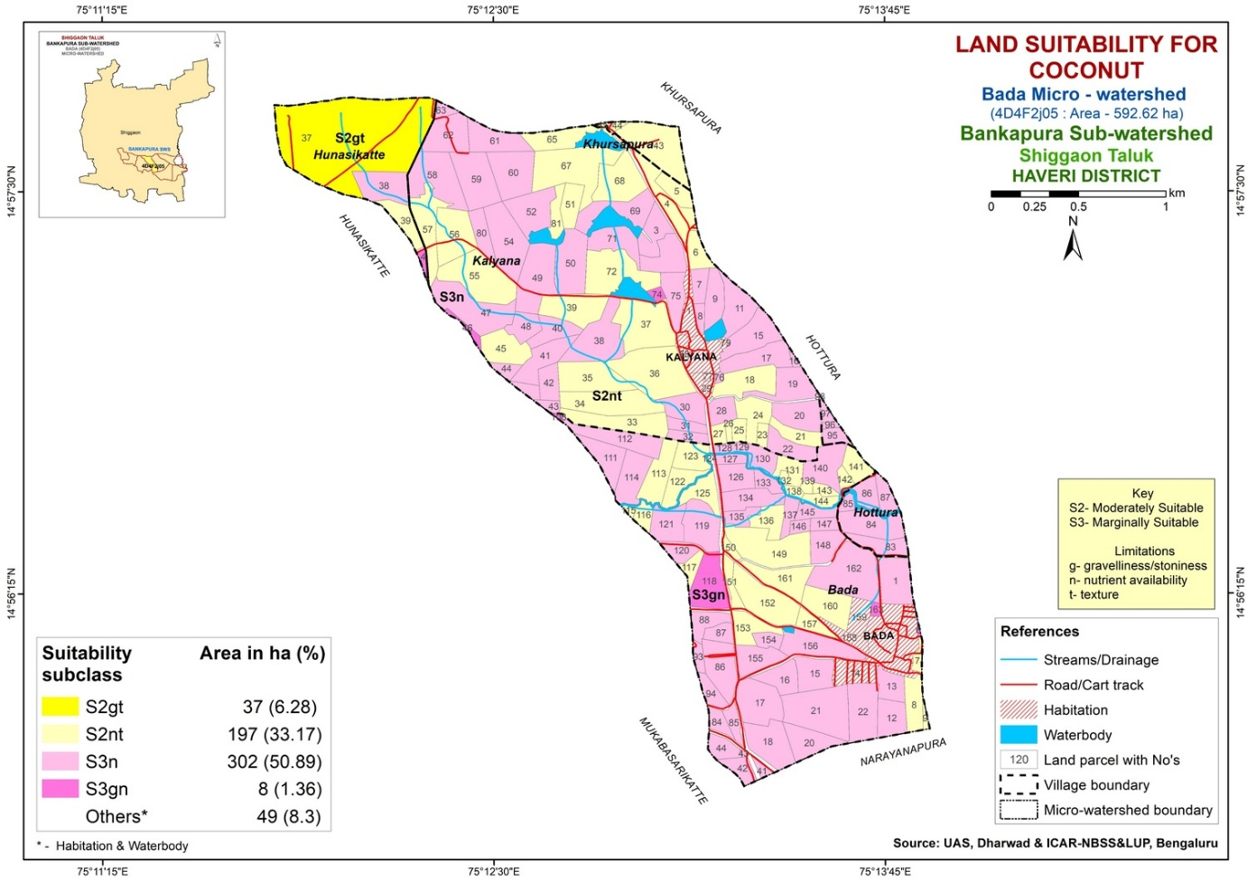

Figure-6. Soil-site suitability map for mango crop in Bada micro watershed
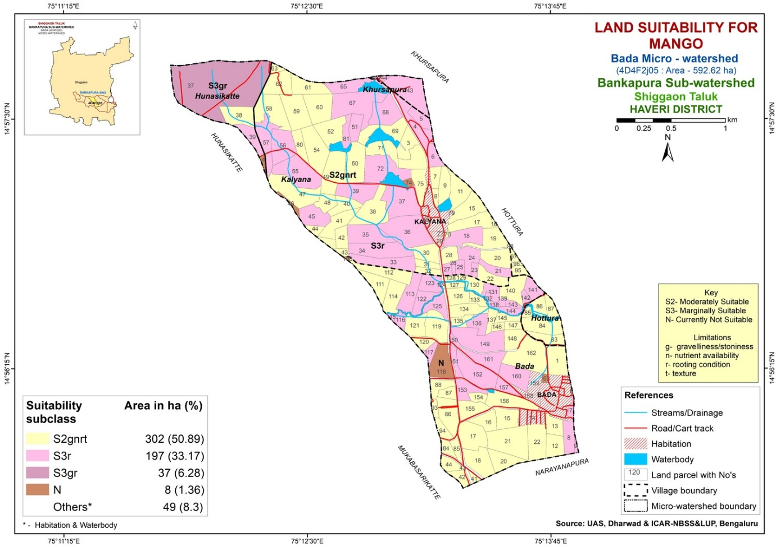
factors for coconut cultivation. The findings of Kabber et al. (2024) corroborate these results, demonstrating that areas such as Krishnarajapete and Arasikere possess moderately suitable (S2) lands for coconut, whereas other regions exhibit more pronounced limitations related to drainage or soil fertility, thereby resulting in marginal suitability classifications.
3.4 Mango
Mango (Mangifera indica), often referred to as the "king of fruits," is well-suited to tropical and subtropical environments and can grow at altitudes up to 1500 meters above sea level. This fruit is cultivated across nearly all Indian states, contributing to approximately 56 per cent of the world's total mango production. The states of Andhra Pradesh, Uttar Pradesh, Bihar, Karnataka, Maharashtra, West Bengal and Gujarat collectively account for about 82 per cent of India's mango production.
A comprehensive evaluation of soil pedons across different land uses was conducted to assess their suitability for mango cultivation. The suitability was classified on a scale ranging from moderately suitable (S2) to not suitable (N) (Figure-6). Soils under agricultural land use were classified as S2, with a subclass designation of S2gnrt, indicating primary limitations related to soil drainage, texture, pH, organic carbon content, depth and gravelliness. In contrast, soils from horticultural and forest land uses were assigned to class S3, with subclasses S3r and S3gr, respectively, reflecting significant constraints such as limited soil depth in horticultural lands and both restricted depth and high gravelliness in forest lands. Barren land pedons were categorized as not suitable (N), with gravelliness identified as the principal limitation, followed by deficiencies in organic carbon and soil depth. Furthermore, soil series from the Chikkumbi-3 micro watershed in Dharwad district have been classified as unsuitable (N) for mango cultivation due to pronounced physical constraints, including inadequate rooting conditions and insufficient moisture availability (Vyas et al., 2024).
3.5 Sapota
Sapota (Manilkara zapota), commonly known as chiku, is a tropical fruit bearing tree native to Central America and widely cultivated in various regions worldwide. In India, sapota cultivation is predominantly concentrated in the states of Maharashtra, Gujarat, Tamil Nadu, Karnataka and Andhra Pradesh. These regions provide the ideal environmental conditions preferred by sapota trees, characterized by warm climatic temperatures and well drained sandy loam soils with a pH between 6.0 and 8.0.
The study analyzed soil-site suitability for sapota cultivation across various land use systems, categorizing the land from moderately suitable (S2) to not suitable (N) (Figure-7). Findings indicated that horticultural and agricultural lands were classified within the S2 suitability class, specifically subclasses S2grt and S2gnrt, respectively. These classifications were predominantly influenced by limitations related to soil drainage, texture, depth and gravelliness in both land uses, with soil pH additionally constraining agricultural lands. Forest areas were assigned to suitability class S3, subclass S3g, characterized by significant gravelliness related limitations. Barren lands were designated as class N, deemed unsuitable for sapota cultivation due to high gravelliness impeding land productivity. Within the Bantanahalli micro-watershed of Davangere district, soils were identified as moderately suitable (S2) for sapota cultivation over 254 hectares and marginally suitable (S3) over 212 hectares, primarily constrained by factors such as limited rooting depth and gravel presence (Anilkumar et al., 2017).
3.6 Guava
In India, guava (Psidium guajava) is widely cultivated in multiple states such as Uttar Pradesh, Maharashtra, Gujarat, Karnataka and Tamil Nadu. These regions provide optimal conditions for guava cultivation, featuring warm climatic temperatures and well drained soils that vary from sandy loam to clay loam, with pH levels between 5.5 and 7.5.
Evaluation of soil-site suitability for guava orchard cultivation across various land use types indicated a classification range from moderately suitable (S2) to not suitable (N) (Figure-8). The analysis identified horticultural and agricultural lands as falling within the S2 suitability class, specifically subclasses S2gt and S2gnt, with primary limitations associated with soil drainage, texture, pH and gravelliness. Forest lands were classified under suitability class S3, subclass S3g, where gravelliness was recognized as the principal constraint. Soils in barren land use areas were categorized as class N, denoting unsuitability for guava cultivation, primarily due to a high gravel content. Vyas et al. (2024) reported that the Chikkumbi-3 micro watershed in Dharwad district demonstrates moderate to marginal suitability for guava cultivation.
4. CONCLUSION
The study concluded that soils within various land use systems of the Bada micro watershed exhibit varying levels of suitability for cultivating crops such as chilli, tomato, coconut, mango, sapota and guava. Specifically, barren land use systems were deemed
Figure-7. Soil-site suitability map for sapota crop in Bada micro watershed
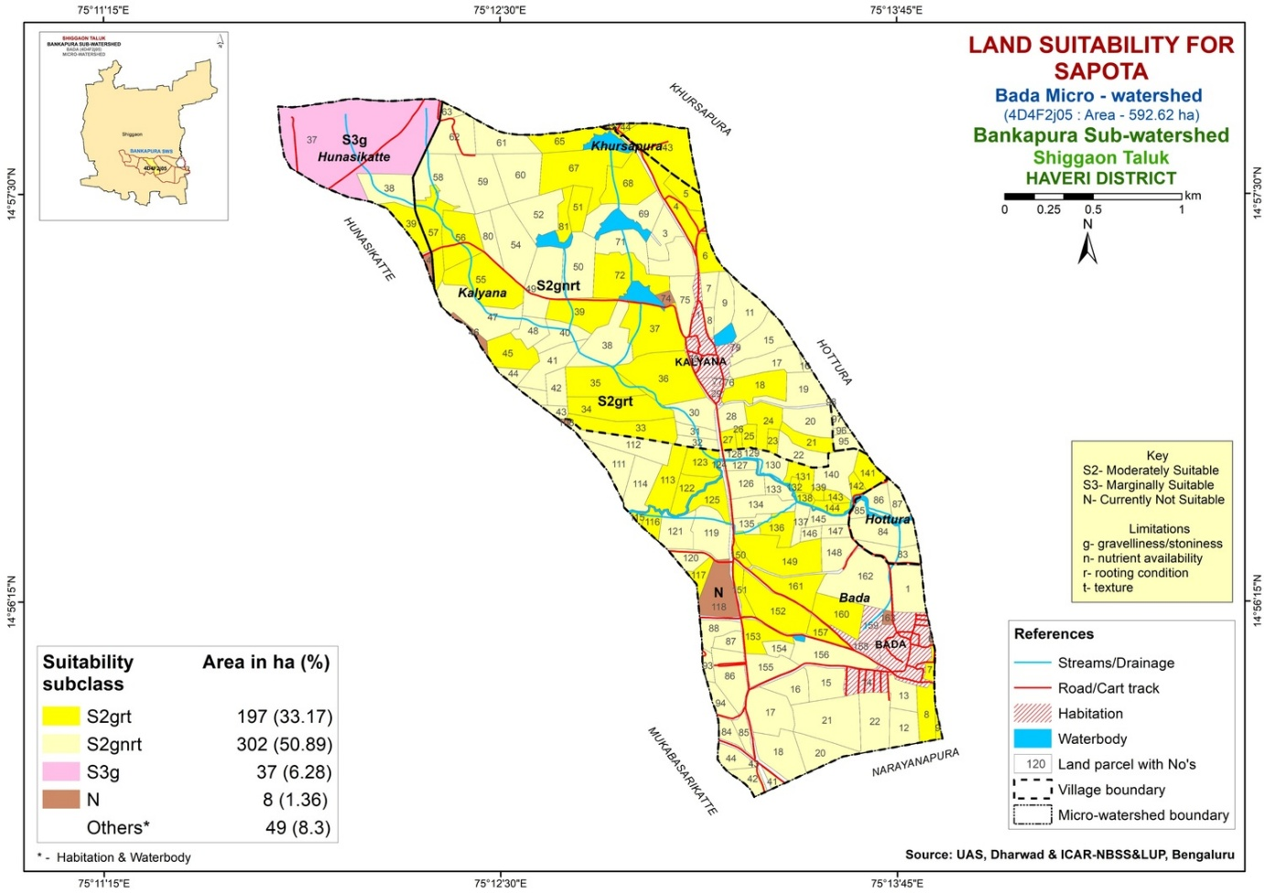

Figure-8. Soil-site suitability map for guava crop in Bada micro watershed
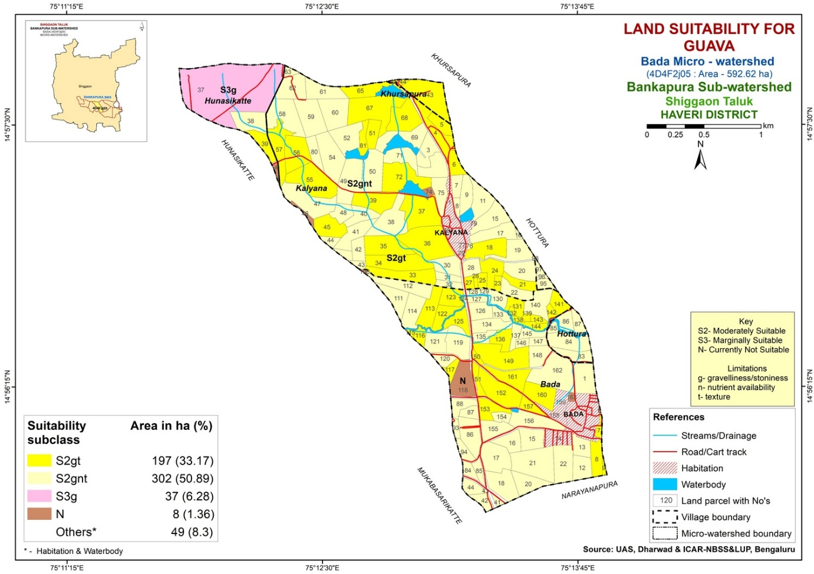
unsuitable for the production of fruit crops including mango, sapota and guava, while forest land use was classified as marginally suitable for growing mango, sapota and guava. The primary constraints identified across all the land uses were gravelliness and nutrient availability. The severity of these limitations ranged from slight to very severe depending on the land use system. Moreover, the integrated application of organic manures alongside inorganic fertilizers is recommended, as this approach not only facilitates sustainable crop yields but also preserves soil health for future generations, thereby mitigating soil degradation and contributing to the enhancement of farmers’ income.

COMPETING INTERESTS DISCLAIMER:
Authors have declared that they have no known competing financial interests OR non-financial interests OR personal relationships that could have appeared to influence the work reported in this paper.

REFERENCES
Anilkumar, S., Dhumgond, P., Satish, A., & Parama, V. R. (2017). Soil resource inventory, land capability and crop suitability assessment of Bantanahalli micro-watershed under semi-arid regions of Karnataka. Journal of Soil and Water Conservation, 16(3), 201-211. https://doi.org/10.5958/2455-7145.2017.00030.3
Anonymous. (1976). A Framework for Land Evaluation. Food and Agriculture Organization of the United Nations, Rome, Italy, p.72.
Anonymous. (2022). Keys to Soil Taxonomy. Soil Survey Staff, United States Department of Agriculture, Washington DC, USA.
Kabber, A., Kumar, K. A., & Harsha, B. R. (2024). Assessment of Land Suitability for Coconut Cultivation in Southern Karnataka, India. Asian Journal of Soil Science and Plant Nutrition, 10(1), 420-428. https://doi.org/10.9734/AJSSPN/2024/v10i1247
Naidu, L. G. K., Ramamurthy, V., Challa, O., Hegde, R., & Krishnan, P. (2006). Manual soil-site suitability criteria for major crops. NBSS Publication No 129, NBSS and LUP, Nagpur, India, pp. 118.
Narsaiah, E., Raj, G. B., Prakash, T. R., Reddy, D. V., & Patnaik, M. C. (2020). Land suitability evaluation for crops in Warangal district of Telangana under Raghunathapally division. Journal of Pharmacognosy and Phytochemistry, 9(4), 874-881.
Pimentel, D., & Burgess, M. (2013). Soil erosion threatens food production. Agriculture, 3(3), 443-463. https://doi.org/10.3390/agriculture3030443
Sehgal, J. (1995). Land resources appraisal for land use planning to meet the challenges of 21st century. Journal of the Indian Society of Soil Science, 43(4), 504-528.
Sharma, J. P., Landey, R. J., Kalbande, A. R., & Mandal, C. (2001). Characteristics and classification of soils of Kathiawar region of Gujarat as influenced by topography. Agropedology, 11(2), 83-90.
Vyas, R. D. V., Patil, P. L., Hebbara, M., & Rajkumara, S. (2024). Soil-site Suitability Assessment for Major Fruit Crops in Chikkumbi-3 Micro-watershed (4D7C5O2f), Karnataka Using Remote Sensing and GIS Techniques. International Journal of Plant & Soil Science, 36(3), 99-110. https://doi.org/10.9734/IJPSS/2024/v36i34404
Yadav, M. B. N., & Patil, P. L. (2025). Soil-Site Suitability Assessment of Horticultural Crops Grown in the Ganjigatti Sub-watershed of Karnataka. Indian Journal of Ecology, 52(1), 47-56. https://doi.org/10.55362/IJE/2025/4454

