Original Research Article

First Assessment of Soil Mite Communities in Togo with special reference to Mesostigmata as Potential Biological Control Agents

Abstract
A survey of soil arthropods was conducted in two contrasting localities of southern Togo, SEAL (Agronomic Experimental station) and GOUNOU KOPE, to assess the richness of soil mites, with a focus on Mesostigmata with potential in biological control. A total of 14,369 arthropods were collected, of which 11,510 were from SEAL and 2,859 from GOUNOU KOPE. Mites were the most abundant group overall (66.2%; 9,056 individuals), followed by Collembola (19.6%) and other insects (14.3%). Arthropod abundances varied by site and land-use type: uncultivated soils supported higher densities than cultivated soils at SEAL, whereas the opposite trend was observed at GOUNOU KOPE. Mite abundance was significantly influenced by site (df = 1, F = 49.16, P < 0.0001), soil type (df = 1, F = 50.12, P < 0.0001), and season (df = 1, F = 36.70, P < 0.0001), with higher densities consistently found at SEAL, in uncultivated soils, and during the rainy season. Taxonomic analysis revealed two mite orders, Oribatida and Mesostigmata, with Oribatida dominating across sites and land-use types. Within Mesostigmata, three families were identified: Ologamasidae, Parasitidae, and Uropodidae. Ologamasidae was the most abundant family, representing 70% and 67% of Mesostigmata in cultivated and uncultivated soils at SEAL, and 56% and 59% at GOUNOU KOPE, respectively. These findings highlight marked spatial and seasonal variation in soil arthropod communities and underline the predominance of predatory Mesostigmata families with potential relevance for biological control in West African agroecosystems.

Introduction
Soil is a dynamic living system whose functioning results from interactions between abiotic factors, such as climate and parent material, and biotic factors, including plants and soil communities. It represents one of the richest habitats on Earth, hosting a vast diversity of organisms that spend all or part of their life cycle within it (Monrozier, 2006; Karimi et al., 2018). Soil fauna is commonly classified by body size and ecological role into microfauna, mesofauna, and macrofauna (Turbé et al., 2010). Among these groups, mesofauna, comprising organisms between 0.2 and 2 mm in size (Gobat et al., 2010) is dominated by mites and springtails, which account for up to 95% of its abundance (Ghezali, 2012).
Mites (Acari) are minute arthropods, barely visible to the naked eye, and are particularly diverse and abundant in tropical ecosystems (Walter and Proctor, 1999). The Oribatida and Mesostigmata are the most prominent groups (Seniczak, 2021). Due to their small size, mites exploit a wide range of microhabitats, from soil to plants (Orgiazzi et al., 2015), often ranking among the most abundant and species-rich arthropods in these environments (Seniczak et al., 2019). Soil mites contribute substantially to forest biodiversity (Lindo et al., 2006) and play key roles in organic matter decomposition and nutrient cycling (Potapov et al., 2022). Their high densities, species richness, and sensitivity to environmental conditions make them suitable indicators for evaluating the effects of management practices on soil biodiversity (N'Dri et al., 2018). Consequently, they are widely recognized as valuable bioindicators of ecosystem health and change (Andrievski and Syso, 2012).
From an agricultural perspective, the Mesostigmata are of particular interest because they include families of predatory mites (Vásquez et al., 2007; Lindquist et al., 2009). Many of these predators, especially members of the Phytoseiidae, are well known for their role in the biological control of phytophagous mites and insect pests, as well as nematodes (McMurtry et al., 2013). More recently, attention has also focused on other soil-dwelling families such as Ascidae (sensu lato), Laelapidae, Macrochelidae, and Ologamasidae for their potential use in crop protection (Castilho et al., 2009).
Despite their ecological and agricultural importance, the biodiversity of soil mites remains poorly studied in West Africa, and virtually no data are available for Togo, in contrast to other regions where such investigations have been more extensively undertaken (Britto et al., 2011).
The objective of this study was to investigate the diversity and composition of soil mites in Togo, with particular emphasis on the group Mesostigmata. By providing the first baseline data on soil mite communities in this country, we aim to contribute to a better understanding of their ecological roles and potential importance for soil health and sustainable agriculture in West Africa.

Methodology
Sampling sites
Soil samples were collected from two sites in the Maritime region of Togo: SEAL (Agronomic Experimental station) (6°22'N, 1°13'E)characterized by ferralitic soils derived from continental deposits, and GOUNOUKOPE (6°12'51"N, 1°31'58''E) along the coastline, with sandy soils of marine origin. Both sites share similar equatorial Guinean climatic conditions, with annual rainfall of 800–1200 mm, mean temperatures of 24–30 °C, and a bimodal rainfall pattern with rainy seasons from April to July and September to December (Worou, 2002).
The two sites differ in their soil types. The Lomé Agricultural Experiment Station is characterized by ferralitic soil, locally known as “barre soil,” derived from continental deposits. This soil type covers approximately 47% of the Maritime region (Worou, 2002) and is also present in Côte d’Ivoire, Ghana, Benin, and Nigeria (Louette, 1988). In contrast, the GOUNOU KOPE coastal site has raw mineral soils of marine origin, predominantly sandy in texture, typical of coastal market gardening areas.

Sample collection and extraction of soil Microarthropods
Priority was given to market gardening sites. At each site, five plots were randomly selected, spaced 200–300 m apart. Within each plot, six sampling points were defined using the “two diagonals” method, with points at least 10 m apart. At each point, soil and litter were collected at a depth of 0–10 cm (Duarte, 2013) using a small shovel within a 40 cm diameter. Samples from the six points were pooled to form a composite sample per plot. Meanwhile samples were also taken from adjacent plots of natural vegetation, representing areas unused or long abandoned for cultivation (considered herein as “Uncultivated soils”), following the same procedure.
Sampling was conducted during both the dry season (December–April) and the rainy season (May–August) of 2022, at a frequency of two sampling rounds per month. The samples collected were placed in plastic bags, each labeled with all relevant information and taken to the laboratory for extraction.
Soil microarthropods were extracted using a modified Berlese-Tullgren method (Tullgren, 1918; Roy et al., 2008; Melo-Molina, 2022). This method is widely recognized as one of the simplest, most efficient, and rapid techniques for extracting microarthropods from soil samples. The principle relies on a temperature gradient that forces organisms to move downward through the soil sample into collection containers (Tullgren, 1918; Roy et al., 2008). Mites were separated from other arthropods (insects, springtails, and non-target mites) under a stereomicroscope. The collected mites were then transferred into 1.5 ml tubes containing 70% ethanol for subsequent identification. Mites were slide-mounted in Hoyer's medium for examination under a phase-contrast microscope, and identified based on illustrated keys provided by Krantz and Walter (2009).

Statistical analysis
The analysis of variance (ANOVA) was used to test the effect of sampling season (dry season vs raining season), soil type (Cultivated vs Uncultivated) and the collection site (SEAL vs GOUNOU KOPE) on the abundance of mites, followed by Turkey HSD multiple range tests to separate means. All analyses were performed using R software (version 4.3.0; R Core Team, 2023).

Results
Arthropods fauna
A total of 14369 arthropods, including mites, springtails, and insects, were collected across the two sampling sites during the study period. Of these, 11510 specimens were obtained from SEAL and 2859 from GOUNOU KOPE (Figure 1). At SEAL, uncultivated soils harbored higher arthropod abundances than cultivated soils, whereas the opposite pattern was observed at GOUNOU KOPE. Overall, the GOUNOU KOPE site had considerably fewer arthropods than SEAL, regardless of land-use type. Among all arthropods, mites were the most abundant group, followed by springtails (Figure 2).
Across all samples, mites were the dominant group, representing 66.2% of total specimens (9,056 individuals), followed by collembolans at 19.6% (2,810) and other insects at 14.3% (2,053) (Figure 2).

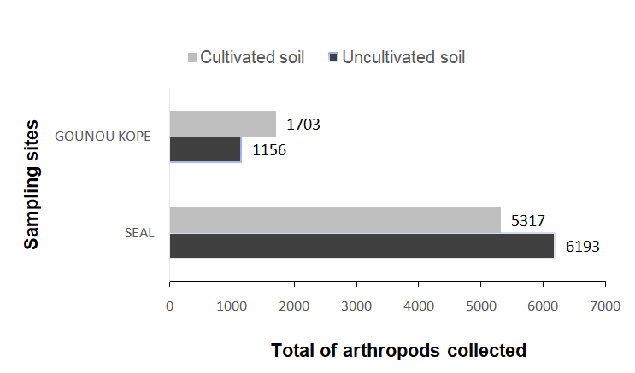

Figure 1: Total number of arthropods collected from soils of the two localities

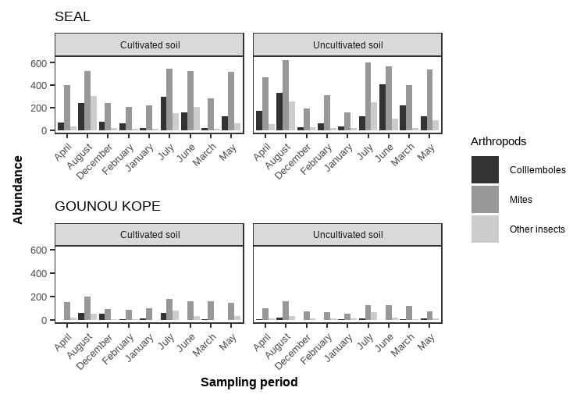
Figure 2: Dynamics of the three groups of arthropods across sampling date in the two localities

Mite abundance by site and soil type
Temporal variation in mite densities by sampling site and soil type is shown in Figure 3. Sampling site had a highly significant effect on mite abundance (F = 49.16, df = 1, P < 0.0001), with SEAL consistently harboring more mites than GOUNOU KOPE. Significant effects were also detected for soil type (F = 50.12, df = 1, P < 0.0001) and sampling season (F = 36.70, df = 1, P < 0.0001), as well as for most of their interactions (Table 1). Overall, mite densities were lower at GOUNOU KOPE than at SEAL, regardless of soil type. Across both sites, mites were significantly more abundant in the rainy season than in the dry season, and in uncultivated soils compared to cultivated soils (Table 2).

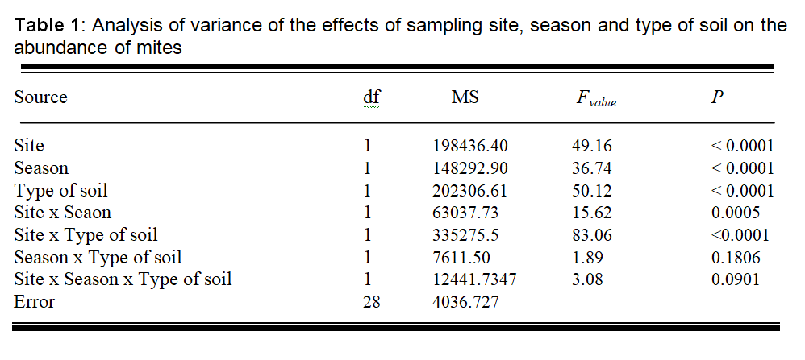
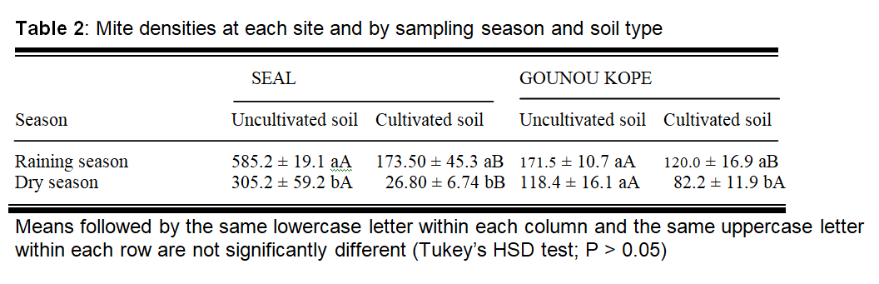
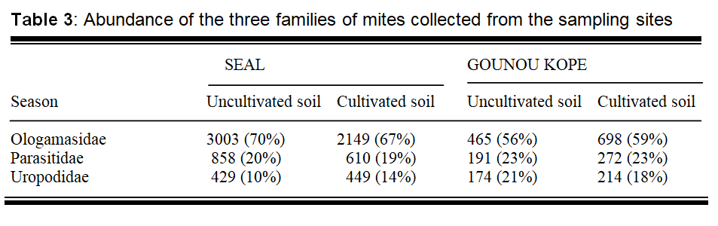

Taxonomic composition of mites
Two orders of mites were identified during the study: Oribatida and Mesostigmata. At both sites, and in both cultivated and uncultivated soils, Oribatida were consistently more abundant than Mesostigmata.
For family-level identification, only Mesostigmata were considered because of their agricultural relevance, particularly their role as potential biological control agents. A total of 9512 Mesostigmata individuals were collected across all sites, belonging to three families: Ologamasidae, Parasitidae, and Uropodidae. The most abundant family was Ologamasidae, with 6315individuals, followed by Parasitidaewith 1931 individuals.
At SEAL, family abundance was higher in uncultivated soils than in cultivated soils. Ologamasidae represented 70% of Mesostigmata in cultivated soil and 67% in uncultivated soil. At GOUNOU KOPE Ologamasidae also dominated, accounting for 56% of individuals in cultivated soil and 59% in uncultivated soil (Table 3)

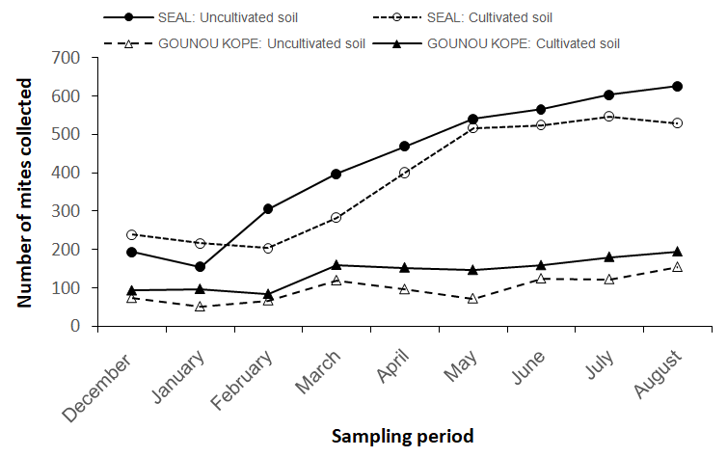
Figure 3: Mite densities across sampling date in the two localities
Discussion
This study provides new insights into the abundance and distribution of soil arthropods, particularly mites, in cultivated and uncultivated soils at two contrasting sites in southern Togo. A total of 12,793 arthropods were collected, with mites representing the dominant group, followed by collembolans and insects. The predominance of mites is consistent with previous studies highlighting their numerical dominance and ecological importance in soil communities (Walter & Proctor, 1999).
A significant site effect was observed, with SEAL supporting higher arthropod and mite abundances than GOUNOU KOPE. This may reflect differences in soil characteristics, microclimate, and land-use history, which are known to influence soil fauna (Nielsen et al., 2010). Soil type also influenced arthropod numbers: at SEAL, uncultivated soils supported more individuals than cultivated soils, whereas at GOUNOU KOPE, a marginal difference was observed between the two types of soil. Such patterns likely result from the effects of cultivation practices, such as tillage, organic matter management, and pesticide use on soil structure and microhabitats (Wardle, 2002; Bardgett & van der Putten, 2014).
Mite abundance varied seasonally, with higher densities recorded during the rainy season compared to the dry season. Increased soil moisture and enhanced decomposition rates during the rainy season likely improve habitat quality and food availability for soil mites (Larsen et al., 2004).
Oribatida were consistently more abundant than Mesostigmata, reflecting their well-known role as decomposers and contributors to nutrient cycling (Behan-Pelletier, 1999). Among Mesostigmata, Ologamasidae, Parasitidae, and Uropodidae were identified, while families such as Ascidae, Melicharidae, and Macrochelidae, often cited for their biological control potential, were absent from our collections. This absence may be due to the limited scope of our sampling sites, which did not encompass the full range of habitats where these families typically occur. Expanding the study to additional sites with varied vegetation types and soil conditions could reveal the presence of these important predatory mites.
Oribatida were consistently more abundant than Mesostigmata, reflecting their well-known role as decomposers and contributors to nutrient cycling (Behan-Pelletier, 1999). Among Mesostigmata, Ologamasidae, Parasitidae, and Uropodidae were identified, while families such as Ascidae, Melicharidae, and Macrochelidae, often cited for their biological control potential—were absent from our collections. This absence may be due to the limited scope of our sampling sites, which did not encompass the full range of habitats where these families typically occur. Expanding the study to additional sites with varied vegetation types and soil conditions could reveal the presence of these important predatory mites.
Overall, the results indicate that soil arthropod communities in southern Togo are influenced by site-specific factors, soil management, and seasonal dynamics. The dominance of mites, and the presence of agriculturally relevant Mesostigmata, highlight the potential of these communities for ecological functions and biological control in local agroecosystems. Future studies with broader spatial coverage are needed to fully capture the diversity of predatory mites and assess their role in sustainable pest management.

References
Andrievskii, V. S. & Syso, A. I. (2012). The effect of different types of anthropogenic changes in soils on oribatid communities in urban ecosystems. Contemp Probl de Ecol 5: 574–579
Behan-Pelletier, V. M. (1999). Oribatid mite biodiversity in agroecosystems: Role for bioindication. Agriculture, Ecosystems and Environment, 74(1–3), 411–423.
Bardgett, R. D., & van der Putten, W. H. (2014). Belowground biodiversity and ecosystem functioning. Nature, 515(7528), 505–511.
Britto, E. P. (2011). Taxonomy of Ascidae sensu Lindquiste Evans (1965) (Acari: Mesostigmata), biology and ecology of selected Brazilian species. University of São Paulo, Luiz de Querioz School of Agriculture, 525 pp.
Duarte, M. E. (2013) Plant and soil mite fauna of sugarcane crops in the Atlantic Forest of Alagoas state, Brazil. Federal University of Alagoas, 96 pages.
Ghezali, D. (2012). Systematics and bioecology of sun mites (Acari-Oribatida) in Algeria (Doctoral dissertation).
Larsen, J., Johansen, A., & Jakobsen, I. (2004). Population dynamics of bacterivorous nematodes and protozoa in the rhizosphere of barley as influenced by the biocontrol fungus Clonostachys rosea. Soil Biology and Biochemistry, 36(12), 1683–1691.
Lindquist, E. E., Krantz, G. W. & Walter, D. E. (2009). Order Mesostigmata. In: Krantz, G.W. & Walter, D.E. (eds) A Handbook of Acarology, Third Edition, Texas Tech University Press, Lubbock, Texas, pp.124-232.
Louette, D. (1988). Synthese of research work on fertilization in barre lands in Benin and Togo.
McMurtry, J. A., De Moraes, G. J., & Famah Sourassou, N. (2013). Revision of the lifestyles of phytoseiid mites (Acari: Phytoseiidae) and implications for biological control strategies. Systematic and Applied Acarology, 18(4), 297–320.
Melo-Molina, E. L. (2022). Edaphic mites (Acari: Mesostigmata) from three regions of Ecuador (Doctoral dissertation, University of São Paulo). Mite families Ascidae Voigts & Oudemans, Blattisociidae Garman, and Melicharidae Hirschmann (Acari: Mesostigmata). Zootaxa, 4112 (1), 1–299.
Monrozier J. (2006): Effect of cultural practices on biodiversity” - Facilitator: L. Days of exchange and prospective 21 & 22 November (Univ. Lyon 1, UMR CNRS 5557 - USC INRA 1193 Microbial Ecology
N'Dri JK, Pokou PK, Séka FA, N'Da RAG, Lagerlöf J (2018). Edaphic characteristics and environmental impact of birch plantations on soil mite (Acari) communities. Acarology 58: 951–962.
Nielsen, U. N., Ayres, E., Wall, D. H., & Bardgett, R. D. (2010). Soil biodiversity and carbon cycling: A review and synthesis of studies examining diversity-function relationships. European Journal of Soil Science, 62(1), 105–116
ORGIAZIZ, A.; Singh, B.; MUR, D.; BARRIOS, E.; Candeler, E.; MOREIRA, F.; De Deyn, G.; Chotte, J.; S6, J.; Hedlund, K.; et al. (2015) World Atlas of Soil Biodiversity; Publications Office of the European Union: Luxembourg, p. 1–176. Paris, 271 p.
Potapov A.M., Beaulieu F., Birkhofer K., Bluhm S.L., Degtyarev M., Devetter M., Goncharov A.A., Gongalsky K.B., Klarner B., Korobushkin D.I., Liebke D.F., Maraun M., Mc Donnell RJ, Pollierer M.M., Schaefer I., Shrubovych J., Semenyuk I.I., Sendra A., Tuma J., Tumova M., Vassilieva A., TingWen Chen, Geisen S., Schmidt O., Tiunov A.V., Scheu S., (2022) - Feeding habits and multifunctional classification of soil-associated consumers from protists to vertebrates. Biological Reviews.
R Core Team. (2023). R: A language and environment for statistical computing. R Foundation for Statistical Computing, Vienna, Austria. https://www.R-project.org/
Roy, S., Bano R., Saxena P., Roy M.M., Nag S.K., Bhatt R.K. (2008). Dynamics of the springtail community du sol associée aux prairies, aux terres cultivées et au peuplement d'arbres Inde centrale semi-aride. Journal de biology des sols & Écologie. ; 28(1&2):122-132.
Seniczak, A.; Bolger, T.; Roth, S.;Seniczak, S.;Djursvoll, P.;Jordal, BH (2019) Diverse mite communities (Mites: Oribatida, Mesostigmata) of a deciduous forest in western Norway.Anne. Zool. Fenn. 56, 121–136. [CrossRef]
Seniczak, A.;Seniczak, S.;Starý, J.;Kaczmarek, S.;Jordal, BH; Kowalski, J.; Roth, S.;Djursvoll, P.;Bolger, T. (2021) High mite diversity (Acari: Oribatida, Mesostigmata) supports the high conservation value of a deciduous forest in eastern Norway. Forests 12, 1098. https://doi.org/10.3390/f12081098.
Tullgren, A. (1918). A very simple selection apparatus for terricolous faunas. Journal of Applied Entomology, 4, 149–150.
Vásquez, C., Sánchez, C. & Valera, N. (2007) Diversity of mites (Acari: Prostigmates, Mesotigmata, Astigmata) associated with the leaf litter of plant formations in the UCLA University Park, Venezuela. Heringie. Zoology Series, 97,466–471.
Krantz, G. W., Walter, D. E. (2009). Collecting, rearing, and preparing specimens. In: Krantz, G. W. & Walter, D. E. (eds.) A Manual of Acarology. Third edition. Texas Tech University Press, pp. 83–94.
Wardle, D. A. (2002). Communities and ecosystems: Linking the aboveground and belowground components. Princeton University Press.
Walter, D.E. & Proctor, H. (1999). Mites: Ecology, evolution and behavior. CABI, Oxon, UK, 352 pp.
Walter, D. E., & Proctor, H. C. (1999). Mites: Ecology, evolution, and behaviour. CABI Publishing. https://doi.org/10.1079/9780851993765.0000
Worou, S. (2002). Dominant soils of Togo - correlation with the World Reference Base. World Soil Resources Report (FAO).

