Fungal Infections, Immunity and Diagnosis: A comprehensive review

Abstract
Fungal infections (mycosis) have emerged as significant global health concerns, particularly among immunocompromised individuals. This comprehensive review examines the intricate interplay between fungal pathogens and host immunity, emphasizing the crucial roles of both innate and adaptive immune responses. The innate immune system serves as the first line of defense, utilizing physical barriers, pattern recognition receptors, phagocytic cells, the complement system, and cytokines to detect and control fungal pathogens. Dendritic cells play a pivotal role in bridging innate and adaptive immunity by presenting fungal antigens to T cells, guiding specific immune responses. Through the coordinated actions of T helper cells, cytotoxic
T cells, B cells, and antibodies, the adaptive immune system offers targeted and long-lasting protection against fungal infections. Despite these robust defense mechanisms, many fungi have evolved sophisticated evasion strategies that complicate immune responses and therapeutic interventions. Advances in diagnostic technologies, including PCR, immunodiagnostic assays, and AI-algorithm have significantly enhanced the early detection and management of fungal infections. Understanding the complex host-fungal interactions and leveraging recent diagnostic innovations are essential for improving outcomes in patients at risk of fungal diseases. This review highlights the need for ongoing research to develop more effective vaccines, immunotherapies, and diagnostic tools in combating the increasing burden of fungal infections.
Keywords: Fungi, Immunity, Innate immunity, Adaptive immunity, Immunotherapy.

Introduction
Fungal infections are responsible for over 1.7 million deaths per year globally, roughly 200,000 more deaths than the bacterial disease tuberculosis (Kainz et al., 2020). Fungi are ubiquitous organisms in diverse environmental niches, including soil, air, plants, and water. Although the vast majority of fungal species are non-pathogenic to humans, a small proportion have evolved mechanisms that enable them to invade and cause disease in susceptible hosts. These diseases, collectively known as mycosis, range from mild superficial infections to severe invasive and systemic illnesses (Seagle et al., 2021). Over the past several decades, there has been a significant increase in the incidence of fungal infections worldwide, primarily driven by the growing population of immunocompromised individuals. Patients with compromised immune systems, whether due to HIV/AIDS, malignancies, organ or hematopoietic stem cell transplantation, immunosuppressive therapies, or autoimmune diseases, are particularly vulnerable to fungal pathogens (Li et al., 2025). The increased use of broad-spectrum antibiotics, corticosteroids, cytotoxic chemotherapy, and biologic immunomodulators has further exacerbated this susceptibility by disrupting normal microbial flora and impairing host immune responses (Airola et al., 2024). Despite the progress in antifungal treatments, invasive fungal infections remain a cause of high morbidity and mortality due to the lack of accurate and rapid diagnosis. The non-specific symptoms of fungal infections mimic those of other microbial infections, such as bacterial or viral infections make this infection seriously challenges (Al-Maqtoofi & Al-Rifaie, 2019). In addition to the time-consuming nature of conventional diagnostic methods, such as culture and microscopy, which require experience and may lack accuracy, particularly during early disease stages of infections (Al-Maqtoofi & Thornton, 2016). Diseases such as disseminated candidiasis, aspergillosis, cryptococcosis, and mucormycosis require a combination of accurate and rapid laboratory diagnostic tests. To control invasive fungal infections, determine prompt treatment, reduce the rate of morbidity and mortality, developing fast and sensitive diagnostic techniques is required (Al-Rifaie & Al-Maqtoofi, 2018).
The immune system contains a complex network of physical, chemical, and cellular barriers that help adaptive immunity for effective fungal pathogens (Wang et al., 2024). Neutrophil is one of the professional phagocytic cells and is considered the first cell involved in antifungal immune response for this reason, deficiency in neutrophil function increase fungal invasion and dissemination (Blaize et al., 2024).
This review highlights the role of the immune system response to fungal infections and the recent diagnostic techniques that may be involved in enhancing early detection and management.

Innate Immune Response to Fungal Infections
The innate immunity is a rapid and non-specific response against microbial infections. The innate immune system has barriers, physical, chemical, and cellular barriers, that work collectively to prevent fungal invasion. The skin contains multilayers of tissues including the epidermis, dermis, cutaneous appendages and subcutaneous tissue. The skin is a part of skin-associated lymphoid tissue (SALT), which comprises both skin cells and professional immune cells (Quaresma, 2019). Around 90% of the epidermis contains keratinocytes, which are able to distinguish between microbiota and microbial pathogens through expression a class of pattern recognition receptors (PRRs) which are surface toll-like receptors (TLRs), specially TLR2 and TLR4, for detection pathogens associated molecular patterns (PAMPs) (Fang et al., 2022). In addition to more specific receptors such as NOD-like receptors (NLRs), RIG-I-like receptors (RLRs), and C-type lectin receptors (CLRs) including Dectin-1 and Dectin-2 for detection fungal antigens like ß-glucans and mannose (Patin et al., 2019). Detection fungal antigens by these receptors results in the production of proinflammatory cytokines by activating NF-κB signalling pathway to produce IL-6, TNF and IL-8 (Li et al., 2012). Following the recognition step, cytokines and chemokines released to attract phagocytic cells and process inflammatory response (Hatinguais et al., 2020). Tracking neutrophils, macrophages, and dendritic cells (DCs) directly to the site of infection enhance fungal elements clearance via phagocytosis and generating reactive oxygen species (ROS). Releasing neutrophil extracellular traps (NETs), and secreting AMPs are effectively kill fungal pathogens (Zhong et al., 2022).
Larger population of innate immune cells such as macrophages, DCs, NKs, mast cells, in addition to specialized adaptive immune cells such as CD4⁺ T-cell, lymphocytes γδ T are localized within the dermis layer (Moyes et al., 2021). For this reason, the skin is the first mechanical barrier prevent fungal infections. Additionally, antimicrobial peptides (AMPs) exhibit broad-spectrum antimicrobial function that plays an essential role in fungal protection in the human organs, like the skin, respiratory tract, digestive system, and bodily fluids such as mucus, saliva, tears, and breast milk (Abdul-Kareem et al., 2023; Burgess et al., 2022).
DCs have a critical role in evoking the adaptive immunity by capturing fungal antigens and presenting them to naïve T cells in secondary lymphoid tissues (Feldman et al., 2019). Recent studies showed that monocytes and natural killer (NK) cells can train immunity after exposure to fungal β-glucans (Quintin, 2019).

Fungal Antigen Presentation and Adaptive Immunity
Managing fungal antigen detection requires coordinating the host's innate and adaptive immune response to eradicate the pathogen and initiate immunological memory. DCs through their PRRs and antigen presentation to antigen-specific
T and B cells link both innate and adaptive immune response through upregulation of co-stimulatory molecules interaction (CD80, CD86 and CD40) and major histocompatibility complex (MHC) molecules class II between DCs and naïve CD4⁺ T-cells (Figure 1) (Goughenour et al., 2023). CD4⁺ T-cells significantly activate host immunity by inducing innate inflammatory immune responses and mediating fungicidal activity. Surface and intracellular PRRs help DCs to recognize fungal antigens such as β-glucans and mannose. Activated CD4⁺ T-cells lead to differentiation into a T-helper (Th) subset of Th1, Th2, Th17, and Treg (regulatory T cell) (Kumaresan et al., 2018). Each of these cells are characterized by specific cytokines production, Th1 cells release interferon-γ (IFN-γ), that play a key role in host defense against intracellular pathogens, Th2 cells are characterized by the production of IL-4, and Th17 cells release unique series of cytokine such as IL-17 family, IL-21, and IL-22 that have a crucial task in fungal infections (Aziz et al., 2023; van de Veerdonk & Netea, 2010). CD8⁺ T cells may participate in fungal clearance through cross-presented via MHC class I molecules (Cruz et al., 2023). Recently, CD8⁺ T cells were reported to differentiate into Tc1, Tc2 and Tc17 cells upon recognition of fungal peptides presented by antigen-presenting cells (Kumaresan et al., 2017). Tc1 cells involve directly killing of fungal-infected host cells by producing cytotoxic factors such as granulysin, perforin, and granzyme K. To activate antifungal immunity via phagocytic cells, Tc1 produce abundant tumor necrosis factor-α (TNF-α) and interferon-γ (INF-γ) (Sharma et al., 2022).

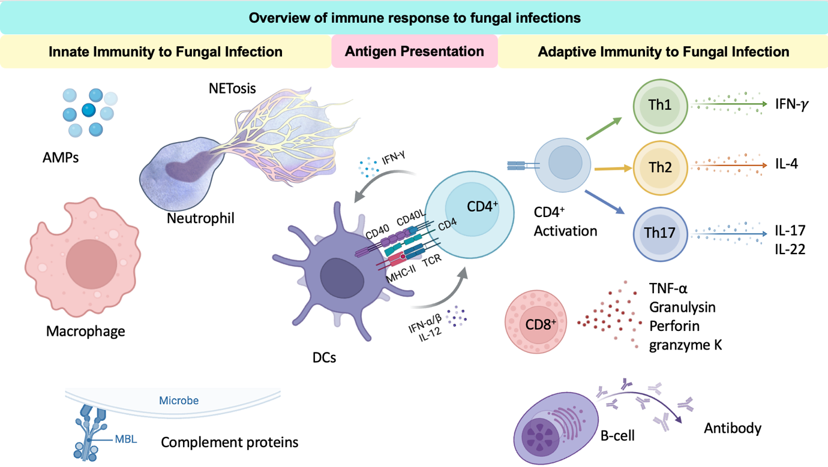
Figure 1. An overview of the host immune response against fungal infection.
Please specify the software utilized for figure generation.

Fungal Infections between Public Awareness and Education

The awareness about the serious threat from fungal infections to human health
is relatively under level globally may lead to delays or misdiagnosis of cases and inadequate treatment. This case facilitates disease transmission and may result in
a fungal infection outbreak (Benedict et al., 2020). For this reason, raising awareness through promoting education and improving the diagnosis of fungal infections is
a critical factor for effectively preventing severe disease.

This section is notably brief and provides only a superficial treatment of the subject matter. It should either be omitted or substantially expanded. Consider incorporating detailed discussions on successful educational initiatives aimed at raising awareness across different global regions to enhance its depth and relevance.

Recent Advances in Fungal Diagnosis
Maximizing survival against fungal infections requires rapid and accurate diagnosis and therapeutic strategies. The non-specific clinical symptoms of invasive fungal infections remain a serious challenge regarding clinical diagnosis. For this reason, physicians focus on bacterial or viral infections. The misdiagnosis leads to inaccurate treatment and wasting time and money. Ultimately, the value of human life and health will be at risk of developing disseminated infections. For this reason, there is a need for urgent, accurate, and rapid fungal diagnosis. The molecular techniques using polymerase chain reaction (PCR), a highly sensitive and specific technique diagnosis of invasive fungal disease (Figure 2). However, this technique is not yet widely implemented due to concerns regarding limited standardization between assays (Brown et al., 2025).
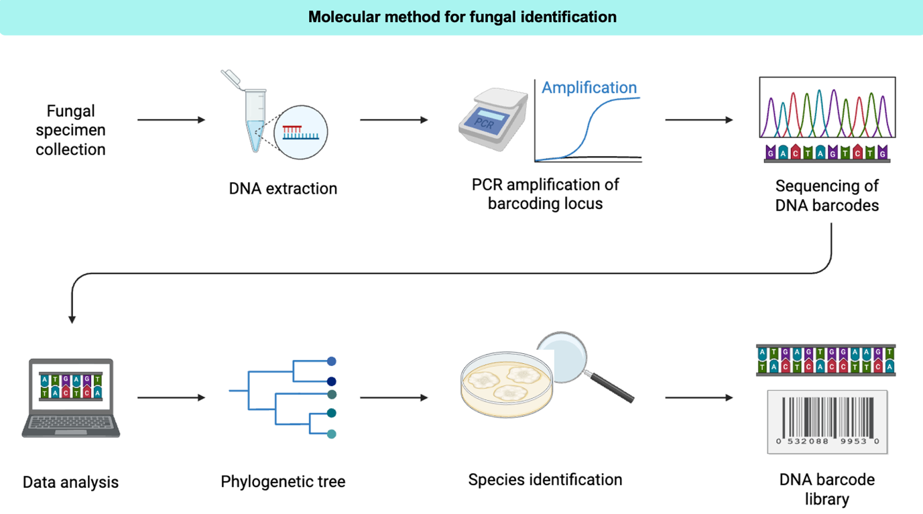
Figure 2. Molecular technique for diagnosis fungal pathogens. Image was created by bioRender.

Immunodiagnostic assays, such as complement fixation and immunodiffusion, to enzyme immunoassays are vital due to their high specificity in diagnosing fungal antigens. Using hybridoma technology and genetic engineering for developing a specific monoclonal antibody is an essential step for a specific immunodiagnostic test that can rely upon for the diagnosis of fungal infections, rather than time-consuming conventional techniques such as culture and histopathology (Figure 3) (Al-Maqtoofi & Thornton, 2016).

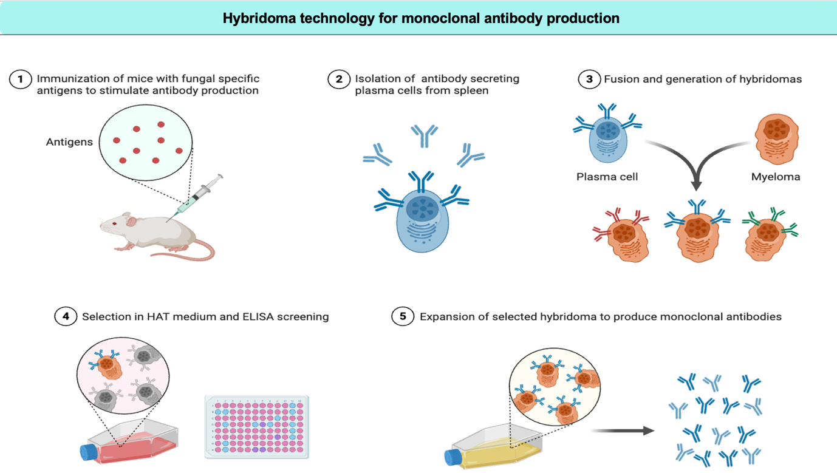

Figure 3. Developing monoclonal antibody specific for fungal antigen using hybridoma technology. Image was created by bioRender.

The application of artificial intelligence (AI) in the field of fungal diagnosis has emerged recently. AI technologies, particularly machine learning (ML) and deep learning (DL) methods, have significantly enhanced diagnostic accuracy, particularly for less experienced clinicians, by analyzing microscopic images from potassium hydroxide (KOH) examinations, fungal culture tests, and histopathologic slides (Hasan Pour, 2025).

Conclusion
Fungal pathogens cause many infections, with life-threatening disease, in immunocompetent and immunocompromised individuals. Early recognition of fungal antigens by the host immune system is a pivotal step to trigger a complex network of innate and adaptive responses that synergistically prevent and control infection. Early, rapid, and specific diagnosis for fungal infections, particularly invasive infections, can improve patient outcomes. Future studies should focus on developing novel immunotherapies, antifungal agents, and effective vaccines and refining diagnostic methods to ensure early and precise identification of fungal pathogens.

References
The manuscript exhibits a high frequency of citations to works by author Al-Maqtoofi, which raises significant concerns regarding potential conflicts of interest. It is strongly recommended to diversify the reference list by incorporating citations from alternative, independent sources.
Abdul-Kareem, H. H., Al-Maqtoofi, M. Y., & Burghal, A. A. (2023). Impact of COVID-19 vaccination on saliva immune barriers: IgA, lysozyme, and lactoferrin. Archives of Virology, 168(12), 293. https://doi.org/10.1007/s00705-023-05914-3
Airola, C., Severino, A., Spinelli, I., Gasbarrini, A., Cammarota, G., Ianiro, G., & Ponziani, F. R. (2024). “Pleiotropic” Effects of Antibiotics: New Modulators in Human Diseases. Antibiotics, 13(12), 1176. https://doi.org/10.3390/antibiotics13121176
Al-Maqtoofi, M., & Thornton, C. R. (2016). Detection of human pathogenic Fusarium species in hospital and communal sink biofilms by using a highly specific monoclonal antibody. Environmental Microbiology, 18(11), 3620–3634. https://doi.org/10.1111/1462-2920.13233
Al-Maqtoofi, M. Y., & Al-Rifaie, A. A. (2019). An Overview of Fusariosis and Diagnosis Problems. Ecology, Environment and Conservation Paper, 25(3), 1084–1087.
Al-Rifaie, A. A., & Al-Maqtoofi, M. Y. (2018). Immunodetection and risk assessment for Aspergillus contamination in nuts using a highly specific monoclonal antibody. Biomedical Research, 29(21). https://doi.org/10.4066/biomedicalresearch.29-18-1098
Aziz, I. A., Al-Maqtoofi, M. Y., & Burghal, A. A. (2023). Interleukin-17 and Immunity of Ocular infections. Acta Microbiologica Hellenica, 231–239. https://doi.org/10.5281/ZENODO.10203266
Benedict, K., Molinari, N. M., & Jackson, B. R. (2020). Public Awareness of Invasive Fungal Diseases—United States, 2019. Morbidity and Mortality Weekly Report, 69(38), 1343. https://doi.org/10.15585/mmwr.mm6938a2
Blaize, M., Thizy, G., Boissonnas, A., Portalier, A., Lanternier, F., de La Porte des Vaux, C., Suarez, F., Bougnoux, M.-E., Guitard, J., Jabet, A., Stocker, N., Aoudjhane, A., Roos-Weil, D., & Fekkar, A. (2024). Invasive Aspergillosis with impaired neutrophil responses against Aspergillus fumigatus in patients treated with Acalabrutinib—Findings from three cases. International Journal of Infectious Diseases, 142, 107000. https://doi.org/10.1016/j.ijid.2024.107000
Brown, L., Cruciani, M., Morton, C. O., Alanio, A., Barnes, R. A., Donnelly, J. P., Hagen, F., Gorton, R., Lackner, M., Loeffler, J., Millon, L., Rautemaa-Richardson, R., & White, P. L. (2025). The Molecular Diagnosis of Invasive Fungal Diseases with a Focus on PCR. Diagnostics, 15(15), 1909. https://doi.org/10.3390/diagnostics15151909
Burgess, T. B., Condliffe, A. M., & Elks, P. M. (2022). A Fun-Guide to Innate Immune Responses to Fungal Infections. Journal of Fungi, 8(8), 805. https://doi.org/10.3390/jof8080805
Cruz, F. M., Chan, A., & Rock, K. L. (2023). Pathways of MHC I cross-presentation of exogenous antigens. Seminars in Immunology, 66, 101729. https://doi.org/10.1016/j.smim.2023.101729
Fang, X., Lian, H., Bi, S., Liu, S., Yuan, X., & Liao, C. (2022). Roles of pattern recognition receptors in response to fungal keratitis. Life Sciences, 307, 120881. https://doi.org/10.1016/j.lfs.2022.120881
Feldman, M. B., Vyas, J. M., & Mansour, M. K. (2019). It takes a village: Phagocytes play a central role in fungal immunity. Seminars in Cell & Developmental Biology, 89, 16–23. https://doi.org/10.1016/j.semcdb.2018.04.008
Goughenour, K. D., Nair, A. S., Xu, J., Olszewski, M. A., & Wozniak, K. L. (2023). Dendritic Cells: Multifunctional Roles in Host Defenses to Cryptococcus Infections. Journal of Fungi, 9(11), 1050. https://doi.org/10.3390/jof9111050
Hasan Pour, B. (2025). Superficial Fungal Infections and Artificial Intelligence: A Review on Current Advances and Opportunities: REVISION. Mycoses, 68(1), e70007. https://doi.org/10.1111/myc.70007
Hatinguais, R., Willment, J. A., & Brown, G. D. (2020). PAMPs of the Fungal Cell Wall and Mammalian PRRs. Current Topics in Microbiology and Immunology, 425, 187–223. https://doi.org/10.1007/82_2020_201
Kainz, K., Bauer, M. A., Madeo, F., & Carmona-Gutierrez, D. (2020). Fungal infections in humans: The silent crisis. Microbial Cell, 7(6), 143–145. https://doi.org/10.15698/mic2020.06.718
Kumaresan, P. R., da Silva, T. A., & Kontoyiannis, D. P. (2017). Methods of Controlling Invasive Fungal Infections Using CD8+ T Cells. Frontiers in Immunology, 8, 1939. https://doi.org/10.3389/fimmu.2017.01939
Kumaresan, P. R., da Silva, T. A., & Kontoyiannis, D. P. (2018). Methods of Controlling Invasive Fungal Infections Using CD8+ T Cells. Frontiers in Immunology, 8. https://doi.org/10.3389/fimmu.2017.01939
Li, D., Fan, S., Zhao, H., Song, J., Guo, L., Li, W., Xu, X., & Li, Q. (2025). Worldwide trends and future projections of fungal skin disease burden: A comprehensive analysis from the Global Burden of Diseases study 2021. Frontiers in Public Health, 13. https://doi.org/10.3389/fpubh.2025.1580221
Li, M., Chen, Q., Sun, J., Shen, Y., & Liu, W. (2012). Inflammatory response of human keratinocytes triggered by Sporothrix schenckii via Toll-like receptor 2 and 4. Journal of Dermatological Science, 66(1), 80–82. https://doi.org/10.1016/j.jdermsci.2012.01.003
Moyes, D. L., Guimarães, A. J., & Figueiredo, R. T. (2021). Editorial: Immunity to Fungal Infections: Insights From the Innate Immune Recognition and Antifungal Effector Mechanisms. Frontiers in Microbiology, 12. https://doi.org/10.3389/fmicb.2021.714013
Patin, E. C., Thompson, A., & Orr, S. J. (2019). Pattern recognition receptors in fungal immunity. Seminars in Cell & Developmental Biology, 89, 24–33. https://doi.org/10.1016/j.semcdb.2018.03.003
Quaresma, J. A. S. (2019). Organization of the Skin Immune System and Compartmentalized Immune Responses in Infectious Diseases. Clinical Microbiology Reviews, 32(4), e00034-18. https://doi.org/10.1128/CMR.00034-18
Quintin, J. (2019). Fungal mediated innate immune memory, what have we learned? Seminars in Cell & Developmental Biology, 89, 71–77. https://doi.org/10.1016/j.semcdb.2018.05.023
Seagle, E. E., Williams, S. L., & Chiller, T. M. (2021). Recent Trends in the Epidemiology of Fungal Infections. Infectious Disease Clinics of North America, 35(2), 237–260. https://doi.org/10.1016/j.idc.2021.03.001
Sharma, J., Mudalagiriyappa, S., & Nanjappa, S. G. (2022). T cell responses to control fungal infection in an immunological memory lens. Frontiers in Immunology, 13, 905867. https://doi.org/10.3389/fimmu.2022.905867
van de Veerdonk, F. L., & Netea, M. G. (2010). T-cell Subsets and Antifungal Host Defenses. Current Fungal Infection Reports, 4(4), 238–243. https://doi.org/10.1007/s12281-010-0034-6
Wang, R., Lan, C., Benlagha, K., Camara, N. S., Miller, H., Kubo, M., Heegaard, S., Lee, P., Yang, L., Forsman, H., Li, X., Zhai, Z., & Liu, C. (2024). The interaction of innate immune and adaptive immune system. MedComm, 5(10), e714. https://doi.org/10.1002/mco2.714
Zhong, H., Lu, R.-Y., & Wang, Y. (2022). Neutrophil extracellular traps in fungal infections: A seesaw battle in hosts. Frontiers in Immunology, 13. https://doi.org/10.3389/fimmu.2022.977493

