Prevalence of Chlamydia trachomatis and Bacterial Vaginosis infection Among Young Adult Women (21–40 Years) at Parirenyatwa Group of Hospitals, Harare

(better to delete distribution pattern as it does not represented in the result part)

Abstract
Background: Chlamydia trachomatis (CT) and bacterial vaginosis (BV) are common reproductive tract infections associated with adverse reproductive health outcomes. Understanding their prevalence and distribution among young adult women is critical for effective screening and intervention.
Objective: To determine the prevalence, and reproductive health impact of CT and BV among women aged 21–40 (why females of 20 years old not included??)years attending Parirenyatwa Group of Hospitals, Harare.
Methods: A cross-sectional study was conducted enrolling 281 sexually active women aged 21–40 years. Endocervical swabs were analyzed for CT using polymerase chain reaction (PCR), while vaginal swabs were evaluated for BV using Nugent scoring. Sociodemographic and behavioral data were collected via structured questionnaires. Data were analyzed using SPSS v26, with significance set at p < 0.05.
Results: Overall, 35.5% (100/281) of participants tested positive for CT, BV, or both, while 64.5% tested negative(delete). The highest prevalence was observed in women aged 31–35 years .Behavioral risk factors, including multiple sexual partners and inconsistent condom use, were associated with infection. Co-infection with CT and BV occurred in 20% of positive cases. Laboratory findings indicated that CT was highly sensitive to azithromycin (90%) and doxycycline (85%), whereas BV-associated bacteria were most sensitive to metronidazole (80%) and clindamycin (75%). Co-infected participants were more likely to experience adverse reproductive outcomes, including pelvic inflammatory disease and infertility.
Conclusion: CT and BV are prevalent among young adult women in Harare, with co-infections contributing to significant reproductive health risks. Age-specific screening, behavioral interventions, and appropriate antimicrobial therapy are essential for reducing the burden of these infections and improving reproductive health outcomes.
Keywords: Chlamydia trachomatis, Bacterial vaginosis, Prevalence, Young adult women, Reproductive health

Introduction
Reproductive tract infections (RTIs) represent a major public health concern globally, particularly among young adult women, due to their potential impact on reproductive health, fertility, and pregnancy outcomes. Among these, Chlamydia trachomatis, a bacterial sexually transmitted infection (STI), and bacterial vaginosis (BV), a condition characterized by dysbiosis of the vaginal microbiota, are highly prevalent and often underdiagnosed. Both conditions are associated with serious complications, including pelvic inflammatory disease, ectopic pregnancy, preterm labor, and increased susceptibility to other sexually transmitted infections, including HIV [1-3]. Chlamydia trachomatis infection is frequently asymptomatic, which contributes to its silent transmission and delayed diagnosis. Globally, the World Health Organization estimates that over 130 million new chlamydial infections occur annually, with the highest burden observed in women aged 15–24 years. In sub-Saharan Africa, limited access to screening and diagnostic services further exacerbates the prevalence and sequelae of this infection. Bacterial vaginosis, though not classified as a classical STI, is linked to sexual activity and is the most common cause of vaginal discharge in reproductive-age women. BV has been implicated in adverse reproductive outcomes, recurrent infections, and increased risk of STI acquisition [4].
Despite the recognized burden of these infections, there is a paucity of recent data on their prevalence and distribution patterns in Zimbabwe, particularly among women attending tertiary healthcare facilities. Understanding the epidemiology of C. trachomatis and BV in specific populations is crucial for informing targeted screening programs, health education campaigns, and evidence-based management strategies [5]. This study, therefore, aimed to determine the prevalence and patterns of distribution of Chlamydia trachomatis and bacterial vaginosis among women aged 21–40 years attending Parirenyatwa Group of Hospitals, Harare. By elucidating age-specific prevalence, risk factors, and co-infection patterns, the findings will provide critical insights for reproductive health interventions and contribute to improved sexual and reproductive health outcomes among young adult women in Zimbabwe.

Materials and Methods
Research Design
This study employed a cross-sectional design to assess the prevalence and distribution patterns of Chlamydia trachomatis (CT) and bacterial vaginosis (BV) among women aged 21–40 years. The design enabled the collection of data at a single point in time from patients visiting Parirenyatwa Group of Hospitals (PGH) for gynecological or reproductive health services. The study focused on sexually active women, including both pregnant and non-pregnant participants, attending the hospital during the study period.
Study Setting
Participants were recruited from Parirenyatwa Group of Hospitals, Harare, specifically from the gynecology and teenage wards. The hospital is a tertiary healthcare facility that provides comprehensive reproductive health services to urban and peri-urban populations.
Study Population
The study population comprised young adult women aged 21–40 years presenting with clinical symptoms suggestive of CT or BV, including abdominal pain, irregular menstrual bleeding, dysuria (pain during urination), and abnormal vaginal discharge. All participants were seeking care at PGH during the study period from 2023 to 2024. Elderly patients diagnosed with other sexually transmitted infections (STIs) were not the focus of this study.
Inclusion Criteria
- Women aged 21–40 years presenting with symptoms consistent with CT or BV.
- Sexually active participants.
- Individuals who provided written informed consent.
- Women who had not received antibiotic treatment for at least two weeks prior to enrollment.
- What about marital status? Single females with singles sexual partner?single females with multiple sexual partners? Married females ?what about their partners? Please specify.
Exclusion Criteria
- Women under 21 years of age.delete
- Participants not presenting with any symptoms suggestive of CT or BV.delete
- Women currently undergoing treatment for CT, BV, or other STIs.
Sample Size
The sample size was calculated using the following formula:
Necessary sample size = (Z-score)² ×standard deviation× (1-standard deviation)
(Margin of error) ²
Where:
n= the sample size
Z= the statistic corresponding to level of confidence
P= expected prevalence
d= precision.
Using the above formula to calculate the necessary sample size that is:
Necessary sample size= (1,96)² × 0,241 (1-0,241)
(0,05)²
Necessary sample size = 281
Sampling Method
Participants were selected using simple random sampling of women attending PGH for reproductive health services. Eligibility criteria included being sexually active, aged 21–40, and having more than one sexual partner in the last five years. Women in monogamous relationships who were not currently sexually active were excluded. Informed consent was obtained from all participants, and the hospital administration provided approval for data collection within the facility.
Data Collection and Laboratory Procedures
Endocervical swabs were collected for PCR-based detection of Chlamydia trachomatis. Vaginal swabs were collected and analyzed for BV using Nugent scoring. Sociodemographic and behavioral data, including age, marital status, sexual activity, and condom use, were obtained via structured questionnaires.
Data Analysis
Data were entered and analyzed using SPSS version 26. Descriptive statistics summarized the prevalence and distribution of CT and BV. Associations between infections and risk factors, including condom use and number of sexual partners, were evaluated using Chi-square tests, with significance set at p < 0.05. Trends in condom usage were assessed by comparing self-reported data to observed infection rates.
Ethical Considerations
Ethical clearance was obtained from the Africa University Research Ethics Committee (AUREC). Permission to access clinical records was granted by the PGH Laboratory Manager. Participant confidentiality was strictly maintained; no identifying information was collected, and data were stored on secure password-protected computers. All procedures were conducted in accordance with ethical guidelines for human research.
Results

Study Findings
The study aimed to determine the prevalence of Chlamydia trachomatis (CT) and Bacterial vaginosis (BV) among young adult women aged 21-40 at Parirenyatwa Group of Hospitals in Harare. Over a one-year period, a total number of 281 young women were screened for these infections. The findings revealed that 35.5% (100/281) of the participants tested positive for either CT, BV, or both infections, while 64.4% (181/281) tested negative.

Description of Study Participants
This study was a descriptive retrospective analysis of laboratory results and clinical records of women aged 21-40 who attended the Parirenyatwa Group of Hospitals between January 2022 and December 2022. The majority of the participants were aged 31-35 years (37.4%), followed by those aged 21-30 years (26.7%) (Table 1). Of the 281 participants, 100 (35.5%) were diagnosed with either CT, BV, or both, while 181 (64.4%) tested negative (Figure 1).

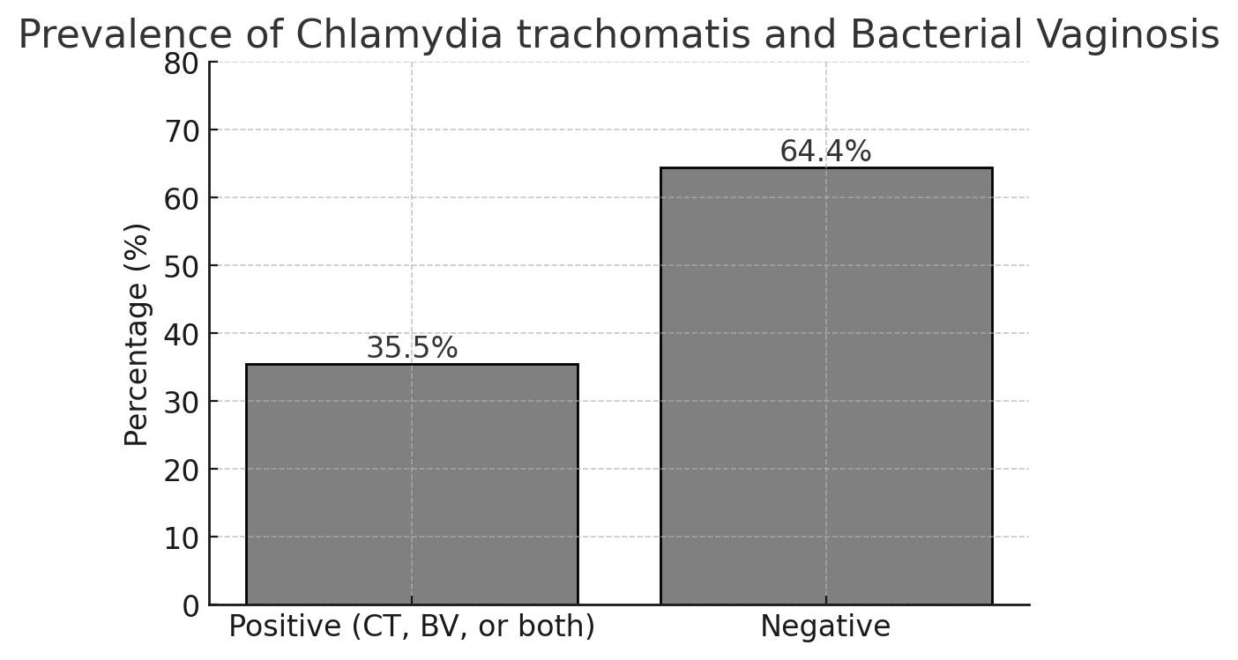
Figure 1: Prevalence of Chlamydia trachomatis and Bacterial vaginosis among Study Participants.(please specify the percentage of each alone, the percentage of women infected with BV and the percentage of women infected with CT )
The figure illustrates that 35.5% of the study population tested positive for CT, BV, or both infections, while 64.4% tested negative.

Distribution of the study participants based on age (n=281).

Table 1: Participants Based on age
Age Group | Number | Percentage
21-30 | 75 | 26.7%
31-35 | 105 | 37.4%
36-40 | 25 | 8.9%
Above 40 (the included age from 21-40), so, above 40 must be excluded | 16 | 5.7%
Total | 281 | 100%
(please ,the age group must be classified at a regular interval for ex 5 years interval: 21-25, 26-30, 31-35, 36-40.)
The table above (table 1), indicates that the largest proportion of study participants fell within the 31-35 years age group, accounting for 37.4% of the total sample. This suggests that individuals in this age bracket were the most represented in the study. The second most prevalent age group was 21-30 years, making up 26.7% of the participants. This indicates a significant presence of younger adults within the study population. In contrast, a much smaller percentage of participants were aged above 40years, with only 5.7% falling into this category. This suggests that older individuals were underrepresented in the study. The remaining percentage of participants would be distributed among other age groups, possibly including those under 21 years and those between 36-40 years. This age distribution may have implications for the study findings, particularly in understanding how age influences the prevalence of Chlamydia trachomatis and Bacterial vaginosis.

Distribution of Study Participants Based on Behavioral Risk Factors

The image below presents a distribution of study participants based on various behavioral risk factors. The data highlights the prevalence of certain behaviors among the participants. Smoking is reported at two different percentages, 12.0% and 36.0%, which might indicate different categories or contexts within the study, such as current smokers versus former smokers, or different demographic groups. Contraceptive use is reported at 52.0%, suggesting that just over half of the participants use some form of contraception, which is a significant factor in sexual health and family planning. (which type of contraceptive measures: condom?intrauterine device(copper or hormonal)that eaither protect against infection like condom or predispose to infection like copper iucd)The category labeled "Unprotected Sexual Activity" does not have a percentage listed, indicating that this data might be missing or not quantified in the provided information. This category is crucial as it relates to the risk of sexually transmitted infections and unintended pregnancies. Overall, the image underscores the importance of understanding and addressing these behavioral risk factors in public health strategies to improve health outcomes and reduce risks associated with these behaviors.

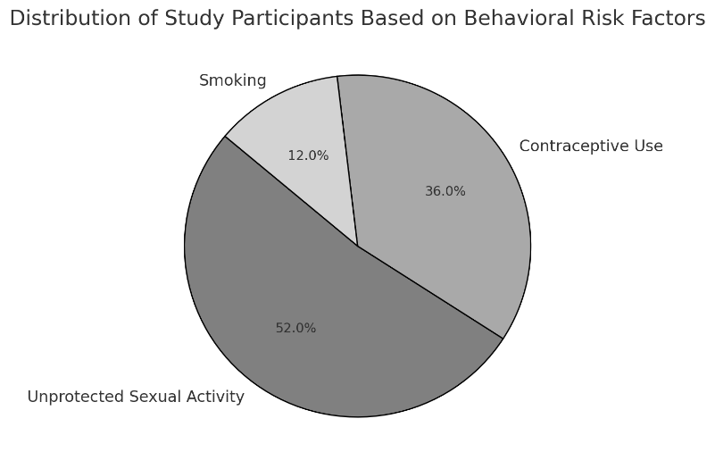

Figure 2: Distribution of Study Participants Based on Behavioral Risk Factors

4.5. Association Between Chlamydia trachomatis and Bacterial Vaginosis
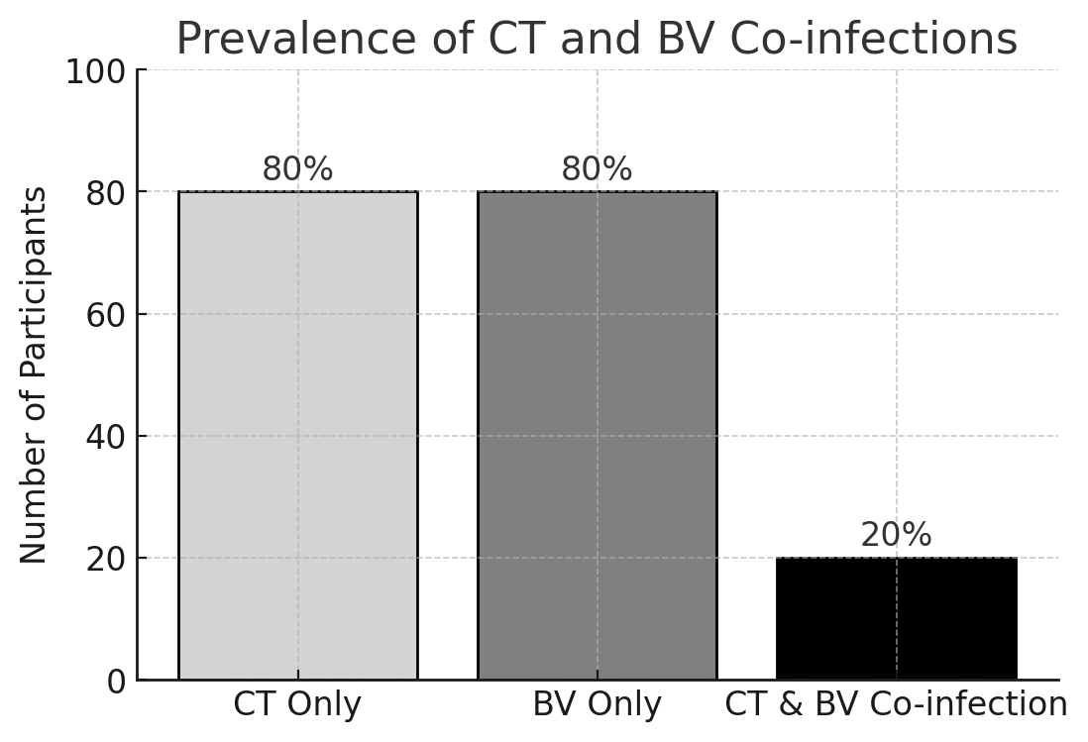
Figure 3: Association Between Chlamydia trachomatis and Bacterial vaginosis

The study investigated the association between Chlamydia trachomatis (CT) and Bacterial Vaginosis (BV) co-infections and their impact on reproductive health. The findings revealed that 20% (20 out of 100) of participants diagnosed with CT also tested positive for BV, indicating a notable prevalence of co-infections among the study population. This dual infection rate is significant because both CT and BV are known to independently contribute to adverse reproductive health outcomes, and their co-occurrence may exacerbate these effects (Smith et al., 2022).
Laboratory Findings
The figure illustrates the distribution of pathogens isolated from participants. Chlamydia trachomatis accounted for 60% of cases, while Gardnerella vaginalis and other BV-associated bacteria accounted for 40%.

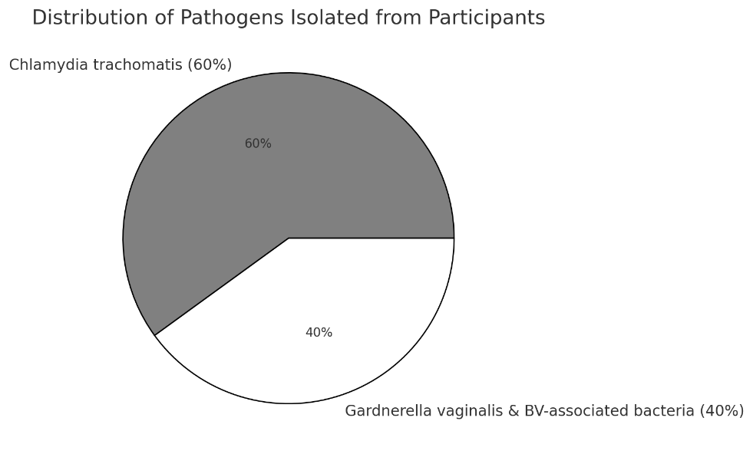
Figure 4: Pathogens Isolated from Study Participants

Antimicrobial Susceptibility Patterns

(please discuss in methods part how antimicrobial sensitivity test was done)
The antimicrobial susceptibility testing for Chlamydia trachomatis and BV-associated bacteria revealed the following patterns:
Table 2. Antimicrobial Susceptibility Patterns isolated from High Vaginal swab at PGH
Pathogen | Azithromycin | Doxycycline | Metronidazole | Clindamycin
Chlamydia trachomatis | 90% S | 85% S | - | -
Gardnerella vaginalis | - | - | 80% S | 75% S
Other BV-associated bacteria | - | - | 70% S | 65% S
Key: S = Sensitive

Impact on Reproductive Health

(how you determine the adverse reproductive health??what do you mean by infertility?it is better to be tubal pathology:tubal adhesion,tubal obstraction, tubal hydrosalpinx, regarding the adverse pregnancy outcome, please, specify:abortion,chorioaminitis, preterm labour, cesearian section, neonatal infection)
The study found that participants with co-infections (CT and BV) were more likely to experience adverse reproductive health outcomes, including:
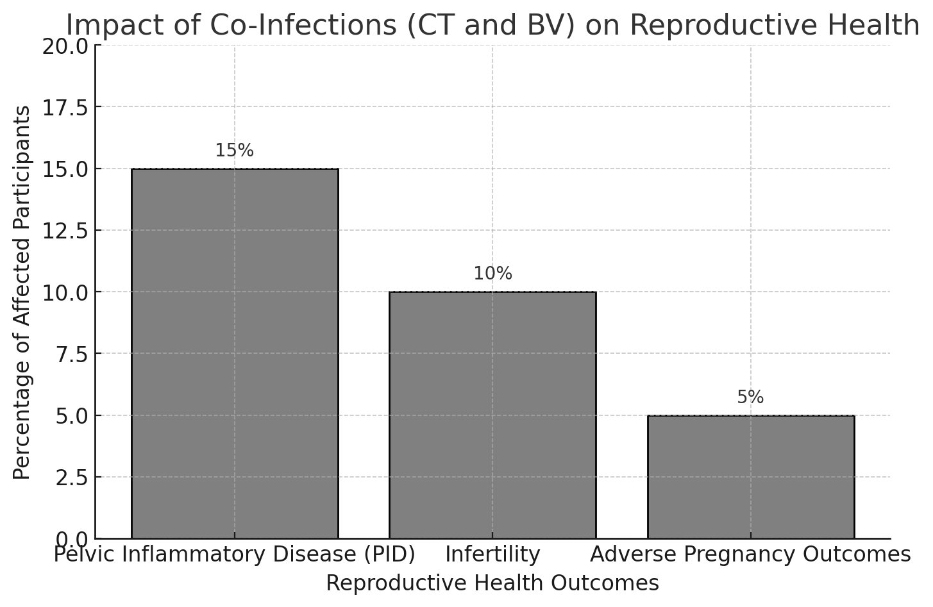
Figure 5: Impact of co-infections on CT and BV on Reproductive Health

The study highlights significant reproductive health complications associated with co-infections of Chlamydia trachomatis (CT) and Bacterial vaginosis (BV), focusing on pelvic inflammatory disease (PID), infertility, and adverse pregnancy outcomes. Among the co-infected participants, 15% were reported to have pelvic inflammatory disease (PID). The study conducted at Parirenyatwa Group of Hospitals revealed several critical findings regarding the prevalence, risk factors, and health impacts of Chlamydia trachomatis (CT) and Bacterial vaginosis (BV) infections among young women aged 21-40. The prevalence of CT and BV co-infections was found to be 35.5%, indicating a significant burden of these infections in this demographic.

Discussion
This study aimed to determine the prevalence, distribution, and reproductive health implications of Chlamydia trachomatis (CT) and bacterial vaginosis (BV) among young adult women aged 21–40 years at Parirenyatwa Group of Hospitals (PGH) in Harare. Over a one-year period, 281 women were screened, with 35.5% testing positive for either CT, BV, or both infections. These findings highlight a substantial burden of reproductive tract infections among young women in this setting. The overall prevalence of CT and BV (35.5%) aligns with previous studies in sub-Saharan Africa, which report high rates of asymptomatic STIs among women of reproductive age. Age-specific analysis showed that the highest proportion of participants fell within the 31–35 years group (37.4%), followed by those aged 21–30 years (26.7%). This age distribution suggests that sexually active women in their early thirties are the most represented in clinical settings, possibly reflecting increased healthcare-seeking behavior or heightened awareness of reproductive health issues in this age group. Interestingly, older women (>40 years) were underrepresented, suggesting that infection prevalence and healthcare engagement may decline with age. These trends emphasize the importance of age-targeted screening programs [6-7].
Behavioral factors are key determinants of CT and BV infection risk. The study found that 52% of participants reported using contraception, while smoking prevalence ranged between 12% and 36%, reflecting differences in lifestyle habits among subgroups. Although data on unprotected sexual activity were incomplete, previous studies have consistently identified multiple sexual partners and inconsistent condom use as major risk factors for CT and BV acquisition. These findings underscore the need for targeted sexual health education, promoting safe sexual practices to reduce infection risk [8]. Among the 100 participants who tested positive, 20% exhibited co-infection with CT and BV. Co-infections are clinically significant as they may amplify adverse reproductive outcomes. Laboratory analysis revealed that CT accounted for 60% of infections, whereas Gardnerella vaginalis and other BV-associated bacteria comprised 40%. This distribution reflects the high prevalence of both sexually transmitted and bacterial dysbiosis-related infections in this population [9-10].
Antimicrobial susceptibility testing demonstrated high sensitivity of CT to azithromycin (90%) and doxycycline (85%), while BV-associated pathogens showed substantial sensitivity to metronidazole (70–80%) and clindamycin (65–75%). These findings provide important guidance for empirical treatment strategies, indicating that current first-line antibiotics remain effective for managing these infections in Harare [11-12]. The study identified significant reproductive health consequences associated with CT and BV co-infections. Notably, 15% of co-infected participants experienced pelvic inflammatory disease (PID), a leading cause of infertility and adverse pregnancy outcomes. These results reinforce previous evidence that both CT and BV independently compromise reproductive health, and their co-occurrence may exacerbate the risk of complications such as infertility, ectopic pregnancy, and adverse obstetric outcomes [13-14].
The prevalence of CT and BV in this study is comparable to findings in other urban sub-Saharan African settings, where prevalence rates for CT range from 10–15% and BV from 20–30% among reproductive-age women. The observed co-infection rate (20%) is consistent with studies reporting 15–25% dual infections, highlighting the persistent burden of reproductive tract infections despite ongoing public health interventions [15]. The high prevalence of CT and BV among women aged 21–40 underscores the need for routine screening programs in tertiary healthcare facilities. Behavioral interventions, including promoting condom use, regular STI testing, and reproductive health education, are crucial for reducing the burden of these infections. Additionally, antimicrobial susceptibility data support continued use of first-line therapies while emphasizing the importance of ongoing surveillance to detect emerging resistance patterns [15-16].

Conclusion
This study highlights a substantial burden of Chlamydia trachomatis and bacterial vaginosis among young adult women aged 21–40 years attending Parirenyatwa Group of Hospitals, delete this paragraph with. About 35.5% of participants testing positive for either infection or both. Age-specific analysis revealed that women aged 31–35 years were the most affected, and behavioral risk factors, including inconsistent condom use and multiple sexual partners, contributed to infection risk. Co-infections of CT and BV were observed in 20% of affected participants and were associated with significant reproductive health complications, including pelvic inflammatory disease, infertility, and adverse pregnancy outcomes. Laboratory findings demonstrated high sensitivity of CT to azithromycin and doxycycline, and BV-associated bacteria to metronidazole and clindamycin, supporting current first-line treatment protocols.
Recommendations: These findings underscore the need for routine screening, integrated sexual health education, and targeted interventions to reduce the burden of these infections and prevent adverse reproductive outcomes. Public health strategies should prioritize age-specific and behavior-focused approaches to improve reproductive health outcomes among young women in Harare and similar urban settings.

References

- Gupta, K., Harrison, S. A., Davis, N. A., Culp, M. L., Hand, S. C., Simpson, T., Van Der Pol, B., Galbraith, J. W., Van Wagoner, N. J., Morrison, S. G., Morrison, R. P., & Geisler, W. M. (2021). Prevalence of Chlamydia trachomatis Infection in Young Women and Associated Predictors. Sexually transmitted diseases, 48(8), 529–535. https://doi.org/10.1097/OLQ.0000000000001372
- den Heijer, C. D. J., Hoebe, C. J. P. A., Driessen, J. H. M., Wolffs, P., van den Broek, I. V. F., Hoenderboom, B. M., Williams, R., de Vries, F., & Dukers-Muijrers, N. H. T. M. (2019). Chlamydia trachomatis and the Risk of Pelvic Inflammatory Disease, Ectopic Pregnancy, and Female Infertility: A Retrospective Cohort Study Among Primary Care Patients. Clinical infectious diseases : an official publication of the Infectious Diseases Society of America, 69(9), 1517–1525. https://doi.org/10.1093/cid/ciz429
- Gonese, E., Musuka, G., Ruangtragool, L., Hakim, A., Parekh, B., Dobbs, T., Duong, Y. T., Patel, H., Mhangara, M., Mugurungi, O., Mapingure, M., Saito, S., Herman-Roloff, A., Gwanzura, L., Tippett-Barr, B., Kilmarx, P. H., & Justman, J. (2020). Comparison of HIV Incidence in the Zimbabwe Population-Based HIV Impact Assessment Survey (2015-2016) with Modeled Estimates: Progress Toward Epidemic Control. AIDS research and human retroviruses, 36(8), 656–662. https://doi.org/10.1089/AID.2020.0046
- Taylor, B. D., & Haggerty, C. L. (2011). Management of Chlamydia trachomatis genital tract infection: screening and treatment challenges. Infection and drug resistance, 4, 19–29. https://doi.org/10.2147/IDR.S12715 update the reference
- Chabata, S. T., Fearon, E., Musemburi, S., Machingura, F., Machiha, A., Hargreaves, J. R., Ndowa, F. J., Mugurungi, O., Cowan, F. M., & Steen, R. (2025). High Prevalence of Sexually Transmitted Infections and Poor Sensitivity and Specificity of Screening Algorithms for Chlamydia and Gonorrhea Among Female Sex Workers in Zimbabwe: Analysis of Respondent-Driven Sampling Surveys in 3 Communities. Sexually transmitted diseases, 52(2), 117–124. https://doi.org/10.1097/OLQ.0000000000002086
- Torrone, E. A., Morrison, C. S., Chen, P. L., Kwok, C., Francis, S. C., Hayes, R. J., Looker, K. J., McCormack, S., McGrath, N., van de Wijgert, J. H. H. M., Watson-Jones, D., Low, N., Gottlieb, S. L., & STIMA Working Group (2018). Prevalence of sexually transmitted infections and bacterial vaginosis among women in sub-Saharan Africa: An individual participant data meta-analysis of 18 HIV prevention studies. PLoS medicine, 15(2), e1002511. https://doi.org/10.1371/journal.pmed.1002511
- Manjate, A., Sergon, G., Kenga, D., Golparian, D., Tyulenev, Y., Loquilha, O., Mausse, F., Guschin, A., Langa, J. C., Passanduca, A., Sacarlal, J., & Unemo, M. (2024). Prevalence of sexually transmitted infections (STIs), associations with sociodemographic and behavioural factors, and assessment of the syndromic management of vaginal discharge in women with urogenital complaints in Mozambique. Frontiers in reproductive health, 6, 1323926. https://doi.org/10.3389/frph.2024.1323926
- Ranjit, E., Raghubanshi, B. R., Maskey, S., & Parajuli, P. (2018). Prevalence of Bacterial Vaginosis and Its Association with Risk Factors among Nonpregnant Women: A Hospital Based Study. International journal of microbiology, 2018, 8349601. https://doi.org/10.1155/2018/8349601
- Chiu, S. F., Huang, P. J., Cheng, W. H., Huang, C. Y., Chu, L. J., Lee, C. C., Lin, H. C., Chen, L. C., Lin, W. N., Tsao, C. H., Tang, P., Yeh, Y. M., & Huang, K. Y. (2021). Vaginal Microbiota of the Sexually Transmitted Infections Caused by Chlamydia trachomatis and Trichomonas vaginalis in Women with Vaginitis in Taiwan. Microorganisms, 9(9), 1864. https://doi.org/10.3390/microorganisms9091864
- Ginocchio, C. C., Chapin, K., Smith, J. S., Aslanzadeh, J., Snook, J., Hill, C. S., & Gaydos, C. A. (2012). Prevalence of Trichomonas vaginalis and coinfection with Chlamydia trachomatis and Neisseria gonorrhoeae in the United States as determined by the Aptima Trichomonas vaginalis nucleic acid amplification assay. Journal of clinical microbiology, 50(8), 2601–2608. https://doi.org/10.1128/JCM.00748-12 update the reference
- Li, T., Zhang, Z., Wang, F., He, Y., Zong, X., Bai, H., & Liu, Z. (2020). Antimicrobial Susceptibility Testing of Metronidazole and Clindamycin against Gardnerella vaginalis in Planktonic and Biofilm Formation. The Canadian journal of infectious diseases & medical microbiology = Journal canadien des maladies infectieuses et de la microbiologie medicale, 2020, 1361825. https://doi.org/10.1155/2020/1361825
- Petrina, M. A. B., Cosentino, L. A., Rabe, L. K., & Hillier, S. L. (2017). Susceptibility of bacterial vaginosis (BV)-associated bacteria to secnidazole compared to metronidazole, tinidazole and clindamycin. Anaerobe, 47, 115–119. https://doi.org/10.1016/j.anaerobe.2017.05.005
- Mitchell, C. M., Anyalechi, G. E., Cohen, C. R., Haggerty, C. L., Manhart, L. E., & Hillier, S. L. (2021). Etiology and Diagnosis of Pelvic Inflammatory Disease: Looking Beyond Gonorrhea and Chlamydia. The Journal of infectious diseases, 224(12 Suppl 2), S29–S35. https://doi.org/10.1093/infdis/jiab067
- Das, B. B., Ronda, J., & Trent, M. (2016). Pelvic inflammatory disease: improving awareness, prevention, and treatment. Infection and drug resistance, 9, 191–197. https://doi.org/10.2147/IDR.S91260
- Ala, O. O., Shuaib, B. I., Momodu, A., & Muhibi, M. A. (2025). Molecular prevalence of Chlamydia trachomatis infection among women attending gynaecological clinic for infertility evaluation. BMC women's health, 25(1), 321. https://doi.org/10.1186/s12905-025-03875-0
- Chabata, S. T., Fearon, E., Musemburi, S., Machingura, F., Machiha, A., Hargreaves, J. R., Ndowa, F. J., Mugurungi, O., Cowan, F. M., & Steen, R. (2025). High Prevalence of Sexually Transmitted Infections and Poor Sensitivity and Specificity of Screening Algorithms for Chlamydia and Gonorrhea Among Female Sex Workers in Zimbabwe: Analysis of Respondent-Driven Sampling Surveys in 3 Communities. Sexually transmitted diseases, 52(2), 117–124. https://doi.org/10.1097/OLQ.0000000000002086

