Role of Gut Microbiota-Derived Metabolites in Modulating Immune Responses in Colorectal Cancer

ABSTRACT
Colorectal cancer (CRC) is a leading cause of global cancer mortality, with its incidence rising due to environmental and lifestyle factors. The gut microbiota influences CRC pathogenesis through the production of bioactive metabolites that modulate the host immune response. This case-control study integrated metabolomic and immunohistochemical analyses to investigate this relationship. We found that CRC patients (n=30) exhibited a significant dysregulation of key metabolites compared to healthy controls (n=30), with fecal butyrate depleted from 52.4 ± 14.2 µg/g to 31.5 ± 11.8 µg/g (p<0.0001) and serum deoxycholic acid (DCA) elevated from 1.2 ± 0.5 µM to 3.1 ± 1.2 µM (p<0.0001). These systemic metabolite levels were strongly correlated with the tumor immune architecture: serum butyrate showed a strong positive correlation with cytotoxic CD8⁺ T-cell density (r = +0.712, p<0.0001) and a negative correlation with immunosuppressive Tregs (r = -0.501, p=0.002), while DCA correlated negatively with CD8⁺ T-cells (r = -0.654, p<0.0001) and positively with Tregs (r = +0.598, p<0.0001). Critically, this metabolomic profile directly impacted patient survival; those with high serum butyrate had a 72% 5-year overall survival rate compared to 48% for those with low levels (HR 0.41, p=0.006). Our findings directly link a dysregulated gut metabolome, characterized by low butyrate/high DCA, to an immunosuppressive tumor microenvironment and poorer clinical outcomes, highlighting these metabolites as promising non-invasive prognostic biomarkers and potential therapeutic targets.
Keywords: Colorectal Cancer, Gut Microbiota, Metabolites, Tumor Microenvironment, Short-Chain Fatty Acids, Butyrate, Deoxycholic Acid, Tumor-Infiltrating Lymphocytes
Introduction
In 2020, colorectal cancer (CRC), the second deadliest cancer and the third most common malignancy, is projected to result in 0.9 million fatalities and 1.9 million new cases worldwide. Because of westernization, the occurrence of colorectal cancer (CRC) is increasing in middle- and low-income nations and is more prevalent in highly developed countries. Moreover, there is an increasing incidence of colorectal cancer at a young age. (Xi and Xu, 2021). CRC accounts for 9.4% of cancer fatalities and 10% of cancer cases globally, which is slightly lower than lung cancer, responsible for 18% of deaths (Olfatifar et al., 2025). According to forecasts of population growth, aging, and human progression, it is anticipated that there will be 3.2 million fresh instances of colorectal cancer globally by 2040 (Morgan et al., 2023). The main reason for the increase in colorectal cancer cases is the heightened exposure to environmental risk factors resulting from the westernization of lifestyle and diet (Zhang et al., 2025). This increase is expected to be particularly evident in countries with high or very high Human Development Indexes (HDIs). Nonetheless, there is significant variability in the occurrence of CRC globally, affected by factors such as age, sex, location, and socioeconomic status. Europe, comprising nations such as the Netherlands, Norway, Slovakia, and Hungary, is notable for certain regions with the highest incidence rates (Morgan et al., 2023)

Figure 1: Fusobacterium nucleatum Colorectal (Abed et al., 2016)
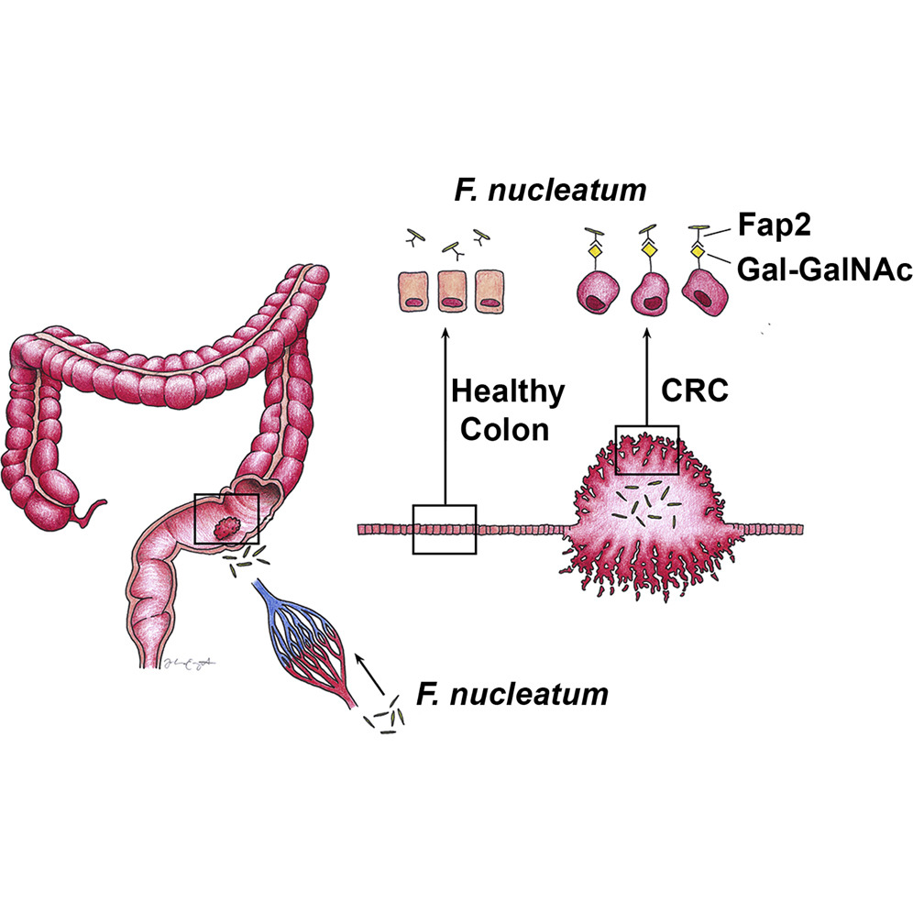
The gram-negative anaerobic bacterium Fusobacterium nucleatum has become a key role in the pathophysiology of colorectal cancer (CRC) (Ye et al., 2024). By inducing the release of pro-inflammatory cytokines such as IL-1β, IL-6, and TNF-α, the bacterium creates a chronic inflammatory response in the intestinal mucosa, which promotes the growth of cancer (Alon-Maimon, et al., 2022). Through adhesins like FadA, F. nucleatum attaches itself to and penetrates epithelial cells, disrupting cell junctions and promoting the epithelial-to-mesenchymal transition (EMT), which is linked to the progression of cancer (Pignatelli et al., 2023). The bacterium also alters the host immune system, reducing the activity of immune cells and fostering an environment that is conducive to the establishment of tumors. It further influences carcinogenic pathways by causing dysbiosis through its interactions with the gut microbiota (Sung et al., 2021).. There is proof that F. nucleatum can damage DNA directly by producing reactive oxygen species or indirectly by producing (Olfatifar et al., 2025).
Figure 2: Fusobacterium nucleatum–Mediated Immune Evasion in Cells (Pignatelli et al., 2023)
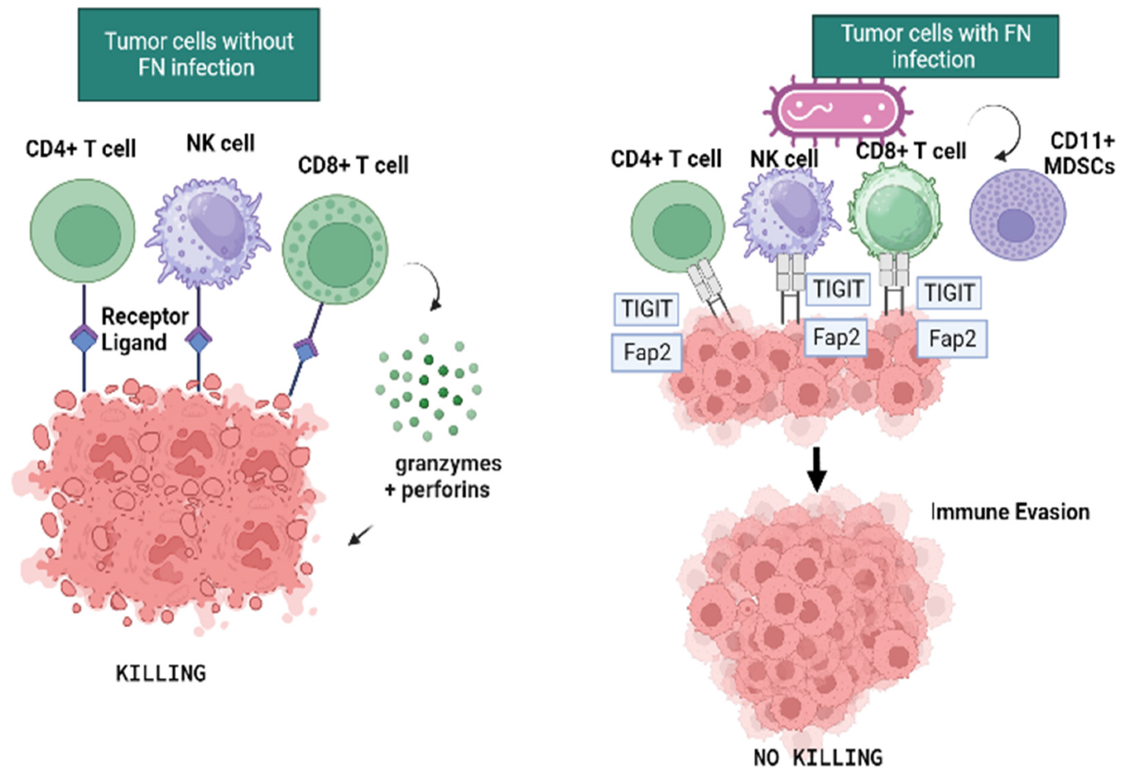

In CRC, certain gut bacteria play an active role rather than merely observing; they influence the progression of the disease by altering host immunology and epithelial tissue structure to encourage tumor development (Neurath et al., 2025). This section summarizes the existing data on two interconnected areas: (1) the primary strategies utilized by bacterial pathogens to affect immune regulation and evasion in colorectal cancer; and (2) the methods by which pathogenic bacteria compromise the intestinal barrier in this condition

Table 1: Bacteria associated with colorectal cancer (Zou et al., 2018)
Microorganisms | Role in affecting CRC | Function
Enterococcus faecalis | Promoter | generating extracellular superoxide, which damages DNA
Shigella | Promoter | Induction of inflammation
Escherichia coli NC101 | Promoter | Creation of cytotoxins, cyclomodulin synthesis, and genotoxins
Bacteroides fragilis | Promoter | Th17/IL-17 inflammatory response induction, E-cadherin cleavage stimulation, and B. fragilis toxin generation.
Streptococcus bovis | Promoter | Prolonged inflammatory reaction
Helicobacter pylori | Promoter | Making a multipurpose toxin VacA
Fusoacterium nucleatum | Promoters | enhanced in colorectal cancer; initiating the Wnt signaling pathway(  and triggering the inflammatory nuclear factor-kappa b (NF-kb) signaling pathway (
Bifidobacterium | Protective | Decreased the activity of β-glucuronidase
Eubacterium rectale | Protective | Produces Butyrate
Clostridium septicum | Protective | Produces secondary bile acids
Faecalibacxterium prausnitzii | Protective | Generates Butyrate
Lactobacilus | Protective | Activating Toll-like receptors and decreasing lactic acid generation

2. METHODOLOGY
The study utilized a case-control framework that combined clinical metabolomic and immunohistochemical assessments to investigate the connection between microbial metabolites and the immune microenvironment.
2.1 Study Cohort and Sample Collection
Stool samples and blood from peripheral veins were gathered before any bowel prep was performed. Surgically removed CRC tumor tissues and corresponding adjacent normal tissues (>5cm from the tumor edge) were collected. The Institutional Review Board approved the ethics, and all participants gave written consent
2.2 Metabolomic Profiling using LC-MS/MS
Fecal metabolites were obtained through a methanol-water mixture. Acetonitrile was used to deproteinize the serum. Quantitative analysis focusing on SCFAs (butyrate, propionate, acetate), secondary bile acids (deoxycholic acid -DCA, lithocholic acid-LCA), and tryptophan metabolites (indole-3-propionate acid-IPA, kynurenine) was conducted using the Agilent 6495C Triple Quadrupole LC/MS System. Multiple reaction monitoring (MRM) utilizing stable isotope-labelled internal standard was employed for accurate quantification. Metabolite levels were adjusted to fecal weight (µg/g) or serum volume (µM)
2.3 Immune Profiling via Immunohistochemistry (IHC)
Formalin-fixed, paraffin-embedded (FFPE) CRC tissue sections (4µm) were analyzed using antibodies targeting CD8 (cytotoxic T-cells, clone C8/144B), CD4 (helper T-cells, clone SP35), and FOXP3 (regulatory T-cells, clone 236A/E7). The staining process was carried out on the Ventana Benchmark Ultra autostainer. Whole slide images underwent digital scanning, and immune cell densities were assessed in five random high-power fields (HPF, 400x) inside the tumor core and invasive margin using QuPath digital pathology software (Yil-Hillial et al., 2025)
2.4 Statistical Analysis
Statistical analyses were performed utilizing GraphPad Prism v10.0 and R software. The Mann-Whitney U test was employed for comparisons between two groups. Spearman's rank correlation coefficient was utilized to evaluate the associations between metabolite levels and immune cell densities. Survival analysis was conducted via the Kaplan-Meier approach combined with the log-rank test
3. Results
3.1 Alteration in Microbial Levels in CRC Patients
We initially assessed the levels of important microbiota-derived metabolites in stool and blood samples from CRC patients and healthy individuals
Table 2: Concentrations of gut microbiota-derived metabolites in study cohorts
Metabolite | Healthy Control (n-30) | CRC Patients (n=30) | P-value
Fecal Butyrate (µg/g) | 52.4 ± 14.2 | 31.5 ± 11.8 | <0.0001
Serum Butyrate(µM) | 8.9 ± 2.5 | 5.3 ± 2.1 | <0.0001
Fecal IPA (µg/g) | 15.8 ± 5.1 | 10.3 ± 4.2 | <0.001
Serum DCA (µM) | 1.2 ± 0.5 | 3.1 ± 1.2 | <0.0001
Serum Kynurenine (µM) | 0.8 ± 0.3 | 1.9 ± 0.6 | <0.0001
Data presented as mean ± SD. P-values from Mann-Whitney U test
Analysis showed a marked reduction of helpful metabolites, particularly butyrate and IPA, in CRC patients. In contrast, levels of the pro-tumorigenic metabolite DCA and the immunoregulatory compound kynurenine were notably increased

3.2 Correlation Between Metabolites and Tumor-Infiltrating Lymphocytes
We next correlated systemic (serum) metabolite levels with the density of specific immune cell populations within CRC tumors.
Table 3: Correlation (Spearman’s r) of serum metabolite levels with immune cell density in CRC tumors
Serum Metabolite | CD8⁺ T-cells | CD4⁺ T-cells | FOXP3⁺ Tregs
Butyrate | +0.712 (p<0.0001) | +0.325 (p=0.072) | -0.501 (p=0.002)
IPA | +0.633 (p<0.0001) | +0.288 (p=0.104) | -0.421 (p=0.009)
DCA | -0.654 (p<0.0001) | -0,210 (p=0.214) | +0.598 (p<0.0001)
Kynurenine | -0.454 (p=0.006) | -0.105 (p=0.006) | +0.537 (p<0.001)
A significant positive correlation was noted between serum butyrate and IPA levels and the quantity of cytotoxic CD8+ T-cells. These metabolites showed an inverse correlation with the density of immunosuppressive Treg cells. A contrasting pattern was observed for DCA and kynurenine, which showed a negative correlation with CD8+ T-cells and a positive correlation with Tregs
3.3 Association with Clinical Parameters
Patients were stratified into high and low groups based on median serum butyrate and DCA levels.
Table 4: Five-year overall survival based on metabolite levels
Group | 5-Year Overall Survival (%) | Hazard Ratio (95% CI) | p-value
High Serum Butyrate (n=25) | 72% | 0.41 (0.22-0.78) | 0.006
Low Serum Butyrate (n=25) | 48% | 1.0
High Serum DCA (n=25) | 76% | 0.35 (0.18-0.69) | 0.002
Low Serum DCA (n=25) | 44% | 1.0
Kaplan-Meier analysis indicated that patients with elevated serum butyrate or reduced serum DCA levels exhibited significantly better 5-year overall survival compared to patients with low butyrate or high DCA levels.
4. Discussion
Our research offers an in-depth examination that directly associates the levels of particular gut-derived metabolites with the immune environment and clinical outcomes in colorectal cancer. The findings indicate a notable change in the gut metabolome of CRC patients, marked by a decrease in immune-protective metabolites (butyrate, IPA) and an increase in immune-toxic metabolites (DCA, kynurenine) (Eiman et al., 2025; Perl et al., 2025).

The significant reduction of butyrate, an important SCFA, is a crucial discovery. Butyrate’s function goes beyond HDAC inhibition in colonocytes to include direct immunomodulation (Kalkan et al., 2025). Our findings indicate a robust positive correlation between serum butyrate and the infiltration of CD8+ T-cells, consistent with recent research showing that butyrate boosts the cytotoxic activity and growth of CD8+ T-cells by functioning as an HDAC inhibitor in the lymphocytes, facilitating epigenetic reprogramming toward an effector phenotype (He et al., 2021). Although it seems contradictory since butyrate promotes colonic Tregs, the negative association with Tregs might illustrate the intricate, context-sensitive characteristics of the TIME, wherein butyrate could primarily enhance anti-tumor cytotoxicity within the acidic, hypoxic tumor core (Luu et al., 2019).
Likewise, the reduction in IPA, an AhR ligand derived from tryptophan, indicates the failure of an essential mechanism for maintaining immune homeostasis and epithelial stability. It is widely recognized that AhR activation mediated by IPA enhances barrier function and diminishes inflammation (Rothhammer and Quintana, 2019). Due to its beneficial connection with CD8⁺ T-cells, its removal likely results in intestinal permeability, ongoing inflammation, and a weakened anti-cancer response.Likewise, the reduction in IPA, an AhR ligand derived from tryptophan, indicates the failure of an essential mechanism for maintaining immune homeostasis and epithelial stability. It is widely recognized that AhR activation mediated by IPA enhances barrier function and diminishes inflammation (Rothhammer and Quintana, 2019). Due to its beneficial connection with CD8⁺ T-cells, its removal likely results in intestinal permeability, ongoing inflammation, and a weakened anti-cancer response.

Conversely, a detrimental pathway in CRC is marked by the rise of DCA, a byproduct of bile acid. While DCA is recognized for causing DNA damage (Jia et al 2018), our results show that it additionally exhibits immunosuppressive properties. DCA might aid in developing an immunosuppressive TIME by either directly impairing T-cell activity or inducing a tolerogenic profile in antigen-presenting cells, supported by the strong positive relationship between DCA and Treg density alongside its negative correlation with CD8⁺ T-cells (Ma et al., 2018). The heightened kynurenine implies a tolerogenic environment as it diminishes effector T-cell responses and promotes Treg development. Our results are more clinically significant when this metabolomic information is paired with patient survival outcomes. Patients exhibiting a "favorable" metabolomic profile (elevated butyrate/low DCA) experience a significant survival advantage, indicating that these metabolites are potential non-invasive biomarkers (Prendergast et al., 2018).
Our results become more clinically significant when this metabolomic data is paired with patient survival outcomes. These metabolites serve as hopeful non-invasive prognostic markers due to the significant survival benefit observed in individuals possessing a "favorable" metabolomic profile (high butyrate/low DCA).
Conclusion
In summary, a suppressive TIME (low CD8⁺, high Tregs) and diminished overall survival in colorectal cancer are significantly associated with a gut microbiome metabolome marked by low butyrate/IPA and high DCA/kynurenine levels. Altering the gut microbiome via dietary modifications, pre/probiotics, or chosen microbial groups, these metabolites demonstrate potential as therapeutic targets that could favorably influence the immune system and improve results for individuals with colorectal cancer.

References
Abed, J., Emgård, J. E., Zamir, G., Faroja, M., Almogy, G., Grenov, A., & Bachrach, G. (2016). Fap2 mediates Fusobacterium nucleatum colorectal adenocarcinoma enrichment by binding to tumor-expressed Gal-GalNAc. Cell host & microbe, 20(2), 215-225.
Alon-Maimon, T.; Mandelboim, O.; and Bachrach, G. (2022). Fusobacterium nucleatum and cancer. Periodontology , 89, 166–180
Eiman, L., Moazzam, K., Anjum, D. S., Kausar, H., Sharif, E., & Ibrahim, W. N. (2025). Gut Dysbiosis in Cancer Immunotherapy: Microbiota-Mediated Resistance and Emerging Treatments. Frontiers in Immunology, 16, 1575452.
Galasso, L., Termite, F., Mignini, I., Esposto, G., Borriello, R., Vitale, F., ... & Zocco, M. A. (2025). Unraveling the role of fusobacterium nucleatum in colorectal cancer: molecular mechanisms and pathogenic insights. Cancers, 17(3), 368.
He, Y., Fu, L., Li, Y., Wang, W., Gong, M., Zhang, J., ... & Guo, X. (2021). Gut microbial metabolites facilitate anticancer therapy efficacy by modulating cytotoxic CD8+ T cell immunity. Cell metabolism, 33(5), 988-1000.
Jia, W., Xie, G., & Jia, W. (2018). Bile acid–microbiota crosstalk in gastrointestinal inflammation and carcinogenesis. Nature reviews Gastroenterology & hepatology, 15(2), 111-128.
Kalkan, A. E., BinMowyna, M. N., Raposo, A., Ahmad, M. F., Ahmed, F., Otayf, A. Y., ... & Karav, S. (2025). Beyond the gut: unveiling butyrate’s global health impact through gut health and dysbiosis-related conditions: a narrative review. Nutrients, 17(8), 1305.
Luu, M., Pautz, S., Kohl, V., Singh, R., Romero, R., Lucas, S., & Visekruna, A. (2019). The short-chain fatty acid pentanoate suppresses autoimmunity by modulating the metabolic-epigenetic crosstalk in lymphocytes. Nature communications, 10(1), 760.
Ma, C., Han, M., Heinrich, B., Fu, Q., Zhang, Q., Sandhu, M., & Greten, T. F. (2018). Gut microbiome–mediated bile acid metabolism regulates liver cancer via NKT cells. Science, 360(6391), eaan5931.
Morgan, E., Arnold, M., Gini, A., Lorenzoni, V., Cabasag, C. J., Laversanne, M., & Bray, F. (2023). Global burden of colorectal cancer in 2020 and 2040: incidence and mortality estimates from GLOBOCAN. Gut, 72(2), 338-344.
Neagu, A. I., Bostan, M., Ionescu, V. A., Gheorghe, G., Hotnog, C. M., Roman, V., ... & Bleotu, C. (2025). The Impact of the Microbiota on the Immune Response Modulation in Colorectal Cancer. Biomolecules, 15(7), 1005.
Neagu, A. I., Bostan, M., Ionescu, V. A., Gheorghe, G., Hotnog, C. M., Roman, V., ... & Bleotu, C. (2025). The Impact of the Microbiota on the Immune Response Modulation in Colorectal Cancer. Biomolecules, 15(7), 1005.
Neurath, M. F., Artis, D., & Becker, C. (2025). The intestinal barrier: a pivotal role in health, inflammation, and cancer. The Lancet Gastroenterology & Hepatology.
Olfatifar, M., Rafiei, F., Sadeghi, A., Ataei, E., Habibi, M. A., Pezeshgi Modarres, M., ... & Houri, H. (2025). Assessing the colorectal cancer landscape: A comprehensive exploration of future trends in 216 countries and territories from 2021 to 2040. Journal of Epidemiology and Global Health, 15(1), 5.

Perl, M., Fante, M. A., Herfeld, K., Scherer, J. N., Poeck, H., & Orberg, E. T. (2025). Microbiota-derived metabolites: Key modulators of cancer immunotherapies. Med, 6(8).
Pignatelli, P.; Nuccio, F.; Piattelli, A.; Curia, M.C (2023). The Role of Fusobacterium nucleatum in Oral and Colorectal Carcinogenesis. Microorganisms, 11, 2358.
Prendergast, G. C., Malachowski, W. J., Mondal, A., Scherle, P., & Muller, A. J. (2018). Indoleamine 2, 3-dioxygenase and its therapeutic inhibition in cancer. International review of cell and molecular biology, 336, 175-203.
Rothhammer, V., & Quintana, F. J. (2019). The aryl hydrocarbon receptor: an environmental sensor integrating immune responses in health and disease. Nature Reviews Immunology, 19(3), 184-197.
Sung H, Ferlay J, Siegel RL, Laversanne M, Soerjomataram I, and Jemal A (2021). Global Cancer Statistics 2020: GLOBOCAN Estimates of Incidence and Mortality Worldwide for 36 Cancers in 185 Countries. CA Cancer J Clinic.;71(3):209–49.
Xi, Y., & Xu, P. (2021). Global colorectal cancer burden in 2020 and projections to 2040. Translational oncology, 14(10), 101174.
Yli‐Hallila, A., Bankhead, P., Arends, M. J., Lehenkari, P., & Palosaari, S. (2025). QuPath Edu and OpenMicroanatomy: Open‐source virtual microscopy tools for medical education. Journal of Anatomy, 246(5), 846-856.
Zou, S., Fang, L., & Lee, M. H. (2018). Dysbiosis of gut microbiota in promoting the development of colorectal cancer. Gastroenterology report, 6(1), 1-12.

