Short communication
IMPACT OF SOIL DEGRADATION ON AGRONOMIC PRODUCTIVITY AND STRATEGIES FOR RESTORATION

Abstract
Soil erosion is a principal mechanism of land degradation, and wind erosion is particularly marked in northeast China due to its ecological characteristics. However, most investigations on the implications of land degradation on soil quality and crop productivity have concentrated on water-erosion regions, and little focus has been placed on the wind-erosion region. Erosion, primarily caused by water and wind, is one of the most widespread and severe forms of soil degradation. It carries away the nutrient-rich topsoil that is essential for plant growth. Soil erosion leads to the loss of an estimated 75 billion tonnes of soil a year, which in turn causes financial losses of around 400 billion US dollars annually. These alarming statistics underscore the profound economic and ecological consequences of soil degradation on a global scale. Soil degradation leads to nutrient depletion and a decline in soil biodiversity, damaging microorganisms that are essential for breaking down organic matter, recycling nutrients, and maintaining soil health and fertility for sustainable plant growth. This hinders processes such as nitrogen fixation and phosphorus solubilisation, resulting in nutrient-poor soils and lower crops yields. Moreover, healthy soil microbiomes protect plants from diseases.
Keywords: Soil erosion, soil biodiversity, terrestrial ecosystems, human-induced factors
1. Introduction
Soil is the foundation of terrestrial ecosystems and agricultural productivity. It provides essential support for plant growth, regulates water and nutrient cycles, stores carbon, and sustains microbial biodiversity. Globally, more than 95% of food production depends directly or indirectly on soil, underscoring its critical role in food security and environmental sustainability. Despite its importance, soils worldwide are facing severe degradation due to a combination of natural and human-induced factors, threatening agricultural productivity and ecological balance.
Soil degradation is defined as a decline in soil quality caused by physical, chemical, and biological deterioration. Physical degradation includes erosion, compaction, crusting, and loss of structure. Chemical degradation involves nutrient depletion, acidification, salinization, and contamination by pollutants. Biological degradation comprises the decline in organic matter, microbial biomass, and biodiversity. The interplay of these forms of degradation diminishes soil fertility, water-holding capacity, and crop productivity (Wani el al., 2011).
The drivers of soil degradation are complex. Unsustainable land-use practices such as monocropping, deforestation, overgrazing, and excessive tillage accelerate erosion and nutrient loss. Improper irrigation leads to salinization and sodicity, while industrialization and urban expansion introduce heavy metals and pollutants. Climate change exacerbates these effects by altering rainfall patterns, increasing temperatures, and intensifying extreme events.
Degraded soils directly reduce crop yields by impairing nutrient availability, root development, and water retention. They also compromise ecosystem services such as carbon sequestration, water filtration, and climate regulation. The consequences extend to food security, farmer livelihoods, and environmental sustainability. Understanding the mechanisms, drivers, and impacts of soil degradation is crucial for designing effective restoration strategies.
Restoration approaches aim to rehabilitate soil physical, chemical, and biological properties to sustain productivity. Techniques include conservation tillage, organic amendments, biochar application, cover cropping, microbial inoculation, agroforestry, and integrated nutrient management. Advances in remote sensing, GIS, and digital soil monitoring support identification of degraded areas and tracking restoration outcomes. This review synthesizes current knowledge on soil degradation, its impacts on agronomic productivity, and strategies for restoration, highlighting scientific, practical, and policy perspectives.
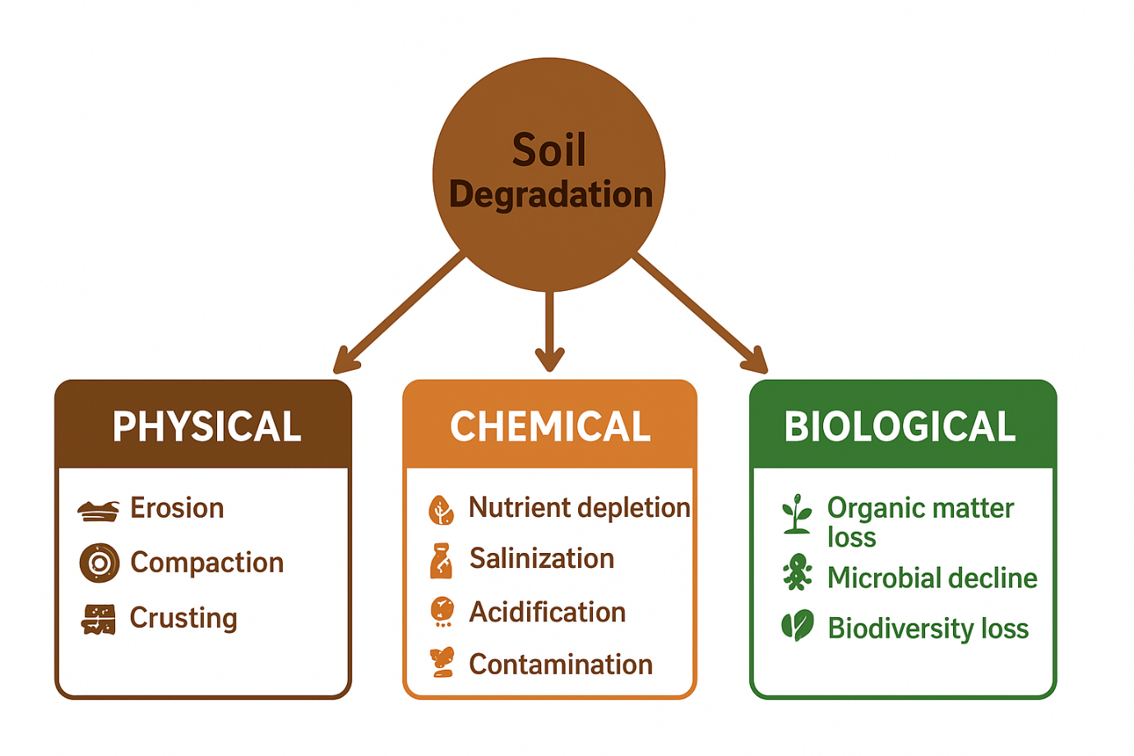
Fig. 1. Types of soil degradation
2. Types and Processes of Soil Degradation
Soil degradation manifests in physical, chemical, and biological forms, each affecting soil function and productivity (Aw-Hassan et al., 2015).
2.1 Physical Degradation (Brehm & Culman, 2023)
- Erosion is the most visible form, caused by wind and water. It removes nutrient-rich topsoil, reduces soil depth, and impairs water-holding capacity. Water erosion is particularly severe on sloped lands, where intense rainfall can remove tons of topsoil annually. Wind erosion dominates in arid and semi-arid regions, leading to dust storms and nutrient loss.
- Compaction occurs due to heavy machinery, overgrazing, and trampling, reducing porosity, infiltration, and root growth. Compacted soils are prone to waterlogging and oxygen limitation, which stress crops and reduce yields.
- Crusting and sealing result from raindrop impact on bare soil, forming a surface barrier that hinders seedling emergence and water infiltration. In arid regions, this reduces crop establishment and productivity significantly.
2.2 Chemical Degradation
- Nutrient depletion arises from continuous cropping without replenishment. Nitrogen, phosphorus, and potassium are most affected, leading to reduced fertility and poor crop performance.
- Salinization and sodicity result from excessive irrigation, poor drainage, or natural processes. Salts accumulate in the root zone, reducing water availability, affecting nutrient uptake, and leading to osmotic stress.
- Acidification occurs due to excessive use of acid-forming fertilizers, leaching of basic cations, and acid rain. Low pH reduces nutrient availability and increases aluminum toxicity, limiting crop growth.
- Contamination from heavy metals, pesticides, and industrial effluents degrades soil quality, reduces microbial activity, and poses food safety risks.
2.3 Biological Degradation
Loss of organic matter diminishes soil fertility, water retention, and aggregate stability. Microbial decline disrupts nutrient cycling, nitrogen fixation, and disease suppression. Reduced biodiversity weakens soil resilience, making it more vulnerable to erosion, drought, and pest outbreaks.
3. Causes and Drivers of Soil Degradation (Jena et al., 2023)
3.1 Anthropogenic Drivers (Pang et al., 2022)
- Deforestation exposes soil to erosion and reduces organic matter input.
- Overgrazing compacts soil, removes protective vegetation, and accelerates erosion.
- Intensive agriculture depletes nutrients, causes salinization, and increases dependence on chemical fertilizers.
- Improper irrigation leads to waterlogging and salt accumulation.
- Industrial and urban pollution introduces heavy metals and toxic compounds.
3.2 Natural Drivers
- Wind and water erosion remove soil particles and nutrients.
- Leaching and runoff transport essential nutrients out of the root zone.
- Climatic variability accelerates degradation by intensifying droughts, floods, and extreme rainfall events.
4. Impacts on Agronomic Productivity (Lal, 1998)
4.1 Physical Impacts
- Erosion removes fertile topsoil, reducing yields by 10–30%.
- Compaction limits root penetration and water access, decreasing plant growth.
- Crusting inhibits germination, reducing crop establishment rates.
4.2 Chemical Impacts
- Nutrient depletion lowers crop yields and quality.
- Salinity and sodicity create osmotic stress and nutrient imbalance.
- Acidification and contamination inhibit microbial activity and crop productivity.
4.3 Biological Impacts
- Decline in soil organic matter reduces fertility and water retention.
- Loss of microbial diversity slows nutrient cycling.
- Weak soil resilience increases susceptibility to pests, diseases, and climate stress.
4.4 Secondary Impacts
- Reduced water-use efficiency and fertilizer effectiveness.
- Increased vulnerability to drought and floods.
- Socio-economic consequences, including reduced income and food insecurity.
5. Monitoring and Assessment of Soil Degradation (Lal, 2015)
5.1 Importance
Monitoring identifies degradation hotspots, informs management decisions, and tracks restoration outcomes.
5.2 Indicators
- Physical: bulk density, porosity, aggregate stability.
- Chemical: pH, electrical conductivity, nutrient content.
- Biological: microbial biomass, enzymatic activity, biodiversity.
5.3 Methods
- Field measurements: erosion plots, soil profiling, vegetation assessment.
- Laboratory analyses: nutrient analysis, organic carbon, contaminants.
- Remote sensing and GIS: satellite imagery, DEMs, erosion modeling.
Emerging technologies such as soil spectroscopy, UAVs, and IoT sensors enhance real-time monitoring and predictive modelling.
6. Strategies for Soil Restoration and Sustainable Management (Bhattacharyya et al., 2015)
6.1 Physical Restoration
- Conservation tillage: no-till or reduced-till preserves soil structure.
- Contour farming and terracing: reduces erosion on sloped lands.
- Mulching: protects soil surface, conserves moisture, and adds organic matter.
- Drainage improvement: prevents waterlogging and salinity build-up.
6.2 Chemical Restoration
- Organic amendments: compost, manure, biochar enhance fertility and water retention.
- Liming: ameliorates acidic soils and improves nutrient availability.
- Gypsum application: corrects sodic soils, restores structure.
- Integrated nutrient management (INM): combines organic and inorganic fertilizers.
6.3 Biological Restoration (Rathi et al., 2024)
- Cover crops and green manures: improve nitrogen content, organic matter, and soil structure.
- Biochar: enhances water retention, nutrient availability, and microbial activity.
- Microbial inoculants: AMF, Rhizobium, and phosphate-solubilizing bacteria improve nutrient uptake.
- Agroforestry: integrates trees with crops to enrich nitrogen, prevent erosion, and improve carbon sequestration.
6.4 Integrated Approaches
- Conservation agriculture: combines minimal disturbance, crop rotation, and soil cover.
- Precision agriculture: site-specific nutrient and water management.
- Policy support and education: incentivizes adoption of sustainable practices.
6.5 Climate-Smart Practices
- Drought-tolerant crops, residue retention, water harvesting, and carbon sequestration strategies support restoration while mitigating climate change.
7. Conclusion and Future Perspectives
Soil degradation significantly undermines agronomic productivity through physical, chemical, and biological deterioration. Erosion, compaction, nutrient depletion, salinization, and loss of biodiversity directly reduce yields and impair ecosystem services. Effective monitoring using field measurements, laboratory analyses, and modern geospatial tools is essential to identify degradation hotspots and guide restoration efforts. Integrated restoration strategies physical, chemical, and biological interventions combined with climate-smart practices have demonstrated success in rehabilitating degraded soils and improving crop productivity. Policy support, farmer education, and technology adoption are critical for scaling these interventions. Future research should focus on adaptive management, long-term monitoring, and cross-sectoral approaches linking agriculture, forestry, water management, and climate mitigation. Restoring soil health is vital for sustainable food production, environmental stability, and resilient agricultural systems for future generations.
References
- Aw-Hassan, A. K., El-Swaify, S. A., & Bationo, A. (2015). Restoration of degraded soil for sustainable agriculture. In B. Dattas & K. L. G. Borthakur (Eds.), Soil Health Restoration and Management (pp. 31–81). Springer Nature. A book chapter providing an extensive overview of land degradation, its major causes (erosion, salt-affected soils, heavy metal contamination), and a broad spectrum of restoration strategies, including agronomic, chemical, and phytoremediation practices.
- Bhattacharyya, R., Ghosh, B. N., Mishra, P. K., Mandal, B., Rao, C. S., Sarkar, D., Das, K., Anil, K. S., Lalitha, M., Hati, K. M., & Franzluebbers, A. J. (2015). Soil degradation in India: Challenges and potential solutions. Sustainability, 7(4), 3528–3570. https://doi.org/10.3390/su7043528 A country-specific review examining the causes and extent of soil degradation in different agro-climatic regions and documenting research results on soil health improvement strategies in various agricultural systems.
- Brehm, T., & Culman, S. (2023). Soil degradation and crop yield declines persist 5 years after pipeline installations. Soil Science Society of America Journal, 87(2), 488–499. https://doi.org/10.1002/saj2.20506 An article detailing the negative impact of physical soil degradation (compaction, horizon mixing) on specific crop yields (corn and soybean) over a multi-year period, highlighting the inadequacy of common remediation practices.
- Jena, S., Patra, D. K., Sharma, N. K., Alam, N., Jana, C., & Lal, R. (2023). Impacts of soil erosion on soil quality and agricultural sustainability in the North-Western Himalayan Region of India. Sustainability, 15(6), 5430. https://doi.org/10.3390/su15065430 Focuses on the regional impact of water erosion, quantifying the decline in soil quality indicators like soil organic carbon, water holding capacity, and nutrient loss, and the subsequent threat to agricultural sustainability.
- Lal, R. (1998). Soil erosion impact on agronomic productivity and environment quality. Critical Reviews in Plant Sciences, 17(4), 319–464. https://doi.org/10.1080/07352689891304245 Although older, this is a foundational paper by R. Lal that comprehensively reviews the physical, chemical, and biological impacts of soil erosion on crop productivity and the broader environment, establishing the critical relationship between soil health and agricultural output.
- Lal, R. (2015). Restoring soil quality to mitigate soil degradation. Sustainability, 7(5), 5875-5895. https://doi.org/10.3390/su7055875 A seminal paper by a leading soil scientist discussing major degradation processes and site-specific restoration techniques like conservation agriculture, integrated nutrient management, and cover cropping.
- Pang, G., Zhu, Y., Ma, Z., Su, Y., Zhang, W., Zhang, B., Ren, J., & Li, M. (2022). Restoring soil functions and agroecosystem services through phytotechnologies. Frontiers in Soil Science, 2, Article 927148. https://doi.org/10.3389/fsoil.2022.927148 This paper reviews phytotechnologies for restoration, emphasizing the role of plants and their root systems in improving soil structure, carbon sequestration, nutrient fertility, and biodiversity through practices like cover cropping and intercropping.
- Rathi, A., Kumar, P., Nangla, S., Sharma, S., & Sharma, S. (2024). Soil restoration strategies for sustaining soil productivity: A review. Asian Research Journal of Agriculture, 17(1), 33–48. https://doi.org/10.9734/arja/2024/v17i1408 This is a recent review on key degradation processes (erosion, low SOC, salinization) and strategies like minimizing erosion and enhancing soil organic carbon (SOC).
- Wani, S. P., Pathak, P., Sreedevi, T. K., Singh, P., & Singh, P. (2011). Land degradation and its control: Lessons learned from sustainable management of natural resources in India. Journal of Water, Land and Environmental Engineering, 11, 1–17. Examines the causes and consequences of land degradation in a major agricultural region and provides case studies and lessons on successful watershed management and natural resource management for restoration.

