Original Research Article

Hydroclimatic Signatures of ENSO Over India Understanding Rainfall Variability and Regional Sensitivity

ABSTRACT
This study investigates the relationship between the El Niño–Southern Oscillation (ENSO) and regional rainfall variability across India using high-resolution gridded rainfall data and the Nino 3.4 index for the period 1951–2023. The Pearson Correlation Coefficient (PCC) was employed to assess the strength and direction of the association between rainfall anomalies and ENSO phases (El Niño and La Niña). Results reveal a strong negative correlation during El Niño years, indicating widespread rainfall deficiency, while La Niña years generally correspond to enhanced precipitation across most regions. Among the five studied regions, North India exhibited the highest negative correlation (r = -0.65) with El Niño, reflecting its pronounced vulnerability to monsoon weakening, whereas South India showed the strongest positive correlation (r = 0.55) with La Niña, suggesting greater rainfall enhancement. Central, East, and West regions displayed moderate correlations, highlighting spatial variations in ENSO influence. The analysis underscores that ENSO remains a major large-scale climate driver affecting India’s rainfall distribution, though its effects are region-specific and modulated by local climatic factors. Understanding these spatial dynamics is essential for improving seasonal monsoon forecasts, agricultural planning, and drought preparedness, thereby contributing to more resilient water resource management strategies under climate variability.

Keywords: El Niño, La Niña, Rainfall Anomaly, Indian Monsoon, Pearson Correlation Coefficient, Drought.

- INTRODUCTION
Precipitation is one of the most critical components of the hydrological cycle, directly influencing water availability, agricultural productivity, and ecosystem health across the Indian subcontinent [1]. India, being largely dependent on the Indian Summer Monsoon (ISM), receives nearly 70–90% of its annual rainfall from this season [2,3]. The variability in this rainfall, both in space and time, plays a pivotal role in shaping the socio-economic and environmental landscape of the country. Changes in rainfall patterns can affect crop yields, water supply, and natural ecosystems, making a thorough understanding of climatic drivers essential for effective water resource management and climate adaptation planning [1,4]. Climate variability, defined as deviations from long-term mean climate conditions, encompasses fluctuations in precipitation, temperature, soil moisture, runoff, and ecological parameters such as vegetation growth [5]. Monitoring these hydrological and ecological indicators is crucial to assess the impacts of climate variability and to design mitigation strategies for extreme events like floods and droughts [6].
The Indian Summer Monsoon is influenced by multiple large-scale ocean-atmosphere interactions, including the El Niño–Southern Oscillation (ENSO), Indian Ocean Dipole (IOD), Pacific Decadal Oscillation (PDO), Atlantic Multidecadal Oscillation (AMO), Madden-Julian Oscillation (MJO), and the Atlantic Zonal Mode (AZM) [7–10]. Among these, ENSO and IOD are considered the primary drivers of interannual monsoon variability due to their strong influence on sea surface temperatures (SSTs) and atmospheric circulation patterns over the Indian Ocean and adjoining regions [11–14]. ENSO, originating in the equatorial Pacific Ocean, manifests as El Niño (warm SST anomalies) and La Niña (cold SST anomalies) events, which are closely associated with below- and above-average monsoon rainfall, respectively [15]. Historical analyses have shown that El Niño events often result in widespread droughts over India, whereas La Niña events are linked to enhanced rainfall and flooding in certain regions [16]. These impacts are not uniform across the country; the influence of ENSO varies significantly among northern, central, southern, eastern, and western regions due to differences in topography, distance from the ocean, and regional circulation patterns [17]. For example, northern India, which lies farther from the ocean and receives the monsoon winds later, tends to experience a stronger negative correlation with El Niño events, while southern India, being closer to the ocean, often exhibits more moderate impacts [12,18].
The IOD, originating in the equatorial Indian Ocean, can reinforce or counteract the effects of ENSO. Positive IOD (PIOD) events are associated with enhanced monsoon rainfall over India, whereas negative IOD (NIOD) events often coincide with deficient rainfall [19,20]. The interactions between ENSO and IOD are complex, with some studies indicating that the cumulative effect of a concurrent El Niño and PIOD can moderate rainfall deficits over India, while other combinations may exacerbate drought conditions [21,22]. Unlike ENSO, which is largely driven by Pacific Ocean dynamics, IOD is primarily governed by local Indian Ocean processes, allowing it to operate independently in modulating regional rainfall patterns [23]. Beyond ENSO and IOD, other teleconnections such as PDO and the North Atlantic Oscillation (NAO) influence the intensity and spatial distribution of monsoon rainfall [24,25]. Studies have shown that multi-decadal variability in these teleconnections can alter the ENSO-monsoon relationship, sometimes weakening or strengthening correlations over particular regions of India [24,26]. These time-varying relationships are especially relevant for long-term planning and climate prediction, as they highlight the non-stationarity of ENSO impacts across different decades. For instance, northern India exhibits an increasing relationship with ENSO influence, central India a decreasing trend, and southern India maintains relatively consistent responses over time [12].
The consequences of ENSO-driven rainfall variability extend to hydrological processes. Variations in rainfall patterns directly affect surface runoff, soil moisture, evapotranspiration, and vegetation dynamics, which are essential for agricultural productivity and ecosystem functioning [5,27,28]. Runoff responses to rainfall are particularly sensitive to antecedent soil moisture, with higher rainfall thresholds required to generate runoff in drier soils [29]. ENSO and IOD events have been shown to significantly impact crop yields in western agro-climatic zones of India, highlighting the socio-economic importance of understanding regional monsoon variability [30]. Moreover, shifts in rainfall patterns due to climate variability can lead to extreme hydrological events such as droughts and floods, posing challenges for water management and disaster mitigation [6,30]. Accurate quantification of ENSO impacts on regional rainfall requires high-resolution datasets. Gridded rainfall products from the India Meteorological Department (IMD) and global datasets like TerraClimate provide detailed spatial and temporal coverage, enabling precise analysis of rainfall anomalies across India [15]. Comparisons of multiple rainfall datasets have demonstrated that fine-resolution gridded products are well-suited for regional-scale studies, ensuring reliable assessments of climate variability impacts. Utilizing these datasets, researchers can explore differential regional responses to ENSO events, revealing areas that are particularly vulnerable to drought or excess rainfall [12].
Despite extensive research on ENSO-ISMR teleconnections, knowledge gaps remain regarding the differential regional responses across India’s diverse climatic zones. Most previous studies have focused on macro-scale analyses or single-region investigations, leaving a lack of comprehensive assessments of how ENSO influences rainfall in multiple regions simultaneously [12,21,22]. Recent studies indicate that the regional impacts of ENSO are modulated not only by the phase of the event but also by interactions with other oceanic and atmospheric drivers, as well as local topography and land-sea contrasts [12,17,18]. For example, compositing standardized rainfall anomalies during ENSO years shows that northern and central India experience pronounced deficits, whereas southern and coastal regions exhibit relatively moderate responses [12,18,21]. Such spatial variability necessitates detailed, region-specific analyses for improved understanding and forecasting of rainfall anomalies. Given the increasing intensity and frequency of ENSO events under global climate change, quantifying their regional impacts is crucial for enhancing climate resilience. Understanding the spatial and temporal heterogeneity of ENSO effects allows for better prediction of drought-prone or flood-prone areas, aiding policymakers, farmers, and water managers in devising regionally tailored mitigation strategies [6]. By combining high-resolution rainfall datasets, ENSO indices, and advanced statistical methods, it is possible to derive robust estimates of rainfall anomalies attributable to ENSO phases and identify the most vulnerable regions [12].
In this context, the present study aims to assess the influence of ENSO on rainfall anomalies across various regions of India by utilizing gridded high-resolution rainfall datasets and statistical correlation analyses. The study focuses on evaluating regional variations in ENSO-rainfall relationships, exploring the extent of rainfall anomalies during El Niño and La Niña events, and providing insights to support effective climate adaptation and water resource management strategies. By emphasizing regional differences, the study seeks to enhance the understanding of ENSO impacts and contribute to improved forecasting and risk mitigation for climate-sensitive sectors throughout India.

- MATERIALS AND METHODS
2.1 Study Area
India, extending from 8°4'N to 37°6'N latitude and 68°7'E to 97°25'E longitude, covers an area of about 3.287 million km² and exhibits diverse climatic and topographic conditions [31]. The Indian Summer Monsoon contributes approximately 70–90% of the annual rainfall, but its distribution varies significantly across regions [32]. For this study, India is divided into five regions to examine ENSO impacts on rainfall: North (Himalayas and Indo-Gangetic plains), South (Peninsular Plateau and coastal plains), Central (Madhya Pradesh and Chhattisgarh), East (eastern coastal plains and hilly terrains), and West (Thar Desert and western coastal areas) [33]. North India is more susceptible to rainfall deficits during El Niño due to its distance from the ocean, while South India receives early monsoon rainfall and shows moderate ENSO sensitivity. Central India has semi-arid to sub-humid conditions with variable responses, East India experiences heavy rainfall influenced by monsoon and cyclones, and West India remains arid and prone to droughts [34]. This regional classification captures the spatial variability of ENSO impacts, enabling better assessment of hydrological and agricultural risks and supporting region-specific climate adaptation strategies [35]. The study area map is shown in Figure 1.
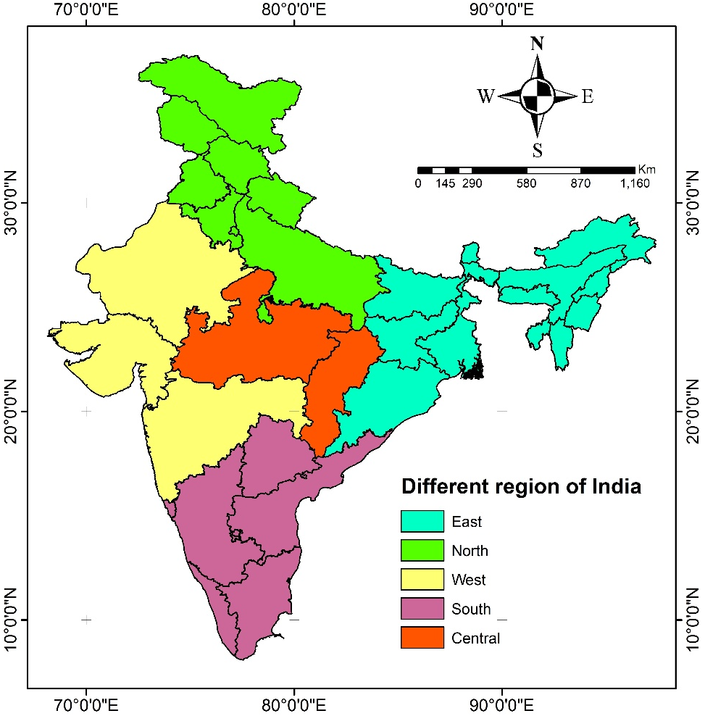
Figure 1: Study area map

2.2 Pearson Correlation Coefficient (PCC)
Pearson Correlation Coefficient (PCC) was used to quantify the strength and direction of the linear relationship between rainfall and ENSO indices. PCC values range from -1 to +1, where positive values indicate a direct relationship, negative values signify an inverse relationship, and values near zero suggest weak or no correlation [39, 40]. This statistical approach provides insight into the interdependencies and patterns between climate variables.
2.3 Nino 3.4 index
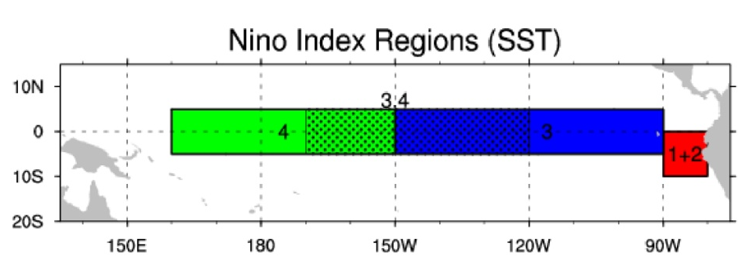
The Nino 3.4 Index, representing sea surface temperature anomalies in the central Pacific (5°N–5°S, 170°W–120°W), was used as the key indicator of El Niño and La Niña events. El Niño events are defined when anomalies exceed +0.5°C for at least three consecutive months, while La Niña events occur when anomalies are below -0.5°C for the same duration [41, 42]. The Index map of the Niño index region is shown in Figure 2.
Figure 2: Nino Index regions
Spatial maps of PCC were generated to illustrate regional differences in ENSO-rainfall relationships, highlighting both positive and negative impacts across northern, central, southern, eastern, and western regions of India. This analysis provides essential information for understanding regional climate variability and planning adaptation strategies for water resources and agriculture [43, 44].
- RESULT AND DISCUSSION
The present section focuses on analyzing the impact of the El Niño–Southern Oscillation (ENSO) on regional rainfall patterns in India. Using high-resolution gridded rainfall data for the period 1951–2023 and the Nino 3.4 index, rainfall anomalies were examined to understand temporal deviations from the long-term average. This analysis allows for the identification of the influence of El Niño and La Niña events on seasonal rainfall across North, South, East, West, and Central India, highlighting regional variations and sensitivities.
3.1 El Niño and La Niña years
The occurrence of El Niño and La Niña events is determined using the Oceanic Niño Index (ONI), which measures the sea surface temperature anomalies in the central and eastern equatorial Pacific Ocean. A positive ONI exceeding +0.5°C for at least five consecutive overlapping 3-month seasons indicates an El Niño event, whereas a negative ONI below -0.5°C for a similar period signifies a La Niña event. These thresholds are widely used to identify ENSO phases affecting global and regional climate patterns. Sea surface temperature anomaly is shown in Figure 3 for the period of 1951 to 2023.
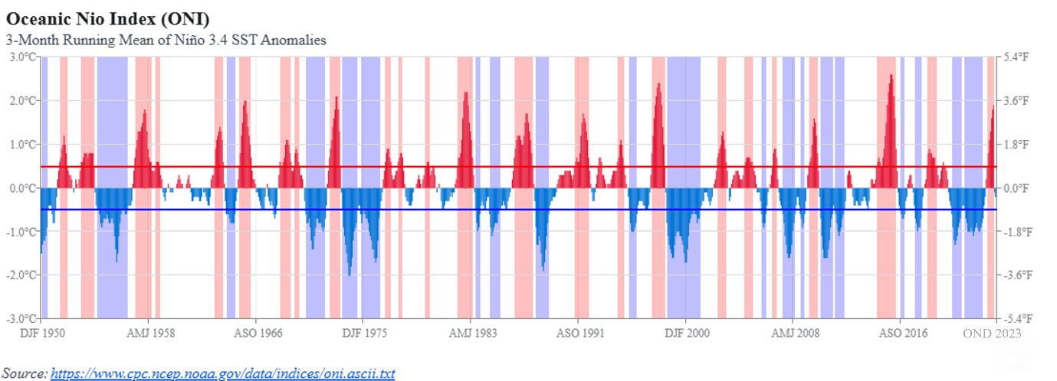Figure 3: Sea surface temperature anomaly
El Niño and La Niña decided based on this value. The table below shows the El Niño and La Niña years that occurred during the period 1951–2023.
Table 1: El Niño and La Niña Years (1951–2023)
El Niño Years | 1951 1953 1957 1965 1968 1972 1976 1982 1986 1991 1997 2002 2004 2009 2015 2023
La Niña Years | 1954 1955 1956 1963 1964 1970 1971 1973 1974 1975 1988 1998 1999 2000 2011 2020 2021 2022

3.2 Rainfall anomaly
Rainfall anomalies provide a clear measure of deviations from the long-term average precipitation and are essential for understanding the impact of climatic phenomena such as ENSO on regional monsoon patterns. By comparing annual rainfall with the climatological mean, it becomes possible to identify periods of excess or deficient rainfall across different parts of India. These anomalies reflect the intensity and spatial distribution of monsoon variability and serve as indicators of droughts or flood-prone conditions. Analysing rainfall anomalies in relation to the Nino 3.4 index (ONI 3.4) allows for a direct assessment of how El Niño and La Niña events influence the monsoon. Positive ONI values typically correspond to El Niño conditions, which can lead to below-average rainfall in many regions, while negative ONI values indicate La Niña events, often resulting in above-average rainfall. Understanding these deviations is crucial for evaluating regional sensitivity to ENSO events and for planning adaptive measures in agriculture, water resource management, and disaster mitigation. The annual anomaly of rainfall and the ONI 3.4 index are shown in Figure 4.

Figure 4: Annual anomaly of Rainfall and ONI 3.4
Figure 4 illustrates the annual deviation of rainfall across five regions of India—North, South, East, West, and Central, in relation to the ONI 3.4 index. The blue bars represent the Niño 3.4 index (ONI 3.4), while the coloured lines indicate rainfall anomalies for each region. A clear pattern emerges where positive ONI 3.4 values (El Niño events) generally correspond with negative rainfall anomalies, indicating below-average rainfall, while negative ONI 3.4 values (La Niña events) align with above-average rainfall, especially in the North and East regions.
The South region demonstrates higher volatility in rainfall deviations during both El Niño and La Niña events, with several instances of extreme positive and negative anomalies. The East and West regions show comparatively moderate variations, indicating that ENSO impacts are region-specific and vary in intensity. The Central region also exhibits a consistent negative correlation with positive ONI 3.4 anomalies, suggesting its vulnerability to rainfall deficits during El Niño events. This regional differentiation highlights the importance of localized climate adaptation strategies for water resource management.
3.3 Relationship between Rainfall and ENSO
The relationship between the El Niño–Southern Oscillation (ENSO) and rainfall variability across India was analysed to understand how large-scale ocean–atmosphere interactions influence the spatial distribution of monsoon rainfall. ENSO events significantly alter global circulation patterns, thereby modulating the strength and extent of the Indian Summer Monsoon Rainfall (ISMR). When El Niño conditions prevail, the warming of the central and eastern equatorial Pacific Ocean weakens the Walker circulation, reduces convection over the Indian Ocean, and suppresses moisture inflow toward the subcontinent. This leads to below-average rainfall and drought-like conditions in several regions. Conversely, during La Niña events, enhanced convection in the western Pacific and stronger cross-equatorial moisture transport intensify the Indian monsoon circulation, often resulting in above-average rainfall.
To quantify this relationship, the Pearson Correlation Coefficient (PCC) was calculated between the Nino 3.4 index and regional rainfall anomalies. The results are summarized in Table 2, which presents the correlation values for five major regions of India—North, South, Central, East, and West—during both El Niño and La Niña phases.
Table 2: Correlation Coefficients Between ENSO Indices and Rainfall Anomalies
S. No. | Region | El Niño | La Niña
1 | North | -0.65 | 0.45
2 | South | -0.1 | 0.55
3 | Central | -0.35 | 0.3
4 | East | -0.25 | 0.4
5 | West | -0.2 | 0.25

The correlation values reveal a distinct spatial variability in the ENSO–rainfall relationship across India. The North region exhibits the highest negative correlation (R = −0.65) during El Niño years, indicating that rainfall decreases sharply when El Niño intensity increases. This strong negative response can be attributed to the geographical positioning of northern India, which lies farthest from the oceanic moisture sources. The monsoon winds reach this region in the later phase of their progression, and any weakening due to ENSO events significantly reduces rainfall. During La Niña years, however, a moderate positive correlation (R = 0.45) is observed, showing that rainfall tends to increase when cooler Pacific conditions prevail.
The South region, on the other hand, shows a weak negative correlation (R = −0.10) with El Niño events but the strongest positive correlation (R = 0.55) during La Niña phases. This pattern suggests that southern India is more responsive to La Niña-driven moisture enhancement than to El Niño-induced suppression. Its proximity to the Arabian Sea and the Bay of Bengal, along with orographic influences from the Western Ghats, contributes to complex rainfall dynamics that sometimes offset El Niño impacts. The high positive correlation during La Niña years reflects the strengthening of monsoon flow and the increased occurrence of heavy rainfall episodes in peninsular India.
In the Central region, a moderate negative correlation (R = −0.35) is recorded during El Niño years, indicating that rainfall generally declines but not as severely as in the North. This region is often affected by both direct monsoon circulation and monsoon depressions originating from the Bay of Bengal, which can occasionally mitigate El Niño effects. The positive correlation (R = 0.30) during La Niña years implies partial recovery of rainfall, suggesting that while the central region experiences fluctuations, it maintains some resilience due to its geographical position and moisture inflow from both coastal and inland sources.
The East region exhibits a weak-to-moderate negative correlation (R = −0.25) with El Niño events and a moderate positive correlation (R = 0.40) with La Niña. Eastern India’s rainfall pattern is influenced by both ENSO and Bay of Bengal depressions, which are sensitive to sea surface temperature variations. During El Niño years, the number and intensity of these depressions decrease, leading to rainfall deficits. Conversely, during La Niña years, favourable SST and wind anomalies enhance convective activity over the Bay, resulting in increased rainfall in states such as Odisha, West Bengal, and parts of Bihar.
The West region demonstrates the weakest overall correlations, with R = −0.20 during El Niño and R = 0.25 during La Niña. Western India receives a substantial portion of its rainfall from the southwest monsoon, which is partly regulated by the strength of low-level jets over the Arabian Sea. While El Niño tends to weaken these jets, causing below-normal rainfall in Gujarat and western Maharashtra, the overall impact is comparatively less pronounced than in other regions. During La Niña, enhanced monsoon circulation slightly increases rainfall, but topographical constraints and regional aridity limit the magnitude of the response. The results of PCC are shown in the spatial map in Figure 5.
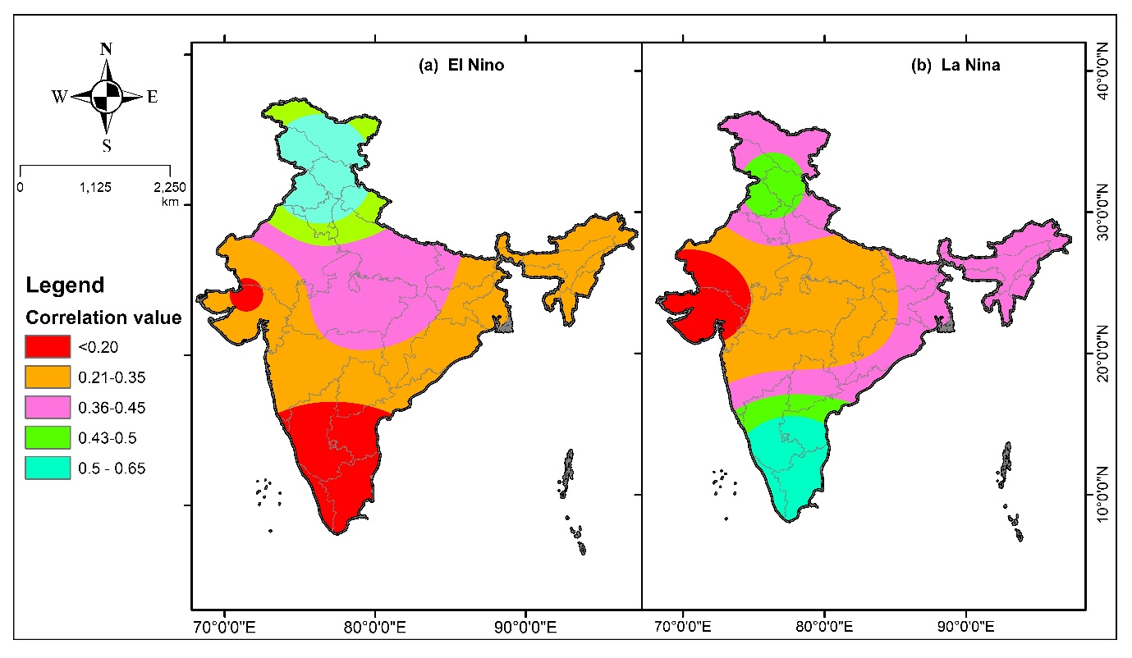
Figure 5: Spatial map of (a) PCC of El Nino and (b) for La Nina with rainfall
Figure 5(a) depicts the spatial distribution of PCC between El Niño events and rainfall, showing dominant negative correlations over northern and central India, signifying the suppressive influence of El Niño on monsoon rainfall. Meanwhile, Figure 5(b) illustrates the correlation pattern for La Niña events, highlighting positive correlations across southern and eastern India, where rainfall typically intensifies under La Niña conditions. Together, these spatial maps clearly delineate how ENSO phases modulate monsoon variability across different climatic zones.
These results affirm that El Niño episodes generally lead to weakened monsoon circulation and reduced precipitation, particularly in inland and northern regions, while La Niña events strengthen the monsoon system, producing above-average rainfall in southern and eastern India. The observed correlations are consistent with previous studies that identified ENSO as a key driver of interannual monsoon variability.
Understanding these regional differences is crucial for climate risk assessment and resource management. North and Central India, being more vulnerable to El Niño-induced droughts, require enhanced irrigation scheduling, drought-resistant crop planning, and early warning systems. Conversely, South and East India, which experience high variability and intense rainfall during La Niña events, need improved flood control, water harvesting infrastructure, and reservoir operation strategies.
Overall, this analysis emphasizes that the ENSO–rainfall relationship in India is spatially heterogeneous. While ENSO acts as a primary driver of large-scale rainfall variability, the response magnitude is modulated by regional factors such as local topography, proximity to the ocean, and interactions with other climate models like the Indian Ocean Dipole (IOD). These findings underscore the need for region-specific climate adaptation measures and predictive modelling frameworks to better anticipate monsoon behaviour under evolving global climate scenarios.
- Conclusion
The analysis clearly establishes a strong linkage between the El Niño–Southern Oscillation (ENSO) and rainfall variability across different regions of India. The results demonstrate that El Niño events, represented by positive Nino 3.4 anomalies, are typically associated with below-normal rainfall and drought-like conditions, whereas La Niña events correspond to enhanced rainfall, often leading to wetter-than-average seasons. This relationship, however, varies notably across regions, emphasizing the spatial diversity of ENSO impacts on India’s hydroclimatic system.
Among all regions, the North region exhibits the strongest response to ENSO fluctuations, with a high negative correlation (r = -0.65) during El Niño years and a moderately positive correlation (r = 0.45) during La Niña years. This pattern indicates that northern India is particularly vulnerable to rainfall deficits during El Niño episodes. The Central region also shows a negative association with El Niño (r = -0.35) and a positive one with La Niña (r = 0.30), suggesting its sensitivity to changes in global ocean-atmosphere circulation. The South region displays an opposite trend, where La Niña strongly enhances rainfall (r = 0.55), while El Niño has a relatively weak impact (r = -0.10). This highlights the complex interplay of ENSO with other climatic drivers, such as the Indian Ocean Dipole (IOD) and local topographical effects. The East and West regions show moderate correlations, implying that although ENSO influences their rainfall patterns, regional factors also play a significant role.
Overall, this study reaffirms that ENSO remains a dominant large-scale driver of rainfall variability over India, yet its impact is not uniform across regions. Recognizing these spatial differences is essential for improving monsoon prediction models, agricultural planning, and drought management. Integrating ENSO forecasts into early warning systems and water resource management frameworks can significantly enhance India’s capacity to mitigate adverse climatic impacts, ensuring sustainable agricultural productivity and water security under changing climate conditions.
Declaration of using AI
The Author hereby declares that no generative AI technologies have been used during the writing or editing of the manuscript.

REFERENCES
- Harishnaika, N., Ahmed, S. A., Kumar, S., & Arpitha, M. (2022). Computation of the spatio-temporal extent of rainfall and long-term meteorological drought assessment using standardized precipitation index over Kolar and Chikkaballapura districts, Karnataka during 1951-2019. Remote Sensing Applications: Society and Environment, 27, 100768.
- Harishnaika, N., Arpitha, M., & Ahmed, S. A. (2024). Spatio-temporal characteristics of rainfall and drought conditions using different drought indices with geospatial approaches in Karnataka state. Journal of Atmospheric and Solar-Terrestrial Physics, 265, 106372.
- Prasanna, V. (2014). Impact of monsoon rainfall on the total foodgrains yield over India. Journal of Earth System Science, 123(5), 1129–1145.
- Shukla, R. P., & Haung, B. (2016). Interannual variability of the Indian summer monsoon associated with air-sea feedback in the northern Indian Ocean. Climate Dynamics, 46, 1977–1990.
- Yun, K. S., & Timmermann, A. (2018). Decadal monsoon-ENSO relationships reexamined. Geophysical Research Letters.
- Nair, P. J., Chakraborty, A., Varikoden, H., Francis, P. A., & Kuttipurath, J. (2018). The local and global climate forcings induced inhomogeneity of Indian rainfall. Scientific Reports, 8, 6062.
- Sabeerali, C. T., Ajayamohan, R. S., Bangalath, H. K., & Chen, N. (2019). Atlantic Zonal Mode: an emerging source of Indian summer monsoon variability in a warming world. Geophysical Research Letters, 46, 4460–4464.
- Krishnaswami, J., Vaidyanathan, S., Rajagopalan, B., Bonnel, M., Sankaran, M., Bhalla, R. S., Badiger, S. (2015). Non-stationary and non-linear influence of ENSO and Indian Ocean Dipole on Indian summer monsoon rainfall and extreme rain events. Climate Dynamics, 45, 175–184.
- Pothapakula, P. K., Primo, C., Sørland, S., & Ahrens, B. (2020). The synergistic impact of ENSO and IOD on Indian summer monsoon rainfall in observations and climate simulations: an information theory perspective. Earth System Dynamics, 11(4), 903–923.
- Ashok, K., Guan, Z., Saji, N. H., & Yamagata, T. (2004). Individual and combined influences of ENSO and the Indian Ocean Dipole on the Indian summer monsoon. Journal of Climate, 17, 3141–3155.
- Behera, S. K., & Yamagata, T. (2003). Influence of the Indian Ocean dipole on the Southern Oscillation. Journal of the Meteorological Society of Japan. Ser. II, 81(1), 169–177.
- Anil, N., Kumar, M. R. R., Sajeev, R., & Saji, P. K. (2016). Role of distinct flavours of IOD events on Indian summer monsoon. Natural Hazards, 82(2), 1317–1326.
- Yadav, V. S., Galkate, R. V., Chandola, V. K., Shukla, A. K., Panda, S., & Shukla, S. (2025). Spatiotemporal characterization of meteorological drought and rainfall variation during El Niño/La Niña event over Bundelkhand region of India. Discover Applied Sciences, 7(5), 464.
- Athira, K. S., Roxy, M. K., Dasgupta, P., Saranya, J. S., Singh, V. K., & Attada, R. (2023). Regional and temporal variability of Indian summer monsoon rainfall in relation to El Niño southern oscillation. Scientific Reports, 13(1).
- Takle, J., & Pai, D. S. (2020). Analysis of summer monsoon rainfall over Maharashtra and its relation with SSTs. Journal of Earth System Science, 129(1).
- Ummenhofer, C. C., Gupta, A. S., Li, Y., Taschetto, A. S., & England, M. H. (2011). Multi-decadal modulation of the El Niño–Indian monsoon relationship by Indian Ocean variability. Environmental Research Letters, 6(3), 034006.
- Ashok, K., Guan, Z., Yamagata, T. (2001). Impact of the Indian Ocean dipole on the relationship between the Indian monsoon rainfall and ENSO. Geophysical Research Letters, 28(23), 4499–4502
- Saji, N. H., & Yamagata, T. (2003). Possible impacts of Indian Ocean Dipole mode events on global climate. Climate Research, 25, 151–169.
- Pillai, P. A., Kiran, V. G., & Suneeth, K. V. (2024). The strengthened role of new predictors of Indian Ocean Dipole (IOD) during the recent decades of weakened ENSO-IOD relationship. Dynamics of Atmospheres and Oceans, 106, 101432.
- Chauhan, A. S., Rani, A., Dahiya, P., Maurya, R. K. S., & Danodia, A. (2024). Understanding the influence of teleconnections on Indian summer monsoon rainfall and agricultural productivity: a case study of Haryana, India (1980–2023). Journal of Water and Climate Change.
- Vijay Shankar Yadav, R. V. Galkate, V. K. Chandola, Ankit Patel, Samikshya Panda, Archana Kaushal & H. R. Ahirwar. (2025). Evaluation of Rainfall Variability and Meteorological Drought in Bundelkhand Region, India. Journal of Experimental Agriculture International, 47(4), 181–200.
- Meyers, G., McIntosh, P., Pigot, L., & Pook, M. (2007). The years of El Niño, La Niña, and interactions with the tropical Indian Ocean. Journal of Climate, 20(13), 2872–2880.
- Stuecker, M. F., Timmermann, A., Jin, F. F., et al. (2017). Revisiting ENSO/Indian Ocean dipole phase relationships. Geophysical Research Letters, 44, 2481–2492.
- Saji, N. H., Goswami, B. N., Vinayachandran, P. N., & Yamagata, T. (1999). A dipole mode in the tropical Indian Ocean. Nature, 401(6751), 360–363.
- Athira, K. S., Roxy, M. K., Dasgupta, P., Saranya, J. S., Singh, V. K., & Attada, R. (2023). Regional and temporal variability of Indian summer monsoon rainfall in relation to El Niño southern oscillation. Scientific Reports, 13(1).
- Pokhrel, S., Chaudhari, H. S., Saha, S. K., et al. (2012). ENSO, IOD and Indian summer monsoon in NCEP climate forecast system. Climate Dynamics, 39, 2143–2165.
- Ashok, K., & Saji, N. H. (2007). On the impacts of ENSO and Indian Ocean Dipole events on sub-regional Indian summer monsoon rainfall. Natural Hazards, 42, 273–285.
- Londhe, D. S., Katpatal, Y. B., Singh, C. K., & Bokde, N. D. (2023). Assessment of vegetation variation and its response to ENSO and IOD in the semi-arid ecosystem of Western India. Journal of Water and Climate Change, 14(8), 2642–2662.
- Vijay Shankar Yadav, R. V. Galkate, V.K. Chandola, Samikshya Panda & Ankit Patel. (2024). Trend Analysis and Change Point Detection of Climatic Parameters in Ambedkar Nagar District of Uttar Pradesh, India. International Journal of Environment and Climate Change, 14(9), 578–605.
- IMD. (2021). IMD Annual Report. India Meteorological Department. https://metnet.imd.gov.in/docs/imdnews/ANNUAL_REPORT2021English.pdf
- Prasanna, V. (2014). Impact of monsoon rainfall on the total foodgrains yield over India. Journal of Earth System Science, 123(5), 1129–1145.
- Athira, K. S., Roxy, M. K., Dasgupta, P., Saranya, J. S., & Singh, V. K. (2023). Regional and temporal variability of Indian summer monsoon rainfall in relation to El Niño southern oscillation. Scientific Reports, 13(1).
- Chauhan, A. S., Rani, A., Dahiya, P., Maurya, R. K. S., & Danodia, A. (2024). Understanding the influence of teleconnections on Indian summer monsoon rainfall and agricultural productivity: A case study of Haryana, India (1980–2023). Journal of Water and Climate Change.
- Pokhrel, S., Chaudhari, H. S., Saha, S. K., et al. (2012). ENSO, IOD and Indian summer monsoon in NCEP climate forecast system. Climate Dynamics, 39, 2143–2165.
- Pai, D. S., Rajeevan, M., Sreejith, O. P., Mukhopadhyay, B., & Satbha, N. S. (2014). Development of a new high spatial resolution (0.25° × 0.25°) long period (1901–2010) daily gridded rainfall dataset over India and its comparison with existing datasets over the region. MAUSAM, 65(1), 1–18.
- Huang, B., Thorne, P. W., Banzon, V. F., Boyer, T., Chepurin, G., Lawrimore, J. H., Menne, M. J., Smith, T. M., Vose, R. S., & Zhang, H. (2017). Extended Reconstructed Sea Surface Temperature, Version 5 (ERSSTv5): Upgrades, validations, and intercomparisons. Journal of Climate, 30(20), 8179–8205.
- NOAA National Centers for Environmental Information. (2023). Nino 3.4 index data. https://www.ncdc.noaa.gov
- Abatzoglou, J., Dobrowski, S., Parks, S., et al. (2018). TerraClimate, a high-resolution global dataset of monthly climate and climatic water balance from 1958–2015. Scientific Data, 5, 170191.
- Wiwoho, B. S., & Astuti, I. S. (2022). Runoff observation in a tropical Brantas watershed as observed from long-term globally available TerraClimate data 2001–2020. Geoenvironmental Disasters, 9, 12.
- Huang, B., Thorne, P. W., Banzon, V. F., Boyer, T., Chepurin, G., Lawrimore, J. H., Menne, M. J., Smith, T. M., Vose, R. S., & Zhang, H. (2017). Extended Reconstructed Sea Surface Temperature, Version 5 (ERSSTv5): Upgrades, validations, and intercomparisons. Journal of Climate, 30(20), 8179–8205.
- Takle, J., & Pai, D. S. (2020). Analysis of summer monsoon rainfall over Maharashtra and its relation with SSTs. Journal of Earth System Science, 129(1).
- Prakash, S. (2019). Performance assessment of CHIRPS, MSWEP, SM2RAIN-CCI, and TMPA precipitation products across India. Journal of Hydrology, 571, 50–59.
- Paul, S., Sharma, P. J., & Teegavarapu, R. S. V. (2024). Spatial assessment of the reproducibility of Indian summer monsoon rainfall regimes in multiple gridded rainfall products. Scientific Reports, 14, 29269.
- Huang, B., L'Heureux, M., Hu, Z. Z., & Zhang, H. M. (2016). Ranking the strongest ENSO events while incorporating SST uncertainty. Geophysical Research Letters, 43(17), 9165-9172.

