Effect of Partial Rootzone Drying Irrigation of Growth and Yield of Tomato (Lycopersicon Lycopersicon L.)

Abstract
The present investigation entitled “Effect of Partial Root-Zone Drying Irrigation on Growth and Yield of Tomato (Lycopersicon esculentum L.)” was carried out during summer 2023 at Tribal Research cum Training Centre, Dediapada, Narmada, Gujarat, to study the response of tomato to different levels of partial root-zone drying (PRD). The experiment comprised four treatments, viz. T1 (100% PRD one side), T2 (75% PRD one side), T3 (50% PRD one side), and T4 (full irrigation both sides as control). Results indicated that among the treatments, T1 recorded the maximum plant height (54.20 cm), stem diameter (2.12 cm), number of branches (22.0), number of leaves (111.2), and leaf area (11.40 cm²), which were significantly superior to T2 and T3 but statistically at par with T4. Soil moisture status was higher under T4 followed by T1, while the lowest values were observed in T3. In terms of yield and fruit quality, T1 gave the highest fruit yield (9258 kg/ha) and favorable fruit diameter (3.26 cm), whereas T2 recorded the highest total soluble solids (8.42 °Brix), reflecting better sweetness under moderate stress. Severe stress in T3 adversely affected both growth and yield attributes. Statistical analysis confirmed that differences among treatments were significant, with T1 consistently outperforming other PRD levels. The overall findings suggest that 100% PRD on one side (T1) is the most effective irrigation strategy for tomato under semi-arid conditions, as it provides a balance of high yield, acceptable fruit quality, and efficient water use. Moderate stress (T2) may be considered for improving fruit quality in specific cases, but severe water restriction (T3) is not advisable due to yield reduction. Thus, PRD emerges as a promising and sustainable irrigation technique for tomato cultivation in water-scarce regions.
Keywords: Partial Root-Zone Drying (PRD), Tomato (Lycopersicon esculentum L.), Deficit Irrigation, Growth Parameters, Yield, Fruit Quality, Water Use Efficiency, Soil Moisture, Sustainable Irrigation.
- Introduction
The efficiency of agricultural operations is crucial for increasing production and productivity while minimizing losses (Dhakad et. al. 2023). Water is one of the most vital resources for crop production, and agriculture is the largest water-consuming sector, accounting for nearly 70% of global water use (FAO, 2011). (Dhakad et.al. 2025) According to a report from India, even a modest 10% improvement in the current level of water use efficiency in irrigation projects could bring an additional 14 million hectares under irrigation within the existing capacities (Swaminathan, 2006). This highlights the urgent need to adopt suitable strategies that ensure the judicious utilization of the limited and increasingly scarce water resources in agriculture, thereby supporting sustained crop production. Water scarcity is closely tied to food security, as agriculture is one of the most immediate sectors affected by groundwater depletion driven by climate change. Addressing this challenge requires the adoption of water-efficient practices that minimize water use in farming while increasing crop productivity to meet the needs of a growing population (Carrijo et al., 2017).
Deficit irrigation (DI) is an increasingly adopted water-saving strategy, particularly in arid and semi-arid regions. In this approach, irrigation is applied at levels below the full crop water requirement (evapotranspiration, ET), thereby enhancing water productivity (Shukla et. al. 2023). Research suggests that the optimal irrigation level under DI ranges between 60% and 100% of ET (Mabhaudhi et al., 2021). Water productivity improves significantly under DI compared to full irrigation, as moderate irrigation promotes a near-linear increase in crop ET and yield up to an optimum point, beyond which additional water no longer enhances yield. However, many farmers tend to over-irrigate in pursuit of higher yields, which not only fails to improve production but also accelerates unproductive water losses and exacerbates global freshwater scarcity (Liu et al., 2022). Partial root-zone drying (PRD) is a modified form of deficit irrigation (DI) designed to enhance water use efficiency (WUE) through controlled drought stress. The technique involves alternating wet and dry zones within the root system, a condition that can be maintained throughout the crop season (Sonawane et al. 2022). The PRD technique is based on understanding the mechanisms that regulate transpiration and involves keeping roughly half of the root system in dry soil while the other half is irrigated. This allows plants to maintain growth with partially reduced stomatal conductance (gs), without experiencing severe drought stress (Kang & Zhang, 2004). The approach was first tested by Grimes et al. (1968) in the USA on cotton using furrow irrigation, and has since been extensively studied across various crops and environments.
Tomatoes are a kitchen essential across India, forming the base of countless daily dishes—from curries to salads and sauces. They're valued for their essential nutrients, particularly vitamins A and C, and antioxidants like lycopene. Ranked as one of the country’s major horticultural crops, tomatoes drive significant agricultural income. According to FAOSTAT data, India produced around 19 million tonnes of tomatoes in 2019, highlighting its substantial role in domestic agriculture. India stands as the world’s second-largest producer of tomatoes—with around 11% of global output—and the majority consumed fresh. The rest is processed into ketchup, sauces, paste, and juices. The domestic tomato processing market reached USD 1.4 billion in 2024, and is expected to grow at a CAGR of 5.14% to USD 2.25 billion by 2033
Tomatoes require a high-water potential for optimal vegetative and reproductive development. Most common irrigation methods for tomato are basin, furrow and drip irrigation. Basin and furrow irrigation not only cause large percolation losses but also restrain the increase in production due to frequent water stress between irrigation intervals and poor irrigation management strategy.
Applying irrigation water throughout the whole season as per the plant water requirement may cause low water productivity in the crop. However, the plants undergo severe water stress when soil-water is very low and the water uptake by roots fails to compensate the optimal plant water requirement. Water stress in critical growth stages of the crop results in reducing the crop yield drastically and it may affect the plant health, causing the lower yields. However, it has been observed in the case of many crops that water stress at non-critical growth stages of the crop enhances the quality of yield besides saving a considerable amount of irrigation water. In the life cycle of Tomato, flower bud development, peak flowering and fruit setting stages are main growth stages. The effect of moisture stress on the growth and yield during these growth stages is important to know. The accuracy in water application, creating a desirable stress at non-critical growth stages may be a crucial strategy for Tomato production in water scarce areas.
Tomato cultivation requires a high-water potential to support both vegetative growth and reproductive development. The most common irrigation methods for tomato are basin, furrow, and drip irrigation. However, basin and furrow methods often result in significant percolation losses and limit productivity due to frequent water stress between irrigations and poor water management. Supplying irrigation water throughout the season strictly based on crop water requirement may lead to low water productivity. Conversely, when soil moisture becomes critically low, roots are unable to meet plant water demand, causing severe water stress. Such stress during critical growth stages not only reduces yield drastically but also affects overall plant health.
Interestingly, studies on various crops show that controlled water stress during non-critical growth stages can improve yield quality while saving substantial irrigation water. In tomato, the critical stages are flower bud development, peak flowering, and fruit setting. Therefore, understanding the effect of moisture stress during these phases is essential. Accurate irrigation scheduling that introduces mild stress only during non-critical stages can be a key strategy for improving tomato production, particularly in water-scarce regions.
Plenty of literature is available on different aspects of tomatoes but to the best of our knowledge, limited literature is available regarding the the effect of Partial Root-Zone Drying (PRD) on growth and yield of tomato. Therefore, the objective of this study was to evaluate growth and yield of tomato under PRD irrigation strategy.
- Material and Methods:
Experiments was carried out to study the effects of partial root zone drying (PRD) irrigation on drip irrigated Tomato. The entire methodology is presented in the following sequence:
2.1 Description of the experimental site
2.1.1 Location
The experiment was carried out at the experimental field plots of the College of Agricultural Engineering and Technology, Dediapada, Dist. Narmada. Dediapada is located at the Latitude of 21º37’38” N and Longitude of 73º35’01” E at an average elevation of 169 m from mean sea level. The location of Dediapada in Gujarat state and satellite image of experimental site has been shown in the figure1.
2.1.2 Climate
The climate of the Dediapada is typical tropical type with an average annual rainfall of about 1245 mm. The greatest amount of precipitation occurs in July, with an average of 480 mm. At an average temperature of 32.6ºC, May is the hottest month of the year. The lowest average temperature in the year occurs in January, when it is around 21.2ºC.
2.1.3 Soil
Geology of the area is dominated by Deccan trap, dikes and alluvium deposits. The soil of the experimental area is considered to be clay loam soil with moderate infiltration rate.
2.1.4 Spacing
90 cm row to row and 45 cm plant to plant spacing was maintained resulting in twelve plant in one row.
2.2 Treatments and experimental design.
2.2.1 Seed Variety and Cultivation
Abhinav: it is semi-determinate with vigorous plant habit, broad leaves with excellent foliage cover, it is very good fruit shape & color, it suitable for long distance transport. Maturity 60 to 65 days after planting, color deep red and glossy.
2.2.2 Fertilizer Application
As per recommendations, fertilizer dose of 75:37.5:37.5 Kg/hectare of N:P:K was applied after planting , Second Dose of fertilizer was applied after flowering , Third Dose of fertilizer was applied after Fruit set, When the crop is in bearing stage 13 gm per plant would be applied. The fertilizer dosage would be same for all the treatments.
NPK fertilizer applied in ratio of 20:20:20
2.2.3 Treatments and Experimental Design
In the proposed experiment effect of four different deficit irrigation strategies on growth and yield of irrigated tomato will be analyzed. The proposed treatments and details are given below in table no 1.
Table. 1 Treatments and Description
Treatment | Description
T1  FPRD (Fixed Partial Root Zone Drying) | In this treatment only one-half side of rootzone would be irrigated while other half will be kept dry throughout the crop period.
T2  FPRD (Fixed Partial Root Zone Drying) | In this treatment only one-half side of rootzone would be irrigated while other half will be kept dry throughout the crop period.
T3  FPRD (Fixed Partial Root Zone Drying) | In this treatment only one-half side of rootzone would be irrigated while other half will be kept dry throughout the crop period.
T4  (control) | In this treatment Both Side of the rootzones are irrigated by drip irrigation.
Fig. 1 Experimental Design and Field Layout
2.2.4 Irrigation Scheduling:
In irrigation scheduling Tomato was irrigated daily from data collected from crop wat 8.0 Software.
Table. 2 Irrigation Scheduling
Month | Decade | Stage | Kc | ETc | ETc | Eff rain | Irri. Req.
 |  |  | Coeff. | lit/day | mm/dec | mm/dec | mm/dec
Feb | 1 | Init | 0.6 | 1.71 | 28.6 | 0 | 28.4
Feb | 2 | Init | 0.6 | 1.81 | 30.2 | 0 | 30.2
Feb | 3 | Init | 0.6 | 1.96 | 26.3 | 0 | 26.3
Mar | 1 | Deve | 0.66 | 2.35 | 39.3 | 0 | 39.3
Mar | 2 | Deve | 0.81 | 3.08 | 51.4 | 0 | 51.4
Mar | 3 | Deve | 0.96 | 3.90 | 71.6 | 0 | 71.6
Apr | 1 | Mid | 1.11 | 4.80 | 80.1 | 0 | 80.1
Apr | 2 | Mid | 1.17 | 5.38 | 89.8 | 0 | 89.8
Apr | 3 | Mid | 1.17 | 5.77 | 96.3 | 0 | 96.2
May | 1 | Late | 1.17 | 6.36 | 106 | 0 | 106
Table 3 Treatment wise Irrigation scheduling
Month | ETc (T1)  Lit/day 100% | ETc (T2)  Lit/day 75% | ETc (T3)  Lit/day 50% | ETc (T4)  Lit/day 100 % (Full irrigation both sides)
Feb | 1.71 | 1.28 | 0.85 | 1.71
Feb | 1.81 | 1.35 | 0.90 | 1.81
Feb | 1.96 | 1.47 | 0.98 | 1.96
Mar | 2.35 | 1.76 | 1.17 | 2.35
Mar | 3.08 | 2.31 | 1.54 | 3.08
Mar | 3.90 | 2.92 | 1.95 | 3.90
Apr | 4.80 | 3.6 | 2.4 | 4.80
Apr | 5.38 | 4.03 | 2.69 | 5.38
Apr | 5.77 | 4.32 | 2.88 | 5.77
May | 6.36 | 4.77 | 3.18 | 6.36
Table 4 Irrigation time (minutes)
Month | ETc (T1)  Lit/day 100% | ETc (T2)  Lit/day 75% | ETc (T3)  Lit/day 50% | ETc (T4)  Lit/day 100 % (Full irrigation both sides)
Feb | 29 | 18 | 16 | 21
Feb | 31 | 19 | 18 | 23
Feb | 34 | 21 | 20 | 25
Mar | 40 | 25 | 23 | 29
Mar | 52 | 33 | 30 | 39
Mar | 66 | 41 | 39 | 49
Apr | 82 | 51 | 48 | 60
Apr | 92 | 57 | 53 | 67
Apr | 99 | 61 | 57 | 72
May | 109 | 68 | 63 | 80
2.2.6 Drip Irrigation Design
Drip laterals of 16 mm size was laid in the field considering plant to plant and row to row spacing. For a row to lateral on either size of the plant was laid. Total eight lateral was laid in four treatments. In case of FPRD T1, T2 and T3 one side of root-zone is to be irrigated in other has to kept dray, on lateral on either size would have blind dripper. In case of Full irrigation T4 both side of root-zone is to be irrigated.
- Measurement and analysis
3.1 Soil water content
The volumetric soil water content will be monitored periodically by gravimetric method. soil samples from both the sides of the root-zone will be collected. One plant per one treatment will be selected for the estimating soil moisture content. The soil sample was kept in an oven for 24 h at 105 °C. After this, the weight of the oven dried sample was taken and moisture content (d.b.) is calculated by using the following equation.
3.2 Vegetative growth parameters
Plant vegetative growth parameters such as plant height (distance from ground surface to top of plant crown), stem diameter (measure by Vernier caliper), Number of leaves per plant, Number of branches per plant, leaf area will also be monitored.
3.3 Parameter at harvesting time
Parameter at harvesting time such as size, shape, TSS, Maturity stages, weight, yield.
Plant Height:
- It was observed that treatment T1 has highest plant height compare to other treatment.
- At the time of harvesting the maximum height recorded in treatment T1, which is 54.2 cm.
- The maximum height recorded in treatment T1 100% water was given from one side of root zone, so this may enhanced root development and nutrient uptake.
- In T2 treatment 75% water was given from one side of root zone, so lack of water affected the growth and yield of the plant. in this treatment has less plant height compare to other treatment.
- In T3 treatment only 50% water was given from one side of root zone, dry to less water the plant could not grow properly. in this treatment has more plant height compare to treatment T2, and less plant height then treatment T1 and treatment T4.
- In T4 treatment full irrigation on both side water was given this cause leaching of nitrogen and other micro nutrients because of this plant height is more compare to treatment 2 and 3, and less compare then treatment 1.
Table 5 Plant height in centimetre
Plant Height (cm)
Days | T1 | T2 | T3 | T4
7 | 25.62 | 26.08 | 22.41 | 23.92
14 | 26.78 | 26.72 | 24.26 | 24.93
21 | 28.77 | 28.71 | 26.09 | 27.11
28 | 31.81 | 28.80 | 28.07 | 31
35 | 37.47 | 28.68 | 27.69 | 34.86
42 | 43.68 | 30.40 | 32.32 | 39.73
49 | 49.48 | 33.69 | 34.13 | 43.62
56 | 52.24 | 35.33 | 36.4 | 45.7
63 | 53.69 | 36.18 | 38.03 | 47.1
70 | 54 | 37.53 | 38.72 | 47.87
Harvest | 54.2 | 38.54 | 39.35 | 48.49
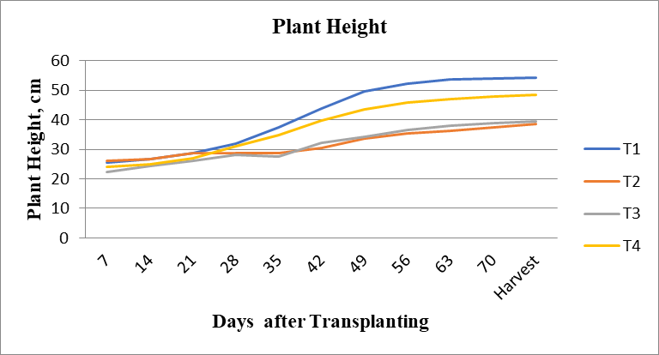
Fig. 2 Plant Height VS Days After Transplanting
Table 6 Statistical Analysis of Plant Height Plant Height During 2022-23
Treatment | Plant Height (cm)
T1 | 54.2
T2 | 38.34
T3 | 39.35
T4 | 48.49
SEm± | 7.82
CD or LSD | 27.06
Test of significance (p=0.05) | S
CV% | 9.12
3.4 Diameter of Stem:
- It was observed that treatment T1 has highest diameter of Stem compare to other treatment.
- At the time of harvesting the maximum diameter of stem recorded in treatment T1, which is 6.49 mm.
- The maximum diameter of Stem recorded in treatment T1 100% water was given from one side of root zone, so this may enhanced root development and nutrient uptake.
- In T2 treatment 75% water was given from one side of root zone, so lack of water affected the growth and yield of the plant. in this treatment has less diameter of stem compare to other treatment.
- In T3 treatment only 50% water was given from one side of root zone, dry to less water the plant could not grow properly. in this treatment has more diameter of stem compare to treatment T2, and less diameter of stem then treatment T1 and treatment T4.
- In T4 treatment full irrigation on both side water was given this cause leaching of nitrogen and other micro nutrients because of this is more compare to treatment 2 and 3, and less compare then treatment 1.
Table 7 Diameter of Stem
Diameter of Stem (mm)
Days | T1 | T2 | T3 | T4
7 | 2.53 | 2.88 | 3.12 | 2.97
14 | 2.67 | 3.1 | 3.22 | 3.09
21 | 3.04 | 3.37 | 3.3 | 3.32
28 | 3.21 | 3.69 | 3.72 | 3.82
35 | 4.13 | 3.91 | 4.07 | 4.22
42 | 4.88 | 4.15 | 4.37 | 5.09
49 | 5.3 | 4.3 | 4.75 | 5.46
56 | 5.45 | 4.5 | 5.03 | 5.84
63 | 5.9 | 4.52 | 5.19 | 6.04
70 | 6.21 | 4.8 | 5.45 | 6.25
Harvest | 6.49 | 5.05 | 5.54 | 6.43
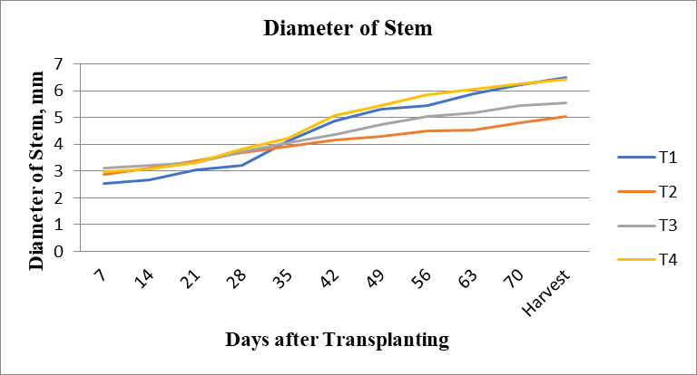
Fig.3 Diameter of Stem VS Days After Transplanting
Table 8 Statistical Analysis of Diameter of Stem During 2022-23
Treatment | Diameter of Stem (mm)
T1 | 6.49
T2 | 5.05
T3 | 5.54
T4 | 6.43
SEm± | 6.7
CD or LSD | 13.6
Test of significance (p=0.05) | S
CV% | 8.2
3.5 Number of Branches:
- It was observed that treatment T1 has more number of branches compare to other treatment.
- At the time of harvesting the maximum number of branches recorded in treatment T1, which is 22.
- The maximum number of branches recorded in treatment T1 100% water was given from one side of root zone, so this may enhanced root development and nutrient uptake.
- In T2 treatment 75% water was given from one side of root zone, so lack of water affected the growth and yield of the plant. in this treatment has less number of branches compare to other treatment.
- In T3 treatment only 50% water was given from one side of root zone, dry to less water the plant could not grow properly. in this treatment has more number of branches compare to treatment T2, and less number of branches then treatment T1 and treatment T4.
- In T4 treatment full irrigation on both side water was given this cause leaching of nitrogen and other micro nutrients because of this is more compare to treatment 2 and 3, and less compare then treatment 1.
Table 9 Number of Branches
Number of Branches
Days | T1 | T2 | T3 | T4
7 | 4 | 3 | 3 | 4
14 | 5 | 4 | 4 | 5
21 | 6 | 5 | 5 | 7
28 | 7 | 5 | 5 | 8
35 | 9 | 6 | 7 | 9
42 | 11 | 7 | 8 | 10
49 | 13 | 7 | 9 | 13
56 | 15 | 7 | 10 | 14
63 | 16 | 8 | 12 | 16
70 | 17 | 9 | 11 | 14
Harvest | 22 | 11 | 13 | 16
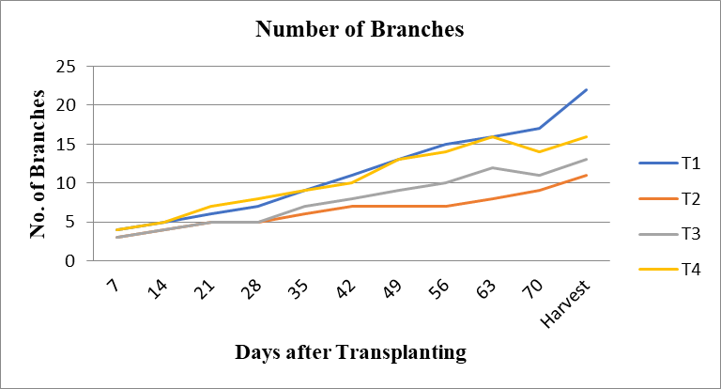
Fig.4 Number of Branches VS Days After Transplanting
Table 10 Statistical Analysis of Number of Branches During 2022-23
Treatment | Number of Branches
T1 | 22
T2 | 11
T3 | 13
T4 | 16
SEm± | 3.14
CD or LSD | 10.85
Test of significance (p=0.05) | S
CV% | 6.14
3.6 Number of Leave:
- It was observed that treatment T1 has more number of leaves compare to other treatment.
- At the time of harvesting the maximum number of leaves recorded in treatment T1, which is 111.
- The maximum number of leaves recorded in treatment T1 100% water was given from one side of root zone, so this may enhanced root development and nutrient uptake.
- In T2 treatment 75% water was given from one side of root zone, so lack of water affected the growth and yield of the plant. in this treatment has less number of leaves compare to other treatment.
- In T3 treatment only 50% water was given from one side of root zone, dry to less water the plant could not grow properly. in this treatment has more number of leaves compare to treatment T2, and less number of leaves then treatment T1 and treatment T4.
- In T4 treatment full irrigation on both side water was given this cause leaching of nitrogen and other micro nutrients because of this is more compare to treatment 2 and 3, and less compare then treatment 1.
Table 11 Number of Leave
Number of leave
Days | T1 | T2 | T3 | T4
7 | 16 | 17 | 12 | 20
14 | 25 | 19 | 18 | 25
21 | 33 | 17 | 23 | 39
28 | 46 | 24 | 32 | 53
35 | 58 | 29 | 49 | 69
42 | 69 | 32 | 49 | 75
49 | 89 | 43 | 67 | 93
56 | 95 | 47 | 75 | 97
63 | 98 | 52 | 80 | 107
70 | 100 | 51 | 73 | 87
Harvest | 111 | 64 | 81 | 96
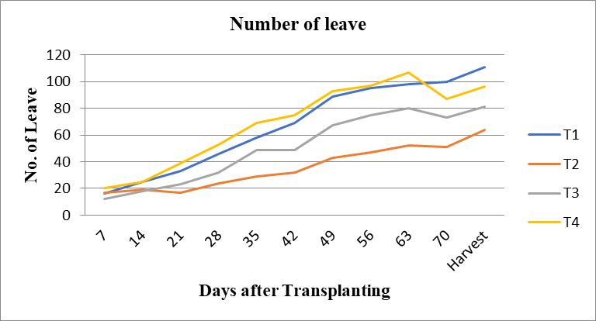
Fig.5 Number of Leave VS Days After Transplanting
Table 12 Number of leaves during 2022-23
Treatment | Number of Leave
T1 | 111
T2 | 64
T3 | 81
T4 | 96
SEm± | 19.50
CD or LSD | 67.45
Test of significance (p=0.05) | S
CV% | 8.64
3.7 Leaf Area:
- It was observed that treatment T1 has more leaf area compare to other treatment.
- At the time of harvesting the maximum leaf area recorded in treatment T1, which is 11.4cm².
- The maximum leaf area recorded in treatment T1 100% water was given from one side of root zone, so this may enhance root development and nutrient uptake.
- In T2 treatment 75% water was given from one side of root zone, so lack of water affected the growth and yield of the plant. in this treatment has less leaf area compare to other treatment.
- In T3 treatment only 50% water was given from one side of root zone, dry to less water the plant could not grow properly. in this treatment has more leaf area compare to treatment T2, and less leaf area then treatment T1 and treatment T4.
- In T4 treatment full irrigation on both side water was given this cause leaching of nitrogen and other micro nutrients because of this is more compare to treatment 2 and 3, and less compare then treatment 1.
Table 13 Leaf area
Leaf Area (cm²)
Days | T1 | T2 | T3 | T4
7 | 2.5 | 2 | 1.5 | 2.5
14 | 4 | 3 | 2.5 | 3
21 | 4 | 3 | 4.5 | 5.5
28 | 3.5 | 4 | 4.5 | 6
35 | 8.5 | 5.5 | 7 | 7.5
42 | 9.5 | 5.5 | 8.5 | 7.5
49 | 11.5 | 6 | 8 | 9.5
56 | 11.8 | 6.8 | 8.8 | 7.7
63 | 11.5 | 7.2 | 9.2 | 9.8
70 | 11.7 | 7.8 | 8.9 | 9.3
Harvest | 11.4 | 8.3 | 9.3 | 9.4
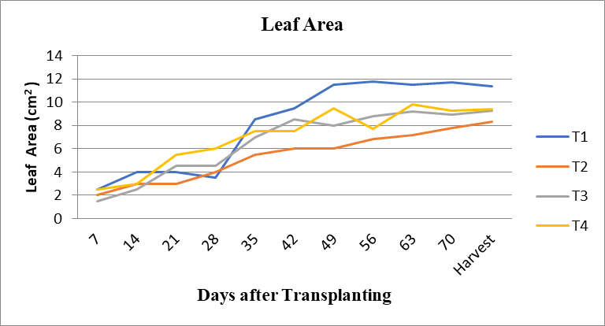
Fig.6 Leaf Area VS Days After Transplanting
3.8 Soil moisture
- It observed that treatment 4 has more soil moisture compare to other treatment.
- Maximum soil moisture recorded in treatment T4 and it is 25.52%.
- In T1 treatment 100% water was given from one side of root zone, so in this treatment has more soil moisture then treatment 2 and treatment 3, and less soil moisture then treatment 4.
- In T2 treatment 75% water was given from one side of root zone so in this treatment has more soil moisture then treatment 3, and less soil moisture than treatment 1 and treatment 4.
- In T3 treatment only 50% water was given from one side of root zone, in this treatment has less soil moisture compare to other treatment.
Table 14 soil moisture
Soil moisture (%)
Days | T1 | T2 | T3 | T4
7 | 18.57 | 17.64 | 16.27 | 20
14 | 19.04 | 16.73 | 15.83 | 20.48
21 | 19.52 | 15.83 | 15.38 | 20
28 | 22 | 16.18 | 15.9 | 21.77
35 | 26.76 | 25.70 | 20.85 | 26.85
42 | 23.80 | 22.72 | 17.37 | 24.4
49 | 25 | 23.1 | 19.04 | 24.37
56 | 24.40 | 22.54 | 18.48 | 23.76
63 | 23.28 | 20.93 | 17.92 | 25
70 | 25 | 20.96 | 20 | 25.52
Harvest | 25.15 | 22.53 | 19.20 | 25.52
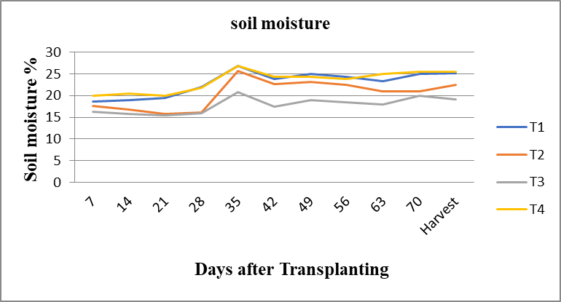
Fig.7 Soil moisture VS Days After Transplanting
Table 15 Weight of tomato
Treatment | Weight of tomato at harvesting time (gm)
T1
R1 | 44
R2 | 54
R3 | 32
AVG | 43
T2
R1 | 49
R2 | 35
R3 | 34
AVG | 38
T3
R1 | 54
R2 | 29
R3 | 25
AVG | 36
T4
R1 | 52
R2 | 33
R3 | 32
AVG | 39
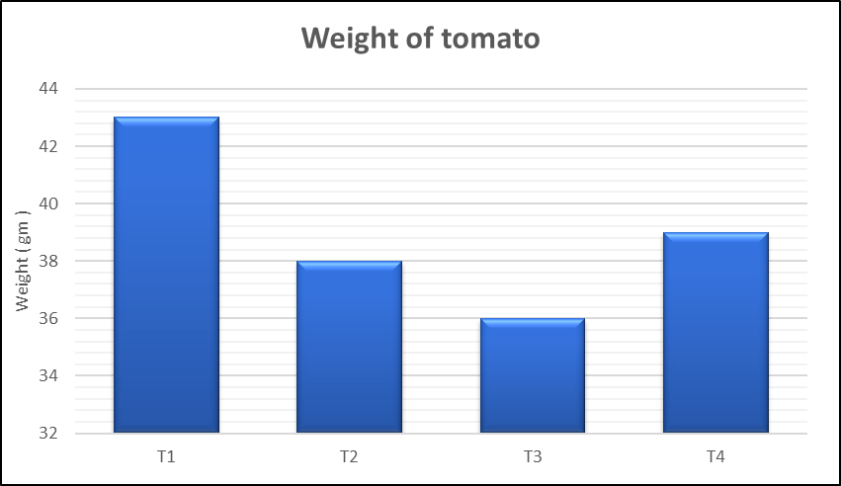
Fig.8 Weight of Tomato VS treatment
3.9 Parameter at harvesting time
Parameter at harvesting time such as size, shape, TSS, Maturity stages, weight.
Size of tomato
Size = (L x B x T)^{1/3}
L = length
B = breadth
T = thickness
Table 16 Size of tomato
Treatment | Average size of tomato (cm)
T1 | 4.8
T2 | 4.73
T3 | 4.87
T4 | 4.88
Statistical Analysis of Size of Tomato
Table 17 Size of Tomato During 2022-23
Treatment | Size of Tomato
T1 | 4.8
T2 | 4.73
T3 | 4.87
T4 | 4.88
SEm± | 9.50
CD or LSD | 5.45
Test of significance (p=0.05) | S
CV% | 8.75
Statistical Analysis of Shape of tomato
Table 18 Shape of tomato
Shape
Different | Treatment
Type of shape | T1 | T2 | T3 | T4
Cylindrical |  | 3 |  | 1
Oblate | 1 | 1 | 2
Round | 4 |  | 2 | 3
Elongated |  | 1
Heart/Cordate |  |  | 1
Flattened |  |  |  | 1
Table 19 Maturity Stage
Maturity Stage
Type of Maturity stage | Treatment
Type of Maturity stage | T1 | T2 | T3 | T4
Mature green | 1 | 3 | 3
Breaker
Turning
Pink
Light red | 3 | 2 | 1 | 2
Fully red | 1 |  | 1 | 3
Table 20 Total Suspended solids
Treatment | Average TSS (%)
T1 | 8.02
T2 | 8.42
T3 | 6.96
T4 | 8.2
Statistical Analysis of Total suspended Solids (TSS)
Table 21 Total suspended Solids (TSS) 2022-23
Treatment | TSS
T1 | 4.8
T2 | 4.73
T3 | 4.87
T4 | 4.88
SEm± | 9.50
CD or LSD | 5.45
Test of significance (p=0.05) | S
CV% | 9.64
Table 22 Weight of Tomato
Treatment | Average weight of tomato (g)
T1 | 30
T2 | 35
T3 | 34
T4 | 37
Statistical Analysis of Weight of Tomato
Table 23 Statistical Analysis Weight of tomato during 2022-23
Treatment | Weight of tomato (g)
T1 | 36
T2 | 39
T3 | 39
T4 | 43
SEm± | 4.81
CD or LSD | 16.64
Test of significance (p=0.05) | S
CV% | 7.43
Table 24 Yield of tomato
Treatment | Average yield of tomato (kg/ha)
T1 | 9258
T2 | 6789
T3 | 5554
T4 | 8023
Statistical Analysis of Yield of Tomato
Table 25 Yield of tomato

Treatment | Yield of tomato
T1 | 9258
T2 | 6789
T3 | 5554
T4 | 8023
SEm± | 56.9
CD or LSD | 4765
Test of significance (p=0.05) | S
CV% | 9.4
- Summary and Conclusion
- It was observed from the experiment that treatment T1(100%) has higher plant height than other treatment. Comparing values at initial 7 days also treatment T2 (75%) observed more plant height as compared to other treatments.
- At harvesting stage also treatment T1(100%) observed higher plant height as compared to treatment T2(100%), T3(50%) and T4(100%). The Highest value of plant height was observed to be 54.2 cm is at harvesting stage in treatment T1(100%).
- Treatment T1(100%) has more diameter of Stem than other treatments. Comparing values at 7 days treatment T3(50%) has more diameter of stem as compared to any other treatments. Treatment T1(100%) has more diameter of stem than treatment T2(100%), T3(50%) and T4(100%). At the harvesting stage. The highest value of diameter of Stem is 6.49 mm is at harvesting stage of treatment T1(100%).
- Treatment T1(100%) has more number of branches than other treatments. Comparing values at 7 days also treatment T1(100%) and treatment T4(100%) has more number of branches as compared to treatment T2(75%) and treatment T3(50%). Treatment T1(100%) has more Number of Branch than treatment T2(75%),T3(50%) and T4(75%) at the Harvesting Stage. The highest value of number of branches is 22 is at harvesting stage of treatment T1(100%).
- Treatment T1(100%) has more number of leave than other treatments. Comparing values at 7 days also treatment t4(100%) has more number of leave as compared to any other treatments. treatment 1 has more number of leave than treatment T2(100%), T3(50%) and T4(100%).at the harvesting stage. The highest value of number of leave is 111 is at harvesting stage of treatment T1(100%).
- Treatment T1(100%) has more leaf area than other treatments. Comparing values at 7 days also treatment T1(100%) and treatment T4(100%) has more leaf area as compared to any other treatments. Treatment T1(100%) has more leaf area than treatment T2(100%), T3(50%) and T4(100%).at the harvesting stage. The highest value of Leaf Area is 11.4 cm² is at harvesting stage of treatment T1(100%).
- Treatment T4(100%) has more soil moisture than any other treatments. Comparing values at 7 days also treatment 4(100%) has more soil moisture as compared to any other treatments. Treatment T4(100%) has more soil moisture than treatment 1(100%),T2(75%) and T3(50%) at the harvesting stage. The highest value of soil moisture is 25.52 % is at harvesting stage of treatment T4(100%).
- First flowering in tomato seen in treatment 1 compare to any other treatment.
- First tomato develop in treatment 1 compare to any other treatment.
- Treatment 1 has more number of flowers per branch than any other treatment. treatment 4 more number of flowers per branch them treatment 2 and 3.
- Treatment 1 has less days of first flowering then any other treatment. Treatment 4 less days of first flowering then treatment 2 and 3.
- Treatment 1 has more number of tomato compere to any other treatment.
- In overall scenario T1 treatment out performed all other treatments, so it can be concluded that, T1 treatment can be adopted for tomato for better yield as compared to all other treatments.
- References
FAO, 2011. The State of the World’s Land and Water Resources for Food and Agriculture (SOLAW)-Managing Systems at Risk. Food and Agriculture Organization of the United Nations, Rome and Earth scan, London.
Swaminathan, M.S., 2006. Report of Sub-committee on More Crop and Income Per Drop of water Advisory Council. pp. P61. http://www.indiawaterportal.org/sites/ indiawaterportal.org/files/GOI%20-%20More%20Crop%20per%20Drop%20Report. pdf.
Dhakad, S., Salunkhe, R. C., Dabhi, K. L., & Gupta, P. (2023). Agricultural drone spraying efficiency enhancement via patternater-based effective swath width determination. The Pharma Innovation Journal, 12(10), 952-961.
Carrijo DR, Lundy ME, Linquist BA (2017) Rice yields and water use under alternate wetting and drying irrigation: a meta-analysis. Field Crops Res 203:173–180. https://doi.org/10.1016/j.fcr.2016.12.002
Mabhaudhi T, Nhamo L, Mpandeli S (2021) Enhancing crop water productivity under increasing water scarcity in South Africa. Clim Change Sci 2021:1–18. https://doi.org/10.1016/B978-0-12-823767 0.00001-X
Liu H, Yuan B, Hu X et al (2022) Drip irrigation enhances water use efficiency without losses in cucumber yield and economic benefits in greenhouses in North China. Irrig Sci 40:135–149. https://doi.org/10. 1007/s00271-021-00756-w
Sonawane, A. V., & Shrivastava, P. K. (2022). Partial root zone drying method of irrigation: A review. Irrigation and Drainage, 71(3), 574-588.
Kang, S., & Zhang, J. (2004). Controlled alternate partial root-zone irrigation: its physiological consequences and impact on water use efficiency. Journal of experimental botany, 55(407), 2437-2446.
Grimes, D., Walhood, V., & Dickens, W. (1968). Alternate-furrow irrigation for San Joaquin valley cotton. California Agriculture, 22(5), 4-6.
Shukla, K., Gupta, P., Dhakad, S., & Panwar, G. (2023). Effect of Auger Size and Depth of Operation on Bulk Density, Cone Index, Germination, Root Length, Root Weight and Cob Weight for Maize Crop.
Dhakad, S., Shalunkhe, R. C., Shukla, K., Seth, N., Dabhi, K. L., & Balas, D. B. (2025). Optimization of operational parameters for agricultural drone spraying in maize crops. Journal of Experimental Agriculture International, 47(1), 105-120.

