Diversity and Pathogenicity of Dominant Fungal Species Causing Postharvest Rot in Mangoes in Côte d’Ivoire

.
ABSTRACT
Aims: to identify the main fungal species responsible for postharvest rot in mangoes in Côte d’Ivoire and to assess their relative pathogenicity.
Methodology: Mango samples showing symptoms of rot were collected from four major production regions (Bagoué, Kabadougou, Poro, and Tchologo). Fungal isolates were obtained using PDA medium supplemented with chloramphenicol and were characterized morphologically, microscopically, and through molecular analysis of the ITS1-ITS2 region. The most frequently isolated fungal species were tested for pathogenicity on healthy mango fruits.
Results: Seventeen fungal isolates were recovered, of which eight accounted for 88.27% of total occurrences. The most frequent were Lasiodiplodia theobromae (20.92%) and Aspergillus niger (17.86%). Molecular identification confirmed that the dominant species included L. theobromae, Rhizopus arrhizus, A. niger, A. fumigatus, A. tubingensis, A. uvarum, Penicillium citrinum, and Colletotrichum gloeosporioides. Pathogenicity tests revealed that L. theobromae and R. arrhizus caused the most severe decay, with over 90% rot observed within three days of inoculation.
Conclusion: Effective management of postharvest mango losses in Côte d’Ivoire requires targeted control strategies against the dominant fungal pathogens, particularly L. theobromae and R. arrhizus.

Keywords: Mango, postharvest rot, pathogenic fungi, Lasiodiplodia theobromae, Rhizopus arrhizus, Côte d’Ivoire

1. INTRODUCTION
Mangoes (Mangifera indica L.) are among the most popular tropical fruits worldwide, valued for their sweet flavor and high nutritional content. In Côte d’Ivoire, annual mango production exceeds 180,000 tons (FAO, 2023), with the northern regions being the main production zones. The Kent variety is by far the most cultivated, representing over 80% of national yield (Pugnet, 2018; Mulder et al., 2019). Over the past four years, Côte d’Ivoire has also ranked among the leading mango exporters to the European market, with 49,544 tons exported in 2023 alone, supporting the livelihoods of more than 100,000 local stakeholders (FAO, 2023).
Despite this success, postharvest losses remain a critical challenge. It is estimated that up to 60% of harvested mangoes are lost due to microbial spoilage, particularly fungal infections (Kouadia et al., 2019; Kouamé et al., 2020). These infections can occur at various stages—from field production to harvest, handling, and storage—and may lead to complete fruit deterioration if not effectively controlled (Zhang et al., 2019). The humid tropical climate in Côte d’Ivoire further favors fungal development (N’Guettia et al., 2014), while the high water and sugar content of mangoes makes them especially vulnerable to fungal attack (Goudarzi et al., 2021).The management of fungal diseases is complicated by the wide diversity of fungal species involved. Although chemical control methods have been used, they are increasingly limited by issues such as pathogen resistance and strict pesticide residue regulations imposed by importing countries. Consequently, researchers have turned toward biological control alternatives (Kossonou et al., 2023; Yéo et al., 2023).
Most studies on mango postharvest fungi in Côte d’Ivoire have focused on a limited range of pathogens, especially those responsible for stem-end rot and anthracnose (N’Guettia et al., 2014; Dembélé et al., 2020; Yéo et al., 2024). Furthermore, many investigations rely solely on morphological criteria for fungal identification (Kouadia et al., 2019), despite growing consensus on the value of molecular tools for accurate and reliable species characterization (Pitt & Hocking, 2009; Lücking et al., 2021). The present study aims to fill this gap by identifying the dominant fungal pathogens involved in mango postharvest rot in Côte d’Ivoire, using both morphological and molecular approaches. We also assess the pathogenicity of the most prevalent species in order to support the development of effective disease management strategies.
2. material and methods
2.1 Sample Collection
Mango fruits were sampled in northern Côte d’Ivoire during two consecutive harvest seasons (April–May 2021 and 2022) across four major production regions: Bagoué, Kabadougou, Poro, and Tchologo. Twenty mango batches were collected from two packing centers and five drying centers, with six fruit samples taken per site. Fruits exhibiting visible signs of spoilage, such as translucent, brown, or black lesions, were placed in sterile, labeled plastic bags, kept in coolers at 4°C, and transported to the laboratory in Abidjan within five days for further analysis.
2.2 Fungal Isolation and phenotypic classification
Spoiled mangoes were rinsed with sterile distilled water and surface-disinfected by immersion in 1% sodium hypochlorite (NaOCl) for three minutes (Dembélé et al., 2020). After drying with sterile paper towels, the surface was swabbed with 70% ethanol. Small fragments were cut from the lesion edges using sterile scalpels and plated on Potato Dextrose Agar (PDA) medium supplemented with 0.1% chloramphenicol. Plates were incubated at 30°C for 3 to 5 days. Emerging fungal colonies were subcultured on PDA to obtain pure isolates. Macroscopic traits (colony morphology, pigmentation) and microscopic characteristics (hyphal structure, spore shape) were observed under a light microscope (ZEISS, Germany). Fungal isolates were classified into distinct morphotypes based on these observations, following standard taxonomic keys (Pitt & Hocking, 2009), and stored at 4°C on PDA slants for further studies.
2.2.2 Frequency of Occurrence
Fungal prevalence was assessed by calculating the frequency of each group according to the following formula:
F = (N/Nt) × 100
where N is the number of appearances of a fungal group and Nₜ is the total number of fungal appearances across all samples (Kouadia et al., 2019).
2.2.3 Fungal molecular identification
Only the most frequent isolates were selected for molecular identification. Fungi were cultured in 5 mL of Potato Dextrose Broth (PDB) and incubated for 5 days at room temperature. Mycelia were harvested by centrifugation at 5,000 rpm, fragmented, and placed in 2 mL tubes containing glass microbeads. DNA was extracted using a bead-beating protocol: 500 µL of extraction buffer were added, followed by mechanical grinding (1 min at 6 beats/s), 2 min incubation on ice, and repetition of the process. After extraction, 200 µL of TE buffer were added and centrifuged at 13,000 rpm for 10 min. The aqueous phase was mixed with 1 mL phenol-chloroform (1:1), vortexed (2 min), and centrifuged again. DNA was precipitated with absolute ethanol at −20°C overnight, washed with 70% ethanol and resuspended in 100 µL of TAE buffer. RNase treatment was performed before final purification. PCR amplification of the ITS1–ITS4 region of fungal rDNA was performed using ITS1/ITS4 primers (White et al., 1990). Fungal identification was done by Sanger sequencing (Microsynth AG ) of the amplicons followed by BLAST alignment against the NCBI GenBank database.
2.2.4 Pathogenicity test
Pathogenicity was tested on mature, visually healthy mango fruits. Fruits were surface-disinfected using the same protocol described above. Wells (4 mm wide, ~3 mm deep) were made using sterile punches. Each wound was inoculated with 20 µL of a 10⁶ spores/mL suspension prepared from 10-day-old fungal cultures (Dembélé et al., 2020). Control fruits received 20 µL of sterile distilled water. Inoculated fruits were incubated at 28 ± 2°C in sterile plastic boxes. Lesion diameters were measured daily, and mean lesion sizes were calculated.

2.3 Statistical analysis
The G-test and the Kruskal–Wallis test were mainly used for statistical analysis. The G-test assessed the independence between fungal occurrence and categorical variables (sampling site or locality), while the Kruskal–Wallis test compared lesion sizes between groups. When significant differences were found, pairwise comparisons were performed using Dunn’s test (significance threshold: α = 0.05). All analyses were conducted using R software (version 4.2.0).
3. results AND DISCUSSION
3.1 RESULT
3.1.1 Fungal Isolates Associated with Mango Spoilage in Côte d’Ivoire
Seventeen fungal isolates were recovered from rotten mango samples. Based on morphological and microscopic analysis, these isolates displayed distinct colony textures, colors, hyphal structures, and spore types. For example, isolates Chp01 and Chp09 produced cottony aerial mycelia, indicative of rapid growth. Chp01 developed gray colonies with thin hyphae, while Chp09 formed white colonies with brown pigmentation and ovoid to elliptical, septate conidia. Other isolates, such as Chp02, Chp03, Chp05, Chp07, Chp13, Chp15, and Chp17, exhibited fluffy aerial mycelia with mostly hyaline hyphae and moderate to rapid growth.
In contrast, Chp04, Chp08, and Chp12 displayed glabrous colony surfaces but differed in pigmentation. Chp04 showed white colonies with branched conidiophores and globose conidia. Chp08 had dark green colonies with conidia arranged in chains, and Chp12 formed green colonies with yellowish mycelia. Lastly, isolates Chp06, Chp10, Chp11, and Chp14 developed woolly mycelia. Chp10 notably produced black spores and non-septate hyphae, while Chp11 had septate hyphae with elliptical conidia (Fig 1).

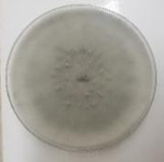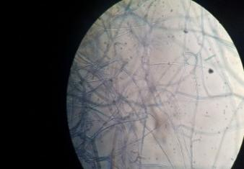  A  B | 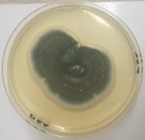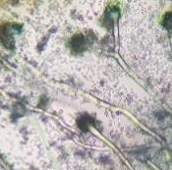  C  D | 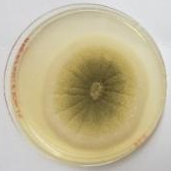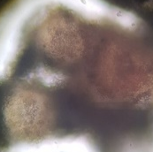  E  F
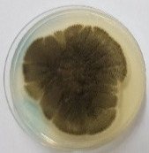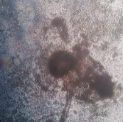  G  H | 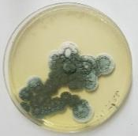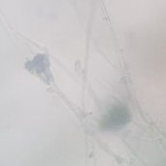  I  J | 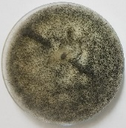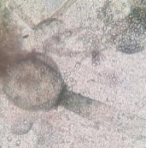  K  L
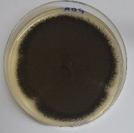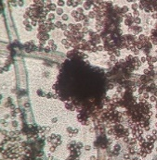  N | 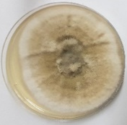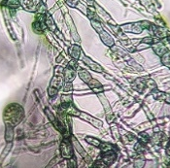  P  O | 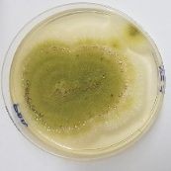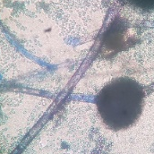  R  Q
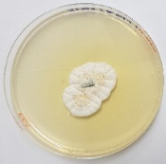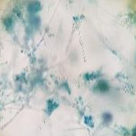  M  S  T | 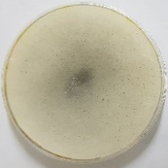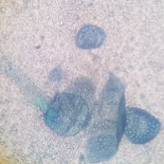  U  V | 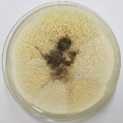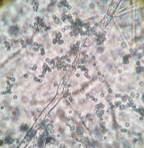  W  X
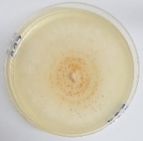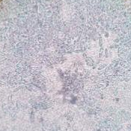  Y  Z | 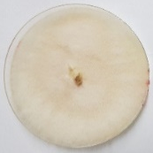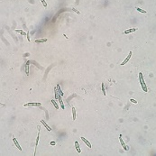  AA  AB | 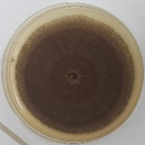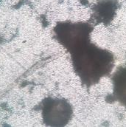  AD  AC
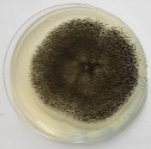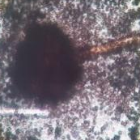  AF  AE | 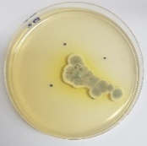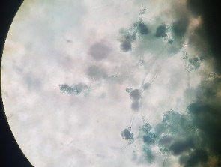  AH  AG
Fig 1 : mascroscopic and microscopic aspects of the fungal isolates.
Colony morphology (left) and microscopic characteristics (right) of each isolate are shown. A–B: Chp01 ; C–D: Chp02 ; E–F: Chp03 ; G–H: Chp04 ; I–J: Chp05 ; K–L: Chp06 ; M–N: Chp07 ; O–P: Chp08 ; Q–R: Chp09 ; S–T: Chp10 ; U–V: Chp11 ; W–X: Chp12 ; Y–Z: Chp13 ; AA–AB: Chp14 ; AC–AD: Chp15 ; AE–AF: Chp16 ; AG–AH: Chp17.

3.1.2 Frequency of occurrence and molecular identification of dominant Isolates
Morphological and microscopic criteria were used to classify the isolates into groups. The distribution of these groups is illustrated in Fig 2. Eight isolates accounted for the majority of observed occurrences (88.27%), with the highest frequencies recorded for Chp01 (20.92%) and Chp03 (17.86%). These were followed by Chp05 (10.71%), Chp10 (9.18%), Chp02 (8.67%), Chp07 (8.16%), Chp17 (7.14%), and Chp04 (5.61%). In contrast, the remaining nine isolates (Chp06, Chp08, Chp09, Chp11, Chp12, Chp13, Chp14, Chp15, and Chp16) each had frequencies below 2%, totaling only 11.73% combined. This suggests a high dominance of a small number of fungal strains in mango spoilage across the sampled regions. Molecular identification of the eight most prevalent isolates was performed via PCR amplification and sequencing of the ITS region. BLAST analysis against the NCBI GenBank database showed that these isolates were Lasiodiplodia theobromae (Chp01), Aspergillus niger (ChP03), Colletotrichum gloeosporioides (Chp05), Rhizopus arrhizus (Chp010), Aspergillus tubingensis (Chp07), Aspergillus fumigatus (Chp02), Aspergillus uvarum (Chp17), Penicillium citrinum (Chp04). (Table 1)

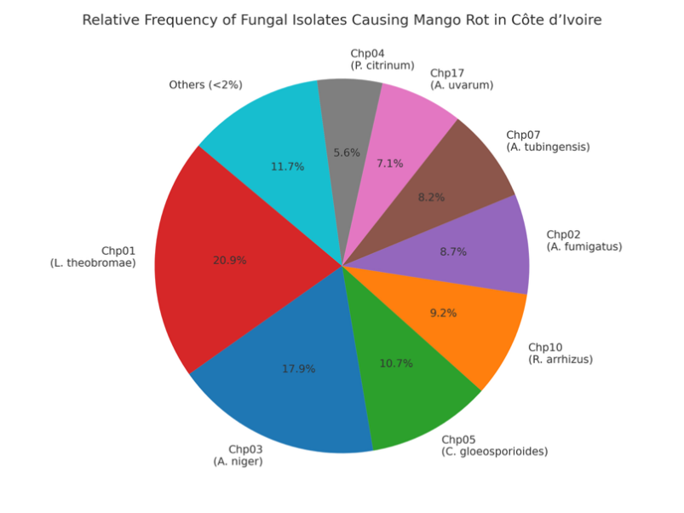
Fig 2: Frequency of occurrence of fungal isolates associated with mango rot in Côte d’Ivoire.
The chart shows the relative abundance (%) of each fungal isolate based on morphological classification. Eight dominant strains (Chp01 to Chp04, Chp05, Chp07, Chp10, Chp17) accounted for 88.27% of total isolates, with Chp01 and Chp03 being the most frequent. Less frequent strains (<2%) were grouped under “Others” for clarity.

Table 1. Dominant fungal species associated with mango rot in Côte d’Ivoire

Isolate Code | Identified Species | Genus | Frequency (%)
Chp01 | Lasiodiplodia theobromae | Lasiodiplodia | 20.92
Chp03 | Aspergillus niger | Aspergillus | 17.86
Chp05 | Colletotrichum gloeosporioides | Colletotrichum | 10.71
Chp10 | Rhizopus arrhizus | Rhizopus | 9.18
Chp02 | Aspergillus fumigatus | Aspergillus | 8.67
Chp07 | Aspergillus tubingensis | Aspergillus | 8.16
Chp17 | Aspergillus uvarum | Aspergillus | 7.14
Chp04 | Penicillium citrinum | Penicillium | 5.61

3.1.3 Pathogenicity of Spoilage Fungi
Pathogenicity tests revealed significant differences in the ability of fungal species to cause decay in mangoes (Table 2). Rhizopus arrhizus caused the most rapid and extensive spoilage, with over 90% decay recorded within three days and 100% by day five. Lasiodiplodia theobromae also showed high virulence, reaching 100% rot by day seven. Other fungi, including species of Aspergillus and Colletotrichum gloeosporioides, caused slower but still significant decay. For instance, Aspergillus uvarum induced 22% decay by day 3 and 84% by day 7. In contrast, Penicillium citrinum caused the least damage, with decay remaining below 15% throughout the observation period.

Table 2. Mean percentage of mango rot caused by different fungal species over a 7-day observation period
Species of fungal | percentages of decay (%)
Species of fungal | Day 3 | Day 5 | Day 7
A. fumigatus | 17 ± 3^{cdeA} | 41 ± 11^{bcA} | 68 ±1 0^{cdAB}
A. niger | 23 ± 2^{cA} | 46 ± 9^{bA} | 70 ± 6^{cdB}
A. tubingesis | 7 ±1 ^{fgA} | 23 ± 1^{deA} | 44 ± 2^{eB}
A. uvarum | 22 ± 3^{cdA} | 45 ± 9^{bA} | 84 ± 5^{bA}
C. gloeosporoides | 12 ± 1^{efB} | 22 ±1 ^{deB} | 40 ± 2^{efB}
L. theobroma | 35 ± 5^{bB} | 68 ± 0^{aB} | 100 ± 0^{aA}
P. citrium | 2 ± 0,5^{gB} | 8 ± 1^{eA} | 11 ±2 ^{hA}
R. arrhizus | 90 ± 7^{aA} | 100 ± 0^{aA} | 100 ± 0^{aA}
Values represent mean lesion development (% rot) ± standard deviation on days 3, 5, and 7 after inoculation of Kent mangoes. Lowercase letters indicate significant differences between fungal species on the same day (Kruskal–Wallis test followed by Dunn's test, p < 0.05). Uppercase letters indicate differences within each fungal species across the three time points.

3.1.4 Association Between Fungal Flora and Sampling Location
Statistical analyses assessed whether fungal composition varied by location. The G-test for independence between fungal communities and sampling region showed no significant difference (p = 0.1794 > 0.05), indicating similar fungal profiles across regions. However, the association between fungal communities and sampling site (e.g., packing vs. drying centers) was significant (p = 0.01393 < 0.05), suggesting that postharvest handling conditions may influence fungal diversity (Table 3).

Table 3. G-test results assessing the association between fungal community composition and sampling factors
Sampling factor | G-value | Degree of freedom | p-value
Region (locality) | 74,223 | 64 | 0,1794
Handling site (facility) | 72,043 | 48 | 0,01393
The independence of fungal species distribution was tested across two factors: geographical region (locality) and postharvest handling site. A significant association was found for sampling site (p < 0.05), but not for region.
3.2 DISCUSSION
The preservation of mangoes in a fresh state remains a critical challenge for the mango value chain due to their high perishability and sensitivity to microbial infections. This study confirmed the presence of a diverse range of fungal species responsible for postharvest rot in Côte d’Ivoire, highlighting both the prevalence and pathogenicity of key isolates. Seventeen fungal species were identified, among which eight accounted for over 88% of all infections. These dominant pathogens included Lasiodiplodia theobromae, Rhizopus arrhizus, Aspergillus niger, A. fumigatus, A. tubingensis, A. uvarum, Penicillium citrinum, and Colletotrichum gloeosporioides. This distribution aligns with previous findings in West Africa and other tropical regions, where these genera have been frequently associated with mango spoilage (Diedhiou et al., 2007; Goudarzi et al., 2021; Kouadia et al., 2019).
Among the species identified, members of the Aspergillus genus were particularly well represented. A. niger, a known agent of black rot, has been widely reported as a major cause of spoilage in stored fruit, including mangoes (Mehndiratta et al., 2020). Other species, such as A. uvarum and A. fumigatus, although less frequently documented, have also demonstrated the ability to degrade fruit tissue significantly.Lasiodiplodia theobromae, an opportunistic pathogen commonly associated with stem-end rot, is capable of penetrating mangoes through wounds, leading to extensive necrosis and loss of fruit integrity. Its high occurrence rate and confirmed virulence in pathogenicity tests corroborate earlier studies conducted in Côte d’Ivoire and elsewhere (Ahmed et al., 2020; Dembele et al., 2020).Rhizopus arrhizus, which caused more than 90% decay within three days of inoculation, emerged as the most aggressive pathogen in this study. Its rapid colonization is consistent with its known preference for humid conditions and damaged fruit tissues (Ali et al., 2018). The severe rotting observed confirms its critical role in mango spoilage during storage and transport, particularly under suboptimal postharvest conditions.In contrast, Penicillium citrinum exhibited limited pathogenicity, suggesting a secondary or opportunistic role. Although Penicillium species are often associated with fruit decay, their impact varies greatly depending on environmental factors and fruit variety (Fatima & Khot, 2017).
The results also demonstrated that fungal composition did not significantly vary across geographical regions, but did differ between types of sampling sites (packing vs. drying centers). This finding indicates that postharvest handling practices may play a greater role in shaping the fungal community than agroecological location. Such observations highlight the importance of hygiene and storage conditions in controlling fungal contamination.
These findings reinforce the need for integrated postharvest management strategies that focus on monitoring critical control points along the mango supply chain. Given the dominance of highly virulent fungi such as L. theobromae and R. arrhizus, future research should explore targeted biocontrol approaches, in line with recent studies conducted in Côte d’Ivoire (Kossonou et al., 2023; Yéo et al., 2023).
4. CONCLUSION
This study identified eight dominant fungal species responsible for postharvest rot in mangoes collected from major production zones in Côte d’Ivoire. Lasiodiplodia theobromae and Rhizopus arrhizus were the most virulent, causing rapid and extensive decay during storage. These results highlight the significant impact of fungal pathogens on mango quality and postharvest losses. Effective disease management strategies should prioritize these two species and focus on improving hygiene practices during handling and storage. The findings also support the implementation of integrated pest management approaches, including biological control alternatives, to ensure the sustainability of the mango sector in Côte d’Ivoire.

References

Abdullah, Q., A. Mahmoud and A. Al-harethi (2016). "Isolation and identification of fungal post-harvest rot of some fruits in Yemen." PSM Microbiology 1(1): 36-44.
Ahmed, A., M. A. Mendez and O. Hassan (2020). "Management Strategies for Colletotrichum gloeosporioides in Mango Production. Plant Disease Management Report, 9(1), 65-78.".
Ali, F. M., A. Asif and A. Shakir (2018). "Postharvest Disease Management: Role of Rhizopus stolonifer in Fruit Decay. Food Quality and Safety, 2(4): 237-243.".
Aoudou, Y. and M. E. G. Phalone (2017). "Isolation and pathogenicity evaluation of postharvest fungal of some fruits in Cameroon." International Journal of Environment, Agriculture and Biotechnology 2(1): 238645.
de Oliveira Costa, V. S., S. J. Michereff, R. B. Martins, C. A. T. Gava, E. S. G. Mizubuti and M. P. S. Câmara (2010). "Species of Botryosphaeriaceae associated on mango in Brazil." European Journal of Plant Pathology 127: 509-519.
Dembele, D. D., A. Kamara, I. Grechi, N. Silué, N. N’goran, Y. Yéo, J.-Y. Rey and D. Koné (2020). "Morphological characteristics and distribution of Colletotrichum isolates morphotypes infecting mango (Mangifera indica L.) in the north of Côte d’Ivoire." African Journal of Food, Agriculture, Nutrition and Development 20(3): 15837-15856.
Diedhiou, P., N. Mbaye, A. Drame and P. Samb (2007). "Alteration of post harvest diseases of mango Mangifera indica through production practices and climatic factors." African Journal of Biotechnology 6(9): 1087-1094.
FAO (2023). "Crops and livestock products statistics. https://www.fao.org/faostat/fr/#data/QCL consulté le 01/03/2024."
FAO (2023). "Major Tropical Fruits Market Review – Preliminary results 2022. Rome, Italie, 33p.".
Fatima, S. and Y. C. Khot (2017). "Isolation of Post Harvest Fungi From Mango (Mangifera indica) Fruits." Epitome: International Journal of Multidisclipinary Research 3: 39-45.
Goudarzi, A., S. Samavi, M. Amiri Mazraie and Z. Majidi (2021). "Fungal pathogens associated with pre‐and postharvest fruit rots of mango in southern Iran." Journal of Phytopathology 169(9): 545-555.
Hecke, T. V. (2012). "Power study of anova versus Kruskal-Wallis test." Journal of Statistics and Management Systems 15(2-3): 241-247.
Kossonou, N. g., L. Zoue, G. Koua and S. Niamke (2023). "Towards biocontrol of post-harvest anthracnose by antagonistic bacteria and yeast isolated from fermented mango (Mangifera indica, var Kent)." Food and Environment Safety Journal 22(2): 101-108.
Kouadia, A. M. J., K. Abo and K. T. Kouadio (2019). "Evolution des infections naturelles sur les mangues, les avocats et les bananes en Côte d’Ivoire et principaux champignons responsables." Journal of Applied Biosciences 134: 13710-13721.
Kouamé, L. M., A. K. Kouamé, L. Ouattara, F. K. N’Guessan, M. W. Alloue-Boraud and M. K. Dje (2020). "Contraintes liées à la production et à la commercialisation des mangues (Mangifera indica) en Côte d’Ivoire: cas des variétés exportées vers l’Europe." Afrique SCIENCE 17(3): 16-27.
Laurencelle, L. (2021). "Les distributions multinomiales, leur mesure par les tests khi2 et G, leur approximation par la loi χ 2 et l’analyse des tableaux de fréquences par filetest G." The Quantitative Methods for Psychology 17: 375-394.
Lücking, R., M. C. Aime, B. Robbertse, A. N. Miller, T. Aoki, H. A. Ariyawansa, G. Cardinali, P. W. Crous, I. S. Druzhinina and D. M. Geiser (2021). "Fungal taxonomy and sequence-based nomenclature." Nature microbiology 6(5): 540-548.
Mehndiratta, P., S. K. Verma and R. Goyal (2020). "Role of Aspergillus niger in Postharvest Decay of Fruits. Journal of Food Science and Technology, 57(3), 948-957.".
Mulder, H., S. Steemers, J. B. Dibouloni, J. Tamini and M. A. Niang (2019). "Value Chain Analysis for Processed Fruits from Burkina Faso, Mali and Ivory Coast." CBI (Centre for the Promotion of Imports from developing countries), Côte d’Ivoire.
Muniandy, R., N. A. Rahman and N. Abd Rahman (2021). "Understanding Mucor in Postharvest Fruit Decay. Journal of Agricultural Science and Technology, 23(5), 1023-1036.".
N'Guettia, M., N. Kouassi, H. A. Diallo and F. Kouakou (2014). "Evaluation of anthracnose disease of mango (Mangifera indica L.) fruits and characterization of causal agent in Côte d'Ivoire."
Pitt, J. I. and A. D. Hocking (2009). "Fungi and Food Spoilage.Springer, 3é édition, New York, USA, 524p.".
Pugnet, V. (2018). "Fiche pays producteur : La mangue en Côte d'Ivoire." FruiTrop 255: 78-83.
White, T. J., T. Bruns, S. J. W. T. Lee and J. Taylor (1990). "Amplification and direct sequencing of fungal ribosomal RNA genes for phylogenetics. In: PCR Protocols: A Guide to Methods and Applications, eds. Innis M.A., Gelfand D.H., Sninsky J.J. et White T.J. Academic Press, Inc., New York, pp315-322 ".
Yeo, Y. S., Y. Kone, D. D. Dembele, E. L. D. G. Amari, J.-Y. Rey, E. M. Del Ponte, D. Fernandez and D. Koné (2024). "Prevalence of mango stem-end rot disease in Côte d'Ivoire and identification of associated fungal pathogens." Tropical Plant Pathology.
Yéo, Y. S., Y. Kone, D. D. Dembele, G. E. Amari, J.-Y. Rey, E. M. Del Ponte Sr, D. Fernandez and D. Kone (2023). "Prevalence of mango postharvest Stem-end rot disease in Cote d'Ivoire and identification of fungal pathogens associated." bioRxiv: 2023.2008. 2002.551668.
Zhang, T., Y. Zhang and J. Zhou (2019). "The postharvest treatment of climacteric fruits: Ethylene and its inhibitors. Horticultural Reviews, 47, 101-122."

