Review Article
Haldina cordifolia (Roxb.): Important underutilized timber species

Abstract
With the increasing demand for timber, pressure on reserved forests has significantly risen. Haldina cordifolia (syn. Adina cordifolia), a valuable multipurpose tree species, plays a crucial role in various industries. Its bark is used for dyeing wool and linen yellow, while its durable wood is widely utilized for timber, furniture, flooring, panelling, construction, agricultural tools, turnery, and bobbins. Native to India, the species is also valued in traditional medicine, with its bark known for antiseptic properties and its roots used as a remedy for dysentery. The wood’s characteristic yellow hue has led to its common name, haldu. This article aims to explore various aspects of Adina cordifolia, including its taxonomy, distribution, botanical description, reproductive biology, breeding systems, seed collection and processing, wood properties, plantation establishment, growth patterns, photochemistry, and medicinal applications.
Keywords: Adina cordifolia, Haldinia cordifolia, haldu
Introduction
Haldina cordifolia Benth. & Hook. f., commonly known as haldu, is a multipurpose deciduous tree belongs to the genus Haldina within the Rubiaceae family and has a chromosome number of 2n = 22 (Bedi et al., 1981). Previously known by its synonym Adina cordifolia (Roxb.) Hook.f. & Benth., this species is valued for its durable timber, medicinal properties, and ecological significance. Adina is from the Greek word adinos, ‘clustered, plentiful, crowded’, referring to the clustered flowers. The genus Haldina is monotypic, characterized by large, opposite leaves, terminal inflorescences, and spherical clusters of small, fragrant flowers. It is the sole species in the Haldinia genus. Lampatia, Tarak Chapa in Assamese, Keli-Kadam in Bengali, Hed, Hedu, Heddi in Marathi, Haladwan, Holdarvo in Gujarati, Girikadamba in Sanskrit, Avanu, Kadambe in Kannada, Manjakadambai, Poonteak in Tamil, Manjakadambu or manjakkatamp in Malayalam, Bandaru, Pasupu Kadamba in Telugu, Lungkhup in Mizo, Kam, and Karma in Nepalese are just a few of its many vernacular names in different languages.
Taxonomy and Nomenclature:
Table 1. Taxonomic classification of Haldina cordifolia Benth. & Hook. f.
Kingdom : | Plantae
Order : | Gentianales
Family : | Rubiaceae
Genus : | Haldina
Species : | Haldina cordifolia/ Adina cordifolia

Geographical distribution and environmental condition
Adina cordifolia (syn. Haldina cordifolia) is found across tropical and subtropical South and Southeast Asia, including India, Nepal, Bangladesh, Myanmar, Thailand, Laos, Cambodia, Vietnam, and Sri Lanka. Haldu may be found in deciduous woods across India, reaching elevations of 900 meters in the sub-Himalayan region. It is also widespread in the forests of South India (Iqbal et al., 2009). Adina thrives at altitudes between 300 and 1,000 meters, favouring well-drained soil with an optimal pH range of 5.5 to 6.5. It requires an annual temperature between 25°C and 35°C and rainfall ranging from 1,000 to 2,000 mm (Muthupandiyan et al., 2019; Treepedia, 2018). The species is not frost-tolerant and grows across diverse geological formations, including granite, gneiss, schist, quartzite, trap, and laterite, up to 1,000 meters above sea level (Kundu, 2018; Muthupandiyan et al., 2019).
Botanical description
Haldu grows to a height of 30–40 meters with a trunk diameter of approximately 22 cm. The clear, straight bole can extend up to 20 meters. Its bark, measuring about 1.3 cm thick, is grey-brown to pale brown, shallowly pitted, horizontally wrinkled, and cracked, with exfoliation occurring in small patches (Sasidharan, 2004; Muthupandiyan et al., 2019). The tree has an ovoid-shaped crown, a reddish blaze, and horizontally spreading branches with monopodial branching. Young shoots are pubescent.
The leaves are large, oval-shaped with a narrow tip and a cleft base. They are arranged in opposite pairs along the branches. The leaves are simple, opposite, decussate, and stipulate, with stipules measuring 10–12 × 7 mm, intrapetiolar, obovate, foliaceous, and caducous. The petiole is 4–10 cm long, stout, and pubescent. The leaf lamina, measuring 10–20 × 10–20 cm, is orbicular, ovate, or broadly ovate, with a cordate base and an acuminate apex. The margin is entire, the upper surface is glabrous, while the underside is pubescent and chartaceous. The leaf venation consists of 5–7 primary nerves from the base, 3–5 pairs of lateral pinnate nerves, with prominent and regular intercostal veins arranged in a scalariform pattern, and domatia are present (Sasidharan, 2004).
Reproductive biology and breeding system
The flowers of Adina cordifolia are small, yellowish, and bisexual, with prominent projecting stigmas resembling pinheads. They are arranged in dense, round, axillary clusters measuring 3–4 mm in diameter and are interspersed with numerous thread-like bracteoles. The hypanthium is 1–2 mm long and densely hairy, while the cup-shaped calyx measures 1.5–2 mm, with a short tube and five lobes ranging from 1.3 to 1.8 mm in length. The corolla, 7–9 mm long, is five-ridged and covered in fine hairs externally, with five oblong lobes (1–2 mm) that are also densely hairy. The flowers have five exerted stamens, each with 0.5 mm filaments and oblong anthers measuring 1–2 mm. The ovary is inferior and two-celled, with numerous ovules attached to a pendulous placenta. The style is slender, and the stigma is globose.

The fruit is a small, brown, turbinate capsule, 2–3 mm long, consisting of two dehiscent cocci. The fruits form dense, spherical clusters that turn black or nearly black when mature. The seeds are numerous, each featuring a tail at one end and a bifid wing at the other (Rokde & Pawar, 2013).
The natural regeneration of haldu is sparse due to their minute seed size, which is primarily dispersed by wind. In some instances, fruit heads fall before all seeds are released, allowing germination to occur within the fallen fruit heads. Although the species produces seeds in large quantities, only a small proportion are successfully established as seedlings. For vegetative propagation, softwood cuttings are the most effective compared to hardwood and semi-hardwood cuttings (Kaushal et al., 2010). Treating cuttings with Indole-3-Butyric Acid (IBA) at a concentration of 2000 mg/L significantly enhances rooting (Yadav et al., 2018). Seed germination occurs within 20–40 days. For in vitro propagation, apical buds or shoot tips serve as ideal explants. Murashige and Skoog (MS) medium supplemented with 1.0% BAP and 0.5% NAA has been found to be highly effective for micropropagation (Sultana et al., 2015).
Seed collection and processing
Seeds are dispersed between April and June, with maturity determined by changes in fruit colour and moisture content. As the fruit ripens, its colour transitions from light green to light brown, and its moisture content ranges between 38-46% (Jeena et al., 2012). During seed collection, a tarpaulin should be spread under the tree to gather fruits by either lopping branches or plucking. After collection, seeds should be sun-dried for 7 to 10 days to reduce the moisture content to 5-6%, ensuring optimal germination (Kundu, 2018).
Wood properties
The yellowish wood of Adina cordifolia exhibits a uniformly fine texture with a straight grain. Its basic density ranges from 503.0 kg/m³ to 663.5 kg/m³, with an average density of 596.7 kg/m³ at breast height (Nair et al., 1991). The sapwood is pale yellowish to yellowish-white, while the heartwood transitions from deep yellow to reddish or brownish upon exposure. The parenchyma is sparse and indistinct to the naked eye. The wood contains fine, numerous, and closely spaced rays, with small vessels occurring solitarily or in radial multiples of two to three (Anoop & Pasha, 2005).
Additional wood properties include a specific gravity of 0.70 at 12% moisture content and a volumetric shrinkage coefficient of 0.45%. The total tangential shrinkage (TS) is 6.8%, while the total radial shrinkage (RS) is 3.4%, giving a TS/RS ratio of 2.0. The wood's mechanical properties include a crushing strength of 55 MPa, static bending strength of 90 MPa, and a modulus of elasticity of 12,770 MPa (Anon, 2012). Its air-dry weight is approximately 40–42 lb/ft³ (CSIR, 1948).
Plantation establishment and growth
The field is thoroughly ploughed, followed by harrowing and planking to achieve a fine tilth and ensure weed-free soil. Before planting, 20 t/ha of FYM is incorporated into the land. The recommended spacing is 4m × 4m (row to row). Nursery-raised seedlings are transplanted into 30cm × 30cm × 30cm pits (Muthupandiyan et al., 2019). Protecting seedlings from drought is crucial for their survival. Each pit is slightly covered with terrain to prevent water stagnation. However, data on nutrient deficiency is currently unavailable (Nair et al., 2004).
Important insect pests and diseases
The insect Parotis vertumanlis inflicts significant damage, destroying over 50% of foliage by folding and feeding within the leaves. Epiplema quadricauda caterpillars cause defoliation in young trees (Nair et al., 1991), which can be managed with a 0.1% solution of Ekalux 25 EC (Quinalphos). Dirades adjutaria leads to defoliation during July and August, while Aristobia approximator feeds on the bark of living shoots. Additionally, Dihamnus cervinus larvae bore into the stems of young saplings (Kundu, 2018).
Medicinal uses
Fresh bark, when ground with brown sugar, is consumed internally to relieve stomachaches (Bhaskar & Samant, 2012). The bark and leaves of Haldina cordifolia are traditionally used to treat cholera, colds, coughs, fever, headaches, scars, jaundice-like symptoms, and urinary disorders (Singh & Dubey, 2012).
Fresh stem bark juice is taken for rheumatism (Jain et al., 2010), while its latex is applied to alleviate toothaches (Kamble et al., 2010; Rokde & Pawar, 2013). The stem bark is also used to reduce fever (Padal et al., 2010). Additionally, leaves are applied to swollen areas to relieve pain and inflammation. The bark exhibits antibacterial properties and is traditionally used for treating eczema, scabies, and other bacterial skin infections, with its paste applied directly to affected areas.
Phytochemistry of Haldinia cordifolia (Roxb.)
Phytochemical compounds, including flavonoids and other secondary metabolites, have been linked to various biological activities (Table 2) such as anti-inflammatory, antimicrobial, and antioxidant properties (Prakash et al., 2015).
Table 2 The phytochemistry of Haldina cordifolia present in different parts of tree
S. N. | Part | Solvent | Activity | References
1 | Leaf, Bark, root. | Methanol | Antioxidant Activity | Surveswaran et al., 2007 ; Baral et al., 2016; Kumari et. al 2017, Dai et al., 2010
2 | Extracts of leaf and stem | Silver Nitrate | Anti-cancer Activity | Sangameswaran et al., 2012’ Dubey et al., 2020 ; Rao et al., 2020
3 | Extracts of leaf and stem | Silver Nitrate | Antibacterial activity | Mohan et Al., 2014; Sayeed and Ali, 2015; Muthupandian et al., 2019; Hossan et al., 2009
4 | Leaves | Hydro-alcoholic | Anti-Diabetes activity | Campus and Bhimber 2016; Sijad andNag 2017
5 | Bark extract | Acetone (AEAC) | Hepatoprotective activity | Medjahed et al., 2016 ; Singh et al., 2018
6 | Bark extract | Crude methanol | Cytotoxic activity | Rashid et al., 2016 ; Nordin et. al 2019, Raypa (PhD thesis)
7 | Bark, Root | Benzene, ethyl acetate | Anti-amoebic activity | Baral et al., 2016; Seshian et al., 2020, Ahmed et al., 2016; Iqbal et al., 2009
8 | Bark, Root | Petroleum ether, ethyl | Anti-inflammatory, Analgesic activity | Jain et al., 2006 ; Thant, 2019 ; Asif, 2015
9 | Stem | Chloroform | Anti-ulcer | Kasinaduni et al., 2009
(Source : Dalu et. al 2021)
Conclusion
This review primarily focuses on the botanical description, geographical distribution, environmental conditions, reproductive biology, breeding system, wood properties, plantation establishment, growth patterns, major pests and diseases, medicinal uses, and phytochemistry of Haldina cordifolia. As a valuable timber species with significant medicinal properties, this multipurpose tree offers numerous benefits. However, despite its ecological and economic importance, Haldina cordifolia remains underutilized and often overlooked. This highlights the need for further research and conservation efforts to promote its sustainable use. The review provides valuable insights into its diverse applications and the benefits of its cultivation.

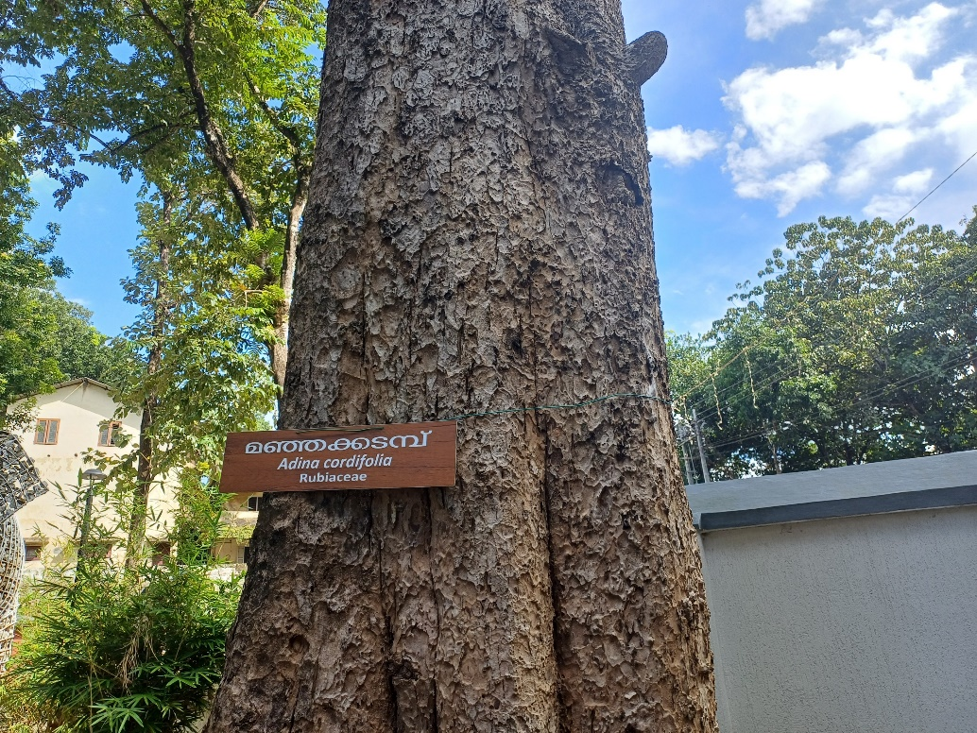
Fig 1 : Haldina cordifolia, which is previously known as Adina cordifolia

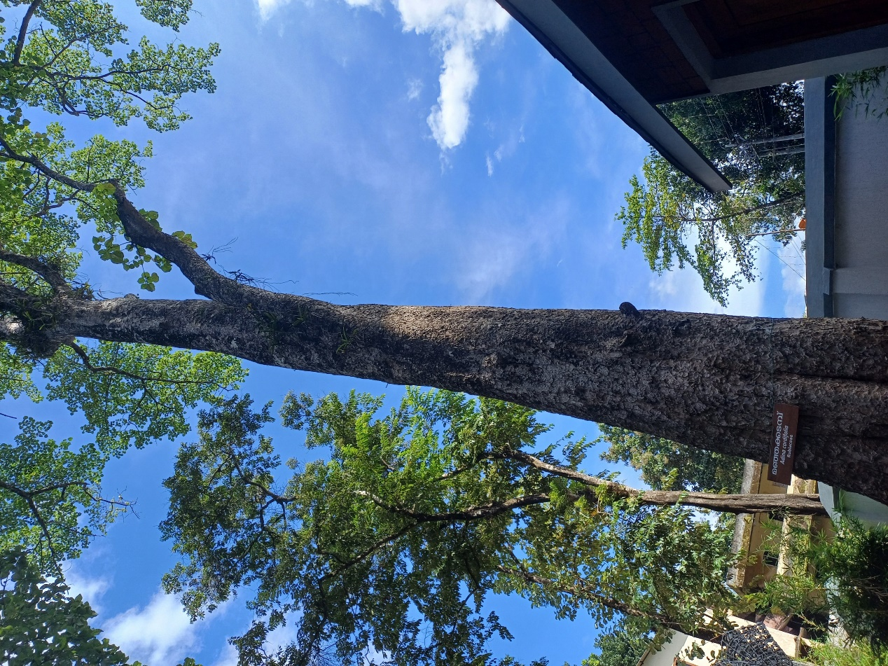
Fig 2 : The photograph shows the long, straight, clean bole stem of the plant
References:
Ahmed AA, Howladar SM, Mohamed HA, Al-Robai SA. 2016. Phytochemistry, Antimicrobial, Antigiardial and Antiamoebic Activities of Selected Plants from Albaha Area, Saudi Arabia. Journal of Advances in Medicine and Medical Research. 23:1-8.
Asif M. 2015. Overview of diverse pharmacological activities of substituted coumarins: Compounds with therapeutic potentials. American Journal of Current Organic Chemistry. 1(1):1-6.
Anoop, E.V. and Pasha, M.K.S. 2005. Timber identification manual- manual of timbers used by wood based handicrafts industry of Kerala, Uttar Pradesh and Rajasthan, pp. 30-31.
Baral P, Dubey A, Tewari S, Vasmatkar P, Verma AK. 2016. Total polyphenolic contents and antioxidant activity of leaf, bark and root of Adina cordifolia Benth. & Hook. Journal of Pharmaceutical, Chemical and Biological Sciences. 4(3):394-401
Bedi, Y.S., Bir, S.S. and Gill, B.S. 1981. Cytopalynology of woody taxa of family Rubiaceae from North and Central India. Proceedings of Indian National Science Academy. 708-715.
Bhaskar A and Samant L. 2012. Traditional medication of Pachmalai Hills, Tamilnadu. Indian Global Journal of Pharmacology. 6: 47-51.
Campus B and Bhimber AJ. 2016. Comparative Anti-Diabetic Evaluation of Different Parts of Himalrandia tetrasperma in Alloxan Induced Diabetic in Mice. J. Chem. Soc. Pak. 38(02):313.
Dai J, Mumper RJ.2010. Plant phenolics: extraction, analysis and their antioxidant and anticancer properties. Molecules.15(10):7313-52.
Dubey I, Mishra A, Saluja MS. 2020. In-Vivo Anticancer Activity of Leaves Extract Of Adina Cordifolia. Journal of Critical Reviews. 7(18):3122-7.
Hossan MS, Hanif A, Khan M, Bari S, Jahan R, Rahmatullah M. 2009. Ethnobotanical survey of the Tripura tribe of Bangladesh. American Eurasian Journal of Sustainable Agriculture. 3(2):253-61.
Iqbal, P.F., Bhat, A.R. and Azam, A. 2009. Antiamoebic coumarins from the root bark of Adina cordifolia and their new thiosemicarbazone derivatives. European Journal of Medicinal Chemistry. 44 (5): 2252-2259.
Jain AP, Pawar RS, Singhai A. 2006. Antiinflammatory and anti nociceptive activity of Adina cordifolia bark. Nigerian Journal of Natural Products and Medicine.10:204-10.
Jeena, L.S., Kaushal, R., Dhakate, P. M. and Tewari, S.K. 2012. Seed maturation indices for better regeneration and multiplication of Haldu (Adina cordifolia). Indian Journal of Agricultural Sciences, 82 (4): 381-383.
Kasinadhuni VR, Rajashekhar G, Rajagopalan R, Sharma VM, Krishna CV, Sairam P, Prasad GS, Sadhukhan S, Rao GG. 1999. Anti ulcer potential of Haldinia cordifolia. Fitoterapia. 70(1):93-5.
Kaushal, R., Jeena, L.S., Chaturvedi, S., Tewari, L. and Tewari, S.K. 2010. Vegetative Propagation of Adina cordifolia (Roxb.) Hook. F. Ex Brandis. Indian Forester. 136(12): 1693-1698.
Kumari S, Verma SM, Kumar H, Kyal CK. 2017. Evaluation of Antibacterial, Antioxidant, Wound Healing Properties of Different Solvent Fractions of Adina cordifolia Leaves in Experimental Animals. Advances in Research.10:1-3.
Kundu, M. 2018. Haldina cordifolia (Roxb.) Ridsdale. Disponible en https://ign.ku.dk/english/employees/ forest-nature-biomass/?pure=en%2Fpublications%2Fhal dina-cordifolia-roxb-ridsdale(ba46f7b9-1eac-4d3a-aa3e-d18ac222d4c0).html
Medjahed Z, Atman-Kilani DI, Fauconnier ML, Richard G, Atmani D. 2016. Hepatoprotective and antidiabetic activities of Fraxinus angustifolia Vahl extracts in animal models: characterization by high performance liquid chromatography analysis. Turkish journal of medical sciences. 46(3):910-20.
Mohan SC, Sasikala K, Anand T, Vengaiah PC, Krishnaraj S. 2014. Green synthesis, antimicrobial and antioxidant effects of silver nanoparticles using Canthium coromandelicum leaves extract. Research Journal of Microbiology. 9(3):142.
Muthupandiyan, S., Gireesan, K., and Warrier K. C. S. 2019. Haldina cordifolia (Roxb.) Ridsale -A promising tree for domestication. International Journal of Agriculture, Environment and Biotechnology. 12 (3): 225-228.
Nag A. Antimicrobial Antioxidative and Antidiabetic Analysis of Crude Ethanolic and Hydroethanolic Extracts of Acalypha indica. Repository of Indian Research in Progress- ShodhGangotri.
Nair, K.K.N., Chacko, K.C., Menon, A.R.R., Bhat, K.V., Mathew, G., Ali, M.I.M. and Pandalai, R.C. 1991. Studies on selected indigenous species for future plantation programmes in Kerala, KFRI Research Report, pp. 83-102.
Nair, K.K.N., Mohanan, C. and Mathew, G. 2004. Plantation Technology of Haldina cordifolia (Manja-kadambu). Kerala Forest Research Institute pp.1-7
Nordin ML, Othman AA, Kadir AA, Shaari R, Osman AY and Mohamed M.2019. Antibacterial and cytotoxic activities of the Syzygium polyanthum leaf extract from Malaysia. Veterinary world. 12(2):236
Prakash V., Saxena S., Gupta S., Saxena, A. K., Yadav R. and Singh S. K. 2015. Preliminary phytochemical screening and biological activities of Adina cordifolia. Journal of Microbial and Biochemical Technology. 7 (1): 33-38 DOI: 10.4172/1948-5948.1000178
Rao PK, Srinivasulu S, Babu BV, Reddi MS and Krishna AR. 2020. Anticancer and antibacterial activity of green synthesized silver nanoparticles using Adina cordifolia. Materials Today: Proceedings.
Rashid RB, Towsif FN, Bushra FA, Tahia F. 2016. Antioxidant, membrane stabilizing and cytotoxic activities of Cissus adnata (Roxb.). Dhaka University Journal of Pharmaceutical Sciences.15(1):69-71.
Raypa P. Studies on micropropagation with metabolite profiling for pharmacogenosic efficacy of Adina cordifolia and biochemical investigations of flowering in Dendrocalamus giganteus (Doctoral dissertation, GB Pant University of Agriculture and Technology, Pantnagar-263145 (Uttarakhand)).
Rokde, Y. and Pawar S. P. 2013. A comprehensive review on Adina cordifolia. International Journal of Pharmaceutical Sciences and Research Review. 18 (2) : 13-16.
Sangameswaran B. and Saluja MS. 2012.Anticancer activity of Adina cordifolia against Ehrlich Ascites Carcinoma (EAC) in mice. Continental Journal of Pharmacology and Toxicology Research. 5(1):7-16.
Sasidharan, N. 2004. Biodiversity documentation for Kerala part 6 : Flowering plants. 1-693 p.
Sayeed MA and Ali MH. 2015. Investigations of analgesic activity of the methanol extract of Haldina cordifolia (Roxb.) bark by using in vivo animal model studies. Research Journal of Botany.10(3):98-103.
Seshian BD, Pandian BR, Durai U. 2020.Adina cordifolia as a corrosion inhibitor–a green approach against mild steel corrosion in 0.5 M sulphuric acid medium. Pigment & Resin Technology.
Singh A. and Dubey N. K. 2012. An ethnobotanical study of plants in Sonebhadra District of Uttar Pradesh, India with reference to their infection by foliar fungi. Journal of Medicinal Plant Research. 6 (14) : 2727-2746.
Singh M, Hussain T, Firdous H, Shaikh S, Danish Rizvi SM, Moin A, Khan M, Kamal MA. 2018. Preclinical hepatoprotective effect of herbalism against ethanol induced hepatotoxicity: a review. Current drug metabolism. 19(12):1002-11.
Sijad S. Evaluation of Antidiabetic Activity of Alcoholic Extracts of Haldina cordifolia Leaf on Streptozotocin Induced Diabetic Rats (Doctoral dissertation, Karpagam College of Pharmacy, Coimbatore).
Sultana, N., Tareq , S.A.M. and Das, S. 2015. In-vitro propagation of Haldu (Adina cordifolia Roxb.). Indian Forester, 141(6): 638-641.
Surveswaran S, Cai YZ, Corke H, Sun M. 2007. Systematic evaluation of natural phenolic antioxidants from 133 Indian medicinal plants. Food chemistry. 102(3):938-53.
TamilNadu Tree Pedia. 2018. Disponible en https:// www.tntreepedia.com/treedetails/?id=fcab36e 04f0d1596be2bc84fd6d5db24.
Thant CC. 2019.Some medicinal tree species found in Padaung Township. 2nd Myanmar Korea Conference Research Journal. 52-59.
Yadav, D., Kumar, D. and Singh, H. 2018. Vegetative propagation of Adina cordifolia through branch cuttings. International Journal of Current Microbiology and Applied Sciences, 7(1): 2678-2687.

