Original Research Article
Nano-Urea to Complement Growth, Yield and Economics of Brinjal under Eastern Dry Zone of Karnataka

ABSTRACT
The available nitrogen status of soils in Eastern dry zone of Karnataka is low because of semi-arid climate having higher temperature that results in more volatilization loss of applied conventional nitrogenous fertilizers. In order to enhance the use efficiency of applied conventional nitrogenous fertilizers and to reduce the cost of cultivation, the present investigation was under taken to study the effect of nitrogen levels and number of nano-urea sprays on performance of brinjal at College of Horticulture, Kolar during Rabi season of 2022 – 23. The experiment was laid out in Randomized Complete Block Design with eleven treatments and three replications. The results obtained indicated that the soil application of recommended doses of FYM, P and K along with 75 per cent RDN through neem coated urea in two split doses (50% as basal dose and 25% at 6 WAP) plus two sprays of nano-urea at 4 and 10 WAP had produced maximum plant height, number of branches per plant and dry matter yield. This treatment also resulted in better yield attributes such as more number of fruits per cluster (2.22), number of fruits per plant (31.10), average fruit length (13.36 cm), fruit yield of 1.18 kg per plant, 32.98 kg per plot and 16.36 t per ha besides, realizing the highest net returns (Rs.2,63,953 per ha) with highest cost benefit ratio (2.35). The results suggest that the treatment involving soil application of recommended doses of FYM, P and K along with 75 per cent RDN through neem coated urea in two split doses (50% as basal dose and 25% at 6 WAP) plus two sprays of nano-urea at 4 and 10 WAP provided better growth, yield and highest cost benefit ratio, indicating a profitable economic returns on investment.
Keywords: Nano-urea; nitrogen levels; brinjal; growth; yield; economics

1. INTRODUCTION
Brinjal (Solanum melongena L.) is the most popular and widely cultivated vegetable crop in the Central, Southern and South-East Asia and in some African countries [1]. It is often called as ‘king of vegetables’ and find its place as the poor man’s vegetable [2] which belongs to the family solanaceae with diploid chromosome number of 2n=24. It is a good source of nutrients such as ascorbic acid, vitamin K, niacin, vitamin B₆, pantothenic acid and also rich in minerals like Ca, Mg, P, K and Fe. It is found useful in treatment of diabetes, asthma, cholera, bronchitis and diarrhoea and known to lower the blood cholesterol and blood sugar levels by regulating the blood pressure [3]. It contains 91.5 g of water, 6.4 g of carbohydrates, 1.3 g of protein, 0.3 g of fat and 0.5 g of mineral matter per 100 g of edible fruit. India is the second largest producer of brinjal in the world next to China which covers 8.14 per cent of total vegetable area and produces 9 per cent of total production.
Brinjal is a long duration crop with high yield and removes large quantities of nutrients from soil [4] and is highly responsive to nitrogen fertilizer application. Nitrogen is one of the essential macronutrients required by the plant for growth, development and yield via synthesis and formation of many important substances and compounds in plant such as amino acids, enzymes, DNA, RNA and chlorophyll and involvement in many metabolic processes like cell division, photosynthesis, protein synthesis and expansion of shoot and root growth. Even after the introduction of high yielding and fertilizer responsive varieties, the yields of many crops have begun to decline due to imbalanced fertilization. Urea contributes about 82 per cent of the total fertilizer consumption in India and about 55 per cent of the total fertilizer nitrogen consumed in the world. Around 30-40 per cent of nitrogen from urea is utilized by plants and the rest gets wasted as a result of leaching, volatilization, denitrification and run off. The high N loss coupled with its low use efficiency forced the farmers to increase the amounts of applied N fertilizers in order to achieve better crop production [5], resulting in rise in the costs of the farming as well as environmental implications [6, 7]. Therefore, there is a need to improve the N availability of plants and to reduce its harmful environmental effects.
Nano-fertilizers have emerged as a promising alternative for ensuring high crop yield while remaining environmentally friendly because of application of less quantity. Liquid nano-urea having a particle size of 1-100 nm in diameter with 10,000 times higher surface area to volume size than normal granular urea, which offers opportunity for better and effective interaction of nano-particles to target sites. Nano-pores and stomatal openings in plant leaves facilitate penetration of nano-urea deep inside the leaves leading to better uptake and higher nutrient use efficiency (NUE) as high as 80 per cent or more thereby stimulate the uptake of other nutrients from soil due to synergistic effect. Nano-fertilizers hold potential to fulfil plant nutrition requirements and sustainable crop production without compromising the yields [8]. The available nitrogen status of soil in Eastern dry zone of Karnataka is low because of semi-arid climate having higher temperature that results in more volatilization loss of applied conventional nitrogenous fertilizers. However, nano-fertilizers seem to be appropriate alternatives to conventional fertilizers for controlled supply of nutrients in general and nano-urea in particular at critical crop growth stages. In this view, present study was conducted to evaluate the performance of brinjal to foliar application of nano-urea under Eastern dry zone of Karnataka.
2. MATERIALS AND METHODS
The present field experiment was carried out during Rabi season of 2022-23 at College of Horticulture, Kolar, located at 13⁰08¹ N latitude and 78⁰10¹ E longitudes with an elevation of about 752.15 m above mean sea level. The experiment was laid out in Randomized Complete Block Design with eleven treatments and three replications. The treatments comprised of absolute control, recommended dose of fertilizers (RDF: 25 t FYM per ha + 125 : 100 : 50 kg N, P₂O₅, K₂O per ha) where 100% recommended P and K were applied as basal dose through soil application of commercial P and K fertilizers while 100% recommended N was applied through soil application of commercial N fertilizer in three split doses (50% as basal dose and remaining 50% in two equal split doses at 6 and 10 WAP) and remaining nine treatments consisted of soil application of 100% recommended dose of FYM, P and K with soil application of either 75% RDN (50% as basal dose and 25% at 6 WAP) or 50% RDN as basal dose along either one or two or three or four sprays of nano-urea at 10 or 4 and 10 or 2, 4 and 10 or 2, 4, 8 and 10 WAP, respectively and only foliar application of nano-urea at 2, 4, 6, 8 and 10 WAP. A 1250 mL per ha of IFFCO liquid nano-urea was applied @ 2 mL per L of water which supplies only 50 g of nitrogen. The 40 days old seedlings of brinjal variety Arka Anand were transplanted in the plots with a spacing of 120 cm × 60 cm.
The growth parameters were recorded at various phases of crop ranging from 30, 60 and 90 days after transplanting. The general view of the brinjal is given in Plate 1. Dry matter yield of leaves, stems, fruits and roots were recorded separately and total dry matter yield was calculated. Yield parameters such as days to first flowering, days to first harvest, number of fruits per cluster, number of fruits per plant, average fruit length, average fruit diameter, average fruit weight, fruit yield and quality parameters such as ascorbic acid, total phenols, total antioxidants and total sugars contents were recorded. The height of five labelled plants was measured from the base to growing tip of the plant and the average plant height was worked out. The branches arising from main stem of five labelled plants in each treatment were counted and the average number of branches per plant was calculated. Five plants in each net plot were randomly uprooted at the end of the experiment to determine the dry weight of different parts of plant i.e., roots, stem, leaves and fruits. The samples were separated and chopped separately into small pieces and oven dried at 65-70⁰C to constant weight to work out dry matter yield per plant (g), per plot (kg) and per hectare (kg). Days to first flowering was recorded by counting the number of days taken after transplanting to appearance of first flower in each treatment and replication. Days to first harvest was recorded by counting the number of days taken after transplanting to first picking in each treatment and replication. The total number of fruits per cluster was recorded by counting the number of fruits in all the pickings in five labelled clusters in each tagged plant in each treatment and the average was worked out. Number of fruits harvested from each picking from five labelled plants in each treatment was recorded and the average number of fruits per plant was calculated. The length of five fruits harvested from five labelled plants in each treatment was measured individually from base to calyx using measuring scale and average was calculated and expressed in centimetre. The girth of five fruits harvested from five labelled plants in each treatment was measured individually using vernier callipers and average was calculated and expressed in centimetre. The total number of fruits harvested from five tagged plants in each treatment at each picking was weighed and the average was worked out and expressed in grams. The weight of fruits harvested from five tagged plants at each picking in each treatment was recorded and the average fruit yield per plant (kg) was worked out. The fruit yield per plot was calculated by adding the fruit weights of all plants in each net plot treatment during each picking and is expressed in kilograms. The fruit yield per plot was converted to per hectare on area basis and expressed in tonnes (t).
Ascorbic acid content of brinjal fruit was estimated using 2, 6 - dichlorophenol indophenol by extracting fruit sample with 4% oxalic acid and titrating against a standard dye as described by [9]. The total phenol content of brinjal fruit was determined using Folin-Ciocalteu reagent in an alkaline medium which was extracted with 80% methanol forming a complex blue compounds that can be measured using spectrophotometer at 650 nm wavelength as outlined by [10]. Total antioxidants were estimated by FRAP assay which is based on the reduction of Fe (III) by the total phenol extract that can be measured using spectrophotometer at 593 nm wavelength as described by [11]. Total sugars in the extract were determined colorimetrically at 650 nm wavelength using anthrone reagent as described by [12]. Cost incurred from land preparation to harvest of crop including cost of all the inputs, cost of all the operations carried out, supervision charge and pre farm to marketing charge were considered for working out the cost of cultivation and expressed as rupees per hectare. The gross return per hectare was calculated by multiplying economic yield obtained per hectare and price of the brinjal fruit in the market at the time of harvest. The net return per hectare was calculated by deducting cost of cultivation per hectare from gross returns per hectare. Treatment wise cost benefit ratio was calculated by dividing the net returns (Rs. Per ha) by cost of cultivation (Rs. per ha). Fishers’ method of analysis of variance was applied for analysis and interpretation of the experimental data as outlined by [13].
3. RESULTS AND DISCUSSION
3.1 Growth attributes of brinjal
From the obtained results, it is apparent that the plant height showed an increasing trend with the advancing crop growth stages (Table 1). Significantly maximum plant height at 30 and 90 DAP was recorded in plots which received soil application of 75 per cent RDN through neem coated urea in two split doses (50% as basal dose and 25% at 6 WAP) plus three sprays of nano-urea at 2, 4 and 10 WAP along with soil application of recommended doses of FYM, P and K (35.97 cm) and soil application of 75 per cent RDN through neem coated urea in two split doses (50% as basal dose and 25% at 6 WAP) plus two sprays of nano-urea at 4 and 10 WAP along with soil application of recommended doses of FYM, P and K (89.50 cm), respectively. The nano encapsulated fertilizers (nano-urea) are known to release nitrogen in regulated manner that reduce the nitrogen loss. The synergistic effect of nitrogen on chlorophyll content and photosynthesis might have contributed for high rate of cell division and cell elongation resulting in enhanced vegetative growth [14, 15]. However at 60 DAP, soil application of 100 per cent RDN through neem coated urea in three split doses (50% as basal dose and remaining 50% in two equal split doses at 6 and 10 WAP) along with soil application of recommended doses of FYM, P and K had resulted in significantly taller plants (81.05 cm) which might be due to the vital role of nitrogen supplied through neem coated urea which is very essential in cell multiplication for lengthening the internodes resulting in increased plant height. These results are in strong agreement with the earlier findings of [16, 17].
Significantly more number of branches per plant (3.90) at 30 DAP were obtained with soil application of 50 per cent RDN through neem coated urea as basal dose plus three sprays of nano-urea at 4, 6 and 10 WAP along with soil application of recommended doses of FYM, P and K (Table 1) which can be attributed to the fact that direct application of conventional urea to soil at early crop growth stages might have caused the easy availability of nutrients to the plant roots for absorption [18]. Whereas, soil application of 75 per cent RDN through neem coated urea in two split doses (50% as basal dose and 25% at 6 WAP) plus two sprays of nano-urea at 4 and 10 WAP along with soil application of recommended doses of FYM, P and K had produced significantly more number of branches per plant at 60 and 90 DAP (10.00 and 17.20, respectively). It might be due to combined application of conventional fertilizer and foliar application of nano-urea in further crop growth stages might have maintained the continuous supply of nitrogen efficiently thereby stimulated the assimilation of carbohydrates and proteins that might have increased the meristematic activity in plants that resulted in greater number of branches per plant. These results are in line with the findings of [14, 19, 20, 21].
Significantly maximum dry matter yield of leaves, stems, roots as well as total dry matter (1110.29, 1309.39, 601.60 and 4457.55 kg / ha, respectively) was obtained due to soil application of 75 per cent RDN through neem coated urea in two split doses (50% as basal dose and 25% at 6 WAP) plus two sprays of nano-urea at 4 and 10 WAP along with soil application of recommended doses of FYM, P and K (Table 1). While, maximum dry matter yield of fruits (2051.83 kg / ha) was obtained due to soil application of 50 per cent RDN through neem coated urea as basal dose plus four sprays of nano-urea at 4, 6, 8 and 10 WAP along with soil application of recommended doses of FYM, P and K. It is known fact that the dry weight is the result of photosynthetic activity and the increased photosynthetic activity to produce larger plant organs that results in the overall growth of plant. The foliar spray of nano-urea which has larger surface area and lesser particle size makes it easy to penetrate into the plant tissue and helps in rapid translocation within the plants thereby improving the nutrient use efficiency which impacts photosynthesis, producing high dry matter yield. These results are similar to the earlier findings of [14, 19, 22, 23].
3.2 Yield attributes and fresh fruit yield of brinjal
The treatment involving soil application of 50 per cent RDN through neem coated urea as basal dose plus three spray of nano-urea at 4, 6 and 10 WAP along with soil application of recommended doses of FYM, P and K (Table 2) had produced early flowering (30.50 days). This was probably the foliar spraying of nano-urea especially during the critical time would have helped in quick supply of photosynthates providing more strength to plants leading to early flowering. On the other hand, nitrogen deficiency in control plots might have affected overall condition of the plant thereby delaying the flowering in nitrogen deficient soils. Similar results have been reported by [19, 21].
Significantly less number of days taken to maturity (54.50) was observed with soil application of 50 per cent RDN through neem coated urea as basal dose plus three sprays of nano-urea at 4, 6 and 10 WAP along with soil application of recommended doses of FYM, P and K (Table 2). The developing fruit acts as a strong sink and during fruit cell division, high amounts of N is needed by fruitlet tissue for rapid cell division and the availability of nitrogen during this stage improves leaf photosynthesis which increases nitrogen concentration in fruit tissues that is needed for early fruit growth. These results are comparable with the findings of [24, 25].
Significantly more number of fruits per cluster (2.22), number of fruits per plant (31.10) and average fruit length (13.36 cm) were obtained with soil application of 75 per cent RDN through neem coated urea in two split doses (50% as basal dose and 25% at 6 WAP) plus two sprays of nano-urea at 4 and 10 WAP along with soil application of recommended doses of FYM, P and K (Table 2). This could be attributed to adequate nitrogen availability from soil and complementary effect of nitrogen available through leaves during reproductive phase that might have increased the flower nodes and fertilization process by maximizing the speed of transport of sugars from their source to sink and the greater translocation of photo-assimilates from the active site of leaves to fruits [20, 23, 26].
Significantly maximum average fruit diameter (2.70 cm) and fruit weight (41.31 g) were witnessed due to soil application of 75 per cent RDN through neem coated urea in two split doses (50% as basal dose and 25% at 6 WAP) plus four sprays of nano-urea at 2, 4, 8 and 10 WAP along with soil application of recommended doses of FYM, P and K (Table 2 and Plate 2). The increased nitrogen fertilizer rate might have increased the leaf nitrogen content which in turn increased the availability of photosynthates and metabolites that helped to develop reproductive structures and increased the number of cells per fruit leading to maximum fruit diameter [27, 28]. The increased accumulation of these photo assimilates in fruits would have contributed for the higher mass of fruits [14, 29].
Significantly maximum fresh fruit yield of 1.18 kg per plant, 32.98 kg per plot and 16.36 t per ha were produced with soil application of 75 per cent RDN through neem coated urea in two split doses (50% as basal dose and 25% at 6 WAP) plus two sprays of nano-urea at 4 and 10 WAP along with soil application of recommended doses of FYM, P and K (Table 2). This might be probably due to complementary effect of nano-nitrogen spray along with soil supplied nitrogen that holds potential to fulfil plant nitrogen requirements along with imparting sustainability to crop production with timely and adequate nitrogen supply, improved nitrogen utilization, rate of photosynthesis, photosynthate accumulation and translocation to the economic part of the plant, increasing the number of fruits per plant and fruit length, thus producing more yield [19, 22, 30].
3.3 Quality attributes of fresh brinjal fruits
The treatment which received soil application of 75 per cent RDN through neem coated urea in two split doses (50% as basal dose and 25% at 6 WAP) plus four sprays of nano-urea at 2, 4, 8 and 10 WAP along with soil application of recommended doses of FYM, P and K (Table 3) had recorded significantly greater amount of total sugars (2.26%). This response of total sugars to the nano-nitrogen fertilization might be due to important roles of nitrogen in chloroplast structure, CO₂ assimilation and activation of enzymes involved in photosynthesis, which lead to increased carbohydrate accumulation and consequently increased sugar content [31]. However, non-significant variations were noticed regarding ascorbic acid, total phenols and antioxidants contents of fruits.
3.4 Economics of brinjal cultivation
The highest gross returns (₹ 3,76,309 per ha), net returns (₹ 2,63,953 per ha) and cost benefit ratio (2.35) were realized with soil application of 75 per cent RDN through neem coated urea in two split doses (50% as basal dose and 25% at 6 WAP) plus two sprays of nano-urea at 4 and 10 WAP along with soil application of recommended doses of FYM, P and K (Figure 1). This might be due to effective utilization of foliar nano-urea that minimizes the dosage of conventional urea to be applied. Further, their efficient delivery system of nutrients at critical crop growth stages might have increased the yield which resulted in higher net returns [20, 32].
4. CONCLUSION
On the basis of results emerged from the present field experiment, it can be concluded that the combined soil application of neem coated urea and nano-urea sprays had significant impact on growth, yield and quality attributes of brinjal. The treatment involving soil application of 75 per cent RDN through neem coated urea in two split doses (50% as basal dose and 25% at 6 WAP) plus two sprays of nano-urea at 4 and 10 WAP was found to be the most effective. This treatment not only provided optimal growth, yield but also had highest cost benefit ratio (2.35), indicating a profitable economic returns on investment.

ABBREVIATIONS
FYM: Farm Yard Manure
RDN: Recommended Dose of Nitrogen
WAP: Weeks After Planting

REFERENCES
1. Karak C, Ray U, Akhtar S, Naik A, Hazra P. Genetic variation and character association in fruit yield components and quality characters in brinjal (Solanum melongena L.). J. Crop Weed. 2012;8(1):86-89.
Available:https://www.cropandweed.com>2012>vol8issue1
2. Som MG, Maity JK. Brinjal - vegetable crops, 3rd revised edition, edited by Bose TK, Kabir J, Maity TK, Parthasarthy VA, Som MG. Naya Prakash Publishers, Kolkata, 2002;1:265-344.
3. Shukla V, Naik LB. Agrotechniques for solanaceous vegetables. In Advances in Horticulture. Malhotra Publishing House, New Delhi, India, 1993;5:364-399.
4. Hedge DM. Nutrient requirements of solanaceous vegetable crop. Food and Fertilizer Technology Centre for the Asian and Pacific Region. Extension Bulletin, Taipei, 1997;441-449.
5. Rathnayaka RMNN, Mahendra S, Iqbal YB, Rifnas LM. Influence of urea and nano-nitrogen fertilizers on the growth and yield of rice (Oryza sativa L.) cultivar ‘Bg 250’. Int. J. Res. Publi. 2018;5(2):1–7.
DOI:10.13140/RG.2.2.14315.59684
6. Chhowalla M. Slow-release nano-fertilizers for bumper crops. ASC Cent Sci. 2017;3(3):156–157.
DOI:10.1021/acscentsci.7600091
7. Marchiol L. Nanofertilisers. An outlook of crop nutrition in the fourth agricultural revolution. Italian J. Agron. 2019;14:183-190.
DOI:10.4081/ija.2019.1367
8. Kumar Y, Tiwari KN, Singh T, Raliya R. Nanofertilizers and their role in sustainable agriculture. Ann. Plant Soil Res. 2021;23(3):238-255.
Available:https://doi.org/10.47815/apsr.2021.10067
9. Ranganna S. Hand book of analysis and quality control for fruit and vegetable products. McGraw Hill Education (India) Pvt. Ltd., New Delhi. 1986;190-210.
10. Singleton VL, Rossi JA. Colorimetry of total phenolics with phosphomolybdic-phosphotungstic acid reagents. Am. J. Enol. Vitic. 1965;16(3):144-158.
DOI:10.5344/ajev.1965.16.3.144
11. Benzie IF, Strain JJ. The ferric reducing ability of plasma (FRAP) as a measure of “antioxidant power”: The FRAP assay. Anal. Biochem. 1996;239(1):70-76.
DOI:10.1006/abio.1996.0292
12. Plummer DT. An Introduction to Practical Biochemistry (2nd Edition), McGraw Hill Book Company Limited, London. 1978;273-275.
13. Sundararaj N, Nagaraju S, Venkataramu MN, Jagannath MK. Design and analysis of field experiments. Directorate of Research, Univ. Agric. Sci., Bengaluru, Issue 22 of U.A.S. misc. series. 1972;44-146.
14. Rawate D, Patel JR, Agrawal AP, Agrawal HP, Pandey D, Patel CR, Verma P, Chandravanshi M, Hetram, Kumar A. Effect of nano urea on productivity of wheat (Triticum aestivum L.) under irrigated condition. The Pharma Innov. J. 2022;11(9):1279-1282.
Available:thepharmajournal.com/archives/2022/vol11issue9/PartO/11-8-398-341.pdf
15. Srivastava A, Singh R. Effect of nitrogen and foliar spray of urea and nano urea on growth and yield of Rabi maize (Zea mays L.). Int. J. Plant Soil Sci. 2023;35(18):2037-2044.
DOI:10.9734/ijpss/2023/v35i183489
16. Sharmin S, Rahman L. Optimization of nitrogen requirement for better growth and yield of brinjal (Solanum melongena L.). Arch. Agr. Environ. Sci. 2019;4(1):33-38.
DOI:10.26832/24566632.2019.040105
17. Sahithi B, Babu KK, Prasanth P, Lakshminarayana D, Gouthami P. Studies on effect of nano-urea and nano-DAP alone and in combination with different levels of nitrogen and phosphorus on growth and yield of marigold (Tagetes erecta L.) Cv. superball. The Pharma Innov. J. 2023;12(11):901-906.
Available:thepharmajournal.com/archives/2023/vol12issue11/PartK/12-11-23-382.pdf
18. Namdeo P, Samaiya RK, Tiwari G, Upadhyay A, Ramakrishnan RS, Dubey RK. Nano-urea improves yield attributes, yield and active ingredients in Ashwagandha (Withania somnifera (L.) Dunal). The Pharma Innov. J. 2023;12(12):1353-1357.
DOI:10.13140/RG.2.2.25536.96000
19. Velmurugan A, Subramani T, Bommayasamy N, Ramakrishna, Kumar M, Swarnam TP. The effect of foliar application of nano–urea (liquid) on rice (Oryza sativa L.). J. Andaman Sci. Assoc. 2021;26(2):76-81.
Available:researchgate.net/publication/360438800
20. Attri M, Sharma N, Sharma BC. Effect of foliar application of nano urea on productivity and profitability of fine rice under irrigated subtropics of Jammu region. Indian J. Ecol. 2022;49(5)(SI):1935-1938.
DOI:https://doi.org/10.55362/IJE/2022/3761
21. Chauhan A, Pallvi, Rattan P, Ludarmani, Sharma A. Effect of pre-soaking of potato (Solanum tuberosum L.) tubers in nano-urea and nano-zinc on its growth, quality and yield. The Pharma Innov. J. 2023;12(7):980-995.
Available:thepharmajournal.com/archives/2023/vol12issue7/PartL/12-6-565-784.pdf
22. Alimohammadi M, Panahpour E, Naseri A. Assessing the effects of urea and nano-nitrogen chelate fertilizers on sugarcane yield and dynamic of nitrate in soil. Soil Sci. Plant Nutr. 2020;66(2):352-359.
Available:https://doi.org/10.1080/00380768.2020.1727298
23. Sahu TK, Kumar M, Kumar N, Chandrakar T, Singh DP. Effect of nano urea application on growth and productivity of rice (Oryza sativa L.) under midland situation of Bastar region. The Pharma Innov. J. 2022;11:185-187.
Available:thepharmajournal.com/archives/?year=2022&vol=11&issue=6&ArticleId=12912
24. Parida HR, Mandal J, Chakraborty NR, Mohanta S. Production performance of brinjal (Solanum melongena L.) genotypes in laterite belt of eastern India. Int. J. Curr. Microbiol. Appl. Sci. 2020;9(7):912-919.
Available:https://doi.org/10.20546/ijcmas.2020.907.106
25. Siva M, Uma Jyothi K, Darajee Rao AVD, Rajyalakshmi M, Patro TSKKK, Emmanuel N, Chennakesavulu B. Stability studies for floral, biochemical and fruit borer incidence characters in brinjal (Solanum melongena L.) over Andhra Pradesh conditions. J. Pharmacogn. Phytochem. 2020;9(4):137-142.
Available:phytojournal.com/archives/2020/vol9issue4/PartB/9-3-141-291.pdf
26. El-Rahman A, Abd-Elkarim NA. Effect of nano-N fertilizer on growth, fruiting and the fruits nutritive value of zaghloul date palm. SVU-Int. J. Agric. Sci. 2022;4(1):124-134.
DOI:10.21608/svuijas.2022.113803.1167
27. Xia G, Cheng L, Lakso A, Goffinet M. Effects of nitrogen supply on source-sink balance and fruit size of ‘Gala’ apple trees. J. Amer. Soc. Hort. Sci. 2009;134(1):126-133.
DOI:10.21273/JASHS.134.1.126
28. Biswas M, Sarkar DR, Asif MI, Sikder RK, Mehraj H, Jamal Uddin AFM. Effect of nitrogen levels on morphological and yield response of BARI tomato-9. J. Sci. Technol. Environ. Inform. 2015;1(2):68-74.
Available:https://ssrn.com/abstract=3688817
29. Shahi R, Yadav A, Shekhar C, Kumar S. Effect of different doses of nitrogen on growth and yield of brinjal (Solanum melongena L.) Cv. Pusa purple long, Kanpur, India. The Pharma Innov. J. 2021;10(9):1228-1230.
Available:thepharmajournal.com/archives/2021/vol10issue9/PartN/10-8-285-634.pdf
30. Sathe RK, Raskar BS. Response of growth and yield parameters of brinjal (Solanum melongena L.) as influenced by different organic treatments. The Pharma Innov. J. 2022;11(4):636-642.
Available:thepharmajournal.com/archives/?year=2022&vol=11&issue=48&ArticleId=11872
31. Manikanta B, Channakeshava S, Bhausaheb Tambat, Mamatha B, Gayathri B. Effect of nano-nitrogen, copper and zinc liquid fertilizers on growth, yield and quality of potato (Solanum tuberosum L.). The Pharma Innov. J. 2023;12(4):2590-2596.
Available:thepharmajournal.com/archives/2023/vol12issue4/PartAE/12-4-157-461.pdf
32. Kannoj A, Choudhary J, Jain D, Tomar M, Patidar R, Choudhary R. Effect of nano urea vs conventional urea on the nutrient content, uptake and economics of black wheat (Triticum aestivum L.) along with biofertilizers. Biol. Forum. 2022;14(2a):499-504.
Available:researchgate.net/publication/365978361

Table 1. Growth parameters at different growth stages of brinjal as influenced by nitrogen levels and number of nano-urea sprays

Treatments | Plant height (cm) |  |  | No. of branches per plant |  |  | Dry matter yield (kg / ha) at harvest
Treatments | 30 DAP | 60 DAP | 90 DAP | 30 DAP | 60 DAP | 90 DAP | Leaves | Stems | Fruits | Roots | Total
T₁ | 30.01 | 62.70 | 69.30 | 2.50 | 6.05 | 8.50 | 486.53 | 656.67 | 1487.78 | 250.82 | 2881.80
T₂ | 33.90 | 81.05 | 82.01 | 3.50 | 9.40 | 15.50 | 871.95 | 898.06 | 1366.30 | 526.21 | 3662.52
T₃ | 31.82 | 71.36 | 82.40 | 2.70 | 7.10 | 11.80 | 545.70 | 687.44 | 924.83 | 395.40 | 2553.36
T₄ | 31.98 | 74.74 | 89.50 | 3.40 | 10.00 | 17.20 | 1110.29 | 1309.39 | 1436.28 | 601.60 | 4457.55
T₅ | 35.97 | 67.19 | 75.48 | 3.33 | 9.00 | 15.10 | 514.45 | 768.90 | 853.61 | 420.19 | 2557.15
T₆ | 31.58 | 74.02 | 81.08 | 3.20 | 9.80 | 15.60 | 792.78 | 1008.76 | 1942.02 | 506.04 | 4249.60
T₇ | 24.75 | 77.66 | 86.48 | 0.80 | 7.70 | 11.80 | 614.73 | 1160.08 | 1380.65 | 292.02 | 3447.48
T₈ | 34.14 | 70.47 | 81.57 | 3.90 | 8.90 | 15.30 | 744.45 | 1056.47 | 993.89 | 381.97 | 3176.77
T₉ | 33.38 | 70.26 | 77.38 | 3.50 | 9.20 | 13.00 | 653.62 | 968.76 | 2051.83 | 575.02 | 4249.23
T₁₀ | 26.77 | 69.41 | 82.80 | 3.70 | 7.30 | 12.40 | 588.06 | 900.08 | 1140.46 | 288.91 | 2917.51
T₁₁ | 31.44 | 73.99 | 86.12 | 0.50 | 7.70 | 7.90 | 361.67 | 815.63 | 614.25 | 186.07 | 1977.62
S. Em± | 0.88 | 1.81 | 1.15 | 0.25 | 0.18 | 0.27 | 23.79 | 32.11 | 107.71 | 63.72 | 154.37
CD @ 5% | 2.58 | 5.34 | 3.38 | 0.74 | 0.53 | 0.81 | 70.19 | 94.72 | 317.74 | 187.97 | 455.38

Treatment details
T₁: Absolute control
T₂: 100% RDN through neem coated urea in three split doses (50% as basal dose and remaining 50% in two equal split doses at 6 and 10 WAP)
T₃: 75% RDN through neem coated urea in two split doses (50% as basal dose and 25% at 6 WAP) + 1 spray of nano-urea at 10 WAP
T₄: 75% RDN through neem coated urea in two split doses (50% as basal dose and 25% at 6 WAP) + 2 sprays of nano-urea at 4 and 10 WAP
T₅: 75% RDN through neem coated urea in two split doses (50% as basal dose and 25% at 6 WAP) + 3 sprays of nano-urea at 2, 4 and 10 WAP
T₆: 75% RDN through neem coated urea in two split doses (50% as basal dose and 25% at 6 WAP) + 4 sprays of nano-urea at 2, 4, 8 and 10 WAP
T₇: 50% RDN through neem coated urea as basal dose + 2 sprays of nano-urea at 6 and 10 WAP
T₈: 50% RDN through neem coated urea as basal dose + 3 sprays of nano-urea at 4, 6 and 10 WAP
T₉: 50% RDN through neem coated urea as basal dose + 4 sprays of nano-urea at 4, 6, 8 and 10 WAP
T₁₀: 50% RDN through neem coated urea as basal dose + 5 sprays of nano-urea at 2, 4, 6, 8 and 10 WAP
T₁₁: Only foliar application of nano-urea at 2, 4, 6, 8 and 10 WAP

Note: Recommended doses of FYM, P and K are added equally to all treatments except T₁; RDN: Recommended Dose of Nitrogen; WAP: Weeks After Planting
Table 2. Yield attributes and fresh fruit yield of brinjal as influenced by nitrogen levels and number of nano-urea sprays

Treatments | Days to first flowering | Days to first harvest | No. of fruits per cluster | No. of fruits per plant | Av. fruit length (cm) | Av. fruit diameter (cm) | Av. fruit weight (g) | Fresh fruit yield
 |  |  |  |  |  |  |  | kg / plant | kg / plot | t / ha
T₁ | 48.50 | 56.00 | 1.68 | 16.80 | 11.31 | 2.27 | 37.11 | 0.62 | 17.46 | 8.66
T₂ | 43.00 | 56.00 | 2.07 | 29.50 | 12.48 | 2.56 | 37.01 | 1.09 | 30.57 | 15.16
T₃ | 44.00 | 56.00 | 1.92 | 19.60 | 12.28 | 2.57 | 39.99 | 0.78 | 21.95 | 10.89
T₄ | 38.00 | 56.00 | 2.22 | 31.10 | 13.36 | 2.57 | 37.88 | 1.18 | 32.98 | 16.36
T₅ | 42.00 | 56.00 | 2.12 | 26.00 | 12.29 | 2.61 | 38.93 | 1.01 | 28.34 | 14.06
T₆ | 37.00 | 55.50 | 2.04 | 27.60 | 13.15 | 2.70 | 41.31 | 1.14 | 31.93 | 15.84
T₇ | 40.50 | 56.00 | 2.04 | 20.40 | 12.13 | 2.58 | 39.18 | 0.80 | 22.38 | 11.10
T₈ | 30.50 | 54.50 | 1.86 | 23.30 | 12.36 | 2.53 | 40.65 | 0.95 | 26.52 | 13.15
T₉ | 46.50 | 56.00 | 2.12 | 29.40 | 12.46 | 2.53 | 38.21 | 1.12 | 31.46 | 15.60
T₁₀ | 43.00 | 56.00 | 2.08 | 22.70 | 12.37 | 2.43 | 38.08 | 0.86 | 24.20 | 12.01
T₁₁ | 42.50 | 56.00 | 1.76 | 17.50 | 12.31 | 2.51 | 37.77 | 0.66 | 18.51 | 9.18
S. Em± | 1.00 | 0.27 | 0.03 | 0.53 | 0.18 | 0.03 | 0.12 | 0.02 | 0.58 | 0.28
CD @ 5% | 2.96 | 0.79 | 0.08 | 1.57 | 0.53 | 0.08 | 0.36 | 0.06 | 1.71 | 0.85

Note: Treatment details are given in Table 1
Table 3. Quality parameters of brinjal fruit as influenced by nitrogen levels and number of nano-urea sprays

Treatments | Ascorbic acid  (mg 100 / g) | Total phenols  (mg / 100 g) | Antioxidants  (mg 100 / g) | Total sugars (%)
T₁ | 7.58 | 44.64 | 12.38 | 0.84
T₂ | 10.97 | 47.90 | 13.99 | 1.88
T₃ | 9.30 | 47.56 | 13.34 | 1.05
T₄ | 11.23 | 49.82 | 15.18 | 1.53
T₅ | 9.11 | 47.00 | 12.56 | 1.64
T₆ | 10.63 | 48.63 | 14.23 | 2.26
T₇ | 8.63 | 46.35 | 13.16 | 1.18
T₈ | 10.50 | 46.68 | 14.28 | 1.19
T₉ | 9.37 | 46.78 | 13.37 | 1.43
T₁₀ | 10.97 | 48.63 | 13.88 | 1.12
T₁₁ | 8.58 | 46.05 | 12.91 | 0.88
S.Em± | 1.25 | 1.78 | 1.11 | 0.15
CD @ 5% | NS | NS | NS | 0.45

Note: Treatment details are given in Table 1
Figure 1: Economics of brinjal cultivation as influenced by nitrogen levels and number of nano-urea sprays
Note: Treatment details are given in Table 1
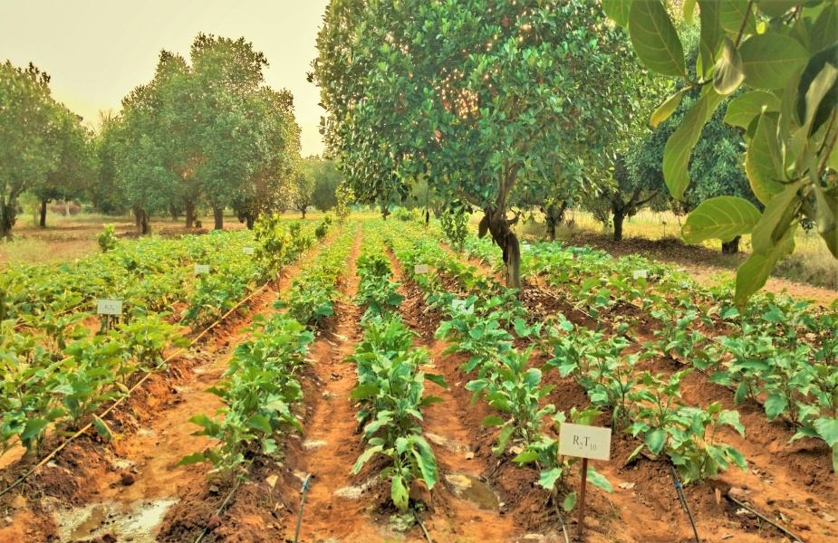  30 DAT | 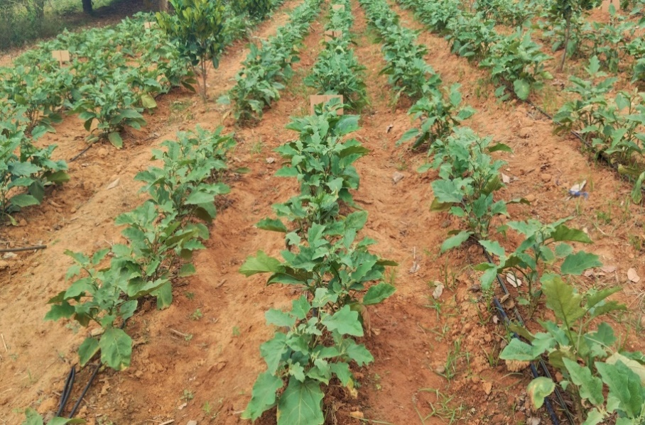  60 DAT

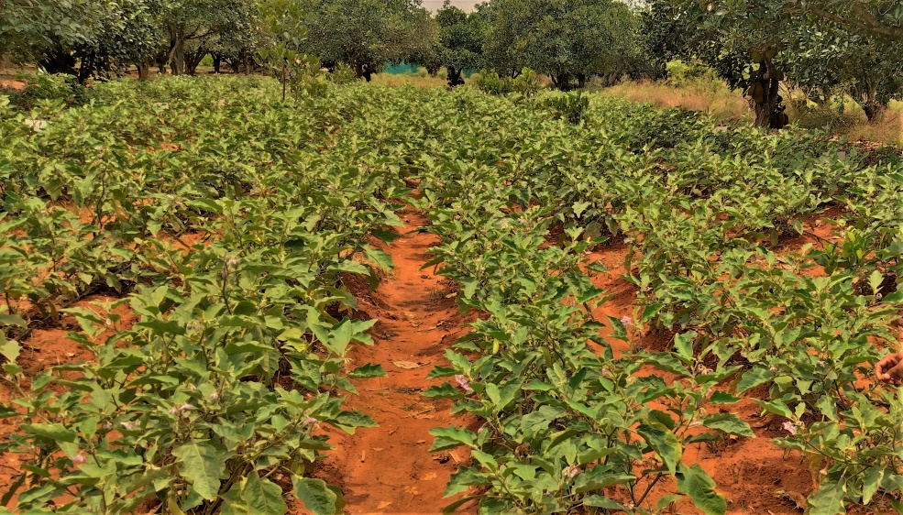
90 DAT
Plate 1. General view of brinjal experimental plot at different growth stages of crop
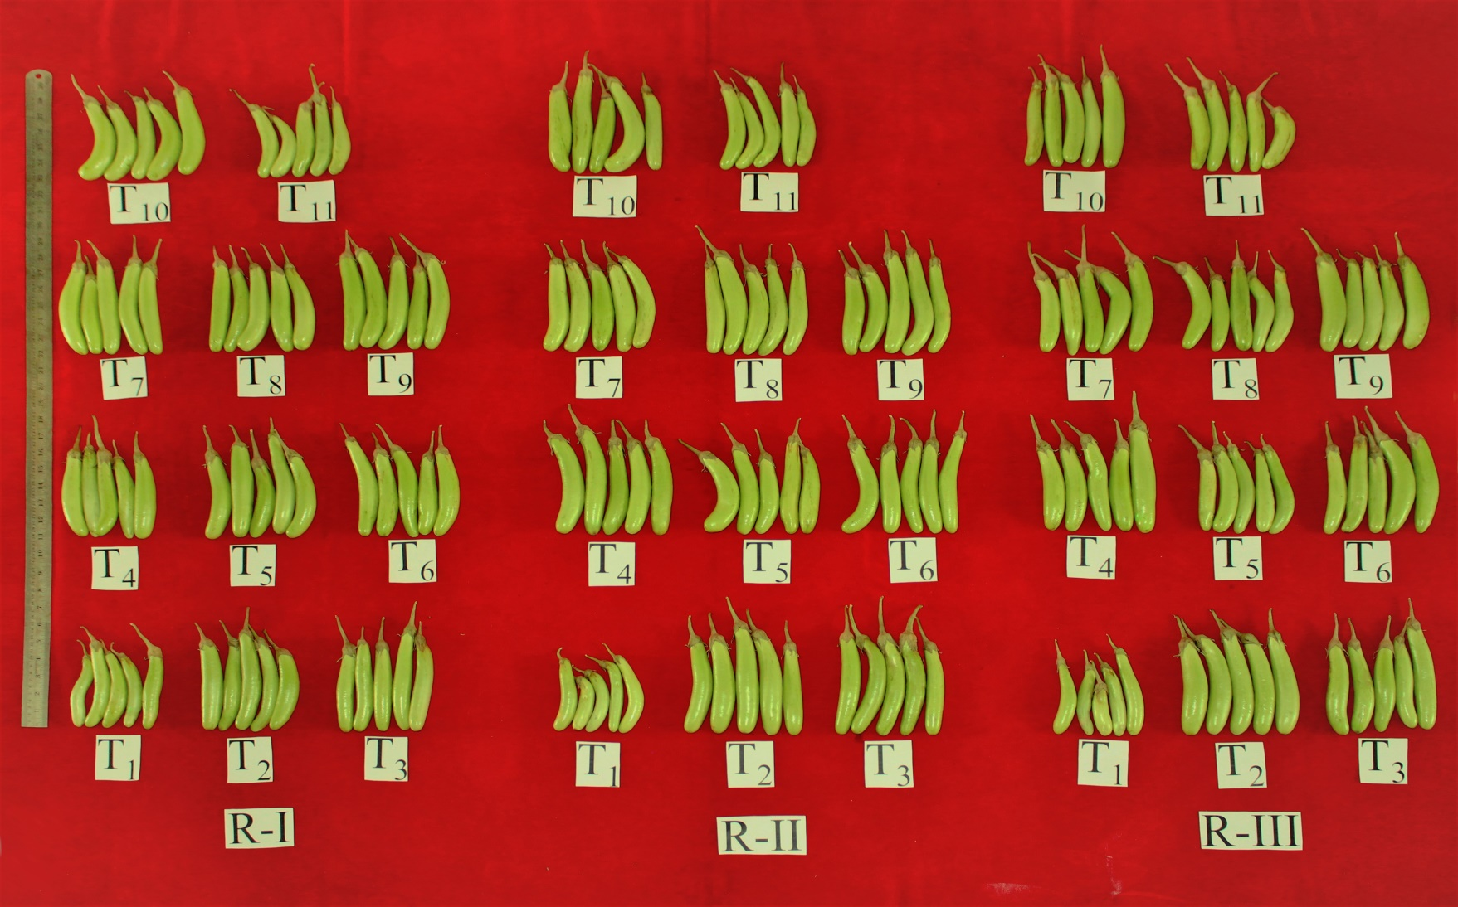
Plate 2. General view of brinjal fruits of all the treatments imposed

