Case report

Aggressive B-Cell Lymphoma Presenting as Ileocolic Intussusception in a Young Adult: A Case Report

Abstract
Aggressive b-cell lymphomas are rare in young adults and can present with unusual clinical manifestations, such as intussusception. we report a case of a 21-year-old male with acute ileocolic intussusception who was ultimately diagnosed with aggressive b-cell lymphoma. this case highlights the diagnostic and therapeutic challenges posed by intussusception secondary to lymphoma in adults, emphasizing the need for a multidisciplinary approach for optimal management.
Keywords: Primary gastro-intestinal lymphoma,ileocolic intussusception,B-cell lymphomas,

Introduction
Intussusception is described as invagination of the proximal intestinal segment within the lumen of the distal intestinal segment, First reported in 1674 by Barbette of Amsterdam and further presented in a detailed report in 1789 by John Hunter[1,2]
Although intussusception is common in children, intussusception represents 1% to 5% of all intestinal obstruction in adults.[3].intussusception in adults are secondary to a pathologic condition that serves as a lead point, such as carcinomas, polyps, Meckel’s diverticulum, colonic diverticulum, strictures or benign neoplasms, which are usually discovered intraoperatively.[4,5]
Primary gastro-intestinal lymphoma accounts for 1%-4% of all gastrointestinal malignancies. Most frequent primary sites are the stomach followed by the small intestine.
Most common non-Hodgkin’s lymphoma is diffuse large B-cell lymphoma and The most common lymphoma causing intussusception.[6]

Case Presentation
A 21-year-old male from RABAT MOROCCO presented to the emergency department of Ibn Sina University Hospital with generalized abdominal pain and persistent vomiting over three days. He had no relevant medical history or underlying conditions, and his initial symptoms were nonspecific, with no obvious signs of infection or trauma.
On admission, the patient was stable in terms of hemodynamic and respiratory status, afebrile, and alert. Physical examination revealed tenderness in the abdomen, with a palpable mass in the right flank, suggestive of a possible obstructive or inflammatory process.
Laboratory tests demonstrated a leukocytosis of 11,800/mm³ and an elevated C-reactive protein (CRP) level of 50 mg/L, indicating an inflammatory response. Abdominal computed tomography (CT) scan revealed an ileocolic intussusception extending to the transverse colon, with notable thickening at the ileocecal junction. These findings raised suspicion for a pathological lead point, possibly a mass, at the intussusception site[Figure1].
Given the urgency of the situation, the patient was taken to the operating room. Intraoperative findings confirmed the presence of ileocolic intussusception with an extensive segment of intestine involved and thickening at the ileocecal junction[Figure 2,3]. Additionally, a small amount of clear peritoneal effusion was noted. A right hemicolectomy was performed, with ileotransverse anastomosis using a mechanical stapler to re-establish bowel continuity. A Redon drain was placed at the anastomosis site for postoperative drainage.
Histopathological examination of the resected specimen confirmed the presence of aggressive B-cell lymphoma.
The patient’s postoperative recovery was uneventful, with gradual clinical and biological improvement. He was discharged on the sixth postoperative day with follow-up instructions.

Discussion
Intussusception occurs when a segment of bowel and its associated mesentery (the intussusceptum) invaginates into the lumen of an adjacent bowel segment (the intussuscipiens). While intussusception is a leading cause of intestinal obstruction in children, it adds only 1%-5% of all obstructions in adults.[7,8]

in adults is a rare condition, and its presence often signifies an underlying pathological cause.
Lymphoma represents 15%-20% of all small intestine tumors and 20%-30% of all primary gastrointestinal lymphomas. Stomach is the most commonly involved site followed by small intestine and rectum.
Adult intussusceptions are classified into three major types according to their site in the alimentary tract: entero-enteric which is limited to the small bowel, ileo-colic or ileo-cecal in which ileum invaginated through the ileo-cecal valve and colon-colic which is confined to the colon[9].
The pre-operative diagnosis of adult intussusception is challenging because the clinical presentation is often vague and the condition is rare. The radiological finding play a key role in the diagnosis Computed tomography is currently considered as the gold standard tool in confirming intussusception, Computed tomography showing Bowel-within-bowel configuration suggested by mesenteric vessels and fat compressed between the walls of the small bowel is pathognomonic of intussusception.[10,11]
Treatment of choice in adults is surgical resection of the involved bowel segment, since the lead point could be malignancy, which could not only metastasize but also attenuates blood flow, leading to necrosis of the involved bowel.[12]
The use of chemotherapy for localized disease is unclear, but it is offered under the assumption that lymphoma is a systemic disease requiring systemic therapy. The current chemotherapeutic standard of care is cyclophosphamide, doxorubicin, vincristine, and prednisone, with or without rituximab. Surgical resection combined with this chemotherapy has been shown to independently improve overall survival for intestinal large B-cell lymphoma[13,14].
Though rare as a cause of intussusception, it is well-documented in medical literature. Lymphomas can occasionally present as abdominal masses, particularly in the gastrointestinal tract, leading to obstruction or intussusception. The prognosis for aggressive lymphomas depends largely on the timeliness of the diagnosis and the effectiveness of subsequent treatment.
A multidisciplinary approach involving radiologists, surgeons, and pathologists is essential for timely diagnosis and effective management, particularly when presentation is atypical.

Conclusion
This case of aggressive B-cell lymphoma presenting as intussusception in a young adult underscores the importance of considering lymphoma in the differential diagnosis of intussusception in adults. Early surgical intervention combined with histopathological analysis is crucial for proper diagnosis and appropriate therapeutic management. This report adds to the limited literature on young adult patients with lymphoma presenting as intussusception, illustrating the need for awareness of this rare but significant clinical entity.

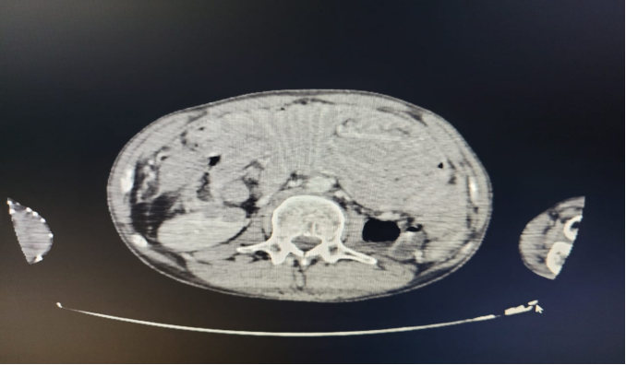

Figure 1 CT SCAN: ileocolic intussusception extending to the transverse colon, with notable thickening at the ileocecal junction

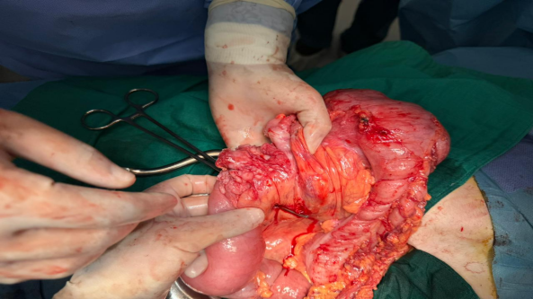
Figure 2 operative specimen of ileocolic intussusception from our patient

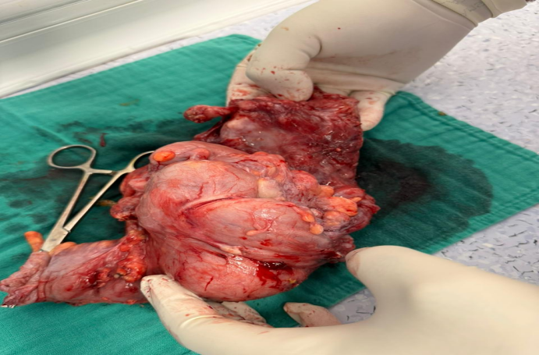
Figure 3 operative specimen of ileocolic intussusception from our patient

References
1. de Moulin D. Paul Barbette, M.D.: a seventeenth-century Amsterdam author of best-selling textbooks. Bull Hist Med. 1985;59:506–514.
2. Noble, Iris. Master surgeon: John hunter. J. Messner, 1971.
3. Luque-de-León E, Sánchez-Pérez MA, Muños-Juárez M, et al. Ileocolic intussusception secondary to Hodgkin’s lymphoma. Report of a case. Rev Gastroenterol México 2011;76:64-7.
4. Yin L, Chen CQ, Peng CH, et al. Primary small-bowel non-Hodgkin’s lymphoma: A study of clinical features, pathology, management and prognosis. J Int Med Res 2007;35:406-15
5. Ghimire P, Wu GY, Zhu L. Primary gastrointestinal lymphoma. World J Gastroenterol 2011;17:697-707.
6. Nagorney DM, Sarr MG, McIlrath DC. Surgical management of intussusception in the adult. Ann Surg. 1981;193:230–236. doi: 10.1097/00000658-198102000-00019.
7.Wagh AN, Ganesan B, Jawale HM, Mishra RA, Bhatt R. A rare case report of large B cell lymphoma in adult presentation as intussusception. Clin Pract. 2020 Oct 16;10(4):1292. doi: 10.4081/cp.2020.1292. PMID: 33123336; PMCID: PMC7586136.
8.Marinis A, Yiallourou A, Samanides L, et al. Intussusception of the bowel in adults: A review. World J Gastroenterol 2009;15:407-11.
9.Zubaidi A, Al-Saif F, Silverman R. Adult intussusception: A retrospective review. Dis Colon Rectum 2006;49: 1546-51.
10.Grin A, Chetty R, Bailey D. Mantle cell lymphoma as a rare cause of intussusception: a report of 2 cases. Ann Diagn Pathol 2009;13:398-401
11.Rockall AG, Hatrick A, Armstrong P, Wastle M. Diagnostic Imaging, Includes Wiley E-Text, 7th Edition. New York: Wiley-Blackwell; 2013.
12.D’Amore F, Brincker H, Grønbæk K, et al. Non-Hodgkin’s lymphoma of the gastrointestinal tract: A populationbased analysis of incidence, geographic distribution, clinicopathologic presentation features, and prognosis. J Clin Oncol 1994;12:1673-84.
13.Kim SJ, Kang HJ, Kim JS, et al. Comparison of treatment strategies for patients with intestinal diffuse large Bcell lymphoma: Surgical resection followed by chemotherapy versus chemotherapy alone. Blood 2011;117:1958-65.
14.Salemis NS, Tsiambas E, Liatsos C, et al. Small bowel intussusception due to a primary non-hodgkin’s lymphoma. An unusual presentation and clinical course. J Gastrointestinal Cancer 2010;41:233-7.

