Original Research Article
Expert perspectives on pregabalin and nortriptyline combination therapy for neuropathic pain in Indian settings

.
ABSTRACT
Objective: To gather clinicians' perspectives on the clinical use and prescription patterns of the combination therapy of pregabalin and nortriptyline for neuropathic pain in Indian settings.
Methodology: This cross-sectional study utilized a multiple-response questionnaire comprising 23 questions designed to gather information on clinical use, prescription patterns, clinical observations, and experiences from specialists regarding the management of neuropathic pain with a combination of pregabalin and nortriptyline in routine settings. Data analysis was performed using descriptive statistics.
Results: The study included 287 experts. Antidepressants, particularly nortriptyline, were identified as the preferred first-line pharmacotherapy by 41% of respondents. Additionally, 61% of clinicians reported frequently prescribing pregabalin for neuropathic pain. Among combination therapies, nortriptyline was the most commonly prescribed alongside pregabalin, as reported by 81% of participants. A significant proportion (65.16%) agreed that the combination of pregabalin and nortriptyline is highly effective for neuropathic pain. Approximately 52% of respondents considered the combination much more effective than monotherapy. The majority of clinicians (42.51%) identified patients with severe neuropathic pain unresponsive to monotherapy as the most likely to benefit from this combination therapy.
Conclusion: The study highlights that clinicians widely prescribe and consider the combination of pregabalin and nortriptyline as highly effective for neuropathic pain, especially in patients unresponsive to monotherapy and those with coexisting anxiety and depression. Clinicians strongly agree on its efficacy and consider it significantly more effective than monotherapy.
Keywords: Neuropathic pain, Antidepressants, Pregabalin, Nortriptyline

1. INTRODUCTION

The International Association for the Study of Pain (IASP) defines neuropathic pain as "pain caused by a lesion or disease of the somatosensory system," emphasizing its complex and often refractory nature. Studies indicate that neuropathic pain affects approximately 7–8% of the general population, significantly impacting quality of life, functional capacity, and socioeconomic burden [1,2]. In the UK, an estimated 7% of the population experiences neuropathic pain [1]. In India, the prevalence is reported to be around 10%, with even higher rates observed among individuals with diabetes, HIV/AIDS, and leprosy [3]. A study from South India reported a prevalence of up to 19% in specific populations, underscoring the substantial burden of neuropathic pain in certain high-risk groups [4].
Managing neuropathic pain presents significant clinical challenges due to its multifaceted pathophysiology and variability in patient response to treatment. Given its distinct pathophysiology, neuropathic pain requires a specialized treatment approach [2,5]. Neuropathic pain management primarily focuses on symptom control, with etiological treatment being possible only in select conditions. The Special Interest Group on Neuropathic Pain (NeuPSIG) recommends gabapentinoids (such as pregabalin), tricyclic antidepressants (TCAs) like nortriptyline, and selective serotonin-norepinephrine reuptake inhibitors (SNRIs) as first-line therapies for neuropathic pain [6].
Pregabalin, a gabapentinoid, modulates neuropathic pain by binding to the α2-δ subunit of voltage-gated calcium channels, reducing Ca²+ influx. Approved by the FDA for neuropathic pain, it effectively reduces pain and improves quality of life with fewer adverse effects like fatigue and dizziness [3,7]. TCAs are among the most extensively studied antidepressants for the treatment of neuropathic pain [8]. Nortriptyline, a TCA, exerts its effects by inhibiting serotonin and norepinephrine reuptake, thereby increasing the availability of these inhibitory neurotransmitters in the descending pain pathway, which helps modulate pain perception [9,10].
For patients who do not achieve adequate relief with monotherapy, combination therapy has emerged as an alternative. The concurrent use of pregabalin and nortriptyline has gained clinical interest due to their complementary mechanisms of action. Pregabalin modulates calcium channels to reduce excitatory neurotransmission, while nortriptyline enhances descending inhibitory pathways through noradrenergic and serotonergic effects [11]. By targeting different aspects of neuropathic pain pathways, this combination provides a synergistic effect, addressing both neuronal hyperexcitability and central sensitization while strengthening inhibitory pathways and reducing pain perception [12-14]. The combination of pregabalin with a TCA is now recognized as a treatment option for patients who are intolerant to high-dose monotherapy [11].
Despite its growing clinical use, data on clinicians' perspectives and the perceived effectiveness of this combination therapy remain limited. This study aims to address this gap by providing valuable insights into clinicians' perspectives on the clinical use of pregabalin and nortriptyline for neuropathic pain in Indian settings.

2. materialS and methods

A cross-sectional study was conducted among experts in managing neuropathic pain in routine clinical practice across India from June 2024 to December 2024. The study was performed after obtaining approval from Bangalore Ethics, an Independent Ethics Committee, which was recognized by the Indian Regulatory Authority, the Drug Controller General of India.
An invitation was sent to clinical professionals across India based on their expertise and experience in treating neuropathic pain in the month of March 2024 for participation in this Indian survey. About 287 clinicians from major cities of all Indian states, representing the geographical distribution, shared their willingness to participate and provide necessary data. Clinicians had the discretion to skip questions they did not wish to answer. Written informed consent was obtained from all participants, who were required to independently complete the questionnaire without consulting peers. Unanswered questions were treated as non-attempts.
The questionnaire booklet titled PENN (Evaluation of Pregabalin and Nortriptyline Combination Therapy for Neuropathic Pain) was sent to the doctors who were interested in participating in this study. The PENN study questionnaire comprised 23 questions covering current feedback, treatment preferences, clinical observations, and specialists’ experiences in managing neuropathic pain with combination therapy.
The data were analyzed using descriptive statistics. Categorical variables were presented as percentages, and the frequency of occurrence and the corresponding percentages were used to represent the distribution of each variable. To visualize the distribution of the categorical variables, graphs and pie charts were created using Microsoft Excel 2019 (version 16.0.17928.20114).
3. results

The study included 287 clinicians. Approximately 52% reported that 21% to 30% of their patients present with neuropathic pain in routine settings each month. According to 41% of participants, the majority of patients with neuropathic pain are between 41 and 50 years of age. Around 47% of experts indicated that approximately 10% to 20% of young patients (<40 years) present with neuropathic pain in routine settings. More than half (58.54%) of respondents identified diabetes mellitus (DM) as the most common cause of neuropathic pain.
According to 43% of clinicians, the most common symptom of neuropathic pain is a burning sensation. Half of the participants (50.17%) reported that the biggest challenge in managing neuropathic pain is poor patient adherence to medication. Additionally, 41% of respondents indicated that antidepressants (e.g., nortriptyline) are the preferred first-line pharmacotherapy for managing neuropathic pain (Fig. 1).

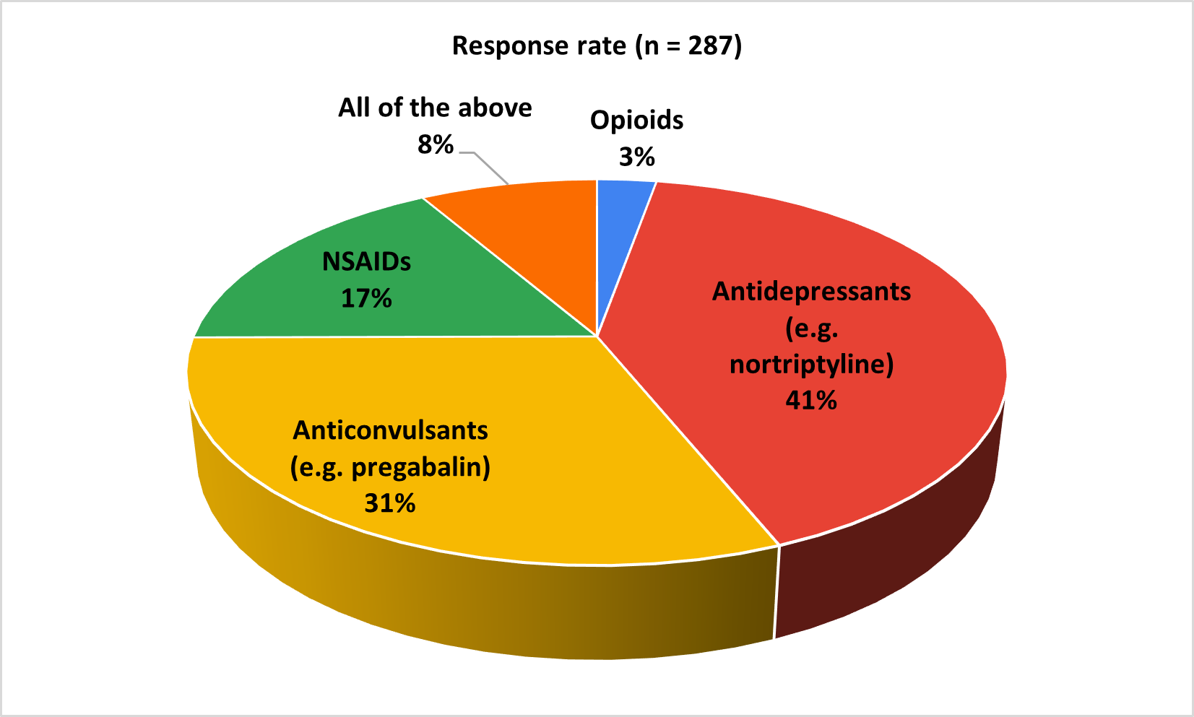
Fig. 1: Distribution of responses to the preferred first-line pharmacotherapy for managing neuropathic pain

About 61% of the participants reported that they prescribe pregabalin frequently for neuropathic pain compared to other medications (Fig. 2). Approximately 40% of clinicians reported observing improvements within the first two weeks of pregabalin use, while an equal proportion (40.42%) noted benefits within two to four weeks.

As reported by 50% of respondents, dizziness is the most commonly observed side effect in patients receiving pregabalin for neuropathic pain. In cases of an inadequate response to pregabalin monotherapy, 38% of respondents preferred combining pregabalin with a TCA, while 32% opted for titration of the pregabalin dose. According to 81% of experts, nortriptyline is the most commonly prescribed medication in combination with pregabalin for neuropathic pain (Fig. 3).

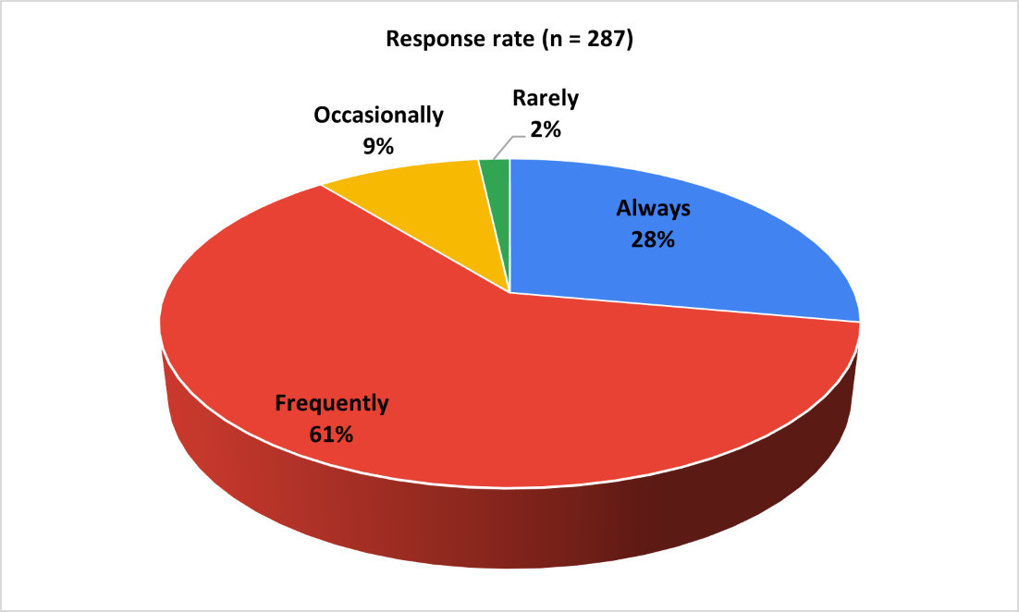
Fig. 2: Distribution of responses to the frequency of pregabalin prescription for neuropathic pain among clinicians

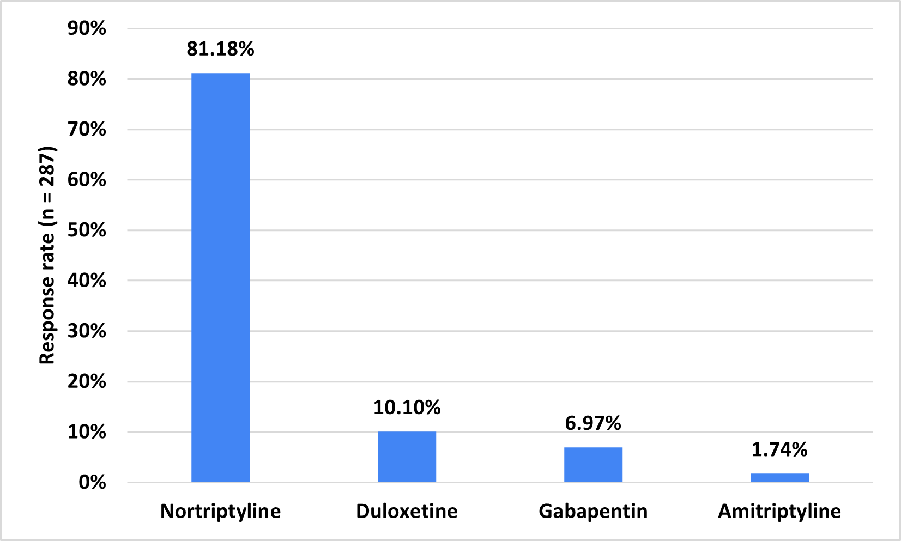
Fig. 3: Distribution of responses to the most commonly prescribed drug in combination with pregabalin for neuropathic pain

The majority of clinicians (65.16%) agreed that the combination of pregabalin with nortriptyline is significantly effective in treating neuropathic pain (Fig. 4). Approximately 57% stated that this combination is frequently prescribed in routine settings for treating neuropathic pain. The majority of experts (53.66%) expected improvement in neuropathic pain symptoms within 2 to 3 weeks of starting pregabalin with nortriptyline.

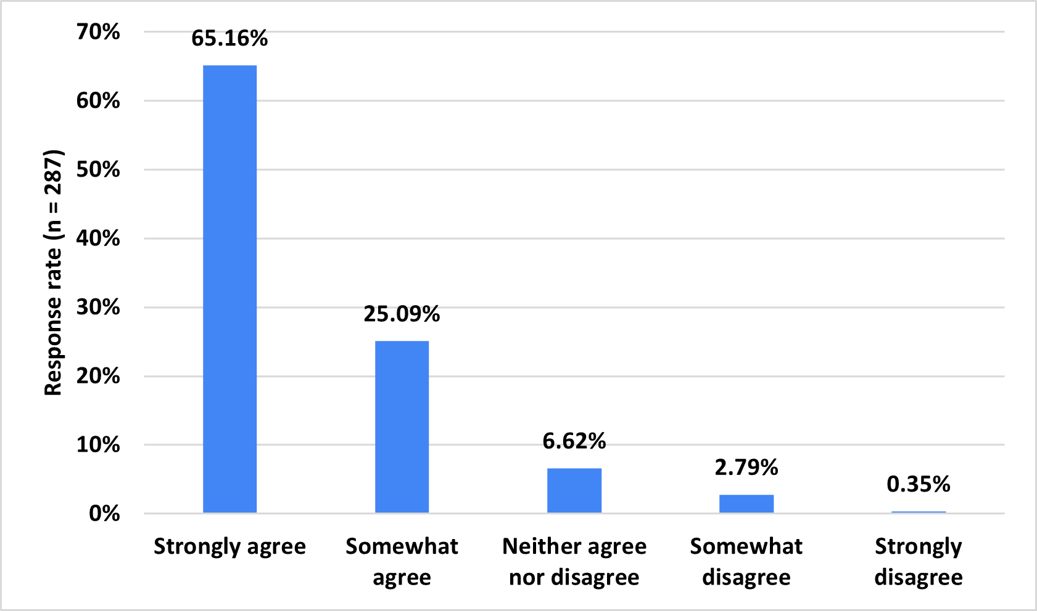
Fig. 4: Distribution of responses to the clinician’s agreement on the efficacy of pregabalin-nortriptyline combination for neuropathic pain

As indicated by 43% of respondents, enhanced pain relief is the primary reason for prescribing a combination of pregabalin and nortriptyline for neuropathic pain. About 52% of clinicians reported that this combination is much more effective than monotherapy (Table 1). According to 52% of participants, approximately 51% to 75% of patients on combination therapy with pregabalin and nortriptyline reported significant improvement in pain management.

Table 1. Distribution of responses to the clinicians' perception on the effectiveness of pregabalin and nortriptyline combination therapy compared to monotherapy for neuropathic pain
Effectiveness | Response rate (n = 287)
Much more effective | 51.92%
Moderately more effective | 36.93%
Slightly more effective | 9.76%
Not more effective | 1.05%
Not attempted | 0.35%

The majority of participants (42.51%) identified patients with severe neuropathic pain unresponsive to monotherapy as the group most likely to benefit from a combination of pregabalin and nortriptyline, while 37% of clinicians indicated that this combination is particularly beneficial for patients with coexisting anxiety and depression (Table 2). Approximately 57% stated that they frequently follow established guidelines (e.g., NICE, IASP) for managing neuropathic pain. About 38% of clinicians reported that they sometimes recommend the addition of non-pharmacological treatments in managing neuropathic pain.

As stated by 64% of participants, patients' reluctance to take medications is the most frequently encountered barrier when treating neuropathic pain. Approximately 33% of respondents reported that the most common approach to evaluating the impact of neuropathic pain on a patient’s quality of life is assessing functional outcomes such as the ability to work and sleep, while 31% of clinicians relied on patient self-reports during consultations.

Table 2: Distribution of responses to the clinicians’ perspectives on patient groups most likely to benefit from pregabalin and nortriptyline combination therapy
Patients group | Response rate (n = 287)
Patients with severe neuropathic pain unresponsive to monotherapy | 42.51%
Patients with coexisting anxiety and depression | 36.59%
Elderly patients with multiple comorbidities | 11.85%
Patients with a history of poor tolerance to other medications | 8.71%
Not attempted | 0.35%

4. discussion

The study findings provide valuable insights into the combination therapy of pregabalin and nortriptyline for the management of neuropathic pain in routine Indian settings. The results indicate that antidepressants, such as nortriptyline, are commonly preferred as first-line pharmacotherapy for managing neuropathic pain. In line with this finding, Dworkin et al. recommended nortriptyline, TCA, as a first-line treatment for neuropathic pain [15]. Additionally, Diego Fornasari emphasized that antidepressants have historically been among the earliest medications used for managing neuropathic pain [16].
In the current study, a significant proportion of clinicians reported prescribing pregabalin frequently for neuropathic pain compared to other medications, reflecting its widespread use in clinical practice. This finding aligns with a multicentre study by Freynhagen et al., which demonstrated that pregabalin significantly reduces neuropathic pain and is well tolerated [17]. Roy et al. found that pregabalin was prescribed to a significant proportion of patients, indicating its effectiveness and preference among clinicians [18]. Derry et al. also highlighted pregabalin as one of the recommended first-line treatments for neuropathic pain, attributing this to its proven efficacy and favorable safety profile [19].
According to the current study, nortriptyline was the most commonly prescribed medication in combination with pregabalin for neuropathic pain. This aligns with evidence from multiple studies supporting the efficacy and tolerability of this combination. An observational study by Giri et al. demonstrated that the combination of pregabalin and nortriptyline was effective and well-tolerated in patients with diabetic peripheral neuropathy [12]. Similarly, a randomized controlled trial by Das et al. concluded that combining pregabalin with nortriptyline led to better patient outcomes compared to pregabalin monotherapy [20]. Holbech et al. also indicated that the combination of pregabalin with a TCA like nortriptyline was widely preferred in clinical practice due to its improved efficacy [11]. Additionally, Bansod et al. reported that a fixed-dose combination of pregabalin and nortriptyline was an effective and well-tolerated option for managing neuropathic pain [21]. The present study further supports these findings, with clinicians strongly agreeing on the combination’s significant effectiveness in managing neuropathic pain. These results are consistent with conclusions by Khajuria et al., Navarro et al., and a meta-analysis by Marielle et al., which emphasized enhanced pain relief with gabapentinoid-antidepressant combinations [22-24].
The current study identified patients with severe neuropathic pain unresponsive to monotherapy as the group most likely to benefit from a combination of pregabalin and nortriptyline. Supporting this, Boccella et al. found that combining gabapentinoids like pregabalin with antidepressants such as nortriptyline provided greater pain relief than monotherapy, particularly in patients with inadequate response to single-agent treatment [25]. Similarly, Danish expert recommendations by Holbech et al. concluded that combining pregabalin with a TCA like nortriptyline is effective for patients who experience insufficient pain relief or cannot tolerate high doses of either drug alone [11].
The key strengths of the study include its large sample size and the use of a well-structured, validated questionnaire to gather data from clinicians. However, certain limitations must be acknowledged. The reliance on expert opinion introduces potential bias, as varying perspectives and preferences may influence the results. Additionally, the survey may not fully capture emerging evidence or evolving trends in neuropathic pain management. A notable limitation is the limited availability of extensive literature specifically addressing the combination of pregabalin and nortriptyline for neuropathic pain treatment. These limitations should be considered when interpreting the findings. To address them, future prospective trials or real-world observational studies are recommended to validate the survey results and provide a more comprehensive understanding of optimal treatment strategies.
5. Conclusion

The study highlights the significant burden of neuropathic pain, with diabetes mellitus as a leading cause. Pregabalin, commonly used as a first-line agent, showed early treatment benefits. The combination of pregabalin with nortriptyline is preferred for severe or refractory cases and patients with anxiety or depression. Despite guideline adherence, poor patient compliance and underuse of non-pharmacological strategies remain key challenges.

COMPETING INTERESTS DISCLAIMER:
Authors have declared that they have no known competing financial interests OR non-financial interests OR personal relationships that could have appeared to influence the work reported in this paper.

References

- Chong S. NICE neuropathic pain guidelines: clarity for initial treatment. Prescriber. 2014;25(6):8–10.
- Sharma H, Rani T, Khan S. An insight into neuropathic pain: A systemic and up-to-date review. Int J Pharm Sci Res. 2023;14(2):607-21.
- Raju N, Villavan S, Ravi S, Murugesan R, Theivendren P, Jaganathan V, et al. Clinical effectiveness and treatment satisfaction between two triple-therapy regimens in treating neuropathic pain: A real-world data. Ibrain. 2023;1‐14.
- Ashok S, Ramu M, Deepa R, Mohan V. Prevalence of neuropathy in type 2 diabetic patients attending a diabetes centre in South India. J Assoc Physicians India. 2002 Apr;50:546–50.
- Treede RD, Jensen TS, Campbell JN, Cruccu G, Dostrovsky JO, Griffin JW, et al. Neuropathic pain: redefinition and a grading system for clinical and research purposes. Neurology. 2008 Apr 29;70(18):1630–5.
- Finnerup NB, Attal N, Haroutounian S, McNicol E, Baron R, Dworkin RH, et al. Pharmacotherapy for neuropathic pain in adults: a systematic review and meta-analysis. Lancet Neurol. 2015 Feb;14(2):162–73.
- Cavalli E, Mammana S, Nicoletti F, Bramanti P, Mazzon E. The neuropathic pain: An overview of the current treatment and future therapeutic approaches. Int J Immunopathol Pharmacol. 2019 Mar 22;33:2058738419838383.
- Bates D, Schultheis BC, Hanes MC, Jolly SM, Chakravarthy KV, Deer TR, et al. A Comprehensive Algorithm for Management of Neuropathic Pain. Pain Med. 2019 Jun;20(Suppl 1):S2–12.
- Derry S, Wiffen PJ, Aldington D, Moore RA. Nortriptyline for neuropathic pain in adults. Cochrane Database Syst Rev. 2015 Jan 8;2015(1):CD011209.
- Maladkar MN, Tekchandani CM, Bajaj RK. A step closer in the management of uncontrolled neuropathic pain: gabapentin-nortriptyline combination. International Journal of Research in Orthopaedics. 2020 Oct 22;6(6):1365–70.
- Holbech JV, Jung A, Jonsson T, Wanning M, Bredahl C, Bach FW. Combination treatment of neuropathic pain: Danish expert recommendations based on a Delphi process. J Pain Res. 2017 Jun 26;10:1467–75.
- Efficacy and Tolerability of a Fixed Dose Combination of Pregabalin and Nortriptyline in the Management of Diabetic Peripheral Neuropathy among Indian Population. Indian Journal of Neurology. 2023 Dec 24;4(1):1–5.
- Verma V, Singh N, Singh Jaggi A. Pregabalin in Neuropathic Pain: Evidences and Possible Mechanisms. Curr Neuropharmacol. 2014 Jan;12(1):44–56.
- Merwar G, Gibbons JR, Hosseini SA, Saadabadi A. Nortriptyline. In: StatPearls [Internet]. Treasure Island (FL): StatPearls Publishing; 2025 [cited 2025 Mar 27]. Available from: http://www.ncbi.nlm.nih.gov/books/NBK482214/
- Dworkin RH, O’Connor AB, Audette J, Baron R, Gourlay GK, Haanpää ML, et al. Recommendations for the pharmacological management of neuropathic pain: an overview and literature update. Mayo Clin Proc. 2010 Mar;85(3 Suppl):S3-14.
- Fornasari D. Pharmacotherapy for Neuropathic Pain: A Review. Pain Ther. 2017 Dec;6(Suppl 1):25–33.
- Freynhagen R, Strojek K, Griesing T, Whalen E, Balkenohl M. Efficacy of pregabalin in neuropathic pain evaluated in a 12-week, randomised, double-blind, multicentre, placebo-controlled trial of flexible- and fixed-dose regimens. Pain. 2005 Jun;115(3):254–63.
- Roy MK, Kuriakose AS, Varma SK, Jacob LA, Beegum NJ. A study on comparative efficacy and cost effectiveness of Pregabalin and Duloxetine used in diabetic neuropathic pain. Diabetes Metab Syndr. 2017;11(1):31–5.
- Derry S, Bell RF, Straube S, Wiffen PJ, Aldington D, Moore RA. Pregabalin for neuropathic pain in adults. Cochrane Database Syst Rev. 2019 Jan 23;2019(1):CD007076.
- Das S, Saxena AK, Chilkoti GT, Singh A, Goel S. Evaluating the efficacy of combination therapy of Pregabalin plus Nortriptyline in the management of PHN patients: A randomized controlled study. International Journal of Medical Reviews and Case Reports. 2023 Aug 1;7(5):42–42.
- Bansod A, Meshram S, Bodele T. Tolerability and efficacy of fixed-dose combination of nortriptyline and pregabalin in managing peripheral neuropathy in diabetics. J Cardiovasc Dis Res. 2024;15(1):506.
- Khajuria K, Gupta S, Dogra DR, Kumar D, Khajuria V. Comparison of pregabalin and nortriptyline on efficacy and safety in postherpetic neuralgia. Asian J Pharm Clin Res. 2021;14(7):74-76.
- Navarro A, Saldaña MT, Pérez C, Torrades S, Rejas J. A cost-consequences analysis of the effect of pregabalin in the treatment of peripheral neuropathic pain in routine medical practice in primary care settings. BMC Neurol. 2011 Jan 20;11:7.
- Balanaser M, Carley M, Baron R, Finnerup NB, Moore RA, Rowbotham MC, et al. Combination pharmacotherapy for the treatment of neuropathic pain in adults: systematic review and meta-analysis. PAIN. 2023 Feb;164(2):230.
- Boccella S, De Filippis L, Giorgio C, Brandolini L, Jones M, Novelli R, et al. Combination Drug Therapy for the Management of Chronic Neuropathic Pain. Biomolecules. 2023 Dec 16;13(12):1802.

