Technical characterization of a pilot mechanized processing unit installed in Ouagadougou: the case of cassava

.
ABSTRACT

Processing operations for tubers such as cassava are traditionally carried out using knives, machetes, mortars and other tools. Mechanized processing units are sometimes used, but they are energy-intensive. Thus, it is necessary to propose processing units that are optimal in energy and meet the needs of users. The technical characterization of the equipment of the pilot mechanized cassava processing unit installed at the Institute of Research in Applied Sciences and Technologies (IRSAT) meets this objective. It was carried out on a washer, a peeler, a grater and a spin dryer. The results showed the spin dryer to be more energy-intensive with a nominal consumption of 7.5 kW. All equipment is equipped with low-voltage three-phase electric motors. The productivities of the equipment are between 100 and 2500 kg/h.

Keywords: cassava, processing unit, technical characterization, mechanized.

1. INTRODUCTION
Cassava is recognized as one of the main sources of energy in the diet of tropical regions. Africa is at the top of world production with more than 154 million tons [1, 2]. Cassava processing is an alternative and a means to obtain long-life products, thus reducing post-harvest losses [3]. Processing involves many difficulties in terms of labour intensity and the absence of optimized and standardized equipment [4]. The processing diagram includes several operations (washing, peeling, grating, spinning, etc.) implemented using equipment. Mechanized processing units are sometimes used, but they are energy-intensive. Bottlenecks exist in the processing chain. They are characterized by the absence of modern equipment, laborious operations, high production costs, and poor hygiene in processing areas [ 5-9]. Added to this are the energy difficulties of Burkina Faso, even though it has enormous solar energy potential, and the high costs of conventional energy [10]. The choice of an appropriate industrial machine is crucial for the competitiveness and efficiency of the company. It must take into account certain factors such as the needs of users, the capacity of the machine, its energy efficiency, its reliability, its impact on the environment and the safety of operators.
Thus, it is necessary to propose a mechanism to make the transformation units energy efficient and meet the needs of users. It is with this in mind that the mechanized pilot transformation unit of the Institute for Research in Applied Sciences and Technologies (IRSAT) was installed as part of a FONRID project in 2021. This project aims to improve the profitability of attiéké production by integrating efficient equipment using solar energy. The objective of this work is to present the technical characteristics of the IRSAT mechanized pilot cassava processing unit.

2. material and methods
2.1. Composition of the cassava processing chain
One of IRSAT's cassava-to-attiéké processing units (or production units) is being developed as part of a project entitled "Establishment of a complete mechanized attiéké platform with integrated renewable energy." The objective is to contribute to improving the profitability of attiéké production by integrating high-performance equipment using solar energy.
Table 1 shows all the equipment in the processing line.

Table 1. Composition of the attiéké production chain (IRSAT, Ouagadougou)
Equipment | Engine reference | Nominal power (kW) | Yield
Washer (Figure 2) | Y2-112 M-2 | 4 | 0.82
Peeler (Figure 3) | LS 100 L | 3 | 0.81
Grater or grinder (Figure 4) | LS 112 / 4 | 4 | 0.82
Wringer (Figure 5) | Y2 - 132 M - 4 | 7.5 | 0.887

Table 1 shows that the nominal power of the wringer motor is the highest. It represents the power that can drive the wringer. Efficiency is the ratio between the nominal power and the electrical power absorbed from the electrical network. The efficiencies were noted on the nameplates of the motors of each equipment. Figure 1 shows the values of nominal power and efficiency on the nameplate for the wringer.

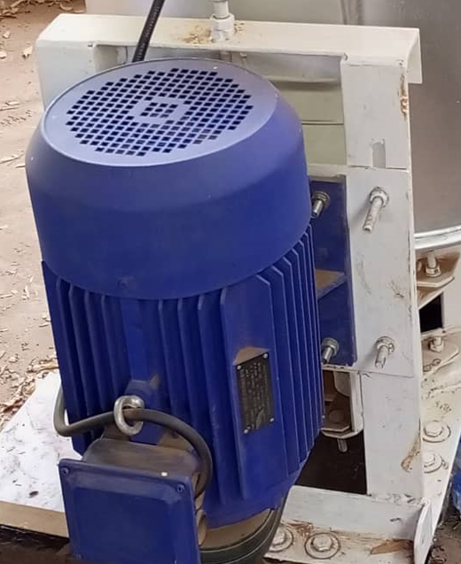 | 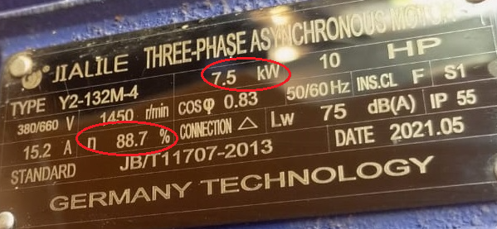
a) Engine overview | b) Engine efficiency and rated power
Fig. 1. Description of the spin dryer motor

Each of these four devices has a low voltage (LV) three-phase asynchronous electric motor. This type of motor is called an induction motor and has two essential parts (stator and rotor). The stator has three coils that create three magnetic fields. These three fields together create a rotating field that drives the rotor in rotation by creating an electromagnetic force. The rotor can be in two different configurations, namely short-circuited or wound [11] [12].
2.2. Description of equipment
The washer:
The washer is shown in Figure 2.
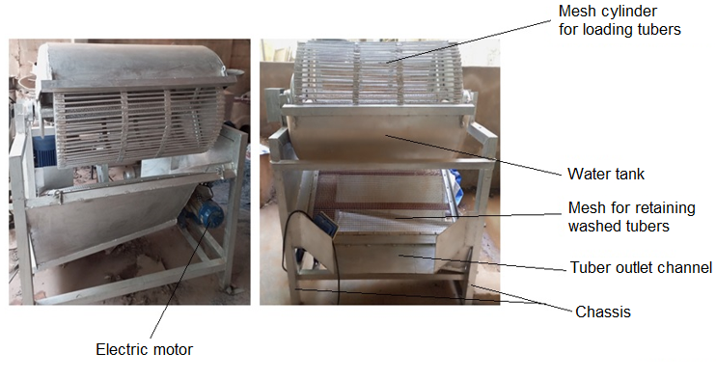
Fig. 2. Washer
The tubers are loaded into the mesh cylinder according to the desired quantity, then water (measured volume) is added to the water tank until the tubers are completely submerged. The engine is started. By operation based on the principles of integration of mixing, friction, lifting and impact, all impurities such as silt and sand are forcefully removed without any breakage of the raw material. The washed tubers are collected through the tuber outlet channel using a container and the washing water is discharged through the water outlet channel.

The peeler:
The peeler is shown in Figure 3.
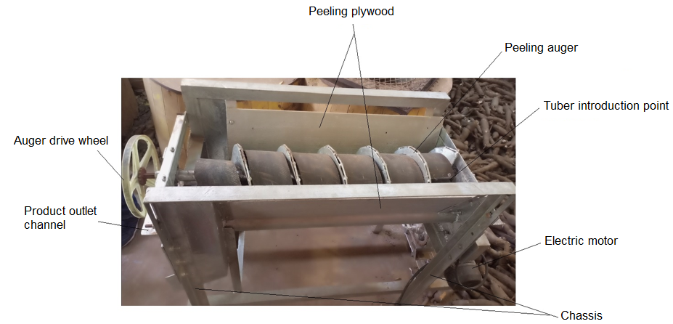
Fig. 3. Peeler

Before loading the hopper (peeling plywood), the equipment is started. The rotational movement of the motor shaft is transmitted to the drum via a series of toothed chain-pinions. The drum therefore performs a continuous rotational movement around the fixed axis. By friction between the metal brushes and the cassava roots, the cassava peel is gradually removed according to the direction of the drive wheel which guides the load and the peeling is carried out. A quantity of water depending on the load is used to clean the peeling brushes. The peelings fall gradually through the gaps between the brush mounts. After a certain time depending on the quantity loaded in the hopper, the level of peeling of all the roots is checked. If the peeling rate is suitable, then the peeled cassava roots are recovered through the product outlet channel.

The grater:
The grater is shown in Figure 4.
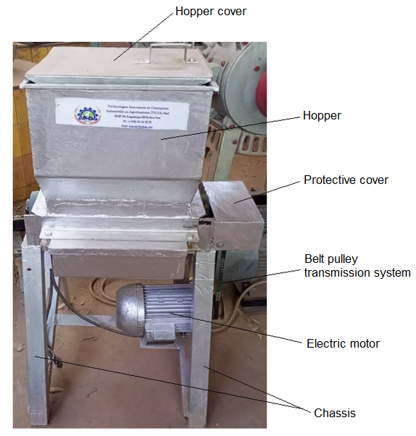
Fig. 4. Grater
The grater, made of stainless steel, meets food and hygiene standards and is powered by an electric motor. It is mainly composed of a frame in a mechanically welded structure, a feed hopper, a grating chamber containing a grating drum, a channel for recovering the finished product. The transmission is provided by a belt pulley which ensures the rotation of the grating drum in the grating chamber.

The wringer:
The wringer is shown in Figure 5.
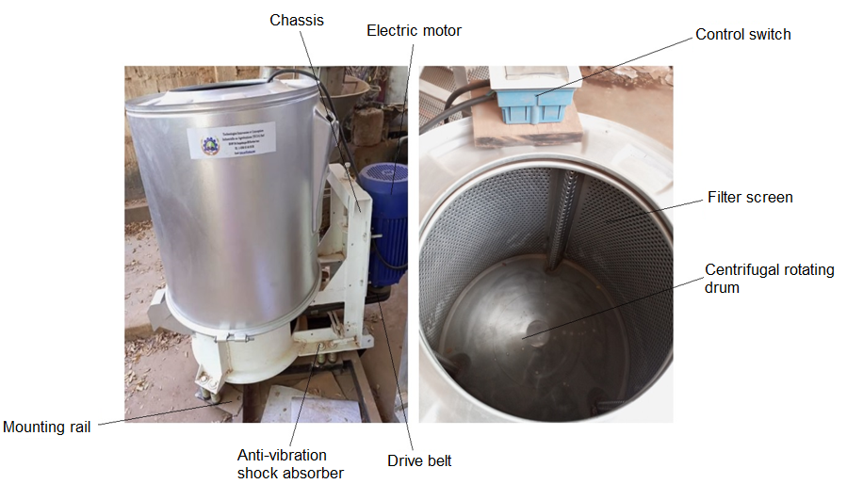
Fig. 5. Wringer
The spin dryer is used to remove water from cassava dough after grating. This is the centrifugation principle. Before this operation, the cassava dough is wrapped in a white cloth or mosquito net that complies with food hygiene. After loading the dough into the hopper containing a filter screen, the motor is started. The rotational movement of the spinning drum is ensured using a belt transmission. This process allows the water to be recovered using a container placed at the outlet channel.
2.3. Measuring tools used
The measurement of the different parameters required the use of several measuring tools:
- The working speed was measured using a tachometer. This method is performed without contact using a laser beam. Reflective adhesive tape is stuck on the machine, then the laser beam is directed towards this tape when the machine is in motion. The tachometer detects the reflections of the beam. Knowing that each reflection corresponds to a complete revolution of the machine, the tachometer calculates its working speed. It is expressed in rpm.
- The productivity of the machine is obtained by measuring the time taken to produce a given quantity of material. The quantity produced is then divided by the time taken and the result corresponds to the productivity of the machine. It is expressed in kg/h.
- The capacity of the loading cylinder was measured using an industrial scale.
- The footprint, the height of the product outlet channel and the height of the water outlet channel were measured using a measuring tape.
- The power absorbed by the machine on the electrical network was calculated from the following equation.
$Pa= \frac{Pn}{r}$ (1)
Pn is the nominal operating power, i.e. the power that can drive the machine and r is the efficiency. Pn and r are given on the machine nameplate.

3. results
3.1. Technical characteristics of the unit's equipment
The technical characterization of the equipment took place from November 2 to 3, 2023. Some characteristics were obtained through measurements carried out on each piece of equipment. Other characteristics come from the equipment's nameplate and technical instructions.

The washer:
Figure 6 shows the washing operation.

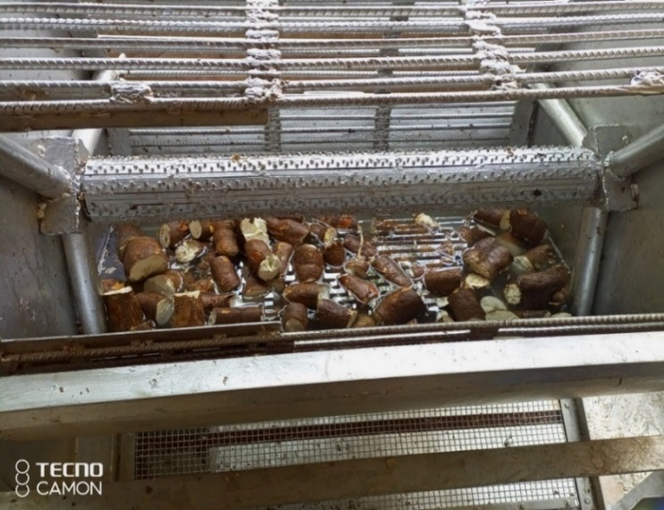 | 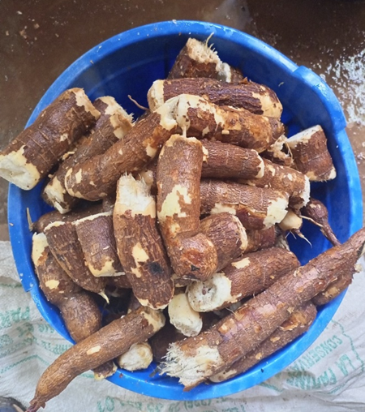
a) Loading (cassava and water) of the washer | b) Cassava after washing
Fig. 6. Cassava washing operation

The technical characteristics of the washer are presented in Table 2.

Table 2. Technical characteristics of the washer
Settings | Specifications
Energy source | Electric
Power consumption (kW) | 4.878
Working speed (rpm) | 15
Dimensions (L x W x H) (mm³) | 1300 x 1500 x 1700
Loading cylinder capacity (m³) | 0.48
Water tray materials | Stainless steel
Chassis materials | Ordinary steel
Productivity (kg/h) | 400
Height of product outlet channel from ground (cm) | 62
Height of the water outlet channel from the ground (cm) | 22

The washing machine is powered by an electric power source with an absorbed power of 4.878 kW. The working speed of the washing machine is 15 rpm. The washing machine has a width of 1300 mm, a length of 1500 mm and a height of 1700 mm. The capacity of the loading cylinder is 0.48 m³. The materials used for the manufacture of the water tank are stainless steel to avoid product contamination and the frames are ordinary steel. The productivity of our equipment is 400 kg / h. The product outlet height from the ground is 60 cm this height guarantees a healthy product at the outlet and the height of the water outlet channel from the ground is 22 cm.

The peeler:
Figure 7 shows the peeling operation.

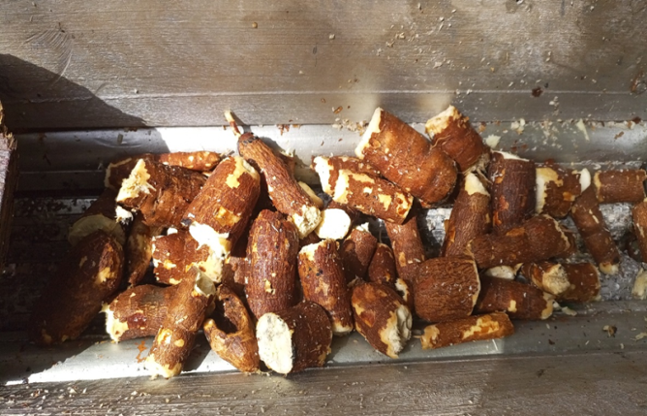 | 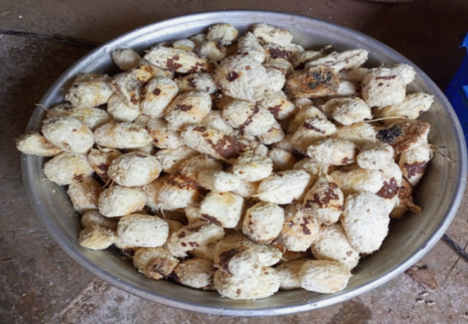
a) Loading cassava for peeling | b) Cassava after peeling
Fig.7. Cassava peeling operation

The technical characteristics of the peeler are presented in Table 3.

Table 3. Technical characteristics of the peeler
Settings | Specifications
Energy source | Electric
Power consumption (kW) | 3.703
Working speed (rpm) | 210
Dimensions (L x W x H) (mm³) | 700 x 1600 x 1100
Loading cylinder capacity (kg) | -
Plywood Materials | Stainless steel
Chassis materials | Ordinary steel
Productivity (kg/h) | 500
Height of product outlet channel from ground (cm) | 60

The peeler is powered by an electric power source with an absorbed power of 3.703 kW. The working speed of the peeler is 210 rpm. The peeler has a width of 700 mm, length of 1600 mm and height of 1100 mm. The materials used for the manufacture of the peeling tear are stainless steel to avoid product contamination and the frames are ordinary steel. The productivity of our equipment is 500 kg/h. The height of the product outlet from the ground is 60 cm this height guarantees a healthy product at the outlet.

The grater:
Figure 8 shows cassava tubers before and after grating.
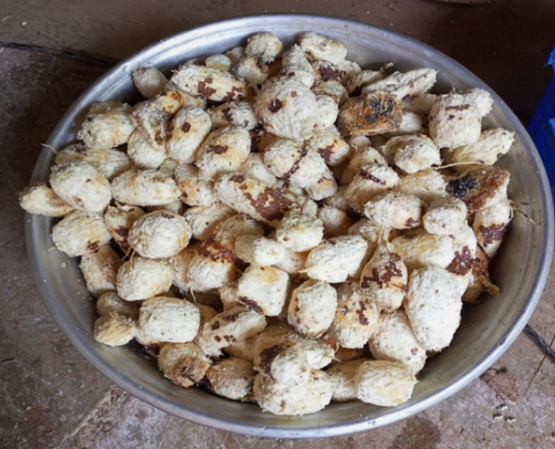 | 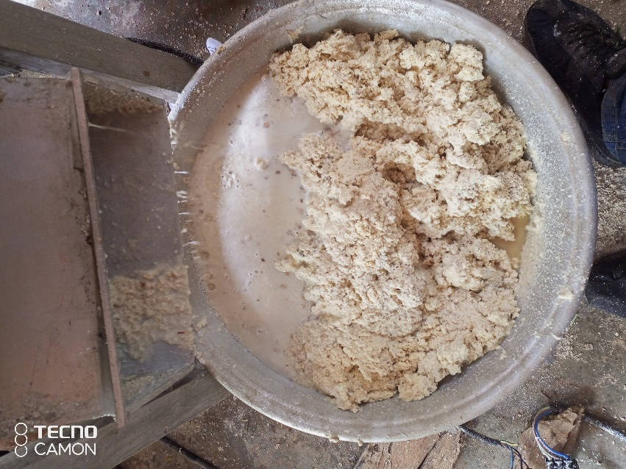
a) Cassava tuber before grating | b) Cassava paste after grating
Figure 8: Appearance of cassava before and after grating

The technical characteristics of the grater are presented in Table 4.

Table 4. Technical characteristics of the grinder or grater
Settings | Specifications
Energy source | Electric
Power consumption (kW) | 4.878
Working speed (rpm) | 1400
Dimensions (L x W x H) (mm³) | 700 x 700 x 1200
Hopper capacity (m³) | 0.05
Hopper Materials | Stainless steel
Chassis materials | Ordinary steel
Productivity (kg/h) | 2500

The grater is powered by an electric power source with an absorbed power of 4.878 kW. The working speed of the grater is 1400 rpm. The grater has a width of 700 mm, length of 700 mm and height of 1200 mm. The capacity of the loading hopper is 0.05 m³. The materials used for the manufacture of the hopper are stainless steel to avoid product contamination and the frames are ordinary steel. The productivity of our equipment is 2500 kg/h.

The wringer:
Figure 9 shows the cassava dough before and after spinning.

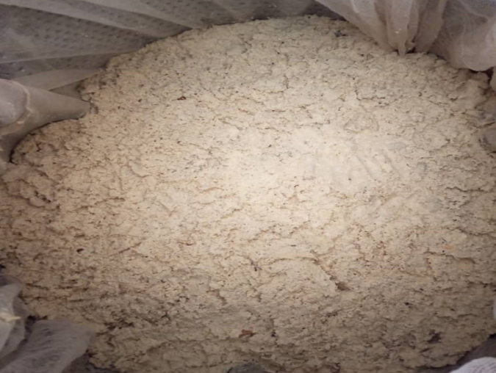 | 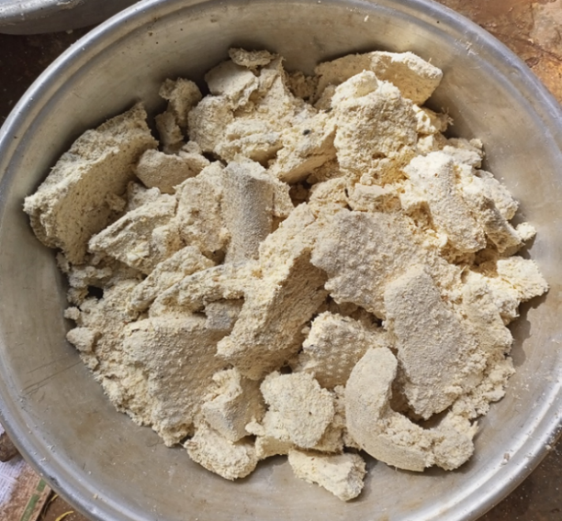
a) Cassava paste in the wringer | b) Cassava paste after spinning
Figure 9: Cassava paste before and after spinning

The technical characteristics of the wringer are presented in Table 5.
Table 5. Technical characteristics of the wringer
Settings | Specifications
Energy source | Electric
Power consumption (kW) | 8.455
Working speed (rpm) | 1450
Dimensions (L x W x H) (mm³) | 1000 x 1400 x 1200
Capacity (m³) | 0.19
Materials | Stainless steel
Chassis materials | Ordinary steel
Productivity (kg/h) | 100
Height of the finished product outlet channel from the ground (cm) | 30.3

The spin dryer is powered by an electric power source with an absorbed power of 8.455 kW. The working speed of the spin dryer is 1450 rpm. The washer has a width of 1000 mm, length of 1400 mm and height of 1200 mm. The loading cylinder capacity is 0.19 m³. The materials used for the manufacture of the hopper and the filter screen are stainless steel to avoid product contamination and the frames are ordinary steel. The productivity of the equipment is 100 kg/h.

4. Conclusion
In this work, we presented all the equipment of the mechanized pilot cassava processing unit and their technical characteristics. The results showed that the most powerful equipment is the spin dryer. All equipment has low-voltage three-phase electric motors. For their manufacture, the material used is stainless steel. The frames are made of ordinary steel. Productivity is between 100 and 2500 kg/h. This study is important for processors because the choice of equipment is made from technical characteristics. In short, the characterization of the machines is essential to ensure their optimal operation, efficiency, safety, and durability.

Consent (where ever applicable)
All authors declare that ‘written informed consent was obtained from the patient (or other approved parties) for publication of this case report and accompanying images. A copy of the written consent is available for review by the Editorial office/Chief Editor/Editorial Board members of this journal.

References
[1] Vodounnou E. C., Semassou G. C., Ahouansou H. R., Fachola H., and Guidi T. C., Study and design of a cassava peeler, International Journal of Innovation and Applied Studies, ISSN 2028-9324 Vol. 35 No. 1 Dec. 2021, pp. 83-97.
[2] FAO/INFOODS. Annual report on the results of 2018. 217 p.
[3] Sawadogo K., Ye S. G., Lingani A. K. H. and Kam S., Cassava-to-Attiéké Transformation: A Diagnosis Study in Banfora, Bobo Dioulasso and Ouagadougou, Current Journal of Applied Science and Technology, Volume 43, Issue 11, Page 68-79, 2024; Item no. CJAST.125327 ISSN: 2457-1024.
[4] Lingani A. K. H., Design and Energy Optimization of a Tuber Cutter with Integrated Maintenance in Chip Production, Doctoral Thesis, Ouagadougou: Joseph KI-ZERBO University, Burkina Faso, 2021.
[5] Cock J. H., Cassava: New Potential for a Neglected Crop, Westview Press, Boulder, CO, USA, 191p. 1985.
[6] KOUAKOU J., Nanga S. N., Catherine P. I., Edoh A. M. P., and Ognakossan K., Cassava Production and Processing, CTA / ISF Cameroon, Yaoundé, 2015.
[7] CTA, Sweet Potato Chips and Flour Production, CTA Practical Guide Series, No. 6. CTA, Wageningen, The Netherlands, 2008.
[8] Fiagan and Chinsman, Appropriate Postharvest Techniques for Root and Tuber Crops in Africa: Evaluation and Recommended Improvements, Tropical Root Crops: Root Crops and the Food Crisis in Africa, Proceedings of the Third Triennial Symposium of the International Society for Tropical Root Crops - Africa Branch, August 17-23, 1986, Owerri, Niger. (1987).
[9] GERES, User Guide for Cassava Processing Equipment. Zou, Benin, (2013).
[10] Lingani A. K. H., Ye S. G., and Kam S., Technical Diagnosis of Cassava Processing Units in the Comoé and Kénédougou Provinces of Burkina Faso, Afrique SCIENCE 18(3) (2021) 61–73.
[11] Hardy J., Bianciotto A., Boye P., Professional Guide to Electrical Trades, DELAGRAVE Edition – 2006, ISBN 978-2-206-08918-8.
[12] Wildi P., Sybille G., Electrotechnics, DeBoeck University, 3rd edition, 2000.

