Original Research Article
Identification by LC-MS of phytocompounds present in ethanol extracts of crushed and sieved Manihot esculenta leaves

ABSTRACT
Aims: This study aims to identify and characterize, using liquid chromatography-mass spectrometry (LC-MS), the phytocompounds present in ethanol extracts obtained from the crushed and sieved leaves of Manihot esculenta, with a view to comparing the chemical composition of these two forms of preparation.
Study design: The research adopts an experimental, analytical, and comparative design aimed at identifying and comparing the phytochemicals present in the ethanol extracts of the crushed and sieved leaves of Manihot esculenta by LC-MS.
Place and Duration of Study: Laboratory of Bio-Organic Chemistry and Natural Substances, Nangui ABROGOUA University, Abidjan, Ivory Coast, between January 2025 and September 2025.
Methodology: After drying, the plant material was ground to obtain a powder known as Broyat. This was then sieved using a 1 mm mesh to produce Tamisat. The ethanol extracts were prepared by Soxhlet extraction, using a liquid-liquid contact process. Phytochemical screening was performed using identification tests based on color reactions in test tubes. Finally, the study was completed by LC-MS analysis performed in positive mode.
Results: Qualitative phytochemical screening revealed the presence of polyphenols, flavonoids, coumarins, tannins, and sterols/terpenes in both matrices, confirming the chemical richness of the species. LC-MS analysis then revealed six bioactive compounds in the Broyat, including scopoletin, scopolin, rutin, nicotiflorin, caffeic acid, and gallic acid, while the Tamisat had a more limited composition, notably lacking hydroxycoumarins such as scopoletin and scopolin.
Conclusion: These results highlight the influence of preparation methods on the metabolic profile obtained. Functionally, the compounds identified are known for their antioxidant, anti-inflammatory, and antidiabetic properties, thus giving M. esculenta leaves potential interest for biomedical and nutritional applications.
Keywords: phytocompounds, Broyat, Tamisat, LC-MS analysis.
- INTRODUCTION
Extraction is a key step in the study of organic compounds derived from plants. Over time, numerous methods and techniques have been developed to obtain extracts concentrated in bioactive compounds. The effectiveness of this operation depends on several parameters, including the nature of the solvent, temperature, solid/liquid ratio, pH, pressure, number of extraction cycles, and particle size of the plant materials (Azmir et al., 2013). The latter, which corresponds to particle size, refers here to the particles obtained after grinding the plant organs and then sieving them. Grinding generates heterogeneous particles, which can be classified according to their size by sieving. In an effort to optimize the extraction of specialized metabolites, some researchers favor the use of Broyat, while others prefer Tamisat. A phytochemical and biological study conducted on Manihot esculenta leaves revealed that Broyat yields a higher number of extractable phytochemicals, regardless of the solvent or species considered. However, Tamisat concentrates more compounds of interest, resulting in higher antioxidant activity (DPPH test) and antibacterial action against Staphylococcus aureus than Broyat from the same species (N'guessan et al., 2024). The present study aims to identify, by LC-MS analysis, the active phytochemicals present in the pulverized and sieved leaves of Manihot esculenta.
- MATERIAL AND METHODS
  - Material
2.1.1 Plant material
The plant material used consists of Manihot esculenta leaves harvested at the Nangui ABROGOUA University (UNA) site in Abidjan, Ivory Coast. Botanical identification was carried out by comparison with specimens from the herbarium of the National Floristic Center (CNF) at Félix Houphouët-Boigny University (Cocody, Abidjan). After harvesting, the leaves were carefully cleaned and then dried successively: two days away from sunlight in a ventilated room, seven days in an air-conditioned room at 18°C, and finally three days in an oven set at 45°C.
2.1.2 Technical equipment
The technical equipment consists of an electric grinder (Nutri Blitzer GS 158-V1457), a rotary evaporator (BÜCHI type EL-131), a Soxhlet extractor, and a liquid chromatograph (Agilent 1260 Infinity) coupled with a mass spectrometer (Agilent 6530 Q-TOF-MS). Mass Hunter Workstation is software for analyzing spectrometric data (HPLC-ESI-MS) provided by the Agilent Quadrupole Time Of Flight (Q-TOF) device, Q-TOF 6200, TOF/6500 series Q TOF B.08.00 (B8058.0).
2.1.3 Chemical equipment
The chemical materials consist of: ethanol, formic acid, acetonitrile, iron (III) chloride, sodium hydroxide, acetic anhydride, acetic acid, copper sulfate, and Shinoda, Molisch, and Fehling's reagents.
  - Methods
2.2.1 Acquisition of powders with different particle sizes
After drying, the plant material was pulverized using an electric grinder (Nutri Blitzer GS 158-V1457) to produce powders called “Broyat.” The Broyat was then passed through a 1 mm mesh sieve to obtain “Tamisat”.
2.2.2 Extraction Soxhlet
A Whatman cartridge containing 5 g of plant powder is placed in the extraction chamber, connected to a refrigerator at the top and to a round-bottom flask containing 300 mL of solvent at the bottom. Ethanol was chosen as the extraction solvent. After vacuum filtration, the ethanol extracts obtained from the crushed and sieved Manihot esculenta leaves were concentrated using a rotary evaporator maintained at 40°C, then stored in bottles protected from light. These crude ethanol extracts were then used both for phytochemical screening by colorimetric reactions and for phytochemical analysis by LC-MS.
2.2.3 Phytochemical screening using color reactions
The analytical methods reported in the literature were applied to identify the phytochemicals contained in the ethanol extracts of the crushed and sieved leaves of Manihot esculenta (Békro et al., 2007).
2.2.4 LC-MS analysis
HPLC-ESI-Q-TOF-MS analysis of the fractions was performed using an Agilent LC-MS system, combining an Agilent 1260 Infinity liquid chromatograph and an Agilent 6530 Q-TOF-MS mass spectrometer equipped with an ESI source. Acquisitions were performed in positive ionization mode. Chromatographic separation was performed on a Sunfire® C18 Waters analytical column (150 mm × 2.1 mm, 3.5 µm) at a flow rate of 250 µL/min. The elution gradient was based on two mobile phases, namely channel A consisting of water acidified with 0.1% formic acid and channel B consisting of acetonitrile, applied according to a 40-minute program comprising a transition from 0 to 5% B between 0 and 5 minutes, followed by a gradual increase from 5 to 95% between 5 and 15 minutes, then from 95 to 100% between 15 and 25 minutes, maintaining 100% B from 25 to 30 minutes, a regression from 100 to 0% between 30 and 32 minutes, and finally stabilizing at 0% B from 32 to 41 minutes. The injection volume was set at 5 µL, and all data were processed and interpreted using Agilent Mass Hunter Workstation software (Kouamé et al., 2025).
- RESULTS AND DISCUSSION
  - Qualitative phytochemical profile
The results of tube tests to detect the presence of certain families and/or classes of metabolites contained in different Manihot esculenta powders (Broyat, Tamisat) are shown in Table 1:
Table 1. Phytocompounds identified in the Broyat and Tamisat from Manihot esculenta leaves
Compound families | Reagents | M. esculenta
Compound families | Reagents | Broyat | Tamisat
Polyphenols | F_{e}Cl₃(2%) | + | +
Tannins | FeCl₃ (1%) | + | +
Flavonoids | Shinoda | + | +
Coumarins | NaOH(10%) | + | +
Terpenes/Sterols | Acetic anhydride +H₂SO₄ | + | +
Saponins | Foam test | - | -
Sugars | Molisch | + | +
Reducing compounds | Fehling | - | -
Proteins | NaOH(20%)+CuSO₄ | + | +
Note: (+): Present; (-) Absent
Identification tests are based on the detection of phytochemicals, according to the principle that, in the presence of specific reagents, these cause visible color changes in the visible spectrum (Békro et al., 2007). Each test was performed in triplicate. The results presented in Table 1 reveal the presence of polyphenols, tannins, flavonoids (particularly flavanones and dihydroflavonols), coumarins, terpenes/sterols, sugars, and proteins in the powders obtained from the Broyat and Tamisat of M. esculenta. However, saponins and reducing compounds were absent in all the extracts analyzed. It also appears that the two types of powder, Broyat and Tamisat, contain the same phytochemical profile.
3.2 Phytochemical composition by LC-MS
To obtain this result, the raw data from HPLC-ESI-MS was automatically processed using Mass Hunter Workstation software, which generates a list of data translated into peaks, each corresponding to a compound present in the analyzed extract. Figure 1 illustrates the MS chromatographic profile of ions detected in positive mode in the Broyat of Manihot esculenta, the results of which are summarized in Table 2.

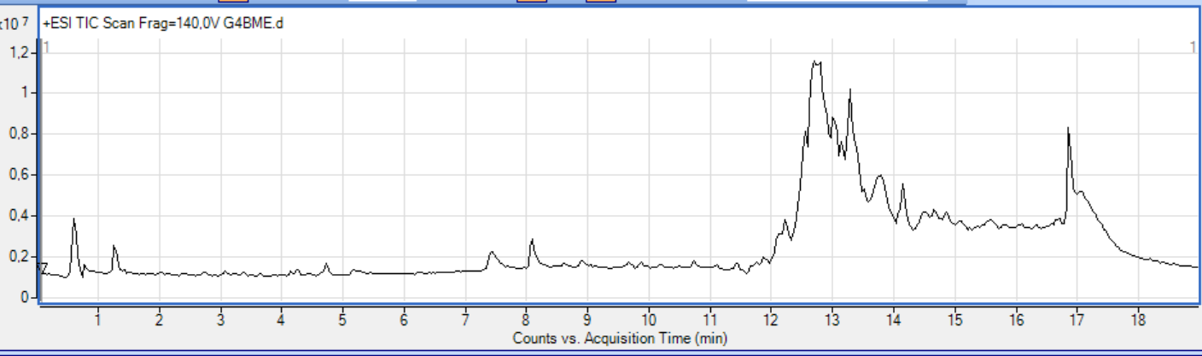
Fig. 1. MS chromatographic profile of Broyat from Manihot esculenta

Table 2. Identification of phytochemical composition by LC-MS/MS of Broyat from Manihot esculenta
Peak | Retention time (RT) in minutes | Molecular formula | Molar mass (g/mol) | MS/MS (m/z) | Compound | Source
1 | 2.740 | C₁₀H₈O₄ | 192 | 193; 163;  151; 141;  133; 127 | Scopoletin | Bayoumi et al., 2008
2 | 2.746 | C₁₆H₁₈O₉ | 354 | 355; 309;  267; 193;  139 | Scopolin | Bayoumi et al., 2008
3 | 4.258 | C₂₇H₃₀O₁₆ | 610 | 611; 459;  435; 401;  303 | Rutin | Jampa et al., 2022 ; Prawat et al., 1995
4 | 4.739 | C₂₇H₃₀O₁₅ | 594 | 595; 431;  353; 287;  129 | Nicotiflorin | Jampa et al., 2022 ; Prawat et al., 1995
5 | 8.282 | C₉H₈O₄ | 180 | 181; 135;  121; 105 | Caffeic acid | Scaria et al., 2023
6 | 10.956 | C₇H₆O₅ | 170 | 171; 143;  137; 131;  101 | Gallic acid | Scaria et al., 2023

-Peak 1 (RT: 2.740 min), presenting a molecular ion at m/z 193 [M+H]⁺, was identified as scopoletin, an oxygenated coumarin with the molecular formula C₁₀H₈O₄ and a molar mass of 192 g/mol. Fragmentation of this ion yielded several characteristic ions: the fragment at m/z 163 [M+H–OCH₃]⁺, resulting from the elimination of a methoxy group (–31 Da); the fragment at m/z 151 [M+H–CO₂]⁺, corresponding to the loss of carbon dioxide (–44 Da); and the fragment at m/z 141 [M+H–C₃H₄O]⁺, resulting from a double loss, that of carbon monoxide (–28 Da) and an ethylene group (–28 Da), followed by a rearrangement; the fragment at m/z 133 [M+H–C₂H₄O₂]⁺, resulting from successive losses of a carbon monoxide molecule (–28 Da), a water molecule (–18 Da) and then a methyl group (–15 Da). Finally, the fragment at m/z 127 derives from the previous one (m/z 141) by the loss of a methyl group (–15 Da). Figure 2 illustrates the MS and MS/MS mass spectra associated with peak 1, while Figure 3 schematizes the different fragmentation pathways of scopoletin.

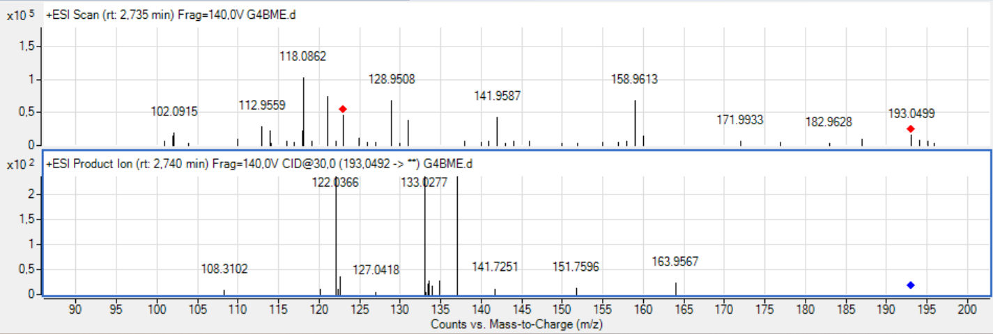
Fig. 2. MS and MS/MS mass spectra of peak 1 of Broyat from M. esculenta

Fig. 3. Diagram of scopoletin fragmentation
-Peak 2 (RT: 2.746 min), characterized by the molecular ion at m/z 355 [M+H]⁺, is identified as scopolin (C₁₆H₁₈O₉, M = 354 g·mol⁻¹), a glucoside derived from scopoletin. The main fragment at m/z 193 [scopoletin + H]⁺ corresponds to the aglycone released after the loss of a glucose (–162 Da). The secondary fragments observed at m/z 309, 267, and 139 result from the successive losses of the CH₃O₂ (–47 Da), C₃H₆O₃ (–90 Da), and C₈H₁₄O₇ (–222 Da) groups, followed by structural rearrangements. Figure 4 shows the MS and MS/MS mass spectra corresponding to peak 2, while Figure 5 shows the fragmentation scheme of scopolin.

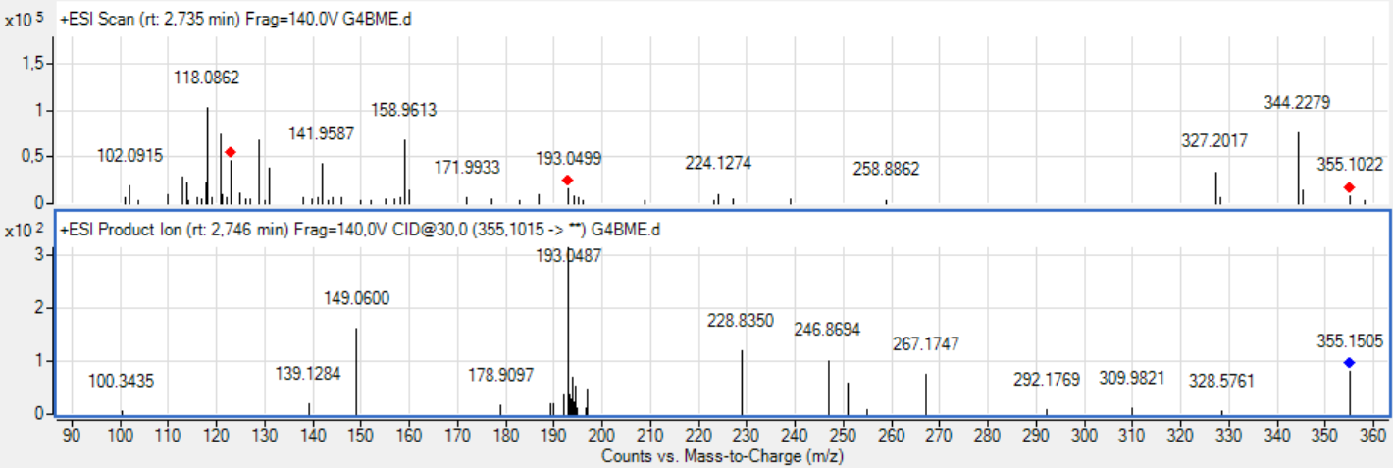
Fig. 4. MS and MS/MS mass spectra of peak 2 of Broyat from M. esculenta
Fig. 5. Diagram of scopolin fragmentation
-Peak 3 (RT: 4.258 min) is attributed to rutin (C₂₇H₃₀O₁₆, M = 610 g/mol), a glycosylated flavonoid also known as quercetin-3-O-rutinoside. The dominant precursor ion at m/z 611 [M+H]⁺ corresponds to the molecular ion, while the fragment at m/z 303 [quercetin + H]⁺, resulting from the loss of the rutinoside disaccharide (–308 Da), represents the aglycone and constitutes the major fragment, with diagnostic value. The signal at m/z 435 [M+H–C₇H₁₃O₅]⁺ results from the loss of a heptose (–177 Da), while the signal observed at m/z 401 comes from 435 after the elimination of two hydroxyl groups (–34 Da). Finally, the fragment at m/z 459 is generated by the loss of a C₇H₄O₄ motif followed by rearrangements. Figures 5 and 6 illustrate the MS and MS/MS mass spectra of peak 3 and the fragmentation scheme of rutin, respectively.

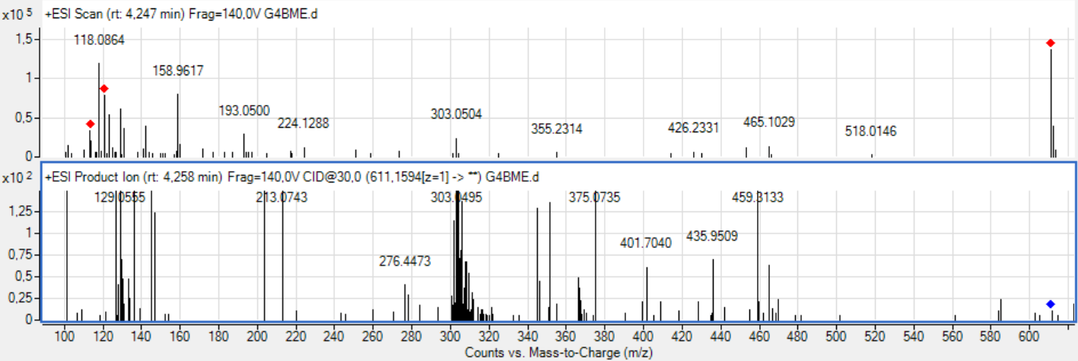
Fig. 5. MS and MS/MS mass spectra of peak 3 of Broyat from M. esculenta
Fig. 6. Diagram of rutin fragmentation
-Peak 4 (RT: 4.739 min) was identified as nicotiflorin, a kaempferol-3-O-rutinoside flavonoid (C₂₇H₃₀O₁₅, M = 594 g/mol). The main precursor ion at m/z 595 [M+H]⁺ corresponds to the molecular ion, while the fragment at m/z 287 [kaempferol + H]⁺, resulting from the loss of the rutinoside disaccharide (–308 Da), corresponds to the aglycone. The signal observed at m/z 431 [M+H–C₆H₁₁O₅]⁺ reflects the elimination of a hexose (–163 Da). The fragment at m/z 129 derives from the loss of a C₉H₈O₃ motif from the m/z 287 ion, while the fragment at m/z 353 results from the elimination of a C₁₃H₇O₅ group (–243 Da) followed by rearrangements. Figures 7 and 8 show the MS and MS/MS mass spectra of peak 4 and the fragmentation scheme of nicotiflorin, respectively.

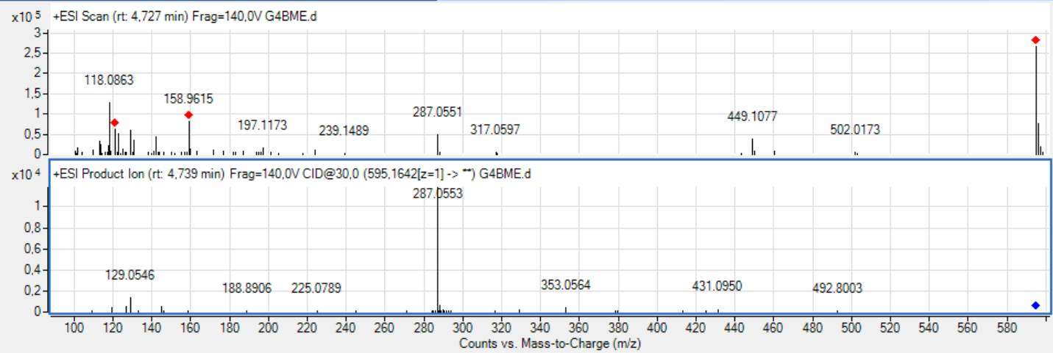
Fig. 7. MS and MS/MS mass spectra of peak 4 of Broyat from M. esculenta
Fig. 8. Diagram of nicotiflorin fragmentation

-Peak 5 (RT: 8.282 min) is attributed to caffeic acid (C₉H₈O₄, M = 180 g/mol), a widely distributed phenolic acid. The molecular ion is detected at m/z 181 [M+H]⁺. The fragment at m/z 135 [M+H–COOH]⁺ results from the loss of a carboxyl group (–45 Da), while the fragment at m/z 121 [M+H–COOH–OH]⁺ corresponds to decarboxylation (–45 Da) followed by the elimination of a hydroxyl group (–17 Da). Finally, the fragment at m/z 105 results from decarboxylation accompanied by the loss of two hydroxyl groups. Figures 9 and 10show the MS and MS/MS mass spectra of peak 5 and the fragmentation scheme of caffeic acid, respectively.

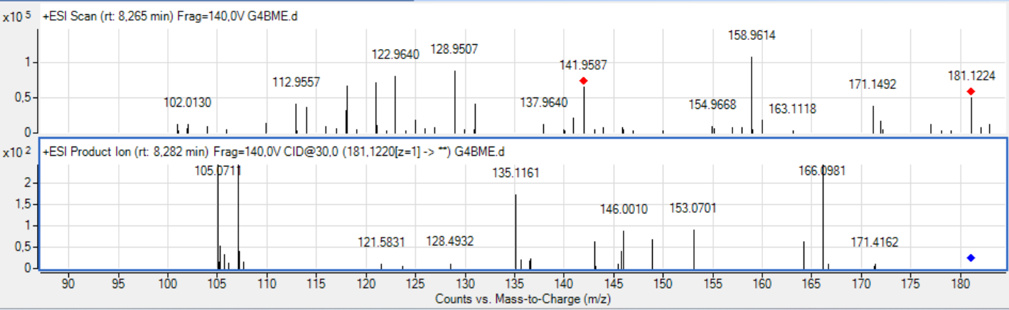
Fig. 9. MS and MS/MS mass spectra of peak 5 of Broyat from M. esculenta
Fig. 10. Diagram of caffeic acid fragmentation

-Peak 6 (TR: 10.956 min) is attributed to gallic acid (C₇H₆O₅, M = 170 g/mol), a trihydroxy phenolic acid. The molecular ion appears at m/z 171 [M+H]⁺, while the fragment at m/z 137 [M+H–2OH]⁺ results from the loss of two hydroxyl groups (–34 Da). The fragments at m/z 143, 131, and 101 reflect the loss of the CH₂OH, C₂H₂O, and CH₂O moieties, respectively, followed by rearrangements. Figures 11 and 12 show the MS and MS/MS mass spectra of peak 6 and the fragmentation scheme of gallic acid.

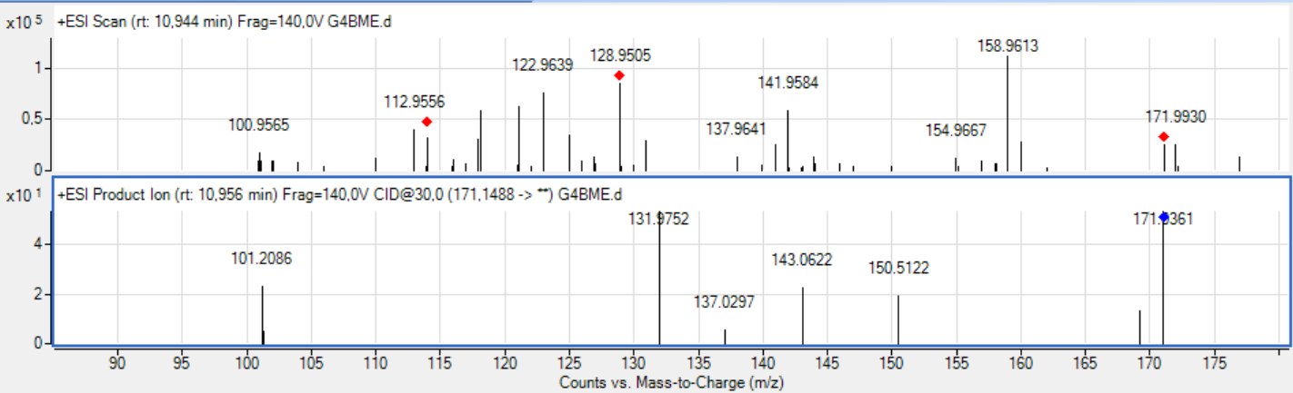
Fig. 11. MS and MS/MS mass spectra of peak 6 of Broyat from M. esculenta

Fig. 12. Diagram of gallic acid fragmentation

Figure 13 shows the MS chromatographic profile of ions detected in positive mode in Manihot esculenta Tamisat, with the corresponding results reported in Table 3.

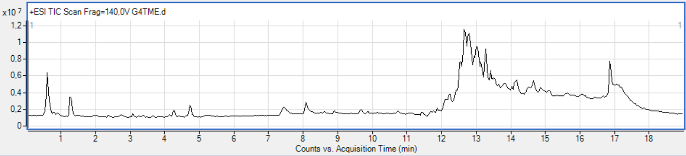
Fig. 13. MS chromatographic profile of Tamisat from Manihot esculenta

Table 3. Identification of phytochemical composition by LC-MS/MS of Tamisat from Manihot esculenta
Peak | Retention time (RT) in minutes | Molecular formula | Molar mass (g/mol) | MS/MS (m/z) | Compound | Source
1 | 4.255 | C₂₇H₃₀O₁₆ | 610 | 611; 465;  303; 191 | Rutin | Jampa et al., 2022 ; Prawat et al., 1995
2 | 4.707 | C₂₇H₃₀O₁₅ | 594 | 595; 449;  329; 287;  129 | Nicotiflorin | Jampa et al., 2022 ; Prawat et al., 1995
3 | 8.273 | C₉H₈O₄ | 180 | 181; 163;  135; 103 | Caffeic acid | Scaria et al., 2023
4 | 11.468 | C₇H₆O₅ | 170 | 171; 155;  131 | Gallic acid | Scaria et al., 2023

-Peak 1 (RT: 4.255 min) is identified as corresponding to rutin. The precursor ion detected at m/z 611 [M+H]⁺ corresponds to the molecular ion. The major diagnostic fragment, observed at m/z 303 [quercetin+H]⁺, results from the loss of the disaccharide rutinoside (–308 Da) and represents the aglycone. A fragment at m/z 465 [M+H–C₆H₁₁O₄]⁺ reflects the elimination of a hexose (–147 Da), while the signal at m/z 191 comes from the loss of the C₁₉H₁₆O₁₁ motif (–420 Da) followed by rearrangements. Figures 14 and 15 show the MS and MS/MS mass spectra of peak 1 and the fragmentation scheme of rutin, respectively.

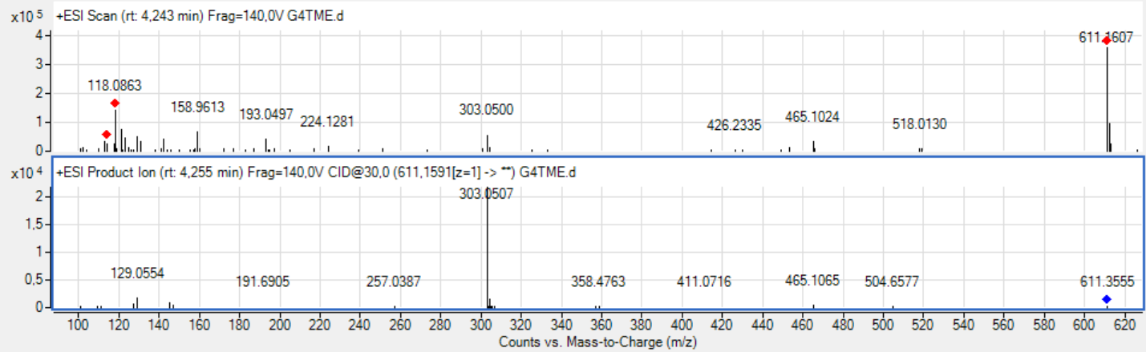
Fig. 14. MS and MS/MS mass spectra of peak 1 of Tamisat from M. esculenta

Fig. 15. Diagram of rutin fragmentation

-Peak 2 (RT: 4.707 min) is identified as nicotiflorin (C₂₇H₃₀O₁₅, M = 594 g·mol⁻¹), with a molecular ion detected at m/z 595 [M+H]⁺. The main fragment at m/z 287 [kaempferol+H]⁺, resulting from the loss of the rutinoside disaccharide (–308 Da), corresponds to the characteristic aglycone. The fragment at m/z 129 derives from the loss of the C₉H₈O₃ motif from the m/z 287 ion. The fragments at m/z 449 and 329 result from the successive losses of the C₆H₁₁O₄ and C₁₀H₁₈O₈ motifs. Figures 16 and 17 show the MS and MS/MS mass spectra of peak 2 and the fragmentation scheme of nicotiflorin, respectively.

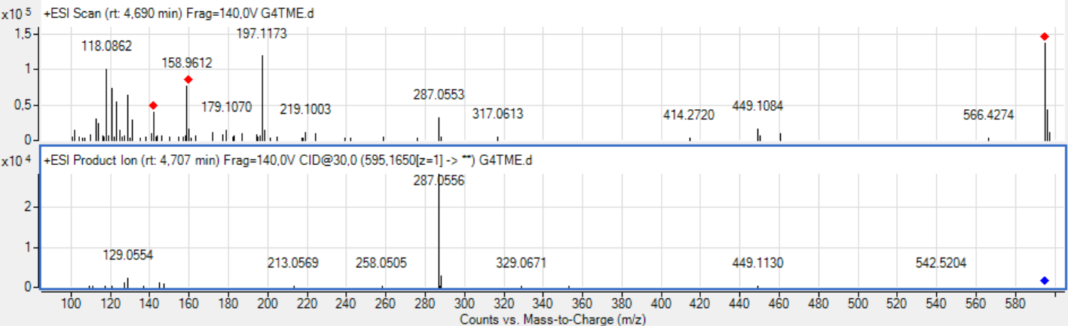
Fig. 16. MS and MS/MS mass spectra of peak 2 of Tamisat from M. esculenta

Fig. 17. Diagram of nicotiflorin fragmentation
-Peak 3 (RT: 8.273 min) is attributed to caffeic acid (3,4-dihydroxycinnamic acid, C₉H₈O₄, M = 180 g·mol⁻¹). The protonated molecular ion is observed at m/z 181 [M+H]⁺, while the fragment at m/z 163 [M+H–H₂O]⁺ results from the loss of a water molecule (–18 Da). The signal at m/z 135 corresponds to the phenolic nucleus, obtained after elimination of the carboxyl group. Finally, the fragment at m/z 103 reflects the loss of two hydroxyl groups from the ion at m/z 135. Figures 18 and 19 show the MS and MS/MS mass spectra of peak 3 and the fragmentation scheme of caffeic acid, respectively.

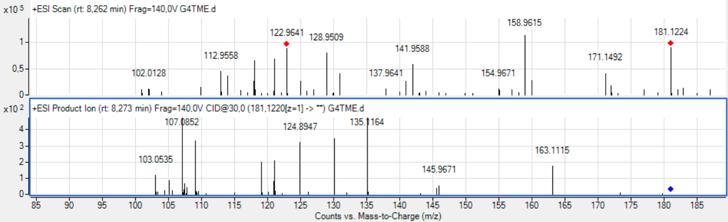
Fig. 18. MS and MS/MS mass spectra of peak 3 of Tamisat from M. esculenta

Fig. 19. Diagram of caffeic acid fragmentation

-Peak 4 (RT: 11.468 min) is attributed to gallic acid (3,4,5-trihydroxybenzoic acid, C₇H₆O₅, M = 180 g·mol⁻¹). The protonated molecular ion is detected at m/z 171 [M+H]⁺, while the fragment at m/z 155 [M+H–OH]⁺ results from the loss of a hydroxyl group (–17 Da). The fragment at m/z 131 corresponds to the elimination of the C₂H₂O motif (–40 Da). Figures 20 and 21 show the MS and MS/MS mass spectra of peak 4 and the fragmentation scheme of gallic acid, respectively.

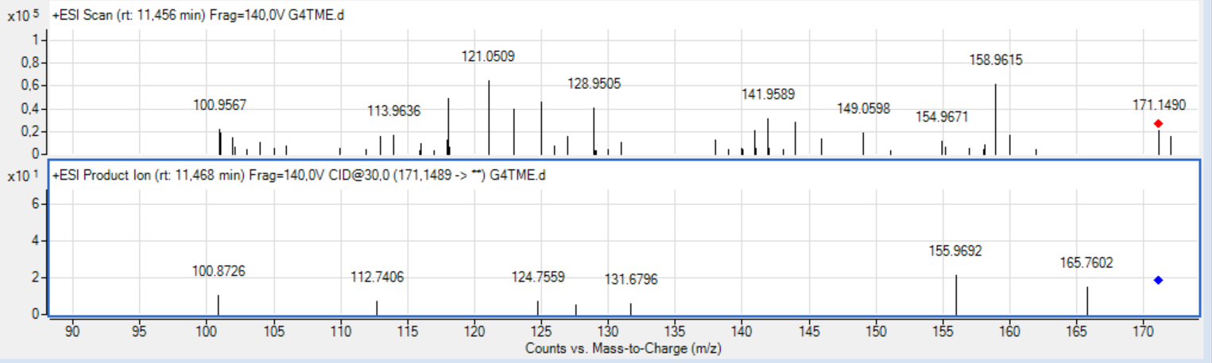
Fig. 20. MS and MS/MS mass spectra of peak 4 of Tamisat from M. esculenta

Fig. 21. Diagram of gallic acid fragmentation

All phytoconstituents identified by LC-MS are shown in figure 22.
Scopoletin Scopolin Rutin
Nicotiflorin Caffeic acid Gallic acid
Fig. 22. Phytocompounds identified by LC-MS in Manihot esculenta leaves
The approach combining colorimetric reactions and LC-MS analysis revealed a diversity of specialized metabolites in Manihot esculenta extracts. Qualitative tests confirm the presence of large families of compounds such as polyphenols, flavonoids, tannins, terpenes/sterols, coumarins, and proteins, already reported in the literature as major constituents of Manihot esculenta (Scaria et al., 2023). The absence of saponins and reducing compounds, observed in both the Broyat and Tamisat, suggests that these classes are not characteristic of M. esculenta leaves, or that they are present in concentrations too low to be detected by colorimetric methods.
LC-MS analysis refines these results by precisely identifying certain bioactive compounds. Six metabolites were characterized in the Broyat: scopoletin, scopolin, rutin, nicotiflorin, caffeic acid, and gallic acid. However, only four (rutin, nicotiflorin, caffeic acid, and gallic acid) are present in theTamisat, suggesting a partial loss of chemical diversity during sieving. This result indicates that the heterogeneous nature of the crushed material promotes better preservation of bioactive compounds, particularly those with low polarity or instability, such as hydroxycoumarins.
The flavonoids identified, particularly rutin and nicotiflorin, confirm previous observations reporting the presence of flavonoid glycosides in Manihot esculenta leaves (Jampa et al., 2022; Prawat et al., 1995). These compounds are known for their antioxidant and anti-inflammatory properties, reinforcing the pharmacological interest of M. esculenta. The detection of hydroxycoumarins (scopoletin and scopolin) only in the Broyat corroborates the work of Bourgaud et al. (2006) and Bayoumi et al. (2008), who emphasize their essential role in the plant's defense against biotic and abiotic stresses, as well as their rapid accumulation after harvest. Their absence in the Tamisat could be attributed to mechanical losses or too low a concentration after particle size separation.
The phenolic acids identified (caffeic acid and gallic acid) are key metabolites in secondary plant metabolism. They play a major role in defense against oxidative stress and are also valued for their biological properties, particularly their antioxidant, antibacterial, and antiproliferative properties. Their presence in both types of extracts demonstrates their abundance and stability in cassava leaves.
Overall, this study highlights the metabolic richness of M. esculenta leaves and suggests that the choice of preparation method (crushed versus sieved) significantly influences the phytochemical composition of the extracts. Broyat preserves a more complete chemical spectrum, including compounds of high biological interest such as hydroxycoumarins, which could have implications for the pharmacological and nutritional value of cassava.
- CONCLUSION
This study used a combination of colorimetric reactions and LC-MS analysis to reveal a significant diversity of specialized metabolites in the leaves of Manihot esculenta. The Broyat is distinguished by a richer chemical spectrum, including hydroxycoumarins, while the Tamisat has a more limited composition but retains the main flavonoids and phenolic acids. These results confirm the decisive role of the preparation method on the quality and diversity of the extracted compounds, and highlight the pharmacological and nutritional interest of this plant.
Looking ahead, further studies on the quantification of metabolites and their correlation with biological activities will provide a better understanding of the influence of particle size on the bioavailability and therapeutic potential of the identified compounds, paving the way for a more targeted use of M. esculenta leaves in the pharmaceutical and agri-food industries.
Competing interests
The authors declared that there are no conflicts of interest.
COMPETING INTERESTS DISCLAIMER:
Authors have declared that they have no known competing financial interests OR non-financial interests OR personal relationships that could have appeared to influence the work reported in this paper.

REFERENCES
Azmir, J., Zaidul, I. S. M., Rahman, M. M., Sharif, K. M., Mohamed, A., Shaena F. et al (2013). Techniques for extraction of bioactive compounds from plant materiels: A review. Journal of food Engineering, 117(4): 426-436.
Bayoumi, S. A. L., Rowan, M. G., Beeching, J. R., & Blagbrough, I. S. (2008). Investigation of biosynthetic pathways to hydroxycou marins during post‐harvest physiological deterioration in cassava roots by using stable isotope labelling. ChemBioChem, 9(18), 3013–3022.
Békro, Y-A., Mamyrbekova-Békro, J. A., Boua, B. B., Tra-Bi, F. H. & Ehilé, E. E. (2007). Ethnobotanical study and phytochemical screening of Caesalpinia benthamiana (Baill.) Herend. Et Zarucchi (Caesalpiniaceae). Sciences and Nature 4 (2): 217-225.
Bourgaud, F., Gravot, A., Milesi, S. & Gontier, E. (2006). Biosynthesis of coumarins in plants: A major pathway still to be unravelled for cytochrome P450 enzymes. Phytochemistry Reviews, 5(2-3), 293-308.
Jampa, M., Sutthanut, K., Weerapreeyakul, N., Tukummee, W., Wattanathorn, J., & Muchimapura, S. (2022). Multiple bioactiv ities of Manihot esculenta leaves: UV filter, anti‐oxidation, anti‐melanogenesis, collagen synthesis enhancement, and anti‐adipogenesis. Molecules, 27(5), 1556.
Kouamé, K. T., Sorho, S., Amon, D. M. N., Yaya, S. (2025). Identification of compounds present in the dichoromethane fraction of young unopened leaves of Piliostigma thonningii by LC-MS. European Journal of Biomedical and Pharmaceutical Sciences, 12(3): 178-188.
N’guessan, P. A., N’guessan, D. M., Konan, D. J., Mamyrbékova-Békro, J. A., Békro, Y. A. (2024). Contribution to Phytochemical, Antioxidant and Antibacterial Studies of Extracts of Crushed, Sieved and Rejected organs of Two Medicinal Plants from Côte d'Ivoire. International Journal of Biochemistry Research & Review, 33 (6): 185-195.
Prawat, H., Mahidol, C., Ruchirawat, S., Prawat, U., Tuntiwachwuttikul, P., Tooptakong, U. et al. (1995). Cyanogenic and non‐cyanogenic glycosides from Manihot esculenta. Phytochemistry, 40(4), 1167–1173.
Scaria, S. S., Balasubramanian, B., Meyyazhagan, A., Gangwar, J., Jaison, J. P., Kurian, J. T. et al. (2023). Cassava (Manihot esculenta Crantz)—A potential source of phytochemicals, food, and nutrition—An updated review. eFood, 5: 127.

