A note on Zeuxine strateumatica (Linnaeus) Schlechter (Orchidaceae) from Muzaffarpur (Bihar), India

.
ABSTRACT

Zeuxine strateumatica (L.) Schltr. is a terrestrial orchid. It is reported from the Muzaffarpur district of Bihar state, India, as a new record for the flora of Muzaffarpur. The present study deals with morpho-taxonomical description along with its associated plant species. The present finding contributes to a better understanding of the geographic range of Z. strateumatica and highlights the potential for further botanical discoveries in the Muzaffarpur district. The paper provides photographs, habitat ecology, phenology, and distributional range for this endemic orchid species to facilitate the identification and conservation measures.

Keywords: Ecology, New distribution, Orchidaceae, Zeuxine
1. INTRODUCTION
Zeuxine strateumatica is commonly known as the soldier orchid or lawn orchid, belonging to the family Orchidaceae. Zeuxine strateumatica is an angiosperm and a monocot that belongs to the Asparagales order and the Orchidaceae family. This annual rhizomatous geophyte primarily grows in a temperate zone. Commonly known as the soldier orchid, it is a terrestrial orchid typically found in moist environments. The soldier orchid is a terrestrial orchid that is mostly found in moist areas. It can be considered invasive, as it is capable of thriving in a variety of habitats, including disturbed areas, floodplains, forests, grasslands, meadows, and woodlands.
Over the years, it has been reported in various parts of the world, often as an introduced species. In 2024, a significant new distribution record was documented in the Yungas forests of Argentina (Martín et al., 2024). This marks the southernmost known occurrence of Z. strateumatica. This discovery highlights the species' ability to adapt to diverse environments. In India, Z. strateumatica has been recorded in many states (Kumar et al. 2005, Gogoi et al., 2012; Bharati, 2018; Jalal and Jayanthi, 2018; Rajwade et al., 2024). Notably, a new distribution record was also established in the Sabarkantha district of Gujarat state (Patel et al., 2020). The distribution records demonstrate the species' widespread presence and its capacity to colonize new habitats across different regions successfully. A comprehensive distribution list indicates that Z. strateumatica is found in Bihar, among other states such as Arunachal Pradesh, Assam, Delhi, Gujarat, Himachal Pradesh, Jammu & Kashmir, Jharkhand, Karnataka, Kerala, Madhya Pradesh, Maharashtra, Manipur, Meghalaya, Mizoram, Nagaland, Odisha, Punjab, Rajasthan, Sikkim, Tamil Nadu, Tripura, Uttarakhand, Uttar Pradesh, and West Bengal (Jalal and Jayanthi, 2018; Kumar and Kumar, 2020; Kumar, 2025). In Bihar, its distribution has been documented in the eco-sensitive zone of Baraila Lake, Salim Ali Jubba Sahni Bird Sanctuary in Vaishali district (Bharati, 2018). A study of the sanctuary’s flora identified Z. strateumatica as the sole representative of the Orchidaceae family in the area. This orchid is typically found in marshy areas and humus-rich soil, often in grasslands and along water bodies (eFloraofIndia, 2024; Rajwade et al., 2024). While specific details about its distribution across Bihar are limited, its occurrence in the Baraila Lake region suggests it may be present in similar habitats throughout the state. The current study aims to enhance the mapping of its broader distribution range in Bihar.

2. Materials and methodS

During the floral diversity work in Muzaffarpur district of Bihar, the authors collected a terrestrial species (Fig. 1). After a thorough review of published literature (Hooker, 1973) and morphological studies, the collected specimen was identified as Zeuxine strateumatica. This species was recorded during the campus survey of Babasaheb Bhimrao Ambedkar University and surrounding areas for the documentation of floral diversity during the year 2024-2025. High-quality photographs of the plant were taken, and GPS coordinates were noted, along with information on associated plant species (Kumar et al., 2005; Rajwade et al., 2024). The genus Zeuxine is represented by 170 species worldwide (Govaerts et al., 2011), with 18 of them identified in India (Misra, 2007). However, only one species of orchids, i.e. as Zeuxine strateumatica, has been reported so far from Bihar (Bharati, 2018).
Additionally, ethnomedicinal surveys conducted by Author D among the Munda tribes of Odisha revealed some interesting medicinal uses for this plant species. The survey was carried out over several months in 2024. Participants, primarily elders and community healers with extensive knowledge of traditional plant-based remedies, were selected through sampling. Data was collected using semi-structured interviews, observations, and direct consultations with traditional healers. Interactions with the informants were conducted in the local dialect to eliminate any language barriers. The plants were identified with the assistance of local botanists and herbalists. Informed consent was obtained from all the participants, ensuring they understood the purpose of the research and the potential benefits of documenting their knowledge.

3. results

Taxonomic Treatment
Zeuxine strateumatica (L.) Schltr. in Bot. Jahrb. Syst. 45: 394. 1911; Santapau and Kapadia, Orchids Bombay 167. t. 38. 1966; Shah, Fl. Gujarat2: 663. 1978; Raghavan et al. in Bull. Bot. Surv. India 84, 1981; Pandey in Shetty and Singh, Fl.Rajasthan 2: 825. 1991; T. Cooke, Fl. Pres. Bombay3: 213. 1958.
It is a terrestrial herb of 4-25 cm height. The roots are short and crowded at the nodes of the underground stem and rhizome. The stem is fleshy, erect or ascending from a decumbent base, thin, smooth, greenish, and tinted with purple or brown. The leaves are dark green, 5-12, spirally arranged, sessile, sheathing, upright, linear to narrowly lanceolate, long-acuminate, keeled, 1-7 cm long, and 2-7 mm broad. The inflorescence is terminal, with dense spikes of 8-26 flowers, 1-8 cm long. Floral bracts are green, ovate-lanceolate to simply lanceolate, about 15 x 4 mm. The flowers are white, with a pronounced yellow lip. The ovary is sessile, thick, and approximately 7 mm long. The dorsal sepal is concave, ovate-oblong to oblong-elliptic, obtuse, 4-6 x 2-3 mm. The lateral sepals are ovate-oblong to oblong-elliptic, obtuse to acute, oblique, 4-5 mm long, 2-3 mm wide. The petals are oblong-lanceolate, falcate, about 4-6 x 1.5 mm, and converge with the dorsal sepal, forming a hood over the column.
The lip is fleshy, attached to the base of the column, base concave, pandurate, broadly rounded, and dilated at the apex, 4 x 3 mm. The column is 1.5 mm long, anther scarious, located between two prominent stigmatic processes, and pollen grains are yellow (own observation, Fig. 2).
Flowering & Fruiting: January-March.
Habitat: Terrestrial, growing in moist sandy soil on grassy land near water bodies.
Specimens Examined: India, Bihar, Muzaffarpur, Babasaheb Bhimrao Ambedkar Bihar University Campus, Latitude 26.1122549°, Longitude 85.3768217°, 54 msl, 11 February 2025. Kadambini Das (HUDBM 532) Herbarium of University Department of Botany, Babasaheb Bhimrao Ambedkar Bihar University, Muzaffarpur, India) (Fig. 3).
Distribution: It is represented by 170 species scattered over the world (Govaerts et al., 2011), with 18 of them identified in India (Misra, 2007). The native range of Zeuxine strateumatica is from Iran to Central Asia, Tropical and Subtropical Asia. The species has been introduced to Alabama, Argentina Northwest, Bahamas, Bermuda, Brazil Southeast, California, Cuba, Florida, Georgia, Hawaii, Jamaica, Louisiana, Mississippi, Puerto Rico, Saudi Arabia, Texas, and Turkey (POWO, 2025). In India, it has been located in Arunachal Pradesh, Assam, Delhi, Gujarat, Himachal Pradesh, Jammu & Kashmir, Jharkhand, Karnataka, Kerala, Madhya Pradesh, Maharashtra, Manipur, Meghalaya, Mizoram, Nagaland, Odisha, Punjab, Rajasthan, Sikkim, Tamil Nadu, Tripura, Uttarakhand, Uttar Pradesh, and West Bengal. In Bihar, so far, it has been reported only from one location, i.e., Vaishali district (Bharati 2018).
Status: Although the species is classified as "least concern" on the IUCN Red List, it faces threats in certain areas of its native range. In some regions of India, where the species is non-indigenous, it has become rare and is endangered due to reduced rainfall, agricultural encroachment, urbanization, and the overgrazing and trampling by livestock (Kotia et al., 2013). It has been described as an opportunistic orchid that thrives in disturbed habitats but will be displaced if the surrounding vegetation undergoes natural succession (Vélez-Gavilán, 2022).
Associated species: Cyanodon dactylon, Melilotus indicus, Cardamine flexuosa, Myosotis scorpioides, and Parietaria sp. were found to be associated with Zeuxine strateumatica.
Ethnomedicinal uses: Our field survey revealed that the Munda tribal community in Jharkhand and Odisha utilizes this plant in two ways: the leaves are consumed as a vegetable, while the roots are used to treat weakness and are believed to possess antioxidant properties.

4. DISCUSSION

The discovery of Zeuxine strateumatica in Muzaffarpur expands the known distribution range of the species and highlights its adaptability. This orchid prefers open, grassy, and disturbed habitats, often colonizing wastelands, roadside verges, and abandoned fields. It thrives in human-altered landscapes, making it an important indicator of ecological resilience (Collins and Brundrett, 2015). The current paper emphasizes the significance of regional botanical surveys. The data suggest that even in heavily modified environments, rare or overlooked species can persist, contributing to local plant diversity. Although Zeuxine strateumatica is not currently endangered, habitat destruction and urbanization threaten many orchid species in India, especially those with specialized habitat requirements (Fay, 2018; Patel & Mohabe, 2024). Interestingly, Zeuxine strateumatica has already been under stress due to overgrazing and trampling by livestock (Kotia et al. 2013). Recognizing the presence of these species can help in planning effective management strategies. To achieve this, it is essential to conduct comprehensive surveys across Bihar and neighbouring states to map its distribution. Such efforts will raise awareness among local communities about the value of native flora and assist in protecting and restoring natural habitats that support indigenous orchid populations. Further research should focus on the exploration of its pollination biology, symbiotic relationships, and its potential uses in traditional and modern medicines.
There are significant ecological and conservation implications arising from the recent discovery of Zeuxine strateumatica in Muzaffarpur, Bihar. Below are some of these implications:
Expansion of regional biodiversity records—This finding is significant for expanding the regional biodiversity records, as no official record of this species had been made from the Muzaffarpur District in Bihar before this observation. Its identification adds a new element to the local flora, highlighting that the botanical diversity in this area remains largely unexplored and requires further exploration (Balkrishna et al., 2024; Jha and Kumari, 2024; Chandra et al., 2025).
Ecological Indicator of Disturbance—With the acceleration of urbanization, many species face habitat loss. However, resilient species like Z. strateumatica demonstrate adaptability and the capability to colonize new areas that are often considered degraded or unsuitable (Neto et al., 2011). These species serve as an ecological indicator of disturbance, revealing both challenges and opportunities for habitat management (Vélez-Gavilán, 2022). Their presence in disturbed habitats highlights the significance of conserving even minor components of biodiversity. Recognition and documentation of such species can foster local appreciation for native flora and promote community engagement in conservation efforts (Paine, 2019; Beckwith et al., 2022).
Indicative of range expansion—Reporting new records of any species is crucial for monitoring their range expansion or contraction. This data, combined with further research, will enhance our understanding of the distribution dynamics of Z. strateumatica and the ecological and environmental pressures that the plant species is facing (Balik et al., 2023; Patel et al., 2020).
Updating ecological and evolutionary research—New distributional records are vital for understanding the environmental niche of the species and contribute to broader ecological and evolutionary studies (Parmesan et al., 2025). This helps researchers understand patterns of genetic variation across different populations. They also provide insights about evolutionary processes such as adaptation, gene flow, and speciation (Jon & Ary, 2022).
Updating taxonomic and phylogenetic relationships—The discovery of new populations may reveal morphological or genetic variations that could lead to taxonomic revisions or the identification of new subspecies or varieties. This enhances the understanding of the species' evolutionary history (Santis et al., 2023).
Habitat management and restoration—The natural distribution of a species decides the effective way of habitat management. New distributional records provide insight into identifying critical habitats that require protection and restoration. For threatened plant species, the establishment and conservation of protected areas become more precise and effective (Araújo et al., 2005; Guisan et al., 2013; Feng et al., 2022).
Filling Knowledge Gaps—New distributional records contribute to filling knowledge gaps regarding unexplored areas, leading to a more complete picture of regional and global plant diversity. This vital information helps in conservation planning and the true extent of biodiversity. It also highlights areas that require further exploration and monitoring to make sure that no important populations are overlooked (Carpio et al., 2013; Sampaio et al., 2025).
Supporting climate change studies—Monitoring the shifts in the distribution of plant species over time provides valuable data for understanding the impacts of climate change. Alterations in the distributional ranges serve as an indicator of environmental change and help in making predictive models for future diversity patterns (Kelly et al., 2008; Mahmoud et al., 2025; Rubenstein et al., 2023).
Enriching regional and global floristic databases—Addition of new plant species to a geographical area enriches floristic databases and online repositories. This facilitates global research collaborations, meta-analysis, and conservation planning. It helps in creating a more comprehensive and accessible knowledge base for scientists worldwide (Panitsa et al., 2021; Bargali et al., 2025; Enríquez-de-Salamanca, 2025; Xiao et al., 2023).
Fostering citizen-led scientific initiatives—New distributional records often involve local communities and citizen scientists, raising awareness about plant conservation. This participatory approach can lead to greater protection efforts and community-based resource management (Panitsa et al., 2021; Mandeville et al., 2023; Jones et al., 2024).
Ecological niche modelling—Accurate distribution ranges are crucial for developing ecological niche models that aid in predicting suitable habitats under current and future conditions. This helps in anticipating the potential spread and decline of the species and suggests proactive conservation (McSHEA, 2014; Santana et al., 2024).
Potential source of medicine—The plant species has been identified as ethnobotanically significant. Research indicates that this species provides an excellent source of green vegetables, and the roots are used to treat weakness and have strong antioxidant properties (Bazzicalupo et al., 2023; Hossain et al., 2025). By discovering new distribution records, the continued availability of this plant might facilitate the exploration of its phytochemically active compounds and additional medicinal uses.

5. CONCLUSIONS
The discovery of Zeuxine strateumatica in Muzaffarpur, Bihar, marks a significant addition to the regional flora. This expands the known distribution range of the species. The presence of this species in disturbed and human-altered habitats underscores its ecological resilience and potential role as an indicator of habitat disturbance. This emphasizes the importance of continued botanical surveys in underexplored regions, especially areas undergoing ongoing land-use changes. These distribution records will help fill knowledge gaps in biodiversity, provide data for ecological, evolutionary, and climate-related research, and inform conservation planning. Furthermore, such discoveries highlight the need to involve local communities in biodiversity documentation and conservation. The recognition, identification, and documentation of highly adaptable yet often overlooked species like Zeuxine strateumatica can increase public awareness and support for protecting native flora. For effective conservation and management strategies, comprehensive surveys across Bihar and neighbouring states are essential. Future research should focus on exploring the species' pollination biology, symbiotic relationships, and potential medicinal uses, thereby contributing both to scientific understanding and practical conservation efforts.

Consent (wherever applicable)

Not applicable.

Ethical approval (wherever applicable)

Not applicable.

COMPETING INTERESTS DISCLAIMER:
Authors have declared that they have no known competing financial interests OR non-financial interests OR personal relationships that could have appeared to influence the work reported in this paper.

References

- Martín, C. M., Ospina, J. C., Morales, A. M., & Keller, H. A. (2024). Zeuxine strateumatica in South America, the soldier orchid arrived in Argentina. Kew Bulletin, 79, 993-98.
- Kumar, P., Pandey, A. K., Rawat, G. S. & Jalal, J. S. (2005). Diversity and conservation of orchids in Jharkhand. In: A. K. Pandey, J. Wen & J. V. V. Dogra (Eds.), Plant Taxonomy: Advances and Relevance. CBS Publishers & Distributors, New Delhi.
- Gogoi, K., Borah, R. L., Das, R., & Yonzone, R. (2012). Present ecological status and diversity of Zeuxine Lindl. a botanically less known orchid of Dibrugarh district of Assam, North East India. International Journal of Plant Research, 5, 160-164.
- Bharati, K. A. (2018). Indicative flora of eco-sensitive zone of Baraila Lake Salim Ali Jubba Sahni Bird Sanctuary, Vaishali district, Bihar. Central National Herbarium, Botanical Survey of India, Howrah.
- Jalal, J. S., & Jayanthi, J. (2018). An updated checklist of the orchids of Maharashtra, India. Lankesteriana, 18, 23-62.
- Rajwade, R. K., Satruhan, & Patel, D. K. (2024). Zeuxine strateumatica (L.) Schlechter. (Orchidaceae): A new addition of the Orchid Flora of Bilaspur District of Chhattisgarh state in Central India. International Journal of Botany Studies, 9, 39-42.
- Patel, S. K., Patel, K. C., Punjani, B. L., Nayi, T. R., & Desai, P. R. (2020). New distributional record of Zeuxine strateumatica (L.) Schltr. (Orchidaceae) to the State Flora of Gujarat from Sabarkantha district, India. International Journal of Current Research in Biosciences and Plant Biology, 7, 36-39.
- Kumar, A., & Kumar, S. (2020). Some medicinal Orchid species of Jharkhand, India. Journal of Biodiversity and Conservation, 4, 398-404.
- Kumar, S. (2025). Conservation in crisis: terrestrial orchids of Mahanadi River Basin and the fight against urbanization and habitat destruction. Journal of Biodiversity Conservation, 9, 1-3.
- eFloraofIndia. (2025). Zeuxine strateumatica. https://efloraofindia.com/efi/zeuxine-strateumatica/
- Hooker, J. D. (1973). The Flora of British India. Volume V Chenopodiaceae to Orchidaceae. Reprinted by M/s BSMPS and Periodical Experts.
- Govaerts, R., Campacci, M. A., Baptista, D., Cribb, P., George, A., Kreuz, K., & Wood, J. (2011). World Checklist of Orchidaceae. The Board of Trustees 135 of the Royal Botanic Gardens, Kew. Published on the internet http://www.kew.org/wcsp/accessed. 2011
- Misra, S. (2007). Orchids of India, a glimpse. Bishen Singh Mahendra Pal Singh Co. Dehradun.
- POWO (2025). Zeuxine strateumatica. "Plants of the World Online. Facilitated by the Royal Botanic Gardens, Kew. Published on the Internet; https://powo.science.kew.org/
- Kotia, A., Kumar, P., & Doo, S. (2013). A note on rediscovery of Zeuxine strateumatica L.) Schltr. (Orchidaceae). Indian Forester, 139(2), 180-181.
- Vélez-Gavilán, J. (2022). Zeuxine strateumatica (soldier’s orchid). CABI Compendium, doi:10.1079/cabicompendium.86802719, CABI International.
- Collins, M. T., & Brundrett, M. C. (2015). Recovery of terrestrial orchids in natural ecosystems after severe disturbance. Editors: Mark Tibbett. In book: Mining in Ecologically Sensitive Landscapes. CSIRO Australia.
- Fay, M. F. (2018). Orchid conservation: how can we meet the challenges in the twenty-first century? Botanical Studies, 59, 16.
- Patel, D., & Mohabe, S. (2024). Orchids of Madhya Pradesh: A comprehensive review. International Journal of Botany Studies, 9(8), 46-48.
- Balkrishna, A., Kumar, A., Joshi, B., Srivastava, A., Arya, V. P., Mohammed, I., Mishra, R. K. (2024). Anisomeles heyneana Benth. (Lamiaceae): A New Distributional Record for Bihar, India. Species, 25: e35s1699.
- Jha, D. K., & Kumari, S. (2024). New Record of Vaucheria from North Bihar, India. Indian Hydrobiology, 23(1), 111-116.
- Chandra, A., Naithani, H. B., & Verma, P. K. (2025). Forest Phyto-Diversity Assessment of West Champaran District of Bihar, Eastern India. American Journal of Agriculture and Forestry, 13(2), 103-117.
- Neto, L. M., Miranda, M. R., & Cruz, D. (2011). Zeuxine strateumatica (Orchidaceae) goes south: a first record for Brazil. Kew Bulletin, 66, 155-158.
- Paine, R.T. (2019). Ecological disturbance. Encyclopedia Britannica. https://www.britannica.com/science/ecological-disturbance
- Beckwith, B. R., Johansson, E. M., & Huff, V. J. (2022). Connecting people, plants and place: A native plant society's journey towards a community of practice. People and Nature, 4(6), 1414-1425.
- Parmesan, C., Gaines, S., Gonzalez, L., Kaufman, D. M., Kingsolver, J., Peterson, T., & Sagarin, R. (2005). Empirical perspectives on species' borders: from traditional biogeography to global change. Oikos, 108, 58-75.
- Jon, B., & Ary, H. (2022). Understanding the biology of species' ranges: when and how does evolution change the rules of ecological engagement? Philosophical Transactions of the Royal Society, B37720210027.
- Santis, S. D., Spada, F., & Magri, D. (2023). Geographic Range vs. Occurrence Records in Plant Distribution Mapping: The Case of Arbutus in the Old World. Forests, 14(5), 1010.
- Araújo, M. B., Thuiller, W., Williams, P. H., & Reginster, I. (2005). Downscaling European Species Atlas Distributions to a Finer Resolution: Implications for Conservation Planning. Global Ecology and Biodiversity, 14, 17-30.
- Guisan, A., Tingley, R., Baumgartner, J. B., Naujokaitis-Lewis, I., Sutcliffe, P. R., Tulloch, A. I. T., Regan, T. J., Brotons, L., McDonald-Madden, E., Mantyka-Pringle, C., et al. (2013). Predicting Species Distributions for Conservation Decisions. Ecology Letters, 16, 1424-1435.
- Feng, L., Sun, J., El-Kassaby, Y. A., Yang, X., Tian, X., & Wang, T. (2022). Predicting Potential Habitat of a Plant Species with Small Populations under Climate Change: Ostrya rehderiana. Forests, 2022, 13(1), 129.
- Balik, J. A., Greig, H. S., Taylor, B. W., & Wissinger, S. A. (2023). Consequences of climate-induced range expansions on multiple ecosystem functions. Communications Biology, 6, 390.
- Carpio, A. P. D., Ariño, A. H., Villarroya, A., Puig, J. & Miranda, R. (2013). The biodiversity data knowledge gap: Assessing information loss in the management of Biosphere Reserves. Biological Conservation, 173(1), 1-14.
- Sampaio, A. C. F., Hoffmann, P. M., Gurski, E. M., Bizarro, O. R., Velazco, S. J. E., Carlucci, M. B., Borgo, M., Ferreira, M. M., Angelo, A. C., & Blum, C. T. (2025). Filling knowledge gaps: A methodological approach for the rapid investigation of species with restricted populations. Perspectives in Ecology and Conservation, 23(2), 130-140.
- Kelly, A. E., & Goulden, M. L. (2008). Rapid shifts in plant distribution with recent climate change. Proceedings of National Academy of Sciences USA, 105(33), 11823-11826.
- Mahmoud, A. R., Farahat, E. A., Hassan, L. M., & Halmy, M. W. A. (2025). Predicting the future impact of climate change on the distribution of species in Egypt’s Mediterranean ecosystems. BMC Plant Biology, 25, 644.
- Rubenstein, M. A., Weiskopf, S. R., Bertrand, R., Carter, S. L., Comte, L., et al. (2023). Climate change and the global redistribution of biodiversity: substantial variation in empirical support for expected range shifts. Environmental Evidence, 12, 7.
- Bargali, S.S., Bargali, K., Singh, M., & Kathayat, A. (2025). Floristic composition and conservation significance of Dev Singh Bisht Campus an academic institute of Kumaun University Nainital. Discover Plants, 2, 162.
- Enríquez-de-Salamanca, Á. (2025). Botanical databases in EIA: opportunities and challenges. Impact Assessment and Project Appraisal, 43(4), 302-312.
- Xiao, C., Zhang, Z., Ma, K., & Lin, Q. (2023). Mapping Asia Plants: Historical Outline and Review of Sources on Floristic Diversity in South Asia. Plants, 12(8), 1617.
- Panitsa, M., Iliopoulou, N., & Petrakis, E. (2021). Citizen Science, Plant Species, and Communities’ Diversity and Conservation on a Mediterranean Biosphere Reserve. Sustainability, 13(17), 9925.
- Mandeville, C. P., Nilsen, E. B., Herfindal, I., & Finstad, A. G. (2023). Participatory monitoring drives biodiversity knowledge in global protected areas. Communications Earth & Environment, 4, 240.
- Jones, S., Zelly, A., Blencowe, A., & Constant, N. (2024). Participatory Approaches to Conservation with Indigenous Peoples and Local Communities: An open access toolkit. Royal Society for the Protection of Birds Centre for Conservation Science, Cambridge, UK.
- McSHEA, W. J. (2014). What are the roles of species distribution models in conservation planning? Environmental Conservation, 41(2), 93-96.
- Santana, J., Sillero, N., Ribeiro, J., Capinha, C., Lopes, R. J., & Reino, L. (2024). Predicting the expansion of invasive species: how much data do we need? NeoBiota 95: 109-132.
- Bazzicalupo, M., Calevo, J., Smeriglio, A., & Cornara, L. (2023). Traditional, Therapeutic Uses and Phytochemistry of Terrestrial European Orchids and Implications for Conservation. Plants, 12(2), 257.
- Hossain, E., Das, K., Majhi, S., Jena, N., & Kumar, S. (2025). Ethnobotanical, phytochemical profiling and cytotoxicity analysis of Zeuxine strateumatica (L.) Schltr.: A terrestrial orchid of India. In Medico-Biowealth of India, Ambika Prasad Research Foundation, Odisha, India.

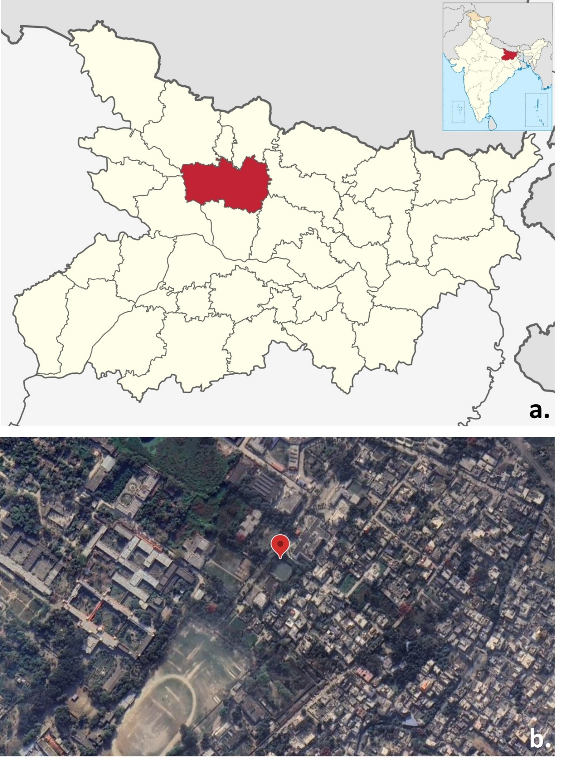
Fig. 1. Location of Study site: a. map shows District Muzaffarpur in the State Bihar (inset shows location of Bihar in the map of India), b. Google earth image showing study site in Muzaffarpur district.

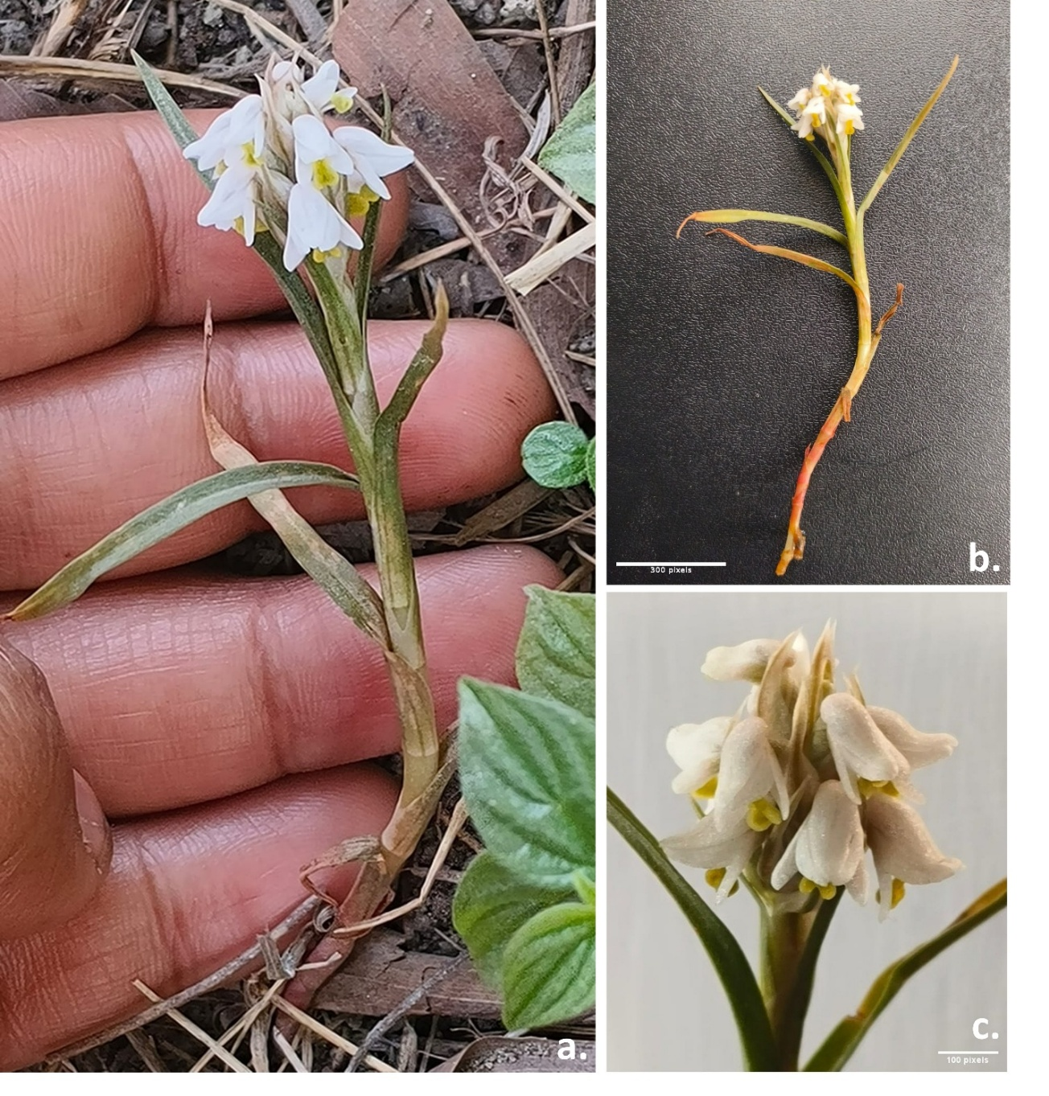
Figure 2. a. Habit of Zeuxine strateumatica, b. whole plant, c. inflorescence of Zeuxine strateumatica showing floral morphology.

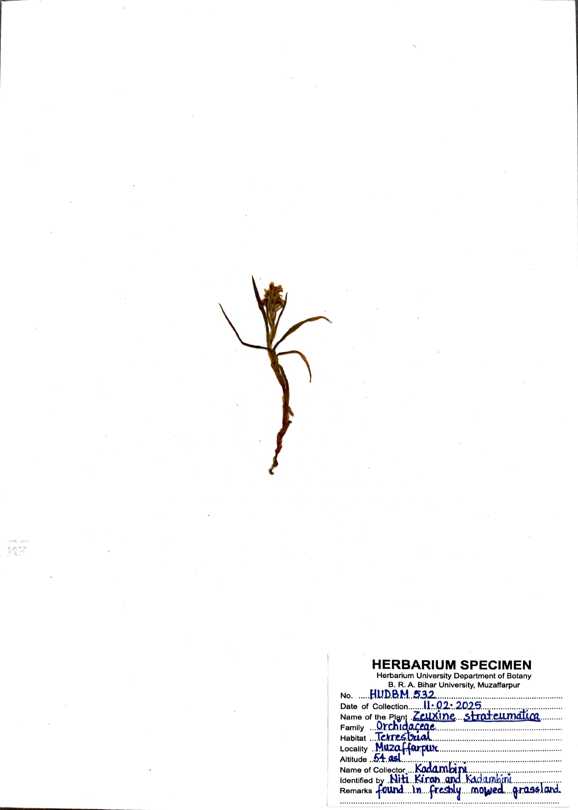

Figure 3. Herbarium specimen of Zeuxine strateumatica deposited at Herbarium University Department of Botany, B. R. A. Bihar University, Muzaffarpur

