Case Report
Trichobezoar Revealing Psychosis in an Adolescent: A Case Report

Abstract
Introduction:
Trichotillomania, often considered an impulse control disorder, can sometimes conceal a more severe underlying psychiatric condition. We report the case of an adolescent initially hospitalized for a trichobezoar, revealing a progressive psychotic disorder.
Clinical Case:
Ms. A, 16 years old, with no significant personal or family medical or psychiatric history, was referred to our department following surgical intervention for a trichobezoar. The psychiatric evaluation revealed chronic psychotic symptoms. The onset dated back approximately four months. Physical and paraclinical investigations (brain imaging, neurological examination, biological tests) were unremarkable.
Discussion:
The differential diagnosis initially ruled out organic, endocrine, and toxic causes. From a psychiatric standpoint, several hypotheses were considered: persistent delusional disorder, bipolar disorder with psychotic features, schizoaffective disorder, and paranoid schizophrenia. The clinical evolution, symptomatology, and impaired social functioning pointed toward early-onset paranoid schizophrenia, without excluding a schizoaffective disorder , comorbid with trichotillomania.
Conclusion:
This case highlights the importance of thorough psychiatric assessment in adolescents presenting with behavioral disorders, even when appearing isolated, as in trichotillomania. Early detection of a psychotic disorder allows for appropriate management and improves functional prognosis.
Keywords: trichotillomania, adolescence, schizophrenia, trichorhizophagia, trichobezoar

Introduction :
Trichotillomania (TTM) is an often debilitating psychiatric condition characterized by recurrent pulling out of one’s own hair, most often the head [1], followed by the eyelashes and eyebrows [2] leading to hair loss and marked functional impairment [3]. In DSM-5, trichotillomania was included in the chapter on obsessive-compulsive and related disorders, along with obsessive-compulsive disorder, excoriation disorder, body dysmorphic disorder, and hoarding disorder [4]. Once believed to be rare, trichotillomania is now thought to affect as much as 4% of the population [5].Co-morbid psychiatric problems are common in children and adults with trichotillomania [1,6]. Repetitive hair pulling or trichotillomania have been described in subjects with schizophrenia in few case reports [7] . We report the case of a teenage girl initially hospitalized for a trichobezoar, which revealed an evolving psychotic disorder.
Case presentation:
Miss A., 16 years old, with no significant personal or family medical or psychiatric history, was referred to our department following surgery for a trichobezoar.
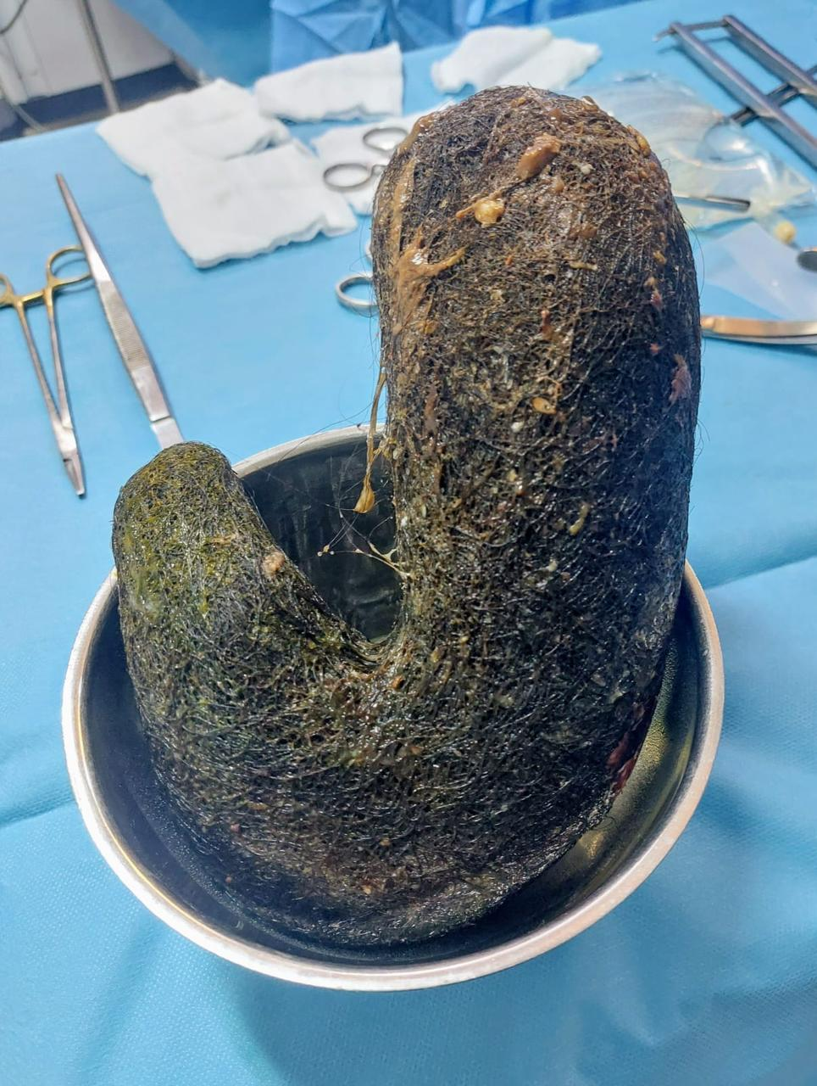
Figure1: Gastric trichobézoar discovered in a 16-year-old girl
The psychiatric interview revealed a poorly systematized, multi-thematic delusional syndrome (persecution, mysticism, grandiosity), associated with auditory hallucinations, behavioral disturbances (mannerisms, initial instability), and denial of symptoms. The onset dated back approximately four months. The hair pulling was not the result of hallucinations; the patient experienced this disorder with a great deal of struggle and anxiety. Physical and paraclinical investigations (brain imaging, neurological examination, biological tests) were unremarkable.
Management:
A biopsychosocial approach was implemented: antipsychotic treatment with risperidone, escitalopram , family psychoeducation, close outpatient follow-up, and long-term support integrating pharmacotherapy, psychological support, and social reintegration.
Discussion:
In DSM-IV-TR, trichotillomania (TTM) is classified as an impulse control disorder (not classified elsewhere), skin picking lacks its own diagnostic category (but might be diagnosed as an impulse control disorder not otherwise specified), and stereotypic movement disorder is classified as a disorder usually first diagnosed in infancy, childhood, or adolescence [8].
For the publication of DSM-5, obsessive-compulsive disorder (OCD) was the subject of significant revisions to its classification and diagnostic criteria. One of these significant changes was the placement of OCD in a new category, “Obsessive-Compulsive and Related Disorders (OCRDs),” which also includes trichotillomania (hair-pulling disorder) [9] . The diagnostic criteria require that recurrent hair pulling results in hair loss and the individual makes repeated attempts to decrease and stop hair pulling. Trichotillomania should not be diagnosed if hair pulling is the result of a medical condition or another mental disorder[10].
Trichotillomania occurs with a variety of other disorders, such as major depressive disorder , anxiety disorders , and substance use disorders [4]. Other comorbid conditions reported include dissociative experiences, dementia, Parkinson’s disease, partial seizures, and Prader- Willi syndrome [11].
Data regarding the pathophysiology of trichotillomania are limited. The potential relevance of the SAPAP3 protein in particular to trichotillomania is reinforced by the finding that rare variations in the SAPAP3 gene are associated with human disorders such as hair pulling [12]. Several neurotransmitter and neuropeptide systems have been thought to contribute to TTM pathology. Much of the molecular research on TTM has focused on the monoaminergic systems (e.g., the serotonin, dopamine, and norepinephrine systems) [13]. In terms of psychological etiology, it has been suggested that hair pulling may regulate emotional states or stressful events. Hair pulling may function as a means of escaping from or avoiding aversive experiences, and temporary relief from these negative emotions may maintain the behavior through a negative reinforcement cycle[14].
A case of trichotillomania with trichorhizophagia in a 58-year-old man with schizophrenia responded well to olanzapine with escitalopram. Escitalopram was shown to be effective in many of the obsessive spectrum disorders. This case points to the efficacy of combination of olanzapine and escitalopram particularly in patents showing psychotic symptoms along with trichotillomania [11]. Case reports suggest that use of selective serotonin inhibitors (SSRIs) may be useful in the treatment of trichotillomania in subjects with schizophrenia also [7].
A 29-year-old woman was also admitted to the inpatient unit with a diagnosis of schizophrenia. She had been experiencing a chronic illness with an insidious onset over the past 13 years. Following the stabilization of her psychotic symptoms, she was questioned about her hair-pulling behavior. The patient described a strong urge to pull out her hair, accompanied by feelings of tension and anxiety, which would subside only after engaging in the behavior. She further explained that this urge was often triggered by stress related to interpersonal conflicts within her family. Notably, she denied any connection between her hair-pulling behavior and her psychotic symptoms. Based on this information, a comorbid diagnosis of trichotillomania was established [7].
On the other hand , a patient presented with history of a continuous psychotic syndrome and history of hair pulling in response to command auditory hallucinations. There was correlation between response of psychosis to antipsychotics and reduction in hair pulling. This case highlights the differences between hair pulling of trichotillomania and that secondary to psychosis. These unusual features should raise an index of suspicion in the clinician when hair pulling is encountered in patients with schizophrenia, thereby avoiding a diagnosis of co-morbid trichotillomania and the resultant pharmacotherapy with additional agents to antipsychotics which may worsen the underlying psychosis and add to the burden of illness [10].
Conclusion :
Trichotillomania has multiple possible etiologies as well as several comorbidities . One must always investigate whether there are psychotic symptoms that may be evolving concurrently. It is always necessary to differentiate whether it is trichotillomania comorbid with schizophrenia, or a condition resulting from an influence syndrome and auditory hallucinations.

References :
1. Woods DW, Houghton DC. Diagnosis, Evaluation, and Management of Trichotillomania. Psychiatric Clinics of North America. sept 2014;37(3):301‑17.
2. Okuyan M, İvelik İ, Okumuş B, Hocaoğlu Ç, Kılınç K, Çetin FH, et al. Total hair, eyebrows, and eyelashes loss in trichotillomania: a case report.
3. Christenson, G. A., Pyle, R. L., & Mitchell, J. E. (1991). Estimated lifetime prevalence of trichotillomania in college students. Journal of Clinical Psychiatry, 52(10), 415–417.
4. Grant JE, Chamberlain SR. Trichotillomania. AJP. 1 sept 2016;173(9):868‑74.
5. Kähkönen, S. (2002). Trichotillomania in a schizophrenia patient. CNS Spectrums, 7 (10), 751–752.
6. Chandran NS, Novak J, Iorizzo M, Grimalt R, Oranje AP. Trichotillomania in Children. Skin Appendage Disord. 2015;1(1):18‑24.
7. Ruchita Shah, Mansi Somaiya, and Sandeep Grover. Trichotillomania Comorbid with Schizophrenia .Department of Psychiatry, Postgraduate Institute of Medical Education and Research, Chandigarh, India.
8. Stein DJ, Grant JE, Franklin ME, Keuthen N, Lochner C, Singer HS, et al. Trichotillomania (hair pulling disorder), skin picking disorder, and stereotypic movement disorder: toward DSM-V. Depress Anxiety. juin 2010;27(6):611‑26.
9. Van Ameringen M, Patterson B, Simpson W. DSM-5 OBSESSIVE-COMPULSIVE AND RELATED DISORDERS: CLINICAL IMPLICATIONS OF NEW CRITERIA: Review: DSM-5 OCD and Related Disorders. Depress Anxiety. juin 2014;31(6):487‑93.
10. Solomon, S., & Singaravelu, R. (2015, May). Auditory Hallucinations with an Unusual Content. Journal of Clinical and Diagnostic Research, 9(5), VD06–VD07.
11. Suresh Kumar P, Rajmohan V. Trichotillomania with trichorhizophagia in a schizophrenic patient: Case report and review of literature. Indian J Psychiatry. 2012;54(2):196.
12. Bienvenu OJ, Wang Y, Shugart YY, Welch JM, Grados MA, Fyer AJ, et al. Sapap3 and pathological grooming in humans: Results from the OCD collaborative genetics study. American J of Med Genetics Pt B. 5 juill 2009;150B(5):710‑20.
13. Swedo, S. E., Leonard, H. L., Rapoport, J. L., Lenane, M. C., Goldberger, E. L., & Cheslow, D. L. (1989). A double-blind comparison of clomipramine and desipramine in the treatment of trichotillomania (hair pulling). The New England Journal of Medicine, 321(8), 497–501.
14. Roberts S, O’Connor K, Bélanger C. Emotion regulation and other psychological models for body-focused repetitive behaviors. Clinical Psychology Review. août 2013;33(6):745‑62.

