Case report

EROSIVE ORAL LICHEN PLANUS – A CASE REPORT

ABSTRACT
Oral lichen planus is a commonly encountered chronic inflammatory cell mediated immune disease of the oral mucosa, ¹¹commonly presenting as bilateral white striations known as Wickham's striae, which are often located primarily in atrophic or erosive lesions. ¹¹Both specific immune responses and non-specific inflammatory pathways are involved in the pathogenesis of this disease. Disruption of physiological immune regulation is thought to be a particularly important factor, which may involve CD40, TNF-α, MMPs, Fas ligand, and mast cell degradation. Treatment options are available, and the course of the condition is often influenced by a number of local and systemic factors. Oral lichen planus is more often diagnosed in female patients as compared to male patients, and diagnosis usually occurs based on clinical findings and histopathological findings, including immunofluorescence and cytology. In some cases oral lichen planus may resolve spontaneously; however, treatment can be needed. In this care report, we present a 51-year-old female patient who reported to the Department of Oral Medicine and Radiology diagnosed with oral lichen planus.
Key words: Oral lichen planus, Wickham's striae, autoimmune disease, immunofluorescence.

INTRODUCTION
Oral Lichen Planus is a chronic inflammatory T cell mediated disorder with alternating periods of exacerbation and remission. Treatment is mainly concerned with controlling inflammation and reducing discomfort.⁶Lichen planus is a chronic inflammatory condition most commonly affecting the skin and mucosa that also affects the nails, hair follicles, genitals, eyes, and esophagus. Less commonly, lichen planus can occur in the bladder, nasal passages, larynx, and anus. About 25% of Oral Lichen Planus patients have genital lesions, while cutaneous lesions develop in roughly 15% of cases.⁶ Oral Lichen Planus is more frequent in middle-aged and older females, believed to represent localized autoimmune response related to aberrant T cells. Oral lichen planus presents clinically in six major subtypes: reticular type, papular type, plaque-like type, atrophic/erosive type, ulcerative type, and bullous type. Lesions typically occur on the buccal mucosa, tongue, and gingiva, and generally appear bilaterally and symmetrically.¹ Because of the clinical appearance of oral lichen planus lesions, particularly the plaque-like and atrophic/erosive variants, they can be misdiagnosed as other oral white and red lesions; for example, leukoplakia and erythroleukoplakia. Corticosteroids are the primary treatment for oral lichen planus and long-term follow-up is often necessary.⁵
CASE REPORT
A 51-year-old female patient reported to the department of Oral Medicine and Radiology with a chief complaint of a persistent burning sensation in the oral cavity for the past 1 month, especially during meals. The patient gave a history of burning sensation while eating spicy food, with normal mouth opening. There were no additional symptoms like pain or ulceration. Medical history revealed patient was known diabetic for the past 10 years and under medication, hypertensive for the past 10 years and under medication, and patient has hypothyroidism for the past 10 years and under medication and hyperlipidemia for past 5 years. No previous dental history present. Personal history revealed a mixed diet, patient brushes twice daily. The patient was using colgate toothbrush with medium bristles and Darbur red (non fluoridated) toothpaste. On physical examination the patient was conscious and well oriented to time, place and person surrounding them. No noticeable abnormalities were observed in extraoral examination. On intraoral Examination, inspection on soft tissue revealed white striations known as Wickham’s striae present on the buccal mucosa of both right and left side. Extends from the 2nd molar region to the pterygomandibular region with radiating white striae which was erythematous in right side and superior to the 2nd premolar to the 2nd molar region in the left buccal mucosa also radiating white striations on the floor of the mouth. It was also seen in the lower lips. On palpation tenderness present in the right pterygomandibular region with elevated ulcerative lesions. The hard tissue examination revealed abrasions on teeth 24, 25, 34, 46, and 15 and furcation involvement in 46 and 47. The lesion was provisionally diagnosed as erosive oral lichen planus. Systemic lupus erythematosus, candidiasis, benign MMPs, pemphigus vulgaris, erythema multiforme, chronic ulcerative stomatitis, frictional keratosis, lichenoid drug reaction, and lichenoid lesions are among the differential diagnoses for erosive oral lichen planus. Retinal oral lichen planus can occasionally mimic oral leukoplakia. The final diagnosis was erosive lichen planus in left and right buccal mucosa which was established based on the clinical findings and the symptoms. For management the patient was prescribed a multivitamin (A to Z Plus) for 15 days after food once a day in the morning and topical corticosteroid ointment (Kenocort 0.1%) thrice a day for one week. After 10 days the patient was called for a biopsy and review. On the second visit, a noticeable reduction in white striations on the right pterygomandibular region was observed. Patients also revealed that the discomfort while eating spicy food was reduced. As signs and symptoms were reduced patient was asked to continue the medication for another week (multivitamin-A to Z Plus for 15 days and topical corticosteroid ointment-Kenocort 0.1% for one week.). The patient was called for regular follow-ups at 1 month, 3 months and 6 months and she is under observation.
Figure 1: Bilateral white striae (Wickham’s striae) present on buccal mucosa and lower lip.
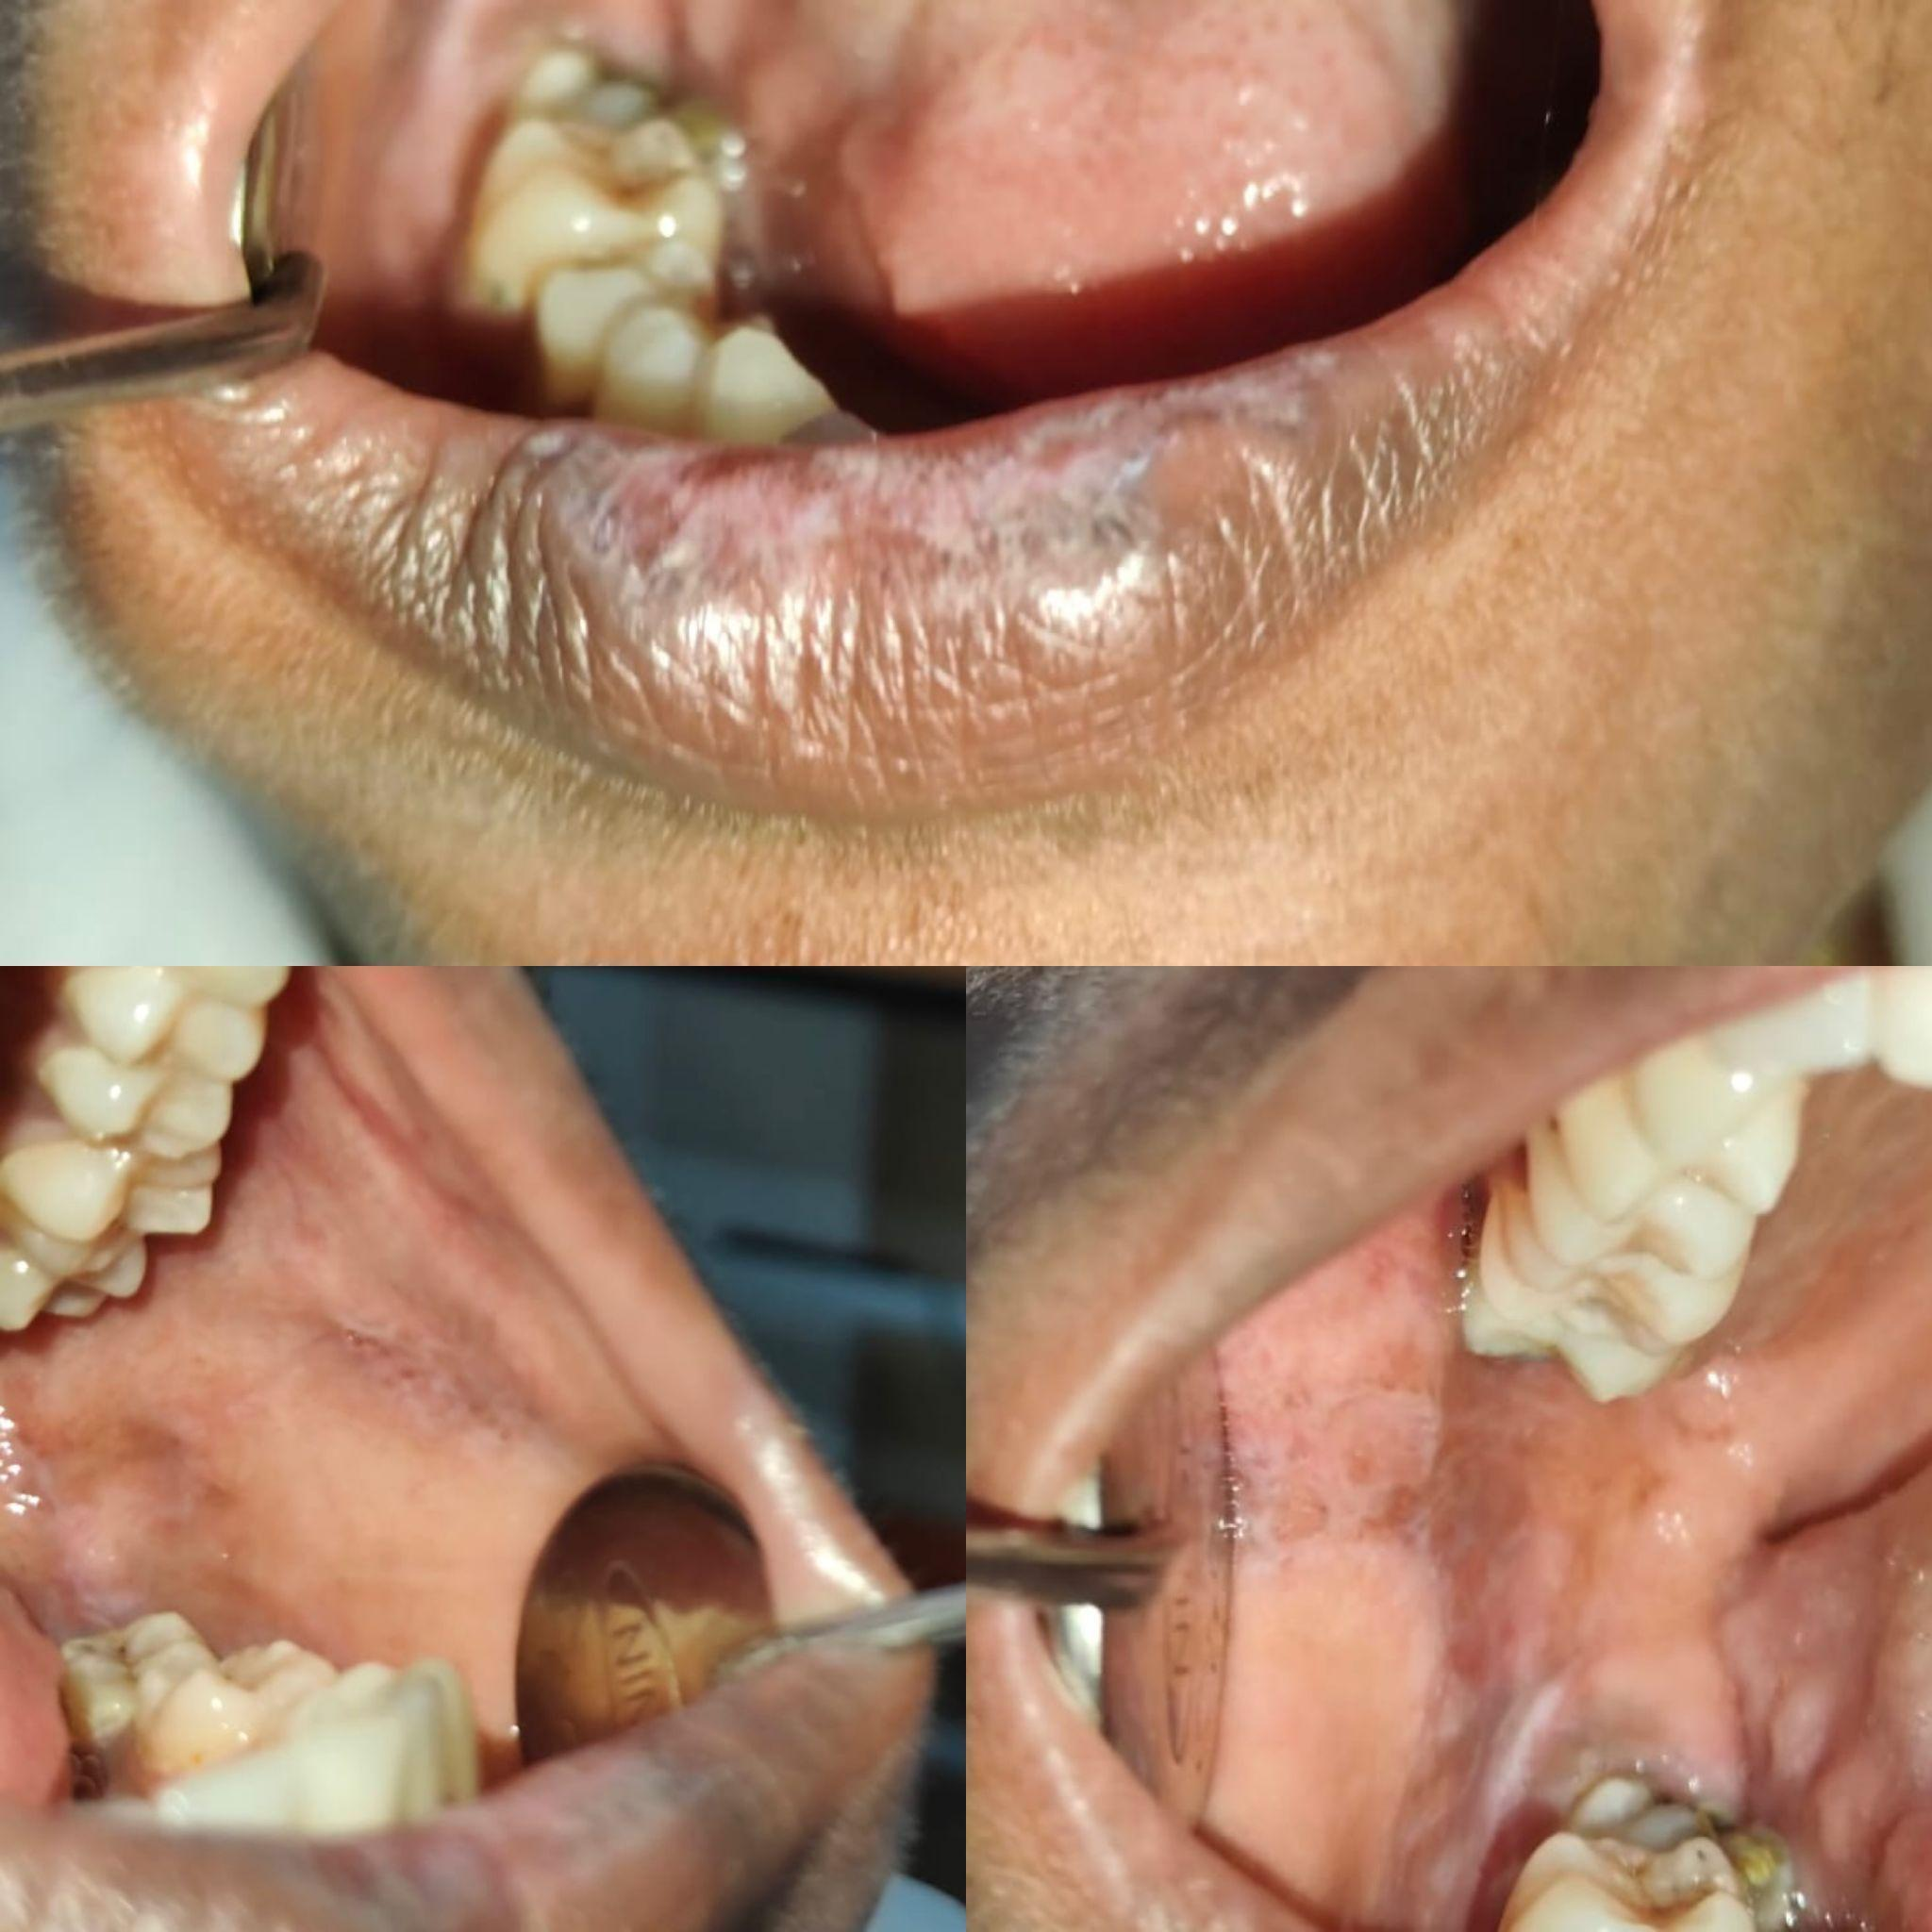

Figure 2: Marked improvement in lesion appearance (reduced Wickham’s striae in left buccal mucosa) after one week of treatment.
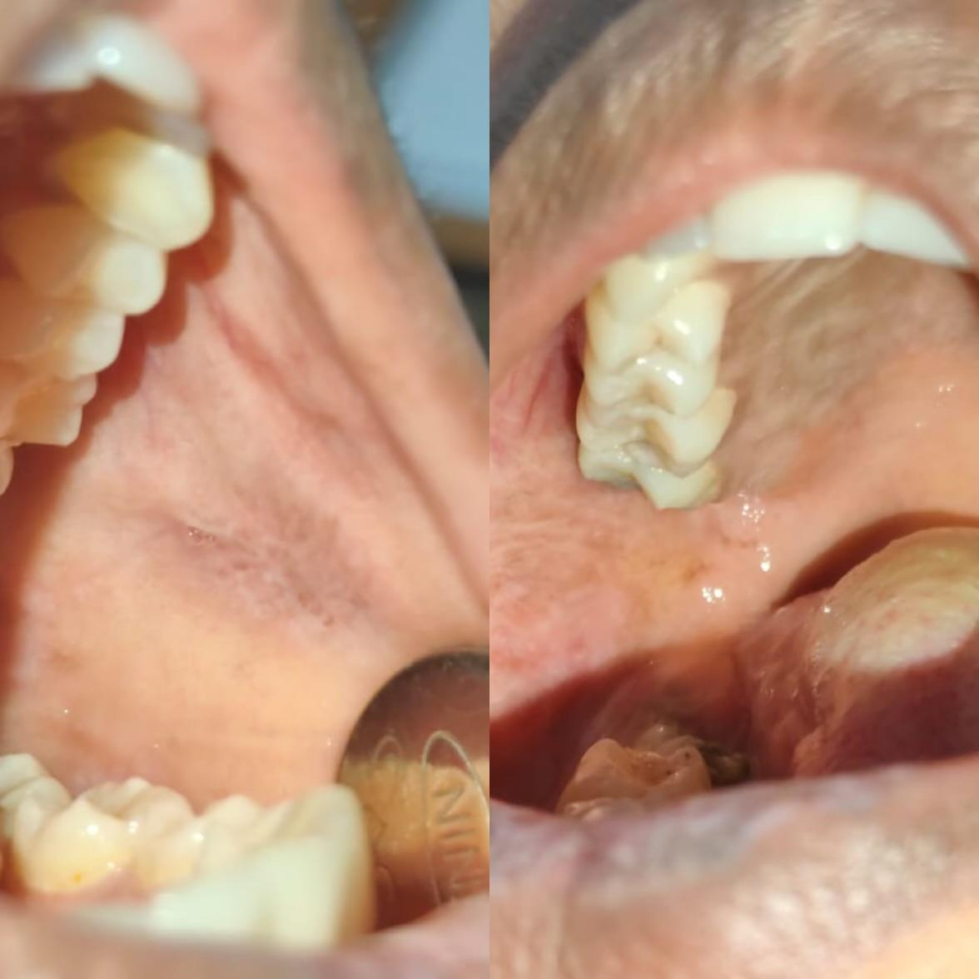

DISCUSSION
Oral Lichen Planus is a chronic inflammatory autoimmune disorder of the oral mucosa ⁸ estimated to affect approximately 1 to percent of the general population. ³ The condition occurs more in females, particularly for individuals in their 40s, 50s and beyond, with a ratio of female-to-male of approximately 1.5:1^{10.} Ten years after Erasmus Wilson, a physician from England, made the first comprehensive description of oral lichen planus, he proposed it was completely identical to lichen ruber, described years earlier by Hebra, because of its unique papular nature and ability to occur alone or in a cluster. Kaposi first observed a special form of the disease, which he termed lichen ruber pemphigoides in 1892. After a few years in 1895 Wickham first described the characteristic network of fine white lines over the papules, now termed Wickham's striae. The first systematic discussion of the microscopic features of the disorder was organized by Darier, paving the way for an understanding of the histopathology of lichens planter. ⁸
The etiology of oral lichen planus is unknown, however, many associated predisposing factors have been postulated for an association. While familial inheritance is rare, a few genetic markers are HLA-A3, A11, A28, B8, DR1. Restorative and/or prosthetic materials may act as sensitizers. Materials reported as contact allergens include silver amalgam, gold, cobalt, palladium, and chromium⁸, as well as non-metallic materials such as epoxy resins (e.g. composite resins) and long use of dentures. Drug-related lichenoid reactions have been reported with several medications⁸, including NSAIDs, beta-blockers, sulfonylureas, ACE inhibitors, and antimalarial agents.⁸ Flavoring agents used in toothpaste, particularly those based on cinnamon, have also been implicated as potentially allergenic.⁸
Infectious factors have also been evaluated. A number of studies have posited a relationship between oral lichen planus and gram-negative anaerobic bacilli or spirochetes⁸ though this relationship has not been established. Viral relationships have been more regularly defined, including Human papillomavirus, Epstein–Barr virus and human herpesvirus-6, ⁸ as well as infection with HIV. Autoimmune diseases may co-occur with oral lichen planus. ⁸ Psychological stress and anxiety are also considered major contributors. Lifestyle factors may contribute as well. While oral lichen planus is not generally noted to be significantly higher in cigarette smokers, tobacco use has been reported as a potential risk factor in some Indian groups. Patients with oral lichen planus frequently had a history of betel nut chewing. Although trauma is not accepted as a cause, it may serve as a facilitator of some other etiological factors. Systemic factors, such as hyperglycemia and hypertension, have also demonstrated an increased frequency or association with oral lichen planus in various studies.⁸
Both specific and non-specific responses of the immune system lead to oral lichen planus. In the specific response, basal keratinocytes present antigens to CD8+ cytotoxic T-cells that damage keratinocytes specifically. The non-specific response mediates damage through mast cell degranulation and stimulating matrix metalloproteinases (MMPs). Together, these processes lead to T-cell accumulation in the superficial lamina propria with basement membrane disruption allowing T-cell penetration into the epithelium, ultimately resulting in keratinocyte apoptosis. The involvement of TGF-β1 has been implicated in the sustained presence of oral lichen planus, due to TGF-β1-mediated insufficient immunosuppression. ⁹
The histopathology of oral lichen planus¹⁵ is unique and characterized by liquefactive degeneration of basal cells with keratinocyte apoptosis, a dense band-like infiltration of lymphocytes at the junction between the epithelium and connective tissue, focal areas¹⁵ of hyperkeratinization (which is clinically described as Wickham's striae), thinning of the epithelium with shortened, sharply pointed "saw-tooth" rete ridges, and Civatte bodies.10 Clinically, oral lichen planus may present in a variety of distinct forms, including having a reticular type, papular type, plaque-like, atrophic/erosive type, ulcerative type, and bullous type appearance.¹ An additional clinical feature includes the Koebner phenomenon as new lesions occur on previously unaffected mucosa after trauma.
The characteristic appearance of oral lichen planus, especially Wickham's striae, supports the clinical diagnosis of oral lichen planus and Wickham's striae are considered to be pathognomonic. The differential diagnosis.¹² of erosive oral lichen planus includes systemic lupus erythematosus, oral candidiasis, benign mucous membrane pemphigoid, pemphigus vulgaris, chronic ulcerative stomatitis, erythema multiforme, frictional keratosis, lichenoid drug reactions, and lichenoid contact lesions.¹² In addition, the plaque-type variant of oral lichen planus may appear very similar to oral leukoplakia..¹² More work-ups and investigations will be needed when desquamative lesions are suspected. A smear examination is typically the initial analysis and the Tzanck test is an easy, inexpensive, and minimally invasive approach that can aid in diagnosis. Direct immunofluorescence is useful and particularly important in patients with erosive lesions, especially desquamative gingivitis, to help differentiate oral lichen planus from vesiculobullous diseases, such as PV or MM disease. In oral lichen planus, direct immunofluorescence generally shows irregular, shaggy-like deposits of fibrinogen and complement along the basement membrane zone and, at times, with depositions around colloid bodies. Importantly, fibrinogen will not be exclusive to oral lichen planus, as similar finding will occur in other oral potentially malignant disorders. ⁶ Indirect immunofluorescence is not considered a reliable diagnostic tool for oral lichen planus. ⁸
Given the potential systemic implications of oral lichen planus, a multidisciplinary management approach is often required. Continuous follow-up and early therapeutic intervention are particularly important due to the risk of malignant transformation. ⁵
Management: Topical therapy remains the mainstay of treatment. Topical corticosteroids are widely used in various formulations such as drops, pastes, gels, and sprays. Common examples include triamcinolone, fluticasone nasal spray preparations, and clobetasol propionate in multiple delivery forms. For gingival lesions, corticosteroids may be administered using polyvinyl siloxane medication trays, allowing localized drug retention for a few hours.⁸ Topical calcineurin inhibitors such as tacrolimus (Protopic) and pimecrolimus (Elidel) have also been shown to be effective alternatives in controlling immune-mediated inflammation.³ Other pharmacologic options include systemic or adjunctive agents such as corticosteroids, calcineurin inhibitors, acetaminophen, and topical anesthetics like lidocaine, which can be used for symptomatic relief.
It is important to note that oral lichen planus¹³ is a chronic condition that does not completely resolve. However, most patients experience alternating periods of exacerbation and remission. In many cases, lesions may remain painless and require no intervention, whereas others may necessitate strong prescription therapies to achieve adequate symptom control.

REFERENCES
^{1.} Lysitsa S, Samson J, Gerber-Wicht C, Lang U, Lombardi T. COX-2 expression in oral lichen planus. Dermatology (Basel). 2008;217(2):150-155.
^{2.} Lin H, Xu J, Wang Y, Zhou X. Atypical Clinical Presentation of Oral Erosive Lichen Planus. Oral Sci Int. 2025;12(1):60–64.
^{3.} Shukla A, Sharma A, Sinha S. Erosive Oral Lichen Planus in an Elderly Patient. Scientific Dental Journal. 2022;6(2):67–70.
^{4.} Malhotra A, Kaur J, Singh H, et al. Oral Lichen Planus and Its Relationship with Systemic Diseases. J Family Med Prim Care. 2018;7(6):1176–1183.
^{5.} Dayma A, Sharma A, Rajput A. Erosive Lichen Planus of Gingiva – A Case Report. IP Int J Clin Exp Dent. 2020;6(2):133–136.
^{6.} Baroudi K, Alenazi A. Oral Lichen Planus. StatPearls. Treasure Island (FL): StatPearls Publishing; 2023.
^{7.} Patil S, Rao RS, Sanketh DS, Warnakulasuriya S. Therapeutic strategies for oral lichen planus: A review. Front Med. 2022;9:997190.
^{8.} Gupta S, Jawanda MK. Oral Lichen Planus: An update on etiology, pathogenesis, diagnosis and treatment. Int J Oral Maxillofac Surg. 2015;14(1):1–12.
^{9.} Sugerman PB, Savage NW, Walsh LJ, et al. The pathogenesis of oral lichen planus. Crit Rev Oral Biol Med. 2002;13(4):350–365.
^{10.} van der Meij EH, van der Waal I. Lack of clinicopathologic correlation in the diagnosis of oral lichen planus based on the WHO criteria. Oral Surg Oral Med Oral Pathol Oral Radiol Endod. 2003;96(6):701–707.
¹¹Dissemond J. Oral lichen planus: an overview. J Dermatolog Treat. 2004;15(3):136-40. doi:10.1080/09546630410031945.
¹²Gururaj N, et al. Diagnosis and management of oral lichen planus – Review. J Oral Pathol Med. 2022;51(7)
¹³Mignogna MD, Lo Russo L, Fedele S, Buonaiuto C, Ruoppo E, Conrotto D, et al. Immune activation and chronic inflammation as the cause of malignancy in oral lichen planus: is there any evidence? Oral Dis. 2004;10(5):241-59.
¹⁴Shirasuna K, Yokozawa M, Uchida K, Mikami S, Yoshino K, et al. Title unknown. J Dermatol Sci. 2010;—. DOI:10.1111/j.1529-8019.2010.01322.x.
¹⁵Edwards PC, Kelsch R. Oral lichen planus: clinical presentation and management. J Can Dent Assoc. 2002;68(8):494-9.

