Assessment of lipid profile and cardiac histological changes following administration of Methanol Root Extract of Newbouldia laevis in Rats

Abstract

Herbal therapies with antimalarial activities are increasingly studied not just for efficacy but also for safety. Methanol root extract of Newbouldia laevis has shown antimalarial potential in mice, however, the lipid-modulating effects remain unclear. This study investigated the effects of methanol root extract of N. laevis on serum lipid profile and cardiac histology in healthy rats. Albino Wistar rats were administered 125, 250, 500, and 750 mg/kg/body weight methanol root extract of N. laevis. Serum total cholesterol, LDL-Cholesterol, HDL-cholesterol and triacylglycerides were determined. Histological examination of heart tissue was performed to assess the structural changes. A dose-dependent increase was observed in serum cholesterol concentrations with 750 mg/kg group presenting the highest cholesterol concentration (5.83±0.06 mmol/L), while 125 mg/kg group presented the lowest (3.84±0.21 mmol/L). HDL-cholesterol (1.00±0.09 mmol/L) decreased significantly at 500-750 mg/kg doses, with the control group showed the highest (2.20±0.10 mmol/L). Rat groups of 125-250 mg/kg/bw presented lipid profiles comparable to untreated control, indicating no adverse biochemical effects. Also, higher doses recorded higher triacylglycerides, VLDL, lower HDL, elevated atherogenic index of plasma (AIP), atherogenic coefficient (AC) and Castelli indices indicating hyperlipidemia and increased risk of cardiovascular disease. Elevated AIP values observed in rats administered 500-750 mg/kg methanol root extract of N. laevis were within the high-risk category, reflecting a strongly atherogenic lipid profile. Cardiac histopathology corroborated these by presenting gross cellular depletion of cells of the cardiac muscle at the connective tissue and exfiltration of the nuclei of muscle cells. Collectively, these findings suggest that while low doses may be relatively safe, higher doses of N. laevis extract significantly increase cardiovascular risk markers and may predispose to atherogenic complications
Keywords: Total cholesterol, triacylglycerides, atherogenic index, dyslipidaemia, cardiovascular disease

Introduction
Malaria remains one of the most significant infectious diseases worldwide, causing 608,000 deaths in 2022, with the highest mortality rates recorded among young children in sub-Saharan Africa (WHO, 2023). Maria is though commonly characterized by haematological alterations it also disrupts significantly host lipid metabolism, presenting as dyslipidaemia (Mesquita et al., 2016; de Souza et al., 2013). These metabolic fluctuations in lipids may exacerbate disease pathology and increase cardiovascular risk. Some conventional antimalarial drugs have shown effectiveness at reversing some biochemical imbalances but face challenges of resistance and toxicity (WHO, 2023). Consequently, herbal therapies are gaining interest, and some have shown both antimalarial and lipid-modulating effects (Atanu et al., 2022; Oluba et al., 2012).
Over the past decade, significant progress in malaria control has been achieved due to increased investments in prevention, improved diagnostic tools, and better treatment strategies. These efforts contributed to a 36% reduction in malaria mortality between 2010 and 2020 (CDC, 2023). However, despite these efforts, malaria cases and deaths have increased in recent years due to drug resistance, insecticide resistance, climate change, geographical barriers, weak healthcare infrastructure, and financial constraints which delay access to timely malaria treatment (WHO, 2023). Malaria exerts a disproportionate burden on low-income populations, particularly in tropical and subtropical regions where access to healthcare, diagnostic tools, and preventive interventions is severely constrained (WHO, 2023). The disease thrives in environments with poor healthcare infrastructure, where individuals have limited access to insecticide-treated nets (ITNs), effective antimalarial drugs, and rapid diagnostic tests (RDTs). These limitations result in delayed treatment, increased disease severity, and higher mortality rates.
Nigeria has a rich heritage of folk medicine, where various herbal preparations using different plant parts serve as alternatives or complementary therapies to conventional medicine in preventing and treating numerous diseases (Mgbeahuruike et al., 2019; Balogun, 2021). Many Nigerians, particularly those in rural and peri-urban areas, rely on folk medicine due to its availability, the high cost of conventional medicine, poor healthcare infrastructure, and limited access to allopathic medicine (Osuchukwu et al., 2017). Others prefer herbal formulations because they trust them, as these remedies have been traditionally used for generations.
Since malaria is an important global health burden, exacerbated by rising drug resistance and the limited availability of effective therapies, especially in sub-saharan Africa (Mogaka et ai., 2023). This has inspired increased interest in identifying alternative antimalarial agents from medicinal plants. These plants show both antiparasitic effects and ability to modulate host physiology (Mogaka et ai., 2023; Oluba, 2019). The root extracts of Newbouldia laevis was used to effectively treat Plasmodium berghei-infected mice (Obika et al., 2025b-in press).
Newbouldia laevis P. Beauv. Seem, a member of the Bignoniaceae family, is a widespread and common species found in various habitats, including regenerating forests, savanna woodlands, semi-deciduous forests, forest margins, and farms. Newbouldia laevis bark and leaves can be used for treating arthritis and rheumatism. It acts as a painkiller, laxative and also can be used for treating patients suffering from diarrhea and dysentery (Egba et al., 2014). Study by Akerele et al. (2011) revealed that the stem bark of N. laevis has antibacterial activities. The phytochemical evaluation of the root bark by Obika et al. (2025a in press) showed the presence of flavonoids, alkaloids, saponins, tannins and GC-FID revealed appreciable amount of ribalinidine saponin, sapogenin, rutin, kaempferol Obika et al. (2025b in press). Newbouldia laevis bark and roots can be used for treating swellings, and oedema arising through dietary deficiency. It contains anti-cancerous properties hence it can be used for treating tumors and cancers. The leaf extract can be used for both eye and ear treatments. N. laevis serves as an antidote for treating venomous stings and bites (Egba et al., 2014). Obika et al. (2025ab in press) evaluated the toxicological effect of methanol root extract of N laevis and the in vivo antimalarial potential of methanol and aqueous extracts of N laevis on plasmodium berghei-infected (NK65) infected mice. These studies presented no observable adverse effect at low doses (125 and 250 mg/kg body weight) of the methanol extracts and also effectively lowered the parasitaemia count at Day 7 indicating the extract as a potential alternative treatment for malaria and good source for drug development

However, Alterations in lipid metabolism are a recognized complication of malaria. Infection with Plasmodium species frequently disrupts host lipid profiles which may contribute to disease severity and organ dysfunction (Oluba, 2019). Some plant extracts have demonstrated dual benefits: reducing parasitemia and restoring lipid homeostasis (Oluba, 2019).
For instance, a terpenoid extract from Ganoderma lucidum enhanced survival in Plasmodium berghei-infected mice while lowering erythrocyte and hepatic triglycerides, cholesterol, LDL, and phospholipids (Oluba, 2019). Similarly, ethanolic extracts of Ficus sur leaves in P. berghei-infected rats restored LDL and total cholesterol levels and improved HDL levels, although triglycerides remained unchanged.
On the basis of the possible fluctuation on lipid profile it becomes important to investigate the effects of the plant extract on both parasitemia and lipid metabolism. In this study the effect of methanol root extracts of N. laevis (used to treat mice infected with Plasmodium-berghei) on lipid profile of albino Wistar rats was evaluated.

This dual approach not only elucidates the potential antimalarial action of methanol root extracts of N. laevis but also its capacity to mitigate malaria-associated dyslipidemia and tissue pathology—offering a more comprehensive evaluation that could have translational relevance in pharmacognosy and antimalarial development.
MATERIALS AND METHODS
Materials
Chemicals/Reagents Used
Materials used in this study include; Concentrated NH₄OH, frothing reagent, Olive oil, Acetic anhydride (CH₃CO)₂O, Glacial acetic acid (CH₃COOH), BDH Methanol, Tween 80, Giemsa stain, Phosphate buffer saline (PBS) of pH7.2, ethylene diamine tetraacetic acid (EDTA),0.1% Ferric chloride, diluted ammonia, Sulphuric acid, 20% acetic acid, ethanol, all the chemicals were of analytical grade.
Plants Collection and Preparation
Fresh roots of Newbouldia laevis plants were collected at Umuezeala (Umudaranwaneri) Awo-Omamma in Oru-East Local Government Area, Imo State of Nigeria. In August 2015. The primary sampling point was georeferenced using the Mobile Topographer application at latitude 5.66849354° N and longitude 6.95121404° E (WGS 84 datum), with an altitude of 158.60 meters above the ellipsoid. The plant was identified by plant taxonomist in the Department of Forestry and Wildlife Technology at the Federal University of Technology Owerri. The plant voucher number at “Ujor Forestry Harvester Ibadan is (FHI) 29271” and was deposited at the herbarium of the Department of Forestry and Wildlife Technology at Federal University of Technology Owerri with a voucher number FUTO/H100125.
The plant samples were prepared and extracted using the procedure as described by Buss and Butler (2010). Fresh roots were collected in bulk, thoroughly washed with tap water, cut into small pieces, and air-dried at room temperature in the laboratory for approximately seven weeks. The dried roots were then pulverized into fine powder using a crusher. For extraction, 100 g of the powdered material was subjected to crude maceration in methanol for 48 h and subsequently filtered through Whatman No. 1 filter paper. The methanol filtrates obtained were concentrated on a water bath at 45 °C, and the percentage yield was calculated. The resulting extracts were stored at 4 °C in a refrigerator until further use.
Experimental Design
In this study, the 25 albino Wistar rats used were randomly assigned into five groups of five rats each. The control group received Normal saline. The remaining groups were administered graded doses (125 mg/kg, 250 mg/kg, 500 mg/kg, and 750 mg/kg) of methanol root extract of N. laevis. Treatments were given once daily for four consecutive days. Following administration, all animals were monitored for 14 days to observe any signs of toxicity or abnormal behavioral changes. At the end of the observation period, the animals were fasted overnight, mildly anaesthetized and blood samples collected through cardiac puncture. The animals were sacrificed, and the heart organ sample was harvested for histopathological evaluation.

Determination of lipid Profile parameters
Serum level of total cholesterol was quantified by methods described by Stein (1987), using assay kits (Randox Laboratories Ltd). Serum triacylglycerol (TG) concentration was determined by enzymatic method described by Stein (1987), using assay kits (Randox Laboratories Ltd), while serum high density lipoprotein-cholesterol (HDL-c) were measured by the method of Wacnic and Albers (1978), using assay kits (Randox Laboratories Ltd). The serum low density lipoprotein-cholesterol (LDL-c) were calculated in mg/dl according to the protocol of Friedewald et al., (1972) using the equation LDL-c = (TC - TG/5) – HDL-c

Histological Studies of Heart Tissues
The heart organ was subjected to histological studies. The method described by Okoro (2002) was used with minor modifications. The heart tissues samples were fixed in a large quantity of 10% formaldehyde which covered the entire organs and then processed further. The organs were dehydrated by passing through ascending grades of alcohol (30%, 50%, 70%, 90% and absolute alcohol for 1hr, 2hrs and 3hrs each. After dehydration, alcohol was removed from the tissues by immersing in xylene for 3 h and then impregnated by transferring to a bath of molten paraffin wax in the embedding oven. During this stage, the clearing agent was eliminated from the tissues by diffusion into the surrounding wax. Other process include; Embedding, trimming, sectioning, attaching sections to sides, and staining. The staining process began with dewaxing and hydrating the section. To achieve this, the section was first placed on a hot plate at a temperature of 100°C above the melting point for a brief period. Next, it was immersed in xylene for 30 min to dissolve the wax. After xylene treatment, the section was transferred to absolute alcohol for 30 s to remove any residual xylene and prevent it from carrying over to the lower-grade alcohols. The section was then passed through a series of decreasing alcohol concentrations, starting with 90% alcohol for 30 s, followed by 70% alcohol for another 30 s. After alcohol treatment, the section was washed thoroughly in distilled water to remove any remaining alcohol. The section was then differentiated in a solution until only the cell nuclei retained the stain. To restore the natural color of the tissue, the section was blued with scotch in running tap water for 5 min. Finally, the section was counterstained with eosin for 1 minute to enhance the visibility of the tissue structures. It was dehydrated in ascending grades of alcohol, cleared in xylene and mounted with DPX (dibutylpthalate, polystyrene, xylene) and were examined using a light microscope and photographed at a magnification of x400.

Statistical Analysis
All the data generated were analyzed using analysis of variance (ANOVA) SPSS program (version 20.0 SPSS Inc., Chicago, IL, USA). The results were expressed as mean ± standard deviation (SD). P value less than 0.05 was considered as significant (P< 0.05).

RESULTS
The results of the effect of methanol root extract of N. laevis on lipid profile are presented in Figures 1 to 4. A dose-dependent increase was observed in serum cholesterol concentrations (Figure 1). The 750 mg/kg group showed the highest cholesterol concentration (5.83±0.06 mmol/L), while the 125 mg/kg group presented the lowest (3.84±0.21 mmol/L). This suggests that high doses may contribute to hyperlipidemia. High-Density Lipoprotein (HDL) concentrations (Figure 2) decreased significantly at higher doses, with the control group showing the highest (2.20±0.10 mmol/L), and the 750 mg/kg group the lowest (1.00±0.09 mmol/L). This reduction suggests a possible risk for cardiovascular issues. Low-Density Lipoprotein (LDL) concentrations (Figure 3) increased with dose, with the 750 mg/kg group recording the highest (1.42±0.05 mmol/L) and the 125 mg/kg group the lowest (0.98±0.05 mmol/L), suggesting a risk of dyslipidemia. Triglyceride (TAG) concentrations (Figure 4) significantly increased at higher doses. The 750 mg/kg group had the highest (3.62±0.11 mmol/L), while the control group had the lowest TAG concentration (1.55±0.18 mmol/L), indicating possible lipid metabolism alterations.

Figure 1 Total Cholesterol concentration of rats treated with different doses of Methanol root extract of Newbouldia laevis. Values are represented as Mean ± Standard Deviation of triplicate determinations. Bars bearing different alphabets indicate significant difference at p < 0.05.

Figure 2 High density lipoprotein- cholesterol (HDL) concentration of rats treated with different doses of Methanol root extract of Newbouldia laevis. Values are represented as Mean ± Standard Deviation of triplicate determinations. Bars bearing different alphabets indicate significant difference at p < 0.05.

Figure 3 Low density lipoprotein- cholesterol (LDL) concentration of rats treated with different doses of Methanol root extract of Newbouldia laevis. Values are represented as Mean ± Standard Deviation of triplicate determinations. Bars bearing different alphabets indicate significant difference at p < 0.05.

Figure 4 Triacylglyceride (TAG) concentration of rats treated with different doses of Methanol root extract of Newbouldia laevis. Values are represented as Mean ± Standard Deviation of triplicate determinations. Bars bearing different alphabets indicate significant difference at p < 0.05.

Table 1. Effects of methanol root extract of N. laevis on serum lipids and calculated cardiovascular risk markers in rats
Group | Total Chol (mmol/L) | HDL (mmol/L) | LDL (mmol/L) | TAG (mmol/L) | VLDL (mmol/L) | AIP (log10) | AIP Interpretation | Non-HDL (mmol/L) | Atherogenic Coef (AC) | Castelli I (TC/HDL) | Castelli II (LDL/HDL) | Adverse change flags (vs Control)
Control | 4.2425 | 2.2 | 1.07 | 1.55 | 0.31 | -0.1521 | Low risk (<0.11) | 2.0425 | 0.9284 | 1.9284 | 0.4864 | No adverse change vs Control
125 mg/kg | 3.8425 | 2.18 | 0.975 | 1.6925 | 0.3385 | -0.1099 | Low risk (<0.11) | 1.6625 | 0.7626 | 1.7626 | 0.4472 | ↑TAG, ↓HDL, ↑AIP
250 mg/kg | 4.22 | 1.96 | 1.2125 | 2.145 | 0.429 | 0.0392 | Low risk (<0.11) | 2.26 | 1.1531 | 2.1531 | 0.6186 | ↑TAG, ↓HDL, ↑LDL, ↑AIP, ↑CastelliI, ↑CastelliII
500 mg/kg | 5.585 | 1.23 | 1.345 | 3.565 | 0.713 | 0.4622 | High risk (>0.24) | 4.355 | 3.5407 | 4.5407 | 1.0935 | ↑TAG, ↓HDL, ↑LDL, ↑AIP, ↑CastelliI, ↑CastelliII, ↑AC
750 mg/kg | 5.83 | 1 | 1.42 | 3.615 | 0.723 | 0.5581 | High risk (>0.24) | 4.83 | 4.83 | 5.83 | 1.42 | ↑TAG, ↓HDL, ↑LDL, ↑AIP, ↑CastelliI, ↑CastelliII, ↑AC
Total | 4.744 | 1.714 | 1.2045 | 2.5135 | 0.5027 | 0.1663 | Intermediate (0.11–0.24) | 3.03 | 1.7678 | 2.7678 | 0.7027 | ↑TAG, ↓HDL, ↑LDL, ↑AIP, ↑CastelliI, ↑CastelliII, ↑AC

Table 1 summarizes both the primary lipid concentrations and a series of calculated indices in rats administered graded doses of methanol root extract of N. laevis (125, 250, 500, and 750 mg/kg) alongside a control group. Primary biochemical measurements are total cholesterol (TC), high-density lipoprotein cholesterol (HDL-C), low-density lipoprotein cholesterol (LDL-C), and triglycerides (TAG), all expressed in mmol/L. From these values, very low density lipoprotein (VLDL) was estimated using the conventional formula TAG/5. Several derived indices are also presented to better evaluate cardiovascular risk. These include the Atherogenic Index of Plasma (AIP, log10[TAG/HDL]), which is classified into low, intermediate, or high risk categories; non-HDL cholesterol (TC–HDL); the atherogenic coefficient (AC, [TC–HDL]/HDL); and Castelli Risk Indices I (TC/HDL) and II (LDL/HDL). In addition, a column of “adverse change flags” identifies whether each treatment group displayed directional increases or decreases in key parameters (TAG, HDL, LDL, AIP, Castelli indices, AC) relative to the control group. This structure provides a consolidated overview of lipid alterations and calculated cardiovascular risk markers across treatment groups. The results indicate that methanol root extract of N. laevis exerts dose-dependent effects on lipid metabolism. At the lowest dose (125 mg/kg), lipid values were similar to control, indicating minimal disturbance. At 250 mg/kg, early adverse changes appeared, including higher triglycerides and VLDL, lower HDL, and elevated AC and Castelli indices. At 500–750 mg/kg, the effects were more pronounced, with marked rises in triglycerides, VLDL, non-HDL cholesterol, and risk ratios, accompanied by substantial reductions in HDL. Elevated atherogenic index of plasma (AIP) values in these groups fell within the high-risk category, reflecting a strongly atherogenic lipid profile. Collectively, these findings suggest that while low doses may be relatively safe, higher doses of methanol root extract of N. laevis significantly increase cardiovascular risk markers and may predispose to atherogenic complications

Plates 1 to 5 presents the heart histology of rats following sub-acute administration of methanol root extract of N. laevis. Plate 1, presents the histology of normal heart of rats (x400), showing a section of the cardiac muscle. The myofibrils are closed up together that the intercalated discs are clearly seen. The nuclei run at the periphery. Plate 2, presents the histology of heart of rats following sub-acute administration of 125mg/kg of methanol root extract of N. laevis (x400), showing a constricted muscle fibre bundle. There are also joined at the intercalated disc and are numerous than any other section. There was also metaplasia of the muscle, connective tissue cells were intact. Plate 3, presents the histology of heart of rats following sub-acute administration of 250mg/kg of methanol root extract of N. laevis (x400), showing a section of the cardiac muscle. There was gross cellular depletion of the cells of the cardiac muscle at the connective tissue. The fibre bundles branch and the muscles are intact. Plate 4, shows the histology of heart of rats following sub-acute administration of 500mg/kg of methanol root extract of N. laevis (x400), showing the myocardium region. The myofibrils run in bundles and are joined to each other at its intercalated disc. They appear to be slight loss of muscles fibre cells. Plate 5 shows the histology of heart of rats following sub-acute administration of 750mg/kg of methanol root extract of N. laevis (x400), showing the thickened cardiac bundles though joined at the intercalated disc. There were some loss of connective tissue cells and exfiltration of the nuclei of the muscle cells

P1
MF
MF
MF
P2
ID
ID
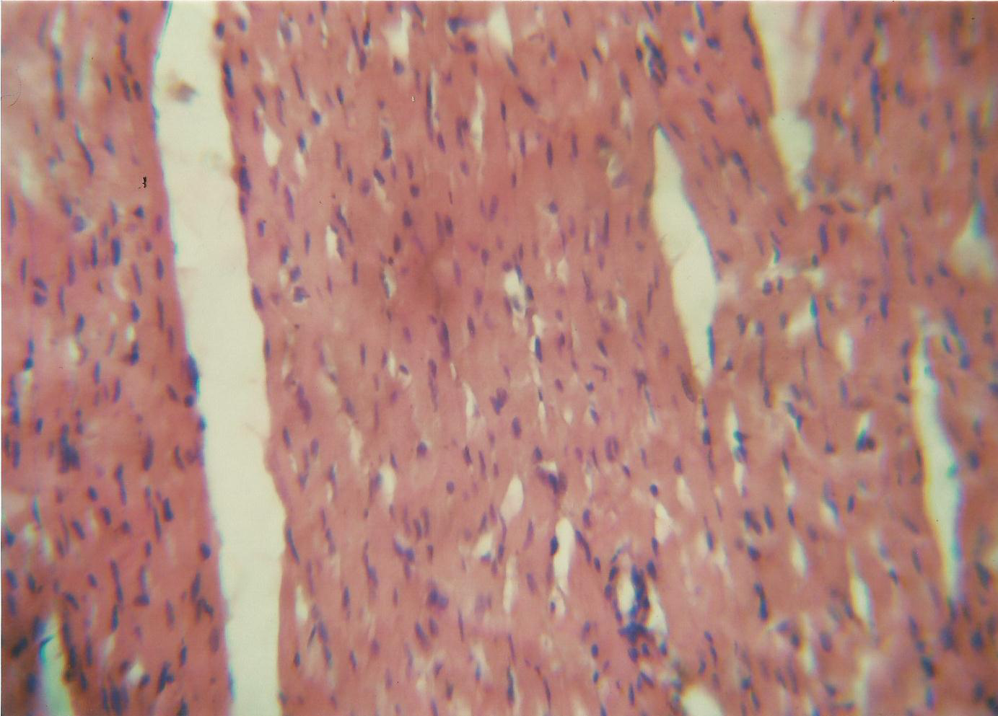
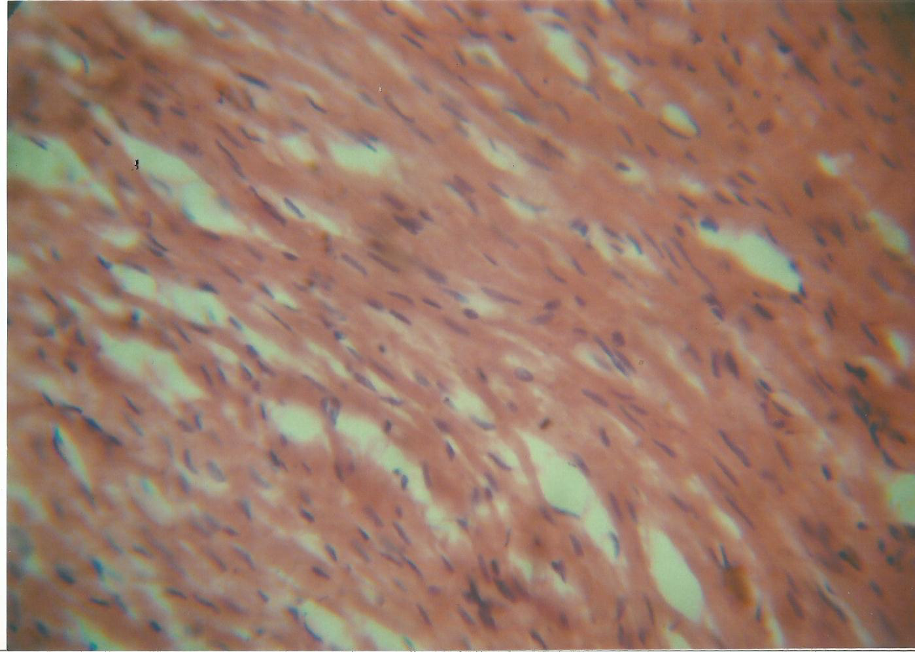
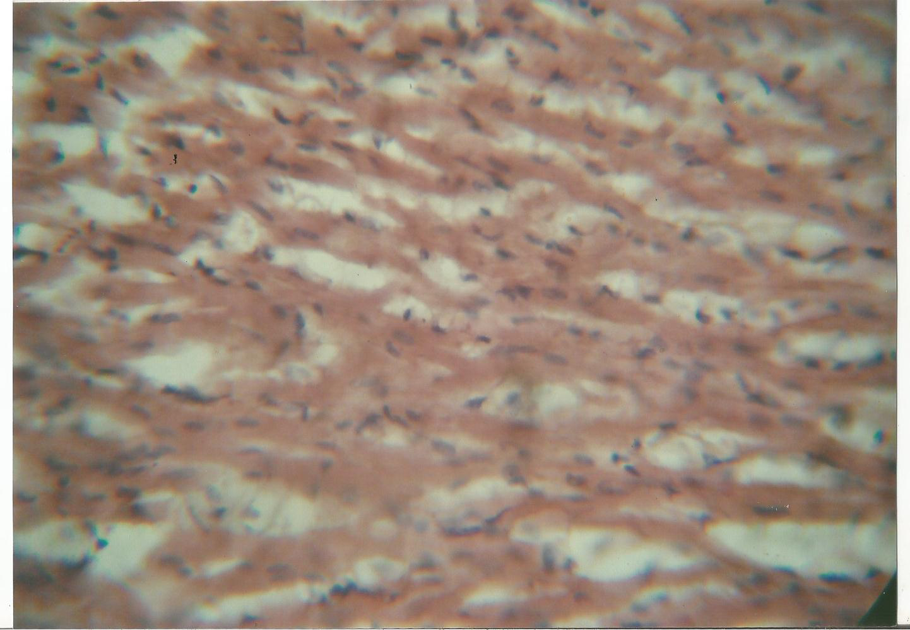
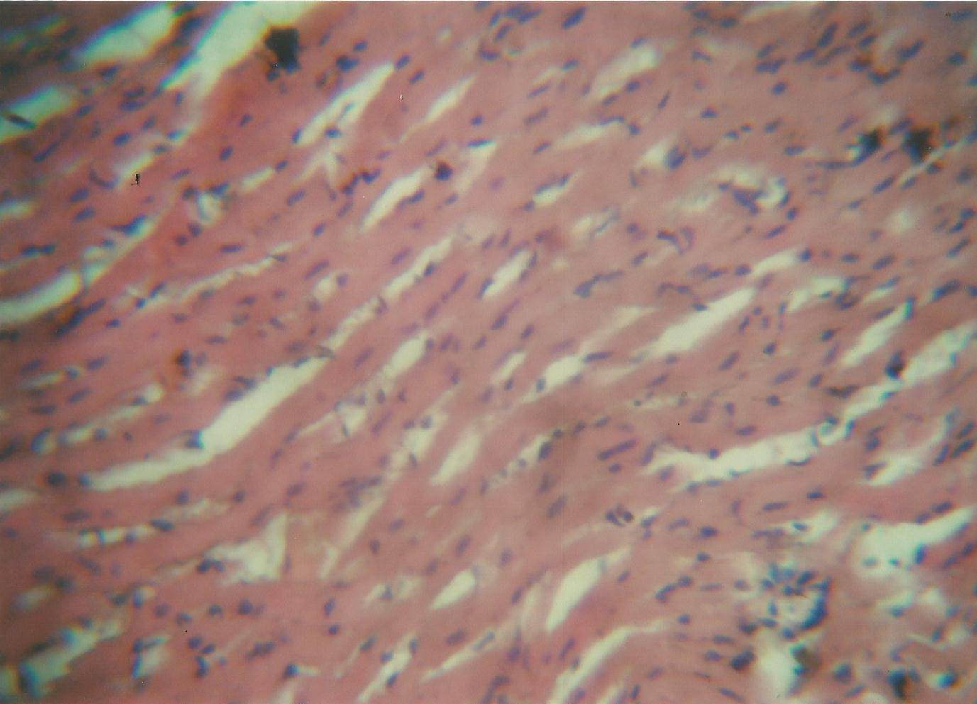
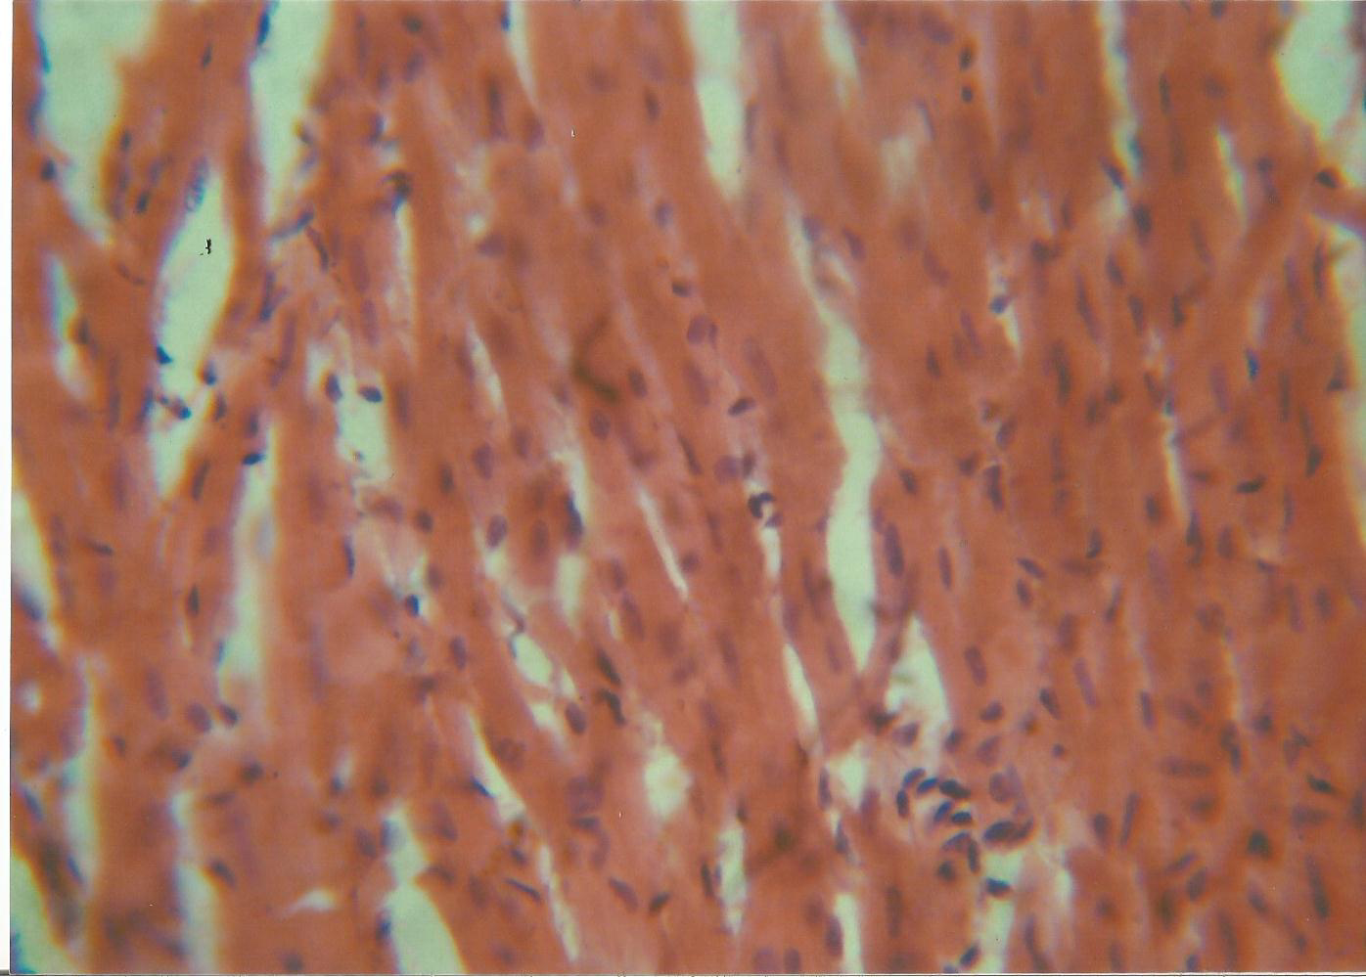

Plates 1 to 5 Histology of heart of rats following sub-acute administration of 750mg/kg of methanol root extract of N. laevis (x400).
Plate 1 (P1) Control
Plate 2 (P2) administered 125 mg/kg
Plate 3 (P3) administered 250 mg/kg
Plate 4 (P4) administered 500 mg/kg
Plate 5 (P5) administered 750 mg/kg

KEY: EC = endocardium, MC = myocardium, ID = intercalated discs, MF= muscle fibre, N = nuclei
MC
EC
ID
MC

ID

MF
MF
MF
MC

MC

P3
MF
MF
MF
MC
MC
P4

MC
MC
ID
N
P5

DISCUSSION
The qualitative phytochemical analyses of the methanol root extract of Newbouldia laevis revealed a rich array of bioactive compounds, including tannins, saponins, flavonoids, alkaloids, phenols, oxalates, phytates, and hydrogen cyanide (Obika et al., 2025a in press). These constituents are widely recognized for their antioxidant and antimalarial activities.
The quantitative phytochemical evaluation of the methanol root extract of Newbouldia laevis using Gas Chromatography-Flame Ionization Detector (GC-FID) presented appreciable amount of ribalinidine (62.19 µg/mL), saponin (13.17 µg/mL), sapogenin (12.73 µg/mL), rutin (10.84 µg/mL), kaempferol (9.45 µg/mL), tannin (7.16 µg/mL), catechin (5.52 µg/mL) lunamarine (2.00 µg/mL) etc. (Obika et al., 2025b in press). Generally, the presence of diverse phytochemicals in N. laevis supports its traditional use in managing malaria and oxidative stress-related diseases. The combined antioxidant and antimalarial activities highlight the therapeutic potential of the plant extract.
The lipid profile findings following the administration of N. laevis methanol root extract reveal a dose-dependent alteration in lipid metabolism, with potential implications for cardiovascular health. These biochemical changes are likely linked to the phytochemical constituents of N. laevis and their known metabolic interactions. N. laevis contains a variety of bioactive compounds, including alkaloids, tannins, flavonoids, saponins, glycosides, and phenolics, which contribute to its diverse pharmacological effects (Rashed, 2021ab, Onyema et al 2023; Obika et al., 2025ab-in press). While these constituents have demonstrated therapeutic properties; such as antioxidant, antimicrobial, and antimalarial activities (Obika et al., 2025b-in press), their impact on lipid metabolism can vary depending on dose and bioavailability. Saponins, for example, are known to modulate lipid absorption and transport. At low concentrations, they may exhibit hypolipidemic effects by binding to cholesterol and bile acids, thereby reducing serum lipid levels. However, at higher doses, saponins can disrupt cell membrane integrity and interfere with lipoprotein metabolism, leading to elevated lipid levels (Böttger & Melzig, 2013; Ujowundu et al., 2015ab; Alloubani et al., 2021). Similarly, flavonoids and phenolic compounds typically promote favorable lipid profiles through their antioxidant properties, but in excess, they may exert pro-oxidant effects or inhibit lipid-regulating enzymes, disrupting metabolic homeostasis (Yahfoufi et al., 2018).
In the present study, high-dose N. laevis extract (750 mg/kg) resulted in significantly elevated total cholesterol and low-density lipoprotein (LDL) levels. Elevated LDL is a recognized risk factor for atherosclerosis and cardiovascular disease, suggesting that high concentrations of the extract may stimulate hepatic cholesterol synthesis or hinder clearance mechanisms (Ganjali, et al., 2018; Alloubani et al., 2021). Moreover, high doses of N. laevis extract (500 and 750 mg/kg) were associated with a marked decrease in high-density lipoprotein (HDL), which plays a critical role in reverse cholesterol transport. A reduction in HDL levels is indicative of impaired lipid clearance and heightened cardiovascular risk, possibly due to oxidative stress or inhibited synthesis of apolipoprotein-A1 by the phytochemicals present in the N. laevis extract (Brewer & Santamarina-Fojo, 2003; Yalcinkaya et al., 2019; Onyema et al., 2023). Also, triglyceride (TAG) levels were significantly elevated at higher doses of N. laevis extract, pointing to possible increases in lipogenesis or suppression of lipoprotein lipase activity. Tannins and saponins have been shown to interfere with enzymes like pancreatic lipase and hepatic lipid regulators, which could explain this disruption (Marrelli et al., 2016; Pirahanchi et al., 2023).
On consideration of the atherogenic index and cardiovascular risk, the result of the study showed that at lower doses of N. laevis extract (125 mg/kg), lipid parameters in rats remained close to control values, with only slight increases in triglycerides and VLDL, while the Atherogenic Index of Plasma (AIP) stayed negative (−0.11), corresponding to a low-risk category (<0.11) (Dobiasova & Frohlich, 2001). At 250 mg/kg, VLDL and triglycerides rose while HDL declined, resulting in higher Castelli ratios and atherogenic coefficient, although AIP (0.04) still indicated low risk. These changes suggest early adverse lipid shifts despite preserved AIP classification. By contrast, high-dose groups (500–750 mg/kg) demonstrated pronounced dyslipidemia, characterized by elevated VLDL (0.71–0.72 mmol/L), suppressed HDL, and markedly raised AIP values (0.46–0.56), consistent with the “high-risk” category (>0.24). Elevated AIP has been associated with small dense LDL particles and greater cardiovascular risk in both experimental models and clinical populations (Niroumand et al., 2015; Onat et al., 2010). Thus, methanol root extract of N. laevis induces a dose-dependent deterioration of lipid homeostasis with potentially atherogenic consequences.

The histological studies of heart tissue administered sub-acute doses of N. laevis methanol root extract revealed dose-dependent changes in cardiac muscle structure, indicating potential cardiotoxicity. In the control group (Plate 1), the heart displayed normal myofibrils, intercalated discs, and peripheral nuclei, signifying healthy heart function (Guyton & Hall, 2011). Rats dosed with 125 mg/kg (Plate 2), showed mild alterations, such as constricted muscle fiber bundles and increased intercalated disc junctions, indicating early myocardial stress potentially from metabolic disturbance or ion flux changes (Rashed, 2021). At a dose of 250 mg/kg (Plate 3), more severe depletion of cardiac muscle cells and connective tissue were presented indicating myocardial injury, possibly due to oxidative damage or inflammation (Jaeschke et al., 2012). At a dose of 500 mg/kg (Plate 4), a slight loss of muscle fibers was presented indicated ongoing myocardial injury and functional impairment, which could affect cardiac output (Pessayre et al., 2010). At the highest dose of 750 mg/kg (Plate 5), marked tissue damage, including thickened muscle bundles and loss of connective tissue, suggesting potential acute myocardial injury, likely driven by oxidative stress and inflammation from bioactive compounds such as saponins and alkaloids (Yahfoufi et al., 2018; Sahu et al., 2022). Finally, higher doses of N. laevis extract induced severe myocardial stress, pointing to potential cardiovascular risks at elevated concentrations.
Conclusion
In this study the administration of methanol root extract of N. laevis produced clear, dose-dependent alterations in lipid metabolism in rats. While the lowest dose (125 mg/kg) had minimal impact on lipid parameters, intermediate dosing (250 mg/kg) initiated adverse shifts, including elevated triglycerides, VLDL, and unfavorable risk ratios. At higher doses (500–750 mg/kg), these changes were pronounced, with significant rises in non-HDL cholesterol, VLDL, and atherogenic indices alongside a marked decline in HDL. Elevated Atherogenic Index of Plasma (AIP) values placed these groups in the high-risk category, indicating the development of a strongly atherogenic lipid profile. These findings suggest that methanol root extract of N. laevis may be metabolically safe at low doses however, it presented increasingly harmful variations to lipid homeostasis and cardiovascular risk markers at higher concentrations. Further studies should investigate the mechanisms underlying these lipid alterations, including hepatic lipid handling and oxidative stress pathways. It is recommended that if methanol root extract of N. laevis is considered for therapeutic or nutritional use, its administration should be restricted to low doses, with careful monitoring of lipid profiles to avoid potential cardiometabolic complications.
Data Availability
The data that supports the findings of this study are available from the authors upon reasonable request.
Consent and Ethical Approval
It is not applicable.
Competing Interests
Authors have declared that no competing interests exist.
References
Akerele, J. O., Ayinde, B. A., and Ngiagah, J. (2011), Phytochemical and Antibacterial Evaluations of the Stem Bark of Newbouldialaevis against Isolates from Infected Wounds and Eyes, Tropical Journal of Pharmaceutical Research; 10 (2): 211-217.
Alloubani, A., Nimer, R., & Samara, R. (2021). Relationship between Hyperlipidemia, Cardiovascular Disease and Stroke: A Systematic Review. Current cardiology reviews, 17(6), e051121189015.
Atanu, F. O., Rotimi, D., Ilesanmi, O. B., Al Malki, J. S., Batiha, G. E., & Idakwoji, P. A. (2022). Hydroethanolic extracts of Senna alata leaves possess antimalarial effects and reverse haematological and biochemical perturbation in Plasmodium berghei-infected mice. Journal of Integrative Medicine, 20(1), 67–78.
Balogun, J. A. (2021). Emerging developments in traditional medicine practice in Nigeria. In The Nigerian Healthcare System (pp. 235–275). Springer.
Böttger, S., & Melzig, M. F. (2013). The influence of saponins on cell membrane cholesterol. Bioorganic & Medicinal Chemistry, 21(22), 7118–7124.
Brewer, H. B., Jr, & Santamarina-Fojo, S. (2003). Clinical significance of high-density lipoproteins and the development of atherosclerosis: focus on the role of the adenosine triphosphate-binding cassette protein A1 transporter. The American journal of cardiology, 92(4B), 10K–16K.
Buss, A.D., & Butler, M.S. (2010). Natural product chemistry for drug discovery. The Royal Society of Chemistry Cambridge. 153.
Centers for Disease Control and Prevention (CDC). (2023). Malaria Facts and Statistics. Retrieved from https://www.cdc.gov/malaria
de Souza, J. B., Leliwa-Sumann, E., & others. (2013). Serum lipids and lipoproteins in malaria: A systematic review and meta-analysis. Malaria Journal, 12(1), 442.
Dobiasova, M., & Frohlich, J. (2001). The plasma parameter log(TG/HDL-C) as an atherogenic index: correlation with lipoprotein particle size. Clinical Biochemistry, 34(7), 583–588.
Egba, S. I., Sunday, G. I. and Anaduaka, E. G. (2014), The effect of oral administration of aqueous extract of Newbouldialaevis leaves on fertility hormones of male albino rats, Journal of Pharmacy and Biological Sciences; 9(3): 61-62.
Friedewald, W. T., Levy, R. and Fradrickson, D. S. (1972). Estimation ofconcentration of low density lipoprotein. Fundamentals of Clinical Chemistry. W. B Sauders Philadelphia, 3: 470-479
Ganjali, S., Gotto, A. M., Jr, Ruscica, M., Atkin, S. L., Butler, A. E., Banach, M., & Sahebkar, A. (2018). Monocyte-to-HDL-cholesterol ratio as a prognostic marker in cardiovascular diseases. Journal of cellular physiology, 233(12), 9237–9246.
Guyton, A. C., & Hall, J. E. (2011). Textbook of medical physiology (12th ed.). Philadelphia, PA: Saunders/Elsevier.
Jaeschke, H., McGill, M. R., & Ramachandran, A. (2012). Oxidant stress, mitochondria, and cell death mechanisms in drug-induced liver injury: lessons learned from acetaminophen hepatotoxicity. Drug metabolism reviews, 44(1), 88–106.
Marrelli, M., Conforti, F., Araniti, F., & Statti, G. A. (2016). Effects of Saponins on Lipid Metabolism: A Review of Potential Health Benefits in the Treatment of Obesity. Molecules, 21(10), 1404.
Mesquita, T. C., Martin, T. G. O., Alves, E. R., Mello, M. B., Nery, A. F., Gomes, L. T., & Fontes, C. J. (2016). Changes in serum lipid profile in acute and convalescent *Plasmodium vivax* malaria: A cohort study. Malaria Journal, 15, 1–7.
Mgbeahuruike, E. E., Holm, Y., Vuorela, H., Amandikwa, C., & Fyhrquist, P. (2019). An ethnobotanical survey and antifungal activity of Piper guineense used for the treatment of fungal infections in West-African traditional medicine. Journal of Ethnopharmacology, 229, 157–166.
Mogaka, C., Eyong, K. I., Waffo, A. F., Abuga, K., Tolo, F. M., Orwa, J. A., … Owuor, B. O. (2023). Antiplasmodial activity, in vivo toxicity and in silico studies of the aqueous root extract of Carissa edulis (Forssk.) Vahl (Apocynaceae). Journal of Ethnopharmacology, 310, 116383. https://doi.org/10.1016/j.jep.2023.116383
Niroumand, S., Khajedaluee, M., Khadem-Rezaiyan, M., et al. (2015). Atherogenic Index of Plasma (AIP): A marker of cardiovascular disease. Medical Journal of the Islamic Republic of Iran, 29, 240.
Obika CJ, Ene AC, Ujowundu CO, Ujowundu FN, Nwokocha GC, Onwuliri VA (2025b). Toxicological Assessment of Methanol Root Extract of Newbouldia Laevis in Rats After Therapeutic Evaluation Against Plasmodium-berghei in Mice. Trop J Nat Prod Res. 9(9):
Obika, C. J., Ujowundu, C. O., Ene, A. C., Ujowundu, F. N., Onwuliri, V. A., Chiegboka, N. A., Udensi, U. J., & Mba, B. A. (2025 in press). In vivo antimalarial potential of methanol and aqueous extracts of Newbouldia laevis on Plasmodium berghei-infected (NK65) mice. African Journal of Biological Sciences.
Okoro, I. (2002). Manual of Pratical of Histology. 2nd Ed. Peace Publishers, Owerri. Imo State.
Oluba, L. J., Onyeneke, E. C., Babatola, L. J., Eidangbe, G. O., & others. (2012). Modulation of lipoprotein cholesterol levels in Plasmodium berghei malarial infection by crude aqueous extract of Ganoderma lucidum. Cholesterol, 2012, Article ID 536396. [https://doi.org/10.1155/2012/536396](https://doi.org/10.1155/2012/536396)
Oluba, O. M. (2019). Terpenoid extract of Ganoderma lucidum restores lipid homeostasis in Plasmodium berghei-infected mice. Comparative Clinical Pathology, 28(1), 149–156. https://doi.org/10.1007/s00580-018-2815-1
Onat, A., Can, G., Kaya, H., & Hergenç, G. (2010). Atherogenic index of plasma (log10 triglyceride/HDL-cholesterol) predicts high blood pressure, diabetes, and vascular events. Clinical Chemistry and Laboratory Medicine, 48(12), 1827–1834.
Onyema C.R., Ujowundu C.O., Ujowundu F.N., Onwuliri V.A., Alisa C.O., Ezim O.E., Ibeh R.C., Asiwe E.S., Onyeocha I.O., Achilike J.J., Amaralam E.C., Ugwu C.M. (2023) Assessment of Hepatoprotective and Antidyslipidemic activities of Phenolic leaf extract of Vitex doniana on Alloxan-Induced Diabetic Rats. International Journal of Chemical and Biochemical Sciences. 24 (4):25-37
Osuchukwu, N. C., Eko, J. E., Abia, R. P., & Ochei, K. C. (2017). Use of herbal medicine among adult residents in Calabar Metropolis, Cross River State Nigeria. Journal of Complementary and Alternative Medicine Research, 2(3), 1–14.
Pessayre, D., Mansouri, A., Berson, A., & Fromenty, B. (2010). Mitochondrial involvement in drug-induced liver injury. Handbook of experimental pharmacology, (196), 311–365.
Pirahanchi, Y., Anoruo, M. D., & Sharma, S. (2023). Biochemistry, lipoprotein lipase. StatPearls Publishing.
Rashed, K. (2021). Phytochemical and biological effects of Newbouldia laevis: A review. Plantae Scientia, 4(4–5), 208–213.
Sahu, S. C., Long, M., & Walton, J. C. (2022). Saponins and their toxicological mechanisms. Toxicology Reports, 9, 857–864.
Stein, E.A., 1987. Lipids, Lipoproteins and Apolipoproteins. In: Tietz, N.W. (Ed.), 3rd Edn., Fundamentals of Clinical Chemistry. WB Saunders, Philadelphia, pp: 470-479.
Ujowundu F. N., Ukoha A. I., Ojiako A. O. and Nwaoguikpe R. N. (2015a) Gas chromatographic characterization of the flavonoids, alkaloids, saponins, and tannins isolated from C. dolichopentalum leaves. Journal of Chemical and Pharmaceutical Research. 7(12):1094-1103 ISSN : 0975-7384: CODEN(USA) : JCPRC5
Ujowundu FN, Ukoha AI, Ojiako AO, Nwaoguikpe RN (2015b) Isola¬tion of bioactive phytochemicals in leaves of Combretum dolichopentalum and their hydrogen peroxide scavenging potentials. Pharm Anal Acta 6: 444. doi:10.4172/21532435.1000444. ISSN: 2153-2435 PAA
Wacnic, R. G. and Alber, J. J. (1978). A comprehensive evaluation of the heparin manganese precipitation procedure for estimating high density lipoprotein cholestsrol. Journal of Lipid Research, 19: 65-76.
World Health Organization. (2023). World malaria report 2023. Geneva: WHO. [https://www.who.int/publications/i/item/9789240089822](https://www.who.int/
Yahfoufi, N., Alsadi, N., Jambi, M., & Matar, C. (2018). The immunomodulatory and anti-inflammatory role of polyphenols. Nutrients, 10(11), 1618.
Yalcinkaya, A., Unal, S., & Oztas, Y. (2019). Altered HDL particle in sickle cell disease: decreased cholesterol content is associated with hemolysis, whereas decreased Apolipoprotein A1 is linked to inflammation. Lipids in health and disease, 18(1), 225.

