Original Research Article
A Comparative Study of the Phytochemical and Protein Profiles of Phaseolus vulgaris Varieties: Black Beans versus Kidney Beans
ABSTRACT
Aims: The study aimed to conduct a comparative analysis of the phytochemical and protein profiles of black beans and kidney beans to better understand their distinct nutritional properties and health benefits.
Study Design: This was a comparative, in vitro study focusing on the biochemical analysis of two different bean varieties.
Place and Duration of Study: Institute of Innovative Learning and Research Academy, Indore, Madhya Pradesh, India: January 2025 – February 2025.
Methodology: Kidney and black bean extracts were prepared and analyzed for their phytochemical content using qualitative tests for flavonoids, terpenoids, glycosides, saponins, tannins, phenols, steroids, alkaloids, and anthocyanins. Total antioxidant capacity (TAC) was measured using the phosphomolybdate assay, with results expressed as Ascorbic Acid Equivalent (AAE). Protein concentration was quantified using the Folin-Lowry method, and protein profiles were analyzed via SDS-PAGE to determine molecular weight ranges and diversity.
Results: Black bean extract demonstrated a higher total protein concentration (38.7 mg/ml) compared to kidney bean extract (33.7 mg/ml). The TAC was also superior in black beans (0.93 mg AAE/ml) versus kidney beans (0.74 mg AAE/ml). Phytochemical analysis showed that black beans were richer in flavonoids and anthocyanins, while kidney beans contained more terpenoids, glycosides, and steroids. SDS-PAGE revealed a greater diversity of proteins in kidney beans, with five distinct bands compared to three in black beans.
Conclusion: Both black and kidney beans are valuable nutrient sources with complementary benefits. Black beans excel in their antioxidant capacity and total protein content, while kidney beans are distinguished by a wider variety of protein types. This research provides a basis for future studies and emphasizes the importance of dietary diversity.

Keywords: Antioxidant, phytochemicals, protein, SDS-PAGE, Folin-Lowry, legumes, Phaseolus vulgaris, nutritional analysis.

- INTRODUCTION
Beans, particularly those from the species Phaseolus vulgaris, serve as a major food source globally, with kidney beans and black beans being two prominent varieties. These beans are staples in many diets, especially in Latin America, where they are cultivated extensively on small farms and contribute significantly to local nutrition and economy. Phaseolus vulgaris has been domesticated for approximately 8,000 years, making it one of the most widely cultivated legumes. They play a crucial role in sustainable agriculture through their ability to fix atmospheric nitrogen (Dida, 2019). Kidney beans and black beans are vital components of a balanced diet, particularly for those following vegetarian and vegan lifestyles, due to their rich nutritional profiles. Both types of beans are excellent sources of protein, which is essential for essential for tissue repair, immune function, enzyme production and overall health (Kaur, 2023; Iqbal et al., 2012). They are also high in dietary fiber, which aids in digestion and helps regulate blood sugar levels, thereby reducing the risk of chronic diseases such as diabetes and heart disease (Geil & Anderson, 1994). Their low fat and cholesterol-free nature makes them an ideal meat alternative, promoting heart health and weight management. Furthermore, the presence of bioactive compounds in beans offers antioxidant properties, which may help prevent various degenerative diseases (Dimopoulou et al., 2024). Thus, incorporating kidney and black beans into diets can significantly enhance health outcomes and dietary diversity.
Kidney beans and black beans are both rich sources of plant-based protein, essential for maintaining health and supporting dietary diversity. Kidney beans contain approximately 20-30% protein, with a favorable amino acid profile, making them a high-quality protein source (Srenuja et al., 2023). Similarly, black beans are noted for their well-balanced essential amino acids and high nutritional value, contributing significantly to energy, dietary fiber, and essential minerals. Unlike animal proteins, which often come with health risks associated with saturated fats and cholesterol, beans provide essential amino acids without these drawbacks, promoting cardiovascular health and aiding in weight management (Nguyen, 2023; Kaur, 2023). Furthermore, both types of beans exhibit functional properties that enhance their application in food products, underscoring their potential as nutritious alternatives in various diets.
While the nutritional benefits of both kidney beans and black beans are well-documented, a comparative analysis of their specific phytochemical and protein profiles is essential to fully understand their respective contributions to human health. Research indicates that black beans possess a higher content of phytochemicals, which confer potent antioxidant, antidiabetic, and anti-inflammatory properties, making them particularly beneficial for chronic disease prevention (Meenu et al., 2023). Conversely, kidney beans are noted for their significant phenolic compounds and antioxidant activity, which also contribute to health benefits (Carbas et al., 2020).
This research addresses a notable gap in the literature: the lack of a direct, comprehensive comparison of the specific phytochemical and protein profiles of kidney and black beans. While the general nutritional benefits of both legumes are known, a detailed, head-to-head analysis is necessary to fully understand their distinct health-promoting properties. Our study will bridge this gap by contrasting their phytochemical composition, total antioxidant capacity (TAC), and protein profiles. The findings are expected to provide clear insights into the unique nutritional strengths of each bean, which can inform dietary recommendations and guide future food product development.

- methodology
- Collection of samples
Kidney beans and black beans (Fig. 1) were procured from a local market in Indore, Madhya Pradesh, India.
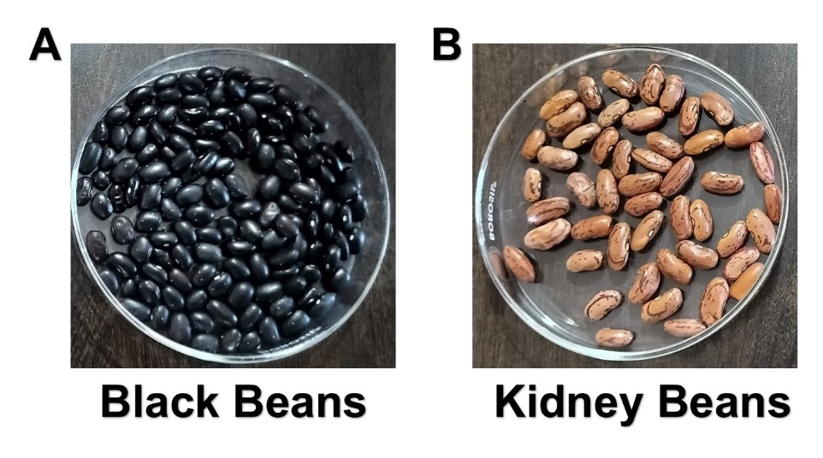
Fig. 1: The two bean varieties studied: (A) Black beans and (B) Kidney beans.
- Preparation of Kidney and Black Bean Extracts
A 3 gm sample of kidney and black beans was soaked overnight, then homogenized in 40 mM Tris buffer (pH 7.4). The resulting mixture was centrifuged at 5,000 rpm. The supernatant was then collected and stored for subsequent protein and phytochemical analysis.
- Phytochemical Analysis
- Phenols
- Ferric Chloride Test: A deep blue-black color developed upon the addition of 5% ferric chloride (FeCl₃​) to the bean extract.
- Folin-Ciocalteu (FC) Reagent Test: A deep blue-black color also emerged after combining 1M sodium carbonate (Na₂​CO₃​) and 1:5 diluted FC reagent with the bean extract.
- Flavonoids
Alkaline Reagent Test: The development of a deep yellow color upon the addition of 10% sodium hydroxide (NaOH) to the bean extract indicated the presence of flavonoids.
- Tannins
Braymer's Test: A deep blue-black color formed when 10% FeCl₃​ was added to the bean extract.
- Alkaloids
Wagner's Test: A few drops of Wagner's reagent were added to the extract, and the formation of a brown precipitate confirmed the presence of alkaloids.
- Saponins
Foam Test: The vigorous shaking of the bean extract with water resulted in the formation of a persistent foam that remained for 3 minutes.
- Steroids and Terpenoids
Salkowski Test: A reddish-brown color formed at the interface when chloroform and concentrated sulfuric acid (H₂​SO₄​) were carefully added to the extract.
- Glycosides
Keller-Kiliani Test: After gentle heating and cooling, a brown ring formed at the junction of the liquid after transferring the extract, glacial acetic acid, and FeCl₃​ mixture to a test tube containing H₂​SO₄.
- Anthocyanins
The presence of Anthocyanins, water-soluble pigments, was confirmed by two separate tests:
- The formation of an orange ring at the liquid interface after the careful addition of concentrated H₂​SO₄ to the extract.
- The formation of a red ring at the liquid interface after the careful addition of concentrated hydrochloric acid (HCl) to the extract (Patel et al., 2023).
- Total Antioxidant Capacity (TAC) by Phosphomolybdate Assay
The total antioxidant capacity (TAC) of the bean extract was measured using the phosphomolybdate assay. This method is based on the principle that antioxidants reduce molybdenum (VI) ions to molybdenum (V) ions, which produces a stable, bluish-green complex. The color intensity is directly proportional to the antioxidant concentration and is measured by absorbance at 670 nm. For the analysis, the sample was mixed with distilled water and phosphomolybdate reagent, then incubated at 95°C for 15 minutes. A standard curve, prepared using ascorbic acid in concentrations from 25 µg to 125 µg, was used to standardize the results. The final TAC of the bean extract was expressed as the Ascorbic Acid Equivalent (AAE) per milligram of the sample (Deepali et al., 2024).
- Protein Estimation by the Folin-Lowry Method
The Folin-Lowry method (Lowry et al., 1951) was used to quantify the protein concentration in a bean extract. This assay relies on a two-step reaction. First, proteins react with copper ions in an alkaline solution to form a complex (the biuret reaction). Second, this complex, along with specific amino acid residues (tyrosine and tryptophan), reduces the Folin-Ciocalteu (FC) reagent. This reduction produces a blue color whose intensity is directly proportional to the protein concentration. A standard curve was created using Bovine Serum Albumin (BSA), with concentrations ranging from 25 to 400 µg. Alkaline copper reagent was added to each standard and the sample, followed by a 10-minute incubation at room temperature. The FC reagent was then added, and the absorbance was measured at 670 nm against a reagent blank. The protein concentration of the bean extract was determined by comparing its absorbance to the standard curve.
- Protein Profiling by SDS-PAGE
Protein samples were analyzed by SDS-PAGE (Sodium Dodecyl Sulfate-Polyacrylamide Gel Electrophoresis) (Pillai et al, 2025) to determine their molecular weight profiles. Equal quantities of protein samples, along with an 11-100 kDa molecular weight marker, were loaded onto a polyacrylamide gel. The gel was composed of a 13% separating gel (pH 8.8) and a 4% stacking gel (pH 6.8), both containing polyacrylamide, bisacrylamide, and SDS. Gel polymerization was initiated by ammonium per sulfate (APS) and TEMED. For sample preparation, a loading dye containing bromophenol blue (BPB) as a tracking dye, SDS, glycerol, and β-mercaptoethanol was added. The samples were then boiled to ensure protein denaturation before being loaded. Electrophoresis was conducted until the BPB tracking dye reached the bottom of the gel. Afterward, the gels were stained for one hour with Coomassie Brilliant Blue R-250 and then destained with a solution of 30% methanol and 10% acetic acid to visualize the protein bands.
- results
- Preparation of Kidney and Black Bean Extracts
A significant difference in yield was observed between the black bean and kidney bean extracts (Table 1). The higher yield from the black beans suggests their initial extract contained a lower concentration of insoluble solids compared to the kidney bean extract. This difference likely reflects distinct physicochemical properties between the two bean types, such as varying levels of starch, fiber, or large protein aggregates that are removed during centrifugation.
Table 1: Extraction yield of kidney beans and black beans.
Sample | Initial volume | Final volume | % yield
Kidney beans | 30ml | 20 ml | 66.66%
Black beans | 30 ml | 25 ml | 83.33%

- Phytochemical Screening
Based on the phytochemical analysis, black beans are a richer source of flavonoids and anthocyanins, while kidney beans contain a higher concentration of terpenoids, glycosides, and steroids (Table 2). This suggests that while both are nutritionally valuable, their distinct chemical profiles likely contribute to different biological activities.

Table 2: The results of phytochemical screening of kidney and black bean extracts.
S.No. | Phytochemicals | Kidney Bean | Black Bean
1 | Flavonoids | + | ++
2 | Terpenoids | ++ | +
3 | Glycosides | ++ | +
4 | Saponins | + | +
5 | Tannins | - | -
6 | Phenols | - (Ferric chloride)  ++ (FC reagent) | - (Ferric chloride)  ++ (FC reagent)
7 | Steroids | ++ | +
8 | Alkaloids | ++ | ++
9 | Anthocyanins | + (H₂SO₄)  - (HCl) | ++ (H₂SO₄)  + (HCl)

- Total Antioxidant Capacity (TAC) Assay
The Total Antioxidant Capacity (TAC) of the bean extracts was quantified using the phosphomolybdate assay, which measures the ability of a substance to reduce molybdenum ions. To standardize the results, a calibration curve was prepared using ascorbic acid as a standard (Fig. 2). The results clearly show that the black bean extract (0.93 mg AAE/ml) has a higher TAC than the kidney bean extract (0.74 mg AAE/ml). This indicates that the black bean extract is more effective at neutralizing free radicals. This result aligns with the previous phytochemical screening results, which identified a higher concentration of potent antioxidants like flavonoids and anthocyanins in black beans. The superior antioxidant capacity of the black beans can, therefore, be directly correlated with their richer content of these specific compounds.
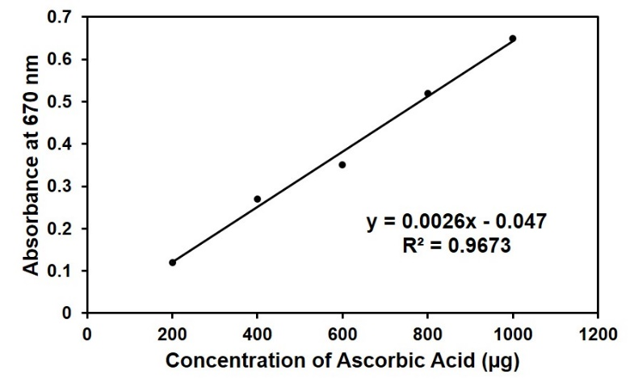
Fig. 2: Ascorbic Acid Standard Curve.
- Protein Estimation
The Biuret test successfully confirmed and quantified the protein content in black beans and kidney beans. Utilizing a standard curve derived from bovine serum albumin (BSA) (Fig. 3), the total protein concentration in the bean extracts was determined. The results showed that black beans had a protein content of 38.7 mg/ml, while kidney beans contained 33.7 mg/ml. This indicates that black beans have a higher protein concentration compared to kidney beans, underscoring the nutritional differences between these common bean varieties.
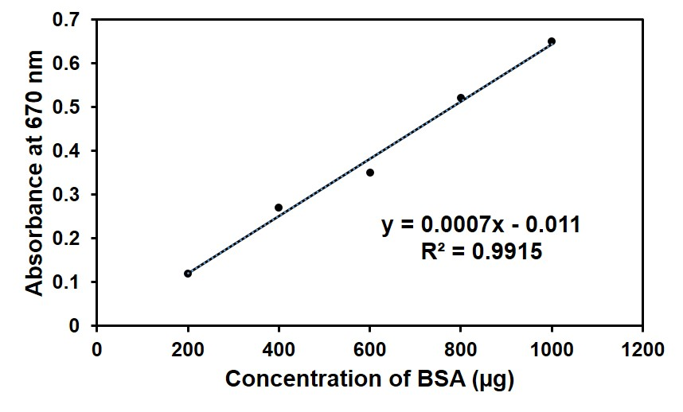
Fig. 3: Standard curve of bovine serum albumin (BSA).
- Comparative Protein Profiles of Kidney and Black Beans
SDS-PAGE results revealed distinct protein profiles for kidney and black bean extracts (Fig. 4), indicating a more diverse protein composition in kidney beans. A protein ladder with a known molecular weight range of 17-100 kDa was used as a standard. The kidney bean extracts, analyzed at three different concentrations (50 µL, 25 µL, and 10 µL), showed five distinct protein bands ranging from approximately 17-75 kDa. The intensity of these bands was directly proportional to the volume of the extract loaded. In contrast, the black bean extracts, analyzed at the same concentrations, displayed a less diverse profile with only three distinct bands in the 25-75 kDa range. The absence of bands below 25 kDa suggests that the black bean sample lacks the smaller proteins found in the kidney bean extract. The varying band intensities within the kidney and black bean samples clearly demonstrate that higher sample concentrations (50 µL) result in darker, more prominent bands due to the presence of more protein. This comparative analysis highlights the compositional differences between the two bean varieties, with kidney beans possessing a greater diversity of proteins.
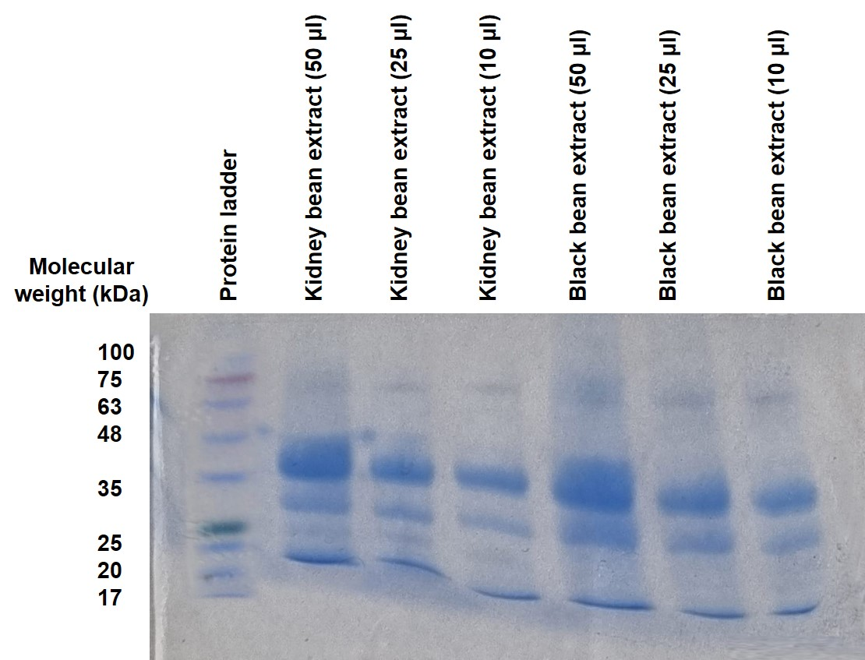
Fig. 4: SDS-PAGE analysis of protein extracts from kidney beans and black beans, showing differences in protein profiles and concentrations.

- DISCUSSION
This study compared kidney and black beans, two types of Phaseolus vulgaris, to understand their different health benefits. The research focused on three key areas: phytochemical composition, total antioxidant capacity (TAC), and protein content. The results showed clear differences between the two bean types. Black beans possess a richer concentration of flavonoids and anthocyanins, whereas kidney beans are higher in terpenoids, glycosides, and steroids. A total antioxidant capacity (TAC) assay confirmed this, revealing that black bean extract is more effective at neutralizing free radicals than kidney bean extract. This finding aligns with established research, which consistently demonstrates a direct correlation between a bean's antioxidant capacity and its total phenolic content (Mastura et al., 2017). Darker-colored beans, like black beans, generally contain significantly higher levels of these beneficial compounds compared to lighter varieties (Rodríguez Madrera et al., 2021). Another investigation supports our findings of high total antioxidant capacity (TAC) in black beans. It found similar TAC values, reporting 0.925 mg AAE/g for ethanolic extracts and 0.84 mg AAE/g for aqueous extracts (Patel et al., 2024), closely aligning with our result of 0.93 mg AAE/ml. Using the Folin-Lowry assay, it was observed that black bean extract had a higher total protein concentration than kidney bean extract. This method quantifies protein by measuring a color change, and while other compounds like flavonoids can influence the results, their presence in black beans further highlights the overall bioactive richness of the extract (Singh et al., 2020; Narale et al., 2025). Essentially, the study confirms that black beans are a superior source of both protein and other beneficial compounds. Using SDS-PAGE, a standard technique for separating proteins by molecular weight, it visually confirmed distinct protein profiles in kidney and black beans. The analysis revealed a greater diversity of proteins in kidney beans, showing five distinct bands compared to only three in black beans. This suggests kidney beans contain a wider variety of proteins. The study also successfully identified legumin, a major storage protein in black beans, within the 63-75 kDa range, which is consistent with previous research (Patel et al., 2024; Evangelho et al., 2016). This finding highlights key compositional differences between the two bean varieties, validating the comparative analysis. In conclusion, this study validates the distinct and complementary nutritional profiles of black and kidney beans. The findings confirm the superior antioxidant capacity and higher total protein content of black beans, while also revealing the greater diversity of protein composition within kidney beans as evidenced by SDS-PAGE analysis. These results underscore that while both legumes are valuable nutrient sources, they offer unique and separate benefits—black beans for their potent antioxidant activity and kidney beans for their broader range of protein types. This analysis highlights the importance of incorporating a variety of legumes into the diet to maximize their combined health benefits and establishes a clear foundation for future research utilizing advanced techniques to further elucidate the intricate biochemical properties of these vital crops.

- CONCLUSION
This study successfully compared the phytochemical and protein profiles of black and kidney beans, confirming their distinct and complementary nutritional properties. Black beans showed a superior total protein content and antioxidant capacity. In contrast, kidney beans, despite having a lower overall protein concentration, were found to have a greater diversity of protein types, a finding supported by SDS-PAGE analysis. Overall, these findings highlight that both legumes are valuable nutrient sources, each with unique strengths: black beans excel in antioxidant activity, while kidney beans offer a broader range of protein types. This research provides a basis for future studies and emphasizes the importance of including a variety of legumes in a balanced diet.

References
- Dida, G. (2019). Effect of Lime and Compost Application on the growth and yield of Common Bean (Phaseolus vulgaris L.): A Review. 1(2).
- Kaur, J. (2023). Kidney beans (Phaseolus vulgaris L.) its nutrient profile, health benefits, value-added products and anti-nutritional properties. Pharma Innovation, 12(7), 1524–1528.
- Iqbal, A., Nehvi, F. A., Dar, S. A., & Ali, G. (2012). Health benefits associated with consumption of dry beans (Phaseolus vulgaris L.). Trends in Biosciences, 5(2), 97–100.
- Geil, P. B., & Anderson, J. W. (1994). Nutrition and health implications of dry beans: a review. Journal of The American College of Nutrition, 13(6), 549–558.
- Dimopoulou, M., Vareltzis, P., & Gortzi, O. (2024). A Systematic Review of the Twelve Most Popular Bean Varieties, Highlighting Their Potential as Functional Foods Based on the Health Benefits Derived from Their Nutritional Profiles, Focused on Non-Communicable Diseases. Applied Sciences.
- Srenuja, D., Hema, V., Mohan, R. J., & Vidyalakshmi, R. (2023). Kidney bean: Protein’s treasure trove and creates avenues for a healthy lifestyle. Legume Science.
- Nguyen, H. K. (2023). Black Bean: Composition, Protein Extraction and Functional Properties. International Journal of Multidisciplinary Research and Analysis.
- Kaur, J. (2023). Kidney beans (Phaseolus vulgaris L.) its nutrient profile, health benefits, value-added products and anti-nutritional properties. Pharma Innovation, 12(7), 1524–1528.
- Meenu, M., Chen, P., Mradula, M., Chang, S. K. C., & Xu, B. (2023). New insights into chemical compositions and health‐promoting effects of black beans (Phaseolus vulgaris L.). Food Frontiers.
- Carbas, B., Machado, N., Oppolzer, D., Ferreira, L. M. M., Queiroz, M., Brites, C., As Rosa, E., & Barros, A. (2020). Nutrients, Antinutrients, Phenolic Composition, and Antioxidant Activity of Common Bean Cultivars and their Potential for Food Applications. Antioxidants, 9(2), 186.
- Mastura, Y.H. & Haron, Hasnah & Dang, T.N.. (2017). Total phenolic content and antioxidant capacity of beans: Organic vs inorganic. International Food Research Journal. 24. 510-517.
- Rodríguez Madrera, R., Campa Negrillo, A., Suárez Valles, B., & Ferreira Fernández, J. J. (2021). Phenolic Content and Antioxidant Activity in Seeds of Common Bean (Phaseolus vulgaris L.). Foods, 10(4), 864.
- Patel, S., Sharma, P., Supat, M., Mali, S., Bafna, A., Rangwala, T., Limaye, R., & Puri, P. (2024). Investigation of Antioxidant Potential of Black Beans Due to Phytochemical and Globulin Content for Nutraceutical Application. Defence Life Science Journal, 9(4), 326–334.
- Singh, R., Lu, R., & Hu, M. (2020). Flavonoids interference in common protein assays: Effect of position and degree of hydroxyl substitution. Analytical biochemistry, 597, 113644.
- Narale, H. H., Raut, Y. B., & Bais, S. K. (2025). Exploring the Antioxidant and Antiinflammatory Properties of Phaseolus vulgaris. International Journal of Pharmacy and Herbal Technology, 3(1), 2583-8962.
- EVANGELHO, Jarine & Berrios, Jose & Zanella Pinto, Vania & Dias Antunes, Mariana & Vanier, Nathan & Zavareze, Elessandra. (2016). Antioxidant activity of black bean (Phaseolus vulgaris L.) protein hydrolysates. Food Science and Technology (Campinas). 36..
- Patel, S., Dey, R., Verma, K., Deshbhratar, R., Maru, K. K., Sharma, P., Limaye, R., & Puri, P. (2023). Comparative analysis of antioxidant and anti-inflammatory activities of red, blue, and black tea for health benefits. Brazilian Journal of Science, 2(4), 76–89.
- Deepali, J., Rajput, N., Falguni, B. ., Bindiya, P., Sanjana, P. ., Rashmi, L. ., Neha, S. ., & Payal, P. (2024). Antiulcer Properties of Guava and Chameli Leaves: A Phytochemical Exploration for Oral Ulcer Management. International Journal of Research in Pharmaceutical Sciences, 15(3), 47–58.
- Lowry, O. H., Rosebrough, N. J., Farr, A. L., & Randall, R. J. (1951). "Protein measurement with the Folin phenol reagent". Journal of Biological Chemistry, 193(1), 265–275.
- Pillai, L., Chouhan, R., Sagre, R., Khanuja, S., Kolasiya, R., Rathore, V., Patel, S., Limaye, R., & Puri, P. (2025). Comparative nutritional and phytochemical profiles of some exotic and local berries for health boosting effects . Brazilian Journal of Science, 4(3), 25–39.

