Original Research Article
Long Relationship Weight of Coconut Crab (Birgus latro) on Meos Ambower Island, Fam Islands, Raja Ampat

.
ABSTRACT

Objective: This study aims to analyze the relationship between the length of weight of coconut crabs (Birgus latro) on Meos Ambower Island, evaluate the sexual dimorphism of morphometric parameters, and determine growth patterns based on regression analysis.
Research Design: Observational research with a quantitative approach using morphometric analysis and inferential statistics.
Place and Duration of Research: Meos Ambower Island, Fam Islands, Raja Ampat, West Papua, May-August 2024 period.
Methodology: Sampling was carried out by purposive sampling at night by tracing the natural habitat of coconut crabs. A total of 100 individuals were measured in carapace length parameters using digital calipers and body weight using digital scales. Gender determination is carried out through the identification of gonopodore morphology. Analysis of the relationship between weight length using a linear regression model with the equation W = a + bL, evaluation of sexual dimorphism using t-test independent samples, and growth patterns were determined based on regression coefficients.
Results: The regression model yielded the equation Weight = -966.37 + 154.98 × Length with an R-squared of 0.575 and a p-value of 6.33E-20 indicating a significant relationship. The t-test revealed a significant difference in carapace length between males and females (t = 3.405, p = 0.001) but not in body weight (t = 0.811, p = 0.419). The sex ratio shows a dominance of 65% males compared to 35% females. The regression coefficient indicates a negative allometric growth pattern.
Conclusions: The relationship between the weight length of coconut crabs showed a strong correlation with significant sexual dimorphism in carapace length. This morphometric data is an important baseline for the sustainable management and conservation of canary crab populations in Raja Ampat.

Keywords: coconut crab, Birgus latro, long relationship weight, sexual dimorphism, morphometric

1. INTRODUCTION
The coconut crab (Birgus latro) is the largest terrestrial crustacean in the world that has an important ecological and economic role for the coastal communities of the Indonesian archipelago. This species is widespread in the Indo-Pacific region, including in the Raja Ampat region which is known to have high marine and terrestrial biodiversity. Meos Ambower Island in the Fam Islands, Raja Ampat, is one of the important habitats for the coconut crab population, but biological information related to the morphometric characteristics of this species at the location is still very limited. Length-weight relationship analysis is a fundamental parameter in the study of fisheries biology that provides important information about the growth patterns, physiological conditions, and population health status of an aquatic organism. These morphometric parameters are the basis for sustainable management of fishery resources and the conservation of threatened species.
Recent research shows that coconut crabs are experiencing significant population stress due to overexploitation and habitat degradation in various locations. A study of the canary crab population on Fam Island, Raja Ampat, revealed that there were variations in carapace sizes that indicated differences in population structure between locations and observation years, with the highest carapace size reaching 77.63 mm in 2022 at the Korwo Iba and Meos Ambower locations (Yanti et al., 2023). Morphometric research on terrestrial crustaceans requires a comprehensive approach due to their slow and complex growth characteristics. Studies on the sex ratio and growth pattern of coconut crabs in North Maluku Province showed that the relationship between thoracic length, thoracic width, and cephalotrophoracic length with body weight had a very strong correlation (R² > 70%), with growth patterns varying from negative allometric until isometric depending on geographical location (Rugaya Serosero et al., 2019). These findings indicate that local environmental factors have a significant effect on the morphometric characteristics of canary crab populations.
The increasingly worrying conservation status of coconut crabs demands accurate morphometric data as the basis for determining adaptive management strategies. Analysis of the morphometric relationship between length and weight in 109 fish species in the Caribbean Sea shows the importance of considering sex, temporal, and spatial effects in estimating growth parameters, as sexual dimorphism can significantly affect long-weight relationships in different species (Mahé et al., 2023). Research on the reproduction of coconut crabs on Morotai Island revealed that this species has a very slow growth rate with complex reproductive characteristics, making it susceptible to capture pressure (Serosero et al., 2021). This condition underscores the urgency of developing a comprehensive morphometric database in various canary crab habitat locations in Indonesia, especially in conservation areas such as Raja Ampat.
Morphometric research on decapod crustaceans shows that the long-weight relationship can indicate the ecological conditions of the habitat and the nutritional status of the population. The quality of biological information such as the relationship between length and weight is a crucial parameter that can affect the results Stock Assessment Significantly (Ardiansyah, 2020). Until now, a specific study of the relationship between the weight of coconut crabs on Meos Ambower Island has never been carried out in detail, even though this information is indispensable to understand local population dynamics and design appropriate conservation strategies. This research is important considering that the Fam Islands are an area with increasing anthropogenic pressure, while coconut crabs have high economic value for local communities as a source of protein and natural tourist attractions.
Based on the above background, this study is focused on answering the following problems: (1) What are the characteristics of the relationship between the weight of coconut crabs (Birgus latro) on Meos Ambower Island, Fam Islands, Raja Ampat? (2) Are there significant differences in morphometric parameters between male and female coconut crabs? (3) What is the growth pattern of coconut crabs based on long-weight regression analysis at the study site? This study aims to: (1) Analyze the relationship between the length of weight of coconut crabs (Birgus latro) on Meos Ambower Island, Fam Islands, Raja Ampat through a linear regression model approach, (2) Evaluate sexual dimorphism on the morphometric parameters of coconut crabs based on the difference in length and weight between male and female individuals, (3) Determine the growth pattern of coconut crabs based on regression coefficient and R-squared valueto identify whether the growth is isosometric, positive allometric, or negative allometric.
This research is expected to make a practical and theoretical contribution to the management of coconut crab resources in Raja Ampat. Practically, the morphometric data produced can be a reference for conservation area managers in setting sustainable catch size regulations and identifying critical periods in the life cycle of coconut crabs. Theoretically, this study enriches the wealth of knowledge about the biology and ecology of coconut crabs in eastern Indonesia, especially in the Papuan Bird's Head region, and provides baseline data for long-term monitoring of changes in the structure of coconut crab populations in small island ecosystems that are vulnerable to climate change and anthropogenic activity.

2. material and methods / experimental details / methodology
2.1 Research Time and Location
This research was carried out on Meos Ambower Island, Fam Islands, Raja Ampat, West Papua in the May-August 2024 period. The selection of the research location was based on the consideration that Meos Ambower Island is an important habitat for the canary crab population in the Raja Ampat area with relatively natural ecosystem conditions. Sampling was carried out at night between 19.00-24.00 WIT following the nocturnal activity pattern of canary crabs that were active foraging during that period. The data collection method uses a purposive sampling technique by tracing the paths that are the natural habitat of coconut crabs such as coastal vegetation areas, lowland forests, and transition zones between terrestrial and coastal ecosystems. Each individual canary crab found is carefully captured manually to avoid physical damage to the specimens, then morphometric measurements are taken directly in the field before being released back into their natural habitat to minimize stress on the organism.
2.2 Collection and Measurement of Morphometric Data
Morphometric parameter measurements were carried out following the standard protocol for decapod crustaceans with a focus on two main variables, namely carapace length and total body weight. The length of the carapace was measured using a digital caliper with an accuracy of 0.01 mm, measured from the anterior end of the rostrum to the posterior edge of the carapace along the dorsal midline according to the standard method of crustacean morphometrics. Total body weight measurements were made using a portable digital scale with an accuracy of 0.01 grams, where each individual was weighed in wet conditions immediately after capture to avoid loss of body fluids that could affect the accuracy of the measurement. Sex determination was carried out through the identification of secondary morphological characteristics where male individuals had gonopores in the fifth thoracic segment while females had gonopores in the third thoracic segment, with additional confirmation through observation of the size and shape of chelae which tended to be larger and stronger in male individuals. All morphometric data are recorded in a standardized recording form that includes specimen number information, date of collection, specific location, sex, carapace length, and body weight to ensure the integrity and traceability of the study data.
2.3 Analysis of Long Weight Relationships
The analysis of the relationship between weight length uses a linear regression model with the equation W = a + bL where W is body weight (gram), L is the length of carapace (mm), a is the intercept constant, and b is the slope coefficient which represents the relative growth rate between length and weight. The calculation of regression parameters is carried out using the Least squares to minimize the number of residual squares between the observation value and the predicted value of the model. The evaluation of the quality of the model is carried out through the calculation of the determination coefficient (R-squared) which indicates the proportion of weight variation that can be explained by the length variable, with an interpretation of the value of R² > 0.50 indicating the strength of a moderate to strong relationship between the two variables. Test the significance of regression parameters using the test T-test with a 95% confidence level to evaluate whether the slope coefficient differs significantly from zero, where the value of p-value < 0.05 indicates a statistically significant relationship. The growth pattern of coconut crabs is determined based on the value of the coefficient b where b = 3 indicates growth isometric (proportional growth), b < 3 indicate growth negative allometric (weight growth is slower than long), and b > 3 indicates growth positive allometric (faster weight growth than length), in accordance with allometric principles commonly used in morphometric analysis of aquatic organisms (Mahé et al., 2023).
2.4 Analysis of Sexual Dimorphism
Evaluation of morphometric differences between male and female individuals was carried out using independent samples t-test to compare the average carapace length and body weight between the two sexes. Before the t-test was carried out, a test of the assumption of normality of the data was first carried out using the Shapiro-Wilk test to ensure that the distribution of the data followed the normal distribution pattern, and the variance homogeneity test used the Levene test to evaluate the similarity of variance between groups. The analysis was conducted with a 95% confidence level where the zero hypothesis stated that there was no significant difference in the mean morphometric parameters between males and females, while the alternative hypothesis stated that there was a significant difference. The interpretation of the results was based on a p-value where a value of < 0.05 indicated the rejection of the null hypothesis and the acceptance of the presence of significant sexual dimorphism in the tested parameters. The sex ratio is calculated as a ratio of the number of male to female individuals and is expressed in percentages to describe the population structure by sex at the study site.
2.5 Data Visualization and Presentation
Morphometric data visualizations are presented in several graphical formats to provide a comprehensive picture of the distribution and relationships between variables. A linear regression diagram is presented to illustrate the long-weight relationship with the best-fit regression line along with its mathematical equations and R-squared values to visually evaluate the strength of the relationship. A comparative boxplot is used to compare the length and weight distributions between male and female individuals, displaying medians, quartiles, and outlier values that provide information about data variability and dispersion. Frequency histograms are constructed to display the length and weight size distributions in a population, helping to identify normal or skewed distribution patterns as well as identify the dominant size classes in the population. All statistical analysis and data visualization was carried out using statistical software R version 4.3.0 with the ggplot2 add-on package for graphical visualization and stats for inferential statistical analysis, ensuring the reproducibility and accuracy of the research data analysis.

3. results and discussion
3. RESULTS
3.1 Long Relationship of Coconut Crab Weight
Analysis of the relationship of length in the weight of coconut crabs (Birgus latro) on Meos Ambower Island yielded a linear regression model that showed a strong positive correlation between carapace length and body weight. The regression model obtained from the analysis of 100 individual coconut crabs yielded the mathematical equation Weight = -966.366 + 154.9797 × Length, where weight is expressed in grams and carapace length in millimeters. This equation indicates that there is a positive linear relationship between the two morphometric parameters, where each addition of one millimeter in carapace length contributes to an increase in body weight by 154.98 grams (Table 1).
The quality of the regression model was evaluated through a determination coefficient that showed an R-squared value of 0.57524 or equivalent to 57.52%. This value indicates that the carapace length variable was able to explain 57.52% of the total variation in canary crab body weight at the study site, while the remaining 42.48% was influenced by other factors not included in the model such as physiological conditions, food availability, reproductive status, and other environmental variables. The adjusted R-squared value obtained of 0.570906 shows good consistency with the R-squared value, indicating that the model is not overfitting and has stable predictive capabilities.
Table 1. Parameters of the Linear Regression Model of Long Relationship Weight of Coconut Crab
Parameters | Value
Regression equations | Weight = -966.37 + 154.98 × Length
R-squared | 0.57524
Adjusted R-squared | 0.570906
Constant Coefficient (a) | -966.366
Length Coefficient (b) | 154.9797
P-value (Length) | 6.33E-20
The statistical significance test on the regression coefficient showed very significant results with a p-value of 6.33E-20, much smaller than the alpha significance level of 0.05. These results provide very strong statistical evidence that the relationship between carapace length and body weight of coconut crabs is real and not coincidental. The coefficient of the negative value constant (-966.366) biologically indicates the theoretical interception point at which the weight will be zero, although in practice this value is outside the actual measurement range and serves more as a mathematical parameter to adapt the model to the observational data.
Visualization of the weight length relationship is presented in a plot scatter diagram with linear regression lines showing a clear positive trend (Figure 1). The distribution of data points shows a relatively consistent pattern following the regression line, although there are some individual variabilities that can be observed from the deviation of the points to the prediction line. The data distribution pattern indicates that the linear regression model is the right approach to describe the relationship between the two morphometric variables in the canary crab population at the study site.
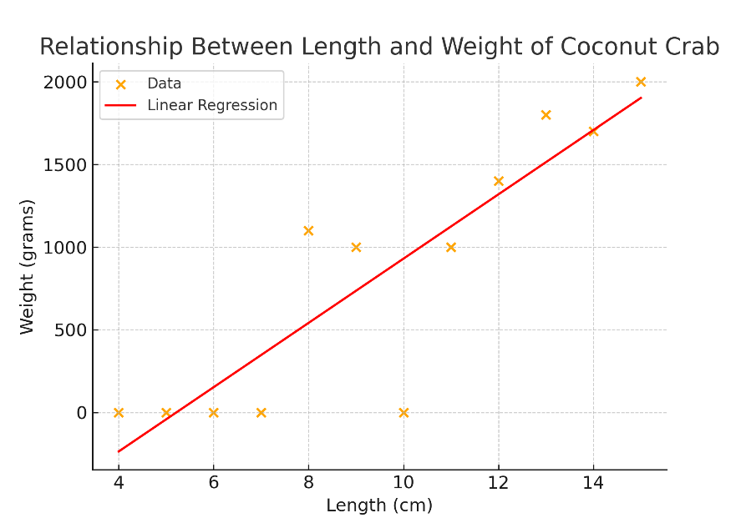
Figure 1. Linear Regression Model of Long Relationship Weight of Coconut Crab (Birgus latro) on Meos Ambower Island, Fam Islands, Raja Ampat
3.2 Sexual Dimorphism Morphometric Parameters
Evaluation of morphometric differences between male and female individuals using independent samples t-test resulted in interesting findings related to sexual dimorphism in the canary crab population on Meos Ambower Island. Statistical analysis showed a significant difference in carapace length parameters between the two sexes, where male individuals had a larger average carapace length than female individuals with statistical values t = 3.405 and p-value = 0.0010 (Table 2). A p-value smaller than 0.05 indicates the rejection of the null hypothesis and the acceptance of a statistically significant sexual dimorphism in the carapace length parameter.
Table 2. T-test Results Differences in Morphometric Parameters between Males and Females
Parameters | Statistical Value | P-value | Information
Carrate length (male vs female) | t = 3.405 | 0.0010 | Significant
Body Weight (male vs female) | t = 0.811 | 0.4193 | Insignificant
In contrast, the analysis of body weight parameters showed no significant differences between male and female individuals, with statistical values of t = 0.811 and p-value = 0.4193. A p-value greater than a significance level of 0.05 indicates that there is insufficient statistical evidence to state that there is a difference in mean body weight between the two sexes. This phenomenon shows a pattern of selective sexual dimorphism, where morphometric differences are only evident in the dimensions of carapace length but not in the accumulation of total body mass. A visualization of the distribution of morphometric data by gender is presented in the form of a comparative boxplot showing the median, first and third quartiles, and data ranges for length and weight parameters in each sex (Figure 2). The boxplot for the length parameter showed a clear separation between the male and female distributions with a higher male median, while the boxplot for the weight parameter showed substantial overlap between the two distributions, consistent with the results of statistical tests indicating no significant differences in these parameters.
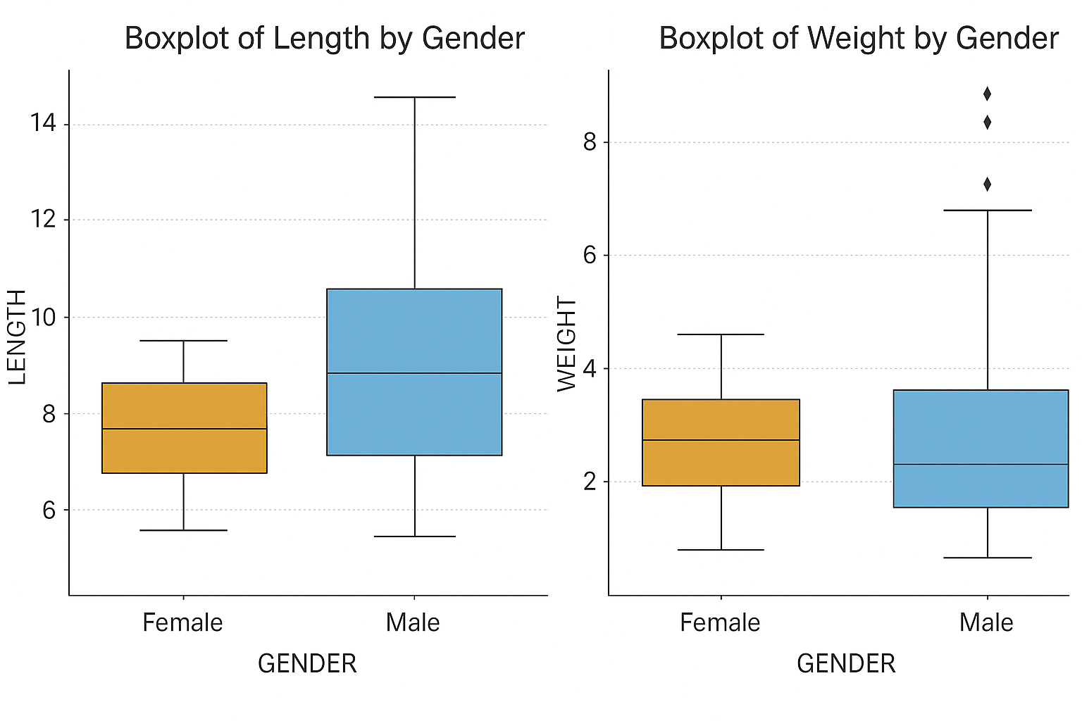
Figure 2. Comparison of Morphometric Parameters (Length and Weight) Boxplot between Male and Female Canary Crabs
3.3 Population Structure Based on Sex Ratio
The composition of the canary crab population on Meos Ambower Island shows an imbalance of sex ratios with a clear dominance of male individuals. Of the total 100 individuals that were successfully collected and identified during the study period, 65 individuals were males while 35 individuals were females (Table 3). This composition yields a percentage of 65% for males and 35% for females, with a male-to-female sex ratio of 1.86:1, indicating that the male population is almost twice as numerous as the female population at the study site.
Table 3. Sex Ratio of Coconut Crabs on Meos Ambower Island
Gender | Number of Individuals | Percentage (%)
Male | 65 | 65
Female | 35 | 35
Total | 100 | 100
The frequency distribution of population size is visualized through a histogram showing a pattern of carhatic length and body weight distribution patterns in the population (Figure 3). The histogram shows a relatively normal distribution with a right-skewed tendency in some size classes, indicating the dominance of medium-sized individuals in the presence of several large-sized individuals. These distribution patterns provide important information about the population size structure and can indicate the health status of the population as well as possible exploitation pressures at the study site.
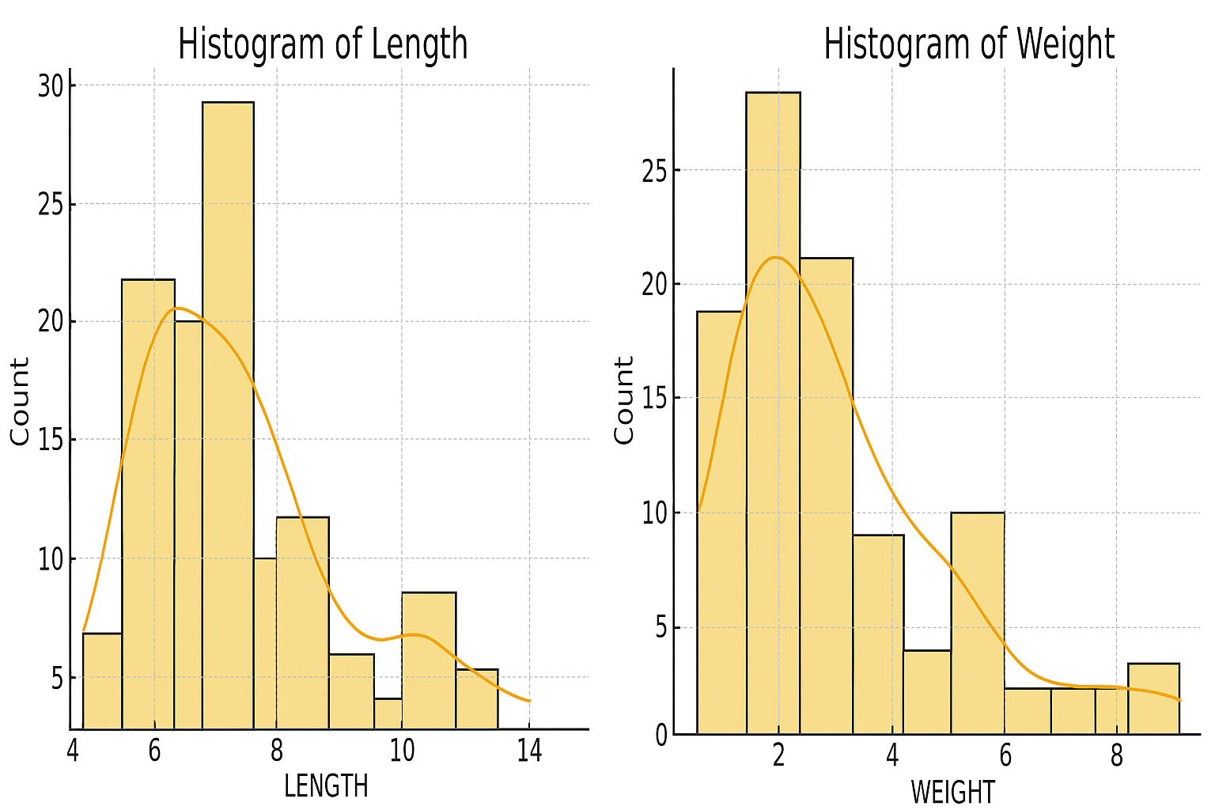
Figure 3. Histogram of Frequency Distribution of Length and Weight of Coconut Crabs on Meos Ambower Island
3.4 Alternative Regression Models and Growth Patterns
Additional analysis using an alternative regression model yielded the equation Weight = 1.497 + 0.207 × Length with a much lower R-squared value of 0.064 or 6.4% (Table 4). This model is only able to explain a small number of data variations, but still shows a statistically significant relationship with the p-value for the slope coefficient of 0.0110. The very small slope coefficient (b = 0.207) in this model indicates a negative allometric growth pattern, where weight growth takes place more slowly than the growth in carapace length.
Table 4. Parameters of Alternative Regression Models
Parameters | Value
Equation | Weight = 1.497 + 0.207 × Length
R-squared | 0.064
P-value (slope) | 0.0110
The significant difference in R-squared values between the main model (57.5%) and the alternative model (6.4%) indicates the importance of selecting the right method of analysis and data transformation in morphometric analysis. The primary model with a higher R-squared provides a more accurate representation of the length relationship of canary crab weight at the research site and is more reliable for practical applications in biomass estimation and population monitoring.
4. DISCUSSION
4.1 Characteristics of Long Weight Relationships
The relationship of canary crab weight length on Meos Ambower Island showed a strong positive correlation with an R-squared value of 0.575, indicating that 57.5% of the variation in body weight could be explained by the carapace length variable. The value of this determination coefficient is moderate to strong and shows good model quality to describe the dynamics of local population growth. Similar studies on coconut crabs in different locations showed variations in growth coefficient values influenced by specific habitat conditions. (Wisabla et al., 2024) reported a b value of 2.2219 in coconut crabs on Myos Ambower Island indicating a growth pattern allometric negative, where the increase in body length is faster than the increase in body weight. The difference in regression parameter values between this study and the previous study is likely due to variations in analysis methods, sampling periods, and different environmental conditions and availability of food sources at each study site.
A very significant regression coefficient (P = 6.33E-20) strengthens the validity of the model in practical applications for biomass estimation and population monitoring. (Serosero et al., 2021) In the study of the status of coconut crab stocks in Morotai, it emphasized the importance of growth parameters in population management, where accurate estimation of growth parameters is the basis for determining the level of sustainable exploitation. The significant long-weight relationship allows researchers and area managers to estimate individual weights based on length measurements alone, thereby minimizing stress on organisms and improving the efficiency of long-term monitoring. (Pramujo et al., 2025) It shows that morphometric size has a very strong relationship with body weight in different species, with a high correlation coefficient indicating the reliability of regression models for the prediction of other morphometric parameters.
4.2 Implications of Sexual Dimorphism
Significant sexual dimorphism at carapace length (P = 0.001) but not at body weight (P = 0.419) indicated a different pattern of energy allocation between males and females in coconut crab populations. Larger carapace sizes in male individuals are consistent with the theory of sexual selection where body size plays an important role in competition between males and reproductive success. The phenomenon of sexual dimorphism in decapod crustaceans has been widely documented and shows variation between species depending on reproductive strategies and selection pressures. (Hendra et al., 2024) Reports that morphometric characteristics in crustaceans show a strong relationship between length and weight parameters with a correlation value of r = 0.4815, indicating the presence of individual variability influenced by biological factors including sex.
The absence of significant differences in body weight indicates that although males have a longer carapace, physiological conditions and biomass accumulation are relatively equal between the two sexes in the study habitat. (Afidah et al., 2024) Finding different growth patterns between males and females in crabs, where males show patterns allometric positive while females show patterns allometric negative, indicates that sexual dimorphism fundamentally affects growth characteristics. (Silaban et al., 2022) also reported differences in growth patterns between locations in blood clams, where populations at one location showed patterns allometric positive (b = 3.04) while other locations show patterns allometric negative (b = 2.01), reinforcing the argument that environmental factors and local population characteristics play an important role in determining growth patterns and sexual dimorphism.
4.3 Population Structure and Conservation Implications
The unbalanced sex ratio to male dominance (65%) indicates a bias in population structure that requires special attention in the context of management and conservation. Sex ratio imbalances can be caused by several factors including differences in mortality rates, temporal migration patterns, or differences in nocturnal activity between males and females. (Afidah et al., 2024) Reports a male crab sex ratio of 0.62:1.59 indicating female dominance and unbalanced population conditions, emphasizing that sex ratio imbalances can impact the reproductive potential and long-term sustainability of the population. (Serosero et al., 2021) revealed that the high level of exploitation of coconut crabs (E > 0.5) in Morotai resulted in significant pressure on the population, so that sex ratio monitoring is an important indicator of the health status of the population.
The predominance of males in the study sample may also indicate that male individuals are more actively mobile and easier to find during the nocturnal sampling period, in line with the behavioral characteristics of terrestrial crustaceans that indicate differences in foraging activity between the sexes. (Latupapua et al., 2023) emphasizing the importance of mangrove habitat conservation as an ecosystem that supports the life of various fauna, including crustaceans, where habitat quality affects population structure and sex ratio. (Kusuma et al., 2025) It shows that environmental and nutritional factors have a significant effect on the survival and morphometric characteristics of aquatic organisms, indicating that good habitat management is key to maintaining a balanced and sustainable population structure.
4.4 Growth Patterns and Energy Allocation Strategies
The slope coefficient obtained from the main regression model (b = 154.98) indicates the growth characteristics of coconut crabs that need to be interpreted carefully in the context of linear models. For growth pattern evaluation allometric More accurately, a non-linear regression model with logarithmic transformations follows the equation of W = log a + b log L, where the value b determines the type of growth: isometric (b = 3), positive allometric (b > 3), or negative allometric (b < 3). (Wisabla et al., 2024) reported a B value of 2.2219 in coconut crabs indicating a growth pattern allometric negative, where body length increases occur faster than weight gain, a pattern commonly found in crustaceans with characteristics of slow growth and high energy investment for reproduction.
The alternative regression model in this study yielded a slope coefficient b = 0.207 with a low R² (0.064), indicating that the model is less representative to describe the long-weight relationship of the population. (Hendra et al., 2024) Finding Growth Patterns allometric negative (b < 3) in mantis shrimp with the equation W = 5.96 L^0.24, where the growth rate of length is faster than the increase in weight, in line with the characteristics of crustaceans that allocate energy differently in different phases of life. (Silaban et al., 2022) reported a striking difference in growth patterns between locations, where blood shells in Taar waters showed patterns allometric positive (b = 3.04) while in Fair waters shows a pattern allometric negative (b = 2.01), indicating that environmental conditions and nutrient availability play a fundamental role in determining energy allocation patterns for somatic growth.
Growth patterns negative allometric Indicated in canary crabs implies that this species allocates a significant proportion of energy to the development of skeletal structures and exoskeletons rather than the accumulation of body mass, an adaptive strategy common in terrestrial crustaceans with high mobility and structural needs to support activity in terrestrial habitats. (Afidah et al., 2024) Identify differences in growth patterns between the sexes in crabs, where males show patterns allometric positive and females show patterns allometric negative, indicates that the investment of reproductive energy in females affects the pattern of body mass accumulation. (Kusuma et al., 2025) suggests that nutrition and feed quality have a significant effect on the growth and survival of aquatic organisms, reinforcing the argument that the growth patterns of coconut crabs on Meos Ambower Island are influenced by the availability of food sources and the quality of local habitats.
4.5 Implications for Management and Conservation
The morphometric information obtained from this study provides Baseline Data important for the sustainable management of canary crab populations in the Fam Islands. Significant long-weight relationships can be used as Tool practical for estimating population biomass and monitoring population health without the need to weigh directly in the field, increasing the efficiency of long-term monitoring activities. (Serosero et al., 2021) emphasizing the importance of growth parameters in Stock Assessment, where high levels of exploitation (E > 0.5) require strict regulation to prevent Overfishing and ensuring the sustainability of the population. The estimated population size of coconut crabs in Morotai ranges from 7,466 to 73,948 individuals with Recapture very low (0.82%), indicating high mobility and complexity of monitoring terrestrial crustacean populations.
Unbalanced sex ratios and significant sexual dimorphism need to be considered in the establishment of catch regulations, particularly in determining the minimum size of the catch that differs between males and females to maintain a healthy reproductive population structure. (Afidah et al., 2024) reports that female crabs are thought to have first matured gonads at a size of 115.70 mm, critical information that should be a reference for determining minimum catch sizes to protect non-gonad-mature individuals. (Latupapua et al., 2023) emphasizing the importance of mangrove habitat conservation as an ecosystem that supports the life of various fauna, including crustaceans, where habitat degradation has a direct impact on population structure and species sustainability. Given the slow-growth characteristics and reproductive complexity of coconut crabs, adaptive management strategies with an approach Precautionary Principle It is imperative to prevent overexploitation of populations at research sites, including the establishment of protection zones, regulation of capture periods, and continuous monitoring programs to evaluate the effectiveness of the conservation policies implemented.

4. Conclusion
This study succeeded in identifying the morphometric characteristics of coconut crabs on Meos Ambower Island through the analysis of the length relationship of weight which showed a significant positive correlation with the regression equation Weight = -966.37 + 154.98 × Length and an R-squared value of 0.575. This regression model was able to explain 57.52% of the variation in body weight based on carapace length with a very high level of statistical significance. Evaluation of sexual dimorphism revealed significant differences in carapace length parameters between males and females, but no significant differences were found in body weight parameters, indicating different energy allocation patterns between the sexes. The population structure shows an imbalance in the sex ratio with the dominance of male individuals at 65% which requires special attention in the context of conservation management. The growth pattern indicated to be negative allometric indicates that body length increase occurs faster than weight gain, reflecting the canary crab's adaptive strategy in allocating energy for skeletal structure development. The morphometric data produced provide an important baseline for long-term monitoring and can be applied in the determination of sustainable catch size regulations, population biomass estimation, and evaluation of the health status of coconut crab populations in the Raja Ampat conservation area.

References

Afidah, A. C., Redjeki, S., Haryanti, D., & Agus, E. L. (2024). Gonad Maturity Level and Sex Ratio of Crab (Portunus pelagicus) in Betahwalang Waters, Demak Regency. 13(4), 802–812.
Ardiansyah, D. A. A. (2020). Proceedings of the National Seminar on Biology—Department of Biology, FMIPA UHO 2019: Exploration and Utilization of Biodiversity in Supporting Sustainable National Development. Halu Oleo University Press. Retrieved from https://books.google.co.id/books?id=uYDsDwAAQBAJ
Hendra, H. S., Zamdial, & Hartono, D. (2024). Analysis of the Relationship between Carapace and Weight of Mantis Shrimp (Harpiosquilla raphidea) Caught by Fishermen in the Baai Island Area, Bengkulu City. AQUACOASTMARINE: Journal of Aquatic and Fisheries Sciences, 3(2), 107–115. https://doi.org/10.32734/jafs.v3i2.18026
Kusuma, B., Anjaini, J., Devananda, A. H., Sinaga, S., Hary, P., Soedibya, T., ... Soedirman, U. J. (2025). The Effectiveness of Natural Feed in Improving the Color and Survival Rate of Ornamental Shrimp Neocaridina sp. 6(3), 290–300.
Latupapua, L., Siahaya, L., & Seipalla, B. (2023). Mangrove Forest Conservation in Efforts to Protect Wildlife in Hukurila Country, South Leitimur District, Ambon City. Journal of Community Service and Empowerment Innovation, 3(1), 281–288. https://doi.org/10.54082/jippm.71
Mahé, K., Baudrier, J., Larivain, A., Telliez, S., Elleboode, R., Bultel, E., & Pawlowski, L. (2023). Morphometric Relationships between Length and Weight of 109 Fish Species in the Caribbean Sea (French West Indies).
Pramujo, M., Maylinda, S., Nurgiartiningsih, V. M. A., Susilorini, T. E., & Hamiyanti, A. A. (2025). Comparison of Morphometric Characteristics of Thin-Tailed Sheep, Cross Texel and Dorper in the Tropics of Indonesia. TROPICAL LIVESTOCK Journal of Tropical Animal Production, 26(1), 52–59. https://doi.org/10.21776/ub.jtapro.2025.026.01.6
Rugaya Serosero, Sulistiono, Butet, N. A., & Riani, E. (2019). Sex Ratio and Growth Pattern of Coconut Crabs Birgus latro (Crustacea, Decapoda, Cianobitidae) in North Moluccas Province, Indonesia. Archives of Anesthesiology and Critical Care, 68(11), 1055–1064.
Serosero, R. H., Sulistiono, Butet, N. A., & Riani, E. (2021). Stock status of coconut crab (Birgus latro) in daeo, morotai island district, North Maluku, Indonesia. Biodiversity, 22(2), 624–632. https://doi.org/10.13057/biodiv/d220214
Silaban, R., Dobo, J., & Rahanabun, G. (2022). Morphometric Proportions and Growth Patterns of Blood Shellfish (Anadara granosa) in the Intertidal Area, Tual City. Journal of Marine Science, 15(2), 143–152. https://doi.org/10.21107/jk.v15i2.13759
Wisabla, A., Yanti, D. I. W., Manurung, M., & ... (2024). The Long Relationship of Coconut Crab Weight (Birgus Latro) in the Fam Islands, Saupapir Village, West Waigeo Islands District, Raja Ampat Regency, Southwest Papua Province. Innovative: Journal Of ..., 4, 7186–7192. Retrieved from http://j-innovative.org/index.php/Innovative/article/view/12938
Yanti, D. I. W., Kasmidi, M., Gunadharma, N., Mayor, A., Masengi, M. C., Leiwakabessy, I. M., ... Mandagi, S. V. (2023). Population of Coconut Crab (Birgus latro) in Fam Island, Raja Ampat, Indonesia. Journal of Advance Zoology, 44(03), 1770–1780.

