Original Research Article

Reproductive Biology of Twait Shad (Alosa fallax) in Syrian Marine Waters, Eastern Mediterranean

.
ABSTRACT

This study investigates the reproductive biology of Twait Shad (Alosa fallax) in the coastal waters of Latakia Governorate, Syria. Fish samples (1,200 specimens) were collected using local fishing methods (Gillnets and Purse nets) from October 20, 2021, to September 14, 2023.
The total length of the sampled fish ranged from 10.4 to 21 cm, with an average of 14.27 cm ± 3. The studied population consisted of males, who outnumbered females, comprising 59.4% and 40.6%, respectively.
The reproductive study showed that A.fallax spawns in Syrian marine waters from April to September, with a single peak in May for both sexes. The highest gonad somatic index (GSI%) values were recorded in May. The length at first sexual maturity was 17.1 cm for males and 19.1 cm for females.
The hepatosomatic index (HSI%) reached its highest values during the first year of the study, in October 2022 (1.91 ± 1.01), and in September 2023 (3.92 ± 3.05).

Keywords: Clupeidae, Alosa fallax, Syrian marine waters, Reproduction, Sexual maturity, Fertility

1. INTRODUCTION

Food security is a significant global concern, with approximately 735 million people experiencing hunger and malnutrition, as reported by the Food and Agriculture Organization (FAO, 2023). Diets in low-income countries primarily rely on staple crops such as wheat, rice, and maize, which provide essential energy and nutrients. However, these staples often lack critical micronutrients such as iron, iodine, zinc, and calcium. Fish can serve as a vital source of these nutrients, playing a pivotal role in reducing micronutrient deficiencies (Béné & Heck, 2010).
Understanding fish biology, particularly reproduction, has become increasingly important in combating malnutrition in many countries, especially those facing protein deficiencies. Fish are consumed directly by humans or indirectly through their use in animal feed and agricultural fertilizers. Fisheries have long been a crucial natural resource, providing protein to human populations throughout history.
Twait shad (Alosa fallax), a species from the family Clupeidae, is widely distributed in coastal and marine waters of the Mediterranean region and Western Europe. This species is of significant ecological importance, serving as a critical link in the aquatic food chain and providing a primary food source for various predators. Furthermore, Alosa fallax holds local economic value, particularly for coastal communities that rely on its capture for food and trade. However, environmental changes and overfishing pose significant threats to its populations, underscoring the importance of studying its reproductive biology for conservation purposes.
Studying fish reproduction, fertility, and the size and age at first sexual maturity provides essential data for maintaining species populations in their natural habitats. Knowledge of reproductive behavior informs the development of aquaculture strategies and management practices, including artificial breeding programs. Additionally, determining the spawning season of fish species is critical for enforcing fishing restrictions during breeding periods. Identifying the size at first sexual maturity aids in designing fishing nets with appropriate mesh sizes, allowing juvenile fish to grow and reproduce before being harvested (Al-Balawi, 2005).
Fish gonads undergo several stages of sexual maturation before reaching full maturity. Studying these stages allows researchers to determine the spawning period and its associated reproductive patterns. During the sexual maturation cycle, significant changes occur in the gonadosomatic index (GSI), reflecting the accumulation of reproductive materials such as eggs, often at the expense of somatic growth due to energy transfer (Mukhtar, 1982).

2. material and methods

The gonads were removed and weighed, and their maturity stages were determined visually. They were then fixed in 7% formalin for histological sectioning to determine the stages of sexual maturity.
The following relationships were used to study reproduction:

2.1 Gonado-Somatic Index (GSI%):
The Gonado-Somatic Index reflects the percentage relationship between gonad weight and body weight, a crucial indicator of sexual maturity stages in fish. This relationship allows for determining the spawning season by tracking monthly changes, which correspond to the highest GSI% values. The GSI% was calculated using the formula (Bagenal, 1978):
𝐺𝑆𝐼=% Gw/Ew ×100
Gw: Gonad weight (g)
Ew: Eviscerated body weight (g)
Eviscerated body weight was used instead of total body weight to avoid errors caused by changes in visceral weight during different reproductive phases, as gonads grow to occupy more than one-third of the abdominal cavity when mature.
2.2 Sex Ratio:
The sex ratio of males to females was estimated monthly for the studied species and overall, throughout the study period. The sex ratio reflects environmental conditions and whether they are suitable for the species.
2.3 Fecundity Estimation:
Fecundity is defined as the number of mature oocytes in the ovary, ready for ovulation before the spawning period (Bagenal, 1973). Fecundity in mature females was determined using the wet weight method. After washing the oocytes and placing them on filter paper to absorb excess water, 0.1 g of the ovarian eggs were weighed using a sensitive balance. The eggs were then placed on a glass slide with chambers to estimate the number of eggs in each chamber. This process was repeated in different areas of the ovary (anterior, middle, and posterior parts) to obtain the average number of eggs per unit weight, and then the total number of eggs in 1 g of ovarian weight was calculated.
Absolute Fecundity: Absolute fecundity was calculated using the following formula:
𝐹𝑎=𝐺𝑤×𝐷
Fa: Absolute fecundity (number of eggs)
Gw: Ovarian weight (g)
D: Number of eggs per 1 g of ovarian weight (Bagenal, 1973).
Relative Fecundity: Relative fecundity was calculated using the following formula (Nikolskii, 1963):
𝐹𝑟=𝐹𝑎×𝐸𝑤
Fr: Relative fecundity (eggs per unit body weight without guts)
Fa: Absolute fecundity
Ew: Eviscerated body weight (g)
The relationship between absolute and relative fecundity was examined in relation to total length (TL), eviscerated body weight (Ew), and ovarian weight (Gw) of the females studied.
2.4 Hepato-Somatic Index (HSI%):
The Hepato-Somatic Index was used to determine the percentage relationship between liver weight and eviscerated body weight, calculated using the following formula (Pravdin, 1966):
𝐻𝑆𝐼% = (Lw )/Ew × 100
Lw: Liver weight (g)
Ew: Eviscerated body weight (g)
2.5 Condition Factor:
It gives an image of the effectiveness of feeding in increasing the weight of the fish by applying Fulton's law (Pravdin, 1966):
K= ( W)/(l 3) ×100 W: Total weight of the fish.
ℓ: Standard length of the fish.
2.6 Histological Study:
Samples from the gonads preserved in formalin were processed and treated according to the following steps using specialized equipment in the Tishreen University Hospital: The gonads were preserved in 10% formalin for one day to stabilize the tissues. A series of routine procedures were then followed to process the tissues with paraffin wax and obtain permanent slides containing tissue sections according to the reference procedures.

3. results and discussion

3.1 Histological and Morphological Development of Gonads
3.1.1 Sexual Maturity Stages:
The study identified five sexual maturity stages in A.fallax, aligning with the findings of Balli (2017). However, this classification did not match the six-stage gonadal development scale described by Nikolskii (1974), as the third and fourth stages were combined into a single stage in the studied A.fallax.
Stage 1: Immature
The gonads were very small and adhered to the lower spine, occupying approximately one-third of the body cavity length. The ovary appeared pink and transparent, with oocytes not visible to the naked eye (Figure 1A). The testis was white and thread-like in appearance (Figure 1B). This stage was observed year-round except during April, May, and June
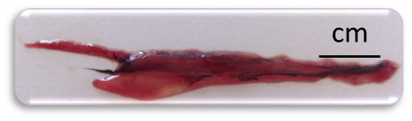  A: A first-stage mature A.fallax weighing 22.5g, 18cm long, gonad weight 0.12g, caught on 6/14/2022 | 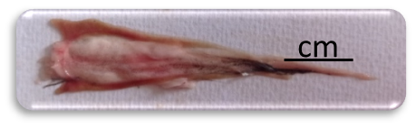B: Testicle in the first stage of maturity of A.fallax, weighing 35.02 g, length 15.5 cm, gonad weight 0.44 g, caught on 10/20/2021
Fig. 1. A, B. Gonads in the first stage of sexual maturity in A.fallax caught in the marine waters of Lattakia Governorate (2021-2023).
Histological preparations of the ovary revealed germ cells appearing as either oogonia or oocytes in the cytoplasmic growth stage (Figure 2A).
Oogonia:
- These are the primary germ cells formed in the gonadal epithelium.
- They are spherical and tiny, making them invisible to the naked eye.
- In histological sections, they appear as transparent cells with relatively large nuclei surrounded by a thin layer of cytoplasm.
The germ cells in the testes were represented by spermatogonia (Figure 2B).
Spermatogonia:
- These are the primary germ cells in the testicular epithelium.
- They are large and spherical, with large nuclei surrounded by a thick layer of cytoplasm.

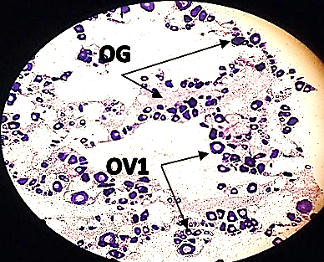  A: Histological section of an ovary at the early stage of maturation in A.fallax, OVA1 (primary oocytes), OG: ovipositor. | 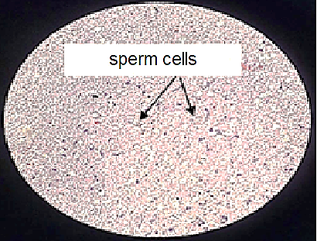  B: Histological section of testis at the early stage of maturity in A.fallax
Fig. 2. A ,B Histological section of the gonads of A.fallax at the first stage of sexual maturity, magnification (×40).

Stage 2: Juvenile
This stage is characterized by significant gonadal development compared to the first stage. The ovary and testis occupy approximately half the length of the body cavity. The ovary appears pink and translucent, with ova not visible to the naked eye (Figure 3A). The testis is white, flat, and has firm, elastic tissues (Figure 3B). This stage typically extends from January to September.

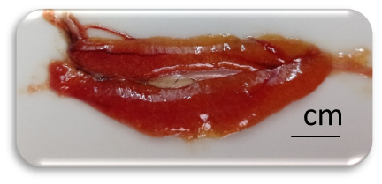  A: Ovary of the second stage of sexual maturity of A.fallax, weighing 22.3 g, length 13.5 cm, weight of the gonad 0.26 g, caught on 3/13/2022 | 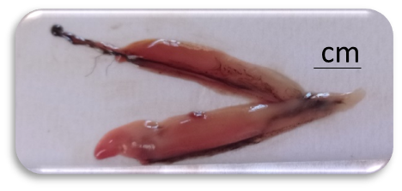B: Testicle of the second stage of sexual maturity of A.fallax, weighing 44.69 g, length 17.5 cm, gonad weight 0.16 g, caught on 10/20/2021
Fig 3. A, B gonads in the second stage of sexual maturity in A.fallax caught in the marine waters of Lattakia Governorate (2021-2023).
Ovary In histological sections, oocytes are observed during the cytoplasmic growth stage, marked by nutrient accumulation, including yolk granules and lipid droplets (Figure 4A).
- At the end of this stage, oocytes grow significantly, reaching sizes tens of times larger than primary oogonia.
- The oocytes become opaque with colors ranging from pale yellow to bright orange due to yolk accumulation.
The testis Seminiferous tubules in the testis are filled with cysts containing spermatogenic cells at various developmental stages (Figure 4B).
The development of spermatogenic cells occurs in the following stages:
- Proliferation: Cells undergo mitotic division.
- Growth and Maturation: Cells develop into primary spermatocytes, secondary spermatocytes, and later spermatids.
- Meiosis: Reductional division occurs, resulting in four haploid male gametes per cell.
- Differentiation: Haploid gametes mature into spermatozoa with distinct structural features.
Histological observations reveal spermatozoa at different developmental stages in the testis.

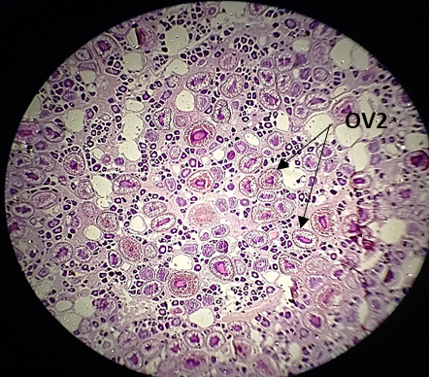  A: Histological section of an ovary at the second stage of maturity in A.fallax OV2 (secondary oocytes). | 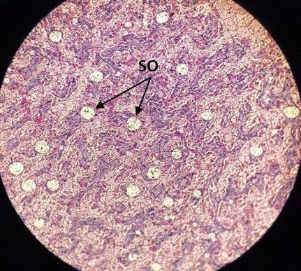  B: Histological section of testis at the second stage of maturity in A.fallax SO spermatocytes.

Fig 4. A , B Histological section of the gonads of A.fallax at the second stage of sexual maturity. Magnification (×40).
Stage 3: Pre-Maturity
During this stage, the large-sized testes and ovaries occupy approximately two-thirds of the body cavity. However, no reproductive products are observed to exude from the body when slight pressure (stripping) is applied to the fish's abdomen. The ovary appears yellowish-pink with a granular texture, and ova are visible to the naked eye (Figure 5A), while the testes exhibit a milky white color (Figure 5B). This stage occurs in (Alosa fallax) from March to August
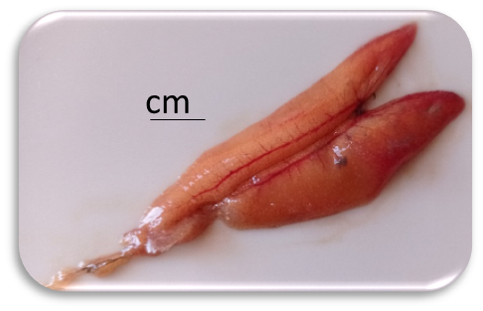  A: Ovary of the third stage of sexual maturity of A.fallax, weighing 59.87 g, length 19 cm, gonad weight 2.05 g, caught on 4/28/2022 | 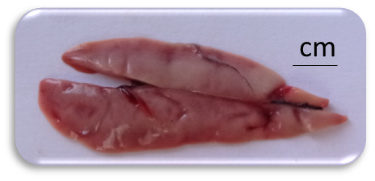  B: Testicle of the third stage of maturity of A.fallax, weighing 32.45 g, length 17 cm, gonad weight 2.17 g, caught on 4/28/2022
Fig. 5. A, B. Gonads in the third stage of sexual maturity in A.fallax caught in the marine waters of Lattakia Governorate (2021-2023).
Microscopic histological examination of the ovaries (Figure 6:A) revealed the presence of mature oocytes prepared for release during the next reproductive cycle. These cells are filled with yolk, with a significant reduction in ovarian wall thickness, and their cytoplasm is densely packed with yolk granules. In the testes (Figure 6:B), small-sized spermatozoa were observed in the seminiferous tubules. These spermatozoa displayed oval and round shapes with minimal cytoplasm. Additionally, the testes contained reserve germ cells represented by spermatogonia, indicating the ongoing process of spermatogenesis.
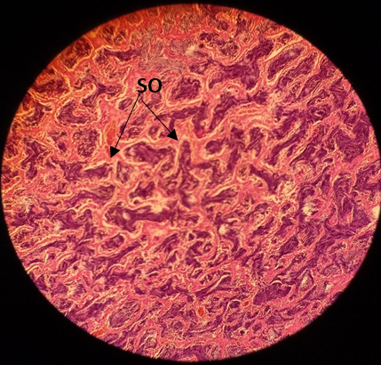 B: Histological section of testis at the third stage of sexual maturity in A.fallax SO spermatocytes | s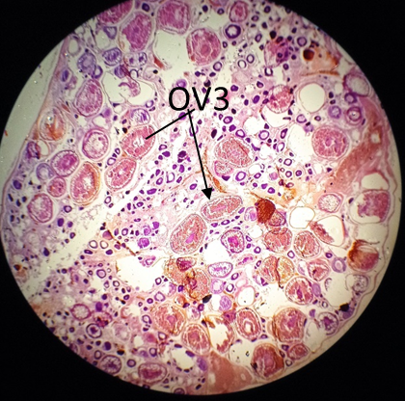  A: Histological section of an ovary at the third stage of sexual maturity in A.fallax.
Fig 6. A, B. Tissue sections of the gonads of A.fallax at the third stage of sexual maturity. Magnification (×40).

Stage 4: Maturation
During this stage, both the ovary and the testis occupy about two-thirds of the body cavity. The ovary is orange-pink with distinct superficial blood vessels, and the ova is large, transparent, mature, and ready for fertilization (Figure 7A). The testis appears creamy white, soft in texture, and contains seminal fluid rich in spermatozoa (Figure 7B). At this stage, reproductive products are easily released when slight pressure is applied to the abdomen or when the fish is shaken. This stage is observed from April to September.
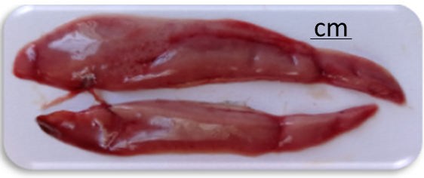  B: Testicle of the fourth stage of sexual maturity of A.fallax, weighing 109.14 g, length 23.5 cm, gonad weight 11.04 g, caught on 4/28/2022 | 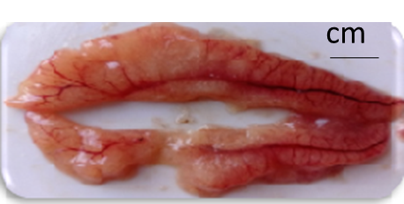  A: A fourth-stage mature A.fallax weighing 112.25 g, 24.5 cm long, gonad weight 14.24 g, caught on 4/28/2022
Fig. 7. A, B. gonads in the fourth stage of sexual maturity in A.fallax caught in the marine waters of Lattakia Governorate (2021-2023).
Microscopic histological examination of the ovary (Figure 8A) revealed the presence of ruptured follicles from which ova were released, with subsequent resorption expected. Reserve germ cells dedicated to future reproductive cycles were also observed. Most ova appeared scattered, with homogenous liquid yolk and large vacuoles visible within the ova. In the testis (Figure 8B), seminal fluid containing spermatozoa was observed, facilitating their release from the body during spawning.

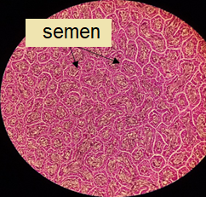  B: Histological section of testis at the fourth stage of sexual maturity in A.fallax | 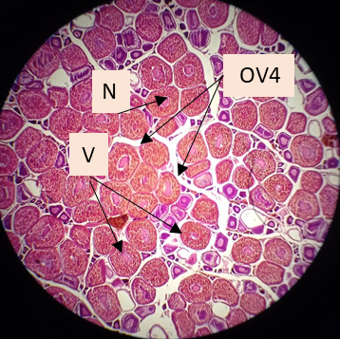  A: Histological section of an ovary at the fourth stage of sexual maturity in A.fallax. (N) Nucleus, (V) Yolk.
Fig. 8. A, B Histological section of the gonads of A.fallax at the fourth stage of sexual maturity. Magnification (×40).
Stage 5: Post-Puberty and Ovulation
At this stage, the testes and ovaries shrink to about half the length of the body cavity, marking the completion of egg-laying (ovulation) or sperm release. The gonads appear small and flaccid, often containing only a few residual eggs or remnants of sperm. The ovary takes on a deep red color due to hemorrhaging caused by the rupture of ovarian follicles (Figure 9A), while the empty follicles and residual eggs undergo resorption. The testes become small, ribbon-like, devoid of seminal fluid, and appear pink (Figure 9B). This stage is observed in A.fallax during August and September.
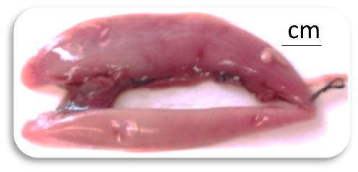  B: Testicle of the fifth stage of sexual maturity of a sardine, weighing 86.42 g, length 24 cm, gonad weight .71 g, caught on 6/14/2022 | 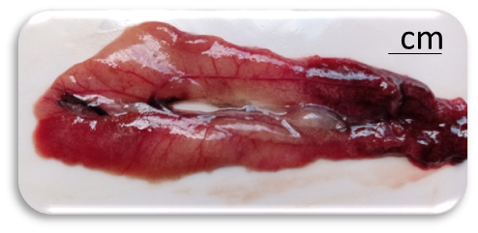  A: Ovary of the fifth stage of sexual maturity of a sardine, weighing 72.32 g, length 24 cm, gonad weight 1.8 g, caught on 6/14/2022
Fig. 9. A, B gonads at the fifth stage of sexual maturity in A.fallax caught in the marine waters of Lattakia Governorate (2021-2023).
Microscopic histological examination of the ovaries in females (Figure 10A) revealed oocytes at various stages of yolk deposition and empty spaces where ova had been released. A small number of oocytes showed signs of yolk blockage, and some yellow bodies were observed. Additionally, cells still undergoing maturation and follicular walls from ruptured ovarian follicles were identified. In males (Figure 10 B), the seminiferous lobules appeared empty of spermatozoa, indicating that most had been released during reproduction.

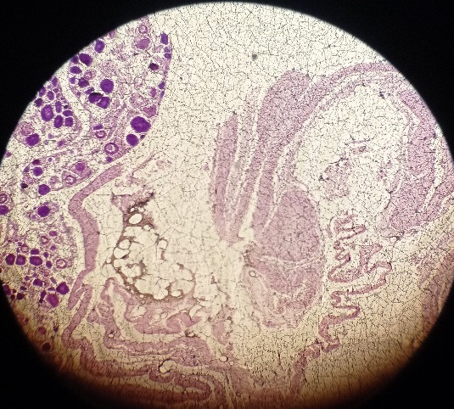  B: Histological section of testis at the fifth stage of sexual maturity in sardine scale fish (empty lobes of sperm) × 10 | 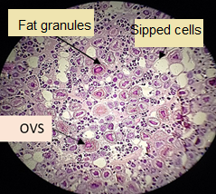  A: Histological section of an ovary at the fifth stage of sexual maturity in the sardine grouper ×10
Fig. 10. A, B. Histological section of the gonads of A.fallax at the fifth stage of sexual maturity. Magnification (×10).

3.2 Hepato Somatic Index (HIS%):

The Hepato-Somatic Index (HIS%), representing the percentage ratio of liver weight to eviscerated body weight, fluctuates in response to environmental changes. During favorable environmental conditions, nutrients are stored in the liver to support metabolic needs during periods of food scarcity or throughout migration and reproduction seasons, providing energy for gonadal maturation (Pravdin, 1966)
.
3.2.1 Males of A.fallax:

First Year (2021-2022): The lowest value was recorded in February (0.33±0.634) during cold weather. The highest value was observed in October (1.77±2.04) post-reproductive season.
Second Year (2022-2023): The lowest value was recorded in November (0.77±1.09) during winter due to low temperatures and limited feeding. The highest value was recorded in September (0.466±1.79) post-reproductive season.

3.2.2. Females of A.fallax:

First Year: The lowest value was observed in February.(0.25±0.515) The highest value was recorded in October (1.01±1.91) post-reproductive season.
Second Year: The lowest value was recorded in November (0.77±0.09). The highest value was observed in September (3.05±3.92).
The HIS did not decrease during the reproductive season (April-August), indicating that A.fallax relies on direct feeding from the environment to support its reproductive needs rather than using liver reserves. (Figure 11)

Fig. 11. Monthly changes in liver index values ​​in female and male A.fallax

3.3. Condition Factor:
The condition factor values did not decline during the reproductive months (April-September), supporting the idea that A.fallax continues feeding during reproduction. Similar findings were reported in studies on the same species in Lithuania (Stankus, 2009) and Scotland (Maitland, 2005). (Figure 12)

Fig. 12. Monthly changes in the values ​​of the condition factor in A.fallax during the research 2021-2023

3.4 Monthly Changes in the Gonadosomatic Index (GSI%) in A.fallax:
The average values of the GSI for female A.fallax (Figure 13) during the first year of research (October 2021 to September 2022) ranged from (0.04±0.097%) in January to (1.51±6.64%) in May, with an average ovary weight of (0.04±0.03 g) in January and (1.66±5.27 g) in May.
For the second year of research (October 2022 to September 2023), the GSI values for females ranged between (0.03±0.102%) in December and (1.2±4.66%) in April, with an average ovary weight of (0.25±0.11 g) in December and (2.24±3.66 g) in April. The reproductive period and gonadal maturity extended from April to September.
Results indicated that the first stage spanned from October to March, the second stage of gonadal maturity occurred in February and March, the third stage extended from March to May, while the fourth stage of full maturity lasted from April to September. The fifth stage (regression) occurred in August and September.
For male A.fallax (Figure 13), the average GSI values during the first year ranged between (0.035±0.083%) in December and (1.59±5.217%) in May, with an average testis weight of (0.19±0.08 g) in December and (1.97±5.11 g) in May. During the second year, GSI values ranged from (0.005±0.06%) in November to (2.35±4.4%) in May, with an average testis weight of (0.07±0.04 g) in November and (2.52±3.34 g) in May.
The first stage of testicular maturation during the first year extended from October to April, the second stage occurred between March and June, the third stage spanned from April to July, and the fourth stage of maturity lasted from April to September, with the regression phase occurring in September.
The two-year monitoring of monthly changes in GSI% (October 2021 to September 2023) indicated that the reproductive season of A.fallax in Syrian marine waters lasted from April to September. The timing of sexual maturity and the peak GSI values for both males and females coincided, with the highest values observed in May during the study period.
These findings suggest that A.fallax requires a full year to complete its reproductive cycle, with batch spawning occurring during spring and summer. The GSI values for females were consistently higher than those for males over the two years, likely due to the greater weight of eggs in ovaries compared to sperm in testes.
When comparing reproductive periods across different regions, the results of this study align with similar findings. However, GSI values for A.fallax in Syrian waters were lower compared to other areas, such as Scotland (Maitland & Lyle, 2005), where GSI values reached 23.32% for males and 20.63% for females, and Ireland (King & Roche, 2008), where values reached up to 15% for females. In the Iberian Peninsula (Nachon et al., 2015), higher GSI values were also reported.
The smaller sizes of A.fallax in Syrian waters may be attributed to limited food availability, regional ocean currents, and overfishing, which prevents these fish from reaching larger sizes. Additionally, the migratory behavior of A.fallax, which includes spawning migrations to rivers (Aprahamian et al., 2003), also influences these observations. Table (1) summarizes these findings.

Fig. 13. Monthly changes in the values ​​of the sexual maturity index (GSI%) in males and females of A.fallax during the research period 2021-2023.

Table 1. Comparison of changes in the values ​​of the sexual maturity index (GSI%) in male and female A.fallax in the marine waters of Lattakia Governorate with studies in other geographical areas:
GSI % values for females | GSI % values for males | Reference | Place
23.32% | 20.63% | Maitland&Lyle,2005 | Scotland
- | 13.7 to 15% | King&Roche,2008 | Ireland
- | 0.47 to 4.93% | Nachon et al.,2015 | Iberian Peninsula
0.06 to 6.64% | 0.097 to 2.2% | Current Search | Syria

3.5. Comparison of Reproductive Periods of A.fallax Across Different Global Regions:
The reproductive periods of A.fallax exhibit consistency across various global regions, occurring during the spring and summer months. This aligns with observations in Syrian waters, as indicated by the current study, and matches findings from Germany, France, the Atlantic Ocean, Scotland, and Ireland. Relevant studies corroborating these results include (Boscking, 1982), (Mennesson-Boisneau & Boisneau, 1990), (Aprahamian et al., 2003), (Maitland & Lyle, 2005), and (King & Roche et al., 2008) (Table 2).
Table 2. Comparison of the breeding season of A.fallax on the Syrian coast with studies in different geographical areas:
Breeding months | Reference | Place
April to June | Bocking, 1982 | Germany
April to July | Mennesson-Boisnean&Boisneau, 1990 | France
From May to September for the fish of the north  February to July for Southern Fishes | Aprahamian et al., 2003 | Atlantic
In spring and summer | Maitland&Lyle, 2005 | Scotland
April to July | King&Roche et al., 2008 | Ireland
April to September | Current Search | Syria

3.6. Fertility in A.fallax :
During the first year of the study, 34 mature A.fallax were observed. The total fertility of females was estimated at 4,497.63 eggs for fish weighing between 30.38 g and 143.09 g, with an average weig1ht of 84.71 ± 12.83 g. Their standard lengths ranged from 12.83 cm to 20.5 cm, averaging 17.69 ± 1.28 cm. The relative fertility during this period was calculated at 173.429 eggs.
In the second year, 56 mature individuals were recorded. The total fertility of females increased to 24,030.05 eggs for fish weighing between 45.16 g and 101.52 g, with an average weight of 91.96 ± 21.03 g. Standard lengths ranged from 14.33 cm to 19.32 cm, averaging 19.5 ± 1.6 cm. Relative fertility during this year reached 249.177 eggs (Table 3).

Table 3: Fertility of A.fallax fish caught in the marine waters of Lattakia Governorate:

Absolute fertility | Relative fertility | Weight of the pipe/g | Maximum height | Standard length/cm | Total female weight/g | Number of adult female | Months
3088.83667 | 102.452392 | 1.82±0.12 | 2.93±0.12 | 12.83±0.29 | 30.38±3.71 | 5 | April | 2021/2022
16424.55 | 16424.55 | 5.11±1.97 | 4.4±0.36 | 18.17±1.258 | 111.8±18.09 | 8 | May | 2021/2022
6667.48 | 79.5736961 | 2.83 | 0.41±4.7 | 20.5 | 83.79 | 7 | June | 2021/2022
7437.51428 | 142.251279 | 1.791±0.59 | 4.286±0.23 | 17.5±4.153 | 56.161±100.73 | 5 | July | 2021/2022
11612.515 | 148.507021 | 1.683±0.22 | 3.8±0.27 | 17.625±1.27 | 83.02±60.17 | 6 | August | 2021/2022
24497.64 | 173.429997 | 4.915±1.8 | 3.75±0.78 | 19.5±0.71 | 143.09±26.22 | 3 | September | 2021/2022
12553.787 | 135.94049 | 3.03±0.78 | 3.98±0.29 | 17.69±1.28 | 84.71±12.85 | - | Average | 2021/2022
36263.54922 | 387.752 | 4.842±1.53 | 4.26±0.54 | 17.3±1.033 | 91.96±21.03 | 15 | April | 2022/2023
27448.16 | 272.6301 | 3.17±0.58 | 4.13±0.4 | 19.25±1.29 | 101.52±21.64 | 11 | May | 2022/2023
33957.16364 | 321.7588 | 3.69±1.98 | 4.13±0.55 | 19.32±2.09 | 99.3±31.04 | 16 | June | 2022/2023
14163.4525 | 166.0451 | 1.49±0.33 | 4.3±0.5 | 16.38±3.35 | 92.21±23.1 | 9 | July | 2022/2023
7850.353333 | 173.4447 | 0.89±0.32 | 3.27±0.06 | 14.33±1.155 | 45.16±8.54 | 3 | August | 2022/2023
24497.64 | 173.43 | 4.92±1.80 | 3.75±0.78 | 19.5±0.71 | 143±26.22 | 2 | September | 2022/2023
24030.05311 | 249.1768 | 3.17±1.1 | 3.97±0.47 | 19.5±1.6 | 91.96±21.03 | - | Average | 2022/2023

When comparing the results of the current study with findings from previous research in different parts of the world, A.fallax exhibited the highest fertility rates in the Atlantic Ocean (Aprahamian et al., 2003) and the Iberian Peninsula (Nachon et al., 2015). The fertility levels were similar to those reported in France (Taverny, 1991) and Portugal (Pina, 2000). However, the fertility observed in this study was lower than that recorded in Morocco (Sabatié, 1993) and Britain (Aprahamian et al., 2003) (Table 4).

Table 4. Comparison of changes in absolute fertility values ​​of A.fallax fish on the Syrian coast with studies in different geographical areas:
Absolute fertility | Reference | Place
25942 | Aprahamian et al.,2003 | Atlantic
24963 | Nachon et al., 2015 | Iberian Peninsula
139479 | Aprahamian et al., 2003 | England
403562 | Taverny, 1991 | France
403562 | Pina, 2000 | Portugal
86700 | Sabatié,1993 | Morocco
34500.35 | Current Search | Syria

3.7 Length at First Sexual Maturity in A.fallax:
Fish with lengths below 17 cm were sexually immature in both males and females. The frequency of sexual maturity increased with larger fish sizes, reaching 50% maturity at a length of 17.1 cm for males (Figure 14) and 19.1 cm for females (Figure 15). Most of the fish caught were below these lengths, indicating that this species is subject to overfishing. This issue is exacerbated by using these A.fallax as bait for catching other fish, which could lead to stock depletion in the coming years.

Fig. 14. Percentage of mature males according to total length in A.fallax.

Fig. 15. Percentage of mature females according to total length in A.fallax.
Comparison of Current Results with Studies on A.fallax from Different Regions. The results of this study differ from similar research on the same species in various geographic locations. In England, the length at first sexual maturity was recorded as 33 cm for males and 34 cm for females (Aprahamian & Lester, 2001). In Spain, a study by (Lopez et al., 2002) reported lengths of 47.6 cm for females and 36.5 cm for males. Similarly, Scotland, (Maitland & Lyle, 2005) observed lengths of 48.1 cm for females and 42.1 cm for males.
These differences may be attributed to the variation in the sizes of the fish caught between the current study area and other regions. Water temperature plays a significant role in determining the speed at which fish species reach sexual maturity. Fish in waters closer to the equator tend to grow faster, reaching maturity at smaller sizes (Lombardi-Carlson et al., 2003).
4. Conclusions:
The results of this study indicate that the twaite shad (A.fallax) in Syrian marine waters follow a batch spawning pattern, with the reproductive period extending over several months from April to September. The peak sexual maturity for both males and females coincides in May, characterized by high absolute fecundity in mature females during this time.
The study also highlights that overfishing poses a significant threat to this species, compelling them to reproduce at smaller sizes and younger ages compared to their counterparts in other regions worldwide. This phenomenon is attributed to the depletion of fish stocks caused by increased fishing pressure, especially as these fish are used as bait for catching other species.
Based on these findings, it is recommended to impose a fishing ban during the warm months (April to September) to protect the critical spawning period for this species and allow them to reproduce and grow naturally. These measures are essential for preserving fish stock sustainability and ensuring ecological balance in the Syrian marine environment.

Ethical approval

Not applicable

References

Al-Balawi, M. (2005). Reproductive Biology of Marine Fish. Journal of Marine Biology Research, 6(2), 215-228.
Aprahamian, M. W., Baglinière, J. L., Sabatie, M. R., Alexandrino, P., Thiel, R. A. L. F., & Aprahamian, C. D. (2003). Biology, status, and conservation of the anadromous Atlantic twaite shad Alosa fallax. In American Fisheries Society Symposium (Vol. 35), 103-124.

‏ Aprahamian, M. W; Aprahamian, C. D; Baglinière, J. L; Sabatié, R; Alexandrino, P (2003). Alosa alosa and Alosa fallax spp.: literature review and bibliography. Environment Agency, Warrington, UK.374.
Aprahamian, M.W. and Lester, S.M. (2001) Variation in the age at first spawning of female twaite shad (Alosa fallax) from the river Severn, England. Bulletin francais de la peche et de la pisciculture. Bull. Fr. Peche Piscic. 941-951
Baali, A; Bourassi, H; Falah, S; Abderrazik, W; Manchih, K; Amenzoui, K; Yahyaoui, A (2017). Reproductive Biology of Sardinella sp.(Sardinella aurita and Sardinella maderensis) in the South of Morocco. Pakistan journal of biological sciences: PJBS, 20(4), 165-178.
Bagenal, T. (1973). Fecundity of Fish. Fisheries Biology, 2(1), 30-40.
Bagenal, T. (1978). Methods for Assessment of Fish Production in Fresh Waters. Blackwell Scientific, Oxford.
Béné, C., & Heck, S. (2010). Fisheries and the Millennium Development Goals: Solutions for Africa. Fish and Fisheries, 11(4), 534-547.
Blaxter, J. H. S., & Hunter, J. R. (1982). The biology of the clupeoid fishes. Advances in Marine Biology, 20, 1–223.
Böcking, W (1982). Nachen und Netze. Die Rheinfischerei zwischen Emmerich und HonnefWerken und Wohnen. Volkskundliche Untersuchungen im Rheinland. RheinlandVerlag GmbH, Köln, Germany.987.
FAO (2023). The State of Food Security and Nutrition in the World 2023. Rome, FAO.
King, J. J; Roche, W (2008). Aspects of anadromous Allis shad (Alosa Linnaeus) and Twaite shad (Alosa fallax Lacépède) biology in four Irish Special Areas of Conservation (SACs): status, spawning indications and implications for conservation designation. In Fish and Diadromy in Europe (ecology, management, conservation) Proceedings of the symposium held 29 March–1 April 2005. Bordeaux, France (pp. 145-154). Springer Netherlands.‏
Lombardi-Carlson, L.A; Cortés, E; Parsons, A; Manire, C.A. (2003). Latitudinal variation in life-history traits of bonnethead sharks, Sphyrna tiburo, (Carcharhiniformes:Sphyrnidae) from the eastern Gulf of Mexico. Marine and Freshwater Research, 54, 875–883.
López-Verdejo, A; Montero, F. E; de la Gándara, F; Gallego, M. A; Ortega, A; Raga, J. A; Palacios-Abella, J. F. (2022). A severe microsporidian disease in cultured Atlantic Bluefin Tuna (Thunnus thynnus). IMA fungus, Chicago., 13(1), 1-14.
Maitland, P. S. (2005). Ecology of Sardines in Scottish Waters. Marine Biology Journal.
Mennesson-Boisneau, C; P. Boisneau. (1990). Recherches sur les aloses du bassin de la Loire: migration, répartition, reproduction, caractéristiques biologiques et taxonomie des aloses (Alosa sp.). Doctoral dissertation. Universités de Rennes I et de Paris XII, Val de Marne, France.258.
Mukhtar, M. (1982). Reproductive Dynamics of Clupeid Fish in the Mediterranean Sea. Mediterranean Fisheries Journal, 8(1), 45-59.
Nachón, D. J; Barca, S; Silva, S; Vieira-Lanero, R; Servia, M. J; Lago, L; Cobo, F. (2015). Some aspects of the reproductive biology of the twaite shad, Alosa fallax (Lacépède, 1803), in the River Ulla (Northwest of the Iberian Peninsula). In Frontiers in Marine Science. Conference Abstract: XV European Congress of Ichthyology.
Nikolskii, G. V. (1963). The Ecology of Fishes. Academic Press, New York.
Pina, T. A. S. (2000). Aspectos da reprodução de savelha, Alosa fallax (Lacépède, 1803). nos rios Mira e Guadiana. Master’s thesis. Universidade de Coimbra, Coimbra, Portugal.
Pravdin, I. F. (1966). Methods of Studying Fish Nutrition and Feeding in Aquaculture. Academic Press.
Sabatié, M. R. (1993). Recherches sur l'écologie et la biologie des aloses du Maroc (Alosa Linné, 1758 et Alosa fallax Lacépède, 1803). Exploitation et taxinomie des populations atlantiques; bioécologie des aloses de l'oued Sebou. [Ecological and biological researches on shad in Marocco (Alosa Linné, 1758 et Alosa fallax Lacépède, 1803), fishing and taxonomy of Atlantic populations, bioecology of shad in Sebou River]. annexes. Thèse de Doctorat. Brest: Université de Bretagne Occidentale en Océanologie Biologique. 326 pp.
Stankus, A. (2009). Seasonal Dynamics of Sardine Energy Reserves. Lithuanian Fisheries Research Journal.
Taverny, C. (1991a). Pêche, biologie, écologie des Aloses dans le Système Gironde Garonne-Dordogne (Fishing, biology, ecology of shads in the system of Gironde, Garonne-Dordogne). Bordeaux: Cemagref.(4), 392.
Whitehead, P. J. P. (1985). FAO Species Catalogue, Vol. 7: Clupeoid Fishes of the World.

