DevelopmentImplementation of the Kombucha Genitri (Elaeocarpus ganitrus) E-Module to Improve Students Understanding of Fermentation Concepts

.
ABSTRACT

Objective: The aim of this study is to develop an e-module based on the findings of the study of the fermentation of kombucha leaves of Ggenitri (Elaeocarpus ganitrus) as a learning media for the Biotechnology course, as well as to test its validity and effectiveness in improving students' understanding and critical thinking skills.
Study design: Development research with the ASIE model (Analyze, Strategize, Implement, Evaluate).
Place and Duration of Study:Biology Education Study Program, PGRI Madiun University, in the 2024/2025 academic year.
Methodology: The methodology of this study was ASIE model, which includes tothe analyze, strategize, implement, and evaluate stages. The analyze stage was conducted through interviews with lecturers to identify the need for teaching materials and analysis of the kombucha Ggenitri fermentation material. The strategize stage included content planning, visual design, research-based material development, and validation by media and material experts. HOTS questions were used in the pretest and posttest. The implement stage was conducted on Biology Education students using a one-group pre-test/post-testpretest–posttest design. The evaluate stage included data analysis from validation results and N-gain tests on student learning outcomes.
Results: The validation results showed a feasibility percentage of 95% (media experts) and 86.67% (material experts), categorized as very feasible. The effectiveness test showed an average pretest score of 43.45 and a posttest score of 84.5, with an N-gain of 0.72, which is considered high. These findings indicate a significant increase in students' understanding of the fermentation concept and the potential of kombucha Ggenitri as a functional food product.
Conclusion: The e-module based on the findings of the fermentation of kombucha Ggenitri was developed as a valid, feasible, and effective learning resource for use in Biotechnology courses. The developed media enhanced students' conceptual understanding and critical thinking skills through contextual presentation of the material.

Keywords: E-module, Kombucha, Development (Mention should be made of recommendation. The keywords should be minimum of four)

1.0 INTRODUCTION
The breadth of information and knowledge sources accessible to students during the learning process plays a crucial role in determining the quality of learning outcomes. The gap between information technology developments and real-world conditions underscores the need for innovation in the form of integrated electronic teaching materials in digital learning. Teaching materials should be designed with innovative elements that can support the development of student’s competencies. Innovation itself is key to addressing changes and advances in information technology in the 4.0 era, particularly in education. An effective learning process no longer focuses on the lecturer as the center of activity, but rather positions students as active subjects, both physically and mentally.(Arianti, 2021).
E-modules are a form of e-educational material that is classified as interactive teaching material because it integrates text, images and videos, and allows users to control it directly.(Noris et al., 2024 The nemaes of the authors should stated on the first instance). E-module media has high flexibility and portability, and is easy to use, so it can visualize the material and processes of an event that is difficult to observe directly. E-module comes from the English letter "e" representing the electronic element, while "module" refers to structured learning materials (Ricu Sidiq & Najuah 2020)Another advantage is that e-modules can be easily accessed by students via devices such as smartphones or laptops. It's important to develop biotechnology modules to present abstract concepts in a contextual way that's relevant to local potential (T Tompe et al., 2022).
One form of innovation in e-module development is the creation of e-modules based on research findings. Project-based courses, such as Biotechnology, require e-modules as a medium for independent learning.(Jumiarni et al., 2024)The existence of research-based e-modules is crucial, given that effective learning resources contribute significantly to students' ease of conceptual understanding. E-modules have advantages over printed learning materials, particularly in their ability to present learning media such as video, audio, animation, and various interactive features that can be accessed and replayed as needed. These characteristics make e-modules innovative learning materials because they are able to present comprehensive, engaging content and optimally support cognitive development.(Irmawati et al., 2023). The systematics of compiling e-modules based on research results include design, production and evaluation.(Ende et al., 2022)The e-module development process utilizes Microsoft Office Word to compile research-based materials, then visually designs them using the Canva platform.
Developments in learning technology are encouraging the integration of biotechnology research into teaching media such as e-modules, particularly with a contextual approach based on kombucha fermentation. Research by(Rahayu Lestari et al., 2023)This study demonstrates that the project-based learning food microbiology e-module on kombucha fermentation has proven to be highly valid and practical, and is capable of increasing student engagement and understanding through interactive, independent learning. This aligns with the training activities conducted by(Susilawati et al., 2024)which provides simple biotechnology practical training to biology teachers at MGMP through the production of kombucha as a form of strengthening practical competency and direct application in science learning in schools with limited resources. Furthermore, the study of bio-culture by (Lianto et al., 2021)highlights the potential of kombucha SCOBY not only as a food fermentation ingredient, but also as a biodegradable material for the development of sustainable products, such as synthetic leather or eco-friendly packaging.
Based on a brief interview with a lecturer teaching the Biotechnology course in the Biology Education Study Program at Universitas PGRI Madiun, there is currently no research-based e-module available that addresses the chemical characteristics of kombucha Ggenitri leaves. This material aligns with the learning outcomes in the Applied Biotechnology course, particularly in the analysis of the application of food biotechnology in everyday life. The use of e-modules is considered effective in improving students' conceptual understanding in the biotechnology course.(Noris et al., 2024). In addition to being an innovative learning medium, e-modules can also be designed to integrate research findings, thus providing a contextual and real-life case-based learning experience. The e-module based on the topic of Ggenitri kombucha fermentation was chosen because it combines several important aspects of biotechnology such as the potential of Ggenitri leaves, the production of Ggenitri kombucha, and kombucha fermentation, which have a deep correlation in the food industry functionally. The e-module material contains the production of Ggenitri kombucha as a local potential.
1.1 Research objective.
Developing e-modules based on research findings is crucial for providing relevant and applicable learning resources. Research conducted by(Mubarrak et al., 2024)has developed a Flip HTML5-based e-module for the Biotechnology course, but the content is still limited to general material and has not yet addressed specific research findings. To date, no e-module has been found that specifically discusses research findings related to total acid, reducing sugar, and pH in kombucha from Ggenitri leaves (Elaeocarpus ganitrus), especially those that relate these parameters to fermentation time as a learning resource in biotechnology learning. Genitri leaves (Elaeocarpus ganitrus) as a local potential contain active compounds such as steroids, alkaloids, terpenoids, tannins, and flavonoids that have high antioxidant activity thanks to their flavonoid and phenol content.(Sidha et al., 2024). Therefore, developing research-based e-modules is a strategic step to address the gap in contextual, empirically data-driven learning resources. The developed e-modules are expected to not only broaden students' understanding of the fermentation process but also foster critical thinking and analytical skills, as well as the ability to interpret data relevant to the development of functional food products.

2.0 Materials and methods
Research Design.
This development research uses the ASIE model which consists of four main stages, namely analysis, strategic planning, implementation, and evaluation. The analysis phase aims to identify students' initial needs, characteristics, and learning patterns so that the developed e-module aligns with user profiles. At this stage, interviews were conducted with lecturers teaching biotechnology courses to obtain information regarding the availability of teaching materials and materials requiring innovative learning media. Furthermore, material analysis on the topic of kombucha Ggenitri fermentation was conducted to ensure the content aligned with learning outcomes.

2.1 Research Instrument.
The strategize phase focused on the e-module development process, from content planning and visual design to developing materials based on research on kombucha genitri fermentation. Validation was then conducted by media and content experts to assess the product's feasibility before testing. This phase also included the development of test instruments in the form of higher-order thinking skills (HOTS) questions, which were used in pretests and posttests to measure student understanding.

The implementation phase was carried out after the e-module was declared feasible based on validation results. The trial was conducted on biology education students who had taken a biotechnology course. The research design used was a one-group pretest–posttest design, where students were given a pretest before learning, then studied the material through the e-module, and concluded with a posttest to determine improvements in learning outcomes.
2.2 Data analysis.
The evaluation stage is the final assessment process for the e-module. The evaluation includes analysis of expert validation data (media and materials) and analysis of student trial results (pretest–posttest). The material experts in this study were biology lecturers who mastered biotechnology topics, particularly fermentation. Media experts were lecturers or practitioners with expertise in the field of learning technology. The media expert's assessment covered aspects of format, content organization, typography, layout, and visual appeal, while the material expert's assessment covered content suitability, conceptual accuracy, and the material's relevance to biotechnology learning objectives. The analysis of the e-module validation data was calculated using the following formula:
Validity Value = X100%$\frac{Score}{Maximal score}$

The results of the assessment percentage data obtained are interpreted according to the validity criteria in table 1. The assessment percentage data obtained are then interpreted according to table 2.
Table 1. Assessment Criteria for E-Module Compilation
Score | Indicator
1 | Not good/not appropriate
2 | Not good/not suitable
3 | Good enough/suitable enough
4 | Very Good/ Appropriate
Adopted and developed from(Faizah et al., 2023)

The following is a table of E-module validity categories:
Table 2. E-Module Validity Categories
Achievement Level (%) | Category
81-100 | Very Valid
61-80 | Valid
41-60 | Quite Valid
21-40 | Less Valid
0-20 | Invalid
Adopted and developed from(Noprina & Handayani, 2021)

Data on the effectiveness of the e-module on mastery of critical thinking skills was obtained through pre-tests and pos-tests. Students' critical thinking skills were measured by comparing the results of the two tests, then analyzed using the N-Gain test adapted from Hake (1999).
The following is a table of the E-module effectiveness criteria:
N-gain =$\frac{Skor Pretest-Skor postest }{100-skor pretest}$
Table 3. E-module Effectiveness Criteria Based on N-Gain
Value Range | Criteria
0.70<𝑔≤1.00 | Tall
0.30<𝑔≤0.70 | Currently
0.00<𝑔≤0.30 | Low
Adopted and developed from (Philosophy et al., 2025)

3.0 Results and Discussion
The analysis of the need for e-modules based on the results of interviews with lecturers in charge of the Biotechnology course shows that e-modules based on research are highly needed in the Biotechnology course, especially in the Biology Education Study Program at PGRI Madiun University. The e-module focuses on the fermentation of kombucha using local ingredients, namely genitri, which can be used as a reference, teaching material, and learning resource in the Food Biotechnology course. One of the learning outcomes in the Biotechnology course is analyzing the fermentation process as an application of industrial biotechnology. The e-module compiled is considered linear and needed in learning.
3.1 E-module features.
Development of research E-modules based on the results of the development of E-modules, a display of some of the E-module features is presented as follows:
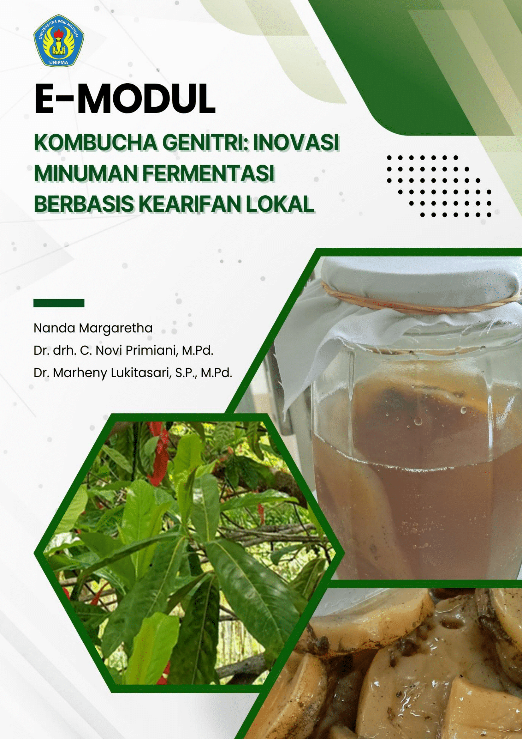  Figure 1. Cover Features | 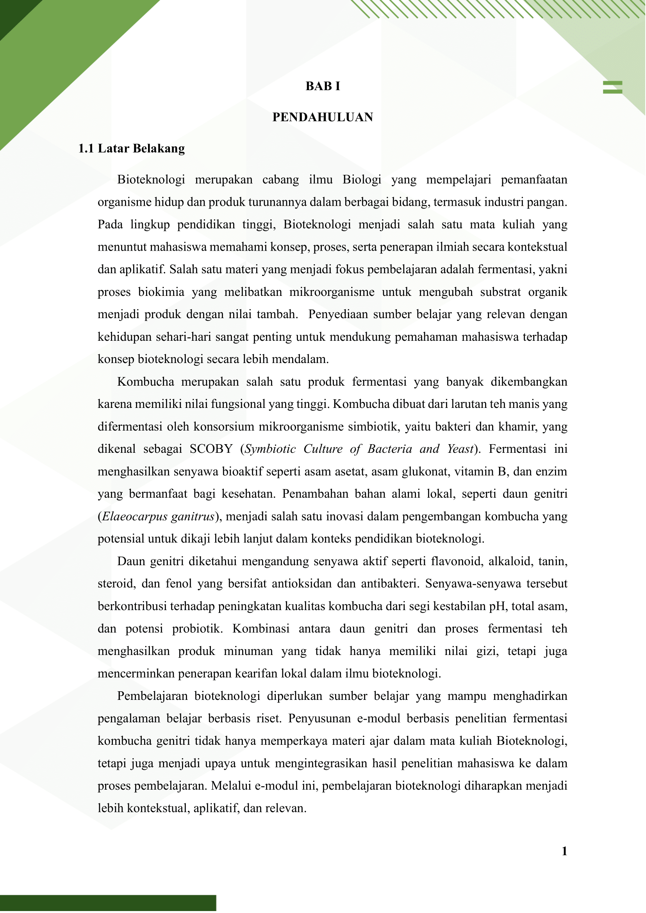Figure 2. Introduction Features | 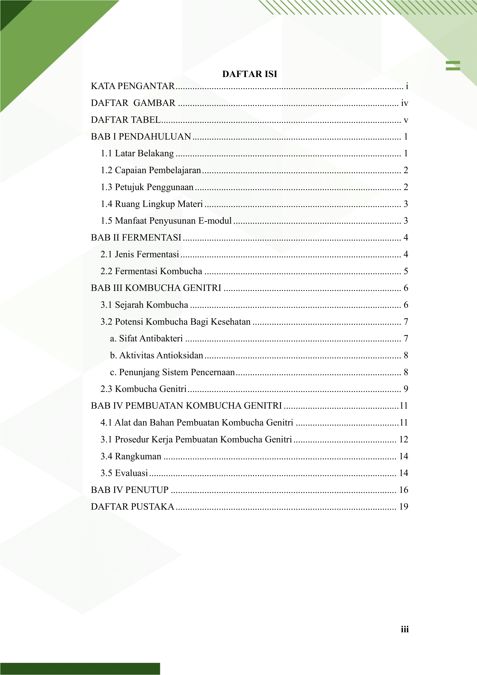  Figure 3. Table of Contents feature

The e-module was developed based on research focusing on the potential of kombucha genitri and kombucha fermentation techniques. Validation of the e-module was conducted by media experts, examining several aspects, resulting in the following data:
Table 4. Media Expert Validation Results
No. | Rated aspect | Assessment Score
No. | Rated aspect | 1 | 2 | 3 | 4
1. | Language Presentation
- Grammatical Correctness:
- Sentence structure according to rules
- Spelling and punctuation
 | - Integration of Language and Context
 | - Ease of understanding messages or information in learning activities
 | - Accurate use of symbols and punctuation
2 | Learning Aspects
 | - Suitability of media with learning resources
 | - Clarity of learning flow in e-modules
 | - Clarity of theme and sub-theme levels in e-modules
 | - The ability of e-modules to attract students' attention and participation in learning
 | - Clarity and functionality of images with concepts
3. | Systematics
 | - E-module cover design
 | - Compliance of the e-module structure with the table of contents
 | - Clarity of letters displayed on the e-module
 | - Suitability of button selection and placement on e-module
 | - Accuracy in selecting the color of text, images and e-module background
 | Total |  |  | 52

The validation of material experts is presented in the following table:
Table 5. Validation by Material Experts
No. | Rated aspect | Assessment Score
No. | Rated aspect | 1 | 2 | 3 | 4
1. | Presentation
 | - Consistency of systematic presentation of material
 | - The complexity of the concepts presented
 | - There are instructions for use and a summary
 | - Presentation of conceptual and applicable e-modules for students
 | - The presentation of e-modules is in accordance with one of the learning outcomes of the biotechnology course.
2 | Contents
 | - Explanation of the concept of microbial fermentation in biotechnology
 | - Compliance with the scope of biotechnology studies, especially food fermentation
 | - The presentation of research results is relevant to the needs of biotechnology courses.
 | - Compliance with the Development of Science and Technology
 | - Current Affairs, Features, Examples and References
 | - E-modules can be accessed repeatedly
 | - Suitability of the image to the material presented
 | - E-modules can be accessed anywhere
 | - The material presented can be practiced in the Biotechnology course.
 | - Materials in accordance with scientific developments
 | Total | 52

3.2 Material validation.
The e-module was assessed by subject matter and media experts using a validation instrument developed based on feasibility aspects. A summary of the validation results can be seen in the following table:

Table 6. Summary of Media and Material Validation Tests
Validator | Rated aspect | Maximum score | Score obtained | Presentation | Eligibility criteria
Media expert | Language, presentation aspects and systematics | 60 | 57 | 95% | Very worthy
Subject matter expert | Presentation, suitability of content | 60 | 52 | 86.67% | Very worthy

The results table shows that the E-module obtained a percentage of 95% from the feasibility test from media experts and 86.67% from material experts who had very valid indicators based on the criteria in table 2.
3.3 Validators’ suggestions.
During the revision stage, the media expert and material expert validators received suggestions, including several sections that required changes. The following are the validators' suggestions regarding the e-module developed during the validation test:
Table 7. Revision Suggestions from Media Expert and Material Expert Validators
Validator | Suggestion | Repair
Media Expert Validator | There are a few typos on page 4 and page 5. | Already repaired
Subject Matter Expert Validator | It would be better to add a separate concept of fermentation, various types of fermentation and which type of fermentation kombucha is included in. | A special chapter on the concept of fermentation has been added.

The e-module was then revised to address wording errors and add a special chapter on fermentation. The following is a look at the e-module before and after revision:

FIG 4. e-module before and after revision
Before | After
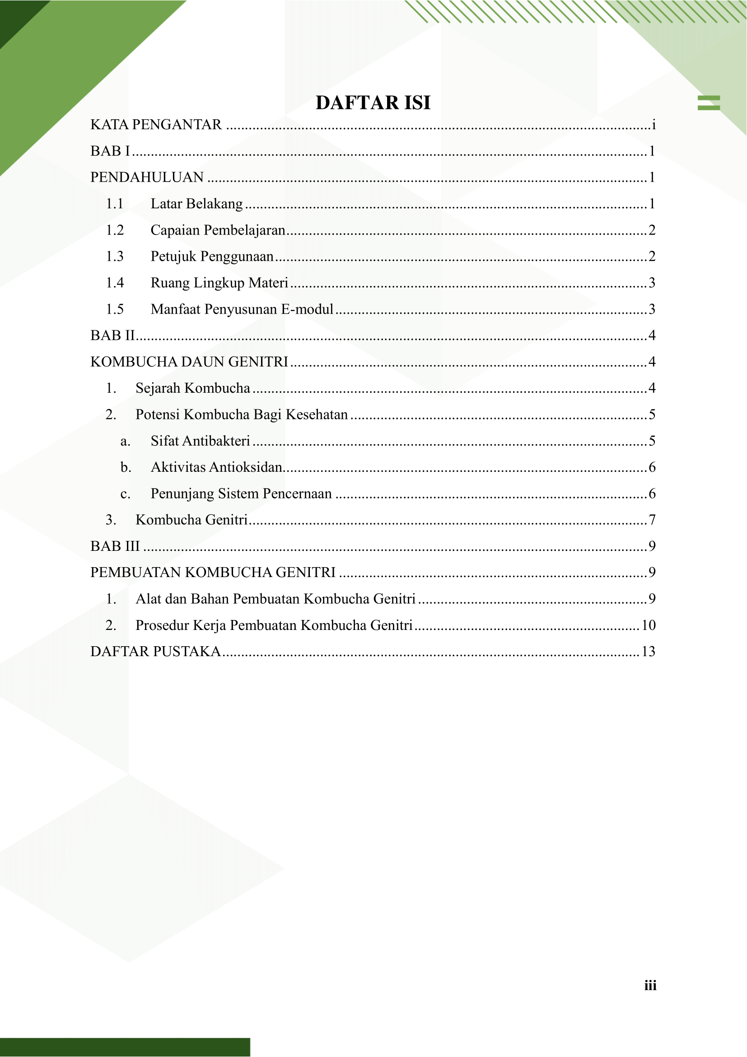

The effectiveness of the e-module was determined based on the pretest and posttest results for students, consisting of 10 questions focused on the content of the developed e-module. The pretest and posttest scores were processed using an N-gain test to determine the effectiveness of the e-module. The results of the N-gain test are shown in Table 8.
The e-module was developed based on research on kombucha genitri, specifically on the fermentation process. The development of the e-module was based on an analysis of the need for materials conducted through interviews with lecturers in charge of the Biotechnology course of the Biology Education study program, Universitas PGRI Madiun. The learning outcomes of white biotechnology, which emphasize fermentation and industrial biotechnology, demonstrate the existence of a research-based e-module that is structured, linear, and needed in the learning process as a reference, teaching material, or learning resource. The results of the e-module validation conducted by media experts and material experts showed results of 95% by media experts and 86.67% by material experts, respectively. The resulting data show that the e-module compiled and developed is valid and suitable for use based on the e-module validity categories in Table 2. The feasibility of the media in compiling the e-module is based on the presentation and systematic aspects. The media expert validator added suggestions for correcting word errors on pages 4 and 5, and these have been corrected. Meanwhile, the validation test by material experts focused on the presentation and suitability of the e-module content. The material expert validator provided several suggestions, including the addition of a chapter that focuses on explaining the various types of fermentation and the concept of fermentation in kombucha, which was then revised and added to chapter 2, namely the special chapter on fermentation.
Table 8. N-gain Test Results
Pretest Average | Posttest Mean | N-gain | Criteria
43.45 | 84.5 | 0.72 | Tall
(Philosophy et al., 2025)
The table shows that the N-gain value is 0.72, which is considered high based on the criteria in Table 3.
3.4 Discussion.
The results of the N-gain effectiveness test on the protest and pretest results conducted on students showed an increase in scores. The high N-gain value indicates that the e-module improved students' understanding of the fermentation topic and the potential of kombucha genitri. The development of the e-module was able to improve students' critical thinking skills because it contained various advantages, one of which was encouraging more seriousness and focus in completing the learning material.(Nurlaili et al., 2021)The N-gain test results showed an average of 0.72, indicating that the results were in the high category. This data aligns with research on e-modules based on guided discovery learning in learning colligative material, which obtained an N-gain of 0.71 (high).(Luthfiani & Yerimadesi, 2022)Studies show that the use of e-modules in online learning significantly increases students' motivation, self-confidence, and learning outcomes.(Delita et al., 2022)

4.0 Conclusion AND RECOMMENDATION.
The development of an e-module based on the results of research on the fermentation of kombucha leaves of genitri has successfully produced valid, feasible, and effective teaching materials for use in Biotechnology learning. The validation results show a very high feasibility percentage, namely 95% by media experts and 86.67% by material experts. The effectiveness test using the N-gain method obtained a score of 0.72 (high category), which indicates a significant increase in students' understanding of the concept of fermentation and critical thinking skills. This e-module is able to present material contextually and can be an alternative innovative learning resource relevant to the learning outcomes of the Biotechnology course.
There needs to be recommendation(s)

COMPETING INTERESTS DISCLAIMER:
Authors have declared that they have no known competing financial interests OR non-financial interests OR personal relationships that could have appeared to influence the work reported in this paper.

Reference
Arianti, IF (2021) 'Development of E-Module as an Independent Learning Course for Educational Technology Students', Journal Students, pp. 457–465.
Delita, F., Berutu, N. and Nofrion (2022) 'Online Learning: the Effects of Using E-Modules on Self-Efficacy, Motivation and Learning Outcomes', Turkish Online Journal of Distance Education, 23(4), pp. 0–3. Available at: https://doi.org/10.17718/tojde.1182760.
Faizah, S., Sa'adah, N. and Saraswati, S. (2023) 'Validation Analysis of Flipbook E-Modules on Conclusion Drawing Material in Mathematical Logic', JNPM (National Journal of Mathematics Education), 7(2), p. 414. Available at: https://doi.org/10.33603/jnpm.v7i1.7680.
Irmawati, I., Baktiar, M. and Hutapea, B. (2023) 'Utilization of Canva Application-Based E-Module Teaching Materials in the Mathematics Education Study Program in the Distance Learning Process', Journal of Science and Computer Education, 3(01), pp. 145–152. Available at: https://doi.org/10.47709/jpsk.v3i01.2738.
Jumiarni, D. et al. (2024) Development of Biotechnology E-Module Based on Integrated Project Based Learning with STEM Approach. Atlantis Press SARL. Available at: https://doi.org/10.2991/978-2-38476-108-1_17.
Lianto, F., Trisno, R. and Husin, D. (2021) 'BIODEGRATED SHEET BUILDING MATERIALS on material quality. The aim is to continue previous research and', Jurnal Muara Sains, 5(2), pp. 563–576.
Luthfiani, A. and Yerimadesi, Y. (2022) 'Effectiveness of e-module based on guided discovery learning on learning outcomes of high school students', Pijar Mipa Journal, 17(6), pp. 770–774. Available at: https://doi.org/10.29303/jpm.v17i6.4252.
Mubarrak, J., Nasution, M. and Kunci, K. (2024) 'Development of Flip HTML 5 Based E-Modules in Biotechnology Course at Biology Study Program, Pasir Pengaraian University', Chemistry, Mathematics and Physics Education, 1(1), pp. 16–26. Available at: https://journal.stedca.com/index.php/biochamp.
Nillofa Ende, AM, Jasril, IR and Jaya, P. (2022) 'Design and Creation of Canva-Based Interactive E-Modules in Basic Electrical and Electronics Subjects', JTEV (Journal of Electrical and Vocational Engineering), 8(2), p. 193. Available at: https://doi.org/10.24036/jtev.v8i2.117118.
Noprina, W. and Handayani, DF (2021) 'The Quality of Electronic Modules Based on Contextual Teaching and Learning Integrated with Character Education for Writing Scientific Papers', Ranah: Jurnal Kajian Bahasa, 10(1), p. 119. Available at: https://doi.org/10.26499/rnh.v10i1.3347.
Noris, M. et al. (2024) 'the Development of Scientific-Based E-Modules To Improve Conceptual Understanding of Nutrition Students in Biotechnology Subjects', Journal of Excellence Humanities and Religiosity, 1(1), pp. 110–121. Available at: https://doi.org/10.34304/joehr.v1i1.196.
Nurlaili, R., Zubaidah, S. and Kuswantoro, H. (2021) 'Development of Discovery Learning-Based E-module to Improve Critical Thinking Skills of Grade XII Students Based on Research on Canonical Correlation Analysis of Soybean Plant Crosses', Journal of Education: Theory, Research, and Development, 6(2), p. 213. Available at: https://doi.org/10.17977/jptpp.v6i2.14451.
Philosophy, E. et al. (2025) 'Alacrity : Journal Of Education', 5(1), pp. 350–359.
Rahayu Lestari, S., Susanto, H. and Pendidikan, J. (2023) 'The Development Project Based-Learning Food Microbiology E-Module Based on The Study of Kombucha Fermentation-471X DOAJ-SHERPA/RoMEO-Google Scholar-IPI', (5), pp. 364–370. Available at: http://journal.um.ac.id/index.php/jptpp/EISSN:2502.
Ricu Sidiq and Najuah (2020) 'Development of Android-Based Interactive E-Modules for the Teaching and Learning Strategy Course', Journal of History Education, 9(1), pp. 1–14. Available at: https://doi.org/10.21009/jps.091.01.
Sidha, W. et al. (2024) 'Antioxidant Activity Test and Phytochemical Screening of N-Hexane Extract of Genitri Fruit (Elaeocarpus ganitrus Roxb. ex G. Don) using DPPH Method Antioxidant Activity Test and Phytochemical Screening of N-hexane Extract of Genitri Fruit (Elaeocarpus ganit', 8(1), pp. 50–59.
Susilawati, PR et al. (2024) 'Simple Biotechnology Practical Training: Making Kombucha for Biology Teachers of MGMP Yogyakarta City Introduction Practicals are an integral component in biology learning that cannot be separated from the science education process. Hofstein & Lune', 5636(3), pp. 452–462.
T Tompe, Y., Daud, F. and . S. (2022) 'Development of Biotechnology Modules Based on Local Potential as a Learning Resource for Grade XII Students of SMA Negeri 13 Luwu Utara', UNM Journal of Biological Education, 6(1), p. 92. Available at: https://doi.org/10.35580/ujbe.v6i1.23669.

