Enhanced Sonochemical Degradation of Rhodamine B in Aqueous Solutions: The Role of Additives

Abstract
In the last few years, the control of water pollution has become increasingly important. Textile industries consume large amounts of dyestuffs for fabric coloring, and these substances are frequently present in industrial wastewaters, often consisting of hazardous compounds with serious environmental and health impacts. Different kinds of traditional methods such as solvent extraction, incineration, chemical dehalogenation, and biodegradation. These have been used for dye removal; however, there remains a need for alternative treatments capable of effectively handling large volumes of effluents. Sonochemical degradation has recently been reported as an appropriate and attractive process for the treatment of toxic dyestuffs. This study investigates the breakdown of dye molecules in aquatic media using ultrasonic irradiation to clarify the degradation mechanism. Experiments were conducted in a 50–60 Hz ultrasonic reactor with 100 mL dye solutions at the concentration of 25 mg/L. The effects of various additives, including inorganic salts (FeSO₄, NaCl, Na₂SO₄, NaNO₃), hydrogen peroxide, carbon tetrachloride, Glucose, and Sucrose, the sonochemical degradation of Rhodamine B (RhB) was investigated.
Results showed that degradation was highly influenced by the initial concentration of the substrate and pH. FeSO₄ addition enhanced RhB degradation, while increased CCl₄ concentrations accelerated removal through oxidant chlorine species. Optimum concentrations of H₂O₂ and Na₂SO₄ further improved degradation efficiency. Additions of NaCl and NaNO₃ also enhanced the process. However, higher glucose and sucrose concentrations marginally decreased the breakdown efficiency, indicating that radiation from ultrasonic waves remains a encouraging approach for the removal of RhB, even in complex aqueous systems.
Key Words: Rhodamine B, Ultrasound, Sonication, Additives, Reaction rate.

- INTRODUCTION
Basic Violet 10, or Rhodamine B (RhB), is a basic dye based on xanthene, first developed in 1887 by Ceresole, with extensive applications in textiles, leather, jute, paper, food, paints, inks, and as a fluorescent tracer. It is a vivid reddish-violet dye that dissolves in water and is not volatile, mostly employed for dyeing natural and synthetic fibers such as cotton, silk, bamboo, and leather, and also as a staining reagent in biological and industrial processes. Despite its usefulness, RhB poses significant environmental and health hazards: ingestion or exposure can lead to irritation of the respiratory system, gastrointestinal tract, eyes, and skin, whereas chronic toxicity, neurotoxicity, carcinogenicity, and toxicity to reproduction and development are long-term effects. Industrial effluents containing RhB and related synthetic dyes contribute heavily to aquatic pollution, as even trace amounts of dyes in wastewater can impart visible coloration, reduce light penetration, hinder photosynthesis in aquatic plants, alter gas solubility, disrupt natural purification, and raise the chemical oxygen requirement, pH fluctuations, and biodegradation resistance. Conventional dye removal process for example coagulation, flotation, chemical oxidation, flotation,solvent extraction, and membrane filtration have been applied, but these often fail due to high dye stability, cost, and low efficiency. As a result, focus has turned to Advanced Oxidation Processes (AOPs), which mineralize stubborn contaminants by producing hydroxyl radicals (•OH), which are extremely reactive and non-selective oxidants. Among AOPs, sonochemical oxidation has emerged as a promising approach, utilizing ultrasonic irradiation to induce acoustic cavitation in aqueous systems. Microbubbles aggressively form, expand, and collapse during cavitation, creating extremely high localized temperatures (~5000 K) and pressures (hundreds of bars) in a matter of microseconds. Water vapor thermally dissociates as a result of this collapse, releasing hydrogen atoms and hydroxyl radicals that oxidize contaminants by diffusing or recombining with the bulk solution. The degradation of dyes in such systems proceeds mainly via two pathways: (i) pyrolytic decomposition of volatile dye molecules trapped within collapsing bubbles, and (ii) Diffuse hydroxyl radicals oxidize dye molecules at the bulk medium or bubble–liquid contact. The efficiency of such processes can be further influenced by additives, salts, oxidants, and catalysts, which modify radical generation, transfer, and reaction mechanisms. This study sought to examine the effects of several additions, including ferrous sulfate (FeSO₄), carbon tetrachloride (CCl₄), hydrogen peroxide (H₂O₂), inorganic salts (Na₂SO₄, NaNO₃, NaCl), glucose and sucrose on RhB's sonolytic breakdown. Furthermore, the impacts of a few experimental conditions on the dye's sonochemical degradation were examined, including pH and initial dye concentration. To our knowledge, RhB is degraded sonochemically in the presence of different parameters in a sonication is the first time in the world. Numerous studies have reported the ultrashonic degradation of dyes and related organic contaminants, with variations in dye structure, operational parameters, and catalyst systems.
Gayathri et al. (2010) demonstrated that persulfate activated by cobalt ions, when combined with ultrasonication, markedly enhanced the decolorization efficiency of both basic dyes (RhB, methylene blue) and acid dyes (Acid Orange II, Acid Scarlet Red 3R) [01]. Okitsu et al. (2005) showed that ultrasonic irradiation favored azo dye degradation, while addition of radical scavengers like tert-butanol suppressed the process, confirming the dominant role of hydroxyl radicals [02]. Similarly, Rehorek et al. (2004) reported effective mineralization of azo dyes under ultrasound (850 kHz, 60–120 W), highlighting hydroxyl radical attack as the mechanism responsible for azo bond cleavage and aromatic ring hydroxylation [03]. Wang et al. (2008) compared degradation rates of Acid Red B and RhB in the sight of nanosized ZnO, finding higher efficiency and pseudo-first-order kinetics, with degradation strongly influenced by catalyst loading and pH [04]. Priya et al. (2006) studied RhB degradation with TiO₂ catalysts, observing higher rates with anatase phase compared to Degussa P-25, with degradation enhanced by lower pH and higher ultrasound intensity [05]. Other reports highlighted the synergistic effect of combining ultrasound with photocatalysts such as TiO₂, Au/TiO₂, Ag/TiO₂, and combustion-synthesized TiO₂, This enhanced the dyes' ability to produce radicals, discolor, and remove all organic carbon [06].
Several studies focused on additives and reaction conditions. Merouani et al. (2010) showed that iron ions accelerated RhB degradation, with the order Fe(II) > Fe(III) > Fe(0), and that CCl₄ enhanced removal by forming reactive chlorine species. Hydrogen peroxide and Na₂SO₄ also improved degradation up to an optimum concentration, while high levels of glucose and sucrose decreased removal efficiency due to competitive radical consumption [07]. Uddin et al. (2016) examined the role of dissolved gases and additives, reporting that Ar gas provided the highest efficiency, while CCl₄ enhanced degradation via chlorine radicals [08]. Zhang et al. (2009) and Song et al. (2009) coupled ultrasound with Fenton and Fenton-like reagents, confirming enhanced decolorization with H₂O₂, Fe salts, and fly ash [09, 10]. Wang et al. (2010) coupled ultrasound with electrolysis, reporting accelerated azo bond cleavage and aromatic ring breakdown under acidic conditions [11]. Beyond azo and xanthene dyes, ultrasound has also been applied to phenols, polycyclic aromatic hydrocarbons (PAHs), and other contaminants. Petrier et al. (2010) showed that carbonate radicals generated from bicarbonate ions improved bisphenol-A degradation [12]. Psillakis et al. (2003, 2004) investigated PAH sonodegradation, noting complete removal of low molecular weight PAHs but recalcitrance of higher ones, and enhanced degradation in the presence of Fe²⁺ due to Fenton-like reactions [13, 14]. Kim et al. (2003) demonstrated pseudo-first-order decomposition of Benzothiophene [15]. Maleki et al. (2005) studied phenol degradation, finding that ultrasound reduced phenol toxicity in effluents despite low reaction rates [16].
The role of adsorption in combination with sonication has also been widely studied. Li et al. (2009) and Sayan et al. (2008) showed that ultrasound synergistically enhanced adsorption of dyes such as Direct Blue 78 and Reactive Blue 19 on graphite and activated carbon, achieving nearly complete decolorization [17, 18]. Entezari et al. (2006, 2007) reported improved sono-sorption of methylene blue and Reactive Black 5, where ultrasonic treatment significantly accelerated removal compared to conventional sorption [19, 20]. Tang et al. (2012) introduced TiO₂-coated activated carbon as a sonocatalyst, achieving over 80% RhB removal under optimized conditions [21]. While Ling et al. (2016) reported Bi2WO6 as an efficient and reusable sonocatalyst for dye degradation [22]. Kobayashi et al. (2015) highlighted the role of catalyst type, with TiO₂ particles offering greater enhancement than Al₂O₃ during methylene blue sonodegradation [23].
Overall, literature consistently shows that ultrasound alone can degrade dyes and pollutants via hydroxyl radical attack and thermal effects, but its efficiency is significantly improved by the presence of catalysts (TiO₂, ZnO, Bi2WO6, Fe, Au), oxidants (H₂O₂, persulfate, CCl₄), and suitable operating conditions (pH, gas atmosphere, frequency, power). The reactions generally follow pseudo-first-order kinetics, with degradation pathways involving azo bond scission, demethylation, hydroxylation, and aromatic ring opening. Despite substantial advances, challenges remain in scaling sonochemical processes due to reactor geometry, energy efficiency, and mass transfer limitations, as shown by Kandasamy Thangavadivel et al. (2013), who demonstrated that reactor diameter and liquid height strongly influence sonochemical activity [24].
The present work builds upon these studies by systematically investigating The deterioration caused by sonochemically of Rhodamine B under varying conditions of additives (FeSO₄, H₂O₂, CCl₄, salts, glucose, sucrose), initial dye concentration, and pH. To the best of our knowledge, no comprehensive study has yet been reported on RhB sonolysis under such a range of parameters in a single framework, making this study a novel contribution towards understanding and optimizing the sonochemical removal of hazardous dyes from aqueous systems.
- Experimental Section
  - Chemicals, Apparatus and Equipments
    - List of chemicals used:
Rhodamine B (C₂₈H₃₁ClN₂O₃): (Loba chemie pvt. Ltd 107 wodehouse Road, Mumbai 400005, India), Sodium chloride (NaCl): RANBAXY Fine chemicals Limited A-3, Okhla industrial Area, phase-1, New Delhi-110020 (ISO 9001: 2000 certified company), Ferrous sulphate (FeSO₄): Merck Limited, Mumbai-400.018, Sodium sulphate (Na₂SO₄): Merck KGaA, 64271 Darmstadt, Germany, Sodium nitrate (NaNO₃): GB 636-77, Hydrogen peroxide (H₂O₂): Merck KGaA, 64271 Darmstadt, Germany , Carbon tetrachloride (CCl₄): Merck, D-6100 Darmstadt, F.R. Germany, Glucose and Sucrose: From market, Sulphuric acid (H₂SO₄): Merck KGaA, 64271 Darmstadt, Germany, Sodium hydroxide (NaOH): Merck life science private limited.Shiv Sagar Estate ` A` Dr Annie Besant Road, Worli, Mumbai-400018. The chemicals were used as we received.

    - List of Equipments
A sonicator (Soniclean 250HT; 50-60Hz; 320W) to break down dyes, a piezoelectric transducer, and a UV-Vis Spectrophotometer (UV Mini 1240; Shimadzu Company) to measure absorbance from dye molecules.

2.2. Experimental Procedure
All studies except those conducted to investigate the impact of starting dye concentration started with a RhB solution concentration of 25 mg L⁻¹ dye stuff prepared by adding 0.0125g dyestuff into 500 mL of distilled water. RhB (25 mgL⁻¹) aqueous solutions with various additives were made by adding the necessary amount of each ingredient and stirring with a magnetic bar. Under various conditions, the sonolytic degradation of RhB was performed at 50–60 Hz with a constant solution volume of 100 mL following the steps shown in figure 1. 320 W of ultrasonic power was set aside from runs that looked into the impact of power. With water circulating, the solution's temperature was kept steady at the necessary level. A UV-Vis Spectrophotometer (UV Mini 1240; Shimadzu Company) was used to measure the dye concentrations in aqueous samples that were extracted from the solution. With the exception of those carried out to investigate the impact of solution pH, experiments were carried out at pH 2 and pH 10.02, which came from the dissolving of RhB in distilled water without any additional modification. In order to examine the impact of pH, 0.5N H₂SO₄ or 0.5N NaOH aqueous solutions were used to change the pH of the solution.
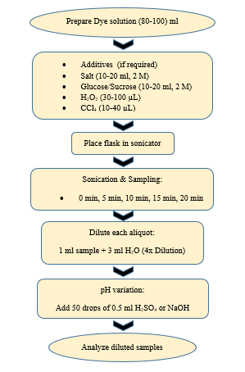
figure 1: Sonication process of dyestuff solution.
2.3. Calorimetric power measurement
First of all, temperature change of the sonicator machine had to measure. For this purpose, the following procedure was followed:
100 ml H₂O was taken in a conical flask. Then the temperature of water was determined with a digital thermometer till the temperature was stabled known as initial temperature, T₁. After that, the apparatus was set into the sonicator machine. The machine was operated for 30 seconds and temperature reading was noted as final temperature for 30 seconds, T₂. Then waited till the temperature decreased and stabled again. It was taken as initial temperature for 60 seconds, T₁ and final temperature T₂ after operating the machine for a minute. Procedure was repeated for 4 times i.e. for 2 minutes in total.

2.4 Measurement of temperature change with increasing sonication time
A method for assessing an ultrasonic reaction field quantitatively has been studied. One of the key components of sonochemistry is ultrasonic power. One of the most used techniques for determining a solution's actual ultrasonic power input is calorimetry. The computed ultrasonic output power (P) is provided by equation (16).

$P=\frac{dT}{dt}C_{p}M$-----------------------------(01)
Here,
C_{p} = heat capacity of water
M = mass of water
T = temperature of the sample solution
t = ultrasonic irradiation time.

Table-01: Measurement of temperature change:
Observation  No. | Sonication  Time  (sec) | Initial Temperature  (⁰C) | Final Temperature  (⁰C) | Temperature Change  (⁰C) | Actual power  (Watt)
01 | 30 | 24.7 | 25.0 | 0.3 | 4.180
02 | 60 | 25.2 | 25.6 | 0.4 | 2.787
03 | 90 | 25.6 | 26.1 | 0.5 | 2.322
04 | 120 | 26.0 | 26.6 | 0.6 | 2.096
05 | 150 | 26.4 | 27.1 | 0.7 | 1.951
06 | 180 | 26.7 | 27.6 | 0.8 | 1.858

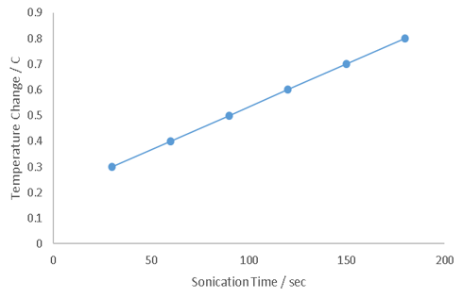

Figure-2: Graphical chart for measurement of temperature change with increasing sonication time
Table 01 and Figure 2 show that the temperature at the reaction site is rising as the sonication time increases. Once more, warmth enhances the rate of reaction. Therefore, we can conclude that as the sonication period increases, the dye material's rate of degradation would also increase.
Using a UV–visible spectrophotometer (UV Mini 1240), a well-known method for figuring out dyestuff concentrations based on Beer’s law calibration plots was used. The bandwidth was 0.5 nm and the wavelength resolution was 1 nm. The glass cell's optical path measured one centimeter in length. For methylene blue and methyl orange, the maximum absorption wavelengths were found to be 665 nm and 464 nm, respectively. The calibration plot was then made. Over the course of the measurements, the calibration was done five times. This plot's linearization typically had a determination coefficient that was near 99.99%.

3 RESULTS AND DISCUSSION

3.1. Effect of operational parameters

3.1.1. Effect of initial dye concentration

When 100mL of RhB solutions with a concentration of 25mgL−1 were exposed to 50-60 Hz and 320W ultrasonic irradiation, the dye concentration decreased exponentially over time. The initial rate of RhB degradation is seen in Fig. 3.

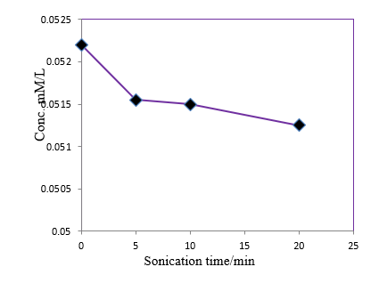

Figure-3: Initial RhB degradation rates as predicted and observed experimentally (conditions: volume: 100 mL; initial dye concentration: 25 mgL⁻¹; frequency: 50-60 Hz; power: 320W).

RhB does not degrade according to a first-order kinetic equation. For comparison, the initial degradation rate (mg L⁻¹ min⁻¹) was utilized instead. After reaching 25 mg L⁻¹, the rate rose with concentration and then stayed almost constant. This shows that breakdown takes place at the bubble–liquid contact as well as in the bulk liquid. At low concentrations of dye, OH radicals largely recombine to form H₂O₂, giving lower rates. With increasing dye concentration, OH radical attack rises until saturation at the bubble surface leads to constant rates. At higher concentrations, radicals are scavenged, H₂O₂ yield decreases, and reactions occur mainly at the interface.

3.1.2. Effect of pH
The effect of pH on sonochemical breakdown of RhB (25 mg L−1) was studied at pH 1.93 and 10.02. Results showed that degradation rates differ under acidic and basic conditions, with the highest rate at low pH and significant degradation in neutral medium. In aqueous solution, RhB exists as cationic (RhB⁺) or zwitterionic (RhB±) forms. At pH above the pKa, the carboxyl group of RhB⁺ is deprotonated, yielding RhB±. Although both forms show similar absorption spectra, RhB exhibits lowest hydrophilicity at very low pH, enhancing degradation, while at higher pH, sonolytic degradation occurs much more slowly. While basic pH (pH=10.02) modifies hydrophobic properties, RhB accumulates at the bubble interface at acidic pH, boosting OH radical assault.

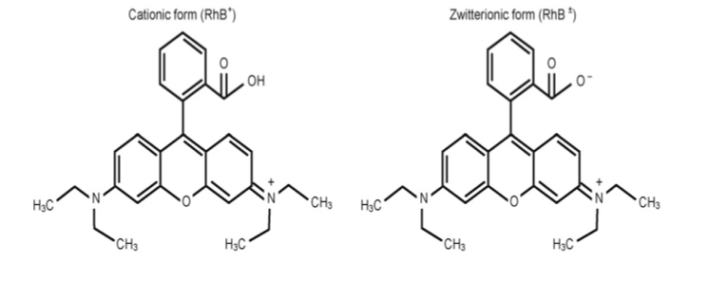

Figure 4 : Forms of RhB in water.

3.2. Effect of various additives
3.2.1: Effect of FeSO₄ addition
RhB's ultrasonic deterioration in the presence of FeSO₄ was examined. Figure-5 shows the initial degradation rate for RhB sonolytic degradation as a function of FeSO₄ concentration.
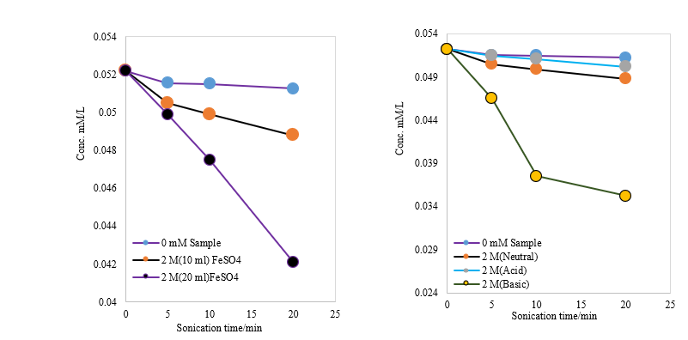
Figure-5: Time dependence of sonochemical degradation of RhB in the absence and presence of FeSO4 at neutral medium. | Figure-6: Time dependence of sonochemical degradation of RhB in the absence and presence of FeSO4 at acidic, basic and neutral condition.

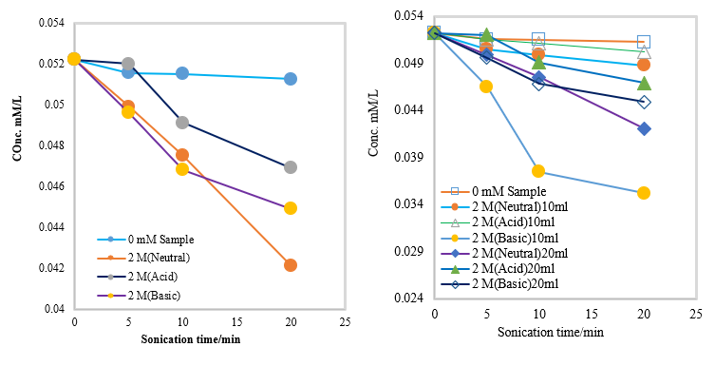

Figure-7: Time dependence of sonochemical degradation of RhB in the absence and presence of FeSO4 at acidic, basic and neutral condition. | Figure-8: Time dependence of sonochemical degradation of RhB in the absence and presence of FeSO4 at acidic, basic and neutral condition.

RhB concentration over time during sonication with FeSO₄ is illustrated in Figures 5–8. In Figure 5, degradation increased at neutral pH, where K₂ (20 mM) and K₃ (10 mM) were 1 and 4 times higher than K1 (0 mM). Figure 6 shows that FeSO₄ enhanced degradation at acidic, neutral, and basic conditions, with K₂, K₃, and K₄ being 2, 4, and 22 times higher than K₁. In Figure7, K₂, K₃, and K₄ were 1, 5, and 8 times higher, respectively. Overall, FeSO₄ addition enhanced RhB degradation (Fig. 8). This effect is linked to increased surface active sites of Fe⁰ and Fe²⁺, which promotes •OH production. Ultrasonic shock waves clean deactivated surfaces and fragment Fe⁰ particles, improving mass transfer. Fe²⁺ accelerates degradation more effectively than Fe³⁺ due to faster reaction with H₂O₂. However, excess FeSO₄ leads to self-quenching of •OH, so optimum Fe²⁺ concentration is crucial for maximum efficiency.

3.2.2: Effect of NaCl addition
The effect of NaCl on the sonolytic degradation of RhB was investigated. Figure-9 shows the initial degradation rate for the sonolytic degradation of RhB as a function of NaCl concentration.

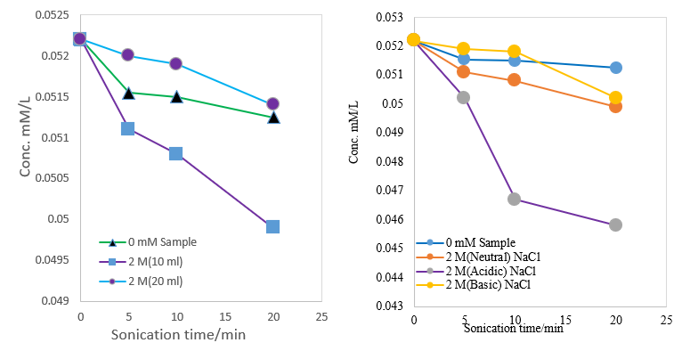
Figure-9: Time dependence of sonochemical degradation of RhB in the absence and presence of NaCl at neutral medium.

Figure-10: Time dependence of sonochemical degradation of RhB in the absence and presence of NaCl at acidic, basic and neutral condition.

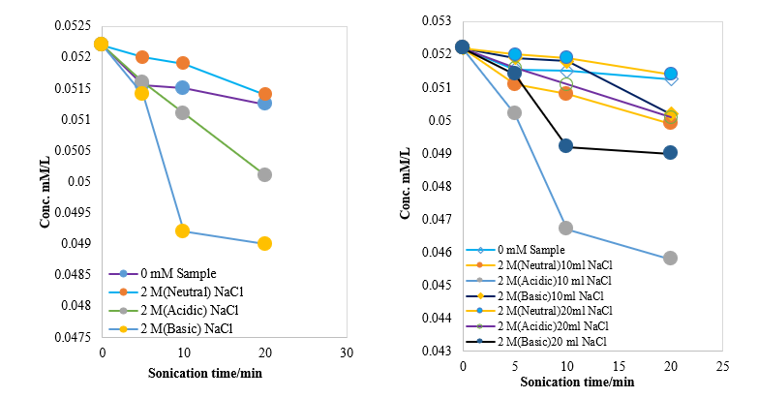
Figure-11: Time dependence of sonochemical degradation of RhB in the absence and presence of NaCl at acidic, basic and neutral condition.

Figure-12: Time dependence of sonochemical degradation of RhB in the absence and presence of NaCl at acidic, basic and neutral condition.

Figures 9–11 illustrate the effect of NaCl on RhB degradation under sonication. In Figure 9, the rate increased at neutral pH, where K₂ (10 mM) was 2 times higher than K₁ (0 mM). Figure 8 shows enhancement at neutral, basic, and acidic conditions, with K₂, K₃, and K₄ being 2, 2, and 7 times higher, respectively. In Figure 11, K₂ (acidic) and K₃ (basic) were 2 and 4 times higher than K₁. Overall, NaCl addition enhanced RhB degradation (Fig. 12), with maximum effect at 25 g L⁻¹. Salt addition pushes RhB molecules from the bulk phase to the bubble interface by increasing hydrophilicity, surface tension, and ionic strength, while reducing vapor pressure [25-29].

3.2.3. Effect of salt (Na₂SO₄) addition
The sonolytic degradation of RhB solutions was examined with the inorganic salt Na₂SO₄ to assess the impact of salt addition on dye degradation at a concentration of 25 mg L−1. Figure-13 illustrates the impact of Na₂SO₄ salt on the sonolytic degradation of RhB in aqueous solution.

Figure-13: Time dependence of sonochemical degradation of RhB in the absence and absence and presence of Na₂SO₄ at neutral medium.

Figure-14: Time dependence of sonochemical degradation of RhB in the absence and presence of Na₂SO₄ at neutral medium.

Figure-16: Time dependence of sonochemical degradation of RhB in the absence and presence of Na₂SO₄ at different concentration at neutral medium.

Figure-15: Time dependence of sonochemical degradation of RhB in the absence and presence of Na₂SO₄ at neutral medium.

Figure-18: Time dependence of sonochemical degradation of RhB in the absence and presence of Na₂SO₄ at acidic, basic and neutral condition
Figure-17: Time dependence of sonochemical degradation of RhB in the absence and presence of Na₂SO₄ at different concentration at neutral medium.

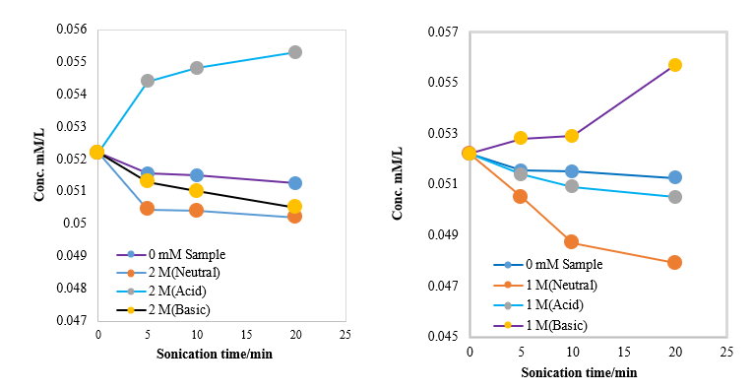
Figure-19: Time dependence of sonochemical degradation of RhB in the absence and presence of Na₂SO₄ at acidic, basic and neutral condition.

Figure-20: Time dependence of sonochemical degradation of RhB in the absence and presence of Na₂SO₄ at acidic, basic and neutral condition.

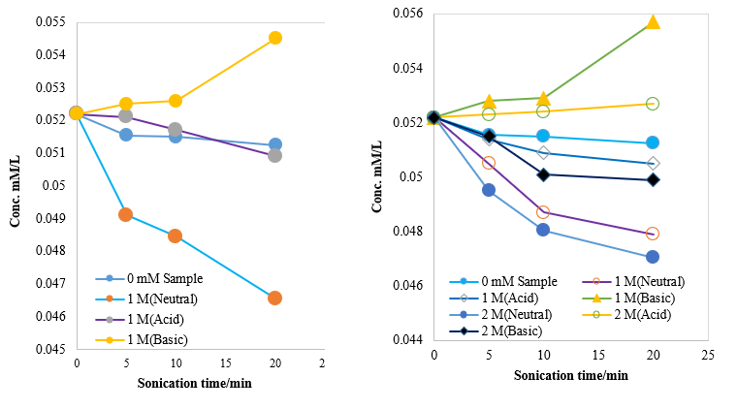
Figure-21: Time dependence of sonochemical degradation of RhB in the absence and presence of Na₂SO₄ at acidic, basic and neutral condition.

Figure-22: Time dependence of sonochemical degradation of RhB in the absence and presence of Na₂SO₄ at different concentration at acidic, basic and neutral condition.

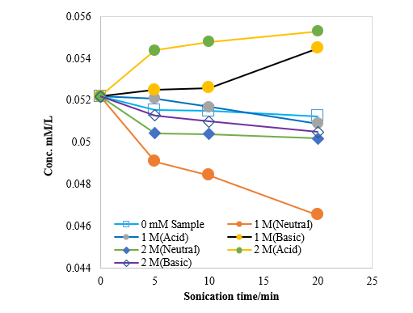

Figure-23: Time dependence of sonochemical degradation of RhB in the absence and presence of Na₂SO₄ at various concentration at acidic, basic and neutral condition.

Figures 13–16 demonstrate the impact of Na₂SO₄ on RhB degradation under neutral conditions. In Figure 22, K₂ (20 mM) and K₃ (10 mM) were 2 and 6 times higher than K₁ (0 mM). Figure 23 showed K₂ (10 mM) and K₃ (20 mM) increased 5 and 6 times, while in Figure 15 both K₂ (10 mM) and K₃ (20 mM) were 3 times higher. Figure 17 revealed K₂ (0.5 M), K₃ (1 M), and K₄ (2 M) enhanced rates by 3, 5, and 6 times, whereas Figure 18 showed K₂ (0.5 M), K₃ (1 M), and K₄ (2 M) were 3, 6, and 2 times higher than K₁. Overall, Na₂SO₄ addition significantly enhanced RhB degradation efficiency at neutral pH, with optimum effects observed at specific concentrations.
Figures 17–20 illustrate the effect of Na₂SO₄ on RhB degradation under different pH conditions. At neutral medium, degradation was consistently enhanced, with rate constants increasing up to 6 times compared to K₁ (0 mM). In basic medium (pH 10.02), enhancement was also observed, though in some cases the rate decreased, indicating accumulation. Similarly, in acidic medium (pH 1.93), the effect varied: in some systems the rate was enhanced (up to 2 times), while in others it decreased significantly, showing accumulation. Overall, 1 M Na₂SO₄ improved degradation in acidic and neutral media but caused accumulation in basic medium, whereas 2 M Na₂SO₄ enhanced degradation in basic and neutral media but led to accumulation in acidic medium.
Figures 21 and 23 show the impact of Na₂SO₄ on RhB degradation. Addition of Na₂SO₄ slightly enhanced degradation up to 25 g L⁻¹ compared to the control, with only a minor decrease in its positive effect at higher levels. The initial degradation rate was still higher than the one observed without Na₂SO₄, suggesting an optimum concentration for maximum efficiency. This enhancement occurs as salt addition drives RhB molecules from the large quantity solution to the bubble–liquid interface. Na₂SO₄ also increases hydrophilicity, surface tension, and ionic strength although lowering vapor pressure, thereby promoting sonolytic degradation [25, 27-29].

3.2.4: Effect of NaNO₃ addition

To examine the impact resulting from the incorporation of NaNO₃, RhB sonolytic degradation at a concentration of 25 mg L−1 was carried out in a 2M NaNO₃ solution. Figure-24 exemplifies these results.

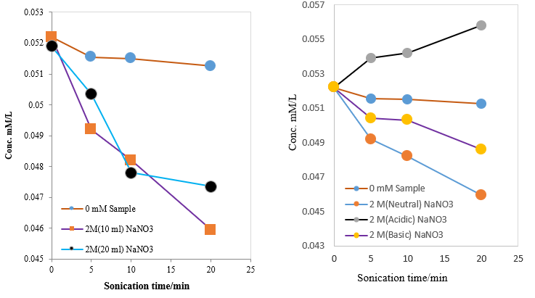
Figure-24: Time dependence of sonochemical degradation of RhB in the absence and presence of NaNO₃ at neutral medium.

Figure-25: Time dependence of sonochemical degradation of RhB in the absence and presence of NaNO₃ at acidic, basic and neutral condition.

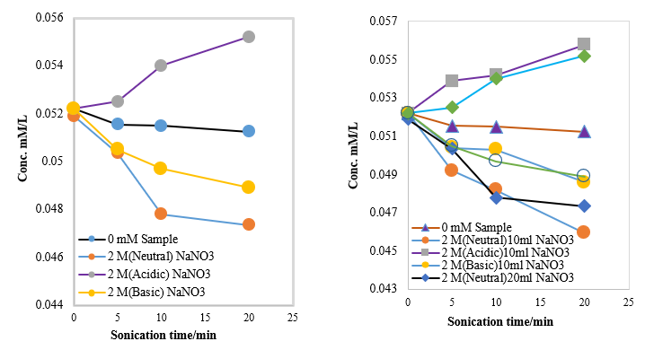
Figure-26: Time dependence of sonochemical degradation of RhB in the absence and presence of NaNO₃ at acidic, basic and neutral condition.

Figure-27: Time dependence of sonochemical degradation of RhB in the absence and presence of NaNO₃ at acidic, basic and neutral condition.

The fig.-24: shows time dependence of sonication time Vs. Conc. mM/L. From that figure it is noticed that rate of degradation of RhB significantly improved in the presence of NaNO₃ at neutral condition. The rate constant K₂ (for 20ml) and K₃ (for 10 ml) is 6 and 7 times higher than K₁ (for 0mM). The fig.-24: shows time dependence of sonication time Vs. Conc. mM/L. From that figure it is notice that rate of degradation of RhB significantly improved in the presence of NaNO₃ at basic (pH=10.02) condition and neutral condition.
The rate constant K₂ (for basic) and K₃ (for neutral) is 4 and 7 times higher than K₁ (for 0mM). Where as in acidic (pH=1.93) condition that rate was decreased significantly, it means accumulated.
The fig.-25: shows time dependence of sonication time Vs. Conc. mM/L. From that figure it is noticed that rate of degradation of RhB significantly increased in the presence of NaNO₃ at basic (pH=10.02) condition and neutral condition. The rate constant K₂ (for basic) and K₃ (for neutral) is 4 and 6 times higher than K₁ (for 0mM). Where as in acidic (pH=1.93) condition that rate was decreased significantly, it means accumulated.
In these systems, the addition of NaNO₃ in a neutral medium enhanced the ultrasonic degradation of RhB. For basic media, RhB underwent enhanced ultrasonic degradation; conversely, in acidic media, the degradation rate decreased significantly, indicating accumulation. Figure-24 illustrates the impact of NaNO₃ salt addition on the sonolytic degradation of RhB in an aqueous solution. Figure-26 shows that the addition of NaNO₃ improved the degradation of RhB up to 25 g L−1 compared to the absence of this salt. The addition of salt to the dye aqueous solution pushes RhB molecules from the bulk aqueous phase to the bulk bubble interface. Salt may enhance the aqueous phase's hydrophilicity, surface tension, and ionic strength while reducing its vapor pressure[.

3.2.5: Effect of hydrogen peroxide addition

The sonolytic degradation of RhB solutions was studied, focusing on the effects of adding H₂O₂. The degradation of RhB at a concentration of 25 mg L−1 in the presence of 30, 60, and 100 µL H₂O₂ was examined. Figure 28 provides an illustration of these findings.
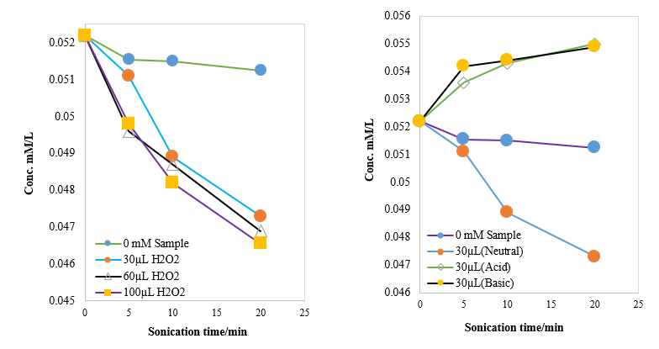
Figure-29: Time dependence of sonochemical degradation of RhB in the absence and presence of H₂O₂ at acidic, basic and neutral condition.

Figure-28: Time dependence of sonochemical degradation of RhB in the absence and presence of H₂O₂ at various concentration at neutral condition.

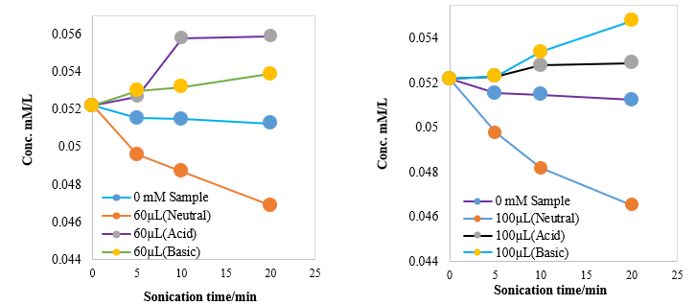
Figure-30: Time dependence of sonochemical degradation of RhB in the absence and presence of H₂O₂ at acidic, basic and neutral condition.
Figure-31: Time dependence of sonochemical degradation of RhB in the absence and presence of H₂O₂ at acidic, basic and neutral condition

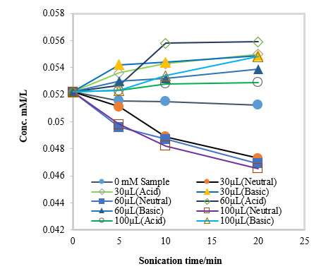
Figure-32: Time dependence of sonochemical degradation of RhB in the absence and presence of H2O2 at different concentration in `acidic, basic and neutral medium.

The fig.-28: shows time dependence of sonication time Vs. Conc. mM/L. From that figure it is noticed that rate of degradation of RhB significantly improved in the presence of H₂O₂ at neutral condition in presence of 30 µL, 60 µL and 100 µL H₂O₂.
The fig.-29: shows time dependence of sonication time Vs. Conc. mM/L. From that figure it is noticed that rate of degradation of RhB significantly improved in the presence of H₂O₂ at neutral condition in presence of 30 µL H₂O₂. The rate constant K₂ (for neutral) is 5 times higher than K₁ (for 0mM). Where as in acidic and basic medium that rate was decreased significantly, it means accumulated.
The fig.-30: shows time dependence of sonication time Vs. Conc. mM/L. From that figure it is noticed that rate of degradation of RhB significantly improved in the presence of H₂O₂ at neutral condition in presence of 60 µL H₂O₂. The rate constant K₂ (for neutral) is 6 times higher than K₁ (for 0mM). Where as in acidic and basic medium that rate was decreased significantly, it means accumulated.

The fig. 32: shows time dependence of sonication time Vs. Conc. mM/L. From this figure it is observed that rate of degradation of RhB significantly increased in the presence of H₂O₂ at neutral condition in presence of 100 µL H₂O₂. The rate constant K₂ (for neutral) is 6 times higher than K₁ (for 0mM). Where as in acidic and basic medium that rate was decreased significantly, it means accumulated.

When H₂O₂ was added to the ultrasound system in a neutral medium, the rate of dye degradation increased. This is a result of the breakdown of hydrogen peroxide into hydroxyl radicals, which leads to a high degradation rate [28-29]. Where as in acidic and basic medium that rate was decreased significantly, it means accumulated. The rate of degradation rose as the concentration of H₂O₂ increased to 100 mgL−1, but then it declined thereafter. To assess the impact of H₂O₂ by itself on RhB degradation, control experiments were conducted where H₂O₂ was added from an external source to a continuously stirred solution of 25mg L⁻¹ RhB in 100mL.

3.2.6: Effect of carbon tetrachloride addition

The ultrasonic degradation of RhB is expected to have been studied with varying concentrations of carbon tetrachloride at 10 µL, 20 µL, and 40 µL. Results obtained are shown in Fig.-33.

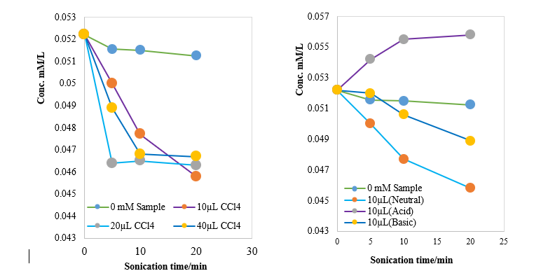
Figure-33: Time dependence of sonochemical degradation of RhB in the absence and presence of CCl₄ at various concentration in neutral medium.

Figure-34: Time dependence of sonochemical degradation of RhB in the absence and presence of CCl₄ at acidic, basic and neutral medium.

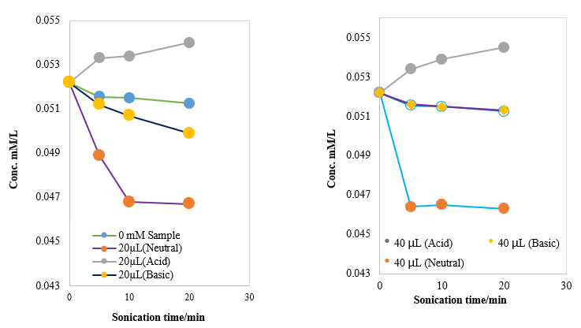
Figure-35: Time dependence of sonochemical degradation of RhB in the absence and presence of CCl₄ at acidic, basic and neutral medium.

Figure-36: Time dependence of sonochemical degradation of RhB in the absence and presence of CCl₄ at acidic, basic and neutral medium.

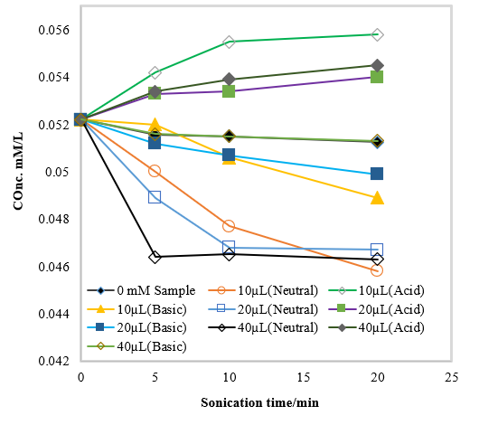
Figure-37: Time dependence of sonochemical degradation of RhB in the absence and presence of CCl₄ at various concentration at acidic, basic and neutral medium.

The fig. 33: shows time dependence of sonication time Vs. Conc. mM/L. From that figure it is noticed that rate of degradation of RhB significantly improved in the presence of CCl₄ at neutral condition in presence of 10 µL, 20 µL and 40 µL CCl₄.
The fig. 34: shows time dependence of sonication time Vs. Conc. mM/L. From that figure it is noticed that rate of degradation of RhB significantly improved in the presence of CCl₄ at neutral and basic condition in presence of 10 µL CCl₄. The rate constant K₂ (for neutral) and K₃ (for basic) is 7 and 3 times higher than K₁ (for 0mM). Where as in acidic medium that rate was decreased significantly, it means accumulated.
The fig. 35: shows time dependence of sonication time Vs. Conc. mM/L. From that figure it is noticed that rate of degradation of RhB significantly improved in the presence of CCl₄ at neutral and basic condition in presence of 20 µL CCl₄. The rate constant K₂ (for neutral) and K₃ (for basic) is 7 and 2 times higher than K₁ (for 0mM) where as in acidic medium that rate was decreased significantly, it means accumulated.
The fig. 36: shows time dependence of sonication time Vs. Conc. mM/L. From that figure it is noticed that rate of degradation of RhB significantly improved in the presence of CCl₄ at neutral and basic condition in presence of 40 µL CCl₄. The rate constant K₂ (for neutral) and K₃ (for basic) is 8 and 1 times higher than K₁ (for 0mM) where as in acidic medium that rate was decreased significantly, it means accumulated.
It was noticed that the degradation of dye was significantly enhanced by the addition of CCl₄ in both neutral and basic (pH=10.02) medium whereas in case of acidic (pH=1.93) medium it is accumulated with time. The enhancement can be attributed to the degradation of CCl₄ through pyrolytic cleavage within cavitation bubbles, resulting in the release of oxidizing agents that may interact with dye molecules. Various research teams have investigated the sonolytic breakdown of CCl₄ [29-34]
The overall reaction can be written as-
CCl₄→ •CCl3 +•Cl (1)
CCl₄→: CCl₂ +Cl₂ (2)
•CCl₃→: CCl₂ +•Cl (3)
•CCl₃ +•CCl₃→ CCl₄ +: CCl₂ (4)
•CCl₃ +•CCl₃→ C₂Cl₆ (5)
: CCl₂ +: CCl₂→ C₂Cl₄ (6)
•Cl + •Cl → Cl₂ (7)
Cl₂ +H₂O → HClO + HCl (8)
The sonolytic breakdown of CCl₄ produces •Cl radicals that initiate a series of recombination reactions, resulting in the formation of additional active species like HClO, Cl₂, and chlorine-containing radicals (•Cl, •CCl₃, and: CCl₂). These species possess strong oxidizing properties and significantly enhance the degradation of RhB in aqueous solution.
As shown in fig. 39, the destruction rate rose as the concentration of CCl₄ increased.

3.2.7: Effect of glucose addition
The sonolytic degradation of RhB solutions was examined in the presence of organic competitors like glucose (water solubility: 0.661×10³ gL⁻¹, Kow: 1.5×10⁻³, Henry’s law constant: 4.28×10⁻²⁰ atmm³mol⁻¹). Figure 38 illustrates the impact of adding glucose (2 M) on the sonochemical degradation of RhB (25 mgL⁻¹).

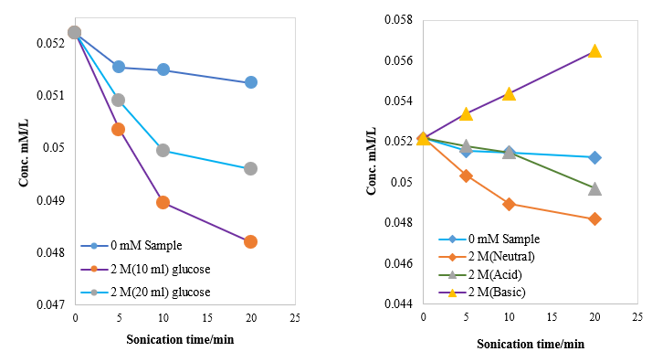
Figure-38: Time dependence of sonochemical degradation of RhB in the absence and presence of glucose at neutral medium.

Figure-39: Time dependence of sonochemical degradation of RhB in the absence and presence of glucose at acidic, basic and neutral medium.

The fig.-38: shows time dependence of sonication time Vs. Conc. mM/L. From that figure it is noticed that rate of degradation of RhB significantly enhanced in the presence of glucose at neutral condition. The rate constant K₂ (for 20 ml) and K₃ (for 10 ml) is 3 and 5 times higher than K₁.
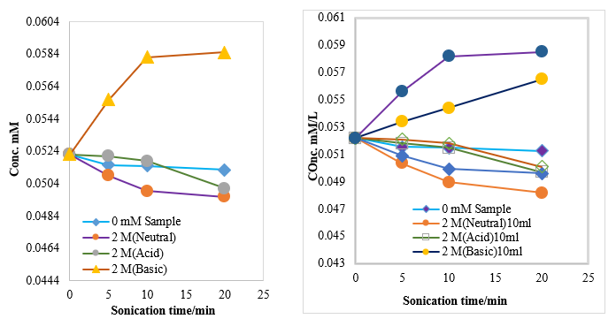
Figure-40: Time dependence of sonochemical degradation of RhB in the absence and presence of glucose at acidic, basic and neutral medium.

Figure-41: Time dependence of sonochemical degradation of RhB in the absence and presence of glucose at various concentration at acidic, basic and neutral medium.

The fig. 37: shows time dependence of sonication time Vs. Conc. mM/L. From that figure it is noticed that rate of degradation of RhB significantly enhanced in the presence of glucose at neutral and acidic condition. The rate constant K₂ (for acid condition) and K₃ (for neutral condition) is 2 and 5 times higher than K₁. Where as in basic medium that rate was decreased significantly, it means accumulated.
The fig. 38: shows time dependence of sonication time Vs. Conc. mM/L. From that figure it is noticed that rate of degradation of RhB significantly enhanced in the presence of glucose at neutral and acidic condition. The rate constant K₂ (for acid condition) and K₃ (for neutral condition) is 2 and 3 times higher than K₁ (for 0mM sample). Where as in basic medium that rate was decreased significantly, it means accumulated.
It was noticed that the sonolytic degradation of dye significantly enhanced in the presence of glucose at neutral and acidic (pH=1.93) condition. In case of basic (pH=10.02) condition, the sonolytic degradation of dye decreased significantly, it means accumulated.
The small reduction in the extent of RhB removal as the relative concentration of glucose in the mixture rises clearly indicates interfacial reactions between RhB and hydroxyl radicals. The current investigation showed that ultrasonic irradiation is a promising method for removing RhB from glucose-containing alimentary liquids.

3.2.8: Effect of sucrose addition

RhB solutions were examined for sonolytic degradation in the presence of organic competitors, including sucrose (water solubility: 2.1×10³ gL⁻¹, Kow: 2×10⁻⁴, Henry’s law constant: 4.4×10⁻²² atmm³ mol⁻¹). This Fig42. illustrates the impact of adding sucrose (2 M) on the sonochemical degradation of RhB (25 mgL⁻¹).

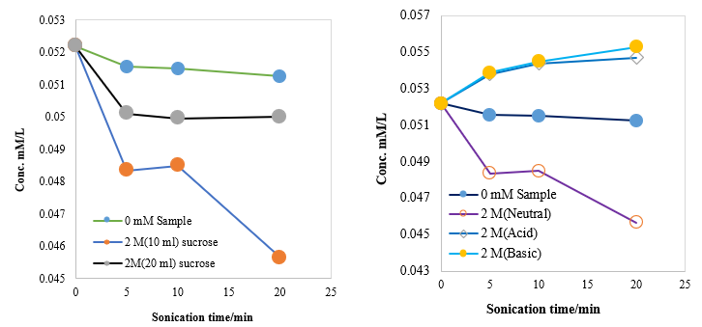

Figure-42: Time dependence of sonochemical degradation of RhB in the absence and presence of sucrose at neutral medium.

Figure-43: Time dependence of sonochemical degradation of RhB in the absence and presence of sucrose at acidic, basic and neutral medium.

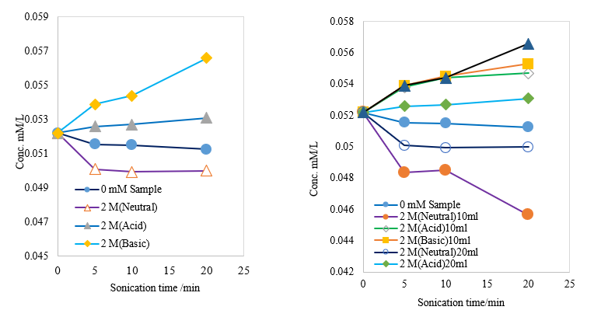
Figure-44: Time dependence of sonochemical degradation of RhB in the absence and presence of sucrose at acidic, basic and neutral medium.

Figure-45: Time dependence of sonochemical degradation of RhB in the absence and presence of sucrose at various concentration at acidic, basic and neutral medium.
and neutral medium.

The fig.41: shows time dependence of sonication time Vs. Conc. mM/L. From that figure it is noticed that rate of degradation of RhB significantly enhenced in the presence of glucose at neutral condition. The rate constant K₂ (for 20 ml) and K₃ (for 10 ml) is 3 and 7 times higher than K₁ (for 0mM sample).Tthe absence and presence of sucrose at acidic, basic and neutral medium.
The fig.43: shows time dependence of sonication time Vs. Conc. mM/L. From that figure it is noticed that rate of degradation of RhB significantly enhenced in the presence of sucrose at neutral condition. The rate constant K₂ (for neutral condition) is 7 times higher than K₁ (for 0mM sample). Where as in acidic (pH=1.93) and basic (pH=10.02) medium that rate was decreased significantly, it means accumulated.
The fig. 44: shows time dependence of sonication time Vs. Conc. mM/L. From that figure it is noticed that rate of degradation of RhB significantly enhenced in the presence of sucrose at neutral condition. The rate constant K₂ (for neutral condition) is 3 times higher than K₁ (for 0mM sample). Where as in acidic (pH=1.93) and basic (pH=10.02) medium that rate was decreased significantly, it means accumulated.
It was observed that the sonolytic degradation of dye RhB significantly enhenced in the presence of sucrose at neutral condition. In case of acidic (pH=1.93) condition and basic (pH=10.02) condition, the sonolytic degradation of dye decreased significantly, it means accumulated.
The slight accumulate in the degree of RhB removal by a decrease in the relative concentration of sucrose in the mixture is a clear indication of interfacial reactions of RhB with hydroxyl radical. The present study demonstrated that ultrasonic irradiation is a promising process for the removal of RhB from alimentary liquids containing sucrose.

- Conclusion
The current study has demonstrated that ultrasonic irradiation can effectively eliminate Dye from water. This research shows that the main reactions involved in sonochemical degradation are those with hydroxyl radicals. The initial degradation of the dye molecule was found to have increased. However, the incorporation of inorganic salts and additives increased the degradation rate. This research work concludes that dye substances can be effectively removed from water using an ultra-sound system in the presence of inorganic salts and additives. Compared to other treatment systems, it should be a low-cost option.

5. Reference
[01]. | Gayathri P¹, Praveena Juliya Dorathi R, Palanivelu K. Sonochemical degradation of textile dyes in aqueous solution using sulphate radicals activated by immobilized cobalt ions. Ultrason Sonochem. 2010 Mar; 17(3):566-71. doi: 10.1016/j.ultsonch.2009.11.019.
[02]. | KenjiOkitsuªKazuyaIwasaki^{b}YoshihiroYobiko^{b}HiroshiBandowªRokuroNishimuraªYasuakiMaeda,ª Sonochemical degradation of azo dyes in aqueous solution: a new heterogeneous kinetics model taking into account the local concentration of OH radicals and azo dyes, ELSEVIER, Volume 12, Issue 4, March 2005, Pages 255-262.
[03]. | AstridRehorekªMichaelTauber^{ab}GeorgGübitz^{b}, Application of power ultrasound for azo dye degradation, ELSEVIER, Volume 11, Issues 3–4, May 2004, Pages 177-182.
[04]. | JunWang^{ab}ZheJiangªZhaohongZhang^{c}YingpengXieªXiaofangWang^{b}ZhiqiangXingªRuiXuªXiangdongZhangª, Sonocatalytic degradation of acid red B and rhodamine B catalyzed by nano-sized ZnO powder under ultrasonic irradiation, ELSEVIER, Volume 15, Issue 5, , July 2008, Pages 768-774.
[05]. | B. Muktha, M. H. Priya, Giridhar Madras and T. N. Guru Row, Kinetics of TiO₂-Catalyzed Ultrasonic Degradation of Rhodamine Dyes, ACS publications, J. Phys. Chem. C, 2012, 116 (9), pp 5333–5341 ,Publication Date (Web): February 7, 2012 (Article).
[06]. | JunWangBaodongGuoXiangdongZhangZhaohongZhangJiantaoHanJingWu, Sonocatalytic degradation of methyl orange in the presence of TiO₂ catalysts and catalytic activity comparison of rutile and anatase, , ELSEVIER, Volume 12, Issue 5, April 2005, Pages 331-337.
[07]. | Slimane Merouani, Oualid Hamdaoui∗, Fethi Saoudi, Mahdi Chiha, Sonochemical degradation of Rhodamine B in aqueous phase: Effects of additives, Chemical Engineering Journal 158 (2010) 550–557.
[08]. | Md. Helal Uddina,^{b}, Kenji Okitsua,∗, Effect of CCl₄ or C₆F₁₄ on sonochemical degradation of dyes andphenolic compounds in an aqueous solution, Journal of Water Process Engineering 12 (2016) 66–71 Contents lists.
[09]. | HuiZhangJianhuaZhangChunyangZhangFangLiuDaobinZhang, Degradation of C.I. Acid Orange 7 by the advanced Fenton process in combination with ultrasonic irradiation, ELSEVIER, Volume 16, Issue 3, March 2009, Pages 325-330.
[10]. | Song YL1, Li JT. Degradation of C.I. Direct Black 168 from aqueous solution by fly ash/H₂O₂ combining ultrasound.,Ultrason Sonochem. 2009 Apr;16(4):440-4. doi: 10.1016/j.ultsonch.2008.12.011. Epub 2009 Jan 4.
[11]. | XiaoningWangJinpingJiaYalinWang, Enhanced photocatalytic–electrolytic degradation of Reactive Brilliant Red X-3B in the presence of water jet cavitation, ELSEVIER, Volume 23, March 2015, Pages 93-99.
[12]. | ChristianPétrierªRicardoTorresPalma^{bc}EvelyneCombet^{b}GeorgiosSarantakos^{d}StéphaneBaupªCésarPulgarin^{d} ,Enhanced sonochemical degradation of bisphenol-A by bicarbonate ions, , ELSEVIER, Volume 17, Issue 1, January 2010, Pages 111-115.
[13]. | Psillakis E1, Ntelekos A, Mantzavinos D, Nikolopoulos E, Kalogerakis N., Solid-phase microextraction to monitor the sonochemical degradation of polycyclic aromatic hydrocarbons in water. J Environ Monit. 2003 Feb;5(1):135-40.
[14]. | Psillakis E1, Goula G, Kalogerakis N, Mantzavinos D., Degradation of polycyclic aromatic hydrocarbons in aqueous solutions by ultrasonic irradiation. J Hazard Mater. 2004 Apr 30; 108(1-2):95-102.
[15]. | Il-Kyu Kim,Seok-Jun Yoa,Jea-Keun Lee,Chin-Pao Huang. Reaction pathways and kinetic modeling for sonochemical decomposition of benzothiophene, Korean Journal of Chemical Engineering, November 2003, Volume 20, Issue 6, pp 1045–1053.
[16]. | *A. Maleki, A. H. Mahvi, F. Vaezi and R. Nabizadeh, ULTRASONIC DEGRADATION OF PHENOL AND DETERMINATION OF THE OXIDATION BY-PRODUCTS TOXICITY, Iran. J. Environ. Health. Sci. Eng., 2005, Vol. 2, No. 3, pp. 201-206
[17]. | J.-T. Li, Y.-L. Song, C.-M. Liu, X.-Y. Meng. Decolourization of C.I. Direct blue 78 aqueous solution in presence of exfoliated graphite under ultrasound irradiation, • September 2009.
[18]. | Sayan E1, Esra Edecan M , An optimization study using response surface methods on the decolorization of Reactive Blue 19 from aqueous solution by ultrasound. Ultrason Sonochem., 2008 Apr;15(4):530-8. Epub 2007 Aug 14.
[19]. | Entezari MH1, Sharif Al-Hoseini Z., Sono-sorption as a new method for the removal of methylene blue from aqueous solution., Ultrason Sonochem. ,2007 Jul;14(5):599-604. Epub 2006 Dec 5.
[20]. | Entezari MH1, Al-Hoseini ZS, Ashraf N., Fast and efficient removal of Reactive Black 5 from aqueous solution by a combined method of ultrasound and sorption process. Ultrason Sonochem. 2008 Apr;15(4):433-7. Epub 2007 Sep 20.
[21]. | Soke Kwan Tang, Tjoon Tow Teng, Abbas F. M. Alkarkhi, and Zhimin Li, Sonocatalytic Degradation of Rhodamine B in Aqueous Solution in the Presence of TiO2 Coated Activated Carbon, International Journal of Environmental Science and Development, Vol. 3, No. 1, February 2012.
[22]. | Ling-Ling He a, Xian-Ping Liu a, Yong-Xia Wang a, Zhi-Xin Wang a, Yan-Jie Yang a, Yan-Ping Gao a, Bin Liu b,⇑, Xin Wangb, Sonochemical degradation of methyl orange in the presence of Bi2WO6: Effect of operating parameters and the generated reactive oxygen species, Ultrasonics Sonochemistry 33 (2016) 90–98.
[23]. | Daisuke Kobayashi1,^{2*,} Kaho Shimakage², Chiemi Honma², Hideyuki Matsumoto³, Katsuto Otake², Atsushi Shono², Effect of Particle Addition on Ultrasonic Degradation Reaction Rate, Open Journal of Acoustics, 2015, 5, 67-72.
[24]. | Kandasamy Thangavadivel ^{a,*,} Kenji Okitsu ^{a,**,} Gary Owens ^{b}, Peter J. Lesniewski c, Rokuro Nishimura a, Influence of sonochemical reactor diameter and liquid height on methyl orange degradation under 200 kHz indirect sonication, Journal of Environmental Chemical Engineering 1 (2013) 275–280.
[25] | Monira, S., Ashifuzzaman, M., Islam, M.M., Hossain, M.J., Okitsu, K., Rahman, M.H., Islam, M.S. and Uddin, M.H., 2022. Effects of Additives on Sonolytic Degradation of Azo Dye Molecules Found in Industrial Wastewater. Jurnal Kejuruteraan. 34(1), 41-50.
[26] | Uddin M. H., Islam M. M., Rahman B. S., Khatun M. S., Huda M. T., Arifuzzaman G. M., Hossain M.J, Islam M. S, 2018. Sonochemical degradation of phenol and Para-Chlorophenol in an Ultrasonic bath in the presence of inorganic salts and H₂O₂. International Journal for Excogitation Education and Research. 1(1), 53-63.
[27] | Hossain J., Monira S., Shahinuzzaman M., Avick M.S.B., Islam M.S., Khatun M., Razzaque S.M., Uddin M.H., 2023. Effect of Additives on Decomposition of Methyl Orange and Congo Red Dyes Found in Industrial Wastewater. Asian Journal of Physical and Chemical Sciences, 11(3), 52-63.
[28] | Islam, M. S., Avick M. S. B, Hossain ., Alam, M. S., & Uddin, M. H., 2024, Sonochemical Analysis of Methylene Blue with Additives and ZnO Nanoparticles in Aqueous Medium, International Reaserch Journal of Pure and Applied Chemistry, 25( 2), 1-10,  DOI: 10.9734/IRJPAC/2024/v25i2846
[29] | Islam, S., Avick, S. B., Alam, M. S., & Uddin, M. H., 2024, Investigation ZnO and Different Additives on Ultrasonic Degradation of Bisphenol A. Journal of Chemical Health Risks, 14(4), 867-879. DOI: 10.60829/jchr.2024.92351
[30] | Petrier C., Francony A., 1997, Ultrasonic waste-water treatment: incidence of ultrasonic frequency on the rate of phenol and carbon tetrachloride degradation, Ultrason. Sonochem.,4, 295–300.
[31] | Suslick K.S., Mdleleni M.M., Ries J.T., 1997, Chemistry induced by hydrodynamic cavitation, J. Am. Chem. Soc., 119, 9303–9304.
[32] | Francony A., Petrier C., 1996, Sonochemical degradation of carbon tetrachloride in aqueous solution at two frequencies: 20 kHz and 500 kHz, Ultrason. Sonochem., 3, S77–S82.
[33] | Hua I., Hoffmann M. K., 1996, Kinetics and mechanism of the sonolytic degradation of CCl4: intermediates and byproducts, Environ. Sci. Technol., 30, 864–871.
[34] | Islam, M. S., Avick M. S. B, Hossain ., Alam, M. S., & Uddin, M. H., 2024, Sonochemical Analysis of Methylene Blue with Additives and ZnO Nanoparticles in Aqueous Medium, International Reaserch Journal of Pure and Applied Chemistry, 25( 2), 1-10,  DOI: 10.9734/IRJPAC/2024/v25i2846

