Case report
Negative Pressure Pulmonary Oedema Following Laryngospasm: A Potentially Fatal yet Reversible Complication of General Anaesthesia – A Case Report

ABSTRACT
Negative pressure pulmonary oedema (NPPE) is a rare but potentially fatal complication following tracheal intubation and general anaesthesia. We report the case of a 57-year-old male who underwent arthroscopy under general anaesthesia at another hospital. Shortly after extubation, the patient developed acute respiratory distress accompanied by pink frothy secretions and oxygen desaturation. Immediate reintubation was performed, and he was subsequently transferred to our facility, where he was successfully managed with positive pressure mechanical ventilation. NPPE often results from laryngospasm, which induces forceful inspiration against a closed glottis, generating markedly negative intrathoracic pressure and leading to rapid transudation of fluid into the pulmonary interstitium and alveoli. This condition typically manifests within minutes after extubation, and prompt diagnosis with early intervention is essential to prevent morbidity and mortality. In our case, symptoms resolved completely within 24 hours of appropriate ventilatory support. This report highlights the importance of recognising NPPE in the immediate postoperative period and instituting rapid, targeted management to ensure favourable outcomes.
Introduction
Negative pressure pulmonary oedema (NPPE) is a form of noncardiogenic pulmonary oedema which occurs after an upper airway obstruction. It is a potentially life-threatening complication that develops rapidly after upper airway obstruction in otherwise healthy young persons who are capable of producing markedly large intrathoracic pressures. The incidence of NPPE, has been estimated to be up to 12 % post obstruction ^{[1]}. NPPE is a rare, but potentially life-threatening complication of general anaesthesia with tracheal intubation that occurs in 0.05%–0.1% of the cases.^{[2]} Most patients with NPPE are treated with mechanical ventilation, with few reported cases requiring extracorporeal membrane oxygenation (ECMO) ^{[3]}. Here we present a severe case of negative pressure pulmonary oedema which was diagnosed in a timely manner and successfully managed by intubation and mechanical ventilation.

CASE PRESENTATION
57-year-old male with known case of Hypertension, Type 2 Diabetes Mellitus and Lymphoma was admitted to a previous hospital for arthroscopic ligament reconstruction under General Anaesthesia. He had no allergies or cardiac diseases. Perioperative physical examination was unremarkable, and vital signs stable.
Premedication’s were given and General anaesthesia was induced with intravenous administration of Propofol, Fentanyl and Rocuronium. Patient was intubated using 8mm Endotracheal tube and maintenance was achieved with Sevoflurane, Remifentanil and Rocuronium. Surgery was uneventful with minimal blood loss. Extubation was performed after confirmation of complete consciousness and spontaneous breathing. Patient suddenly went into respiratory distress and intense coughing with expectoration of frothy red sputum and sudden fall in oxygen saturation. Patient was immediately re-intubated with 8mm endotracheal tube and shifted to our hospital for further management.
On arrival to our ER, patient was under sedation and ventilated via Bain circuit, a pink frothy fluid was seen coming out of endotracheal tube. Endotracheal tube suction was given and patient was mechanically ventilated in ACMV VC mode with tidal volume 6ml/kg, positive end expiratory pressure (PEEP) 10 cm H2O and FiO2 90%. Echocardiography showed good LV function with Ejection Fraction (EF) 55%. Patient was maintaining an oxygen saturation of 96%. Patient was slowly weaned off from ventilator and extubated the next day. Patient was maintaining good oxygen saturation and symptom free since then, hence discharged 3 days later.
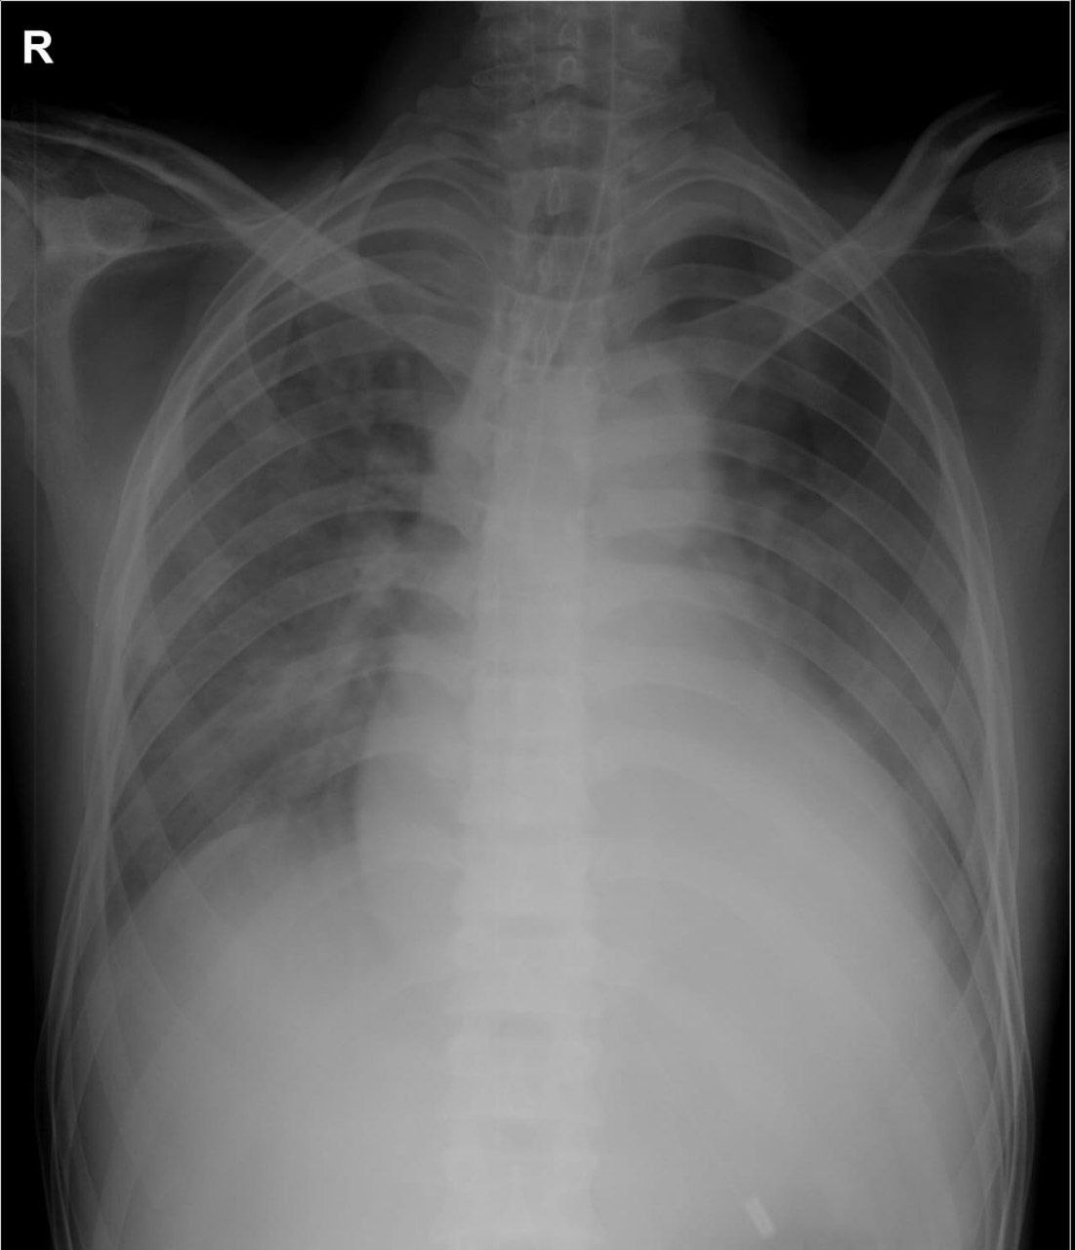

DISCUSSION
Negative pressure pulmonary oedema, also known as post obstructive pulmonary oedema, is a pure form of hydrostatic oedema ^{[14]}, characterised by the formation of negative intrathoracic pressure in cases with upper airway obstruction, leading to severe hypoxemia and pulmonary oedema.^{[4]} Most NPPE cases in children have been caused by glottis or subglottic obstruction.^{[5]} But in adults most common reported reason for a NPPE is post-extubation laryngospasm.^{[6]}
Dr. Deepika et al. reported one of the largest scale case series studies in patients developed

Fig 1 : XRAY of patient showing features of pulmonary oedema
NPPE in the operating rooms, post-anesthesia care units (PACU), and ICU after surgery. The overall incidence of post-extubation NPPE was 0.094% (30 cases in 31,826 surgical patients) in their clinical case review (Deepika et al. 1997).^{[7]} A similar incidence of 0.084% (14 cases in 16,653 surgical patients) was reported during orthopaedic surgery that eventually developed post-extubation NPPE (Patton and Baker Jr 2000).^{[8]} Several perioperative risk factors of post-extubation NPPE have been proposed, including patients of younger age, male, generally healthy (ASA I–II), difficult intubation, use of irritant volatile agents, operation on the head and neck region, obese, and recent upper airway infection.^{[7,9-13]} Similarly, Our patient was a middle aged healthy male, post arthroscopic surgery who developed severe laryngospasm and pink frothy secretion with saturation fall minutes after extubation, radiological evidence of pulmonary oedema and normal cardiac status , which rules out cardiogenic cause of oedema. Further the onset and time course of clinical and radiological recovery was in agreement with aetiology of negative pressure pulmonary oedema.
Swift diagnosis and intervention are necessary in Negative Pressure Pulmonary Oedema. Failure to diagnose NPPE correctly may lead to unnecessary administration of antibiotics and anticoagulants, and other therapeutic modalities. Treatment of NPPE with or without alveolar haemorrhage consists mainly of supportive measures. Supplement of oxygen may be sufficient in most cases and modest diuresis may be beneficial even though patients do not have peripheral oedema ^{[15]}. The use of steroids is controversial; however, they have been shown to lessen the pulmonary oedema lesion resulting from trauma ^{[16]}. High negative pressures may cause damage to pulmonary alveoli and capillaries, steroid administration may be useful in such conditions. Other measures could be adopted during surgery to minimise development of NPPE, including pharyngeal suctioning or intravenous injection of lidocaine.^{[17]}
CONCLUSION
Negative pressure pulmonary oedema is a rare, but potentially fatal complication post extubation. Although it is a self-limiting condition that can be managed by reintubation and mechanical positive pressure ventilation, it may complicate the outcomes of simple surgical procedures and cause prolonged ICU stay, and need for mechanical ventilation in otherwise healthy individuals. This may increase the cost of surgery and delay their return to normal day-to-day activities. Marked decrease in oxygen saturation shortly after extubation should stimulate a high index of suspicion for NPPE. Early diagnosis and recognition are likely to lead to successful management of this potentially serious complication.

Declaration of Conflicting Interests
The authors declared no potential conflicts of interest with respect to the research, authorship, and/or publication of this article.

Ethical Approval
Our institution exempts individual case reports and case series from the requirement of ethical approval.

Patient Consent
Informed written consent was secured from the patient regarding their involvement and the dissemination of their data.

REFERENCES
- Tami TA, Chu F, Wildes TO, Kaplan M. Pulmonary edema and acute upper airway obstruction. Laryngoscope. 1986;96:506–509. doi: 10.1288/00005537-198605000-00007.
- Liu R, Wang J, Zhao G, et al. Negative pressure pulmonary edema after general anesthesia: a case report and literature review. Medicine 2019;98:e15389.
- Marino D, Baggi M, Casso G, et al. Near-Fatal acute postobstructive pulmonary oedema requiring extracorporal membrane oxygenation. Intensive Care Med 2010;36:365–6.
- Bhattacharya M, Kallet RH, Ware LB, et al. Negative-Pressure pulmonary edema. Chest 2016;150:927–33
- Berdai AM, Labib S, Harandou M. Postobstructive pulmonary edema following accidental near-hanging. Am J Case Rep. 2013;14:350–3
- Chen Y, Zhang X. Acute postobstructive pulmonary edema following laryngospasm in elderly patients: a case report. J Perianesth Nurs. 2018;
- Deepika K, Kenaan CA, Barrocas AM, Fonseca JJ, Bikazi GB. Negative pressure pulmonary edema after acute upper airway obstruction. J Clin Anesth. 1997;9:403–8.
- Patton WC, Baker CL Jr. Prevalence of negative-pressure pulmonary edema at an orthopaedic hospital. J South Orthop Assoc. 2000;9:248–53
- Lang SA, Duncan PG, Shephard DA, Ha HC. Pulmonary oedema associated with airway obstruction. Can J Anaesth. 1990;37:210–8.
- Lorch DG, Sahn SA. Post-extubation pulmonary edema following anesthesia induced by upper airway obstruction. Are certain patients at increased risk? Chest. 1968;90:802–5
- Ghofaily LA, Simmons C, Chen L, Liu R. Negative pressure pulmonary edema after laryngospasm: a revisit with a case report. J Anesth Clin Res. 2013;3:252.
- Krodel DJ, Bittner EA, Abdulnour R, Brown R, Eikermann M. Case scenario: acute postoperative negative pressure pulmonary edema. Anesthesiology. 2010; 113:200–7.
- McConkey PP. Postobstructive pulmonary oedema - a case series and review. Anaesth Intensive Care. 2000;28:72–6.
- Kapoor MC. Negative Pressure Pulmonary Oedema. Indian Journal of Anaesthesia. 2011; 55(1):10.
- Mulkey Z, Yarbrough S, Guerra D, Roongsritong C, Nugent K, Phy MP. Postextubation pulmonary edema: a case series and review. Respir Med 2008; 102: 1659-62
- Oswalt CE, Gates GA, Holmstrom MG. Pulmonary edema as a complication of acute airway obstruction. JAMA 1977; 238: 1833-5.
- Gefke K, Andersen LW, Friesel E. Lidocaine given intravenously as a suppressant of cough and laryngospasm in connection with extubation after tonsillectomy. Acta Anaesthesiol Scand 1983; 27: 111-2

