Case Report
The Adrenal Gland as a Rare Metastatic Site of Oesophageal Carcinoma: A Case Report

Abstract:
Oesophageal squamous cell carcinoma (OSCC) frequently metastasizes to lymph nodes, liver, lung, bone, and brain; adrenal involvement is rare and is detected incidentally or during autopsy. Herein, we report a case of a 42-year-old male presenting with progressive dysphagia, diagnosed with moderately differentiated OSCC. On imaging, a distal oesophageal lesion with a left adrenal nodule was seen. Following neoadjuvant chemoradiotherapy, the patient underwent Ivor Lewis esophagectomy with left adrenalectomy. Histopathology confirmed adrenal metastasis from OSCC. The final stage was ypT3 ypN0 ypM1 (Stage IVB), with a Modified Ryan Tumor Regression score of 2. The present case highlights the importance of thorough metastatic workup in oesophageal cancer, as adrenal lesions may be the first or only sign of distant spread. Histopathological confirmation is crucial for guiding appropriate surgical and therapeutic decisions.
Key words: Oesophageal carcinoma, Adrenal gland, metastasis, carcinoma, squamous cell carcinoma
Introduction
Oesophageal cancer is one of the most aggressive tumours within the gastrointestinal system [2]. Oesophageal cancers are predominantly squamous cell carcinomas (90%), with adenocarcinomas and metastases each contributing approximately 5% [1]. Frequent clinical symptoms include dysphagia, odynophagia, and weight loss [1]. Oesophageal Squamous cell carcinomas (OSCC) metastasize to the lymph nodes, lungs, liver, bone, brain, and rarely adrenal glands [8]. Owing to their abundant blood supply, the adrenal glands are a frequent target for hematogenous metastases despite their small size [3]. Whereas, metastases to adrenal glands are common from lung, gastrointestinal, breast, kidney carcinoma, and melanoma, which are mostly incidentally detected and identified on imaging studies, particularly during postoperative follow-up [3,8]. Adrenal metastasis from oesophageal carcinoma is extremely rare and most commonly identified during autopsy [6,8]. Although the primary tumour usually directs the diagnostic approach, it is important to recognize that adrenal involvement can, in some cases, be the initial clinical presentation [3]. Treatment and prognosis of OSCC are mainly dependent on the tumor-node-metastasis (TNM) stage of the tumour. The overall 5-year survival rate for oesophageal cancer is around 24%, but it improves to 35–50% in patients who are eligible for curative treatment involving neoadjuvant or perioperative chemo/radiotherapy followed by surgery. [5] A median survival duration of 36 months (range, 14–71 months) has been reported following adrenalectomy, with patients demonstrating relatively extended survival [8].
Case Presentation:
A 42-year-old male presented with progressive dysphagia for 6 months. CECT showed circumferential mural thickening of the distal oesophagus (D7–D8 level) measuring 8–10 cm in length and 10 mm in wall thickness, along with multiple paraesophageal lymph nodes and the presence of a nodule (16.2 × 18 mm) in the left adrenal gland. UGIE showed a sclerosing growth at 30 cm from the incisors with post-radiotherapy changes. Initial biopsy confirmed moderately differentiated squamous cell carcinoma (MDSCC), following which the patient received neoadjuvant chemoradiotherapy (45 Gy/25 fractions, STP protocol). He underwent an Open Ivor Lewis esophagectomy with left adrenalectomy and feeding jejunostomy. Frozen section of the adrenal nodule revealed metastatic squamous cell carcinoma with focal keratinization. Residual compressed adrenal parenchyma was identified at the periphery. On microscopy, sections examined from the Ivor Lewis esophagectomy specimen showed residual transmurally infiltrating MDSCC with lymphovascular and perineural invasion, negative resected margins with no lymph nodes involved (0/18). Immunohistochemistry (IHC) showed p40 positivity in the primary tumor. The metastatic lesion in the adrenal gland also demonstrated p40 immunopositivity in tumor cells, while SF1 highlighted the normal adrenal tissue. Thus, the adrenal lesion was confirmed as metastatic MDSCC. The pathological stage was ypT3 ypN0 ypM1 (Stage IVB), with a Modified Ryan tumor regression score of 2 and Mandard TRG (Tumor Regression Grading) 3.

Discussion:
Worldwide, oesophageal cancer ranks 10th in incidence and 6th in terms of cancer-related deaths. Among oesophageal cancers, squamous cell carcinoma is the most prevalent, and its incidence increases with age, reaching a peak in the seventh decade [1]. OSCC occurs equally in the middle and lower thirds of oesophagus, with a higher incidence reported in Black individuals compared to Whites. Major risk factors include chronic alcohol consumption and tobacco use. Management of advanced oesophageal malignancies requires a multidisciplinary approach.[1] The Phase III KEYNOTE-590 trial, involving 749 patients with oesophageal cancer (70% SCC, 90% metastatic), highlighted the evolving treatment landscape. While esophagectomy with neoadjuvant chemo- or radiotherapy remains the standard treatment approach, immune checkpoint inhibitors (ICIs) have been introduced as new therapeutic options. [9] However, the discovery of incidental adrenal lesions during staging can complicate surgical management. Common metastatic sites include the liver, lungs, bones, and brain, with autopsy studies reporting adrenal involvement in 3–12% of oesophageal cancer cases.[3]
Adrenal incidentalomas have a prevalence ranging from 0.2 to 7.0% in the general population. [3] The differential diagnosis of adrenal incidentalomas consists of benign diseases like adrenocortical adenomas along with primary adrenocortical cancer and metastatic tumor deposits. Among distant metastatic sites, the adrenal gland is commonly involved in cases of primary lung cancer. [1] Tumours from the breast, thyroid, ovary, renal cell carcinoma, lymphomas, and melanomas usually metastasize to the adrenal glands. Management of adrenal metastasis is personalised and depends largely on the nature of the primary carcinoma. Metastases are typically detected during postoperative surveillance using imaging modalities such as CT, PET, or MRI [10]. On imaging, adrenal metastases often exhibit features such as irregular contours, heterogeneous internal architecture, increased vascularity on contrast-enhanced CT, and elevated standardized uptake values (SUV) on PET scans [10]. Adrenal metastasis from oesophageal carcinoma is rare, though only a few case reports have been reported. [1-5] One study revealed 3% incidence of adrenal metastasis from oesophageal carcinoma [6] while another reported an incidence of 12% from an autopsy series.[7]. Few studies have previously highlighted the rarity and clinical relevance of adrenal metastasis in oesophageal squamous cell carcinoma (ESCC). Lam and Lo (2002), through a review spanning three decades, observed frequent adrenal metastases from lung, breast, and gastrointestinal cancers, stressing the role of thorough histopathological evaluation due to the silent nature of these lesions. Kashyap et al. (2012) reported a case of OSCC with adrenal metastasis detected via PET/CT, highlighting the value and limitations of metabolic imaging for identifying small mucosal lesions [1]. Kanaya et al. (2017) presented a case and reviewed eight others, suggesting that adrenalectomy for solitary adrenal metastasis from OESCC may confer long-term survival benefits [8]. A retrospective cohort by van Doesburg et al. (2023) found adrenal incidentalomas to be common in OSCC patients, reinforcing the importance of accurate differentiation between benign and metastatic lesions [5]. Panwar et al. (2024), in a comprehensive analysis, emphasized that many adrenal metastases remain clinically occult and require pathological confirmation even in the absence of a known primary tumor [3]. Lastly, Wang et al. (2025) reported that neoadjuvant chemoradiotherapy improves pathological response in resectable ESCC, thereby supporting its use in multimodal treatment strategies [9]. The present case highlights the importance of thorough metastatic workup in oesophageal cancer, as adrenal lesions may be the first or only sign of distant spread. Histopathological confirmation is crucial for guiding appropriate surgical and therapeutic decisions.
Conclusion:
Most tumours originating in the adrenal gland are benign adenomas, while primary malignant adrenal tumours are rare. Metastatic involvement of the adrenal glands is most commonly due to primary tumours of the lung, gastrointestinal tract, breast, kidney, and melanoma. Adrenal metastases are typically detected during postoperative surveillance using imaging modalities such as CT, PET, or MRI. Management is tailored on a case-by-case basis, guided by the nature of the primary malignancy. Consequently, histopathological evaluation plays a crucial role in establishing an accurate diagnosis and directing appropriate therapy. Early identification and timely surgical intervention are essential to prevent potential complications and improve outcomes.
Declarations:
Ethics approval – Written consent was taken from the guardians of all the patients included in the study. The present case report does not involve any human subject research or any medical intervention hence Institutional Review Board (IRB) approval was waived due to the use of retrospective and non-identifiable data.
Consent to participate – Written consent was taken from the guardians of all the parents included in the study.
References:
- Kashyap R, Mittal BR, Bhattacharya A, Singh B. Unusual presentation of oesophageal carcinoma with adrenal metastasis. Indian J Nucl Med. 2012;27(3):181–2. doi:10.4103/0972-3919.112725
- Wei Y, Han S, Shi Y, et al. Complete response of advanced esophageal squamous cell carcinoma with first-line chemotherapy combined with immunotherapy: a case report. Front Immunol. 2025;16:1511663. doi:10.3389/fimmu.2025.1511663
- Panwar V, Cai Q, Jia L. Metastatic diseases to the adrenal gland: A comprehensive study from an academic institution with emphasis on clinical occult cases. Pathol Res Pract. 2024;261:155487. doi:10.1016/j.prp.2024.155487
- Point du Jour KS, Alwelaie Y, Coleman A, Tadros T, Aneja R, Reid MD. Adrenal gland fine needle aspiration: a multi-institutional analysis of 139 cases. J Am Soc Cytopathol. 2021;10(2):168–74. doi:10.1016/j.jasc.2020.08.004
- van Doesburg JR, Voeten DM, Kalff MC, van Berge Henegouwen MI, Jol S, van den Bergh JE, et al. Incidence and oncological implication of adrenal incidentalomas in esophageal cancer patients. Dis Esophagus. 2023;36(9):doad003. doi:10.1093/dote/doad003
- Lam KY, Lo CY. Metastatic tumours of the adrenal glands: a 30-year experience in a teaching hospital. Clin Endocrinol (Oxf). 2002;56(1):95–101. doi:10.1046/j.0300-0664.2001.01435.x
- Boland GW, Blake MA, Holalkere NS, Hahn PF. PET/CT for the characterization of adrenal masses in patients with cancer: qualitative versus quantitative accuracy in 150 consecutive patients. AJR Am J Roentgenol. 2009;192(4):956–62. doi:10.2214/AJR.08.1431
- Kanaya N, Noma K, Okada T, et al. A case of long-term survival after surgical resection for solitary adrenal recurrence of esophageal squamous carcinoma. Surg Case Rep. 2017;3:61. doi:10.1186/s40792-017-0337-8
- Wang X, Wen D, Feng H, Luo M. Clinical efficacy of different neoadjuvant therapies for resectable esophageal squamous cell carcinoma. World J Surg Oncol. 2025;23:243. doi:10.1186/s12957-025-03897-w
- Quint LE, Hepburn LM, Francis IR, Whyte RI, Orringer MB. Incidental adrenal masses detected on chest CT in patients with lung cancer. World J Gastrointest Oncol. 2014;6(4):112–7. doi:10.4251/wjgo.v6.i4.112

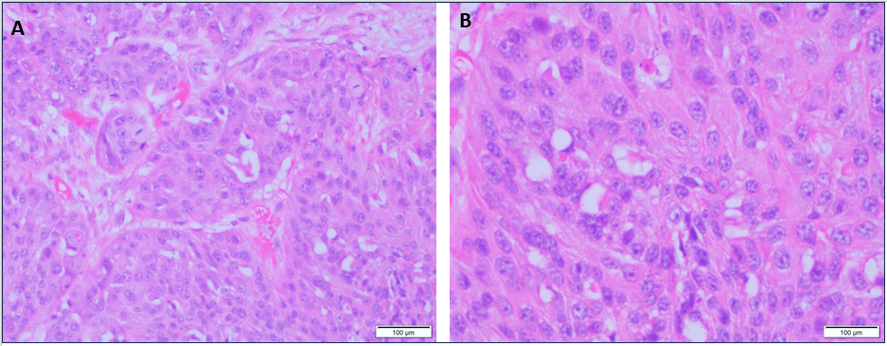

Figure 1: Histopathological images of the primary oesophageal tumour, demonstrating moderately
differentiated squamous cell carcinoma. A: Low-power view (20×) showing invasive tumour architecture. B:
High-power view (40×) highlighting cellular and nuclear features characteristic of squamous differentiation.
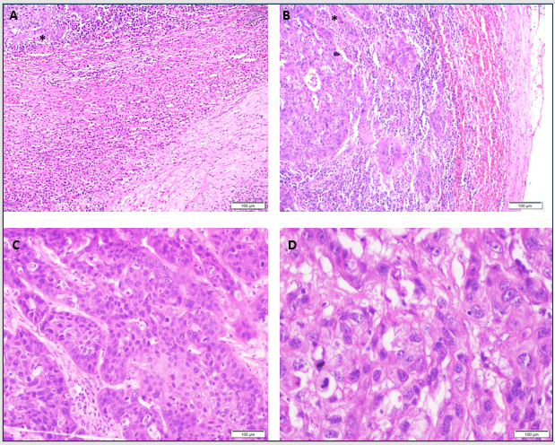

Figure 2: Representative H&E-stained sections showing metastatic moderately differentiated squamous cell
carcinoma (MDSCC) involving the adrenal gland. (A, B: 10×; C: 20×; D: 40× magnification). Adjacent normal
adrenal parenchyma is also seen. (* indicates metastatic MDSCC).

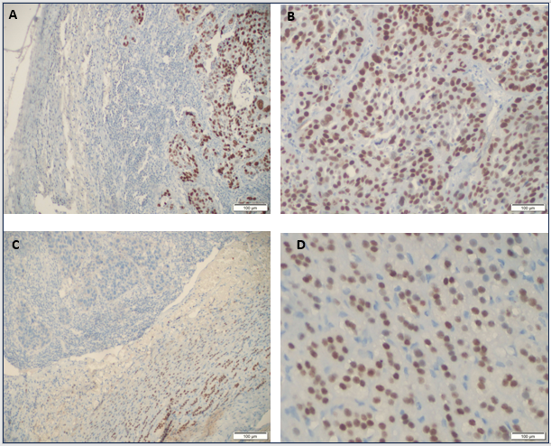
Figure 3: Immunohistochemical staining highlights differential marker expression in metastatic tumor and
normal adrenal tissue. p40 shows strong nuclear positivity in the metastatic squamous cell carcinoma, while
the adjacent normal adrenal gland is immunonegative (A: 10×; B: 20×). Steroidogenic factor 1 (SF1) shows
nuclear positivity in normal adrenal parenchyma but is negative in the tumor area (C: 10×; D: 40×).

