Case study

Mortality and Morbidity in Extremely Preterm Infants: A Retrospective Case Series and Review of the Literature

.
ABSTRACT

Aims: To describe neonatal mortality and morbidity among extremely preterm infants admitted to the Mohammed V Military Teaching Hospital (HMIMV), Rabat, Morocco, through a retrospective case series, and to contextualize findings with published international literature.
Study Design: Retrospective case series and literature review.
Place and Duration of Study: Neonatology Department, HMIMV, Rabat, Morocco, 2019–2025.
Methodology: We retrospectively reviewed 14 cases of neonatal deaths among preterm infants. Data collected included gestational age, birth weight, maternal characteristics, cause of preterm birth, complications, and age at death. Maternal variables included age, obstetric history, history of prematurity, medical complications such as hypertension or preeclampsia, and mode of delivery. Neonatal variables included gestational age, birth weight, Apgar score, complications (respiratory distress syndrome, sepsis, necrotizing enterocolitis, intraventricular hemorrhage, congenital anomalies, and metabolic disorders), and timing of death. Cases were analyzed descriptively. Findings were compared with published cohorts from Ethiopia, Tunisia, Ghana, Trinidad and Tobago, and high-income countries to highlight similarities and differences. Ethical approval was waived due to the retrospective and anonymized nature of the study.
Results: Among 14 preterm neonates, respiratory distress (57%), infections (42%), and congenital anomalies (21%) were the main causes of death. Most deaths occurred within the first week of life, while late neonatal deaths were mainly associated with nosocomial infections and necrotizing enterocolitis. Advanced maternal age (≥35 years) was associated with lower gestational ages at birth. Graphical analysis confirmed the etiological shift from respiratory to infectious causes as gestational maturity increased.
Conclusion: Neonatal mortality among extremely preterm infants remains high, especially for very low birth weight neonates. Respiratory distress, infections, and congenital anomalies are the leading causes of death. Expanding access to antenatal corticosteroids, Kangaroo Mother Care, breastfeeding, and infection prevention are crucial to reduce mortality.

Keywords: Neonatal mortality, preterm birth, very low birth weight, respiratory distress syndrome, sepsis, congenital anomalies, Kangaroo Mother Care, case series, literature review.

1. INTRODUCTION
Neonatal mortality in preterm infants remains a major global health challenge, accounting for nearly one million deaths each year [1]. Preterm birth, defined as delivery before 37 weeks of gestation, affects about 13 million infants annually, with extremely preterm and very low birth weight neonates carrying the highest risk [2,3]. Prognosis is closely related to gestational age and birth weight, with survival exceeding 80% at 25 weeks in high-income countries but remaining below 40% in many low- and middle-income settings [4,5].
The leading causes of death include respiratory distress syndrome, sepsis, necrotizing enterocolitis, intraventricular hemorrhage, and congenital anomalies [6–8]. Despite advances in neonatal intensive care, wide disparities persist. Interventions such as antenatal corticosteroids, Kangaroo Mother Care, early breastfeeding, and infection prevention have proven effective [9–11].
This study reports a 14-case series of neonatal deaths among preterm infants admitted to a tertiary hospital in Morocco and discusses the findings in light of current literature [12–15].

2. MATERIAL AND METHODS
This was a retrospective descriptive study conducted at the Neonatology Department of HMIMV, Rabat, Morocco, between January 2019 and March 2025. Fourteen cases of neonatal deaths among preterm infants were identified from hospital records.
For each case, maternal and neonatal data were collected, including maternal age, parity, history of abortions, prior preterm birth, preeclampsia, hypertension, and infections. Mode of delivery (vaginal vs cesarean) and indication were recorded. Neonatal data included gestational age (weeks of amenorrhea), birth weight, anthropometric measures, and Apgar scores at 1 and 5 minutes. Neonatal complications considered were respiratory distress syndrome (RDS), sepsis, necrotizing enterocolitis (NEC), intraventricular hemorrhage (IVH), congenital anomalies, and metabolic disorders. Timing of death was categorized as early (<7 days) vs late (≥7 days).
The study focused on both descriptive and analytical analyses. Results were compared with published series from Ethiopia, Tunisia, Ghana, Trinidad and Tobago, and high-income countries to highlight similarities and differences in mortality patterns and risk factors. Ethical approval was waived by the local institutional review board due to the retrospective and anonymized nature of the data.

3. RESULTS

Baseline Characteristics : A total of 14 preterm infants were included. The mean gestational age at birth was 29.4 weeks (range: 27–33). More than one-third (36%) were extremely preterm (<28 weeks), and 64% had a very low birth weight (<1500 g). The mean birth weight was 1350 g (range: 900–1900). The sex ratio was balanced. Regarding maternal characteristics, 29% of mothers were ≥35 years old (Table 1).
Causes of Death : The main causes of death were RDS (57%), infections (42%), and congenital anomalies (21%). Other contributing factors included NEC (14%) and IVH (7%). Several infants had multiple complications (Table 2).
Timing of Death : Distinct mortality patterns were identified (Table 3): - All RDS-related deaths occurred early (<7 days). - All infection-related deaths occurred late (≥7 days). - Congenital anomalies were also associated with late deaths.
Graphical Analysis : The scatterplot (Figure 1) shows the relationship between gestational age, birth weight, and cause of death. RDS clustered among the lowest GA/weight infants, infections predominated in moderately preterm infants (≈30–32 weeks), and anomalies were distributed across gestational ages.
The boxplot (Figure 2) highlights the influence of maternal age: infants of mothers ≥35 years were delivered at lower gestational ages compared to those of younger mothers.

Figure 1. Relationship between gestational age, birth weight, and cause of death (n=14). Each point represents a preterm infant. Colors indicate main cause: RDS, infections, or anomalies.
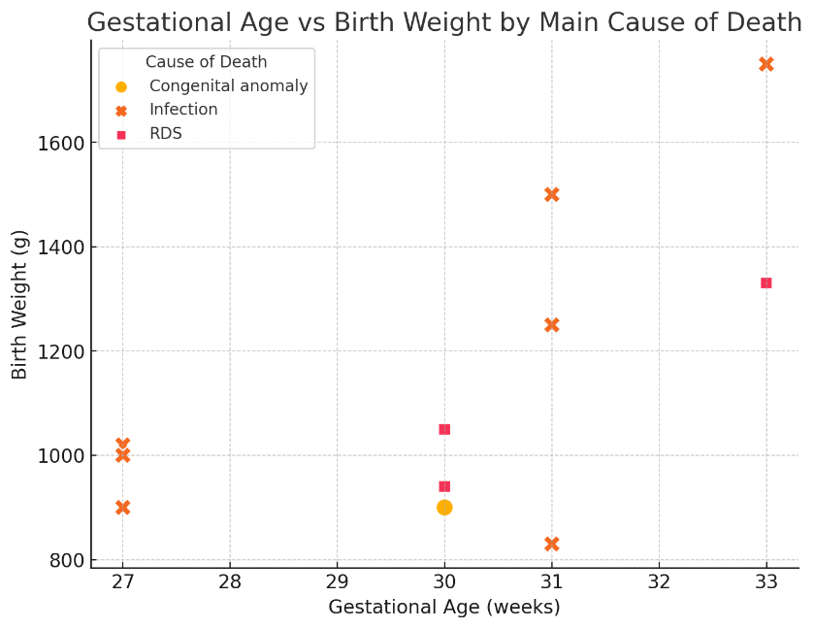

Figure 2. Gestational age by maternal age category. Boxplot showing lower GA at birth in infants of mothers ≥35 years.
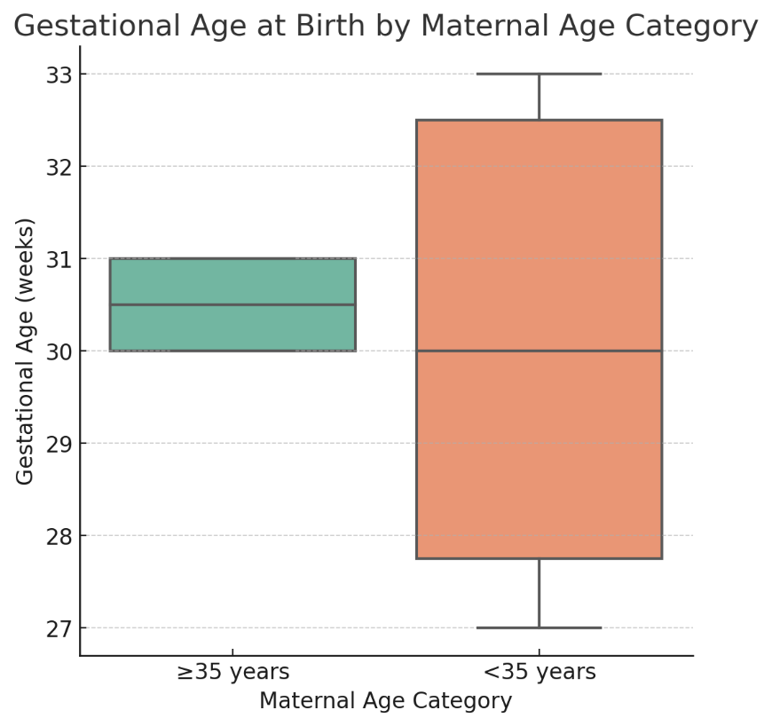
Table 1. Baseline characteristics of preterm infants (n=14).
Variable | Findings
Mean gestational age (weeks) | 29.4 (range: 27–33)
Extremely preterm (<28 weeks) | 5 (36%)
Very preterm (28–31 weeks) | 7 (50%)
Moderate preterm (32–34 weeks) | 2 (14%)
Mean birth weight (g) | 1350 (range: 900–1900)
VLBW (<1500 g) | 9 (64%)
Male : Female | ≈ 1 : 1
Maternal age ≥35 years | 4 (29%)

Table 2. Main causes of death.
Cause | n (%)
Respiratory distress syndrome | 8 (57%)
Infections (sepsis, nosocomial) | 6 (42%)
Congenital anomalies | 3 (21%)
NEC | 2 (14%)
IVH | 1 (7%)
Metabolic complications | 1 (7%)
Table 3. Timing of death by cause.
Cause of death | Early (<7 days) | Late (≥7 days) | Total
RDS | 3 | 0 | 3
Infections | 0 | 8 | 8
Congenital anomalies | 0 | 3 | 3
Total | 3 | 11 | 14

4. Discussion

This retrospective case series provides insights into the mortality and morbidity associated with extreme prematurity. In our cohort, the majority were born before 30 weeks and weighed <1500 g (Table 1), confirming immaturity and very low birth weight as major predictors of neonatal death [3,5].
Etiology of Death and Timing
The causes of death reflect a dual burden. RDS predominated at the lowest gestational ages and weights, infections occurred later in moderately preterm infants, and anomalies contributed across ages (Tables 2–3). Figure 1 confirms the etiological shift: RDS in the most immature, infections in those who survived longer, anomalies across groups. These findings are consistent with Ethiopia (RDS and asphyxia as predictors [5]), Tunisia (nosocomial infections in late deaths [7]), and HICs (>80% survival at 25 weeks with antenatal corticosteroids and surfactant [3,9]).
Maternal Risk Factors
Maternal age was an important determinant. In our series, 29% of mothers were ≥35 years (Table 1). Figure 2 shows their infants had lower gestational ages, likely linked to hypertensive disorders, preeclampsia, and placental abnormalities. This matches previous studies reporting increased prematurity risk in mothers >40 and <17 years [6,7]. Limited antenatal care and socio-economic factors also play key roles in LMICs [8].
Clinical and Public Health Implications
Our findings highlight that early deaths are mostly due to immaturity, while late deaths are preventable. Priorities include antenatal corticosteroids, early non-invasive ventilation, Kangaroo Mother Care, breastfeeding, and infection prevention [9,11,12]. Strengthening perinatal networks and access to evidence-based interventions is essential to reduce mortality gaps between low- and high-resource settings.

5. CONCLUSION

Neonatal mortality among preterm infants remains a major challenge, particularly in low- and middle-income countries where access to advanced neonatal intensive care is limited [2,5,7]. Our 14-case series confirms the predominance of respiratory distress, infections, and congenital anomalies as leading causes of death. Early neonatal deaths were mainly due to respiratory and neurological immaturity, whereas late deaths reflected the burden of nosocomial infections and necrotizing enterocolitis.
Improving survival requires the systematic use of antenatal corticosteroids, promotion of Kangaroo Mother Care, early initiation of breastfeeding, and strengthened infection control practices [6,9,12]. Context-adapted strategies are essential to reduce preventable deaths and to narrow the survival gap between high- and low-resource settings.

Consent

Not applicable. Individual consent was not required as data were collected retrospectively and anonymized.

Ethical approval

Ethical approval: waived by the local Institutional Review Board (IRB) for retrospective anonymized chart review. Individual consent was not required.

Definitions, Acronyms, Abbreviations
GA: Gestational Age
BW: Birth Weight
VLBW: Very Low Birth Weight (<1500 g)
ELBW: Extremely Low Birth Weight (<1000 g)
RDS: Respiratory Distress Syndrome
NEC: Necrotizing Enterocolitis
IVH: Intraventricular Hemorrhage
KMC: Kangaroo Mother Care
NICU: Neonatal Intensive Care Unit

References

- United Nations Inter-agency Group for Child Mortality Estimation (UN IGME). Levels and Trends in Child Mortality 2023. New York: UNICEF; 2024. Available from: https://data.unicef.org/resources/levels-and-trends-in-child-mortality-2023/
- World Health Organization. Preterm birth – Fact sheet. Geneva: WHO; 2023 May 10. Available from: https://www.who.int/news-room/fact-sheets/detail/preterm-birth
- Stoll BJ, Hansen NI, Bell EF, et al. Neonatal outcomes of extremely preterm infants from the NICHD Neonatal Research Network. Pediatrics. 2010;126(3):443-56. doi:10.1542/peds.2009-2959
- Edwards EM, Ehret DEY, Soll RF, Horbar JD, et al. Survival of infants born at 22 to 25 weeks’ gestation receiving care in the NICU: 2020–2022. Pediatrics. 2024;154(4):e2024065963. doi:10.1542/peds.2024-065963
- Girma B, Tsegaye B, Alemayehu T, Wondimu M. Survival and predictors of mortality among preterm neonates: a 5-year cohort study in Northern Ethiopia. Front Pediatr. 2023;10:1083749. doi:10.3389/fped.2022.1083749
- Tirore LL, Abate AT, Tesfaye Z, et al. Incidence of mortality and its predictors among preterm neonates admitted to the NICU of NEMMCSH. BMC Pediatr. 2024;24:92. doi:10.1186/s12887-024-04992-9
- Chioukh FZ, Ben Ameur K, Ben Miled N, et al. Extremely preterm infants in Tunisia: Where are we now? Tunis Med. 2018;96(8-9):510-3. PMID: 30430530. Available from: https://latunisiemedicale.com/index.php/tunismed/article/view/3434
- Agbeno EK, Osarfo J, Ashong J, et al. Determinants of preterm survival in a tertiary hospital in Ghana: a ten-year review. PLoS One. 2021;16(1):e0246005. doi:10.1371/journal.pone.0246005
- Sweet DG, Carnielli V, Greisen G, et al. European Consensus Guidelines on the Management of Respiratory Distress Syndrome—2019 Update. Neonatology. 2019;115(4):432-50. doi:10.1159/000499361
- Shane AL, Sánchez PJ, Stoll BJ. Neonatal sepsis. Lancet. 2017;390(10104):1770-80. doi:10.1016/S0140-6736(17)31002-4
- Roberts D, Brown J, Medley N, Dalziel SR. Antenatal corticosteroids for accelerating fetal lung maturation for women at risk of preterm birth. Cochrane Database Syst Rev. 2017;(3):CD004454. doi:10.1002/14651858.CD004454.pub3
- Conde-Agudelo A, Díaz-Rossello JL. Kangaroo Mother Care to reduce morbidity and mortality in low birthweight infants. Cochrane Database Syst Rev. 2016;(8):CD002771. doi:10.1002/14651858.CD002771.pub4
- Ancel PY, Goffinet F, Kuhn P, et al. Survival and morbidity of preterm children born at 22 through 34 weeks’ gestation in France in 2011: results of the EPIPAGE-2 cohort study. JAMA Pediatr. 2015;169(3):230-8. doi:10.1001/jamapediatrics.2014.3351
- Cupen K, Barran A, Singh V, Dialsingh I. Risk factors associated with preterm neonatal mortality: a case study using data from Mt. Hope Women’s Hospital in Trinidad and Tobago. Children (Basel). 2017;4(12):108. doi:10.3390/children4120108

