Building a Smart Home Automation System Using GSM Network

Abstract
In this research, a GSM Network-based Home Automation System was developed and implemented. Specifically, it involved designing and constructing an embedded home power control system for monitoring and managing various household appliances such as bulbs and fans. The project was structured into two main sections: Hardware and Software. The Hardware section encompassed key units including the GSM module, Power supply, Microcontroller, and Driver. On the other hand, the Software section comprised essential components such as PCB Droid, Arduino Droid, Quick Silver software, and C++ Programming language. One notable feature of the system was a 10-second delay following the initial SMS command to facilitate the execution of subsequent commands. Ultimately, the project was successfully executed, achieving its objectives in the realm of home automation.
Keywords: Home, Automation, Microcontroller,
Introduction
Automation is the technology that allows little or no human intervention when controlling a device or a process. (Akanniet al, 2018). Global System of Mobile Communication (GSM) based Home Automation System is an electrical and electronic system designed to control home appliances with a mobile phone. The rapid advancement of mobile communication technology and wide availability makes it possible to incorporate mobile technology into Home Automation Systems.
Wireless devices having electronic properties that can operate electrical devices from a distance are considered remote. The remote control is designed to provide convenience to its user, and a means through which direct operation of the device is achieved in devices that pose inconvenience (such as digital light processing protector wounded on the high ceiling being manipulated from floor level) while operating. Since the beginning of the industrial revolution, remote control has taken a new pace from ultrasonic tones to infrared (engineered control system which uses infrared to send a digital code pulse of infrared radiation to control device functions including power volume channel, track change, heat fan speed among others) and now, to Bluetooth connectivity,
motion sensor enables capabilities and voice control. (Warey and Stabe, 2011).
Utilizing Home Automation could lead to more efficient and intelligent energy-saving techniques. By integrating Information and Communication Technology (ICT) with renewable energy systems such as solar power or wind power, homes can autonomously make decisions about whether to store energy or expend it for a given appliance, leading to overall positive environmental impacts and lower electricity bills for the consumers using the system. To do this, researchers propose using data from sensors regarding consumer activity within the home to anticipate consumer needs and balance that with energy consumption. Home Automation includes a variety of smart security systems and surveillance setups. This allows consumers to monitor their homes while away, and to information in case anything bad happens. The system is a flexible tool that will offer this service at any time, and from anywhere with the constraints of the technologies being applied. Possible target appliances include (but are not limited to) climate control systems, security systems, lights; and anything with an electrical interface. The proposed approach for designing this system is to implement a microcontroller-based control module that receives the instructions and commands for the cellular phone over the GSM network.

Materials and methods
This Project is divided into two sections the Hardware section and the Software Section.
Hardware Subsystem/Components
. The Hardware section has the following Subsystems: GSM module unit: this unit consists of the Sim800l GSM module, the Power Supply unit: unit comprises the transformer, rectifier, smoothening capacitor, IN4006 diode and LM7805 regulator, the Microcontroller unit: unit consists of the Atmega328P microcontroller and Driver unit: this unit consists of a 4-channel relay module, capacitors, resistors, and diodes.
Software Subsystems and Components
In this project, the software components used are as follows
- PCB Droid: An android software used for designing a circuit board by etching.
- ArduioDroid: An Android version of the Arduino programming software for programming or assigning codes to the microcontroller.
- Quick Copper Software: android software used for designing and simulation of the circuit diagram of this project.
- C⁺⁺ Programming language: A programming language recognized by the Atmega 328P microcontroller.
Components test and Circuit Analysis
This test was carried out component by component to ensure the values of individual components used in the circuit such as resistors, capacitors, transistors and LED. Components like the relay module were tested on a project board to ensure that all the relays were functional. Also, the SIM800L GSM module was tested to ensure that it transmitted the signal effectively. Continuity test was done with the help of a Multimeter set with the rotatory function select switch set to test for Continuity. Each component and connection points were tested to ensure that they were all closed.

DRIVER UNIT
BULB 1
4
CHAN
BULB 2
4
CHAN
BULB 3
4
CHAN
BULB 4
4
CHAN

MICROCONTROLLER
UNIT

GSM
MODULE
UNIT
DC POWER SUPPLY UNIT
AC POWER SUPPLY
WIRELESS COMMUNICATION

CON

PHONE

Fig. 1: Block Diagram of the project
System Test
After coupling the entire system, its power cable was connected to the 220 mains supply and the system switch was turned on the following functions were tested.
- The charging system was tested to ensure it was charging the Li-Po battery that powers the GSM module and the microcontroller.
- Messages were sent to the system to test the switching of the LED bulbs and the time taken for the system to respond.
- A test was carried out to ensure that the system was not heating up or producing smoke.
Power Supply Unit
TRANSFORMER
SMOOTHENING CAPACITOR
RECTIFIER
REGULATOR
FORWARD BIAS DIODE
220V
AC

REGULATED
5V DC

Fig. 2: The block diagram of 5V DC-regulated power supply unit
The transformer is connected to mains of 220v/50Hz through a power cord of R ohm resistance. The transformer’s (12v/500mA) secondary output is connected to the bridge rectifier source inputs. An output is taken from the negative and positive terminals of the rectifier and connected to the corresponding pins in the 1000$μ$F/35v capacitor.
This bridge rectifier converts the AC voltage to a pulsating DC voltage while the capacitor filters the AC voltage left and equally smoothens the signal into a pure DC voltage of 12V. The positive terminal of the capacitor is connected to pin 1 of the 7805 voltage regulator, while the negative terminal connects to pin 2 of the regulator. This regulator produces an output of +5v between pin 3 and pin 2(Ground).
Voltage regulation
To obtain the required 12V voltage for the charging circuit, a transformer of 55 turns in the Primary winding and 3 turns in the Secondary winding transformer is used such that applying Equation 2.1;
$$\frac{V_{p}}{V_{s}}=\frac{N_{p}}{N_{s}}$$
Voltage in the primary, $V_{P} = 220V$
$$V_{S}=\frac{V_{P}×N_{S}}{N_{P}}=\frac{220V×3}{55}=12V$$
Power Consumption
The amount of power consumed by the circuit during operation is measured. Power consumption for the circuit is measured using the formula;
$P=VI$ Equation 3.1
Where Voltage, V = 5.0V, Current, I = 0.5A
$$P = 5.0×0.5 = 2.5Watts$$
Current flow
Current flowing from the battery to the microcontroller was measured using Equation 2.4
V = IR
V = the regulated 5volts from the LM7805 transistor
R = 1KΩ resistor that resists the current flowing into the optical coupler of the microcontroller
Therefore, the current flowing into the microcontroller is given as;
$$I=\frac{V}{R}=\frac{5V}{1000Ω}=0.005A=5mA$$

Method
Construction of this project was done on a Programmed Circuit Board (PCB). This circuit board was constructed from a plane copper board. Based on the number of components to be soldered on the board, the board was cut to the required size with a hand saw. The placement of components was programmed on an art paper using an android application called PCB Droid and the details were then transferred to the copper board by etching.
Components were then inserted and soldered after holes had been drilled at designated points on the PCB. Tracks were lined up on the back side of the board using lead.
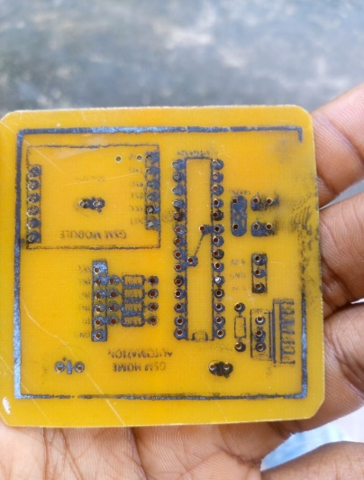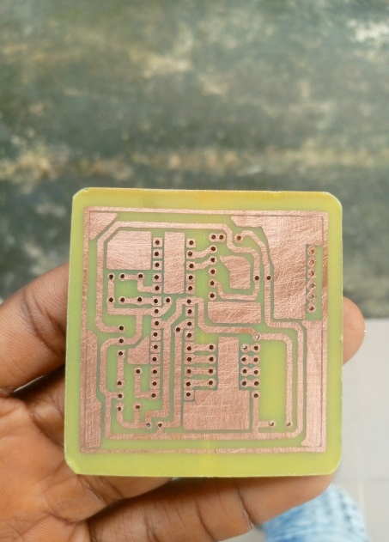

Plate 1: Front side and Back side of the PCB for the project

System Flowchart
SYSTEM POWER
GSM AWAITS SMS COMMAND
MICROCONTROLLER PROCESSING COMMAND
IS
COMMAND
VALID
RELAY ON/OFF
LOAD ON/OFF
YES
NO

Fig. 3: System Flowchart of the Project
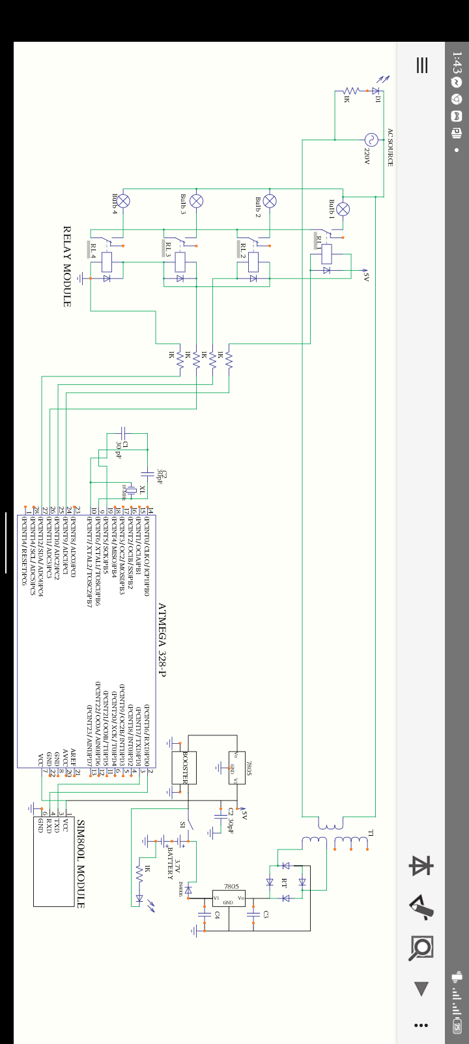

Fig. 4: Circuit Diagram of Project
Results Analysis and Discussion
Result
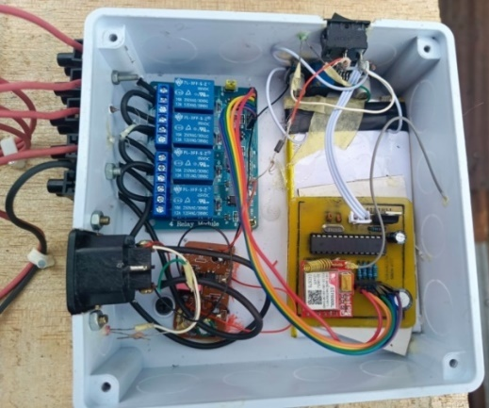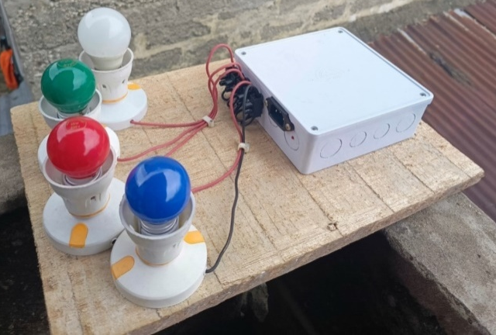
Figure 5: Complete interconnection of the project Plate 2: Picture of the Complete Project
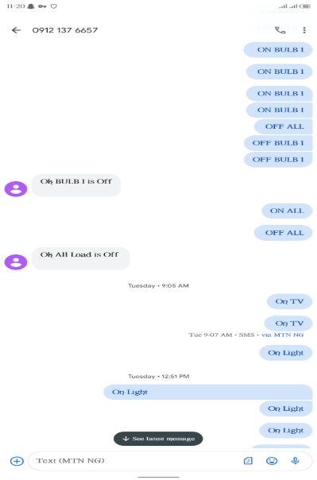
Figure 6: A picture showing some SMS sent to the system for operation
The following was observed after the construction of the system;
- SMS detection: The system successfully detects SMS sent through a mobile after the GSM module has connected to a network
- Switching Speed: The system took an average of 5 seconds to detect an SMS and switch the ON or OFF the bulbs.
- Reliability: The circuit’s ability to consistently respond to SMS commands was evaluated over multiple trials and observed that it is 90% reliable as it detects SMS commands. The Circuit’s 10% failure to recognize an SMS command is due to poor network conditions.
- Detection distance: There is no limit to the distance to which the system can recognize an SMS command. This is because it uses a GSM network.
Discussion
A smartphone was used to provide communication between an Atmega328P microcontroller and a Sim800l module through the sending of SMS. In this project sim800l module and the Atmega328P microcontroller were used for hardware implementation. It communicates with the microcontrollers using serial communication (USART), and it has a frequency of 2.45GHz. Relays are the switch that operates on electricity. It is based on electromagnetism. The switches open and close the circuits by receiving electrical signals from outside sources, as soon as the relay receives a signal from the Microcontroller it will turn on the respective electrical component. The
The sim800l module and the Microcontroller are powered by a Direct Current (DC) battery with a regulated voltage of 4 volts.
The charging module was also installed in the system to automatically charge the DC battery while it is being connected to an Alternating Current (AC) source. The number of devices to be connected depends on the number of modules in the relay.After the complete interconnection of the system, a SIM card is inserted into the GSM module as it is turned on. A red light comes on to indicate that the Sim800l module is on, it blinks as the Sim800l module connects to a network. After it connects an SMS is sent to the GSM module by a Mobile phone, and then the GSM module receives that SMS and passes it to the Atmega328 microcontroller. Now the microcontroller reads this SMS, extracts the main command from the received string and stores it in a variable. After this, the microcontroller compares this string with the predefined string (as programmed into it). If it matches the microcontroller sends a signal to the relay via the relay driver for turning ON or OFF the home appliances. When the appliances are ON or OFF the microcontroller also sends a string to the GSM module which is sent back to the Mobile phone as a response to the command sent to the system. An SMS to know the status of the appliances can be sent to the system which will respond by telling the user which appliance is ON or OFF.
This research uses 4 bulbs for demonstration which indicates different home appliances. Below is the list of messages which is sent via SMS to turn ON or OFF the different bulbs and also the response by the system;
Table 1: A table showing messages sent responses and the operation by the system.

S/N | Message | Response | Operation
1 | On Light | Ok Light is On | First Bulb On
2 | Off Light | Ok Light is of | First Bulb Off
3 | On Fan | Ok Fan is On | Second Bulb On
4 | Off Fan | Ok Fan is Off | Second Bulb off
5 | On TV | OK TV is On | Third Bulb On
6 | Off TV | OK TV is Off | Third Bulb off
7 | On Fridge | OK Fridge is On | Fourth Bulb On
8 | Off Fridge | Ok Fridge is Off | Fourth Bulb Off
9 | On All | OK All appliances are On | All Bulbs On
10 | Off All | OK All appliances are Off | All Bulbs Off

Conclusion
In this research, a low-cost, wireless and Flexible Home automation system has been designed. This system provides a more convenient way of living for individuals such that they can control their appliances by just sending an SMS. The Home Automation System is implemented using an Atmega328 microcontroller, Bulbs, Sim800l GSM module and a relay module. With the help of the System, management in classrooms may be greatly simplified and a great deal of energy can be saved. It can also be useful in large malls, and event halls. Warehouses, industries and many other locations in addition to schools and colleges.

References
Akanni, A. A., Badrudee, A. A., Oluwaseun, O. A., &Jimoh, K. O. (2018): Design and Implementing of a Microcontroller Based Auto-Switch Power Controller. International Conference on Green Energy Technology, pp. 106-109.

Anish K., Rakesh Bute and Avaneet Ranjan (2021). Control Your Home Appliances from anywhere using a Mobile Phone and a GSM module. Circuits Today. In Arduino.

Brush, A. J., Lee, Bongshin, Mahajan, Ratul, Agarwal, Sharad, Saroiu, Stefan, Dixon, Colin (2011). Home Automation in the Wild: Challenges and Opportunities. Microsoft Research.

Chip Hall of Fame (2017): Microchip Technology PIC 16C84 Microcontroller. IEEE. Retrieved September 16, 2018.

Duff, Wilmer (1916). A Textbook of Physics (4th ed.). Philadelphia: P. Blakiston’s Son & Co. p. 361. Retrieved 2016-12-01.

Harder, Douglas Wilhem (2014): A Motor with a Constant Force (Force Source). Department of Electrical and Computer Engineering, University of Waterloo. Retrieved 9 November 2014.

HayetLamine and Hafedh Abid (2014): Remote control of a domestic equipment from an Android application based on Raspberry pi card. IEEE transaction 15th international conference on Sciences and Techniques of Automatic control & computer engineering.

Heckman, D. (2008): A Small World. Smart Houses and the Dream of the Perfect day, Duke University Press, London, UK.

iControl Networks (2015). State of the Smart Home Report (PDF). Archived from the original (PDF) on 29 June 2021. (Retrieved 5 November 2020).

Jayant Mani Tripathi, Sanjeev Kumar Mallik (2023): An adaptive protection coordination strategy utilizing user-defined characteristics of DORCs in a microgrid. Electric Power System Research. Volume 214, Part A.

Krishna Rathi, Dinesh Patil, Sayli Bhavsar, Ketaki Jadhva, Prof.Saurabh V.Thakur (2017): Gesture Human-Machine Interface (GHMI) in Home Automation, in IRJET, vol. 04.

Mandula, K.; Parupalli, R.; Murty, C. A. S.; Magesh, E.; Lunagariya, R. (2015).Mobile based home automation using Internet of Things(IoT). International Conference on Control, Instrumentation, Communication and Computational Technologies (ICCICCT). pp. 340–343.

NainsiSoni, Manish Dubey:A review on Home Automation System with Speech Recongition and Machine learning in IJARCSMS, vol.5, Issued 4, April 2017.

Rout, Kshirod Kumar, Mallick, Samuchita; Mishra, Sivkuinar (2018). Design and Implementation of an Internet of Things-based Prototype for a Smart Home Automation System.International Conference on Recent Innovations in Electrical, Electronics & Communication Engineering (ICRIEECE). Bhubaneswar, India: IEEE. pp. 67-72.

Rye, Dave (October 1999). “My life at X10”. AV and Automated industyeMagazine. Archived from the \original on September 30, 2014. Retrieved October 8, 2014.

Sriskanthan, N; Tan, F.; Karande, A. (2002): Bluetooth based home automation system. Microprocessor and Microsystems. 26(6): 281-289.

Tooley, Mike (2013): Electrical Circuits: Fundamentals and Applications, 3rd Ed. Routledge. p. 81. ISBN 978-1-136-40731-4.

