Original Research Article

Socio-Economic Status and Extension Participation of Marine Fishermen in Andhra Pradesh

ABSTRACT
Aim: To assess the socioeconomic status, economic motivations, and extension participation of marine fishermen in Andhra Pradesh, and to examine the roles, linkages, and perspectives of resource managers and research experts in supporting sustainable fisheries development.
Study design: A cross-sectional descriptive study
Place and Duration of Study: The study was conducted across all coastal districts of Andhra Pradesh—Srikakulam, Vizianagaram, Visakhapatnam, Kakinada, Bapatla, and Nellore between 2023 - 2024, involving fishermen, fisheries officials, and experts from institutions.
Methodology: A comprehensive sampling design was employed to represent all stakeholder groups in Andhra Pradesh’s marine fisheries sector. Fishermen were categorized into mechanized (n = 120), motorized (n = 200), and non-motorized (n = 40) sectors to capture diverse socioeconomic conditions and practices. Additionally, 30 research experts from premier institutions Central Institute of Fisheries Technology (CIFT), Central Marine Fisheries Research Institute (CMFRI), Fishery Survey of India – Visakhapatnam (FSI), The National Institute of Fisheries Post Harvest Technology and Training NIFPHATT, Andhra University located in Visakhapatnam and C.F.Sc. in Muthukur, Nellore District further 31 fisheries officials from the Department of Fisheries were included, bringing the total sample to 421 respondents.
Result: Marine fishermen in Andhra Pradesh were predominantly middle-aged (mean 46.4 years) with substantial fishing experience (26.8 years), and 60% combined fishing with other livelihood activities. Participation in extension activities was generally low, with over 90% rarely attending field days or method demonstrations, while meetings and seminars recorded slightly higher engagement (24.9%). Economic motivation was moderate (mean score 0.52 ± 0.16), reflecting both a strong profit orientation and adherence to traditional practices.
Conclusion: The study highlights that marine fishermen in Andhra Pradesh have moderate economic motivation but limited engagement with extension services and weak linkages with resource managers and research experts. Low participation in capacity-building programs indicate gaps in knowledge transfer. Strengthening extension outreach, fostering trust, and promoting targeted training and digital tools are essential to enhance adoption of innovations and support sustainable fisheries development. Addressing these socioeconomic and institutional gaps can contribute to more equitable and resilient coastal livelihoods.
Keywords: Marine fisheries, socioeconomic status, extent of linkages, awareness, Andhra Pradesh.

1. INTRODUCTION
The marine fisheries are core to the socio-economic thriving of coastal regions (Andrews et al., 2021). They occupy a primary role in enabling people to live, feed, and contribute to the economies of nations. The State of Andhra Pradesh in India is endowed with a coastline of about 974 km and leads in marine fisheries production as well as seafood export to a large share. According to the 2010 census by CMFRI, the marine fisherman populace for 9 coastal districts of Andhra Pradesh is 605,000 with 163,000 fisherman families and 151,000 active fishermen. The fisheries sector contributes 6.04% of AP's GSDP. Overall, fish production has increased more than twofold over the last decade from 814,000 tons in 2005-06 to 2,766,000 M.T. in 2016-17 (Andhra Pradesh fisheries). Millions depend on marine resources for their living, most especially small-scale and artisanal fishermen who are largely dependent on traditional knowledge and skills (Béné, 2006). However, increasing demand for fish, combined with competition from other anthropogenic activities including overfishing, climate change, and decreasing fish stocks, gives room for modern interventions in sustainable management. Extension services are the connecting link between fishermen and scientific research through knowledge dissemination, capacity building, and support for sustainable practices (Cvitanovic et al., 2015). However, access to and effectiveness of extension services is often dependent on the level of SES of fishermen, their awareness about extension services, and the extent of linkages between these two critical stakeholders.
Fishermen, like any other group, have diverse socioeconomic profiles such that they may influence the resources available to them, the extent of their decision-making ability, and how well they have adapted to management changes in their fisheries (Charles, 1988). Education income level, and access to credit facilities are driving forces of the adoption of high-level fishing practices and compliance with required regulatory measures (Tietze, 2016). Socioeconomic disparities further result in different levels of extension participation, leaving certain segments of the population more disadvantaged. Scientific and technological advances are the innovations that extension officers make within the sector by informing fishermen about government schemes and ensuring compliance among them with guidelines for sustainable fishing (Bradley et al., 2019). Whether or not these are made functional depends highly on the relationship between fishermen and extension officers, and such relationship can be traced to socioeconomic and cultural lines.
The socioeconomic condition of the fishermen and their relation of awareness and linkages with the extension personnel should present convincing information for formulating strategic interventions (Nayak et al., 2014; Johnson, 2010). Through identifying barriers and enablers in this dynamic, policies, and extension agencies are enabled to develop strategies that not only overcome inequities and build trust but also advocate for sustainable practices in fisheries. This study pursues the objectives of three different dimensions study about Andhra Pradesh on the socioeconomic status of fishermen under marine fisheries: their education, income, asset possession, and resource accessibility; extent of linkage between fishermen and extension personnel (viz., frequency, quality and outcomes of interactions with them); and finally awareness levels of fishermen as to extension services in terms of schemes, programs, and sustainable fishing practices that extension agencies have propagated. In this way, all these objectives contribute toward a complete understanding regarding the interaction that exists among various socioeconomic factors, extension linkages, and awareness levels so that evidence-based policy recommendations are made toward developing the marine fisheries sector of Andhra Pradesh.
2. METHODOLOGY
The study employed a comprehensive sampling design to represent all stakeholder groups involved in the marine fisheries sector of Andhra Pradesh, covering the socioeconomic status, linkage, and awareness levels of fishermen and extension personnel. Geographically, the survey encompassed all coastal districts, including Srikakulam, Vizianagaram, Visakhapatnam, Kakinada, Bapatla and Nellore, ensuring complete spatial coverage.
Fishermen were categorized into three sectors—mechanized, motorized, and non-motorized—to capture the diversity of socioeconomic conditions and practices. The mechanized sector included 120 respondents, with representation from major fishing harbors: Visakhapatnam (60), Kakinada (40), and Nizampatnam (20) in Bapatla district. The motorized sector comprised 200 respondents, proportionately sampled across districts according to the distribution of different fishing crafts and landings, ensuring coverage of varied socioeconomic profiles. The non-motorized sector, representing traditional fishing practices, included 40 respondents primarily from Srikakulam and Prakasam districts, where such activities are concentrated.
The research and extension system perspective was captured through 61 respondents. Thirty experts were purposively selected from premier institutions, including CIFT, CMFRI, CIFE, FSI, NIFPHATT, Andhra University, and C.F.Sc. – Muthukur, based on their specialized knowledge in fisheries research and development. The remaining 31 respondents were randomly sampled officials from the Department of Fisheries across diverse districts, providing a balanced administrative viewpoint.
This design ensured representation of all relevant stakeholder groups—fishermen, extension personnel, and research and development agencies—allowing for a holistic assessment of socioeconomic conditions in marine fisheries. Data analysis involved percentage calculations to determine the distribution of responses, while weighted mean scores were used to quantify perceptions of stakeholders regarding different study items. This methodology enabled a nuanced understanding of the interactions, priorities, and conditions prevailing across the marine fisheries sector in Andhra Pradesh, providing a robust basis for informed policy recommendations and targeted interventions.
3. RESULTS AND DISCUSSION
The demographic analysis revealed that resource users were older (mean age 46.4 years) with considerable fishing experience (26.8 years), whereas resource managers were younger (35.8 years) with relatively less experience (8.4 years). A majority of resource users combined fishing with other occupations (60.4%), reflecting livelihood diversification. Gender distribution indicated male dominance across groups, with females constituting about one-fourth of the respondents. In terms of time utilization, resource managers focused more on administration (28.9%) and implementation of departmental schemes (28.8%), while research experts devoted greater attention to applied research (27.3%) and teaching (18.8%). The study also shows how middle-aged people dominate this sector, with the average age of fishermen recorded at 46.4 years, reflecting the age dependency of fishing practices across generations. Among resource users, a combination of fishing and other activities was common, which demonstrates that while fishing remains a significant livelihood resource, it is not sufficient for sustaining households. Similar findings were noted by Immanuel et al. (2006),

Table 1: Socioeconomic profile
Demographic factors |  | Mean
 |  | Resource users | Resource managers | Research experts
Age |  | 46.4 ± 8.1 | 35.8 ± 6.9 | 48.1 ± 9.3
Gender | Female |  | 27.3 | 26.7
Gender | Male |  | 62.7 | 73.3
Experience |  | 26.8 ± 16.2 | 8.4 ± 4.8 | 20.1 ± 9.4
Occupation | Only Fishing | 39.6
Occupation | Fishing + Others | 60.4
Time utilization pattern (%) | Training |  | 5.3 ± 6.8 | Basic research | 13.0 ± 7.61
Time utilization pattern (%) | Implementation of departmental schemes |  | 28.8 ± 15.8 | Applied research | 27.3 ± 15.3
Time utilization pattern (%) | Input supply/credits |  | 12.9 ± 7.9 | Analytical work | 9.5 ± 6.7
Time utilization pattern (%) | Providing infrastructural facilities |  | 10.7 ± 6.1 | Consultancy services | 7.1 ± 7.1
Time utilization pattern (%) | Administration |  | 28.9 ± 20.7 | Extension/Training | 12.2 ± 17.0
Time utilization pattern (%) | Teaching |  | 5.3 ± 8.8 | Teaching | 18.8 ± 23.1
Time utilization pattern (%) | Research |  | 3.2 ± 7.6 | Administration | 12.7 ± 14.6
Time utilization pattern (%) | Other extension works |  | 5.8 ± 6.2

The demographic characteristics, professional background, and time utilization patterns of resource users, resource managers, and research experts involved in marine fisheries in Andhra Pradesh reveal distinct profiles that highlight their varying roles and experiences (Table 1). The average age of resource users is 46.4 years and that of resource managers and research experts is comparatively younger at 35.8 years and older at 48.1 years respectively. Gender distribution among resource managers shows higher representation of men (73.3%) than women (26.7%) (Figure 1).
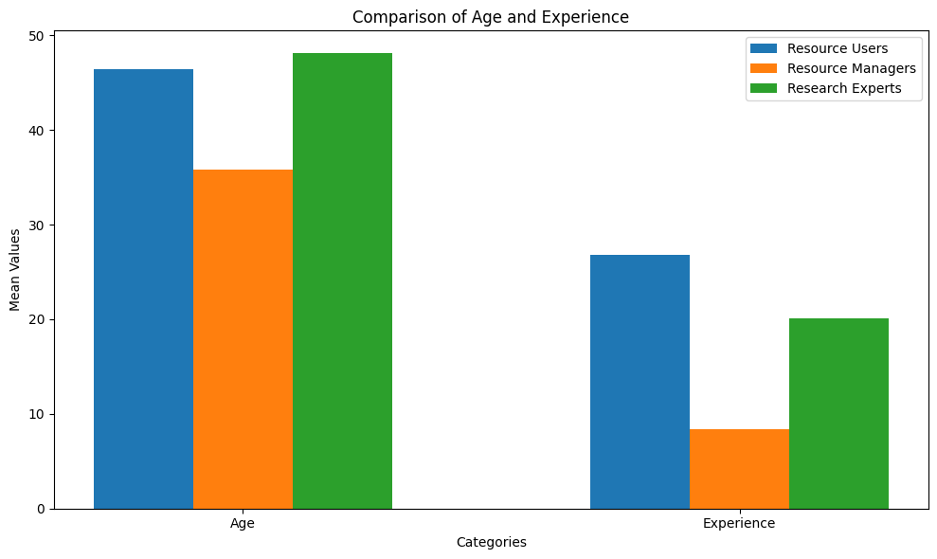
Figure 1: Bar graph showing the difference in age and experience among the resource users, resource managers, and research experts

A vast majority of resource users, that is, approximately 60.4%, engage in fishing along with other economic activities, while the remaining 39.6% derive income only from fishing (Figure 2). Varying professional experiences are evident, whereas resource users have an average of 26.8 years, research experts spend an average of 20.1 years, and resource managers, on the contrary, are at an average of 8.4 years (Figure 1).
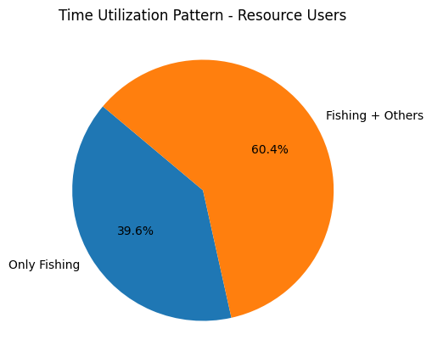
Figure 2: Pie diagram showing the time utilization pattern of resource users
Stakeholders spend an almost equal share of resource management time on administration (28.9%) and implementation of departmental schemes (28.8%) while imputing supply (12.9%) and provisioning of infrastructures take lower proportions of time at 10.7% (Figure 3). On the other hand, major portions of working time for research experts are accounted for applied research (27.3%), teaching (18.8%), and basic research (13.0%). Very little time is allocated by both groups to research-specific activities of consultancy (7.1%) and analytical works (9.5%), indicating a very limited integration of research into practical applications. Thus, these findings show that there are need for strengthening cooperation and targeted capacity-building initiatives to harmonize the activities of fishermen, extension personnel, and research experts for sustainable development of the marine fisheries sector.
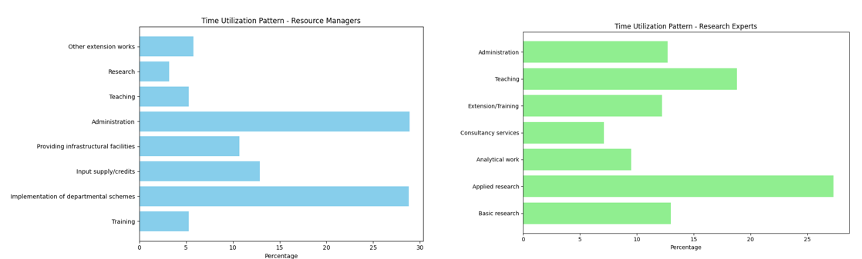
Figure 3: Bar diagram showing the time utilization pattern of resource managers and research experts

Table 2 Economic Motivation of Resource Users-Weighted Mean Scores
Statements | Response Option | Frequency | Unit mean score
One should always try for more catches and better returns | Strongly agree | 65.6 | 0.29 ± 0.15
One should always try for more catches and better returns | Agree | 29.0 | 0.29 ± 0.15
One should always try for more catches and better returns | Undecided | 2.2 | 0.29 ± 0.15
One should always try for more catches and better returns | Disagree | 1.9 | 0.29 ± 0.15
One should always try for more catches and better returns | Strongly disagree | 1.4 | 0.29 ± 0.15
The most successful fisher is one who makes the maximum profit | Strongly agree | 35.5 | 0.36 ± 0.15
 | Agree | 57.7 | 0.36 ± 0.15
 | Undecided | .3 | 0.36 ± 0.15
 | Disagree | 6.0 | 0.36 ± 0.15
 | Strongly disagree | .5 | 0.36 ± 0.15
Higher-income is not the ultimate good thing to be aimed at in life | Strongly agree | 8.4 | 0.61 ± 0.24
 | Agree | 38.2 | 0.61 ± 0.24
 | Undecided | 12.2 | 0.61 ± 0.24
 | Disagree | 32.8 | 0.61 ± 0.24
 | Strongly disagree | 8.4 | 0.61 ± 0.24
Even though the returns are average, one should be happy with his traditional ways of occupation | Strongly agree | 27.1 | 0.66 ± 0.28
 | Agree | 27.4 | 0.66 ± 0.28
 | Undecided | 5.4 | 0.66 ± 0.28
 | Disagree | 30.1 | 0.66 ± 0.28
 | Strongly disagree | 10.0 | 0.66 ± 0.28
One should always seek new methods to improve income and standard of living | Strongly agree | 43.6 | 0.64 0.32 ±
 | Agree | 46.6 | 0.64 0.32 ±
 | Undecided | 4.6 | 0.64 0.32 ±
 | Disagree | 5.1 | 0.64 0.32 ±
Income for the sustenance of life is enough, and trying to get more is greediness | Strongly agree | 10.6 | 0.55 ± 0.23
 | Agree | 19.2 | 0.55 ± 0.23
 | Undecided | 7.9 | 0.55 ± 0.23
 | Disagree | 58.5 | 0.55 ± 0.23
 | Strongly disagree | 3.8 | 0.55 ± 0.23
 | Overall all mean score |  | 0.52 ± 0.16
The economic motivation for each statement Coding was given Positive Statements: "Strongly Disagree" (1), "Disagree" (2), "Undecided" (3), "Agree" (4), "Strongly Agree" (5); and for Negative Statements Reversed Code.
Resource user draws others their representations of attitudes, from which they seek income and occupational worth (Table 3). The earlier statement `One should try, as at all times, for more catch and better returns" was a strong belief possessed by 65.6% of the respondents which translates into high economic drive reflecting a unit mean score of 0.29 ± 0.15. Likewise, 93.2% strongly affirmative or affirmative everything suggested regarding "The most successful fisher is who makes the maximum profit," emphasizing the essence of profitability, with a mean score of 0.36 ± 0.15. In contrast, there also appear traditional and conservative views about the matters because, for example, although 54.5 percent agreed that "Even though the yields are ordinary, one should be satisfied with his traditional ways of occupation," 40.1 percent disagreed, showing a mix of opinion towards modern practices and old practices. Exactly, however, 90.2 percent agreed that "Someone should always try to adopt other methods of improving income and standard of living," having a very high mean score of 0.64 ± 0.32 upholding openness to innovation for economic advancement. Interestingly, the statement "Higher income is not the ultimate good thing to aim for in life" saw a split in response, with 46.6% agreeing and 41.2% disagreeing, suggesting quite nuanced perspectives about how to balance this with other priorities in life. The least support was given to the proposition that "Income for the sustenance of life is sufficient; seeking more is greed," with only 29.8 percent agreeing and a mean score of 0.55 ± 0.23, which indicates a general aspiration towards economic growth that is felt by the populace. A general average score of 0.52 ± 0.16 reflects a mass of economic motive among users of resources, thus mixing ambition for a higher amount and traditional values. Overall, though, the mean score of 0.52 ± 0.16 indicates an economic motivation among resource users at the moderate level accompanied by a mix of aspiration for better earnings and respect for traditional values.
Table 3: Extension Participation of Resource Users (Normalized Unit scores)

Extension participation
 | Response Option | Frequency (%) | Unit mean score
Field days | Occasionally | 2.2 | 0.33 ± 0.01
Field days | Rarely | 97.6 | 0.33 ± 0.01
Method demonstrations | Regularly | 3.0 | 0.37 ± 0.13
Method demonstrations | Occasionally | 5.1 | 0.37 ± 0.13
Method demonstrations | Rarely | 91.6 | 0.37 ± 0.13
Training programmes | Regularly | 7.3 | 0.46 ± 0.21
Training programmes | Occasionally | 24.4 | 0.46 ± 0.21
Training programmes | Rarely | 68.0 | 0.46 ± 0.21
Meetings/ Seminars | Regularly | 24.9 | 0.72 ± 0.18
Meetings/ Seminars | Occasionally | 66.7 | 0.72 ± 0.18
Meetings/ Seminars | Rarely | 8.1 | 0.72 ± 0.18
Exhibitions | Regularly | 2.2 | 0.37 ± 0.12
Exhibitions | Occasionally | 5.7 | 0.37 ± 0.12
Exhibitions | Rarely | 91.9 | 0.37 ± 0.12
Tours | Occasionally | 3.8 | 0.35 ± 0.07
Tours | Rarely | 95.9 | 0.35 ± 0.07
 |  | Overall score | 0.43 ± 0.047

The normed unit scores show that the participation of resource users in extension activities has little involvement in capacity building (Table 4). Participation in field days is particularly low: 97.6% of users attend such events infrequently, leading to a mean attendance score of 0.33 ± 0.01. This demonstrates minimal engagement with such initiatives. Method demonstration also indicates low regular attendance (3.0%), a result of 91.6% having infrequent involvement, and thus arrives at a mean attendance score of 0.37 ± 0.13. Meanwhile, training also portrays slightly better attendance, as 7.3% of the respondents were able to attend regularly, while 24.4% were found to have this program for such attendance occasionally; thus, creating a higher mean score of 0.46 ± 0.21. Meetings and seminars pertain to the most attended activities with 24.9% of the study respondents attending regularly, while 66.7% attended them occasionally, scoring thus a higher mean of 0.72 ± 0.18. On the contrary, exhibitions and tours are rainy very poor participation, where 91.9% and 95.9% of the respondents rarely attend the events, respectively, gathering mean scores of 0.37 ± 0.12 and 0.35 ± 0.07. The overall extension participation score of 0.43 ± 0.047 shows the low extent to which participants were involved in extension activities, hence necessitating focused and time-rich strategies to leverage more outreach and ingrained resource user involvement in these programs for better skills transfer/adoption of sustainable practices.
Conclusion
The study presents a detailed analysis between fishermen and extension personnel with respect to their socio-economic status, linkages, and awareness levels in the marine fisheries sector of Andhra Pradesh. It clearly specifies the gaps in communication, participation, and sustainable practices adopted by resource users against a background where economic limitations, age-old fishing technologies, and low education render them unable to adopt practices. It shows how low participation in extension activities, coupled with poor awareness about fishing legislation and sustainable practices, indicates the need for targeted interventions. The findings also underscore the increasing relevance of digital communication platforms, which provide the opportunity to bridge those gaps. In spite of the economic motivation behind the desire to adopt innovations, mistrust and hesitation toward new practices require trust-building programs and demonstration of apparent benefits. Differences in linkage strength among these stakeholders revealed that resource users have weaker linkages in comparison to resource managers and experts, thus calling for establishing stronger and more permanent relationships for effective fisheries management. Furthermore, comparison with the 2016 survey data shows an improvement in terms of communication infrastructure and membership to cooperatives, but technology adoption, training, and regulatory compliance still left a lot to be desired. There must be a holistic approach to participation in capacity-building programs, use digital tools for outreach, and an alignment of economic aspirations with that of sustainability. Building effective links with fishermen, extension personnel, and research experts will go a long way in providing more equitable and sustainable fisheries development. Addressing the systemic challenges reflected in this study is important for ensuring that marine fisheries in Andhra Pradesh are not only sustainable but also environmentally friendly for the socioeconomic development of fishing communities.
DISCLAIMER (ARTIFICIAL INTELLIGENCE)
Author(s) hereby declare that findings, interpretations, and conclusions presented in this study are those of the authors. No AI-generated content has been used in the writing of the manuscript.

References
Andrews, N., Bennett, N. J., Le Billon, P., Green, S. J., Cisneros-Montemayor, A. M., Amongin, S., & Sumaila, U. R. (2021). Oil, fisheries and coastal communities: A review of impacts on the environment, livelihoods, space and governance. Energy Research & Social Science, 75, 102009.
Andhra Pradesh fisheries. https://fisheries.ap.gov.in/fisheries/marine-fisheries-in-andhra-pradesh-state
Béné, C. (2006). Small-scale fisheries: assessing their contribution to rural livelihoods in developing countries (Vol. 1008, pp. 1-57). Rome, Italy: Food and Agriculture Organization of the United Nations.
Cvitanovic, C., Hobday, A. J., van Kerkhoff, L., Wilson, S. K., Dobbs, K., & Marshall, N. A. (2015). Improving knowledge exchange among scientists and decision-makers to facilitate the adaptive governance of marine resources: a review of knowledge and research needs. Ocean & Coastal Management, 112, 25-35.
Charles, A. T. (1988). Fishery socioeconomics: a survey. Land economics, 64(3), 276-295.
Tietze, U. (2016). Technical and socio-economic characteristics of small-scale coastal fishing communities, and opportunities for poverty alleviation and empowerment. FAO Fisheries and Aquaculture Circular, (C1111), I.
Bradley, D., Merrifield, M., Miller, K. M., Lomonico, S., Wilson, J. R., & Gleason, M. G. (2019). Opportunities to improve fisheries management through innovative technology and advanced data systems. Fish and fisheries, 20(3), 564-583.
Nayak, P. K., Oliveira, L. E., & Berkes, F. (2014). Resource degradation, marginalization, and poverty in small-scale fisheries: threats to social-ecological resilience in India and Brazil. Ecology and Society, 19(2).
Johnson, D. S. (2010). Institutional adaptation as a governability problem in fisheries: patron–client relations in the Junagadh fishery, India. Fish and Fisheries, 11(3), 264-277.
Immanuel, S., Kanagasabapathy, K., & Balasubramaniam, S. (2006). Analysis of the linkages between fishermen and extension personnel in marine fisheries in Kerala. Fishery Technology, 43(2), 230-235.
Gadde, S. H. (2024). Participation of Fisherwomen in Marine Fisheries in Andhra Pradesh. Indian Res. J. Ext. Edu. Vol 24, No. 4.
Deepthi, A., SUJATH KUMAR, N. V., Aruloli, G., Rajkumar, M., Rani, V., & Sudhakar, O. (2024). AWARENESS OF SHRIMP FARMERS ON PRIVATE EXTENSION SERVICES-AN EMPIRICAL MODEL FOR EFFECTIVE EXTENSION SERVICES IN ANDHRA PRADESH, INDIA. Applied Ecology & Environmental Research, 22(1).
Bhargavi, K., Chirwatkar, B. B., Das, A., Behera, S., & Bhakta, D. (2020). Socio-economic status of fisherwomen community in coastal Vizianagaram district of Andhra Pradesh, India. Journal of Fisheries, 8(1), 741-745.
Kumar, K. S. N. P., & Ansari, M. A. (2023). Documenting and Analyzing Targeted Interventions of State Fishery Department of Andhra Pradesh, India. Asian Journal of Agricultural Extension, Economics & Sociology, 41(10), 666-675.
Jacob, M. J. K., & Rao, P. B. (2016). Socio-ecological studies on marine fishing villages in the selective south coastal districts of Andhra Pradesh. Ecotoxicology and Environmental Safety, 134, 344-349.

