Examining the Sleep Patterns Across Age Groups of Ballari city

ABSTRACT
The study carried out on the sleep patterns of the different age groups of the people of Ballari city. Sample size 100 people. 25 male and 25 female of each group of 1-18, 95 people male and female for 19-45, 46-60 and above 60 age group were subjected to asking questions using survey method. Data collected for 1-18 years revealed that male have more response to sleep than females, mobile utilization is extremely high in females than males in the same group. Between 19-45 reveled that both male and female have shown similar response. Between 46-60 group male have less response than female due to stress and occupational stress. Above 60 age male sleep good than females as female watch more TV serials however they us less mobiles. In males no significant correlations were noticed between health status and sex or subjective quality. Further study helps to overcome from the psychosomatic diseases, physcological disorders like sleep apnea, parasomnias, sleep –wake disorders and some other physiological conditions.

Key words: Sleep, Ballari city, Age groups, Mobile use, Insomnia

INTRODUCTION

Although Human humans spend one-third of their lives for sleep but know very little about sleep. However, its function remains to be fully elucidated, sleep is a universal need are reduced and also in general many of our physiological functions are quite variable when we are awake [B]. Of all higher life forms including humans, absence of which as serious physiological consequences.
No behavior so regular and pervasive characterizes our daily life and is yet so little understood as sleep. sleep duration for older adults (46–60 years), 7 hrs or more /night (18–45 years), an even longer duration (>9) is considered appropriate . Mental performance and functions are greatly influenced by the sleep. Sleep greatly influences mental function, and thus, affects performance. Lack of sleep reduces the general alertness, lack of attention (Abdullah et.al, 2019).
Sleep has an important role in human lives. Many researchers have been attempted to study about the sleep circadian rhythms throughout the world. The following papers emphasize the sleep quality, durations, patterns, strategies, food habits, health, effects, disorders and also problems associated with sleep disturbance. Some of reports which are related to the present study are reviewed in this project.
The sleep is an actively regulated process significantly modulated by homeostatic influences that accumulate during ongoing wakefulness and dissipate during sleep and by circadian effects entrained to the 24-hour day David et al., (2016). Metabolism and glucose homeostasis are being influenced by sleep and wake cycle that inturn characterized by distinct hormonal patterns. Stress, depression and anxiety were associated with poor sleep habits Abdullah et al., (2019). Intricate interactions between physiological, behavioral and environmental factors that contribute to sleep and circadian rhythm disturbances in ICU patients Telias et al., (2019). Low quality, distressing, relationships with poorer sleep Amie et al., (2020). The designing for daylight is not only beneficial for buildings that house the sick, but also imparts substantial health benefits for the general population. These benefits of daylight should be considered by developers and architects when designing buildings intended to be human-centered Rohan Nagare et al., (2021).
Study area and Methods
The study area comprised of Ballari. Ballari is officially pronounced as Ballari is a major district in Karnataka it is located at north eastern part of Karnataka. This district belongs to Hyderabad Karnataka .This district was one of the biggest district in Karnataka until the Vijayanagara district was curved out of Ballari district in 2020. In Ballari the area include outpatient door Vidyanagar, Daramill, Gautamnagar, Cantonment, Patel nagar, Belgal cross, Cowl bazaar, Siddharth colony, Kappagal road, Best school, Allipur were the latitude is 15.1394 o N and longitude is 76.9214º E and mean maximum temperature is 31℃ humidity is 23%.we randomly selected these areas to collect the data related to sleep quality. We randomly selected the above areas to study a preliminary survey of sleep quality in Ballari district.
Plate.1 Map of Ballari District Showing Study Area
Results and Discussion
The sleep survey was conducted in Ballari city, VSK University surrounded, Allipur, Daramill, Vidyanagar, Cowl bazaar, Belagal cross, Cantonment, Ashok nagar in the year 2022. The questionnaire method was used to collect the data related to the sleep quality survey. There were 50 questions and surveyed with 400 individuals to know about the present status related to an individual’s sleep quality based on different parameters. The total survey data presented in graphs 1, 2, 3 & 4 respectively.
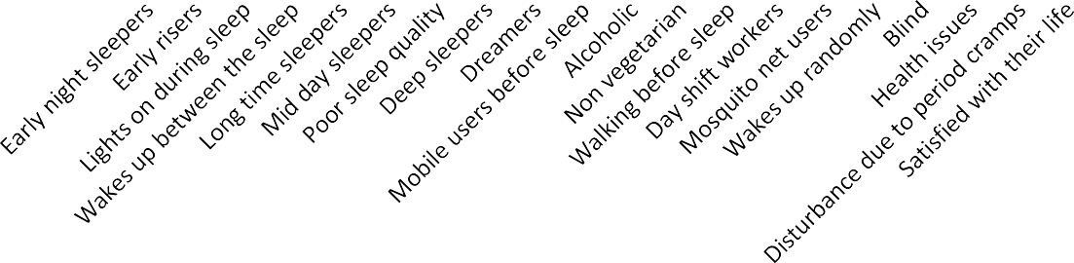
Age group 1-18 years
30
2255
25
25 23
24
20
21 21 21
18 191198
19
17
1717
15
15
1615
10
10
9 9
8
7
10
6
11
8 8
11
67
7
78
9
7
8
17
14
10
8
5
4
5
2
2
5
3
3
0
Male Female
Graph.1: Depicting comparative analysis of various parameters from participant’s survey of sleep quality in male and females.
Considering the different parameters of sleep quality by taking different categories on the X- axis and number of individuals in male and female sleep status on Y-axis respectively. The survey was estimated out of 50 individuals, the number of individuals (i.e., 25 males and 25 females) has participated into the consideration. Among 50 individuals the number of variations found according to the different parameters that were depicted in graph-1. The age group between 1-18 years the early night sleepers were greatly peaked in males, whereas in case of females it shows least character in their sleep due to stress, medications etc. Females show more response to sleep in late nights. And males have the more response to good sleep quality whereas, females have least response because of their household activities and period cramps which may disturb between the sleep. Although on condition to Utilization of mobiles in females were extremely high compare to males, in similar case the manipulation of using Social Medias, internets were least in estimation. Except these all other parameters show the similar responses. Evan et al, (2012), sleep hygiene education programmed might be effective in improving sleep in children and adolescence.

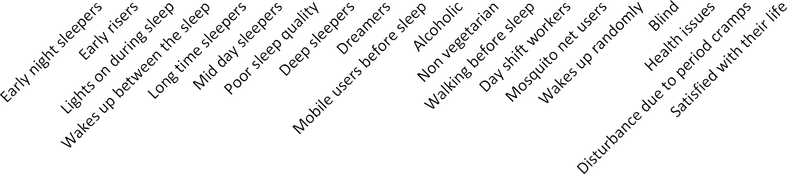
90
80
70
60
50
40
30
20
10
0
Age group 19-45 years
82
75
69
58 56 53
4748
6620 59
59
6674
393742
50
4445
57
4458
6601
58
6635
57
63
57
65
60
51
43
54
56
335
40
41
3354
38
33
3632
3838
22
26
23
112314
18
1153
29
2021
11
3311
23
15
10
16
0
0
male female
Graph.2: Depicting comparative analysis of various parameters from participant’s survey of sleep quality in male and females.
Under the age group of 19-45 years the number of individuals were 95 males and 95 females had participated into the consideration. Among 190 individuals under this age group frequently more number of variations are seen according to different parameters that were depicted in graph-2. The age group between 19-45 years the mobile users are recorded more in both males and females. And the males are high in response to non-vegetarian food habit because, now days youngsters having more conscious towards fitness, strengthening muscles, fast growth. It is observed that the males it is more number in consumption of alcohol due to stress, love failures, depression etc., Rest of all parameters have shown similar responses. Abdul Rahman (2022) there is a weak relationship between the social media, depression, anxiety and poor sleep quality.

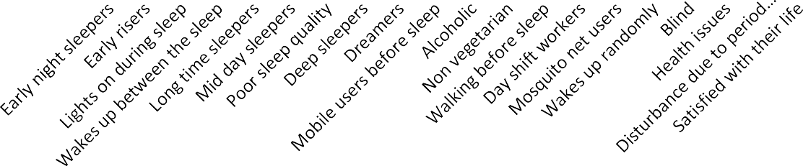
Age group 46-60 years
60
50
40
30
20
10
0
4478 49
40
48
42
30
20
16
10
1
3436
33
2299
2211
4464
39
29
32
33
28 28
22
29
26
14
17
21 21
16
20
12
23
18
20
16
39
31 34
28
23
18
57
15
11
9
13
4 5 5
21
15 15
8
1
111131
1
0
1
male female
Graph.3: Depicting comparative analysis of various parameters from participant’s survey of sleep quality in male and females
Under the age group between 46-60 (Graph -3) the number of individuals are 50 males and 50 females has participated in into the consideration. Among 100 individuals the variations are depicted in the graph-3.The age group between 46-60 it has observed that, males are high in response to difficulty in falling sleep due, to their work tensions, finances and family keep their mind active at night. Night shift workers are seen more in case of males because of the financial problems that drive men to work even in night times. Females response is more towards the satisfaction with their life, as the females under this age group stay home almost and they don’t have any pressures, tensions or the financial pressures. Soon- Yeob et al, (2015), the men with more alcohol consumption suffer from overall poor sleep quality, experience difficulty in maintaining sleep, rather than falling asleep, in case of female show average results in waking up randomly owing to menstrual problems or night sweats and night flashes.

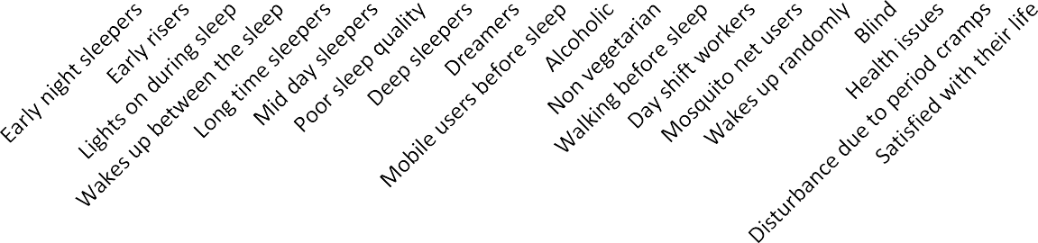
Age group above 60 years
35
30
2299
25
25
23
26
24
24
25
20
21
21
20
2211
20
19
19
16
14
17
17
15
15
15
12
13 13
12
13
12
13

10
10
8
11
11
12
9 9 99
10
9
5
6
6 6
7
6
6 6
6
7
5
4 4
5
5
3
4
2
2
0
1
0
Male Female
Graph.4: Depicting comparative analysis of various parameters from participant’s survey of sleep quality in male and females.
Graph-4 shows the equal proportions and variations in all cases of different parameters in both male and females considering the duration of sleep, health issues, diseases due to sleeplessness. All males and females uner this age group do not tend to work outside as they have lost their strength. Hence, they stay home and have zero pressures and problems. All males and females are facing number of health issues. The males show highest number in good sleep quality whereas, in females they tend watch serials and all the television shows hence, they sleep less. The old age people in our survey has shown no usage of mobile phones as they have less knowledge towards internet and illiterates. Julie et al, (2001), increasing age may be attenuation of homeostatic sleep pressure and to an increase in cortical activation during sleep.

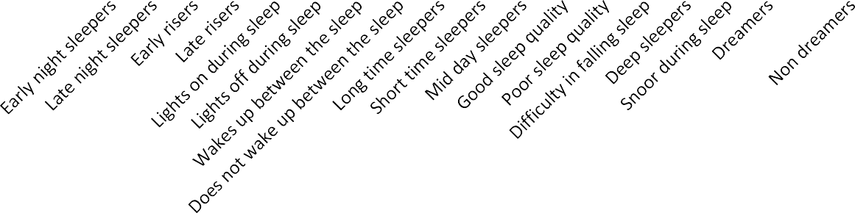
0-18years(Total male-25 Total female-25) Male
0-18years(Total male-25 Total female-25) Female
19-45 Years(Total male-95 Total female-95) Male
19-45 Years(Total male-95 Total female-95) Female
46-60Years(Total male-50 Total female-50 Male
46-60Years(Total male-50 Total female-50 Female
Above 60 Years(Total male-30 Total female-30 Male
80
70
60
50
40
30
20
10
0
Above 60 Years(Total male-30 Total female-30 Female
  - Graph 5: Depicting overall analysis of various parameters from participants survey of sleep quality in male and females.
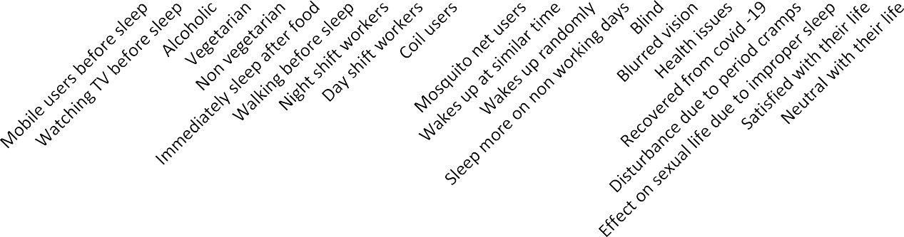
0-18years(Total male-25 Total female-25) Male
0-18years(Total male-25 Total female-25) Female
19-45 Years(Total male-95 Total female-95) Male
46-60Years(Total male-50 Total female-50 Male Above 60 Years(Total male-30 Total female-30 Male
90
19-45 Years(Total male-95 Total female-95) Female
46-60Years(Total male-50 Total female-50 Female Above 60 Years(Total male-30 Total female-30 Female
80
70
60
50
40
30
20
10
0
Graph.6: Depicting Overall comparative analysis of various parameters from participant’s survey of sleep quality in male and females
In graph-5 and 6 on considering overall 400 individuals were surveyed, the percentage of early night sleepers was increased proportion under the age group1-18 years. The maximum participants in survey has been showed increased usage of cell phones, watching TV, early sleepers, waking up randomly, alcoholic consumptions in both males and females. Lim (2022) studied that the usage of social media would not lead to mental health among youngsters. Except old age people the females are more number in response to health issues under age group between 19- 60 Individuals. Jay et al.,(2015) reported that, early sexual maturation as a core component linking early adversity and stress physiology with poor health later in life in females. From children to adults are having high response in usage of mobile phones. Shabnoor et al.,(2016) studied that youngsters are seen in contact with social media regularly which affects people negatively.
And the non-vegetarians are high in males among all the age group due, to the several health benefits, fast growth, strengthening muscles. Sanjay Borude (2019) has studied that, All vegetarian diets are healthy diets, findings utilized to discourage refined and processes food consumption and promote healthy vegetarian food choices. Overall, old age peoples reported significantly poor quality of sleep, more night time awakenings, less frequent napping. The number of night time awakenings increased significantly with age only in males. In males noo significant correlations were found between health status and sex or subjective quality. The most frequently reported causes of disturbed sleep onset and sleep maintenance were worries and nocturia respectively. Subjective quality of sleep was mostly associated with self estimated sleep latency, Middelkoop et al, (1996) sleep disorders are common generally in elderly population. In other case the survey has been estimated that there was no relation between the sleep quality and the age, sex, alcohol consumption, medications, usage of mobile phones. Yilmaz et al.,(2017) Students who do not smoke, sleeps 6-7 hours per day and consuming beverages with less caffeine have better sleep quality of sleep

Conclusion
The survey serves to understand the sleep quality among different individuals in Ballari City. A good respondent were found under respective survey. The estimated survey reveals that males reported most frequent alcoholic habits under all the age group except 1-18 years due to tensions, family pressures, love failures etc. Whereas in case of females owing to various medications, stress, menstrual cramps, household activities etc. were the reasons for waking up randomly during night times.
Regarding the usage of mobile phones in all the age groups except above 60 years were reported high number of responses as they are more technologically advanced, and can find solutions situations which would have otherwise been difficult. The old age people lack to lay behind because their interest has been reduced in such aspects like usage of internets and its gadgets etc.
Thus the survey concluded that sleep plays an important vital role in all living creatures on the earth. In the light of this research we could infer that more than half of the individuals have low sleep quality. It is reported that sleep is important in terms of the health of young adults and it was said that young people need sleep for an average of 9-10 hours. In present study who wakeup early and sleeping 6-7 hours per day have good sleep quality and it is known that alcohol which has Negative effect and it is known that alcohol intake before sleep especially makes it difficult to fall asleep and affects the sleep quality negatively. Hence by this survey we came know that how sleep is important in human life and also our survey helped us to know how is the sleep status of people in Ballari city. As it is a preliminary survey, it helps to know the effects of sleep deprivation. Further study helps to overcome from the psychosomatic diseases, psychological disorders like sleep apnea, parasomnias, sleep –wake disorders and some other physiological conditions. And also helps to illiterates, farmers, some other occupational workers to know the sleep related disorders they are facing due to, their day and night continues work pressures.
Declarations
- Ethics approval and patient consent to participate.
There are no animal studies nevertheless respondents have given consent to participate
- Patient Consent for publication: Respondents have consent for publication
- Animal Studies: Not Applicable
- Conflict of interest: There are no conflicts of interest among the authors
- Availability of data and materials: Data is provided on request.
- Clinical trial registry number: Not applicable
- PROSPERO registry number: Not applicable

References:
- Abdullah Murhaf A-khani, Muhammad Ishaque Sarhandi, Mohamed Saddik Zaghloul, Mohammed Ewid, And Nazmus Saquib,(2019) A cross- Sectional Survey On Sleep Quality, mental health, and academic performance among medical students in Saudi Arabia. https;//Doi.org/10.1186/s13104-019-4713-
- Amie M Gordon, Belinda Carrillo, Christopher M Barnes.(2021) Sleep and Social Relationships In Healthy Populations .Sleep Medicine Reviews 57,101428,
- David W. Carley and Sarah S.farabi. (2016). Physiology of sleep. Doi:10.2337/diaspect.29.1.5
- Evan T, Dione Healey, Andrew R Gray and Barbara C Galland.( 2012) Sleep hygiene intervention for youth aged 10 to 18 years with problematic sleep: a before –after pilot study.http://www.biomedicentral.com/1471- 2431/12/189.
- Jay Belsky, Paula L Ruttle, W Thomas Boyce, Jeffrey M Armstrong, Marilyn J Essex.(2015) Early adversity, elevated Stress physiology, accelerated sexual maturation , and poor health in females.
- Lim S I. (2022) Social Media And Its Association With Poor Sleep Qulity, Depression And Anxiety among Youngsters.
- Middelkoop H A M, Dini A, Smilde-Van den Doel, (1996) Sleep Disorders are Common in the Generally Elderly Population. Journal of Geroniogy :MEDICAL SCIENCES , Vol.51A. N0.3 ,M108-M115.
- Nagare R, May Woo, Piers MacNaughton, Barbara pitnick, Brandon Tinianov and Mariana Figueiro.(2021) Access to Daylight at Home Improves Circadian Alignment, Sleep , and Mental Health in Healthy Adults : A Crossover Study . International Journal of Environmental Research and public Health. https://doi.org/10.3390/ijerph18199980.
- Sanjay Borude. (2019) Which is a Good Diet –Veg or Non-veg Faith-Based Vegetarianism for Protection From Obesity—a Myth or Actuality.
- Shabnoor Siddiqui and Tajinder Singh. (2016) Social Media its Impact With Positive and Negative Aspects. International Journal of Computer Applications Technology and Research Volume 5-Issue2, 71-75, ISSN: 2419-8656
- Soon –Yeob Park , Mi-Kyeong Oh And Jin Young Kim. The Effects of Alcohol ON Quality Of Sleep.
- Telias I and Mary Elizabeth Wilcox. (2019) Sleep and Circadian Rhythm in Critical illiness.
- Yilmaz C K, Sevgisun Kapucu (2017) The Effects of Progressive Relaxation Exercises on Fatigue And Sleep Quality in Individuals With COPD. DOI:10.1097/HNP.000000000000234.
- C] https://www.ncbi.nim.nih.gov

