Original Research Article
Proximate and Mineral composition in Commonly Consumed Diets within North Central Zone of Nigeria

ABSTRACT
Proximate composition refers of the major components of a food sample such as moisture, protein, fat, carbohybrate and ash while minerals are chemical elements required as an essential micronutrient by organisms (livestock and humans) to maintain sound health. This study was aimed at evaluating the proximate and mineral composition in commonly consumed foods within the North-central district of Nigeria. The region comprise of six states namely; Benue, Nasarawa, Kogi, Kwara, Plataeu, Niger and the Federal capital territory, Abuja. A survey was first conducted to obtain the commonly consumed foods within the region using structured questionnaire. From the outcomes of the questionnaire, the various food samples were collected from each state and analyzed for proximate and mineral contents using standard laboratory techniques. The survey revealed the commonly consumed foods in the north-central region of Nigeria to include Ginger, Bambara Nut, Beans, Cassava, Corn Flour, Salt, Sugar, Egusi, Tomatoes, Pepper, Locust Beans, Yam, Rice, Seasoning Cubes, Fish, Crayfish, Dried Okra, Ugwu, Meat, Moringa, Onions, and Kuli-kuli. The results revealed the highest percentage composition of Carbohydrates, crude fats and ash in all the raw and processed samples. Mineral analysis revealed the presence of essential minerals such as calcium, cadmium, cobalt, chromium, copper, iron, potassium, lithium, magnesium, manganese, sodium, nickel, lead, and zinc in the the processed samples and calcium, cadmium, cobalt, chromium, copper, iron, potassium, lithium, magnesium, manganese, sodium, nickel, lead, and zinc in the raw samples indicating the richness of proximate and micro-minerals in the foods consumed within the region.

Keywords: Proximate composition, micro-minerals, North-central, Nigeria.

1.0 INTRODUCTION
Proximate composition refers of the major components of a food sample such as moisture, protein, fat, carbohybrate and ash (Parimelazhagan, 2016). These component are often referred to as the “proximate principles” of a food and their analysis which is carried out using a fundamental technique used by chemist and scientist in various fields characterize the composition of various food product including meats, milk, vegetable, fruits and grains.
Minerals are chemical elements required as an essential micronutrient by organisms (livestock and humans) to maintain sound health throughout life. (Awuchi et al., 2020; Djinovic-Stojanovic et al., 2017). Minerals are needed for the regulation of cellular function, growth, mechanisms of neuromodulation and other biochemical and physiological functions in the body therefore, the lack of essential minerals in the human diet can cause metabolic disorders, organ damage, chronic diseases and ultimately death (Awuchi et al., 2020). at least twenty mineral elements are needed to support human biochemical processes by serving structural and functional roles as well as electrolytes (Zoroddu et al., 2019). Some of these elements such as Ca, P, K are required in large amounts, while others, like Fe, Zn, Cu, I and Se, are required in trace amounts because higher concentrations can be harmful (Martínez-Ballesta et al., 2010). Minerals such as iron and zinc are low in plant based diets (cereal, legume and tuber) and can only be provided through consumption of muscle foods such as beef, pork, chicken etc. to meet the daily recommended level for a healthy life (Martínez-Ballesta et al., 2010). indicated that the daily intake of about 50 g of either meat, poultry, or fish in a staple-based diet will increase the total iron content as well as the amount of bio-available iron in the body.
Food composition databases (FCDB) are vital nutritional information on the constituents of foods that provide values for nutrient contents such as protein, carbohydrates, fat, vitamins and minerals and for other important food components such as proximate composition (Westenbrink et al, 2013). Adequate nutrition is one of the pillars of public health, food composition data is required for assessing diet quality and developing and implementing food-based dietary recommendations and also estimation of nutrient intake from food consumption requires reliable data on food composition. These composition tables generally do not provide information about the origin of substances found in food which can also influence their usability (Elmadfa and Meyer, 2010). Availability may affect what is consumed at any given time as well as the quantity of food consumed. Commonly consumed foods may vary from household to household and food consumption survey will certainly demonstrate the same trend of foods consumed with variant frequencies (Rufina et al., 2017).
Research on food consumption in the six geopolitical zones of Nigeria has been reported which mainly focused on food intake, household diversity, and purchasing power (Chiaka et al., 2022). Further research has been carried out on Nutritionals and Non-nutritional contents of some selected traditional diets commonly consumed in North-West, Nigeria (Dangambo, et al., 2022).
Therefore, there is need to assess the proximate and mineral profile of some commonly prepared diet consume in North Central region of Nigeria.
The international standard for FCDB is that, it should comprise effective national and/or regional food composition to ensure the generation, compilation and dissemination of relevant, reliable and up-to-date national and/or regional food composition databases and tables. Ideally, food composition databases should be constructed using the above-mentioned international standards and should be maintained over time. Well-designed tables and databases should include a good selection of food components and cover most of the foods commonly consumed (USDA, 2012).
However, this is often not the case as many tables only include raw foods and cover only a small number of nutrients, and many lack processed and fortified foods as well as supplements. In many countries, high-quality analytical food composition data are still missing on commonly consumed foods as well as on underutilized and wild foods and on the different varieties (USDA, 2012). Often, only proximate values are analyzed, and fiber is unfortunately often analyzed using the crude fiber method, which is unsuitable for human nutrition. Carbohydrates are rarely analyzed but often calculated by difference. Fortunately, total carbohydrates by difference (i.e. carbohydrates including dietary fibers) has been phased-out in most of the recently published food composition tables/databases (USDA, 2012). However, analytical data are often missing on vitamins, and to a lesser extent, on minerals (Charrondiere et al., 2013).
Many developed countries and some developing countries have institutions responsible for the development, maintenance and dissemination of food composition tables and databases. They have a defined budget and staff assigned for these tasks, and as a result, they regularly publish updated food composition tables and databases. On the other hand, in most developing countries and some developed countries, tables are often produced within projects or as a private initiative, i.e., not within an institutional framework. Such tables are not always maintained over time. Therefore, many developing countries either do not have a food composition table, or have one that is many years old, and is thus out-of-date and contains inadequate data (FOA/INFOODS, 2012). In many cases, the political and institutional support is lacking to develop and maintain food composition programs over time (Charrondiere et al.,2013). The West African food composition table comprises foods that represent average values of the collected compositional data from 9 countries (Benin, Burkina Faso, Gambia, Ghana, Guinea, Mali, Niger, Nigeria and Senegal) (Barbara et al., 2012).
However, there is a need for more geographically specific food composition databases at a global level with a consistent approach employed for their development (Probst et al., 2018). All foods are biological materials and therefore show natural variability in their constituents. This variation may be due to differences in the animal or plant species assessed environmental factors (e.g. soil and climate), variations in agricultural factors or the storage, processing and preparation of foods (Schiener et al., 2015). Even processed foods which are produced under very controlled conditions display some variability due to differences in the constituents of ingredients and differences in processing, packaging and storage. The degree of the differences in nutrient contents also varies for different nutrients. Nutrient content of food differs as a result of differences in production, processing, storage and composition (Rothwell et al., 2013).
Glycemic index (GI) has drawn broad interest worldwide for its implication in health and disease. GI conceptwas developed to provide a numeric classiﬁcation of carbohydrate foods on the assumption that such data would be useful in situations in which glucose tolerance is impaired (David et al., 2002). The glycemic load (GL) of food is a number that estimates how much the food will raise a person's blood glucose level after eating it. One unit of glycemic load approximates the effect of consuming one gram of glucose (Das et al., 2007). Glycemic load represent how much carbohydrate is in the food and how much each gram of carbohydrate in the food raises blood glucose levels. Glycemic load is based on the glycemicindex (GI), and is calculated by multiplying the grams of available carbohydrate in the food times the food's GI and then dividing by 100 (Sun et al., 2015).
Chronic diseases are by far the leading cause of mortality in the world, accounting for 60% of all deaths. Among Nigerian population, it accounts for approximately 24% of all deaths. In credibly, about 38 million people die every year from chronic diseases, Contrary to common perception 82% occur in low and middle-income countries with the estimation of 52 million deaths by the year 2030 (Marrero et al., 2012). The economic burden of chronic diseases in Nigeria reflects on the added cost of health care, complications leading to disability and even premature death (Maiyaki & Garbati, 2014). The cost of treating diseases can be devastating, it weighs down on the individual and is a set back to the country’s health system. From 2011-2025, cumulative economic losses due to chronic diseases is estimated at US$ 7 trillion. The cost of reducing the global NCD burden is US$ 11.2 billion a year: an annual investment of US$ 1-3 per capital (WHO, 2014).
The recognition of the involvement of diet in the development of many diseases has led to an expansion in the number and range of studies of the relationship between diet and health and disease, which has led to a greater focus on nutrient data (Del Rio et al., 2013). At the same time, this has drawn attention for the food databases to be reviewed regularly. Maximal insight into the relation between diet and disease will usually be obtained by examining diets both as constituents and as foods. Calculations of intakes of nutrients and other constituents require a food composition database that is complete and current. The evidence that has emerged from these epidemiological studies has led to a growth in the production of national and international guidance on choosing a healthy diet (Gansevoort et al., 2013). Composition data provide the foundations for the development of education programs on choosing healthy diets. Data of food composition are used for formulating diets with precise nutrient constituent in clinical practice, in the formulation of ration scales and in the devising of emergency food supplies. Food composition data are useful in the assessment of the nutritional value of the food consumed by individuals and populations both nationally and internationally. Therefore, a comprehensive Food Composition Database that is representative of available foods is an essential pre-requisite for quantitative nutritional research (Julia et al., 2014; Poti et al., 2017).
Changes in dietary composition within prevailing norms can affect physiological adaptations that defend body weight. Reduction in glycemic load may aid in the prevention or treatment of certain chronic diseases such as obesity, cardiovascular disease, and diabetes mellitus (Hayward et al., 2015). The higher the GL, the greater the expected elevation in blood glucose which could lead to decrease blood HDL-cholesterol concentrations, increase triglyceridemia, and also be directly toxic by increasing protein glycation, generating oxidative stress, and causing transient hypercoagulation and impaired endothelial function (Ley et al., 2014). A healthy low GI diet is easily able to achieve these goals, perhaps better than any other dietary interventions. Low GI diet can achieve greater reduction in blood pressure, increase the body’s sensitivity to insulin, improve diabetes control, reduce the risk of heart disease, reduce blood cholesterol level, reduction in weight (Ajala et al., 2013). Diets rich in foods with high glycemic index (GI) have been correlated with greater risk of chronic diseases. Low-GI and/or low-GL diets are independently associated with a reduced risk of certain chronic diseases (Barclay et al., 2008). In the North Central of Nigeria, starchy staples (cereals, roots/tubers) and legumes constitute the major part of the traditional diets, up to 70% and 25%, respectively (Maziya-Dixon et al., 2004). Effects emerged from feeding with the high GL meal in the short term may occur in long term and adversely affect the health. Low GL foods should take place with healthy eating practices (Yalçın et al., 2017). Hence this study was aimed at determining the proximate and mineral contents in commonly consumed foods within the North central region of Nigeria.

2.0 MATERIALS AND METHODS

2.1 Materials
2.1.1 Instruments/Equipment
Various instruments were used during the course of this research. They include: Drying Oven, Muffle Furnace (Gallon Kamp, Model-S90 NC/NA), Desiccator (Gilson Inc, Model-MA-204), Crucibles, Kjeldahl Apparatus, Soxhlet Extractor (Heating Mantel, KDM-250), Weighing balance (OHAUS; Pioneer, PA214), Atomic absorption spectroscopy (AAS), Uv Spectrophotometer (Jenway,7305 Spectrophotometer), Water Bath (Digital water bath DK-420,WOM), Centrifuge (80-1,Techrnel&Technel USA), Heating mantle and Glasswares
2.1.2 Chemicals/Reagents
All the chemicals and reagents used in the study were of analyrical grade and include; Sulfuric acid, Methyl red (indicator), Sodium Hydroxide, Petroleum ether, Boric acid, Nitric acid (HNO₃), Hydrochloric acid (HCl), Standard solutions of heavy metals (e.g., Pb, Cd, Cu, Ni, Co, Cr, Fe), Deionized water, Vitamin B1-Thiamine hydrochloric acid, metol solution, liquor Ammonia (AR grade),Chloroform (AR grade),Vitamin B2-stock solution Riboflavin, phosphate-Saline buffer, Methanol, Vitamin B5-Anhydrous sodium sulphate, sodium hydroxide, sulphuric acid, distilled water, pathenol standard, Pathenol standard stock solution, Mclivare buffer, Duquenous reagent, Acetate buffer, Ninhydrin, acetaladehyde, Vitamin B6-Pyridoxine hydrochloride standard solution, papsone, Sulfamilamide, sodium nutrient, sodium carbonate solution, Potassium iodate, Sulfuric Acid, cyclohexane spectrophotometric grade, Standard biotin, Vitamin B9-1,2-Nathoquinone-4-sulphonic acid,sodium salt, zinc dust, potassium hydrogen phthalate solution, buffer solution, Tri-sodium phosphate solution, lactate-Phosphate buffer solution, B12-Nitric acid, Concentration hydrochloric acid Nitroso-R-salt, cobaltrous Nitrate, sodium acetate trihydrate, Standard vitamin B12.

2.2 Methods

2.2.1 Experimental Design
This study employed experimental design to analyze the proximate and mineral composition in the sampled foods. For sample size determination, a stratified sampling technique was utilized, applying the Cochran formula, to determine sample sizes. The survey primarily focused on women aged 18 years and older, particularly mothers and caregivers, within each local government area of the state. In each region, approximately 200 to 250 questionnaires were randomly distributed to achieve a representative sample.

Table 1: Name of Senatorial District for the Survey
S/N |  |  | NAME OF SENATORIAL DISTRICT |  |  | COMPOSITION |  |  | AREA OF STUDY
BENUE
1 |  |  | BENUE NORTH EAST |  |  | KATSINA-ALA, KONSHISHA, KWANDE, LOGO, UKUM, USHONGO, VANDEIKYA |  |  | KATSINA-ALA  USHONGO
2 |  |  | BENUE NORTH WEST |  |  | BURUKU, GBOKO, GUMA, GWER-EAST, GWER-WEST, MARKURDI, TARKA |  |  | MARKURDI  GUMA
3 |  |  | BENUE SOUTH |  |  | ADO, AGATU, APA, OBI, OGBADIBO, OHIMINI, OJU,OKPOKWU, OTUKPO |  |  | OTUKPO  OJU
KOGI
4 |  |  | KOGI CENTRAL |  |  | ADAVI, AJAOKUTA, OGORI/MAGONGO, OKEHI, OKENE |  |  | OKENE  ADAVI
5 |  |  | KOGI EAST |  |  | ANKPA, BASSA, DEKINA, IBAJI, IDAH, IGALAMELA-ODOLU, OFU, OLAMABORO, OMALA |  |  | IDAH  ANKPA
6 |  |  | KOGI WEST |  |  | IJUMU, KABBA, KOGI, LOKOJA, MOPAMURO, YAGBA EAST, YAGBA WEST |  |  | LOKOJA  KABBA
NASSARAWA
7 | NASSARAWA NORTH |  |  |  | AKAWANGA, NASSARAWA EGGON, WAMBA |  |  | AKWANGA  WAMBA
8 | NASSARAWA WEST |  |  |  | NASSARAWA, KEFFI, KOKONA, KARU, TOTO |  |  | KEFFI  NASSARAWA
9 | NASSARAWA SOUTH |  |  |  | LAFIA, AWE, DOMA, KEANA, OBI |  |  | LAFIA  OBI
NIGER
10 |  | NIGER EAST |  | BOSSO, CHACHANGA, GURARA, PAIKORO, RAFI, SHIRORO, MUYA, SULEJA, TAFA |  |  | SULEJA  TAFA
11 |  | NIGER NORTH |  | AGWARA, BORGU, KONTOGORA, MARIGA, RIJAU, WUSHISHI, MASHEGU MAGAMA |  |  | KONTAGORA
12 |  | NIGER SOUTH |  | AGAIE, BIDA, KATCHA, BATAGI, LAPAI, LAVUN, EDATI-IDATI, MOKWA |  |  | BIDA  LAPAI

3.2.2 Area of Study and Sampling.

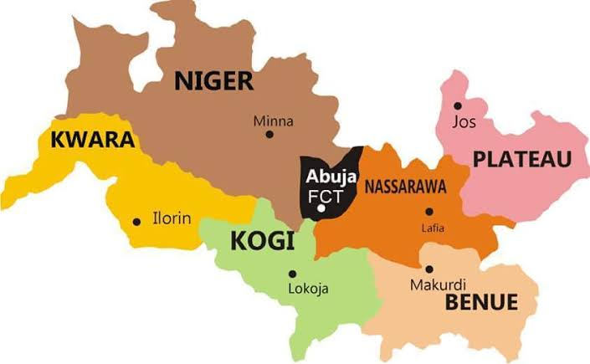

Figure 1: Map of States in North Central, Nigeria Source: Hope Abah Emmanuel, 2020

2.2.2 Data Collection Methods
Questionnaires were used for survey on the commonly consumed foods within the North-central region of Nigeria and the food materials were obtained from local markets to prepare foods as per traditional recipes. These questionnaires were developed and used for documenting the most commonly consumed foods, drinks and snacks, as well as their constituting ingredients and mode of preparations. The outcomes provided important background information on the food composition, dietary factors and nutritional status of a population.

Sample Selection (Food Selection)
Table 2: Food selection classified based on most consumed, moderately consumed and least consumed

S/N | STATE | MOST CONSUMED | MODERATELY CONSUMED | LEAST CONSUMED
 |  | Mostly consumed | Moderately consume | Least consumed
1 | BENUE | ROASTED YAM AND PALM OIL | DAFA (CORN PORRIDGE) | POUNDED YAM AND FRESH FISH SOUP
2 | KOGI | APAPA (MOI-MOI) | OKPA | YAM PORRIDGE (IJOLO)
3 | NASARAWA | TUWO MASARA AND DRIED OKRA SOUP | BOILED CASSSAVA AND PALM OIL | JOLLOF RICE
4 | NIGER | MORINGA (ZOGALE) | POUNDED YAM AND EGUSI SOUP | BEANS PORRIDGE

2.3 Determination of Proximate Composition

2.3.1 Determination of Moisture Content
Moisture content was determined according to the AOAC, 2005 technique. The procedure is as follows: Approximately 5g of sample was weighed into a dry crucible of known weight. Place the crucible in a drying oven at 105ºC for approximately 5 hours. It was removed from the oven, cool in a desiccator and weigh. Re-dry for at least another 1 hour and repeat the process until a constant weigh is achieved. Calculate the moisture (wet weight) loss as follows:
$$percent moisture=\frac{\left(p-a\right)}{p}×100$$
Where,
p= sample weight in grams
a= weight of dried sample in grams

2.3.2 Determination of Ash Content
Ash content was determined according to the AOAC, 2005 technique. The procedure involves weighing approximately 5g of sample into a dry crucible of known weight, it was placed in a drying oven at 100 ºC for at least 10 hours. After which it was transferred the into a muffle furnace and the temperature maintained within 550 to 600 ºC for about 6 hours. The crucible was collected once the sample was completely dried and powdered, cooled in a desiccator and weighed. To ensure the completion of ashing, the crucible was again heated in Muffle furnace for 0.5 hour and weighed. This procedure was repeated until two consecutive weights were recorded and the ash was almost white/ grayish in color. The ash content was calculated as follows:
$$Percent of ash=\frac{weight of ash}{weight of sample taken}×100$$

2.3.3 Determination of Crude Protein
The crude protein was determined according to the Kjeldahl method which is basically, divided into three parts; digestion, distillation, and titration. The procedure was followed as outlined below;
Digestion: 1g of sample was measured into the Kjeldahl digestion flask and 12-15 mL of concentrated sulfuric acid (H2SO4) was add. The mixture in the flask was heated until white fumes could be seen. Heating continued for about 60-90 minutes. 250mL of distilled water was cautiously added to cool the flask.
Distillation: The distilling set of Kjeldahl apparatus is thoroughly washed with distilled water before starting the distillation. In a measuring cylinder 60mL of 40% NaOH is taken and is carefully poured down the side of the Kjeldahl flask.The mouth of the flask is closed with a stopper containing connective tube, which is ultimately connected to the ammonia-receiving flask containing 25mL boric acid solution having methyl red as the indicator. Heat is applied to the flask to allow the mixture boil causing the ammonia contained in the sample to be collected in the boric acid solution containing methyl red. A strong yellow colour indicates successful distillation.
Titration: The ammonia absorbed in the receiving flask containing receiver solution was titrated with 0.1 N HCl. Similarly, a reagent blank was distilled and titrated. The protein content of the sample on the basis of percentage is calculated as follows:
$$percent of protein=\frac{\left(c-b\right)×14×d×6.25}{a}×100$$
Where,
a = sample weight in g.
b= volume of the sodium hydroxide required for the back titration.
c= volume of sodium hydroxide required for the back titration and to neutralize 20 mL of 0.1 N H2SO4 (for blank).
d= Normality of NaOH used for titration.
6.25= conversion factor of nitrogen to protein
14= atomic weight of nitrogen.

2.3.4 Determination of Crude Fat
Crude fat was determined according to the AOAC, 2005 technique. The procedure is as follows: Approximately 10g of sample is taken in a thimble which is then placed in the extraction tube of Soxhlet apparatus. The temperature of the heater is adjusted to allow continuous drop of petroleum ether to fall on the sample in the extraction tube. This took over 16 hours to allow for proper extraction. After which the sample is removed and solvent is evaporated under fume hood.
The extract is completely dried in oven for about 30 minutes at 105ºC. The weight of extract is recorded after cooling in desiccators. The crude fat content of sample is calculated as follows:
$$crude fat percen=\frac{weight of fat extract\left(g\right)}{weight of sample taken\left(g\right)}×100$$

2.3.5 Determination of Crude Fiber
Crude fiber was determined according to the AOAC, 2005 technique. The procedure is as follows: 3g of moisture and fat free sample was added into a 1000 ml beaker, 200 ml of 1.25 sulfuric acid was then added. This was boiled for 30 minutes with constant stirring. After which, the content was filtered while still warm giving 2-3 washings with warm water until it became alkali free.The residue was carefully transferred into a crucible and the weight taken (W1). Then dried in the oven at 100 ºC until smoke ceased to come out, which took 3-4 hours. It was weighed again after drying (W2). The sample filled crucible was placed into muffle furnace at 550 ºC for 4-5 hours ensuring a grey coloured ash was obtained. This was cooled in a desiccator and reweighed (W3). The crude fiber content was then calculated as follows:
$$percent of crude fiber=\frac{\left(W2-W1\right)-\left(W3-W1\right)}{weight of sample}×100$$
Where,
W1= weight of sample and crucible before drying
W2= weight after drying
W3= weight after ashing

2.4 Determination of Minerals and Heavy Metals
Analytical Technique: This involved the use of Atomic Absorption Spectroscopy (AAS): Common for quantifying heavy metals in solutions. It measures the concentration of vaporized atoms based on light absorption.
Quality Control: Calibration: Regularly calibrate instruments using standard reference materials. Blank Samples: Run blanks to detect contamination during the analysis.
Replicates: Analyzing multiple samples or duplicate samples ensures reliability and precision. Principles of Atomic Absorption Spectroscopy (AAS)
1. Absorption of Light: AAS is based on the principle that free metal atoms absorb specific wavelengths of light. Each metal has a unique absorption spectrum, allowing for selective detection.
2. Atomization: The sample is first converted into a gaseous state (atomized), allowing individual metal atoms to interact with the light beam. This is done using a flame or a graphite furnace.
3. Light Source: A hollow cathode lamp specific to the metal being analyzed emits light. When light passes through the vaporized sample, only those wavelengths corresponding to the metal will be absorbed.
4. Detection: The amount of light absorbed is measured, typically using a photodetector. The absorption is proportional to the concentration of the metal in the sample based on Beer-Lambert Law.
Procedures for AAS
1. Sample Preparation: Digestion: Solid samples (like food or soil) were first digested (using acids) to release heavy metals into solution.
Filtration: Where necessary, the digested solution were filtered to remove particulate matter.
2. Preparation of Standards: Calibration standards were prepared with known concentrations of the target metals. These standards helped create a calibration curve.
3. Instrument Setup: The appropriate hollow cathode lamp was selected for the metal of interest. Set the wavelength corresponding to the metal's absorption line.
4. Adjustment of Flame Conditions: The appropriate flame type (air-acetylene or nitrous oxide-acetylene) or graphite furnace conditions for atomization was chosen.
5. Running the Samples: Aspiration of samples into the flame or furnace was monitored.
The instrument measures the amount of light absorbed at the selected wavelengths.
6. Data Analysis: The absorbance values for samples were compared against the calibration curve derived from standards.
The concentration of the target heavy metals in the original sample was then calculated.
7. Quality Control: A blank sample was included and quality control standards to ensure accuracy and reliability of results.
Data Interpretation: Calculation: Results were expressed in mg/kg or µg/L depending on the matrix. Regulatory Standards: Outcomes were compared against established safety limits from organizations like WHO or EPA.
Results and discussion: The results presented in Figure 1 illustrate the proximate analysis of processed food items collected from selected states in North-Central Nigeria, detailing their composition in terms of Ash (%), Moisture (%), Crude Fat (%), Crude Protein (%), Crude Fiber (%), and Carbohydrate (%). This figure highlights a variety of processed foods, including Beans Porridge, Jollof Rice, Pounded Yam and Fish Soup, Pounded Yam and Egusi, Roasted Yam and Red Oil, Okpa, Moi-moi, Yam Porridge, Tuwo Masara, Dried Okra, Cassava, and Kuli-kuli.

2.5 Statistical Analysis
Statistical analysis was performed using SPSS version 25 (statistical packages for social sciences). The food samples were gotten using frequency analysis of food gotten via questionnaires and Google forms. The data expressed as mean ± standard deviation, were analyzed by frequency distribution and one-way analysis of variance (ANOVA) using Statistical packages for social sciences (SPSS) version 25.0 software and p < 0.05 was taken to be significant.

3.0 RESULTS AND DISCUSSION

3.1 Results

3.1.1 Proximate Analysis (%) for processed locally sourced food consumed in the north central states, Nigeria

The results presented in Figure 1 illustrate the proximate analysis of processed food items collected from selected states in North-Central Nigeria, detailing their composition in terms of Ash (%), Moisture (%), Crude Fat (%), Crude Protein (%), Crude Fiber (%), and Carbohydrate (%). This figure highlights a variety of processed foods, including Beans Porridge, Jollof Rice, Pounded Yam and Fish Soup, Pounded Yam and Egusi, Roasted Yam and Red Oil, Okpa, Moi-moi, Yam Porridge, Tuwo Masara, Dried Okra, Cassava, and Kuli-kuli.

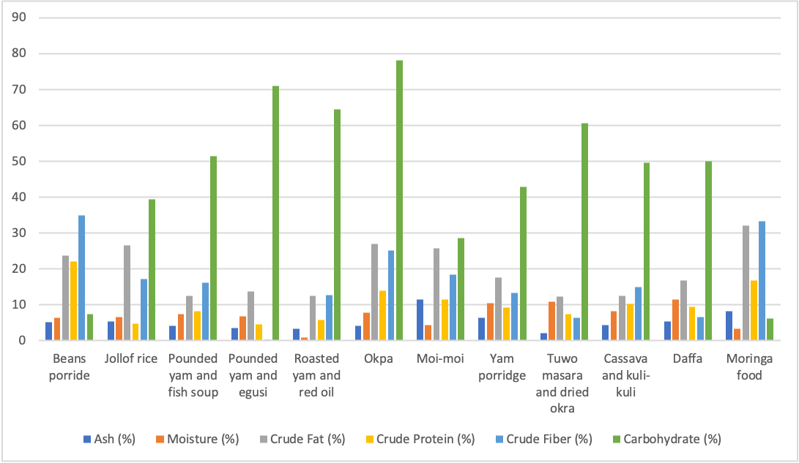
Figure 1. Proximate Analysis (%) for processed locally sourced food consumed in the north central states, Nigeria.

3.1.2 Proximate Analysis (%) for raw locally sourced food ingredients consumed in the north central states, Nigeria
The results presented in Figure 2 illustrate the proximate analysis of raw food items collected from selected states in North-Central Nigeria, detailing their composition in terms of Ash (%), Moisture (%), Crude Fat (%), Crude Protein (%), Crude Fiber (%), and Carbohydrate (%). This figure focuses on a variety of raw ingredients, including Ginger, Bambara Nut, Beans, Cassava, Corn Flour, Salt, Sugar, Egusi, Tomatoes, Pepper, Locust Beans, Yam, Rice, Seasoning Cubes, Fish, Crayfish, Dried Okra, Ugwu, Meat, Moringa, Onions, and Kuli-kuli.

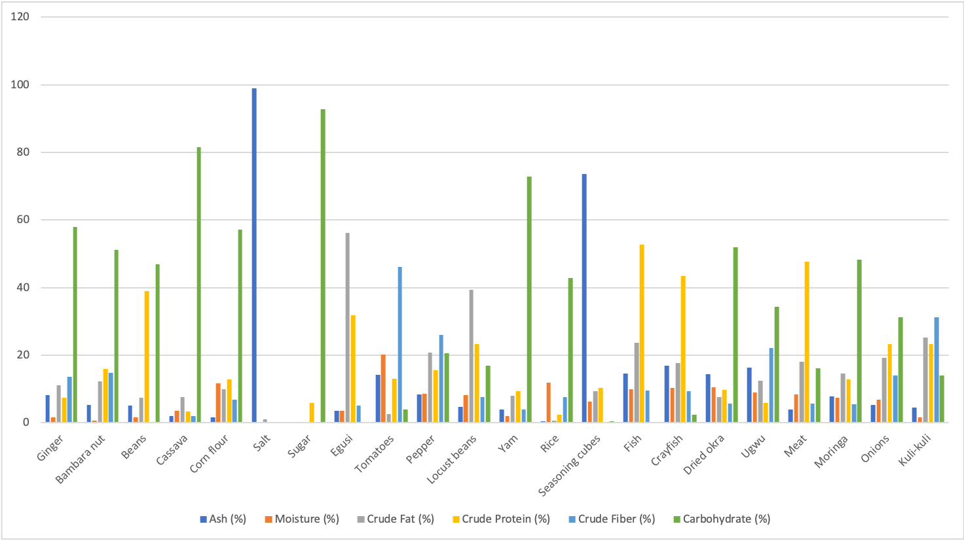
Figure 2. Proximate Analysis (%) for raw locally sourced food ingredients consumed in the north central states, Nigeria.
3.1.3 Mineral constituent for processed locally sourced food consumed in the north central states, Nigeria
The results presented in Figure 3 illustrate the mineral constituents of processed, locally sourced foods consumed in the North-Central states of Nigeria. This analysis reveals significant findings regarding the mineral content of various food items, focusing on essential nutrients such as calcium, cadmium, cobalt, chromium, copper, iron, potassium, lithium, magnesium, manganese, sodium, nickel, lead, and zinc. The figure highlights a diverse range of processed foods, including Beans Porridge, Jollof Rice, Pounded Yam and Fish Soup, Pounded Yam and Egusi, Roasted Yam and Red Oil, Okpa, Moi Moi, Yam Porridge, Tuwo Masara, Dried Okra, Cassava, and Kuli-kuli.

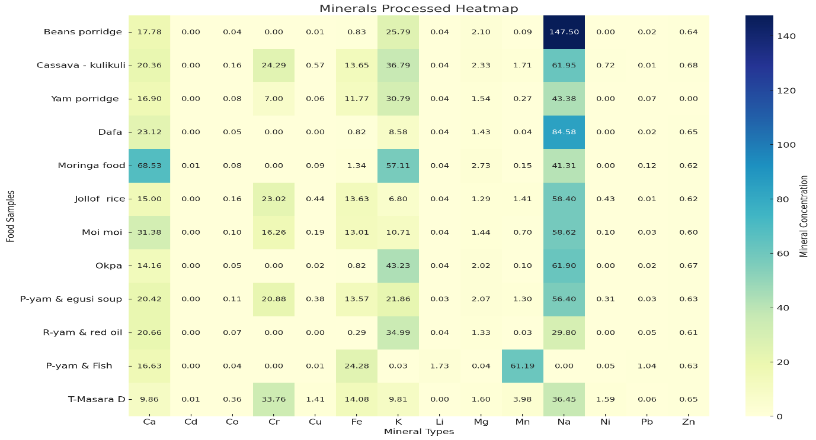
Figure 3. Mineral constituent for processed locally sourced food consumed in the north central states, Nigeria.

3.1.4 Mineral constituent for raw locally sourced food consumed in the north central states, Nigeria
The results presented in Figure 4 illustrate the mineral constituents of raw, locally sourced foods consumed in the North-Central states of Nigeria. This analysis reveals significant findings regarding the mineral content of various food items, focusing on essential nutrients such as calcium, cadmium, cobalt, chromium, copper, iron, potassium, lithium, magnesium, manganese, sodium, nickel, lead, and zinc. The figure highlights a diverse range of raw ingredients, including Ginger, Bambara Nut, Beans, Cassava, Corn Flour, Salt, Sugar, Egusi, Tomatoes, Pepper, Locust Beans, Yam, Rice, Seasoning Cubes, Fish, Crayfish, Dried Okra, Ugwu, Meat, Moringa, Onions, and Kuli-kuli.

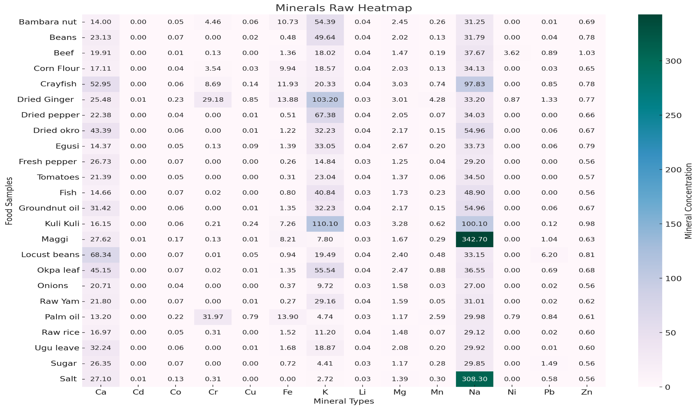
Figure 4. Mineral constituent for raw locally sourced food consumed in the north central states, Nigeria
3.2 Discussion
The results presented in Figures 1 and 2 illustrate the proximate analysis of both processed and raw food items collected from selected states in North-Central Nigeria. Figure 1 highlights processed foods such as Beans Porridge, Jollof Rice, Pounded Yam and Fish Soup, Pounded Yam and Egusi, Roasted Yam and Red Oil, Okpa, Moi-moi, Yam Porridge, Tuwo Masara and Dried Okra, Cassava, and Kuli-kuli, while Figure 2 focuses on raw ingredients including Ginger, Bambara Nut, Beans, Cassava, Corn Flour, Salt, Sugar, Egusi, Tomatoes, Pepper, Locust Beans, Yam, Rice, Seasoning Cubes, Fish, Crayfish, Dried Okra, Ugwu, Meat, Moringa, Onions, and Kuli-kuli.
The biochemical analysis of the food samples presented in the figures reveals significant insights into their nutritional composition, which has important implications for dietary health and food security in the region. Each component—ash, moisture, crude fat, crude protein, crude fiber, and carbohydrates—provides valuable information about the food's nutritional value and potential health benefits.
The ash content of food samples is a critical indicator of their mineral composition and overall nutritional value, reflecting the inorganic residue remaining after organic matter is burned. The analysis reveals a wide range of ash content, from 0.04% in sugar to 98.98% in salt, highlighting significant variability in mineral content across different foods. High ash content foods, such as salt (98.98%), are primarily composed of sodium chloride, which is essential for physiological functions but can contribute to hypertension when consumed excessively (Petrikova et al., 2023). Protein sources like crayfish (16.84%) and fish (14.53%) are rich in minerals such as calcium and phosphorus, vital for bone health (Baker et al., 2016). Moderate ash content is found in foods like Moi-moi (11.41%) and tomatoes (14.20%), which not only provide minerals but also vitamins and antioxidants that enhance overall health (Iwar, & Amu, 2021). Conversely, low ash content foods like rice (0.48%) and sugar (0.04%) indicate minimal mineral presence, suggesting the need for complementary foods to meet mineral requirements. Biochemically, minerals play essential roles in enzyme function, nerve transmission, and muscle contraction, with adequate intake linked to lower risks of chronic diseases such as hypertension and osteoporosis (Iwar& Amu, 2021). The bioavailability of these minerals can be influenced by dietary factors, including the presence of phytates and oxalates, and the combination of foods, such as pairing vitamin C-rich foods with iron sources to enhance absorption (Israr et al., 2013). Understanding ash content can guide dietary recommendations, encouraging the inclusion of mineral-rich foods to improve nutritional status and address specific deficiencies.
Moisture content is a vital parameter in food science, significantly influencing the biochemical properties, nutritional value, shelf life, and safety of food products. The analysis reveals a moisture range from 0.04% in salt to 20.19% in tomatoes, indicating substantial variability across food items. High moisture foods like tomatoes (20.19%) are not only hydrating but also rich in vitamins and antioxidants, such as vitamin C and lycopene, which are linked to reduced chronic disease risk (Zambrano et al., 2019). Dishes like Okpa (7.78%) and Pounded Yam and Fish Soup (7.47%) also benefit from moisture, enhancing texture and nutrient absorption. Moderate moisture levels in staples like rice (11.88%) and corn flour (11.64%) influence cooking times and starch digestibility, while fish (9.87%) and crayfish (10.40%) maintain flavor and protein digestibility. Conversely, low moisture foods, such as Bambara Nut (0.70%) and ginger (1.69%), exhibit longer shelf life due to reduced microbial growth, although they may require rehydration for improved palatability. The moisture content also plays a crucial role in food safety, as high levels can promote spoilage and food-borne pathogens, necessitating preservation methods like drying (WHO, 2022). Additionally, moisture affects the digestibility of macronutrients and cooking methods, with higher moisture foods generally requiring less cooking time (Zambrano et al., 2019). Understanding moisture content is essential for dietary recommendations, promoting high-moisture foods like fruits and vegetables for their health benefits while recognizing the role of low-moisture foods in energy-dense diets (WHO, 2022).
The biochemical analysis of crude fat content in various food samples reveals significant variability, with values ranging from 0.35% in sugar to 56.14% in egusi, highlighting the importance of lipids as a crucial nutritional parameter. High-fat foods like egusi (56.14%) and locust beans (39.40%) are rich in unsaturated fatty acids, which are beneficial for heart health and contribute to energy density and satiety (Omah et al., 2015). Moderate fat content is observed in dishes such as Okpa (26.98%) and Jollof Rice (26.53%), where added oils enhance flavor and facilitate the absorption of fat-soluble vitamins (Fletcher, 2020). Conversely, low-fat foods like rice (0.69%) and sugar (0.35%) primarily serve as energy sources and may require pairing with higher-fat items to meet essential fatty acid needs. Biochemically, fats provide concentrated energy (9 kcal/g), support the intake of essential fatty acids crucial for inflammation regulation and cardiovascular health (Trugo & Torres, 2003), and enhance the absorption of fat-soluble vitamins (A, D, E, and K) (Fletcher, 2020). Additionally, high-fat foods can promote satiety, aiding in appetite regulation and weight management. Understanding the crude fat content in foods is essential for dietary recommendations, emphasizing the need to prioritize unsaturated fats while limiting saturated and trans fats to mitigate cardiovascular disease risk (Trugo & Torres, 2003).
The biochemical analysis of crude protein content in various food samples reveals significant variability, with values ranging from 0.01% in salt to 52.73% in fish, underscoring the importance of protein as a critical nutritional parameter. High-protein foods like fish (52.73%) and meat (47.7%) provide complete proteins, essential amino acids, and vital micronutrients, supporting muscle maintenance, immune function, and overall health (Trugo & Torres, 2003). Moderate protein sources, such as beans (38.97%) and crayfish (43.33%), contribute essential amino acids and other nutrients, while low-protein foods like rice (2.30%) and cassava (3.27%) primarily serve as energy sources, necessitating pairing with higher protein items to meet dietary needs (Petrikova et al., 2012). The quality of protein, determined by the amino acid profile, is crucial for muscle repair and immune function, with high-quality sources enhancing overall health. Additionally, protein's role in promoting satiety can aid in weight management, making it a vital component of dietary recommendations, which suggest adults aim for 46-56 grams of protein daily (Carbone & Pasiakos, 2019). This analysis highlights the need to prioritize high-protein foods in dietary guidelines to ensure adequate protein intake for optimal health outcomes.
The crude fiber content of various food samples was analyzed, revealing a significant range of values from 0.00% (salt) to 46.05% (tomatoes). Tomatoes and moringa food exhibited high crude fiber content, with values of 46.05% and 33.31%, respectively, making them excellent sources of dietary fiber for promoting digestive health, supporting healthy blood sugar levels, and aiding in weight management (Bamishaiye et al.,2011). Moderate fiber content was observed in foods such as beans porridge, kuli-kuli, okpa, ugwu, and pepper, which are rich in soluble and insoluble fiber, supporting digestive health and weight. In contrast, refined and processed foods like salt, sugar, and rice had low fiber content, highlighting the importance of consuming whole, nutrient-dense foods to meet daily fiber recommendations (Ionită-Mîndricanet al.,2022). The biochemical implications of crude fiber content are significant, with dietary fiber playing a crucial role in maintaining digestive health, controlling blood sugar levels, supporting weight management, and promoting cardiovascular health (Bamishaiye et al.,2011).
Carbohydrates are essential macronutrients that serve as the body's primary energy source, with their content varying significantly across different food items, ranging from 0.00% in salt and fish to 92.77% in sugar. High carbohydrate foods, such as sugar (92.77%) and cassava (81.56%), provide quick energy but may lack essential nutrients, potentially leading to health issues like obesity and diabetes when consumed excessively (Holesh et al., 2023). Moderate carbohydrate sources, including okpa (78.11%), yam (72.85%), and jollof rice (39.49%), offer sustained energy and are often rich in dietary fiber, which aids digestion and promotes satiety (Bamishaiye et al.,2011). Conversely, low carbohydrate foods, such as salt (0.00%) and egusi (0.04%), primarily provide minerals or proteins without contributing significantly to carbohydrate intake. The biochemical implications of carbohydrate consumption include energy provision (4 kcal per gram), blood sugar regulation, and dietary fiber contributions that support digestive health and weight management (Holesh et al., 2023). Understanding carbohydrate content is crucial for dietary recommendations, as it is advised that carbohydrates should constitute 45-65% of total daily caloric intake, emphasizing the importance of whole grains, fruits, and vegetables over refined sugars.
The results presented in Figures 3 and 4 provide a comprehensive overview of the mineral constituents found in both processed and raw, locally sourced foods consumed in the North-Central states of Nigeria. Figure 4. highlights the mineral content of various processed foods, revealing essential nutrients such as calcium, cadmium, cobalt, chromium, copper, iron, potassium, lithium, magnesium, manganese, sodium, nickel, lead, and zinc in items like Beans Porridge, Jollof Rice, Pounded Yam and Fish Soup, and Moi Moi, among others. In contrast, Figure 4 focuses on raw ingredients, including Ginger, Bambara Nut, Beans, Cassava, Corn Flour, Salt, Sugar, Egusi, Tomatoes, Pepper, Locust Beans, Yam, Rice, Seasoning Cubes, Fish, Crayfish, Dried Okra, Ugwu, Meat, Moringa, Onions, and Kuli-kuli.
Moringa and Kuli Kuli exhibit the highest calcium concentration among processed foods, with Moringa containing 68.53 mg, significantly surpassing other items such as Moi Moi (31.38 mg) and Dafa (23.12 mg). This high calcium content is essential for bone health, muscle contraction, and nerve function, indicating that incorporating Moringa into the diet could effectively address common calcium deficiencies in the region (Bamishaiye et al.,2011). In contrast, processed foods like Tuwo Masara (9.86 mg) and Okpa (14.16 mg) contribute less to daily calcium intake, suggesting that while they are part of the local diet, they may not be sufficient sources of this vital mineral. When comparing these processed foods to raw ingredients, the biochemical data reveals a diverse range of calcium concentrations. For instance, raw Crayfish contains 52.95 mg of calcium, which is substantial and highlights its potential as a valuable source of this mineral. Additionally, Dried Okra (43.39 mg) and Okpa Leaf (45.15 mg) also provide significant calcium levels, making them important contributors to dietary calcium intake. Notably, Locust Beans, with a calcium concentration of 68.34 mg, rivals Moringa and underscores the nutritional value of raw foods in addressing calcium needs.
The differences in calcium content between processed and raw foods can be attributed to several factors. Processed foods often undergo cooking and preparation methods that can alter their nutrient profiles, sometimes leading to nutrient loss. For example, the preparation of Moi Moi and Dafa may not retain all the calcium present in their raw ingredients. Conversely, raw foods typically preserve their nutrient content better, making them reliable sources of essential minerals. Furthermore, the presence of calcium in processed foods like Moi Moi and Dafa indicates that these dishes can still serve as valuable sources of this essential mineral, particularly when combined with other calcium-rich foods. However, the overall lower calcium content in many processed foods compared to raw ingredients suggests that a balanced diet incorporating both food types is crucial for meeting calcium requirements. Recent studies have reinforced the importance of dietary calcium for health, emphasizing the role of both raw and processed foods in achieving adequate intake. For instance, a study by Petrikova et al.,(2012) highlights the nutritional benefits of traditional foods in Nigeria, while Bamishaiye et al.,2011, discuss the significance of incorporating diverse food sources to combat micronutrient deficiencies. Additionally, research by Israr et al., (2013) emphasizes the need for continuous monitoring of mineral content in local diets to ensure food safety and nutritional adequacy.
The analysis of cadmium levels in various food items reveals important distinctions between processed and raw foods consumed in the North-Central states of Nigeria. Most processed foods, including Beans Porridge, Cassava-Kuli-kuli, and Jollof Rice, showed no detectable cadmium levels, while Moringa, Tuwo Masara, and Dried Okra contained trace amounts (0.01 mg). These low cadmium levels suggest that these foods are generally safe for consumption, posing minimal risk of exposure to this toxic heavy metal, which is associated with kidney damage and increased cancer risk (Chunhabundit, 2016). In contrast, the raw food data indicates that many ingredients also exhibit no detectable cadmium levels. For instance, Bambara Nut, Beans, Beef, Crayfish, Dried Okra, and various vegetables such as Fresh Pepper and Tomatoes all show cadmium concentrations of 0.00 mg. This absence of cadmium in raw foods reinforces their safety and nutritional value, as they are less likely to accumulate harmful substances compared to processed foods that may undergo various cooking and preparation methods(Chunhabundit, 2016; Schaefer et al., 2020).
The presence of trace cadmium in processed foods like Moringa and Tuwo Masara raises questions about the potential sources of contamination, which could stem from environmental factors or agricultural practices. While the levels detected are low, it is essential to monitor these foods to ensure they remain within safe consumption limits. The trace amounts found in processed foods may also reflect the cumulative effects of cadmium exposure from various dietary sources over time (Onakpa, et al.,2018).
Tuwo Masara and Dried Okra exhibit the highest cobalt concentration at 0.36 mg among processed foods, which is essential for vitamin B12 formation, a nutrient vital for red blood cell production and neurological function (Ekuma, 2023). The presence of cobalt in these foods indicates that they can serve as dietary sources of this important mineral, particularly beneficial for individuals on plant-based diets who may be at risk of vitamin B12 deficiency due to limited animal product consumption (Department of Agriculture and Food, 2019). In terms of chromium, Tuwo Masara and Dried Okra also show the highest concentration at 33.76 mg, followed by Cassava-Kuli-kuli (24.29 mg) and Jollof Rice (23.02 mg). Chromium plays a crucial role in carbohydrate, fat, and protein metabolism and enhances insulin action, suggesting that these foods can contribute to improved metabolic health (Office of Dietary Supplements, National Institutes of Health, 2022). The high chromium content in these processed foods highlights their potential to support metabolic functions, particularly in populations at risk for insulin resistance and type 2 diabetes.
When comparing these processed foods to raw ingredients, the biochemical data reveals varying concentrations of cobalt and chromium. For instance, raw Dried Ginger contains 0.23 mg of cobalt and a significant chromium concentration of 29.18 mg, making it a valuable source of both minerals. Additionally, Bambara Nut and Beans provide lower cobalt levels (0.05 mg and 0.07 mg, respectively) but show minimal chromium content, with Beans showing no detectable levels. This indicates that while some raw foods may not provide as much cobalt or chromium as processed options like Tuwo Masara and Dried Okra, they still contribute to overall mineral intake (Ekuma, 2023).
The differences in mineral content between processed and raw foods can be attributed to several factors, including the cooking and preparation methods that processed foods undergo, which can enhance the bioavailability of certain nutrients. For example, the preparation of Tuwo Masara may increase the absorption of cobalt and chromium compared to their raw counterparts. Conversely, raw foods often retain their natural nutrient profiles, making them reliable sources of essential minerals.
Tuwo Masara and Dried Okra exhibit the highest copper concentration at 1.41 mg among processed foods, followed by Cassava-Kuli-kuli (0.57 mg) and Jollof Rice (0.44 mg). Copper is essential for iron metabolism and immune function, playing a critical role in the formation of hemoglobin and the maintenance of healthy connective tissues (Onakpa, et al.,2018). The significant copper content in these processed foods suggests they can contribute to the dietary intake of this vital mineral, particularly for populations that may not consume sufficient amounts from other sources. In terms of iron, Pounded Yam & Fish contains the highest concentration at 24.28 mg, followed closely by Cassava-Kuli-kuli (13.65 mg) and Jollof Rice (13.63 mg). Iron is crucial for oxygen transport in the blood and energy production, making these foods valuable sources for populations at risk of iron deficiency, particularly in regions where anemia is prevalent (Ekuma, 2023; Onianwa et al., 2001). The high iron content in Pounded Yam & Fish underscores its importance in the diet, especially for individuals with increased iron needs, such as pregnant women and growing children.
When examining potassium levels, Moringa and Kuli Kuli have the highest concentration at 57.11 mg, followed by Okpa (43.23 mg) and Cassava-Kuli-kuli (36.79 mg). Potassium is vital for maintaining fluid balance, regulating blood pressure, and supporting muscle and nerve function (Institute of Medicine, 2004). The presence of potassium in these foods highlights their potential role in promoting cardiovascular health and preventing hypertension. Comparing processed foods to raw ingredients reveals a diverse range of mineral concentrations. For instance, raw Dried Ginger contains 0.85 mg of copper, which is significant, and it also provides a substantial iron concentration of 13.88 mg. Additionally, Bambara Nut offers 10.73 mg of iron and 54.39 mg of potassium, making it a valuable source of these essential minerals (Hafeez et al., 2023). However, the copper content in raw foods tends to be lower than that found in processed options like Tuwo Masara and Dried Okra.
Pounded Yam & Fish shows a significantly higher lithium concentration of 1.73 mg compared to other food items, which generally have low levels around 0.04 mg. Lithium is known for its potential effects on mental health and mood stabilization, making it an interesting dietary component for individuals seeking to enhance their mental well-being (Chokhawala, et al.,2024). The high lithium content in Pounded Yam & Fish suggests that this dish could play a role in supporting mental health, particularly in populations that may benefit from dietary interventions. In terms of magnesium, Moringa and Kuli Kuli exhibit the highest concentration at 2.73 mg, followed closely by Cassava-Kuli-kuli (2.33 mg) and Beans Porridge (2.10 mg). Magnesium is essential for numerous physiological functions, including muscle and nerve function, blood glucose control, and blood pressure regulation. Adequate magnesium intake is associated with a reduced risk of chronic diseases, such as cardiovascular disease and type 2 diabetes (Al Alawi et al.,2018). The presence of magnesium in these processed foods highlights their potential role in promoting overall health and preventing chronic conditions.
Pounded Yam & Fish also shows an exceptionally high manganese concentration at 61.19 mg, significantly higher than other foods analyzed. Manganese is involved in antioxidant defense, bone formation, and the metabolism of carbohydrates and fats. The high manganese content in Pounded Yam & Fish suggests that this dish can contribute to the body's antioxidant defenses and support metabolic health (Li & Yang, 2018). When comparing these processed foods to raw ingredients, the biochemical data reveals varying concentrations of lithium, magnesium, and manganese. For instance, raw Dried Ginger contains 3.01 mg of magnesium and 4.28 mg of manganese, making it a valuable source of these minerals. Additionally, Crayfish provides 3.03 mg of magnesium and 0.74 mg of manganese, indicating that certain raw foods can also contribute significantly to mineral intake.
Beans Porridge has the highest sodium concentration at 147.50 mg, raising concerns about potential overconsumption and associated health risks, particularly hypertension. High sodium intake is linked to increased blood pressure, which can lead to cardiovascular diseases. Other notable sources of sodium include Dafa (84.58 mg) and Cassava-Kuli-kuli (61.95 mg). The elevated sodium levels in these processed foods highlight the need for moderation in their consumption, especially for individuals with pre-existing health conditions such as hypertension (Chrysant, 2016; Dong, 2018). In terms of nickel concentration, Tuwo Masara and Dried Okra exhibit the highest levels at 1.59 mg, followed by Cassava-Kuli-kuli (0.72 mg) and Jollof Rice (0.43 mg). While nickel is not considered an essential nutrient for human health, it may play a role in certain biochemical processes, such as enzyme function and metabolism. However, excessive intake of nickel can lead to toxicity and adverse health effects, including allergic reactions and potential carcinogenic effects. The presence of nickel in these processed foods raises questions about dietary sources and the need for monitoring intake to avoid potential health risks (Genchi, et al.,2020).
When comparing these processed foods to raw ingredients, the biochemical data reveals varying concentrations of sodium and nickel. For instance, raw Crayfish contains a significant sodium concentration of 97.83 mg, while other raw foods like Bambara Nut and Beans have lower sodium levels (31.25 mg and 31.79 mg, respectively). This indicates that while some raw foods can contribute to sodium intake, processed foods like Beans Porridge and Kuli Kuli are more significant sources.
Pounded Yam & Fish has the highest lead concentration at 1.04 mg, raising significant health concerns due to lead's neurotoxic effects, particularly for vulnerable populations such as children and pregnant women (Onakpa, et al.,2018). Lead exposure can lead to developmental issues, cognitive impairments, and various health problems, making it critical to monitor and manage dietary sources of this toxic metal. Following Pounded Yam & Fish, Moringa and Kuli Kuli contain 0.12 mg of lead, while Yam Porridge (0.07 mg) and Moi Moi (0.03 mg) also show measurable amounts. The presence of lead in these processed foods highlights the need for food safety measures and public health interventions to reduce exposure, especially in populations at risk. In contrast, zinc concentrations in the analyzed foods are relatively consistent, with Cassava-Kuli-kuli exhibiting the highest concentration at 0.68 mg, followed closely by Okpa (0.67 mg) and Dafa (0.65 mg). Zinc is essential for immune function, wound healing, and overall health, making these foods valuable sources for populations at risk of zinc deficiency (Onakpa, et al.,2018). The relatively high zinc content in these processed foods suggests they can play a significant role in supporting nutritional needs, particularly in regions where dietary zinc intake may be inadequate.
When comparing these processed foods to raw ingredients, the biochemical data reveals varying concentrations of lead and zinc. For instance, raw Bambara Nut contains 0.01 mg of lead and 0.69 mg of zinc, while Beans have slightly higher zinc levels at 0.78 mg but also contain 0.04 mg of lead. The low lead levels in raw foods indicate that they may be safer options compared to some processed foods, which can accumulate contaminants during preparation and cooking (Onakpa, et al.,2018).
3.3 Conclusion
This study which was aimed at determining the proximate and mineral contents in commonly consumed foods within the North- central region of Nigeria revealed diverse and high proximate and mineral contents in some of the processed and raw foods commonly consumed within the region.

COMPETING INTERESTS DISCLAIMER:
Authors have declared that they have no known competing financial interests OR non-financial interests OR personal relationships that could have appeared to influence the work reported in this paper.

References

Ajala, O., English, P., & Pinkney, J. (2013). Systematic review and meta-analysis of different dietary approaches to the management of type 2 diabetes. The American journal of clinical nutrition, 97(3), 505-516.
Al Alawi, A. M., Majoni, S. W., & Falhammar, H. (2018). Magnesium and human health: Perspectives and research directions. International Journal of Endocrinology, 2018, Article 9041694. https://doi.org/10.1155/2018/9041694
AOAC (2005). Amino acids in feeds performic acid oxidation with acid hydrolysis sodium
Awuchi, C.G., Igwe, V.S., AmagwulaI, Echeta, C.K. (2020). Health benefits of micronutrients (vitamins and minerals) and their associated deficiency diseases: a systematic review. Int J Food Sci 3(1):1– 32
Bamishaiye, E. I., Olayemi, F. F., Awagu, E. F., & Bamshaiye, O. M. (2011). Proximate and phytochemical composition of Moringa oleifera leaves at three stages of maturation. Advance Journal of Food Science and Technology, 3(4), 233-237. https://doi.org/10.19026/ajfst.3.1230
Bamishaiye, E. I., Olayemi, F. F., Awagu, E. F., & Bamshaiye, O. M. (2011). Proximate and phytochemical composition of Moringa oleifera leaves at three stages of maturation. Advance Journal of Food Science and Technology, 3(4), 233-237. https://doi.org/10.19026/ajfst.3.1230
Barbara, S. U., Ruth, C., Victor, N. E., Romaric, G. B., Etel, G. F., Babacar, S., Paulina, A., Ingrid, B., Fatimata, O., Arne, O., Isaac, A., George, A. A., Kennedy, B., Henrietta, E., Ifeyironwa, F.S., Ismael, T., and Barbara B. (2012). West African Food Composition Table. Food and Agriculture Organization of the United Nations Rome. ISBN 978-92-5-007207-4.
Barclay, A. W., Petocz, P., McMillan-Price, J., Flood, V. M., Prvan, T., Mitchell, P., & Brand-Miller, J. C. (2008). Glycemic index, glycemic load, and chronic disease risk—a meta-analysis of observational studies. The American journal of clinical nutrition, 87(3), 627-637.
Carbone, J. W., & Pasiakos, S. M. (2019). Dietary protein and muscle mass: Translating science to application and health benefit. Nutrients, 11(5), Article 1133. https://doi.org/10.3390/nu11051133
Charrondiere, U. R., Barbara, S., Ramani, W., Doris, R., Verena, N., and Barbara B. (2013). INFOODS contributions to fulfilling needs and meeting challenges concerning food composition databases. Procedia Food Science. 2:35-45.
Chokhawala, K., Lee, S., & Saadabadi, A. (2024). Lithium. In StatPearls. StatPearls Publishing. https://www.ncbi.nlm.nih.gov/books/NBK519062/?report=printable
Chrysant, S. G. (2016). Effects of high salt intake on blood pressure and cardiovascular disease: The role of COX inhibitors. Clinical Cardiology, 39(4), 240–242. https://doi.org/10.1002/clc.22536
Chunhabundit, R. (2016). Cadmium exposure and potential health risk from foods in contaminated area, Thailand. Toxicological Research, 32(1), 65-72. http://dx.doi.org/10.5487/TR.2016.32.1.065
Das, S. K., Gilhooly, C. H., Golden, J. K., Pittas, A. G., Fuss, P. J., Cheatham, R. A., Lichtenstein, A. H. (2007). Long-term effects of 2 energy-restricted diets differing in glycemic load on dietary adherence, body composition, and metabolism in CALERIE: a 1-y randomized controlled trial. The American journal of clinical nutrition, 85(4), 1023-1030.
David, J.A., Cyril W.C., Livia, S.A., Silvia, F., Maryam H., Augustine M., Alexandra L.J., and Mette Axelsen. (2002). Glycemic index: overview of implications in health and disease. Am J Clin Nutr, 76:266–273.
Del Rio, D., Rodriguez-Mateos, A., Spencer, J. P., Tognolini, M., Borges, G., & Crozier, A. (2013). Dietary (poly) phenolics in human health: structures, bioavailability, and evidence of protective effects against chronic diseases. Antioxidants & redox signaling, 18(14), 1818-1892.
Department of Agriculture and Food. (2019, September 3). Cobalt deficiency in sheep and cattle. Government of Western Australia. https://www.agric.wa.gov.au/livestock-biosecurity/cobalt-deficiency-sheep-and-cattle
Djinovic-Stojanovic, J. M., Nikolic, D. M., Vranic, D. V., Babic, J. A., Milijasevic, M. P., Pezo, L. L., & Jankovic, S. D. (2017). Zinc and magnesium in different types of meat and meat products from the Serbian market. Journal of Food Composition and Analysis, 59, 5054.
Dong, O. M. (2018). Excessive dietary sodium intake and elevated blood pressure: A review of current prevention and management strategies and the emerging role of pharmaconutrigenetics. BMJ Nutrition, Prevention & Health. https://doi.org/10.1136/bmjnph-2018-000004
Ekuma, U. O. (2023). FST 202: Principles of food science and technology. National Open University of Nigeria.
FAO/INFOODS. (2012). INFOODS: Tables and databases. http://www.fao.org/infoods/infoods/tables-and-databases/en/.
Fletcher, J. (2020). What are fat-soluble vitamins? Medical News Today. Medically reviewed by Natalie Olsen, R.D., L.D., ACSM EP-C. https://www.medicalnewstoday.com/articles/320310
Gansevoort, R. T., Correa-Rotter, R., Hemmelgarn, B. R., Jafar, T. H., Heerspink, H. J. L., Mann, J. F., . . . Wen, C. P. (2013). Chronic kidney disease and cardiovascular risk: epidemiology, mechanisms, and prevention. The Lancet, 382(9889), 339-352.
Genchi, G., Carocci, A., Lauria, G., Sinicropi, M. S., & Catalano, A. (2020). Nickel: Human health and environmental toxicology. International Journal of Environmental Research and Public Health, 17(2), Article 512. https://doi.org/10.3390/ijerph17020512
Hafeez, M., Riaz, A., Azam, A., Sajid, M., Faseeh, H., Anjum, F., Rubab, T., Aziz, S., & Latif, M. (2023). Lowering effect of potassium on hypertension. Pakistan Journal of Health Sciences, 4(12). https://doi.org/10.54393/pjhs.v4i12.1198
Hayward, R. A., Reaven, P. D., Wiitala, W. L., Bahn, G. D., Reda, D. J., Ge, L., . . . Emanuele, N. V. (2015). Follow-up of glycemic control and cardiovascular outcomes in type 2 diabetes. New England Journal of Medicine, 372(23), 2197-2206.
Holesh, J. E., Aslam, S., & Martin, A. (2023). Physiology, carbohydrates. In StatPearls [Internet]. StatPearls Publishing. https://www.ncbi.nlm.nih.gov/books/NBK459280/
Institute of Medicine. (2000). Dietary reference intakes for vitamin C, vitamin E, selenium, and carotenoids. National Academies Press. https://doi.org/10.17226/9810
Ionită-Mîndrican, C.-B., Ziani, K., Mititelu, M., Oprea, E., Neacșu, S. M., Morosan, E., Dumitrescu, D.-E., Roșca, A. C., Drăgănescu, D., & Negrei, C. (2022). Therapeutic benefits and dietary restrictions of fiber intake: A state of the art review. Nutrients, 14(13), Article 2641. https://doi.org/10.3390/nu14132641
Israr, B., Frazier, R. A., & Gordon, M. H. (2013). Effects of phytate and minerals on the bioavailability of oxalate from food. Food Chemistry, 141(3), 1690–1693. https://doi.org/10.1016/j.foodchem.2013.05.045
Iwar, I. M., & Amu, C. M. (2021). Nutrient and anti-nutrient composition of processed crayfish (Atya gabonensis) from River Benue, Nigeria. Sustainability, Agri, Food and Environmental Research, X(X), Article 2257. http://dx.doi.org/10.7770/safer-V0N0-art2257
Julia, C., Kesse-Guyot, E., Touvier, M., Méjean, C., Fezeu, L., & Hercberg, S. (2014). Application of the British Food Standards Agency nutrient profiling system in a French food composition database. British Journal of Nutrition, 112(10), 1699-1705.
Ley, S. H., Hamdy, O., Mohan, V., & Hu, F. B. (2014). Prevention and management of type 2 diabetes: dietary components and nutritional strategies. The Lancet, 383(9933), 1999-2007.
Li, L., & Yang, X. (2018). The essential element manganese, oxidative stress, and metabolic diseases: Links and interactions. Oxidative Medicine and Cellular Longevity, 2018, Article 7580707. https://doi.org/10.1155/2018/7580707
Maiyaki, M. B., & Garbati, M. A. (2014). The burden of non-communicable diseases in Nigeria; in the context of globalization. Annals of African medicine, 13(1), 1-10.
Marrero, S. L., Bloom, D. E., & Adashi, E. Y. (2012). Non-communicable diseases: a global health crisis in a new world order. Jama, 307(19), 2037-2038.
Martínez-Ballesta, M. C., Dominguez-Perles, R., Moreno, D. A., Muries, B., Alcaraz-López, C., Bastías, E. & Carvajal, M. J. A. F. S. D. (2010). Minerals in plant food: effect of agricultural practices and role in human health. A review. Agronomy for sustainable development, 30(2), 295-309.
Maziya-Dixon, B., Akinyele, I., Oguntona, E., Nokoe, S., Sanusi, R., & Harris, E. (2004). Nigerian Food Consumption and Nutrition Survey 2001–2003, Summary. International Institute of Tropical Agriculture (IITA), Ibadan, Nigeria.
Office of Dietary Supplements. (2022). Riboflavin - Health professional fact sheet. National Institutes of Health. https://ods.od.nih.gov/factsheets/Riboflavin-HealthProfessional/
Omah, E. C., Ajoiyi, R. A., & Nwankwo, C. S. (2015). Proximate composition and sensory properties of freeze-dried Nigerian soups. Agro-Science: Journal of Tropical Agriculture, Food, Environment and Extension, 14(1), 37-43. https://doi.org/10.4314/as.v14i1.5
Onakpa, M. M., Njan, A. A., & Kalu, O. C. (2018). A review of heavy metal contamination of food crops in Nigeria. Annals of Global Health, 84(3), 488–494. https://doi.org/10.29024/aogh.2314
Onakpa, M. M., Njan, A. A., & Kalu, O. C. (2018). A review of heavy metal contamination of food crops in Nigeria. Annals of Global Health, 84(3), 488–494. https://doi.org/10.29024/aogh.2314
Parimelazhagan Thangaraj, P. (2016). Proximate composition analysis. Pharmacological assays of plant-based natural products, Progress in Drug Research, 21-31.
Petrikova, I., Bhattacharjee, R., & Fraser, P. D. (2023). The ‘Nigerian diet’ and its evolution: Review of the existing literature and household survey data. Foods, 12(3), 443 https://doi.org/10.3390/foods12030443
Petrikova, I., Bhattacharjee, R., & Fraser, P. D. (2023). The ‘Nigerian diet’ and its evolution: Review of the existing literature and household survey data. Foods, 12(3), 443 https://doi.org/10.3390/foods12030443
Poti, J. M., Yoon, E., Hollingsworth, B., Ostrowski, J., Wandell, J., Miles, D. R., & Popkin, B. M. (2017). Development of a food composition database to monitor changes in packaged foods and beverages. Journal of Food Composition and Analysis.
Probst, Y., Guan, V., & Kent, K. (2018). A systematic review of food composition tools used for determining dietary polyphenol intake in estimated intake studies. Food chemistry, 238, 146-152.
Rothwell, J. A., Perez-Jimenez, J., Neveu, V., Medina-Remon, A., M'Hiri, N., García-Lobato, P., Wishart, D. S. (2013). Phenol-Explorer 3.0: a major update of the Phenol-Explorer database to incorporate data on the effects of food processing on polyphenol content. Database, 2013, bat070.
Schaefer, H. R., Dennis, S., & Fitzpatrick, S. (2020). Cadmium: Mitigation strategies to reduce dietary exposure. Journal of Food Science. https://doi.org/10.1111/1750-3841.14997
Schiener, P., Black, K. D., Stanley, M. S., & Green, D. H. (2015). The seasonal variation in the chemical composition of the kelp species Laminaria digitata, Laminaria hyperborea, Saccharina latissima and Alaria esculenta. Journal of applied phycology, 27(1), 363-373.
Sun, L., Lee, D. E. M., Tan, W. J. K., Ranawana, D. V., Quek, Y. C. R., Goh, H. J., & Henry, C. J. (2015). Glycaemic index and glycaemic load of selected popular foods consumed in Southeast Asia. British Journal of Nutrition, 113(5), 843-848.
Trugo, N. M. F., & Torres, A. G. (2003). Fats | Requirements. In Encyclopedia of Food Sciences and Nutrition (2nd ed., pp. 2279-2284). Elsevier Science Ltd. https://doi.org/10.1016/B0-12-227055-X/00444-2
Westenbrink, S., Brunt, K., & van der Kamp, J.-W. (2013). Dietary fibre: challenges in production and use of food composition data. Food chemistry, 140(3), 562-567.
World Health Organization (WHO). WHO Maps: Non-communicable disease trend in all countries, World Health Global Report, 2014.
World Health Organization. (2022). Ranking of low-moisture foods in support of microbiological risk management: Meeting report and systematic review (Microbiological risk assessment series No. 26). https://www.who.int/publications/i/item/9789240044036
Yalçın, T., Al, A., and Rakıcıoğlu, N. (2017). The effects of meal glycemic load on blood glucose levels of adults with different body mass indexes. Indian journal of endocrinology and metabolism, 21(1), 71
Zambrano, M. V., Dutta, B., Mercer, D. G., MacLean, H. L., & Touchie, M. F. (2019). Assessment of moisture content measurement methods of dried food products in small-scale operations in developing countries: A review. Trends in Food Science & Technology, 88, 484–496. https://doi.org/10.1016/j.tifs.2019.03.014
Zoroddu, M. A., Aaseth, J., Crisponi, G., Medici, S., Peana, M., & Nurchi, V. M. (2019). The essential metals for humans: a brief overview. Journal of inorganic biochemistry, 195, 120129.

