Original Research Article
Phytochemical Analysis, Ultraviolet-Visible And Fourier Transform Infrared Spectrometry Evaluations Of N-Hexane Leaf Extract Of Conoclinium Coelestinium ( Blue Mistflower)

ABSTRACT
Objectives: This study evaluate the phytochemical composition and characterization of n-hexane extracts of Conoclinium coelestinum leafs
Method: The fresh leafs were extracted using soxhlet extraction, n-hexane as the solvent and the extract were subjected to phytochemical analysis, characterization was done using Uv-VIS and FTIR
Result: Phytochemicals in the n-hexane fraction were glycosides, steroids, terpenoids,saponin, phytosterols ,triterpenoids, phlobatanins, alkaloids, phenols,protein , amino acid, carbohydrates,fat and oil, tannins, and flavonoids, The UV–Vis spectra of the extracts revealed distinct phytochemical ,the extract showed a strong absorption at ~630 nm (500–700 nm range) and tailing beyond 700 nm, indicating chlorophyll a/b, carotenoids, and chlorophyll degradation products, The FT-IR analyses revealed a wide range of functional groups, including hydroxyls (free and hydrogen-bonded), amine/amide groups, aromatic and aliphatic C–H stretches, carboxylic acids, nitrile/alkyne bonds, high-frequency carbonyls, and conjugated C=O/C=C systems.
Conclusion: This study demonstrates that the leaves of Conoclinium coelestinum possess a rich phytochemical profile
KEYWORDS: conoclinium coelestinium, phytochemical,Ultravoilet-visible and Fourier Transform Infrared Spectroscopy
1.0 INTRODUCTION
A medicinal plant is any plant which, in one or more of its organs, contains substances that can be used for therapeutic purposes or which are precursors for the synthesis of useful drugs. Medicinal plants have been extensively used for treating a variety of infectious diseases for a long time. Drug discovery from these plants involves a versatile approach combining phytochemical, botanical, and molecular techniques. Medicinal plants have proven to be potent sources of antiviral agents with some main advantages over conventional drug therapy due to their broad healing potency and causing no side effects. Medicinal properties derived from plants can come from many different parts of a plant including leaves, roots, bark, fruit, seeds, flowers. Natural products are a great source of biologically active molecules that have the potential to fight illnesses because they are sourced from plants, animals, and microbes. (Hossain, 2024). The natural defense mechanism of plants includes the production of a wide variety of bioactive chemicals. Numerous of these substances, referred to as phytochemicals, are very successful in the fight against microbial infections (Hossain, 2024). Plants contain a wide variety of compounds that can have medicinal properties, including alkaloids, flavonoids, terpene, and phenolic compounds. These compounds can have a range of effects on the body, including anti-inflammatory, analgesic, antimicrobial, and antioxidant activities, polyphenolics which include flavonoids, tannins, quinones, coumarins, and othershave demonstrated notable qualities among phytochemicals (Cowan et al., 1999). terpenoids—another significant class of plant-extract bioactives, essential oils and other terpenoids have been shown to be quite efficient against a variety of bacteria, making them promising candidates for medicinal applications (Masyita et al., 2022). Also, saponins—glycosides present in many plant species have also demonstrate medicinal qualities (Stuardo et al., 2008). Conoclinium coelestinumis commonly used in traditional medicines to treat skin infections and sore throats; the leaves can be applied to wounds to stop the bleeding. Its scented, sticky, vivid blue flowers were formerly a mainstay in Native American healing ceremonies, it was typical to inhale the smoke from the plant, and its flowers and roots were used to make tea that was used to treat anything from fevers to stomach aches (Rankel, 2024). Conoclinium coelestinum (Blue mist flower) belongs to the Asteraceae family, common name Aster family. The plant grows to about 3ft tall with leaves somehow triangular in shape, with short-stemmed lustres of flower formed at almost flat top. The flowers are bright blue or violet about ¼ inch long and propagation is by seed and takes 6 months to grow (Vandevender, 2014).
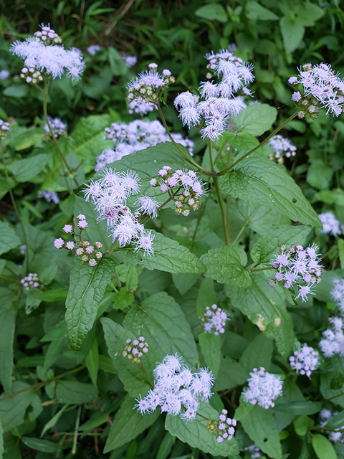
Plate 1.0. A Picture of Blue Mist Flower
2.0 MATERIALS AND METHOD
2.1 COLLECTION, IDENTIFICATION AND PREPARATION OF PLANT
The fresh leafs were gotten from Abraka, Delta State and identity authentication by Micheal, E. Ozioma and a voucher number of DELSU-269, plant name is Conocliumcoelestinium commonly known as Wild Ageratum/ Blue mist flower, family name is Asteraceae. The fresh leaves of the plant were rinsed with water to remove sand and dirt and made into a smooth paste using mortar
2.2 EXTRACTION OF PLANT BY SOXHLET EXTRACTION
1kg of fresh leafs were pulverized to paste like form, Extraction was done using soxhlet extraction, n- hexane at a temperature between 60º c to 65° c, after extraction, the solvent was removed at a controlled temperature of 40º, percentage yield was calculated and sample kept in a sample bottle for further analysis(Nikhal et al., 2010).
Percentage yield $=\frac{weightofextract}{weightofsample}$𝑋100
2.3 DETERMINATION OF THE PHYTOCHEMICALS PRESENT
The phytochemical screening chemical test will be conducted on the extract using standard method as described by Balamurugan et al.(2019),Singh et al. (2022), Trease & Evans. (2002) and swain et al.(2020).
2.3.1 Alkaloids, 1 g of the extract was dissolved in 1 % hydrochloric acid, filtered and 2–3 mL of the filtrate was treated separately with a few drops of Mayer’s, Dragendorff’s and Wagner’s reagents; formation of a cream, orange or reddish-brown precipitate respectively indicated a positive reaction (Trease & Evans, 2002).
2.3.2.Flavonoids, 2 mL of the ethanolic extract was mixed with a small piece of magnesium ribbon and 1–2 drops of concentrated hydrochloric acid were added; development of a pink or red colour confirmed flavonoids (Balamurugan et al., 2019).
2.3.3 Tannins and phenolics, 2 mL of the extract was mixed with a few drops of 5 % ferric chloride solution; the appearance of a blue-black or green coloration indicated a positive result (Singh et al., 2022).
2.3.4 Saponins, 2 mL of the extract was shaken vigorously with 5 mL of distilled water in a test tube and left to stand for 10 minutes; persistent frothing signified the presence of saponins (Swain et al., 2020).
2.3.5Steroids and triterpenoids were tested by mixing 2 mL of extract with 2 mL of acetic anhydride followed by the careful addition of 1 mL of concentrated sulphuric acid; a green or blue colour at the interface confirmed a positive reaction (Balamurugan et al., 2019).
2.3.6 Glycosides were determined by adding 2 mL of glacial acetic acid and one drop of 5 % ferric chloride to 2 mL of extract, then underlaying with 1 mL of concentrated sulphuric acid; a brown ring at the interface indicated glycosides (Singh et al., 2022).
2.3.7 Carbohydrates were tested by adding 2 mL of α-naphthol to 2 mL of extract and carefully pouring 1 mL of concentrated sulphuric acid down the side of the test tube; a violet ring at the interface indicated carbohydrates (Swain et al., 2020).
2.3.8 Proteins and amino acids were determined by adding 1 mL of 10 % NaOH and a few drops of 0.5 % CuSO₄ to 2 mL of extract (violet colour, Biuret reaction) or by adding 2 mL of ninhydrin reagent and heating in a boiling water bath for 2 minutes (purple colour, Ninhydrin reaction) (Trease & Evans, 2002).
2.3.9 Phytosterols, 2 mL of extract was dissolved in 2 mL of chloroform and 1 mL of concentrated sulphuric acid was carefully added down the side of the tube (Salkowski test); a reddish-brown colour indicated sterols. Alternatively, 2 mL of extract was mixed with 2 mL of acetic anhydride and 1 mL of concentrated sulphuric acid (Liebermann–Burchard test); formation of a green or blue colour indicated phytosterols (Trease & Evans, 2002 & Balamurugan et al., 2019).
2.3.10 Phlobatannins were tested by boiling 2 mL of extract with 1 % hydrochloric acid for 5 minutes; deposition of a red precipitate indicated phlobatannins (Singh et al., 2022).
2.3.11.Oils and fats were detected by placing one drop of extract on filter paper and allowing it to dry; the appearance of a translucent spot indicated lipids, by adding a few drops of Sudan III/IV dye to 2 mL of extract and observing a red coloration (Swain et al., 2020).
2.3.12.Tetraterpenoids (carotenoids) were detected by dissolving 2 mL of extract in chloroform and adding 1 mL of freshly prepared 20 % antimony trichloride solution (Carr–Price reaction); a transient blue or green colour indicated carotenoids (Trease & Evans, 2002).
2.3.13.Resins , 2 mL of the extract was dissolved in 5 mL of acetone and then 5 mL of distilled water was added slowly. Formation of a turbid or cloudy solution or precipitation indicated the presence of resins Trease & Evans (2002)
2.4 CHARACTERIZATION
Characterisation of the extracts using UV-vis, FTIR were carried out as described by Cozzolino (2014), Chakravarthi et al. (2023), respectively
2.4.1 UV/VISIBLE SPECTROSCOPY
This was carried out following the basic principle of a UV/VISIBLE spectrum ,is the study of how a sample responds to light.
2.4.1.1 Preparation of Sample For Uv-vis Analysis
0.1g of the sample was dissolved in 10ml of ethanol. The mixture was filtered and the filtrate used for analysis, was carried out between wavelength 190 – 800nm on a UV-spectrophotometer.
2.4.2. INFRARED SPECTROSCOPY
This was carried out following the basic principle of a spectrum Infrared Spectroscopy works by passing infrared light through a sample and measuring the absorption and transmission of the light.
2.4.2.1 Preparation of Sample For FTIR Analysis
0.5g of the sample was mixed with 0.5g of KBr after which 1ml of nujol (a solvent for preparation of sample by Buck M530 IR-spectrophotometer) was introduced into the sample with aid of a syringe to form a paste before introducing it into the instrument sample mould and allowed to scan at a wavelength of 600-4000nm to obtain its spectra wavelength
3.0.RESULT AND DISCUSSION
3.1 PERCENTAGE YIELD
Percentage yield of the n-hexane extract of conoclinium colestinium leafs after soxhlet extraction is expressed below
Percentage yield= $\frac{weightofextract}{weighbtofsample}×100$
n-hexane extract = 65. 122g
$\frac{65.122}{1000}×100$ = 6.5122%
3.2 PHYTOCHEMICAL ANALYSIS
Table 1.0 shows the qualitative phytochemicals present in n-hexane and methanol extract of Conoclinium coelestinium. It shows the plant is rich in bioactive compounds
PHYTOCHEMICALS ANALYSIS | Hexane leafs
Glycoside | +
Steroid | +
Terpenoids | +
Saponin | +
Phytosterols | +
Triterpenoids | +
Phlobatanins | +
Oil & Fats | +
Alkaloids | +
Phenols | +
Tannins | +
Flavonoids | +
Protein | +
Amino Acids | +
Triterpenes | -
Carbohydrate | +
Resins | -
The diverse phytochemical constituents detected in n-hexane leafs extracts suggest significant therapeutic potential. The presence of alkaloids, flavonoids, and phenolic compounds indicates possible antioxidant, anti-inflammatory, and antimicrobial activities, as these compounds are known to scavenge free radicals and modulate immune responses. Abdallah et al., (2024) , Saponins and glycosides may contribute to cardioprotective and immunostimulatory effects, while steroids, triterpenoids, and phytosterols are often associated with anti-inflammatory and analgesic properties. The detection of proteins, amino acids, and carbohydrates highlights the nutritional value of the plant, complementing its medicinal importance. Juang & Liang (2020). Fat and oil act as a structural component of membrane , serving as a form of carbon and energy storage( Ahmed et al .,2021)Overall, the variation in phytochemical composition of the n-hexane suggests that the hexane extract favors non-polar constituents. Altemimi et al., (2017).
3.3 Ultraviolet and Visible (UV) Absorption Spectroscopy Of Conoclinium Coelestinium Leaves
The n-hexane extracts of C.coelestinium was subjected to ultraviolet and visible (UV/Vis) absorption spectroscopy using Apel UV-spectrophotometer PD -30000 Japans.They spectra are as shown in Figure
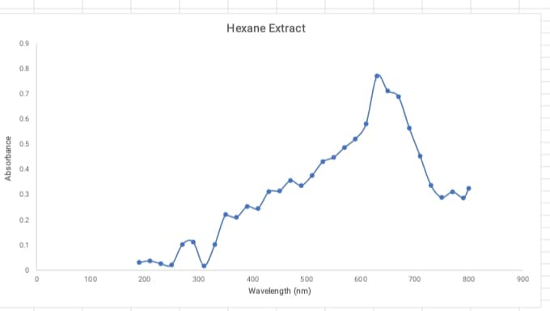figure 1: Ultraviolet and Visible (UV) Absorption Spectrumof N-Hexane Extract Of Conoclinium Coelestinium Leafs
Table 2: showing the various compounds and chromophore present in Ultraviolet and Visible (UV) Absorption Spectrumof N-Hexane Extract of conoclinium coelestinium
λmax (nm) | Absorbance | Chromophore | Compounds
290 | 0.112 | Aromatic/phenolic ring | Flavonoids,phenolics, Mutha et al. (2021).
350 | 0.221 | Extended conjugation | Flavonols, Taniguchi, (Mutha et al. (2021).
390 | 0.253 | conjugated system | benzoquinones; carotenoid Mendes-Pinto et al. (2013).
450 | 0.315 | Carotenoid | Carotenoids, Bas. (2024)
490 | 0.336 | Carotenoid | β-carotene, Institute of Medicine (US) Panel on .(2000).
570 | 0.487 | Porphyrin | Pheophytin, Linnanto & Korppi-Tommola. (2000).
610 | 0.581 | Porphyrin /chlorine | Pheophytin a/b mixture beginning of red absorption, Linnanto & Korppi-Tommola . (2000).
630 | 0.771 | Porphyrin /chlorine | Chlorophyll-type pigments, (Leiger et al. (2020)
650 | 0.712 | Chlorophyll b | Chlorophyll b, Leiger et al. (2020)
670 | 0.689 | Chlorophyll a | Chlorophyll , Solymosi & Mysliwa-Kurdziel . (2017).
690 | 0.564 | Chlorophylls derivatives | Chlorophyll , Solymosi & Mysliwa-Kurdziel. (2017)
730 | 0.337 | Aggregated porphyrins | Chlorophyll/pheophytin aggregates  Litvin et al. (1975).
UV–vis spectrum of the hexane extract shows; a strong visible absorption between 500–700 nm with maxima at ~630 , characteristic of chlorophyll and carotenoids,beyond 700 nm the absorbance tails off, typical of chlorophyll degradation products . conoclinium coelestinium n-hexane plant extract contains green pigments (chlorophyll a/b), Flavonoids, flavonols, carotenoids and some phenolic compounds.
3.4 Infrared Spectroscopy Analysis Of the Extract Of Conoclinium Coelestinium Leafs
The n-hexane and methanolic extracts of C. coelestiniumwas subjected to Infrared Spectroscopy using Bulk Scientific FTIR Machine M530 USA. The spectra are as shown in Figures
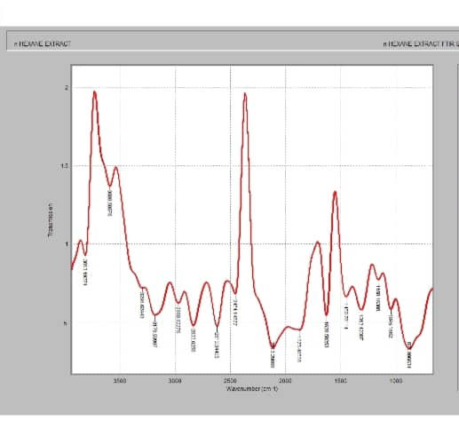
Figure 2 : Infrared Spectrum Analysis of N-Hexane Extract Of Conoclinium Coelestinium Leafs
Table 3: showing various wavenumber at different peak with possible functional groups of conocliniumcolestinium n-hexane extract

Wavenumber(cm⁻¹) | Peak Area | Functional group
3813 | 27.31 | Free O–H stretch (non-H-bonded alcohol / phenol)
3588 | 36.66 | Free weakly H-bonded O–H stretch (alcohol/phenol), Alcohol / Phenol
3296 | 3296 | H-bonded O–H stretch , Broad → O–H
3179 | 24.87 | N–H stretch or strongly H-bonded O–H / =C–H, Amine , Alcohol , Alkene
2968 | 6.63 | C–H asymmetric stretch (–CH₃ / –CH₂–). Alkane , Fatty acid
2833 | 22.58 | C–H symmetric (–CH₂– / –CH₃) or aldehydic C–H. Alkane / Aldehyde
2619 | 23.66 | Broad carboxylic O–H envelope
2454 | 57.62 | Carboxylic O–H envelope (possible overlap with CO₂)
2113 | 525.85 | Triple-bond region: C≡C (alkyne) or C≡N (nitrile). Alkyne / Nitrile
1875 | 27.89 | Carbonyl — likely acid anhydride C=O (upper band)
1628 | 48.76 | conjugated C=O / amide II
The IR spectrum indicates a mixture of functional groups, including free and hydrogen-bonded hydroxyls, amine/amide groups, aliphatic and possible aldehydic C–H, carboxylic acid O–H, triple bonds (nitrile/alkyne), high-frequency carbonyls (likely anhydrides), and aromatic C=C/amide II bands, demonstrating that the sample is a complex, phytochemically rich extract rather than a single compound. Information from IR spectra generally supported phenolic, fatty acid, steroid, carbohydrate and alkaloids
CONCLUSION
This study demonstrates that the leafs of Conoclinium coelestinum possess a rich phytochemical profile, including alkaloids, flavonoids, glycosides, phenols, phlobatanins, saponins, steroids, tannins and terpenoids, which collectively contribute to its therapeutic potential in asthma management

REFERENCE
Abdallah, W. E., Shams, K. A., & El-Shamy, A. M. (2024). Phytochemical analysis and evaluation of its antioxidant, antimicrobial, and cytotoxic activities for different extracts of Casuarina equisetifolia. BMC complementary medicine and therapies, 24(1), 128. https://doi.org/10.1186/s12906-024-04422-4
Ahmed, S., Shah, P., & Ahmed, O. (2021). Biochemistry, Lipids.[Updated 2021 May 9]. StatPearls [Internet]. Treasure Island (FL): StatPearls Publishing
Altemimi, A., Lakhssassi, N., Baharlouei, A., Watson, D. G., & Lightfoot, D. A. (2017). Phytochemicals: Extraction, Isolation, and Identification of Bioactive Compounds from Plant Extracts. Plants (Basel, Switzerland), 6(4), 42. https://doi.org/10.3390/plants6040042
Balamurugan, V., Fatima, S., &Velurajan, S. (2019). A Guide To Phytochemical Analysis. International Journal Of Advance Research And Innovative Ideas In Education, 5(1), 236-245
Bas T. G. (2024). Bioactivity and Bioavailability of Carotenoids Applied in Human Health: Technological Advances and Innovation. International journal of molecular sciences, 25(14), 7603. https://doi.org/10.3390/ijms25147603
Chakravarthi, K. S. S. , Ilango, K. B., Thomas, S.A.M., Devi M.K., Sudharshan, N,.&Swetha ,V.(2023). Uv-Visible Spectroscopy: A Comprehensive Review On Instrumentation. World Journal Of Pharmaceutical Research.. Iso 9001:2015 Certified Journal. Vol 12, Issue 19. Doi: 10.20959/Wjpr202319-30171
Cowan, M. M. (1999). Plant Products As Antimicrobial Agents. Clinical Microbiology Reviews, 12(4), 564-582.Https://Doi.Org/10.1128/Cmr.12.4.564
Cozzolino, D. (2014). Use Of Infrared Spectroscopy For In-Field Measurement And Phenotyping Of Plant Properties: Instrumentation, Data Analysis, And Examples. Applied Spectroscopy Reviews, 49(7), 564-584.Doi:10.1080/05704928.2013.878720
Hossain, T. J. (2024). Methods For Screening And Evaluation Of Antimicrobial Activity: A Review Of Protocols, Advantages, And Limitations. European Journal Of Microbiology And Immunology, 14(2), 97-115.DOI: 10.1556/1886.2024.00035
Institute of Medicine (US) Panel on Dietary Antioxidants and Related Compounds. Dietary Reference Intakes for Vitamin C, Vitamin E, Selenium, and Carotenoids. Washington (DC): National Academies Press (US); 2000. 8, β-Carotene and Other Carotenoids. Available from: https://www.ncbi.nlm.nih.gov/books/NBK225469/
Juang, Y. P., & Liang, P. H. (2020). Biological and Pharmacological Effects of Synthetic Saponins. Molecules (Basel, Switzerland), 25(21), 4974. https://doi.org/10.3390/molecules25214974
Linnanto, J., & Korppi-Tommola, J. (2000). Spectroscopic properties of Mg-chlorin, Mg-porphin and chlorophylls a, b, c 1, c 2, c 3 and d studied by semi-empirical and ab initio MO/CI methods. Physical Chemistry Chemical Physics, 2(21), 4962-4970.
Litvin, F. F., Shubin, V. V., & Sineshchekov, V. A. (1975). Study of different types of chlorophyll a aggregates in solutions and films by absorption and luminescence derivative spectroscopy. Biophysics, 20(2), 202–207.
Leiger, K., Linnanto, J. M., & Freiberg, A. (2020). Establishment of the Qᵧ absorption spectrum of chlorophyll a extending to the near-infrared. Molecules, 25(17), 3796. https://doi.org/10.3390/molecules25173796
Masyita, A., Sari, R. M., Astuti, A. D., Yasir, B., Rumata, N. R., Emran, T. B., ... &Simal-Gandara, J. (2022). Terpenes And Terpenoids As Main Bioactive Compounds Of Essential Oils, Their Roles In Human Health And Potential Application As Natural Food Preservatives. Food Chemistry: X, 13, 100217.Https://Doi.Org/10.1016/J.Fochx.2022.100217
Mendes-Pinto, M. M., Galzerano, D., Telfer, A., Pascal, A. A., Robert, B., & Ilioaia, C. (2013). Mechanisms underlying carotenoid absorption in oxygenic photosynthetic proteins. The Journal of biological chemistry, 288(26), 18758–18765. https://doi.org/10.1074/jbc.M112.423681
Mutha, R. E., Tatiya, A. U., & Surana, S. J. (2021). Flavonoids as natural phenolic compounds and their role in therapeutics: An overview. Future Journal of Pharmaceutical Sciences, 7(1), 25. https://doi.org/10.1186/s43094-020-00161-8
Nikhal, S. B., Dambe, P. A., Ghongade, D. B., &Goupale, D. C. (2010). Hydroalcoholic extraction of Mangifera indica (leaves) by Soxhletion. International Journal of Pharmaceutical Sciences, 2(1), 30-32
Rankel, K. (2024). Symbolism And Benefits OfConocliniumCoelestinuim.March 01, Https://Greg.App/Blue-Mistflower-Benefits/
Singh, A., Lama, R., Panda, A., Marndi, S., Devi, R. S., &Kumar, S. (2022). Phytochemical And Anti-Bacterial Activity OfToddalia asiatica: A Wild Nutraceutical. Asian Pacific Journal Of Health Sciences, 9(2), 235-239.
Solymosi, K., & Mysliwa-Kurdziel, B. (2017). Chlorophylls and their Derivatives Used in Food Industry and Medicine. Mini reviews in medicinal chemistry, 17(13),1194–1222. https://doi.org/10.2174/1389557516666161004161411
Stuardo, M., &San Martín, R. (2008). Antifungal Properties Of Quinoa (Chenopodium Quinoa Willd) Alkali Treated Saponins Against Botrytis Cinerea. Industrial Crops And Products, 27(3), 296-302
Swain, J., Kumar, S., Parida, S., &Jena, P. K. (2020). In-Vitro Screening Of Antibacterial Activities Of Selected Wild Tuberous Plants Of Odisha, India. Asian Journal Of Biological And Life Sciences, 9(1), 79-87
Trease, G. E. &Evans, W. C. (1989). Pharmacognosy. Eleventh Edition. Brailliar Trindel Can. Macmillan Publishers, London
Vandevender, J. (2014). Propagation Protocol For Production Of Container Conoclinium Coelestinum (L) DC

