The Gig Economy and Women: Participation Factors and Reproductive Health Impacts

ABSTRACT
Aims: The study aims to analyze the socio-demographic and occupational profile of women engaged in gig work and to assess the impact of gig work conditions on their reproductive health outcomes.
Study Design: Descriptive and analytical cross-sectional study.
Place and Duration of Study: Conducted in urban Tripura and selected Indian states between June to July 2025.
Methodology: A purposive sampling method was used to select 50 women gig workers aged 18–45 years engaged in platform-based, freelance, and informal service work. Primary data were collected through a structured questionnaire covering socio-demographic variables, occupational factors, and reproductive health indicators. Linear regression and Chi-square tests were applied using SPSS to determine associations between gig work conditions, barriers to healthcare, and reproductive health outcomes.
Results: Findings reveal significant effects of healthcare access barriers on women’s reproductive health (p < 0.05). Barriers were strongly correlated with menstrual irregularities, reproductive tract infections, and pregnancy-related complications. Stress and inadequate rest showed significant associations with physical strain and reproductive tract infections.
Conclusion: The gig economy offers flexible employment but exposes women to serious health vulnerabilities. Lack of formal labor protections, healthcare access, and social security significantly impact women’s reproductive well-being. Policy intervention is crucial to improve healthcare accessibility and labor rights for women gig workers.
Keywords: Gig Economy, Women’s Reproductive Health, Platform-based Work, Urban Informal Employment.

- INTRODUCTION
The gig economy has rapidly transformed India’s labor market, providing flexible income opportunities, particularly for women seeking work-life balance. However, this flexibility often comes at the expense of job security, fair wages, and healthcare benefits. Women’s participation in the gig economy is largely shaped by access to technology, digital literacy, social norms, and safety conditions.
In India, the COVID-19 pandemic accelerated this shift, with approximately 122 million job losses reported in April 2020 (CMIE, 2020). Many displaced workers turned to gig work through platforms like Swiggy, Uber, and Amazon Mechanical Turk. According to NITI Aayog (2022), India had 7.7 million gig workers in 2021, projected to rise to 23.5 million by 2030. Despite this growth, women in gig work remain underrepresented and underserved in policy frameworks.
In North-East India, including Tripura and Assam, platform-based work is emerging as an alternative livelihood, yet barriers such as digital illiteracy, lack of infrastructure, and absence of labor regulation persist. The intersection of gender, informal work, and health challenges forms the core of this study, focusing specifically on reproductive health implications among women gig workers.
1.1 Review of Related Studies
Several researchers have explored aspects of the gig economy and its gendered impacts. Agrawal and Bhukya (2022) examined the Indian gig economy and noted that while flexibility and digital platforms create opportunities, women often face insecurity and limited access to social protections. Kshatriya and Kurien (2023) highlighted the growing post-pandemic shift toward gig-based work, emphasizing the potential for women but underscoring the absence of health and reproductive protections. David et al. (2024) explored India’s digital work transformation and identified challenges such as income instability and lack of maternity benefits. Dokuka et al. (2022) studied gender workload disparities in online gig teaching and found that women worked fewer evening hours due to caregiving roles, pointing to time-related barriers.
Further, Karunakaran (2025) and Kumbhakkudi (2021) noted the gig economy’s expansion in India but emphasized structural inequalities affecting women’s occupational well-being. Despite these valuable contributions, there remains a significant research gap regarding the reproductive health outcomes of women engaged in gig work—especially in regions like North-East India, where the gig economy is still developing. The current study seeks to fill this empirical gap.
Research Objectives
The study aims to:
- Examine the socio-demographic and occupational profile of women engaged in gig work.
- Assess the impact of barriers to healthcare services on reproductive health outcomes.
- Analyze the association between gig work conditions and women’s reproductive health indicators.

- MATERIALS & METHODOLOGY
2.1 Sampling and Participants
A purposive sampling method was adopted to select 50 women engaged in gig work (freelance, online retail, personal care, transportation, and delivery). Participants were aged 18–45 and represented diverse educational and income backgrounds.
2.2 Data Collection Tools and Procedure
Primary data were collected using a structured questionnaire including:
- Socio-demographic variables (age, education, marital status, income)
- Occupational factors (type of gig work, work hours, income stability)
- Reproductive health indicators (menstrual issues, RTIs, pregnancy complications, frequency of health check-ups)
2.3 Data Analysis
Descriptive statistics summarized demographic data. Linear regression examined the impact of healthcare barriers on reproductive health, while Chi-square tests evaluated associations between gig work conditions and health outcomes. Statistical significance was set at p < 0.05.

- RESULTS & DISCUSSION
3.1 FOR OBJECTIVE 1
Objective 1: To study about the socio-demographic and occupational profile of women engaged in gig work.
- Socio-Demographic Profile :
Fig. 1: Education Level- The diagram shows that out of the 50 respondents 20 of them are having Bachelor’s Degree, 11 of them Master’s degree & very least that is 4 respondents were there who did not even complete their secondary level education.

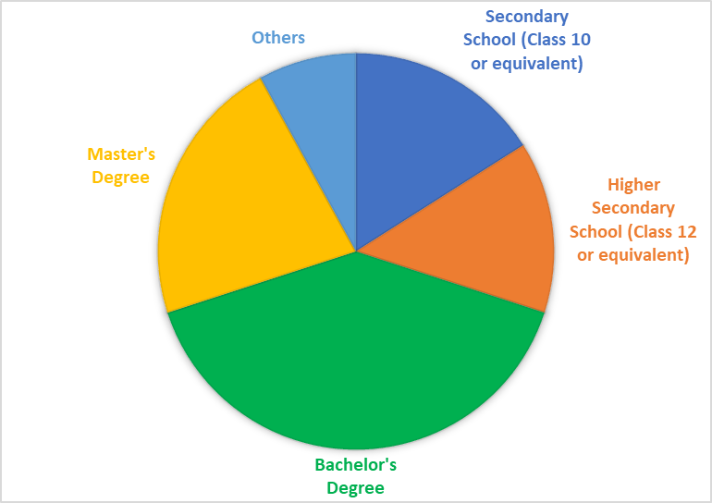
Fig. 1: Education Level
Fig. 2: Marital Status- This figure shows that out of 50 respondents the majority 26 respondents are married and 20 of them are single. The rest of the respondents are divorced, separated and widowed.
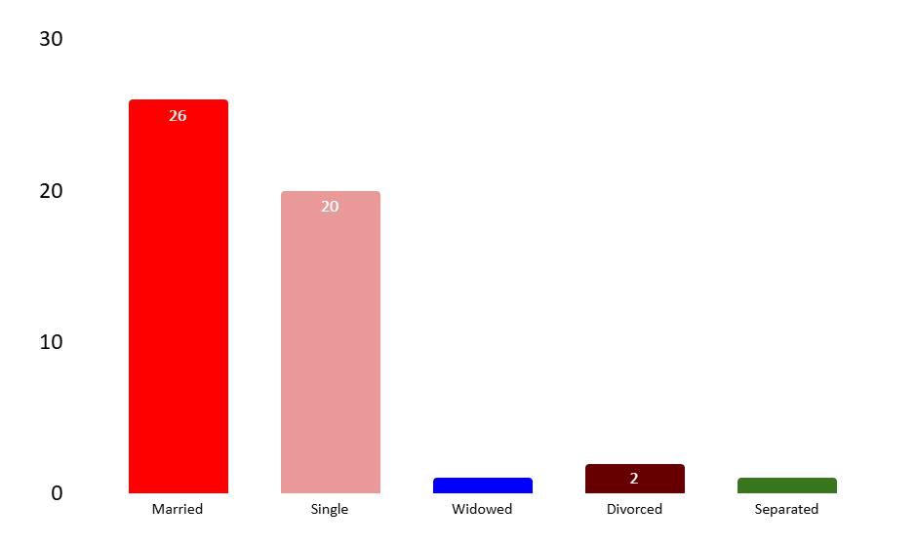
Fig. 2: Marital Status
Fig. 3: Age Group- This figure shows that out of 50 respondents 21 of them which is 42% of my sample are from the age group 26-30 years who are engaged in the gig work and 3 of the respondents are from the age group of 18-20 which is 6% of my sample.

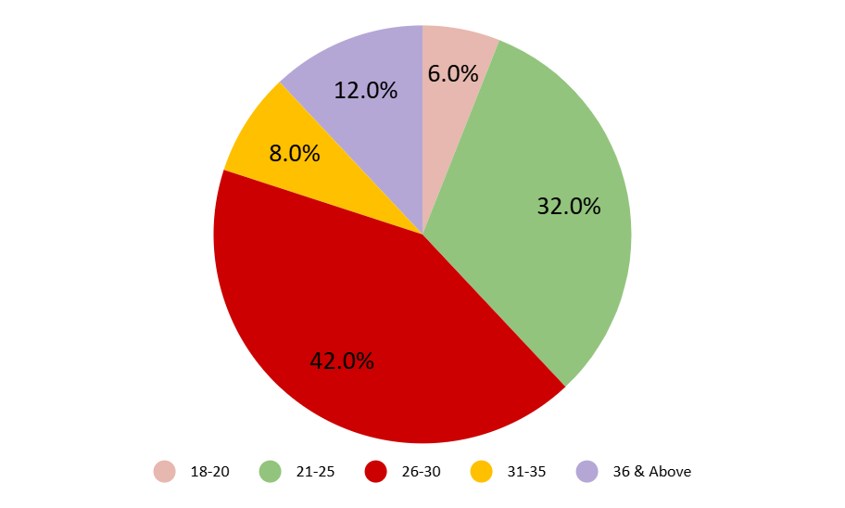
Fig. 3: Age Group
Fig. 4: Type of Gig Work- This figure shows that out of 50 respondents 22 of them are engaged in Transportation and Digital work, 12 of them in Home-based services and the rest of the respondents are into Event and creative services, Online selling and retail & Others like Baking, Content making, Jewellery making etc.

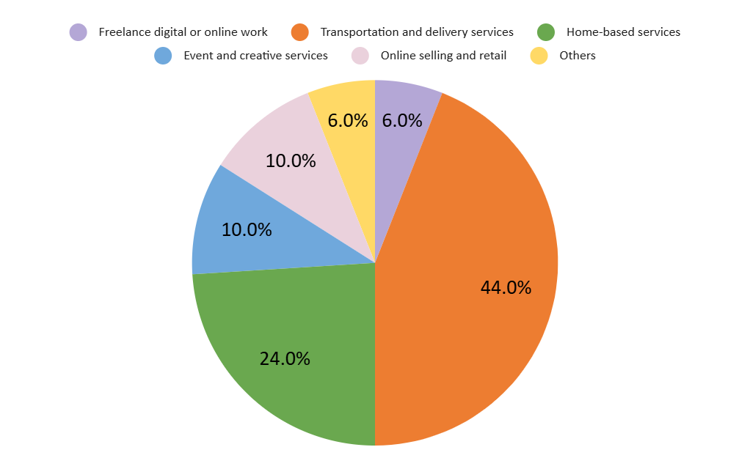
Fig. 4: Type of Gig Work

Fig. 5: Monthly Household Income- In this figure it is observed that out of 50 respondents 20 of the respondents are having monthly household income of Rs. 30000 to Rs. 50000 followed by 15 are having less than 30000, 8 respondents are having monthly household income within Rs. 50001-75000 & 2 of them are having Rs. 75001-100000 & 5 respondents are having more than Rs. 100000 of monthly income.

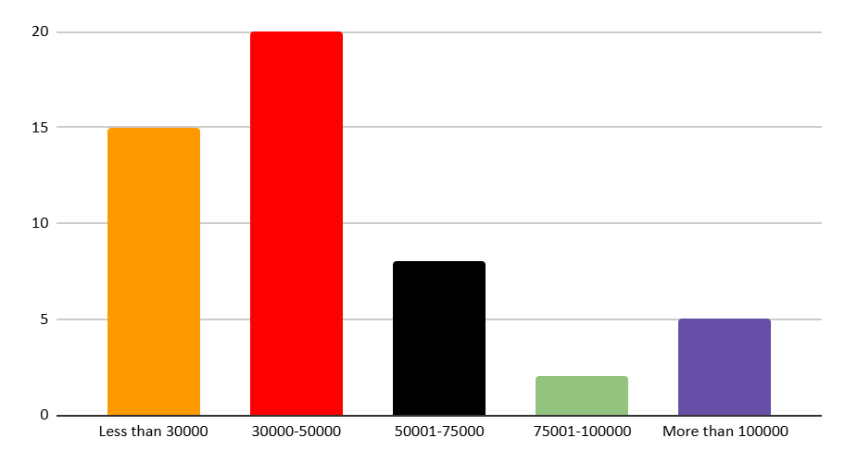
Fig. 5: Monthly Household Income
The above data revealed that women of different age groups with varying educational backgrounds are engaged in different types of gig work, and income levels tend to vary with education and marital status.
- Occupational Profile:
Fig. 6: Average Working Hours- This figure shows that out of 50 respondents 20 respondents which is the maximum of respondents are having an average 4 to 6 working hours followed by 15 are having 6-8 hours and 10 respondents have more than 8 hours of average working hours.

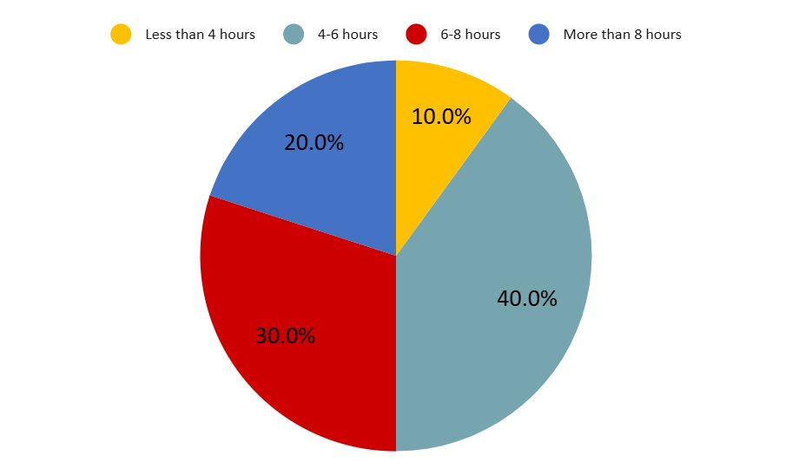
Fig. 6: Average Working Hours
Fig. 7: Duration of Engagement in Gig Work- This below figure shows that maximum respondents are engaged in the gig work for 2 to 5 years followed by 13 respondents are engaged in this profession for 1 to 2 years and least respondents that is 4 are working for 6 months to 1 year.

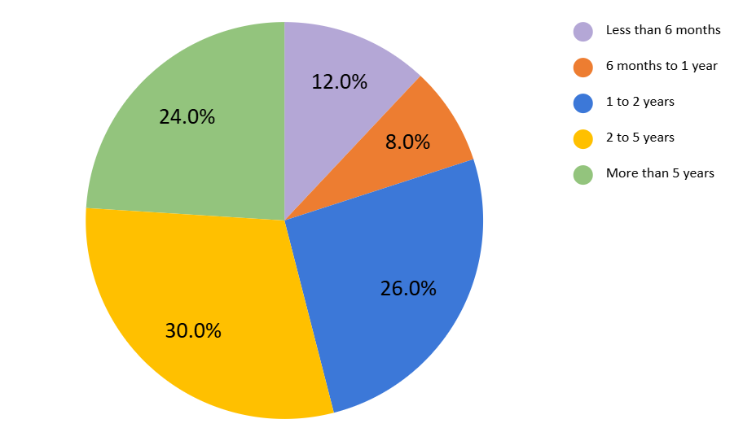
Fig. 7: Duration of Engagement in Gig Work
Fig. 8: Work Travel Time- This figure shows that out of the 50 respondents 20 respondents are not required to travel and following that 12 respondents selected the option that they need less than 1 hour to travel, 11 respondents require 1 to 2 hours & least that is 3 respondents require more than 4 hours to travel to reach their workplace.

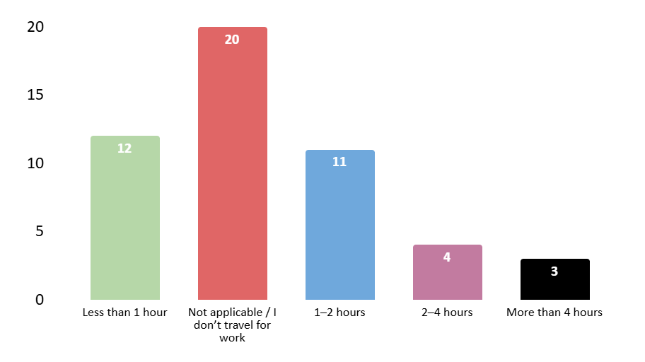
Fig. 8: Work Travel Time
Fig. 9: Perceived Income Stability- This figure shows that the majority of respondents, 20 of them have agreed that there is a perceived income stability in their gig work they are engaged in and 12 of the respondents had been neutral on this statement. 4 of each have been strongly agreed as well as strongly disagreed on this statement.

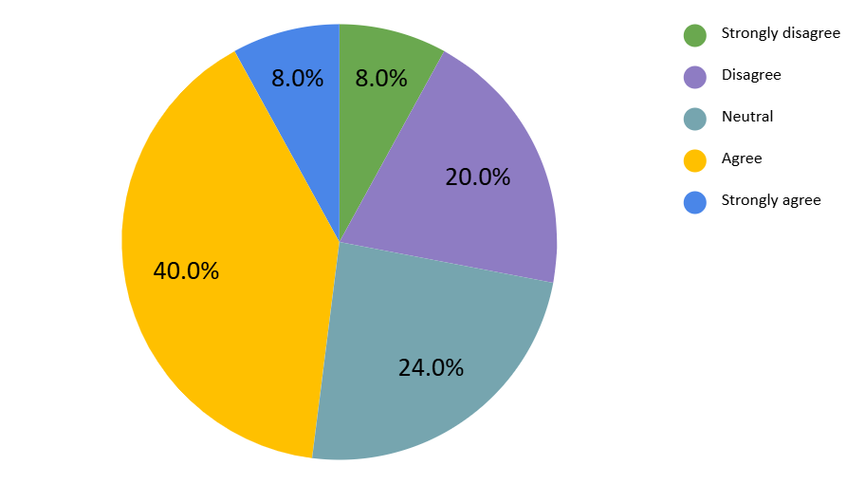
Fig. 9: Perceived Income Stability
It was found that longer engagement and more working hours were often linked with higher perceived income stability. Travel time also had an impact on income satisfaction.

3.2 FOR OBJECTIVE 2
Objective 2: To study the impact of barriers to healthcare services on access to reproductive health care services.
To assess the impact of barriers to healthcare services (independent variable) on reproductive health status (dependent variable) a linear regression analysis was performed.
Table 1 Summary of Regression

Model |  | Unstandardized Coefficients |  | Standardized Coefficients | t | Sig. | Adjusted R Square
 |  | B | Std. Error | Beta | t | Sig. | Adjusted R Square
Physical strain from gig work affecting reproductive health | (Constant) | 1.353 | 0.429 |  | 3.152 | 0.003 | 0.227**
Physical strain from gig work affecting reproductive health | Barriers | 0.572 | 0.146 | 0.493 | 3.922 | 0 | 0.227**
Experience of menstrual irregularities since starting gig work | (Constant) | 0.997 | 0.36 |  | 2.769 | 0.008 | 0.379**
 | Barriers | 0.68 | 0.122 | 0.626 | 5.559 | 0 | 0.379**
Pregnancy during gig work | (Constant) | -0.209 | 0.145 |  | -1.441 | 0.156 | 0.143**
Pregnancy during gig work | Barriers | 0.149 | 0.049 | 0.401 | 3.029 | 0.004 | 0.143**
Pregnancy-related health complications | (Constant) | -0.312 | 0.132 |  | -2.37 | 0.022 | 0.236**
Pregnancy-related health complications | Barriers | 0.179 | 0.045 | 0.501 | 4.015 | 0 | 0.236**
History of reproductive tract infections (RTIs) in past 12 months | (Constant) | 0.701 | 0.33 |  | 2.129 | 0.038 | 0.394**
 | Barriers | 0.642 | 0.112 | 0.637 | 5.731 | 0 | 0.394**
Frequency of reproductive health check-ups | (Constant) | 4.017 | 0.47 |  | 8.543 | 0 | 0.121**
Frequency of reproductive health check-ups | Barriers | -0.444 | 0.16 | -0.372 | -2.78 | 0.008 | 0.121**
p < 0.05 is considered statistically significant and p** < 0.01.
Interpretation
The regression analysis reveals a strong and statistically significant effect of barriers to healthcare services on multiple reproductive health outcomes among women engaged in gig work. All models showed significance at p < 0.01, indicating a reliable relationship.
- For physical strain, the Beta coefficient is 0.493, meaning a one-unit increase in barriers leads to a 0.493-unit increase in physical strain levels.
- For menstrual irregularities, the Beta is 0.626, suggesting that a one-unit rise in barriers increases menstrual irregularities by 0.626 units.
- For reproductive tract infections (RTIs), the Beta is 0.637, showing a strong positive effect where each unit increase in barriers raises RTI incidence by 0.637 units.
- For pregnancy-related health complications, the Beta is 0.501, implying a 0.501-unit increase in complications per unit increase in healthcare barriers.
- For pregnancy during gig work, the Beta is 0.401, indicating a 0.401-unit increase in likelihood with each unit increase in barriers.
- Notably, the frequency of reproductive health check-ups shows a negative Beta of -0.372, meaning as barriers increase, the frequency of check-ups significantly decreases by 0.372 units.
The adjusted R-squared values, ranging from 0.121 to 0.394, show that a moderate to substantial proportion of the variance in reproductive health outcomes is explained by barriers to healthcare access.
In general, the analysis indicates that increased barriers to healthcare significantly worsen reproductive health outcomes among women gig workers, leading to higher instances of physical strain, menstrual issues, infections, and pregnancy-related complications. These barriers also reduce the frequency of reproductive health check-ups, as challenges like financial constraints, long work hours, lack of health insurance, limited awareness, and social stigma make it difficult for women to access routine care. This results in underdiagnosed and untreated health conditions, highlighting the urgent need to improve healthcare accessibility for women working in the gig economy.
These results underscore the urgent need to address physical, financial, and systemic barriers in healthcare accessibility for women gig workers, as they have a measurable and detrimental impact on their reproductive health.
3.3 FOR OBJECTIVE 3
Objective 3: To know the association of gig work conditions with access to reproductive health care services.
To examine the association in between gig work conditions with reproductive health a Chi-square test of independence was applied. This test is suitable for evaluating whether significant associations exist between categorical independent variables and selected dependent reproductive health indicators.
Table 2 Summary of Result

Dependent Variable | Independent Variable | Value | Asymp.Sig. (2-sided) | Whether Significant or not
Physical Strain from Gig Work | Workplace Safety | 9.642 | 0.647 | Not Significant
Physical Strain from Gig Work | Stress due to Gig Work | 30.452 | 0.016 | Significant
Physical Strain from Gig Work | Adequacy of Rest between Work Shift | 40.797 | 0.001 | Significant
Experience of Menstrual Irregularities | Workplace Safety | 15.283 | 0.226 | Not Significant
Experience of Menstrual Irregularities | Stress due to Gig Work | 25.028 | 0.069 | Not Significant
Experience of Menstrual Irregularities | Adequacy of Rest between Work Shift | 32.835 | 0.008 | Significant
Pregnancy during Gig Work | Workplace Safety | 6.822 | 0.078 | Not Significant
Pregnancy during Gig Work | Stress due to Gig Work | 8.111 | 0.088 | Not Significant
Pregnancy during Gig Work | Adequacy of Rest between Work Shift | 10.278 | 0.036 | Significant
Pregnancy-related Health Complications | Workplace Safety | 4.041 | 0.257 | Not Significant
Pregnancy-related Health Complications | Stress due to Gig Work | 5.634 | 0.228 | Not Significant
Pregnancy-related Health Complications | Adequacy of Rest between Work Shift | 6.333 | 0.176 | Not Significant
Reproductive Tract Infections (RTIs) in the last 12 months | Workplace Safety | 21.544 | 0.043 | Significant
Reproductive Tract Infections (RTIs) in the last 12 months | Stress due to Gig Work | 28.868 | 0.025 | Significant
Reproductive Tract Infections (RTIs) in the last 12 months | Adequacy of Rest between Work Shift | 27.26 | 0.039 | Significant
Frequency of Reproductive Health Check-ups | Workplace Safety | 13.289 | 0.348 | Not Significant
Frequency of Reproductive Health Check-ups | Stress due to Gig Work | 20.235 | 0.21 | Not Significant
Frequency of Reproductive Health Check-ups | Adequacy of Rest between Work Shift | 26.856 | 0.043 | Significant

Interpretation
A significant relation has been observed between several dependent reproductive health status and independent gig work conditions variables such as;
- Stress due to gig work (p= 0.016) & Adequacy of rest (p= 0.001) has a significant association with Physical strain from gig work affecting reproductive health.
- Adequacy of rest (p= 0.008) has association with Experience of menstrual irregularities since starting gig work.
- Adequacy of rest (p= 0.036) significantly associated with Pregnancy during gig work.
- Workplace safety perceptions (p= 0.043), Stress due to gig work (p= 0.025), Adequacy of rest between work shifts (p= 0.039) significantly associated with History of reproductive tract infections (RTIs) in the past 12 months.
- Adequacy of rest between work shifts (p= 0.043) has a significant association with Frequency of reproductive health check-ups.

These findings indicate that gig work conditions significantly affect several aspects of women’s reproductive health.
On the other hand, the analysis shows that no significant relationship exists with Workplace safety perceptions and physical strain, menstrual irregularities, pregnancy during gig work, pregnancy-related complications, and frequency of health check-ups.

- CONCLUSION
The study concludes that while gig work provides income and autonomy to women, it also exposes them to health and economic insecurity. Barriers to healthcare access, inadequate rest, and occupational stress contribute significantly to poor reproductive health outcomes. To address these challenges, policymakers and gig platforms must collaborate on gender-sensitive labor policies. Policy formulation should establish a legal framework recognizing women gig workers as a formal labor category entitled to social security, healthcare benefits, and workplace rights. Platform accountability must ensure minimum health insurance coverage, maternity benefits, mandated rest breaks, and safety measures. Skill and health integration programs should combine digital and occupational skill development with reproductive and general health awareness. Finally, a regional focus is needed, prioritizing underrepresented areas like North-East India, where gig work is emerging but institutional and infrastructural support remains limited.

- ETHICAL APPROVAL AND CONSENT
All authors declare that ethical approval was obtained from the Institutional Ethics Committee of ICFAI University Tripura. Written informed consent was obtained from all participants prior to data collection.

- REFERENCES
Agrawal, D., & Bhukya, R. (2022). Effects of the GIG economy on the workplace: A contemporary Indian perspective study. International Journal of Health Sciences, 6(S3), 2701–2718.
Business Today. (2020). India's unemployment hits record high amid COVID-19. Retrieved from https://www.businesstoday.in/
Centre for Monitoring Indian Economy. (2020). Unemployment in India: CMIE report. Retrieved from https://www.cmie.com/
David, S., Rajkumar, M., & Joseph, J. (2024). A study on gig economy in India and redefining the work in the digital era. International Journal of Creative Research Thoughts, 12(4), 790–795.
Dokuka, S., Kapuza, A., Sverdlov, M., & Yalov, T. (2022). Women in gig economy work less in the evenings. Scientific Reports, 12(8502).
Karunakaran, N. (2025). The gig economy in India. International Journal of Multidisciplinary Educational Research, 14(2), 25–34.
Kumbhakkudi, R. (2021). Impact of gig economy on the productivity and job satisfaction of teachers working in self-financing institutions of Kerala. Doctoral Dissertation, Bharathiar University.
NITI Aayog. (2022). India’s booming gig and platform economy: Perspectives and recommendations on the future of work. Retrieved from https://www.niti.gov.in/
Oster, E., & Thornton, R. (2011). Menstruation, sanitary products, and school attendance: Evidence from a randomized evaluation. American Economic Journal: Applied Economics, 3(1), 91–100.
The Shillong Times. (2023). Gig workers in NE face high commission and job insecurity. Retrieved from https://www.theshillongtimes.com/

