Original Research Article

Molecular Characterization and Antibiotic Susceptibility Profile of Salmonella Species Isolated from Municipal Wastewater in Jos, Plateau State

ABSTRACT
Aim: This study characterized antibiotic-resistant Salmonella species from Jos, Plateau State wastewater. One hundred and fifty (150) wastewater samples were collected from ten (10) sample sites.
Study Design: A descriptive cross-sectional study was used in this research
Place and Duration of Study: wastewater was collected from Gada Juth, Bingham, Tudun Wada, Village Hostel, Vom, Abbatoir, Jenta, Farin-Gada, K-Vom, and Angwan-Rukuba of Plateau State from October to November 2023.
Methods: Conventional and molecular laboratory (PCR) techniques were employed to isolate Salmonella species and detect their resistant genes. A disc diffusion assay by Kirby-Bauer was performed to determine the sensitivity of antibiotics against Salmonella isolates.
Results: There was a 2.7% overall prevalence of Salmonella spp in wastewater, with higher rates found in wastewater collected from Jenta (2%) and a lower prevalence rate of 0.67% from wastewater collected from Angwan Rukuba. High susceptibility was recorded for Streptomycin, high resistance was recorded for Gentamicin (75%), Azithromycin (75%) and Ciprofloxacin (50%). All isolates showed 100% resistance to Pefloxacin, Cefotaxime, Ceftazidime, and Ceftriaxone and 100% sensitivity towards Imipenem. Furthermore, all isolates were multi-drug resistant, with the most common multidrug resistance patterns being PEF, CH, CN, CRO, CAZ, CTX, and AZM (50%). All isolates reported multiple antibiotic resistance (MAR) index > 0.2 in the study, indicating high levels of resistance. None of the resistant genes (mph (A) and bla_{CTX-M}) tested were detected among the isolates.
Conclusion: There was a low occurrence of Salmonella and none of the tested genes associated with antibiotic resistance were detected, interestingly, most of the isolates were multidrug resistant, thereby constituting a menace to food safety and general health in the study area.
Keywords: Wastewater, Antibiotic resistance, Salmonella, MDR, Plateau State
1.0 INTRODUCTION
Wastewater serves as a common medium for the spread and transmission of Salmonella serovars, posing risks to the environment and human health. According to the United Nations, over 80% of the world’s wastewater is released back into the environment without treatment or reuse, with this figure rising to over 95% in some of the least-developed countries such as Afghanistan, India, Democratic Republic of Congo, Nigeria and Tanzania [1]. Numerous outbreaks and cases of contamination have been linked to Salmonella in wastewater through the irrigation of crops [2], movement through soil to groundwater [3], or discharge into marine environments [4,5], Although some pathogens are naturally found in aquatic systems, Salmonella can be introduced through pollution from animal or human faeces and sewage [6].
The risk of Salmonella contamination increases due to its ability to survive for extended periods in the environment. This means that Salmonella contamination of groundwater, environmental water, and soil is a consequence of its long survival rates in these ecosystems [7]. Moreover, Salmonella's ability to thrive in relatively high salt concentrations exacerbates contamination in seawater and seafood [8]. Therefore, the ongoing discharge of wastewater into the environment may elevate the concentration of Salmonella, leading to a higher incidence of waterborne diseases.
Antimicrobial resistance (AMR) is the capacity of organisms to resist the effects of antimicrobial agents, which can be either intrinsic due to their structural properties or acquired through genetic mechanisms, such as specific resistance genes. The spread of AMR in the environment occurs through three main processes: horizontal gene transfer (HGT) involving mobile genetic elements, genetic mutations, and vertical gene transfer of mutations [9,10,11] Understanding the mechanisms of AMR spread in environmental settings, such as wastewater, will provide us with knowledge that can inform strategies for mitigating the spread of AMR in wastewater. In Jos, Plateau State, Nigeria, wastewater is often not properly treated and may contain high levels of antibiotic-resistant bacteria.
The results from this research will provide crucial insight into the molecular characteristics of antibiotic-resistant Salmonella in wastewater from Jos. This information will be useful in identifying potential sources of infection and developing strategies to curb the spread of these bacteria in the community. This study compensates for the body of knowledge available around the epidemiology of antibiotic-resistant Salmonella, which poses relevancy in the advancement of effective public health interventions such as phytoremediation [12] and also serves as an effective monitoring tool for the monitoring of vaccination programs globally, and their impact on the local transmission and exposure of typhoid and non-typhoidal Salmonella infection [13].
We characterized antibiotic-resistant Salmonella species from wastewater with specific objectives to isolate and identify Salmonella species from wastewater samples collected, determine the antibiogram profiles of Salmonella isolates and detect the Macrolide resistance gene mphA and bla_{CTX-M} gene from MDR isolates of Salmonella species from wastewater samples collected in Jos and its environs.
2.0 MATERIALS AND METHODS
2.1 Study Area
The study was conducted in Jos metropolis, the capital of Plateau State, comprising two Local Government Areas: Jos North and Jos South. The State is situated at latitude 9° 10’ N and longitude 9° 45′ E in central Nigeria, covering an area of 30,913 square kilometres and housing over 3 million residents based on the 2006 census, resulting in a population density of approximately 391 individuals per square kilometre, Jos is the most densely populated and urbanized area in Plateau State. Due to the presence of many higher educational institutions, churches, commercial activities, and administrative functions, the city has evolved into a cosmopolitan hub [14]. The state derives its name from the remarkable table-top rock formation known as Plateau, which has an altitude ranging from 1200 to 1829 meters above sea level. The climate in the state can be described as temperate compared to other regions of Nigeria, despite its location in a tropical area. The annual mean temperature typically ranges from 18 to 22°C, with annual rainfall averaging 1317.5 mm in the lower plateau and 1460 mm at the plateau's summit [15].
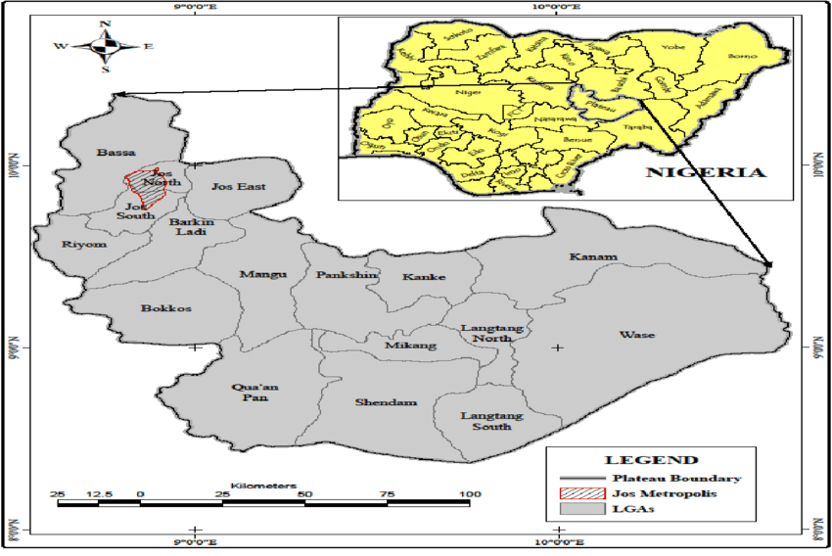
Figure 1: The study area, Jos Metropolis, Plateau State, Nigeria (GIS LAB, Department of Geography and Planning University of Jos, 2018)
2.2 Sample Collection and Technique
A purposeful non-probability sampling technique was used in identifying and selecting eligible sites in the Jos metropolis for wastewater collection. Ten sites in Jos Metropolis were visited for the sampling of the various wastewater for this study. These sites are as follows: Gada Juth, Bingham, Tudun Wada, Village Hostel, Vom, Abbatoir, Jenta, Farin-Gada, K-Vom, Angwan-Rukuba. A total of 15 samples from each of the selected sites for the study were randomly collected weekly between October 2023 to November 2023. All samples were kept in a cooler containing ice packs and were immediately transported to the National Veterinary Research Institution laboratory, Vom and preserved in a refrigerator between 0°C and 4 °C.
2.3 Isolation and Identification of Salmonella Species
For isolation and identification of Salmonella, 1 mL of the wastewater sample was pre-enriched in 9 mL of buffered peptone water (BPW, Oxoid, UK) and incubated at 37℃ for 18 to 24 h. Furthermore, 0.1 mL of the culture was enriched in 10 mL of Rappaport vassiliadis media (Oxoid, UK) and incubated at 42℃ for 18 to 24 h. Aseptically, 10 μl culture broth was streaked in parallel on Xylose Lysine Deoxtcholate agar (XLD) (Oxoid, UK) and incubated at 37℃ for 18 to 24 h. Presumptive Salmonella species were subcultured on Salmonella-Shigella agar (SSA) (Oxoid, UK) at 37℃ for 24h. Colonies with black centres were subcultured on nutrient agar at 37℃ for 24h to obtain a pure culture. Presumptive salmonella isolates were stained using a Gram staining technique to ascertain their microscopic features [16,17,18]. Classical identification of bacterial colonies was performed according to Cheesborough (2006) [16] with slight modification. Biochemical assays such as triple sugar iron (TSI), urease test, indole test, citrate test, methyl red test, motility test and isolates reactions to sugars such as glucose, mannose, maltose, galactose, lactose, cellibiose, melibiose, raffinose, sorbitol, manitol, dulcitol, salicin were performed [16,19]. Results from the biochemical and phenotypical characterization of the isolates were input into the online Advanced Bacterial Identification Software (ABIS) for the identification of isolates [20]
2.4 Molecular Characterization
2.4.1 DNA Extraction
Isolated Salmonella species were subjected to DNA extraction utilizing the Qiagen QIAmp DNA mini kit. A sterile loop scooped the bacterial colonies into 1.5ml microtubes containing 200 µL of phosphate buffer saline (PBS), followed by vortexing and centrifugation for 1 min at 800 rpm. The supernatant was removed, and 200µl PBS was reintroduced to the pellet for dislodging. This mixture was then combined with 20µl of proteinase K solution and 200µl of buffer AL, mixed thoroughly, and incubated at 70°C for 10 minutes. After brief centrifugation for 1 min at 800 rpm, the mixture was transferred to a QIAmp Mini spin column placed in a 2ml collection tube. The flow-through of the collection was discarded. The QIAam Mini spin column was placed in a new 2ml collection tube, 500µl of the buffer AW₁ was added and centrifuged at 800 rpm for 1 min. The flow-through was discarded. 500 µl of buffer AW₂ was added and centrifuged at 1400 rpm for 3 min. The flow-through was discarded and the tubes were dry spun (tense) at 1400 rpm in order to eliminate the chance of possible buffer AW₂ carryover. 150µLof elution buffer (AE) was added to elute the DNA, which was then immediately utilized for PCR analysis.
2.4.2 PCR Analysis
The full length of 16S rRNA, Mph(A) and bla_{CTX-M} gene were amplified through conventional PCR using the universal 16S rRNA, Mph(A) and bla_{CTX-M} primer set (F:5′-TGTTGTGGTTAATAACCGCA-3′ and R:5′-CACAAATCCATCTCTGGA-3′), (F:5′-GTGAGGAGCTTCGCTTCGCGAG-3′ and R:5′-TGCCGCAGGACTCGGAGGTC-3′) and (F:5′-CCCATGGTTAAAAAACACTGC-3′ and R:5′-CAGCGCTTTTGCCGTCTAAG-3′) respectively. Amplification of bacterial DNA was done using a 25µl total reaction volume containing 5 µl of 5X master mix, 1 µl of primer 16S rRNA, MphA, bla_{CTX-M,} 13 µl of nuclease-free water and 5 µl of DNA. The reaction tubes were put in the PCR thermocycler. PCR conditions were set to be as follows: 4 minutes at 95 ºC for initial denaturation, 35 cycles each 1 minute at 94 ºC for denaturation, 1 minute at 52 ºC for annealing and 30 seconds at 72 ºC for extension and final extension at 72 ºC for 10 minutes for 16S rRNA; 5 minutes at 95 ºC for initial denaturation, 35 cycles each 30 secs at 94 ºC for denaturation, 45 secs at 58 ºC for annealing and 45 seconds at 72 ºC for extension and final extension at 72 ºC for 10 minutes for Mph(A); 5 minutes at 95º C for initial denaturation, 35 cycles each 30 secs at 95 ºC for denaturation, 1 minute at 56º C for annealing and 90 seconds at 72 ºC for extension and final extension at 72 ºC for 10 minute for Mph(A) for bla_{CTX-M.} After termination of PCR, the amplified products were visualized on 1.5% agarose gel stained with 8 µl ethidium bromide along with Gel pilots 100bp ladder (Qiagen, Germany, GmbH) and was run for 55 mins at 90 volts; to test primer and probe efficiency we used bacterial strains containing the resistance genes of interest (kindly provided by Dr. G.O.A Agada). The bacterial strains were also included in each PCR run as positive controls and the gel was photographed using a digital camera.
2.5 Antibiotic Susceptibility Testing
The antimicrobial susceptibility test was conducted using the Kirby–Bauer disc diffusion method, following the Clinical and Laboratory Standards guidelines ^{[21]}. Isolates were streaked onto Mueller–Hinton agar and incubated at 37 °C overnight. Bacterial colonies were suspended in 0.9% Sodium Chloride (NaCl) to achieve a McFarland turbidity of 0.5, which corresponds to approximately 1-2 × 10⁸ colony-forming units (CFU)/ml of Escherichia coli strain American Type Culture Collection (ATCC) 25922. Mueller-Hinton (Oxoid, UK) agar plates were swabbed with the adjusted bacterial suspension using a sterile swab. Antibiotic discs were then placed on the agar using a dispenser and incubated at 37˚C for 24 hours. The antibiotic discs used included: Ciprofloxacin (30μg), Gentamicin (10μg), Streptomycin (10μg), Pefloxacin (5μg), Cefotaxime (30μg), Ceftazidime (30μg), Ceftriaxone (30μg), Imipenem (10μg), Chloramphenicol (30μg), and Azithromycin (15μg). The diameters of the inhibition zones were measured with callipers and recorded to the nearest millimeter (mm). Results were interpreted using standard breakpoints as described by Clinical and Laboratory Standards [21].
2.6 Identification of Multi-Drug Resistant (MDR) Salmonella and Determination of Multiple Antibiotic Resistance (MAR) Index
Multi-drug resistance (MDR) is defined as the resistance of bacterial isolates to three or more classes of antibiotics. This characteristic is assessed by examining the resistance patterns of these isolates to various antibiotics [22]. (CLSI guidelines were used to determine the susceptibility of the isolates, and from the result, isolates exhibiting resistance to more than 3 classes of antibiotics are classified as MDR) Additionally, the Multiple Antibiotic Resistance (MAR) index was determined and interpreted following the procedure described by Krumperman (1983) [23] for which the MAR index was calculated using the formula MAR = a/b, where 'a' represents the number of antibiotics to which the isolate is resistant, and 'b' denotes the total number of antibiotics tested for susceptibility.
3. RESULTS
3.1 Prevalence of Salmonella species according to source of wastewater in Jos and environs
In total, 150 samples of wastewater were examined in this study, of which a total of 4 Salmonella isolates were identified (3 from Jenta and 1 from Angwan Rukuba). The result showed that 2.67% of wastewater tested within this study period was contaminated with Salmonella species. Wastewater from Jenta was the most contaminated with Salmonella species, with a prevalence of 2% while, Angwan Rukuba had the lowest prevalence of 0.67%. No Salmonella species were detected from other sources of wastewater examined (Table 1).

Table 1: Prevalence of Salmonella species according to source of wastewater in Jos and its environs
Source | Total Samples Examined | Total Positive Samples | positive samples (%) | Prevalence (%)
Juth | 15 | 0 | 0 | 0
Bingham | 15 | 0 | 0 | 0
Tudun Wada | 15 | 0 | 0 | 0
Village Hostel | 15 | 0 | 0 | 0
Vom | 15 | 0 | 0 | 0
Abbatoir | 15 | 0 | 0 | 0
Jenta | 15 | 3 | 20.00 | 2.00
Farin-Gada | 15 | 0 | 0 | 0
K-Vom | 15 | 0 | 0 | 0
Angwan-Rukuba | 15 | 1 | 6.67 | 0.67
Total | 150 | 4 | 26.67 | 2.67

3.2 Distribution of Salmonella species isolated from wastewater in Jos and environs according to the Advance Bacterial Identification Software (ABIS)
The morphological and biochemical characters of the isolates were tested by ABIS online software which identified only four (4) isolates as Salmonella species. Isolates J1, J9 and J12 were identified as Salmonella enterica subs. Enterica (S. Enterica) with 99% identity similarity while isolate AR5 was identified as Salmonella enterica subs. Houtanae (S. Houtanae) with 94.1% similarity identity (Table 2).
Table 2: Distribution of Salmonella spp isolated from wastewater in Jos and environs according to the Advance Bacterial Identification Software (ABIS)
Sample Identity | Salmonella species identified | ABIS Similarity (%) | Confidence level (%)
J1 | Salmonella Enterica | 99 | High
J9 | Salmonella Enterica | 99 | High
J12 | Salmonella Enterica | 99 | High
AR5 | Salmonella Houtenae | 94.1 | High
Total
Key: %= Percentage

3.3 Occurrence of other bacteria identified in wastewater examined from Jos and environs
The presence of other bacteria detected from wastewater in the study is shown in Figure 2. The most frequently occurring bacteria are Proteus species, showing a prevalence of 42.0%, while Klebsiella species occurred the least with a prevalence of 18%, with other bacteria detected, including E. coli (23.3%) and Pseudomonas species (22%).
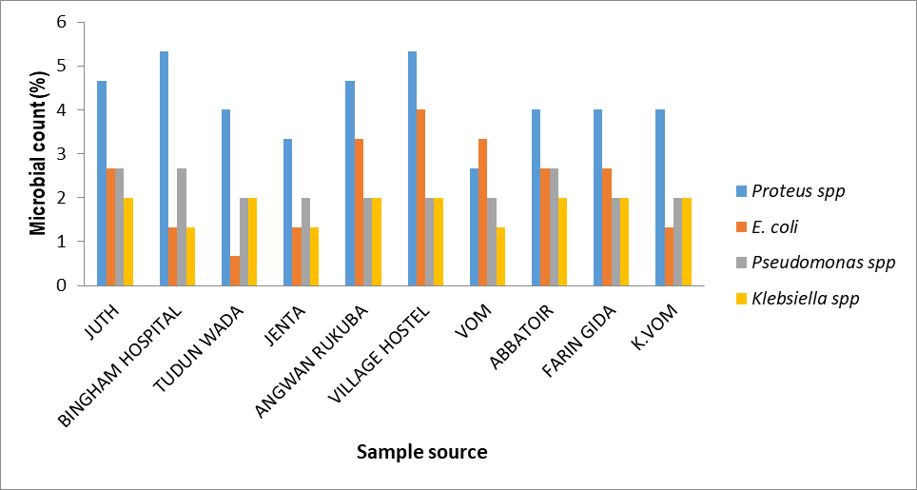
^{Key: %=Percentage}
Figure 2: Occurrence of other bacteria identified in wastewater examined from Jos and environs

3.4 Antibiotic susceptibility pattern of Salmonella species from wastewater in Jos
All isolates were resistant to fluoroquinolones. Four (4) isolates showed (100%) resistant to Chloramphenicol (Phenicol), Cefotaxime, Ceftazidime, Ceftriaxone (Cephalosporins) while 2 (50%) and 3 (75%) of the isolates also exhibits resistance to Ciprofloxacin (Fluoroquinolones), Gentamicin (Aminoglycoside), and Azithromycin (Macrolide) respectively. Three 3 (75%) isolates were sensitive to Streptomycin (Aminoglycosides) while 1(25%) was sensitive to Azithromycin (Macrolide). A complete sensitivity of 4 (100%) was shown to Imipenem (Carbapenem) (Figure 3).
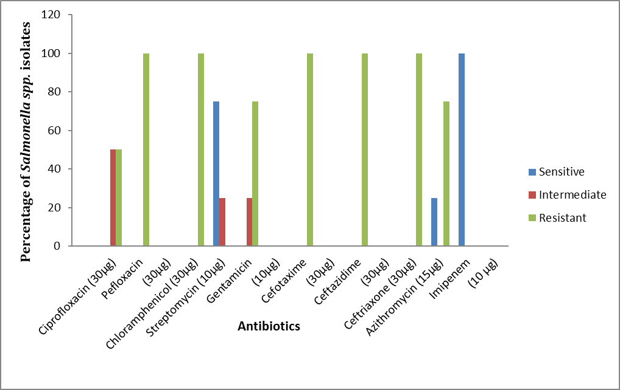^{Key: % = Percentage, N=4}
Figure 3: Antibiotic susceptibility of Salmonella species from wastewater in Jos

3.5 Multi-drug resistance pattern and MAR index of Salmonella isolates from wastewater in Jos and environs
All S. Enterica from this study were found to be multidrug resistant as they were resistant to three (3) or more different classes of antibiotics (Table 8).
Table 3. Multidrug Resistance Pattern and MAR index of Salmonella isolates from wastewater in Jos and environs
Isolates | No. of Antibiotics (10) | MDR Pattern | No. of antibiotic classes | No. of MDR S. spp. | MAR Index
Salmonella Enterica | 6 | CPX, PEF, CH, CRO, CAZ, CTX | 3 | 1 | 0.6
Salmonella Enterica | 8 | CPX, PEF, CH, CN, CRO, CAZ, CTX, AZM | 5 | 1 | 0.8
Salmonella Enterica | 7 | PEF, CH, CN, CRO, CAZ, CTX, AZM | 5 | 1 | 0.7
Keys: CPX=Ciprofloxacin; CH=Chloramphenicol; CN-Gentamicin; CTX-Cefotaxime CAZ-Ceftazidime; CEF-Ceftriaxone; AZM-Azithromycin, PEF= Pefloxacin, No=Number, MDR=Multi-drug resistance

3.6 Molecular characterization of Salmonella species isolated from wastewater in Jos and environs
The Salmonella-specific PCR (16S rRNA) assay demonstrated both specificity and sensitivity and successfully identified four Salmonella isolates containing 16S rRNA in molecular weight 572 bp (Figure 4).
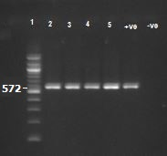
Lane 1: 100 bp Ladder, Lane 2, 3, 4 and 5 reveal amplification of 572 bp fragments 16S rRNA gene. Lane +ve: Positive Control, Lane -ve: Negative control
Plate 1: Salmonella-specific 16S rRNA gene of isolates from wastewater

3.7 Salmonella-specific PCR (bla_{CTX-M} and mphA) assay
In this study, 4 Salmonella isolates were tested for bla_{CTX-M} gene (Plate 2) and the mph (A) gene (Plate 3), of which none of the tested isolates gave positive amplicons.
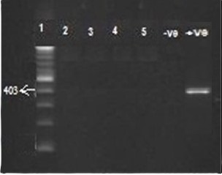
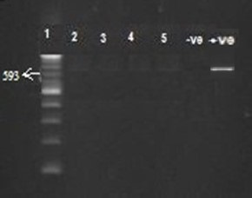

Lane 1: 100 bp Ladder, Lane 2, 3, 4 and 5 did not reveal amplification of 403 bp fragments mphA gene, Lane -ve: Negative control

Lane 1: 100 bp Ladder, Lane 2, 3, 4 and 5 did not reveal
the amplification of 593 bp fragments of the CTX-M
gene. Lane -ve: Negative control

Plate 2. Showing bla_{CTX-M} resistant gene PCR product Plate 3. Showing the mphA-resistant gene PCR product
4. DISCUSSION
In this study, we analysed 150 wastewater samples, identifying Salmonella in only 4 samples (2.67%) (Table 1), a prevalence lower than the 7.5% reported by Dickson et al. (2016) [24] at Nsukka, Nigeria and significantly lower than rates observed in other countries, such as 42.5% by Julien et al. (2014) [25] at Abidjan, Côte d’Ivoire , 38.9% by Krzyzanowski et al. (2014) [26] at Brazil, and 62% by Santiago et al. (2018) [27] at Spain. The lower prevalence may be attributed to several factors affecting Salmonella detection, including predation by bacteriophages [28], chlorination, and industrial pollutants that reduce Salmonella levels [29]. Additional factors influencing Salmonella survival and concentration include the replication site in the gastrointestinal tract, duration of excretion, prevalence among infected individuals, and environmental conditions like dilution and seasonal variations [30]
In applied bacteriology, bacterial strains are isolated and identified phenotypically through the ABIS online system (version 12). This software provides accurate species identification and generates reliable results, making it an essential tool for microbiology laboratories. It offers vital information on the ecological importance, pathology, and other characteristics of the bacterial strains identified [20]. The ABIS online software revealed four (4) isolates as Salmonella species of which three (3) isolates were S. Enterica with 99% identity similarity while one of the isolates was identified as S. Houtanae with 94.1% similarity identity; all isolates identified showed a high confidence level (Table 2). The findings in this study agrees with Sorescu & Stoica (2021) [20] who reported identifying Salmonella species using ABIS with a high identity similarity of 91.3%. Similarly, findings from El Kahlout et al. (2018) [31] agrees with the reliability of ABIS online software in identifying Streptococcus thermophilus, Lactobacillus bulgaricus and Lactobacillus delkbrueckii with high percentage of reliability.
Proteus species occurred the most with prevalence rate of 42.0%, while Klebsiella species occurred the least with a prevalence of 18%, with other bacteria detected, including E. coli (23.3%) and Pseudomonas species (22%) (Figure 2) contradicting findings from Karungamye et al. (2023) [32], who reported Klebsiella pneumoniae as the most prevalent organism in wastewater. Other studies have shown diverse microbial profiles, with treated hospital wastewater samples revealing a significant presence of E. coli (39.5%), Staphylococcus (35.1%), and Klebsiella species (30.7%) [33]. Research from Ghana also highlighted multidrug-resistant bacteria in hospital wastewater [34].
Salmonella isolates from this study exhibited 100% resistance to Pefloxacin, Cefotaxime, Ceftazidime, and Ceftriaxone (Figure 3), corroborating findings from Adley et al. (2011) [35], Oluyege et al. (2009) [36], and Raji et al. (2021) [37], which documented multidrug resistance in Salmonella. This resistance may arise from horizontal gene transfer [38,39,40,41,42] and selective pressure from antibiotic overuse [43,44,45,46]. Notably, 67% of agricultural wastewater contains resistant bacteria [47]. All isolates were sensitive to Imipenem (100%) and 75% sensitive to Streptomycin, with the susceptibility to Imipenem possibly due to its parenteral administration [48]. Our results align with Dong et al. (2020) [49], who reported 91.1% of Salmonella enterica isolates as multidrug-resistant from patients in Henan, similar to report findings in Guandong, Shenghai [50,51,52] and Abia, Nigeria, 99.7% [53].
The observed Multiple Antibiotic Resistance (MAR) index ranged from 0.60 to 0.80 demonstrating a higher MAR index greater than 0.2 for the study (Table 3) as compared to the study by Khan et al. (2015) [54] and Mthembu et al. (2019) [55] who reported indexes ranging from 0.06 to 0.56 in eight isolates and from 0 to 0.88 in 361 faecal respectively. The MDR observed in S. Enterica isolates, particularly against critical antimicrobials like fluoroquinolones and third-generation cephalosporin is alarming, leading to reduced therapeutic options for infected patients, extending hospital stays causing financial strain [56] and transfer of genes to other bacteria. The multidrug resistance pattern observed, with a MAR index of 0.8 (Table 3), indicates severe contamination and a need to evaluate antibiotic consumption practices to mitigate public health risks associated with resistant Salmonella isolates.
For the 16SrRNA analysis, the isolates displayed amplification of a 572bp fragment of the 16S rRNA gene (Plate 1). This result is consistent with findings from Nyabundi et al. (2017) and Sadiq and Othman (2022), but slightly contradicts studies that reported all Salmonella species isolates tested positive for 16S rRNA gene at a molecular weight of 660 bp. PCR of targeted genes for the detection of Salmonella species is a promising molecular tool for the rapid identification of these bacteria [59] because phenotypic methods for bacterial identification mostly don’t lead to accurate bacterial identification in most cases and cannot identify the bacterium on a species level in some cases [61]. The present findings were contrary to 71.74% of blaCTX-M genes detected by Manik et al. (2023) [62] from hospital wastewater in Bangladesh and in Sao Paulo, Brazil by Martone-Rocha et al. (2023) [63]. Studies from China, Taiwan and Nigeria by Wang et al. (2017) [64], Hong et al. (2018) [65] and Jibril et al. (2021) [66] respectively, contradict this present study by detecting Mph(A) drug resistance genes from Salmonella strains from humans, pigs and chickens. The absence of mph(A) and blaCTX-M genes in the Salmonella isolates tested in this study (Plate 2 and Plate 3) indicates a possible susceptibility to azithromycin and Cefotaxime, which are crucial for treating severe Salmonella infections. This could positively impact public health by reducing antibiotic-resistant infections and by ensuring effective treatment options.
5.0 CONCLUSION
Results from this study revealed a low occurrence of Salmonella enterica with a prevalence of 2.7%. All the isolates showed complete resistance to all the cephalosporins, pefloxacin and chloramphenicol used but interestingly they were all susceptible to imipenem. None of the genes tested were detected.
The low occurrence of Salmonella and absence of resistant genes tested in wastewater collected from the area is a positive outcome, but the multidrug resistance reported poses a significant threat to food safety and public health. To address this threat, it is crucial to understand the genetic determinants of antibiotic resistance in wastewater-derived Salmonella populations. This knowledge will provide effective strategies to reduce the spread of resistance, safeguard public health, and protect the environment. Further investigations should be done to identify some other possible pathogenic bacteria present in the wastewater, some more antibiotics should be tested, and other resistant genes should be sorted out.

REFERENCES
- NRDC (2023). “Water Pollution”. Available at: https://www.nrdc.org/stories/water-pollution-everything-you-need-know Retrieved on January 12, 2024
- Heaton, J., & Jones, K. (2008) Microbial contamination of fruit and vegetables and the behaviour of enteropathogens in the phyllosphere: a review. Journal of Applied Microbiology.104: 613–626. DOI: 10.1111/j.1365‐2672.2007.03587.x
- El Heloui, M., Mimouni, R., & Hamadi, F. (2016). Impact of treated wastewater on groundwater quality in the region of Tiznit (Morocco). Journal of Water Reuse and Desalination, 6(3), 454-463.
- Lemarchand, K., & Lebaron, P. (2003) Occurrence of Salmonella spp. and Cryptosporidium spp. in a French coastal watershed: relationship with faecal indicators. FEMS Microbiology Letters. 218: 203–209. DOI: 10.1111/j.1574‐6968.2003.tb11519.
- Harakeh, S., Yassine, H., & El‐Fadel, M. (2006) Antimicrobial‐resistant patterns of Escherichia coli and Salmonella strains in the aquatic Lebanese environments. Journal of Environmental Pollution. 143: 269–277. DOI: 10.1016/
- Amagliani, G., Brandi, G., & Schiavano, G. (2012) Incidence and role of Salmonella in seafood safety. Food Research International. Journal of food Research2012;45: 780–788. DOI: 10.1016/.2011.06.022.
- Winfield, M. D., & Groisman, E. A. (2003) Role of nonhost environments in the lifestyles of Salmonella and Escherichia coli. Applied and Environmental Microbiology. 69:3687–3694.doi: 10.1128/AEM.69.7.3687‐3694.2003

- Johnson, J. Y., Thomas, J., Graham, T., Townshend, I., Byrne, J., Selinger, L., et al. (2003) Prevalence of Escherichia coli O157: H7 and Salmonella spp. in surface waters of southern Alberta and its relation to manure sources. Canadian Journal of Microbiology. 49: 326–335. DOI: 10.1139/w03‐046.
- Wellington, E. M., Boxall, A. B., Cross, P., Feil, E. J., Gaze, W. H., Hawkey, P. M., et al. (2013). The role of the natural environment in the emergence of antibiotic resistance in Gram-negative bacteria. The Lancet infectious diseases, 13(2), 155-165.
- Berendonk, T. U., Manaia, C. M., Merlin, C., Fatta-Kassinos, D., Cytryn, E., Walsh, F., et al. (2015). Tackling antibiotic resistance: the environmental framework. Nature reviews microbiology, 13(5), 310-317.
- Martinez, J. L., & Baquero, F. (2017). “When pathogens and environmental organisms meet,” in antimicrobial resistance in wastewater treatment processes, Hoboken, NJ: John Wiley & Sons, Inc, 15–33.
- Enupe, O.J.; Umar, C.M.; Philip, M.; Musa, E.; Oti, V.B.; Khaliq, A. (2024). Evaluation of the Antibacterial and Antibiofilm Activity of Erythrina senegalensis Leaf Extract Against Multidrug-Resistant Bacteria. Acta Microbiol. Hell. 2024, 69, 258–273. https://doi.org/10.3390/amh69040024
- Rigby, J., Elmerhebi, E., Diness, Y., Mkwanda, C., Tonthola, K., Galloway, H., et al. (2022). Optimized methods for detecting Salmonella Typhi in the environment using validated field sampling, culture and confirmatory molecular approaches. Journal of Applied Microbiology, 132(2), 1503-1517.
- Vivan, E. L., Obasi, M. T., Jerry, P., Ali, A. Y., Sodangi, P. A., Daloeng, H. M., et al. (2015). Analysis of groundwater quality around some dumpsites in Jos metropolis, Plateau State, Nigeria.
- Nimlyat, P. S., Anumah, J. J., Odoala, M. C., & Benjamin, G. K. (2018). Spatial Distribution of the Nature of Indoor Environmental Quality in Hospital Ward Buildings in Nigeria. In Indoor Environmental Quality. IntechOpen.
- Cheesbrough, M. (2006) District Laboratory Practice in Tropical Countries. Part 2, 2nd edition, Cambridge University Press Publication, South Africa, 1-434.
- Tripathi, N., Zubair, M., & Sapra, A. (2025, March 28). Gram staining. StatPearls - NCBI Bookshelf. https://www.ncbi.nlm.nih.gov/books/NBK562156/
- Collee, J.G., Miles, R.S. and Watt, B. (1996). Tests for the Identification of Bacteria. In: Collee, J.G., Marmion, B.P., Fraser, A.G. and Simmons, A., Eds., Mackie & McCartney Practical Medical Microbiology, 14th Edition, Churchill Livingstone, New York, 131-151.
- Barrow GI, Feltham RKA, (2003) eds. Cowan and Steel's Manual for the Identification of Medical Bacteria. 3rd ed. Cambridge University Press; 2003. https://www.cambridge.org/core/books/cowan-and-steels-manual-for-the-identification-of-medical-bacteria/FE9C5458059E3A483219FBD38CBE28C9
- Sorescu, I. O. N. U. T., & Stoica, C. (2021). Online advanced bacterial identification software, an original tool for phenotypic bacterial identification. Romanian Biotechnological Letters, 26(6), 3047-3053.
- Clinical and Laboratory Standard Institute. 2020. Performance Standard for antibiotic Susceptibility Testing; Wayne PA: CLSI document M100, Pennysylvania: Clinical and Laboratory Standard Institute.
- Jangsher A. K, Irfan A.M, S.S. Soni & Sunil M. (2015). Antibiogram and multiple antibiotic resistance index of Salmonella enterica isolates from poultry. Journal of Pure and Applied Microbiology, 9(3), 1-7.
- Krumperman, P.H., 1983. Multiple antibiotic resistance indexing of Escherichia coli to identify high-risk sources of fecal contamination of foods. Appl. Environ. Microbiol. 46, 165–170
- Dickson, D. I., Chibuogwu, I. A., & Maureen, E. I. (2016). Serotyping and molecular typing of Salmonella species isolated from wastewater in Nsukka, Nigeria. African Journal of Microbiology Research, 10(24), 883-889.
- Julien, C. K., Gabazé, G. A. A., Kouamé, K., Stephane, K. K., Bernard, Y. O., & Mireille, D. (2014). The antibiotic resisting profile of Salmonella spp isolated from the sewage of the campus of the University of Cocody, Abidjan, Côte d’Ivoire. International Journal of Tropical Disease & Health, 4(5), 60 620.
- Krzyzanowski, F., Zappelini, L., Martone-Rocha, S., Dropa, M., Matté, M. H., Nacache, F., et al. (2014). Quantification and characterization of Salmonella spp. isolates in sewage sludge with potential usage in agriculture. BMC Microbiol 14, 263 (2014). https://doi.org/10.1186/s12866-014-0263-x
- Santiago, P., Jiménez-Belenguer, A., García-Hernández, J., Estellés, R. M., Hernández Pérez, M., Castillo López, et al. (2018). High prevalence of Salmonella spp. in wastewater reused for irrigation assessed by molecular methods. International journal of hygiene and environmental health, 221(1), 95–101. https://doi.org/10.1016/j.ijheh.2017.10.007
- Shrestha, S., Da Silva, K. E., Shakya, J., Yu, A. T., Katuwal, N., Shrestha, R., et al. (2024). Detection of Salmonella Typhi bacteriophages in surface waters as a scalable approach to environmental surveillance. PLoS neglected tropical diseases, 18(2), e0011912. https://doi.org/10.1371/journal.pntd.0011912
- Oliver, J. D. (2005). The viable but nonculturable state in bacteria. Journal of Microbiolology. 43:93–100. Available online at: https://pdfs.semanticscholar.org/e661/934dca6bb0dbb31a8781f3193232b7b5a8a4.pdf
- Sinclair, R. G., Choi, C. Y., Riley, M. R., & Gerba, C. P. (2008). Pathogen surveillance through monitoring of sewer systems. Advances in applied microbiology, 65, 249.
- El Kahlout, K. E., El Quqa, I. M., El Hindi, M. W., & El Bashiti, T. A. (2018). Isolation, biochemical characterization and DNA identification of yogurt starters Streptococcus thermophilus & Lactobacillus delbrueckii ssp. Bulgaricus in Gaza strip. Advances in Microbiology, 8(12), 1005-1020.
- Karungamye, P.; Rugaika, A.; Mtei, K.; Machunda, R. Antibiotic Resistance Patterns of Escherichia coli, Klebsiella pneumoniae, and Pseudomonas aeruginosa Isolated from Hospital Wastewater. Appl. Microbiol. 2023, 3, 867–882. https://doi.org/10.3390/applmicrobiol3030060
- Dires, S.; Birhanu, T.; Ambelu, A.; Sahilu, G. Antibiotic resistant bacteria removal of subsurface flow constructed wetlands from hospital wastewater. J. Environ. Chem. Eng. 2018, 6, 4265–4272.
- Addae-Nuku, D.S.; Kotey, F.C.; Dayie, N.T.; Osei, M.-M.; Tette, E.M.; Debrah, P.; et al. (2022). Multidrug-Resistant Bacteria in Hospital Wastewater of the Korle Bu Teaching Hospital in Accra, Ghana. Environ. Health Insights 2022, 16, 11786302221130613.
- Adley, C., Dillon, C., Morris, C.P., Delappe, N., & Cormican, M (2011). Prevalence of Salmonella in pig ear pet treats. FRI. 44:193–197.
- Oluyege, J. O., Dada, A. C., & Odeyemi, A. T. (2009). Incidence of multiple antibiotic resistant Gram-negative bacteria isolated from surface and underground water sources in south western region of Nigeria. Water Science and Technology, 59(10), 1929-1936.
- Raji, M. A., Kazeem, H. M., Magyigbe, K. A., Ahmed, A. O., Lawal, D. N., & Raufu, I. A. (2021). Salmonella Serovars, antibiotic resistance, and virulence factors isolated from intestinal content of slaughtered chickens and ready-to-eat chicken gizzards in the Ilorin metropolis, Kwara State, Nigeria. International Journal of Food Science, 2021.
- Sezmis, A. L., Woods, L. C., Peleg, A. Y., & McDonald, M. J. (2023). Horizontal Gene Transfer, Fitness Costs and Mobility Shape the Spread of Antibiotic Resistance Genes into Experimental Populations of Acinetobacter Baylyi. Molecular biology and evolution, 40(3), msad028. https://doi.org/10.1093/molbev/msad028
- Sun, D., Jeannot, K., Xiao, Y., & Knapp, C. W. (2019). Editorial: Horizontal Gene Transfer Mediated Bacterial Antibiotic Resistance. Frontiers in Microbiology, 10. https://doi.org/10.3389/fmicb.2019.01933
- Andersson, D. I., & Hughes, D. (2017). Selection and Transmission of Antibiotic-Resistant Bacteria. Microbiology spectrum, 5(4), 10.1128/microbiolspec.mtbp-0013-2016. https://doi.org/10.1128/microbiolspec.MTBP-0013-2016
- Hao, Z., Beltrán, J. F., Brito, I. L. (2021). Functions predict horizontal gene transfer and the emergence of antibiotic resistance. Sci. Adv. 7,eabj5056(2021). DOI:10.1126/sciadv.abj5056
- Burmeister A. R. (2015). Horizontal Gene Transfer. Evolution, medicine, and public health, 2015(1), 193–194. https://doi.org/10.1093/emph/eov018
- Zhang, G.;Brown, E. W.; González-Escalona, N. (2011). Comparison of real-timePCR, reverse transcriptase real-time PCR, loop-mediated isothermal amplification, and the FDA conventional microbiological method for the detection of Salmonella spp. in produce. Applied and Environmental Microbiology, 77(18), 6495-6501
- Sijbom, M., Büchner, F. L., Saadah, N. H., Numans, M. E., & De Boer, M. G. J. (2023). Trends in antibiotic selection pressure generated in primary care and their association with sentinel antimicrobial resistance patterns in Europe. Journal of Antimicrobial Chemotherapy, 78(5), 1245–1252. https://doi.org/10.1093/jac/dkad082
- Xiong, W., Sun, Y., Ding, X., Wang, M., & Zeng, Z. (2015). Selective pressure of antibiotics on ARGs and bacterial communities in manure-polluted freshwater-sediment microcosms. Frontiers in Microbiology, 6. https://doi.org/10.3389/fmicb.2015.00194
- Muteeb, G., Rehman, M. T., Shahwan, M., & Aatif, M. (2023). Origin of Antibiotics and Antibiotic Resistance, and Their Impacts on Drug Development: A Narrative Review. Pharmaceuticals (Basel, Switzerland), 16(11), 1615. https://doi.org/10.3390/ph16111615
- Cheng, X., Xu, J., Smith, G., & Zhang, Y. (2021). Metagenomic insights into dissemination of antibiotic resistance across bacterial genera in wastewater treatment. Chemosphere, 271, 129563.
- Crump, J. A., Kretsinger, K., Gay, K., Hoekstra, R. M., Vugia, D. J., Hurd, S., et al. (2008). Clinical response and outcome of infection with Salmonella enterica serotype Typhi with decreased susceptibility to fluoroquinolones: a United States foodnet multicenter retrospective cohort study. Antimicrobial agents and chemotherapy, 52(4), 1278-1284.
- Dong, N., Li, Y., Zhao, J., Ma, H., Wang, J., Liang, B., et al. (2020). The phenotypic and molecular characteristics of antimicrobial resistance of Salmonella enterica subsp. enterica serovar Typhimurium in Henan Province, China. BMC infectious diseases, 20(1), 511. https://doi.org/10.1186/s12879-020-05203-3
- CDC (2016). National Antimicrobial Resistance Monitoring System for Enteric Bacteria (NARMS): Human Isolates Surveillance Report for 2014 (Final Report). Atlanta, Georgia: U.S. Department of Health and Human Services, CDC, 2016.
- Zhang, J. Y., Dong, L. W., Ren, Q., Wang, X. Z., Yang, Y., Zhou, W., et al. (2014). Simple and rapid detection of Salmonella by direct PCR amplification of gene fimW. Current microbiology, 69, 429-435.
- Ke, B., Sun, J., He, D., Li, X., Liang, Z., & Ke, C. W. (2014). Serovar distribution, antimicrobial resistance profiles, and PFGE typing of Salmonella enterica strains isolated from 2007–2012 in Guangdong, China. BMC infectious diseases, 14, 1-10.
- Edward, K. C., Ibekwe, V. I., Amadi, E. S., & Umeh, S. I. BACTERIAL EMPIRE.
- Khan, J. A., Irfan, A. M., Soni, S. S., Maherchandani, S., Soni, S. S., & Maherchandani, S. (2015). Antibiogram and multiple antibiotic resistance index of Salmonella enterica isolates from poultry. Journal of Pure and Applied Microbiology, 9(3), 2495-2500.
- Mthembu, T. P., Zishiri, O. T., & El Zowalaty, M. E. (2019). Molecular detection of multidrug-resistant Salmonella isolated from livestock production systems in South Africa. Infection and drug resistance, 3537-3548.
- Salam, M. A., Al-Amin, M. Y., Salam, M. T., Pawar, J. S., Akhter, N., Rabaan, A. A., et al. (2023). Antimicrobial Resistance: A Growing Serious Threat for Global Public Health. Healthcare, 11(13), 1946. https://doi.org/10.3390/healthcare11131946
- Nyabundi, D., Onkoba, N., Kimathi, R., Nyachieo, A., Juma, G., Kinyanjui, P., et al. (2017). Molecular characterization and antibiotic resistance profiles of Salmonella isolated from fecal matter of domestic animals and animal products in Nairobi. Tropical Disease Travel Medical Vaccines. 3(2):1-4. DOI: 1186/s40794-016-0045-6
- Sadiq, M. S., Othman, R. M. (2022) Phylogenetic tree Constructed of Samonella enterica subspecies enterica isolated from animals and humans in Basrah and Baghdad governorates, Iraqi Journal of Veterinary Sciences, vol. 36, no. 4, Oct. 2022, pp. 895-903. https://doi.org/10.33899/ijvs.2022.132478.2096.
- Taddele, M. H., Rathore, R., Dhama, K., & Agarwal, R. K. (2011). Epidemiological characterization of Salmonella gallinarum isolates of poultry origin in India, employing two PCR based typing methods of RAPD-PCR and PCR-RFLP.
- Al Mamun, M. A., Kabir, S. L., Islam, M. M., Lubna, M., Islam, S. S., Akhter, A. T. et al. (2017). Molecular identification and characterization of Salmonella species isolated from poultry value chains of Gazipur and Tangail districts of Bangladesh. African Journal of Microbiology Research, 11(11), 474-481.
- Raman, R.; Colavecchio, A.; Barrere, V.; Levesque, C.; Roger; G.; Lawrence,D. (2017). “Molecular Characterization of bacteria that cause false-positive and false-negative test results on the VIDAS UP Salmonella (SPT) affinity assay”. MSC. Thesis , Faculty of Agriculture and Environmental Sciences; McGill University,Sainte-Anne-de-Bellevue, Québec, Canada.P:1- 76.
- Manik, R. K., Mahmud, Z., Mishu, I. D., Hossen, M. S., Howlader, Z. H., & Nabi, A. N. (2023). Multidrug Resistance Profiles and Resistance Mechanisms to β-Lactams and Fluoroquinolones in Bacterial Isolates from Hospital Wastewater in Bangladesh. Current Issues in Molecular Biology, 45(8), 6485-6502.
- Martone-Rocha, S., Dropa, M., Moreira Calixto da Cruz, B., Belisário Mendes Oliveira Leita, D., Pereira Dos Santos, T., & Pepe Razzolini, M. T. (2023). Antimicrobial profile of non-typhoidal Salmonella isolated from raw sewage in the metropolitan Region of São Paulo, Brazil. Journal of infection in developing countries, 17(1), 86-92.
- Wang, J., Li, Y., Xu, X., Liang, B., Wu, F., Yang, X., & Song, H. (2017). Antimicrobial resistance of Salmonella enterica serovar Typhimurium in Shanghai, China. Frontiers in microbiology, 8, 510.
- Hong, Y. P., Wang, Y. E., Huang, I. H., Liao, Y. C., Kuo, H.C., Liu, Y. Y., et al. (2018). Genetic relationships among multidrug-resistant Salmonella enterica Serovar typhimurium strains from humans and animals. Antimicrobial Agents and Chemotherapy. 62eoo213-18. doi:10.1128/AAC.0023-18
- Jibril, A. H., Okeke, I. N., Dalsgaard, A., Menéndez, V. G., & Olsen, J. E. (2021). Genomic analysis of antimicrobial resistance and resistance plasmids in Salmonella serovars from poultry in Nigeria. Antibiotics, 10(2), 99.

