Case report

Large Solitary Renal Echinococcal Cyst in an Elderly female- A Rare Case Report

ABSTRACT
Aim: The aim of this case report is to emphasize on the importance of parasitic etiologies as one of the differential diagnoses of renal cystic lesions that can be misdiagnosed as neoplasms.
Case Presentation: We report a case of a 68-year-old female who presented with complaints of abdominal distension and right flank pain for six weeks. She had no significant past medical history. On examination, the abdomen was soft, non-tender, with no hepato-splenomegaly. Laboratory investigations were unremarkable except for mild anemia. Abdominal Ultrasonographyrevealed a large cystic lesion,72x84x103 mm approximately arising from the upper pole of right kidney and extending up to the right hepatic lobe. CT scan confirmed a well -defined, non- enhancing cyst with peripheral calcifications (Bosniak II). This led to the suspicion of a hydatid cyst andpatient was investigated for Echinococcus granulosus IgG serology which came out to be positive. Consequently, the patient underwent laparoscopic cystectomy and histopathology confirmed hydatid cyst by demonstrating lamellated membranes with inflammatory infiltrate. The patient was advised Albendazole 400mg twice daily for 3 months. Clinico-radiological assessment showed no recurrence of the disease.
Discussion: Solitary hydatid cystof kidney is a rare finding, representing less than 3% of the cases. These are often misinterpreted as renal or hepatic malignancies making the therapeutic intervention challenging. Clinical and radiological surveillance together with serological assessment for Echinococcus granulosus are essential for diagnosis. Surgery remains the main treatment, while medical therapy with Albendazole may also be considered. Several case reports based on Laparoscopic approaches, have shown favorable outcomes.
Conclusion: Large Renal hydatid cysts are a rare clinical entity which can be mistaken for malignancy. Considering the possibility of echinococcosis as a differential for renal cystic lesions, especially in endemic regions, is essential. Early recognition through imaging and serology followed by timely surgical intervention is important for achieving favorable outcomes.
Keywords: Echinococcus granulosus, Renal cysts, Renal hydatid cyst, Parasitic infection, Case report

INTRODUCTION
Hydatid disease, also known as Echinococcosis, is a significant threat to the public health worldwide [Woolsey et al., 2021].The World health organization (WHO) has mentioned it as one of the 17 neglected diseases to be controlled by 2050 [Wen et al., 2019]. A global-scale assessment from 1991 to 2021 stated that there is a marked increment in the incidence of disease over the years and will continue to rise if proper interventions and public health policies are not framed [Tuergan et al., 2025]. Moreover, the disease remains underreported and misdiagnosed because of its rarity and lack of awareness in countries like India. A recent study has highlighted the emerging trends of alveolar echinococcosis in Kashmir along with endemicity of cystic echinococcosis in Andhra Pradesh, Kashmir and Chennai [Singh et al., 2025].
The mentioned infection is caused by the parasites of the genus Echinococcus that has tremendous diversity in its genotype. Hydatid disease has 4 major forms i.e. alveolar, cystic andneotropical echinococcosis (polycystic and unicystic) caused by Echinococcus multilocularis, Echninococcus granulosus sensu latu, Echninococcus vogeli and Echninococcus oligarthra respectively [Ali et al., 2024]. The incubation period for cystic echinococcosis is variable and in most of the cases, symptoms are only evident when the cyst gains a size such that it starts exerting pressure on the adjacent organs [Woolsey et al., 2021]. This is also a reason behind limited epidemiological data.
The life cycle of Echinococcus shows predator-prey relationship in which the adult worms remain attached to the small intestine of definitive host (dogs and other canids) and gravid proglottids are shed along with host’s feces. These proglottids, containing large number of eggs, are then consumed by intermediate host (sheep and other herbivores). Humans are the accidental intermediate hosts who get infected by feco-oral transmission or unhygienic animal handling practices. the eggs release oncospheres which migrate to different parts of the host via portal venous system and give rise to cysts and daughter cysts. Consequently, the dog eats up the infected intermediate host; thereby completing the life cycle [Govindasamy et al., 2023]. The most common site for development of the cyst is liver followed by lungs. Isolated renal hydatid cyst is therefore, a rare entity that requires immediate attention [Gadelkareem et al., 2018]. Factors responsible for increased morbidity are the cyst size, site, cyst rupture leading to anaphylaxis or dissemination [Mandal et al., 2012]. This creates a notion for increased awareness and needs to be included as one of the differentials for the renal cystic disease.
CASE PRESENTATION:
A 68-year-old female, resident of Uttar Pradesh, presented to our hospital with the complaints of abdominal distension and pain in the right flank region for 6 weeks. She had no significant past and medical history. Her vitals were within the normal range. On examination, the abdomen was soft, non-tender with no hepatosplenomegaly and shifting dullness.
Her blood tests showed hemoglobin to be 9.5 g/dl, TLC: 8000/mm³, platelet count: 1,26,000/mm³, total bilirubin:0.5, direct bilirubin:0.1, ALT: 10, AST:27, ALP:123, Urea nitrogen: 12, creatinine: 0.5, ESR:11 mm/hr. On USG W/A, anechoic cystic mass lesion of size 72*84*103 mm approximately seen in right kidney extendingupto the right lobe of liver with well-defined margins. The Computed Tomography Scan of whole abdomen revealed large well-defined, non-enhancing cystic lesion having thin imperceptible walls with peripheral calcific foci arising from upper pole of right kidney (Benign, BOSNIAK 2). Therefore, a suspicion for hydatid cyst arose. Echinococcus granulosusserology alsocame out to be positive. As a pre-operative medication, Albendazole 400mg twice daily was initiated for 1 month.
Based on above investigations, laparoscopic excision of the cyst was performed following which the clear serous fluid from the cyst was aspirated and sent for cytological examination. Consequently,scolicidal agent, 3% normal saline was injected into the cyst, re-aspirated and the cyst was removed. Grossly, cremish white, fragmented, membranous soft tissue was received. Histopathological slides revealed eosinophilic, lamellated membrane surrounded by mixed inflammatory infiltrate; diagnostic of hydatid cyst.
Post-operatively, patient was advised tablet Albendazole 400mg twice daily and was called for follow-up after 3 months. After extensive clinico-radiological surveillance for 6 months, we found no recurrence of the infection.
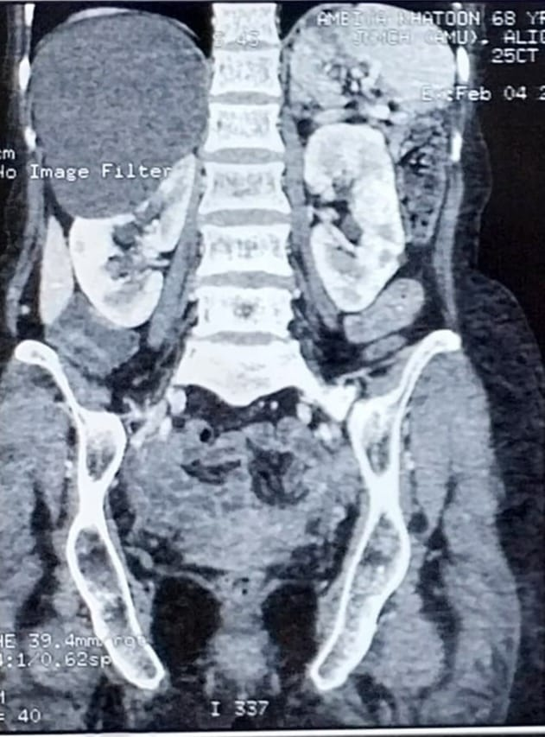
Figure 1: The Computed Tomography Scan of whole abdomen showing large well-defined, non-enhancing cystic lesion having thin imperceptible walls with peripheral calcific foci arising from upper pole of right kidney (Benign lesion, BOSNIAK II).
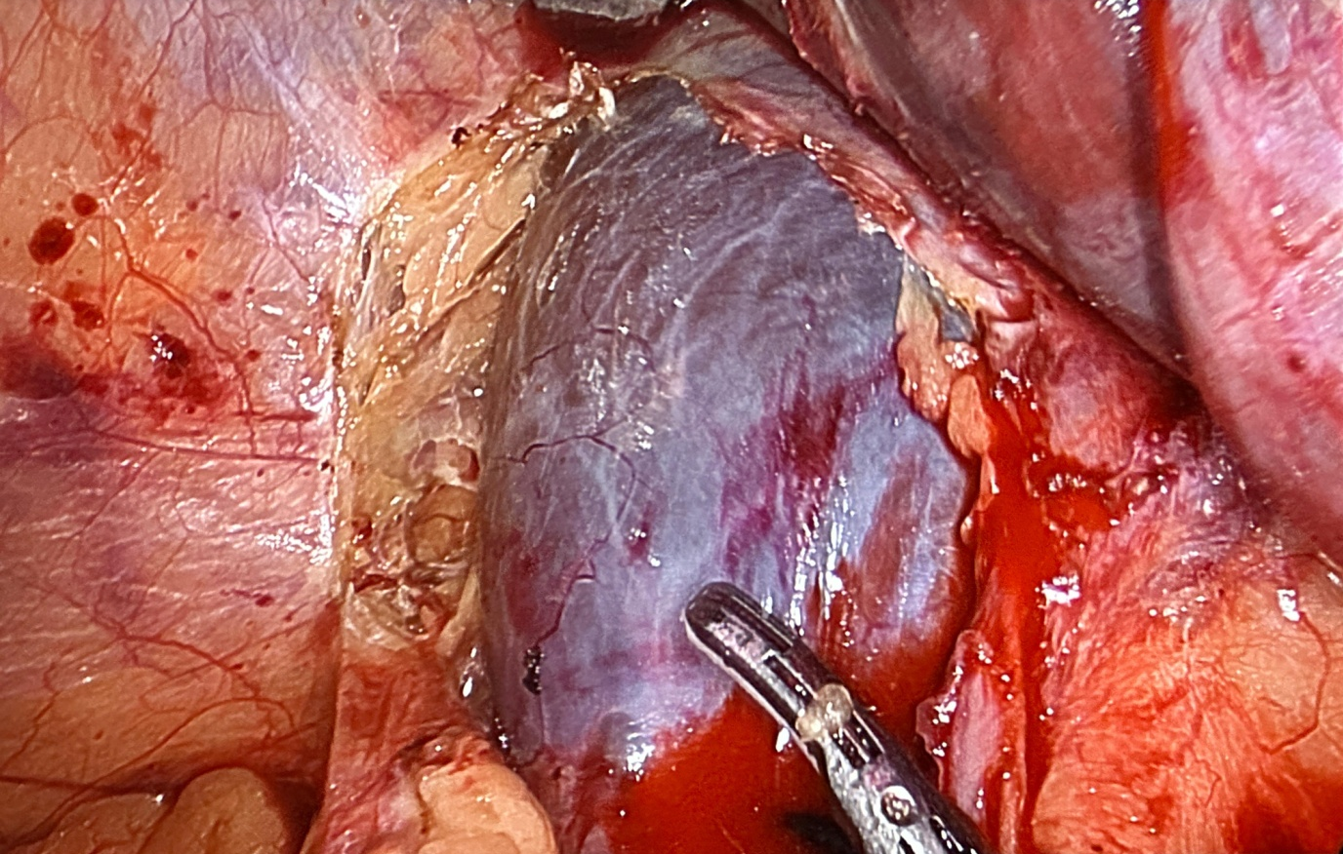
Figure 2: Intraoperative image showing a large renal cyst
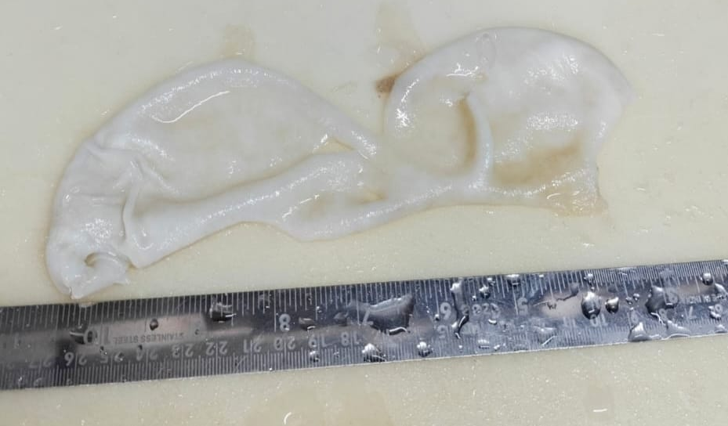
Figure 3: Gross specimen showing white cystic lesion with clear fluid inside with cyst wall thickness - 0.8 cm
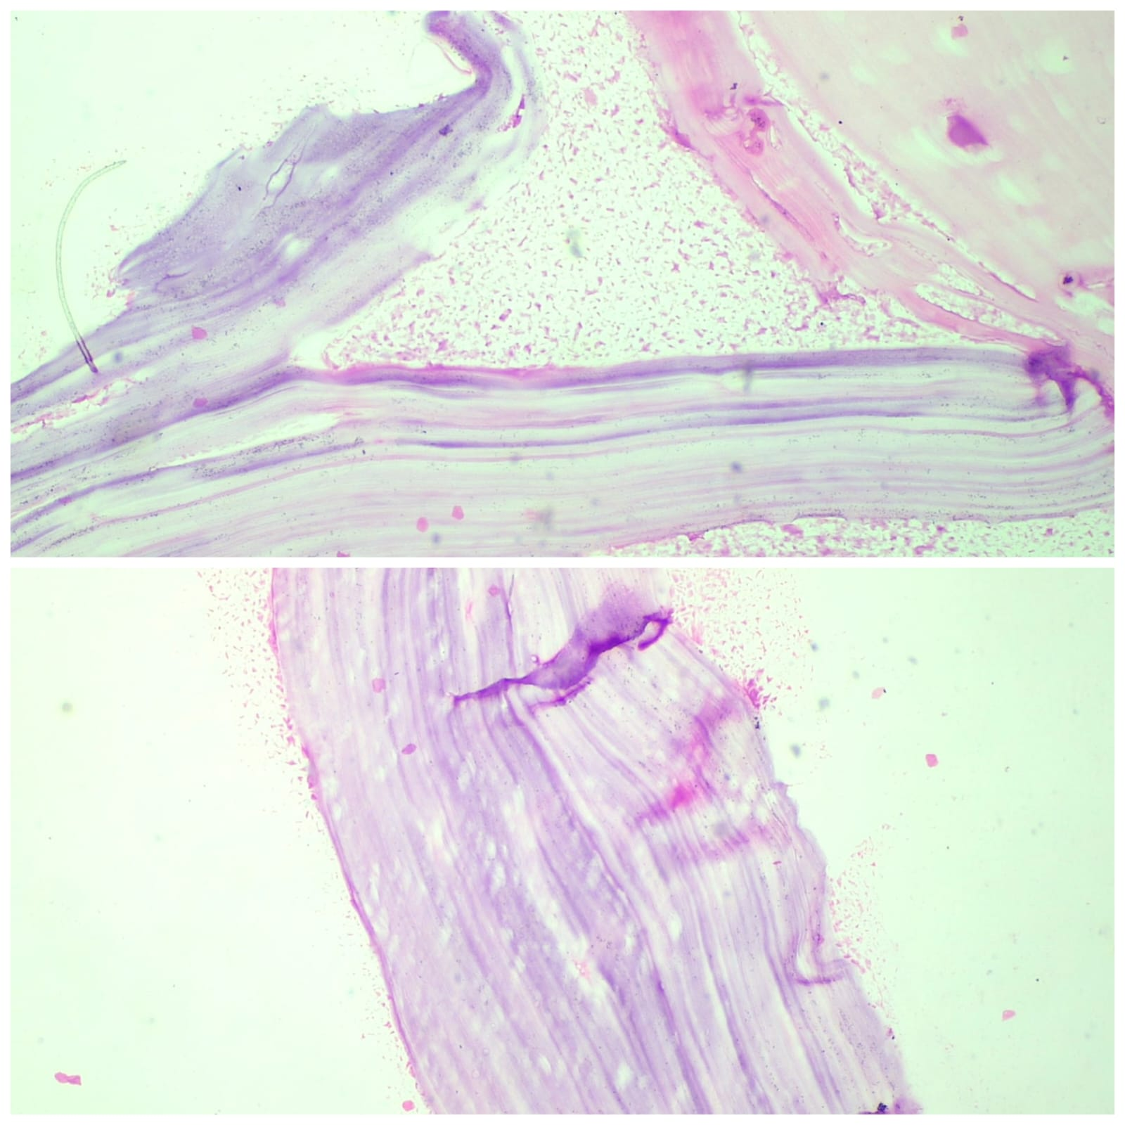
Figure 4: Hematoxylin and Eosin stained sections viewed at 40X showing eosinophilic lamellated membranes of Eccinococcus.

DISCUSSION
Echinococcosis is a neglected zoonotic disease caused by the cestodes of the genus Echinococcus. There is a large diversity in its genotypes that lacks molecular confirmation. Subsequently, taxonomical advancements are yet to be achieved [Ali et al., 2024]. The areas of high endemicity for cystic echinococcosis include western China, Central Asia, South America, Mediterranean countries and eastern Africa. Moreover, New Zealand, and Tasmania in Australia have been declared to have eliminated the disease [Wen et al., 2019]. On the other hand, alveolar echinococcosis is predominant in northern hemisphere and Asia [Singh et al., 2025].

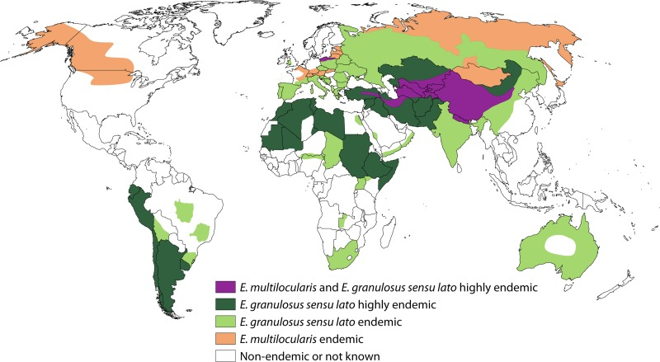

Figure 5: Global map showing distribution of Echinococcus granulosus sensu lato, causing cystic echinococcosis and Echinococcus multilocularis causing alveolar echinococcosis [Wen et al., 2019].
The oncospheres of Echinococcus penetrate the intestinal wall and are transported hematogenously most commonly to the liver and lungs, while only 2–3% bypass these filters to reach the kidney (Horchani et al., 2000). Isolated renal echinococcosis without liver or lung involvement, as in our patient, is therefore rare and can easily be overlooked (Mohammed et al., 2023). From a preventive perspective, interrupting this cycle is critical. Measures such as regular deworming of dogs, safe disposal of infected offal, improved slaughterhouse hygiene and community education in endemic regions have been shown to significantly reduce transmission (WHO, 2025).

Renal hydatid cysts often grow slowly and remain asymptomatic for years. Patients typically present with nonspecific abdominal pain, flank discomfort, or a palpable mass. The only pathognomonic sign is hydatiduria, which occurs when cysts rupture into the collecting system, but this is reported in just 10–20% of cases (Pedrosa et al., 2000). Our patient did not have urinary complaints, which is suggestive of an intact cyst. The absence of hepatic or systemic symptoms further complicated recognition of the disease.

Routine laboratory tests are not diagnostic. Eosinophilia may be present in a proportion of patients but is not specific (Eckert and Deplazes et al., 2004). Serological assays such as ELISA are useful tests but tend to be less sensitive in renal disease compared to hepatic hydatidosis (Pakala et al., 2016). In our case, ELISA was positive, which increased clinical suspicion, but confirmatory diagnosis was relied on imaging and histopathology.

Imaging is crucial in suspected renal hydatid disease. Ultrasonography can reveal daughter cysts or membranes, but computed tomography (CT) offers more detail with calcifications and septations. To standardize interpretation, hydatid cysts are commonly categorized by the Gharbi (I–V) or WHO-IWGE (CE1–CE5) classifications, which range from simple unilocular cysts to complex, calcified, or inactive lesions. Classic features like the wheel spoke sign are helpful, but many lesions appear atypical and can resemble simple cysts or even tumors (Gharbi et al., 1981; von Sinner et al., 1991). In our case, the CT suggested a Bosniak II cyst, creating a false impression of a benign lesion. This highlights how renal hydatid disease can be easily overlooked. Similar diagnostic challenges have been reported by El Malki et al (2009) who described a renal hydatid cyst misdiagnosed as a renal tumor and by Hammade et al (2022) who reported a giant renal cyst mimicking a simple renal cyst until surgery revealed hydatid disease. Conversely, Daoud et al., (2022) reported a renal hydatid cyst that presented with hydatiduria rather than radiological mimicry. These comparisons underline the diverse manifestations of renal echinococcosis and the importance of maintaining broad diagnostic suspicion in endemic areas.

Histopathological examination remains the definitive diagnostic tool. The laminated membranes and inflammatory infiltrate are typical of hydatid disease (Safioleas et al., 1999). Surgery is the treatment of choice and the aim of surgery is to remove the cyst, sterilize the cavity, and preserve renal function wherever possible. Procedures sparing kidney such as cystectomy or partial pericystectomy are generally preferred when renal parenchyma is preserved, while nephrectomy is done for extensively damaged kidneys (Gogus et al., 2003). Intraoperative instillation of scolicidal agents such as hypertonic saline or povidone-iodine, is essential to prevent spillage and anaphylaxis (Aggarwal et al., 2014). Adjunctive medical therapy with albendazole is highly recommended as preoperative treatment reduces intracystic pressure and parasite viability, while postoperative therapy decreases the risk of recurrence (Horton et al., 2003). Recent WHO guidelines (2025; PMID 40690566) and expert consensus (Burnetti et al., 2010) emphasize the importance of combining surgical intervention with perioperative albendazole in complicated or high-risk cysts. Although percutaneous drainage has been useful in hepatic hydatid disease (Akhan et al., 1996; Khuroo et al., 1997), it is not routinely recommended for renal hydatid disease because of the risk of spillage and recurrence. The prognosis after complete removal of cyst and medical therapy is generally good as in our patient; reflecting the effectiveness of a combined surgical and medical approach. Long term follow up is equally important, and it allows timely detection of recurrence and ensures sustained cure.

CONCLUSION
Hydatid disease should always be considered as a differential diagnosis for atypical,complex or large renal cysts especially in endemic regions, even when there is no hepatic involvement. The potential for radiological overlap with benign cysts or neoplasms emphasizes the need for a high index of suspicion and thorough evaluation.

CONSENT
All authors declare that written informed consent was obtained from the patient for publication of this case report and accompanying images.A copy of the written consent is available for review by the Editorial office/Chief Editor/Editorial Board members of this journal.
ETHICAL APPROVAL
Ethical approval for the case report has been applied for and is under review by the Institutional Ethics Committee.
REFERENCES
- Aggarwal S, Sood R, Jindal R, et al. Laparoscopic management of renal hydatid cyst: report of three cases. JSLS. 2014;18(3):e2014.00333.
- Akhan O, Ozmen MN, Dinçer A, Sayek I, Göçmen A. Liver hydatid disease: long-term results of percutaneous treatment. Radiology. 1996;198(1):259–64.
- Ali R, Nazeer S, Elahi MM, Idu EG, Zhang H, Mahmoudvand H, Khan SN, Yang J. Global distribution and definitive host range of Echinococcus species and genotypes: A systematic review. Veterinary Parasitology. 2024 Oct 1;331:110273.
- Brunetti E, Kern P, Vuitton DA; Writing Panel for the WHO-IWGE. Expert consensus for the diagnosis and treatment of cystic and alveolar echinococcosis in humans. Acta Trop. 2010;114(1):1–16. doi:10.1016/j.actatropica.2009.11.001. PMID: 19931502.
- Daoud MF, Ben Haj Hassine A, Kacem N, et al. Primary hydatid cyst of the kidney revealed by hydatiduria. Urology Case Reports. 2022;49:102283. doi:10.1016/j.eucr.2022.102283. PMID: 36469234.
- Eckert J, Deplazes P. Biological, epidemiological, and clinical aspects of echinococcosis. Clin Microbiol Rev. 2004;17(1):107–35.
- El Malki HO, Mohsine R, Souadka A, et al. Hydatid cyst of the kidney misdiagnosed as renal tumor: case report. Cases J. 2009;2:9146.
- Gadelkareem RA, Elqady AA, Abd-Elshafy SK, Imam H, Abolella HA. Isolated renal hydatid cyst misdiagnosed and operated as a cystic renal tumor. Medical Principles and Practice. 2018 Jul 4;27(3):297-300.
- Gharbi HA, Hassine W, Brauner MW, Dupuch K. Ultrasound examination of the hydatic liver. Radiology. 1981;139(2):459–63.
- Gogus C, Safak M, Baltaci S, Turkolmez K. Isolated renal hydatidosis: experience with 20 cases. J Urol. 2003;169(1):186–9.
- Govindasamy A, Bhattarai PR, John J. Liver cystic echinococcosis: a parasitic review. Therapeutic Advances in Infectious Disease. 2023 May;10:20499361231171478.
- Hammade M, Ghazal A, Bitar H, et al. Isolated giant renal hydatid cyst with a simple renal cyst appearance: a case report. J Med Case Rep. 2022;16:68.
- Horchani A, Nouira Y, Chedly A, Attyaoui F, Zribi AS. Hydatid cyst of the kidney: a report of 147 cases. Eur Urol. 2000;38(4):461–7.
- Horton J. Albendazole for the treatment of echinococcosis. Fundam Clin Pharmacol. 2003;17(2):205–12.
- Khuroo MS, Wani NA, Javid G, et al. Percutaneous drainage compared with surgery for hepatic hydatid cysts. N Engl J Med. 1997;337(13):881–7.
- Mandal S, Mandal MD. Human cystic echinococcosis: epidemiologic, zoonotic, clinical, diagnostic and therapeutic aspects. Asian Pacific journal of tropical medicine. 2012 Apr 1;5(4):253-60.
- Mohammed SA, Kishore S, Khan MS, et al. Isolated renal hydatid cyst: a case report. Cureus. 2023;15(4):e37139. Available from: https://pmc.ncbi.nlm.nih.gov/articles/PMC10800591/
- Pakala T, Molina M, Wu GY. Hepatic echinococcal cysts: a review. J Clin Transl Hepatol. 2016;4(1):39–46.
- Pedrosa I, Saíz A, Arrazola J, Ferreirós J, Pedrosa CS. Hydatid disease: radiologic and pathologic features and complications. Radiographics. 2000;20(3):795–817.
- Safioleas M, Misiakos E, Kakisis J, Manti C, Lygidakis N. Surgical treatment for hydatid disease. World J Surg. 1999;23(11):1181–5.
- Singh S, Khurana S, Pradhan P. Systematic review and Meta-analysis Epidemiology and Clinical Characteristics of Alveolar Echinococcosis in India: A Systematic Review and Individual Participant Data Meta-Analysis. Indian Journal of Medical Microbiology. 2025 Aug 13:100951.
- Tuergan T, Abulaiti A, Tulahong A, Zhang R, Shao Y, Aji T. Global, regional and national burden of echinococcosis in 204 countries and territories from 1990 to 2021: a systematic analysis based on the Global Burden of Disease Study 2021. Journal of Infection and Public Health. 2025 May 8:102810.
- von Sinner WN. New diagnostic signs in hydatid disease: radiography, ultrasound, CT and MRI correlated to pathology. Eur J Radiol. 1991;12(2):150–9.
- Wen H, Vuitton L, Tuxun T, Li J, Vuitton DA, Zhang W, McManus DP. Echinococcosis: advances in the 21st century. Clinical microbiology reviews. 2019 Mar 20;32(2):10-128.
- Woolsey ID, Miller AL. Echinococcus granulosus sensu lato and Echinococcus multilocularis: A review. Research in veterinary science. 2021 Mar 1;135:517-22.
- World Health Organization. WHO guidelines for the treatment of cystic and alveolar echinococcosis in humans. Geneva: WHO; 2025. PMID: 40690566.

