Original Research Article

VIABILITY OF PROTECTIVE RELAY COORDINATION AND ENERGY LOSSES IN NORTH CENTRAL STATES, NIGERIA

ABSTRACT
The persistent trend of rationing power supply to consumers by the power industry in Nigeria has become a major setback to industrial, social and economic development of the country. This study analysis the viability of protective relay coordination and energy losses in North Central States of Nigeria, using the Electronics Workbench Tracker. The Tracker records the time of incidence, the restoration time, the date, nature of tripping, weather condition, and the load interrupted. Then by separating the tripping into forced, planed and emergency outages the data was analyzed to determine the equipment outages, Feeders interruption period, load and energy losses for the North Central States of Nigeria. Results shows that a total of 457 outages were recorded for the seven central state of Nigeria and the order of interruption outage is NAF (220) > KGF (196) > ABF (27) > PLF (8) > NIF (3) > BEF (2) > KWF (1). Total outage duration was 1,693.16HR with lower durations experienced in KWF, BEF and NIF, while high durations were experienced in NAF and KGF. Total load loss was 3,275.60MW corresponding to total energy loss of 9,359.87MWH. Out of the total outages, 67.40% (308) were due to forced (faults) outage, 26.70% (122) were on emergency outages while only 5.90% (27) were due to planned (maintenance) outages. Out of the total energy loss, losses due to forced outage was 8,365.87MWH, emergency outage with 833.63MWH, and planned outage with 160.37MWH. High energy losses due to forced (faults) outage implies low standard power equipment and poor network maintenance as show from high outage durations especially in NAF and KGF. Therefore, the findings highlight the importance of improving line and equipment maintenance to enhance power supply, especially in NAF and KGF areas. Also, power industries should invest in improving their network infrastructure, strategically plant poles and consider environmental factors that may affect electricity supply.
Keywords: Differential relaying, workbench, electronic feeder tracker, human machine interface, interruption profile, energy loss.
1. INTRODUCTION
Electricity is a major driving force for the development of any nation. The consumption of this important commodity is widely used as an index of economic development (Nemeth-Durko et al., 2020). It is required for domestic and socio-economic activities by all facets of the global economy (Ezenugu et al., 2017; Oyedepo, 2019). The Electricity consumption population is grouped into three sectors, consists of the residential, commercial and street lighting, and industrial sectors (Alao, 2016; Azodo, 2014). Comparatively, the residential sector accounts for about 30% of total electricity consumption globally (Taale & Kyeremeh, 2019). Globally, one- third of final energy is consumed by the residential sector(Chen et al., 2016; Nemeth-Durkoet al., 2020; Olaniyanet al., 2018; Sachs et al., 2019; Taale & Kyeremeh, 2019; Wang et al., 2020).
In the case of Nigeria, the electrical energy potential is so enormous and is divided into three zones. The North-East classified as zone I, has potential for large-scale power generation characterized by long sunshine hours, about 6hours per day, with solar radiation of 5.7–6.5 kW/m²/day. The North-West and Central as zone II, with great potential for electrical and solar power characterized by Dams which are sources of electrical power and about 5.5hours per day of sunshine, with solar radiation of 5.0–5.7 kW/m²/day. While the Southern Nigeria as zone III, with about 5hours per day of sunshine, with 3.5–5.0 kW/m²/day (Adaramola, 2014). However, It is estimated that about 60,000MW is required for stable power supply which could be achieved by substantial mix of renewable energy (Olaoye et al., 2016). North-Central Nigeria, reflects the broader national trend of increasing reliance on Electricity. This is because in Nigeria, the residential sector accounts for the largest consumption and despite the widespread use of power supply, the quality and availability remain poor across different parts of the region. On the other hand, the power system suffered losses, financial constraints, and energy theft (Emovon et al., 2018). Therefore, protective relay coordination and line tracing have become increasingly important, particularly in areas where energy supply is crucial, such as industries, hospitals, Military Barracks and institutions. Additionally, inadequate infrastructure development and reliance on generators which are expensive and unhealthy due to air pollution, further worsen the problem. In view of the above, this study seeks to address the problem by analyzing the protective relay coordination and energy losses in North Central States of Nigeria, identifying the areas with the higher losses, and exploring the factors that contribute to these deficiencies. The results of this study could provide valuable insights for power industries, policymakers, and other stakeholders working to improve supply in the area.
2. MATERIALS AND METHODS
2.1 Materials
The main materials used for this research are power system transmission lines, frequency meters, instrument for the determination of power flow in control room, 33kv tracker, Human machine interface, power system analyzer.
2.2 Methods
2.2.1 Study Design
This was a mix of both primary and secondary data acquisition and utilization in order to ensure certainty in corroboration. To obtain representative samples for the study, a purposive sampling technique was used to randomly sample the feeders in North Central States. Seven (7) outgoing feeders from Transmission Stations one from each State were used for this study. A combination of observation and remote data acquisition using Man-Machine Interface was utilized to collect the data. Also the Service Level Agreement (SLA) Platform as well as internet and wireless-enabled transmission options that augment preliminary analysis of observed system events, as well as enable remote, real-time data exchange.
2.2.2 Study Area
North Central States of Nigeria located between latitudes 6°431N and 6°451N and longitudes 6°601E and 6°801Ehas human geographical area covering of 242,425 Km² comprising six states Kwara, Niger, Nassarawa, Plateau, Benue, Kogi and the Federal Capital Territory (FCT) stretching across the country longitudinally. Energy infrastructures in North-Central Nigeria are inadequate and grid electricity is unable to meet electricity demand. Many of the houses are below 30 meters and an average road width of about 35 meters. The concrete ground and tarred roads have very relative poor electrical conductivity, The North Central States are known for their diverse terrain including plains, mountains and forests. Table 1 presents the identification codes for the global positioning system (GPS) locations of the feeders in the North-Central State used for this study. While, the map of the North Central States showing the locations of the selected feeders is shown in Figure 1.
2.2.3 Method of Data Collection
For primary data collection, power equipment were employed to capture system parameters directly, as well as remotely monitor and record transient system events for onward transmission, processing and analysis. Secondary data in form of out station data, other weather conditions and site-location info for the study location was obtained from National Aeronautics and Space Administration (NASA) website.
Power system analyzer was used to determine power flow in the Transmission and Distribution network. Tripping information of planned, emergency and forced outages were extracted from Human machine interface (HMI) in the Control Room. Also, the weather condition of each outage was recorded. The collected data was analyzed using 33kv Power Workbench Tracker with a focus to determine the duration, load loss and energy loss in the North Central States of Nigeria.
Table 1: Identification Codes and GPS Location of North Central States of Nigeria
Study Location | Code ID | Latitude | Longitude | Altitude (m)
Abuja Feeder | ABF | 9.0563° N | 7.4985° E | 400.00
Plateau Feeder | PLF | 9.2182° N | 9.5179° E | 1200.00
Kwara Feeder | KWF | 8.9669° N | 4.3874°.E | 286.86
Nasarawa Feeder | NAF | 8.4998° N | 8.1997° E | 400.00
Niger Feeder | NIF | 9.9309° N | 5.5983° E | 200.00
Kogi Feeder | KGF | 7.7337° N | 6.6906 E | 125.00
Benue Feeder | BEF | 7.3369° N | 8.7404° E. | 250.00

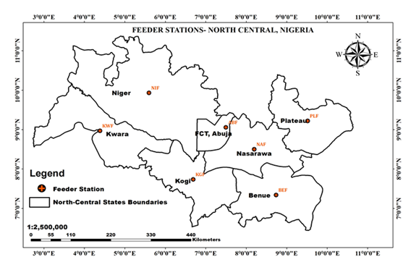
Figure 1: Map of North Central States of Nigeria showing feeder locations
2.2.4 Principle of Differential Relaying
The principle of directional relaying was used to restrict outages to faulty areas, protect power equipment from avoidable damage, and prevent accidents on the line. Differential scheme was used to measure current at each end of the selected zone and to operate where there is a difference between them. The total outage was determined as follows:
T= F+P+ E (1)
where T is the total outage, F is forced outage, P is planned outage and E is emergency outage. Outage duration is the period that a feeder is out of supply, load loss is the load that was carried by a feeder before tripping and energy loss is the energy that power industry lost as a result of system outage. Therefore, the total network loss (energy loss) is expressed as:
(2)
where $P_{loss}$ is the line losses (W), R is the line resistance (Ω), L is the substation to load distance in km, I_{L} is the line current (A).
2.2.5 Electronics Workbench Tracker
The electronics work bench tracker was used for data computation and analysis. The Sub Region and the station are stated. The equipment name as well as the time of outage are taken. Date of interruption and restoration ware also captured. Other data included are duration and outage class. The load interrupted is in megawatt, the weather condition is determined and the party responsible is ascertained for analysis of Service Level Agreement.
2.2.6 Machine Interface Data
The Human Machine Interface Data computed using the Tracker. The tripping and outages are classified into different categories involving Forced, Emergency and Planned outages and computed by the Tracker. The duration and load interrupted are determined for the period of inputted data. The energy loss throughout the period is processed. Total values of each operation is calculated and Data from all Stations captured in the HMI are centrally interpolated using the Workbench Tracker.
2.2.7 Correlation Co-efficient
A mathematical model was formed based on relationship of weather conditions and equipment outage durations, load loss and energy losses using the Pearson’s Correlation Co-efficient. Analysis were done using Microsoft excel and Communication medium Supervised Control and Data Acquisition (SCADA) status was also employed. Regression equation using the Covariance Method is given as:
$\text{M = }\frac{∑(X- X̄) (Y-Ȳ)}{∑(X- X̄)^{2}}$ (3)
$C= \frac{1}{N } (∑Y-M∑X)$ (4)
where
X = Outage duration
Y1 = Load loss
Y2 = Energy loss due to outage
X̄ = Mean outage duration
Ȳ₁= Mean load loss
Ȳ₂= Mean energy loss
N = Number of data point (step)
Though the equation for the regression line gives:
Y = MX + C (5)
Therefore, equation (3) is the general equation of a straight line where M is a gradient, and C is the intercept on the Y-axis (the value where the line cuts the y-axis).
Applying Spearman’s Rank Correlation Coefficient we have:
$R=1-\frac{6\sum{D^{2}}}{N\left(N^{2}-1\right)}$ (6)
Where:
R₁ = Rank Correlation Coefficient Load loss
R₂ = Rank Correlation Coefficient Energy loss
D₁ = Difference in rank between correspondent values of X and Y₁
D₂ = Difference in rank between correspondent values of X and Y₂
N = Number of pairs of variables
3 RESULTS
3.1 Feeder Interruption and Outage Profile
The result of the feeder interruption and outage profile for the North Central States showing the number of outages, outage duration, load loss, and energy loss are shown in Table 2.
Table 2: Feeders Interruption and Outage Profile for North Central States
Feeder ID | Outage |  |  |  | Duration (HR) |  |  |  | Load Loss (MW) |  |  |  |  | Energy Loss (MWH)
Feeder ID | F | P | E | T | F | P | E | T | F | P | E | T | F |  | P | E | T
NAF | 91 | 19 | 110 | 220 | 441.04 | 115.19 | 430.25 | 986.48 | 97.10 | 17.40 | 188.90 | 223.04 | 452.29 |  | 95.38 | 435.86 | 982.53
NIF | 3 | 0 | 0 | 3 | 0.17 | 0.00 | 0.00 | 0.17 | 44.50 | 0.00 | 0.00 | 44.50 | 4.02 |  | 0.00 | 0.00 | 4.02
KGF | 194 | 1 | 1 | 196 | 551.25 | 0.06 | 1.08 | 552.39 | 2774.80 | 0.00 | 22.30 | 2,797.10 | 7,590.22 |  | 0.00 | 25.27 | 7,615.50
ABF | 9 | 7 | 11 | 27 | 45.48 | 11.54 | 69.54 | 127.38 | 35.20 | 40.30 | 75.80 | 151.30 | 194.27 |  | 64.99 | 372.50 | 631.76
PLF | 8 | 0 | 0 | 8 | 21.26 | 0.00 | 0.00 | 21.26 | 39.40 | 0.00 | 0.00 | 38.40 | 82.65 |  | 0.00 | 0.00 | 82.65
BEF | 2 | 0 | 0 | 2 | 0.12 | 0.00 | 0.00 | 0.12 | 10.20 | 0.00 | 0.00 | 10.30 | 1.02 |  | 0.00 | 0.00 | 1.02
KWF | 1 | 0 | 0 | 1 | 4.16 | 0.00 | 0.00 | 4.16 | 9.70 | 0.00 | 0.00 | 9.70 | 41.39 |  | 0.00 | 0.00 | 41.49
Total | 308 | 27 | 122 | 457 | 1,046.28 | 127.21 | 501.27 | 1,693.16 | 3,010.90 | 57.70 | 207.00 | 3,275.60 | 8,365.87 |  | 160.37 | 833.63 | 9,359.87

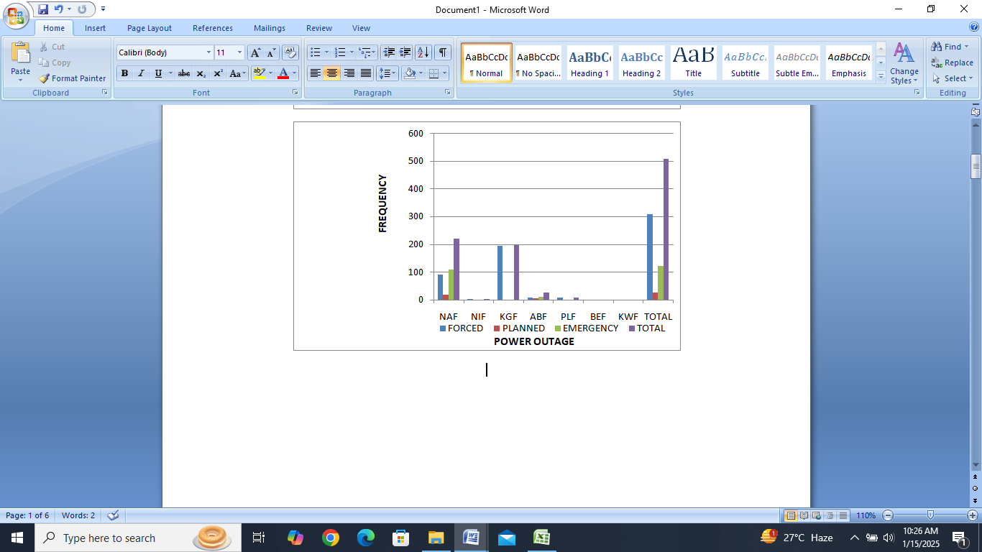
Figure 2: Feeders interruption and outage profile for North Central States
Figure 2 shows the frequency of the feeders’ interruption (outage) for North Central States. NAF recorded the highest interruption of 220 outages where 110 were on emergency, 91 were forced outage and 19 were planned outage. KGF becomes the 2nd with total of 196 outages where 194 were forced outages. ABF becomes 3rd with total of 27 outages in which 11 were emergency, 9 were forced and 7 were planned. PLF, NIF, BEF and KWF were having 8, 3, 2 and 1 outage respectively and all the outages were forced outage. Throughout the 7 states, a total of 457 outages recorded where a forced outage becomes highest with 308, followed by emergency outage with 122, and then planned outage with 27. These represent 67.40%, 26.70% and 5.90% respectively. Therefore, more than half of the outages were due to faults causing equipment trips on its own.
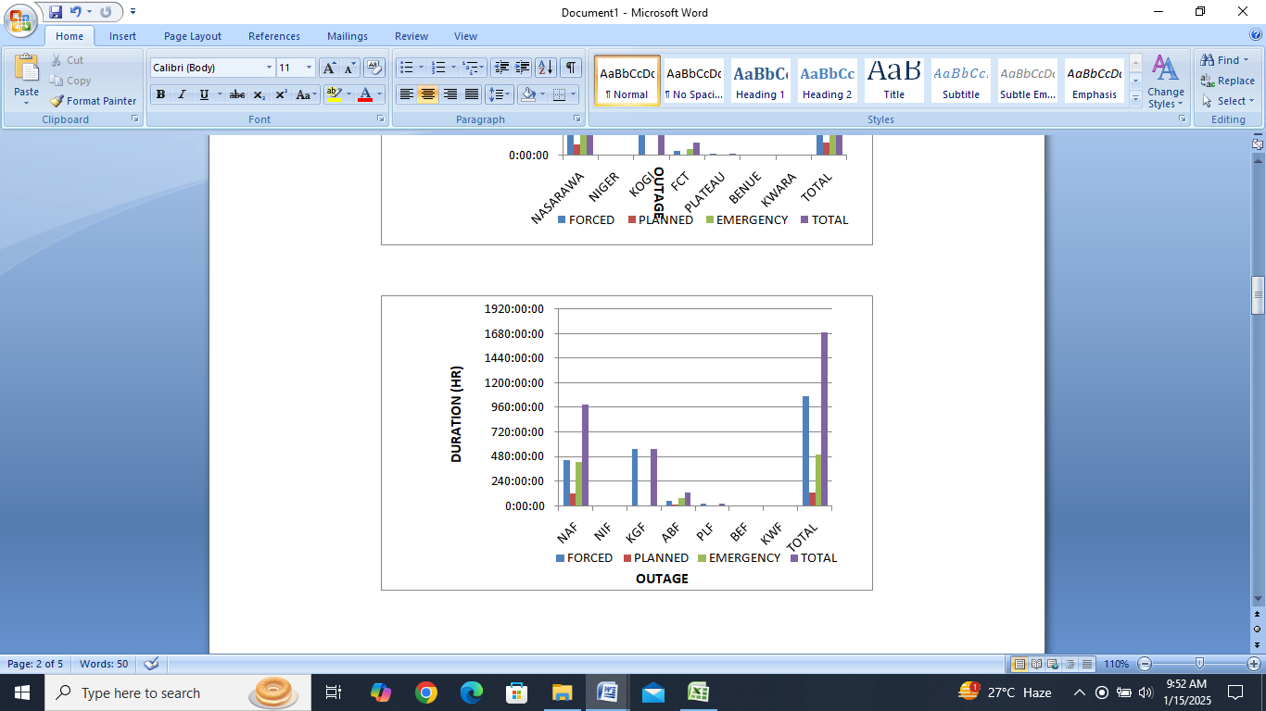
Figure 3: Feeders Outage Duration for North Central States
Figure 3 shows the feeders’ outage duration profile or interruption period for North Central States. NAF recorded the highest interruption period of 986:48hrs where 441:04hrs were forced outage period, 430:25hrs were emergency outage period and 115:19hrs were planned outage period. KGF becomes the 2nd with total of 552:39hrs outages period where 551:25hrs were forced outages period and 1:08hrs were emergency outage period. ABF becomes 3rd with total of 127:38hrs outage period in which 69:54hrs were emergency outage period, 45:48hrs were forced outage period and 11:54hrs were planned outage period.
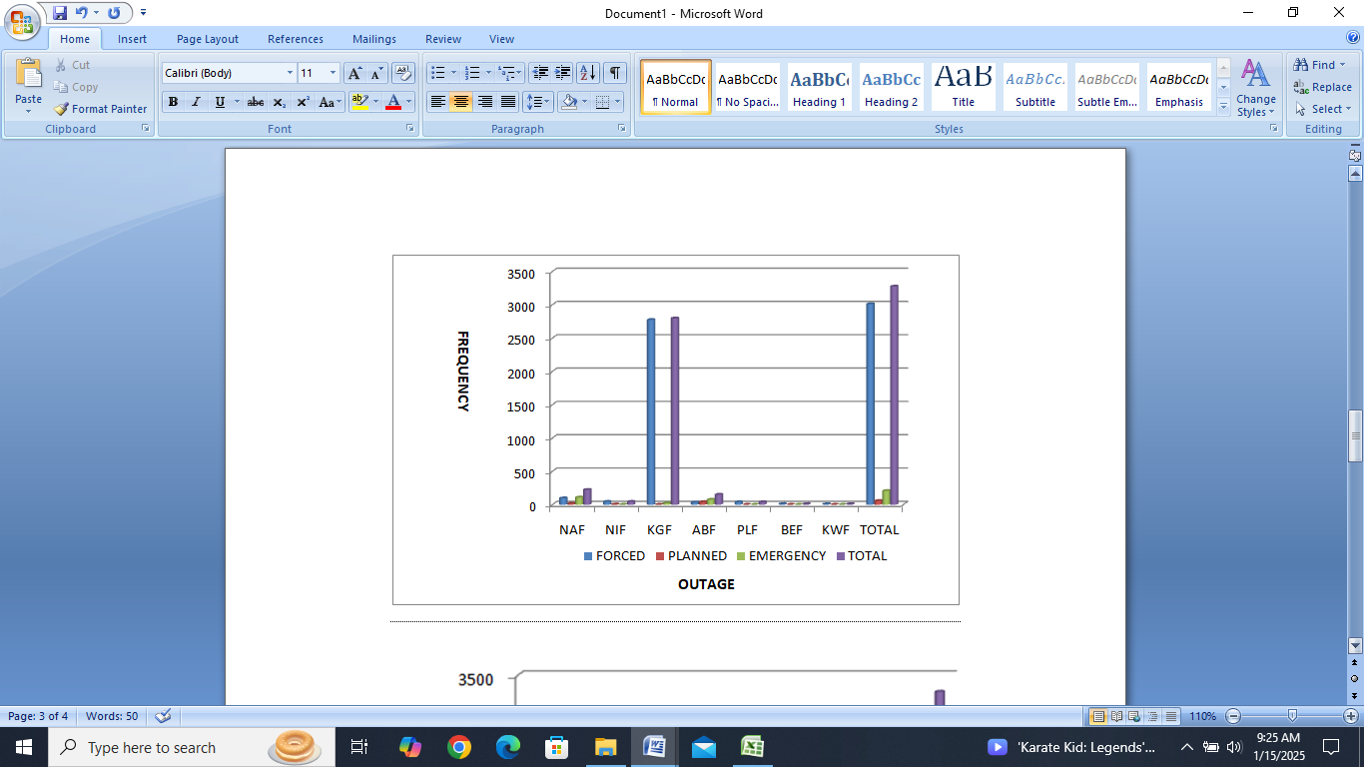
Figure 4: Load Loss (MW) for North Central States
Figure 4 shows summary of load loss profile for North Central States due to feeders’ interruption outage. KGF becomes 1st as it recorded the highest load loss of 2,7972.10MW where 2,774.80MW were due to forced outage, 22.30MW were due to emergency outage and no loss due to planned outage. NAF comes 2nd with total of load loss of 223.40MW where 188.90MW load loss occurred due to emergency outages while 97.10MW and 17.40MW load loss were due to forced and planned outages respectively. NIF comes 3rd with total of 44.50MW load loss were recorded due to a forced outages only. ABF, PLF, BEF and KWF have a total load loss of 151.30MW, 39.40MW, 10.20MW and 9.70MW respectively and all of the loss were due to forced outages except in ABF where 35.20MW and 40.30MW were load loss due to forced and planned outages respectively.
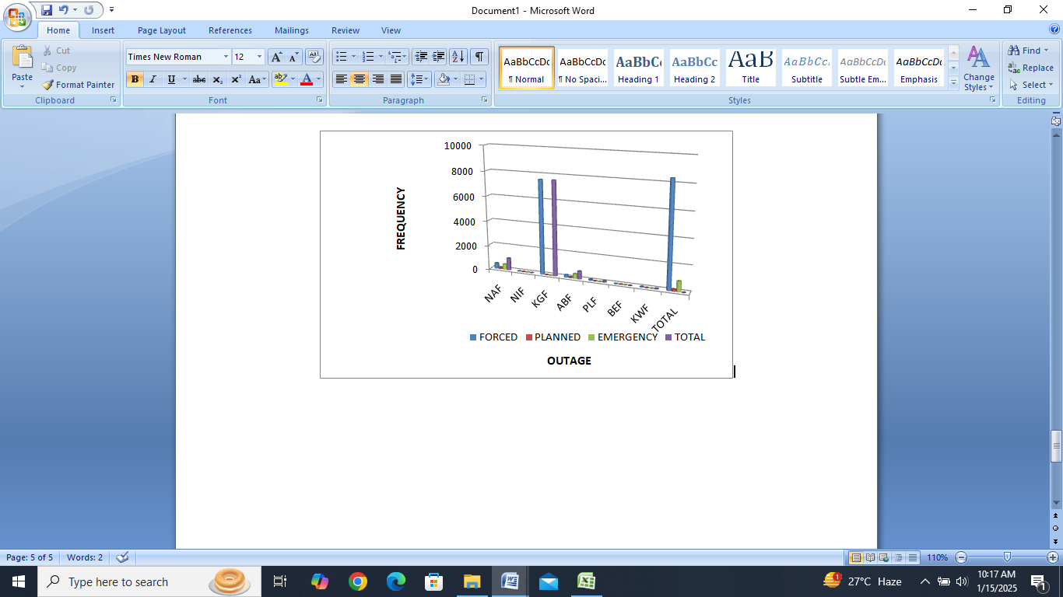
Figure 5: Energy Loss (MWH) of Outgoing Feeders
Figure 5 shows the energy loss profile for North Central States due to feeders’ interruption (outage). KGF comes 1st with a total energy loss of 7,615.50MWH where 7,590.22MWH energy loss was occurred due to a forced outages while 25.27MWH energy loss was due to emergency outages, and no energy loss on planned outage. NAF becomes 2nd as it recorded the highest energy loss of 983.53MWH where 452.29MWH were due to forced outage, 435.86MWH were due to emergency outage and 95.38MWH due to a planned outage. ABF comes 3rd with total energy loss of 631.76MWH where 372.50MWH was energy loss due to emergency outage, 194.27MWH due to a forced outage and 64.99MWH due to a planned outage. Meanwhile, in these 7 states, out of a total energy loss of 9,359.87MWH recorded, energy loss resulting from a forced outage reached 8,365.87MWH, followed by energy loss due to emergency outage with 833.63MWH, and then an energy loss due to a planned outage with 160.37MWH. These represents 89.38%, 8.91% and 1.71% respectively. Therefore, an energy loss due to faults was very heavy.
3.2 Regression and Correlation
Table 3 shows the Duration (X), Load loss (Y1) and Energy loss (Y2) as a result of outages recorded in the North Central States.
Table 3: Regression and Correlation Computation Counter
N | X | $$Y_{1}$$ | $$Y_{2}$$ | $$X-\overline{X}$$ | $$Y_{1}-\overline{Y_{1}}$$ | $$Y_{2}-\overline{Y_{2}}$$ | $${\left(X-\overline{X}\right)}^{2}$$ | $$\left(X-\overline{X}\right)\left(Y_{1}-\overline{Y_{1}}\right)$$ | $$\left(X-\overline{X}\right)\left(Y_{2}-\overline{Y_{2}}\right)$$
1 | 986.48 | 223.04 | 983.53 | 744.77 | -244.85 | -353.56 | 554,682.35 | -182,356.93 | -263,320.88
2 | 0.17 | 44.50 | 4.02 | -241.54 | -423.39 | -1,333.07 | 58,341.57 | 1,02265.62 | 321,989.73
3 | 552.39 | 2797.10 | 7,615.50 | 310.68 | 2329.21 | 6,278.41 | 96,522.06 | 723,638.96 | 1,950576.42
4 | 127.38 | 151.30 | 631.76 | -114.33 | -316.59 | -705.33 | 13,071.35 | 36195.73 | 80,640.38
5 | 21.26 | 39.40 | 82.65 | -220.45 | -428.49 | -1,254.44 | 48,598.20 | 94,460.62 | 276,541.30
6 | 0.12 | 10.20 | 1.02 | -241.59 | -457.69 | -1,336.07 | 58,365.73 | 110,573.33 | 322,781.15
7 | 4.16 | 9.70 | 41.39 | -237.55 | -458.19 | -1,295.70 | 56,430.00 | 108,843.03 | 307,793.54
8 | 1,691.96 | 3275.24 | 9,359.65 | -0.01 | 0.01 | 0.24 | 886,011.26 | 993,620.36 | 299,7001.64

From Table 3 we can see that, even though NAF experienced the highest outage durations of 986.80hrs, the load loss and energy loss was less than that of KGF which have lower outage durations of 552:39hrs (223.04MW against 2,797.10MW and 983.53MWH against 7615.50MWH). This implies that, NAF has a better equipment maintenance culture than KGF, even though it may also depends on the type, nature and condition of the fault. The least outage duration on this profile was experienced by BEF 0.12hrs with a corresponding Load loss of 10.20MW and Energy loss of 1.02MWH. This implies that BEF may have more standard equipment’s, rapid response and are more efficient in line tracing fault clearing, making their network more reliable as compared to others. The regression equation using the covariance method is obtained using equation (3) as follows:
$M_{1} \text{= }\frac{993620.36}{886011.26 }=1.12$
$C_{1}= \frac{1}{7 } \left(3275.24-1.12 x 1691.96\right)=197.18$
Therefore using equation (5), the model equation for Y1 is given as:
$Y_{1}=1.12X+197.18$
$M_{2}\text{ = }\frac{2997001.64}{886011.26}=3.38$
$C_{2}= \frac{1}{7 } \left(9359.65-3.38 x 1691.96\right)=520.12$
Therefore, the model equation for Y2 is given as:
$Y_{2}=3.38X+520.12$
Table 4: Correlation Coefficient
N | X | $$Y_{1}$$ | $$Y_{2}$$ | $$R_{X}$$ | $$R_{Y1}$$ | $$R_{Y2}$$ | $$D_{1}\left(R_{X}-R_{Y1}\right)$$ | $$D_{2}\left(R_{X}-R_{Y2}\right)$$ | $${D_{1}}^{2}$$ | $${D_{2}}^{2}$$
1 | 986.48 | 223.04 | 983.53 | 1 | 2 | 2 | -1 | -1 | 1 | 1
2 | 0.17 | 44.50 | 4.02 | 6 | 4 | 6 | 2 | 0 | 4 | 0
3 | 552.39 | 2797.10 | 7,615.50 | 2 | 1 | 1 | 1 | 1 | 1 | 1
4 | 127.38 | 151.30 | 631.76 | 3 | 3 | 3 | 0 | 0 | 0 | 0
5 | 21.26 | 39.40 | 82.65 | 4 | 5 | 4 | -1 | 0 | 1 | 0
6 | 0.12 | 10.20 | 1.02 | 7 | 6 | 7 | 1 | 0 | 1 | 0
7 | 4.16 | 9.70 | 41.39 | 5 | 7 | 5 | -2 | 0 | 4 | 0
8 | 1,691.96 | 3275.24 | 9,359.65 |  |  |  | 0 | 0 | 12 | 2

Equation 6 is used for the Spearman’s rank correlation coefficient. Also considering Table 4, the following was obtained.
R₁ = $1-\frac{6(12)}{7(7{}^{2}- 1)}$ = $1-\frac{72}{7(49- 1)}$ = $1-\frac{72}{7(48)}$ = $1-\frac{72}{336}$ = $1-0.21$ = 0.79
R₂ = $1-\frac{6(2)}{7(7{}^{2}- 1)}$ = $1-\frac{12}{7(49- 1)}$ = $1-\frac{12}{7(48)}$ = $1-\frac{12}{336}$ = $1-0.036$ = 0.96
The relationship of R1 is very strong since it is above 0.5 (below 50%). It is positive which implies that when X goes up, Y1 also goes up.
Similarly, the relationship of R2 is very strong since it is above 0.5 (below 50%). It is also positive which means when X goes up, Y2 also goes up.
4. DISCUSSION
The findings of this study provide valuable insights of energy loss for North Central States due to feeders’ interruption. Findings of the study have revealed that in North Central States a total of 1,693.16hrs outages period/durations were recorded, out of which forced outage period becomes highest with 1,064.28hrs, followed by emergency outage period with 501.27hrs, and then planned outage period with 127.21hrs. These represent 62.87%, 29.61% and 7.52% of period respectively. In these 7 states, a total energy loss of 9,359.87MWH was recorded, out of which energy loss resulting from a forced outage reached 8,365.87MWH, followed by emergency outage with 833.63MWH, and then planned outage with 160.37MWH. These represents 89.38%, 8.91% and 1.71% respectively. This finding differs from the study of Nazir et al. (2014), who used HOMER Pro to work on the optimization of renewable energy sources for a micro grid model design at Padang, Indonesia; and obtained an energy loss of 617,945kWh/yr. This is because their load assessment measured an average consumption of 1 hour per day at 4 days a week, or 23 hours loss per day using a power analyzer; while this study measured energy loss captured by work bench which has wider coverage, Another reason is their scaled down load profile, due to the exclusion of parts of the campus load in their assessment.
It could be deduced from the findings that NAF and KGF have higher energy losses due to frequent outages and outage duration while Abuja do more in terms of line tracing and maintenance. Finding also revealed that Power Equipment in PLF, NIF, BEF and KWF were better maintained on time due to the low outages experienced especially in KWF, BEF and NIF. The findings highlight the importance of improving line and equipment maintenance to enhance better power supply, especially in NAF and KGF areas. Therefore, Transmission and Distribution companies industries should improve on their network infrastructure, carry out regular fault clearing to avoid tripping and improve better supply.
5. CONCLUSION
This study highlights the varying outages and energy losses in North Central States of Nigeria identifying NAF and KGF states as having more energy losses due to frequent tripping and duration of outage. Planned outages are done more in PLF, NIF, BEF and KWF which is the reason for low tripping and better supply. Maintenance work is often done in ABF and emergency outages are low. It underscores the importance of strategic placement of transmitting and distributing stations to improve network coverage and power supply, especially in areas with poor Transmission lines. Based on the findings of this study, it is recommended that the power industries should invest in improving their infrastructure as in line with findings of Al Momani et al (2017) including the installation of more distribution transformers to enhance better supply. Tree trimming, cross arm replacement should be done when necessary to prevent forced outages. Power companies should assess and mitigate these factors to improve supply, and regulatory body NERC should monitor and enforce standards for quality supply. Finally, collaboration between power industries and government agencies can help improve power supply, especially in underserved areas.

COMPETING INTERESTS DISCLAIMER:
Authors have declared that they have no known competing financial interests OR non-financial interests OR personal relationships that could have appeared to influence the work reported in this paper.

REFERENCES
Adaramola, M. S. (2014). Viability of grid-connected solar PV energy system in Jos, Nigeria. International Journal of Electrical Power & Energy Systems, 61(1), 64-69.
Agbetuyi, A. F., Udeme, E. O., Obiakor, E., Kayode, O. O. & Owolabi, B. (2018). Performance and Yield Assessment for Renewable Dispersed Generation in Nigeria: Case Study on Grid-Tied Solar PV Systems. Paper presented at the IOP Conference Series: Materials Science and Engineering, 413(1), 1-8.
Ahmadi, M. H., Ghazvini, M., Sadeghzadeh, M., Alhuyi Nazari, M., Kumar, R., Naeimi, A. & Ming, T. (2018). Solar power technology for electricity generation: A critical review. Energy Science & Engineering, 6(5), 340-361.
Ahmed, A. & Kunya, B. I. (2019). Investigation of Wind Energy Resource on the Basis of Weibull and Rayleigh Models in North Eastern and Western, Nigeria. American Journal of Aerospace Engineering, 6(1), 27-32.
Ahmed, M. F. & Gawad, A. F. A. (2016). Utilization of Wind Energy in Green Buildings. Paper presented at the Twelfth International Conference of Fluid Dynamics, Le Méridien Pyramids Hotel, Cairo, Egypt, 19-20.
Aika, T., Igbinovia, S. & Orukpe, P. (2020). Feasibility Assessment of Wind Energy Potential for Electricity Generation in Nigeria. Jordan Journal of Electrical Engineering, 6(1), 25-34.
Ajayi, O. O., Fagbenle, R. O., Katende, J., Ndambuki, J. M., Omole, D. O. & Badejo, A. A. (2014). Wind energy study and energy cost of wind electricity generation in nigeria: Past and recent results and a case study for south west nigeria. Energies, 7(12), 8508-8534.
Akinyele, D. (2017). Techno-economic design and performance analysis of nanogrid systems for households in energy-poor villages. Sustainable Cities and Society, 34,(1), 335-357.
Al Ghaithi, H. M., Fotis, G. P. & Vita, V. (2017). Techno-economic assessment of hybrid energy off-grid system—A case study for Masirah island in Oman. International Journal of Power and Energy Research, 1(1), 103-116.
Al Momani, T., Harb, A. & Amoura, F. (2017). Impact of photovoltaic systems on voltage profile and power losses of distribution networks in jordan. Paper presented at the 2017 8th International Renewable Energy Congress (IREC), 1-6.
Alao, A. A. (2016). Residential and Industrial Electricity Consumption Dynamics and Economic Growth in Nigeria 1980-2010. International Journal of Economy, Energy and Environment, 1(3), 55-63.
Annapolis, M. D. (2020). Wind Turbines. Lakewood, United State: CFD Open Series.
Aoun, N. & Bailek, N. (2019). Evaluation of mathematical methods to characterize the electrical parameters of photovoltaic modules. Energy Conversion and Management, 193(1), 25-38.
Areo, I., Sako, K. C. & Lucky, E. (2019). Assessment of Public Restroom Distribution Pattern in Gwarinpa, Federal Capital City;(FCC) Abuja. Confluence Journal of Environmental Studies, 13(1), 12-22.
Ayadi, O., Al-Assad, R. & Al Asfar, J. (2018). Techno-economic assessment of a grid connected photovoltaic system for the University of Jordan. Sustainable Cities and Society, 39(1), 93-98.
Ayodele, T. & Ogunjuyigbe, A. (2015). Wind energy resource, wind energy conversion system modelling and integration: a survey. International Journal of Sustainable Energy, 34(10), 657-671.
Ayodele, T., Ogunjuyigbe, A., Odigie, O. & Jimoh, A. (2018). On the most suitable sites for wind farm development in Nigeria. Data in Brief, 19(1), 29-41.
Azerefegn, T. M., Bhandari, R. & Ramayya, A. V. (2020). Techno-economic analysis of grid-integrated PV/wind systems for electricity reliability enhancement in Ethiopian industrial park. Sustainable Cities and Society, 53(1), 1-32.
Azodo, A. P. (2014). Electric power supply, main source and backing: A survey of residential utilization features. International Journal of Research Studies in Management, 3(2), 87-102.
Babatunde, M. A. & Shuaibu, M. I. (2009). The demand for residential electricity in Nigeria: a bound testing approach. Paper presented at 2nd International Workshop on Empirical Methods in Energy Economics, Zurich, Switzerland, 1-16.
Baji, V. & Ashok, S. (1998). Wheeling power—a case study in India. International Journal of Electrical Power & Energy Systems, 20(5), 333-336.
Barzegkar-Ntovom, G. A., Chatzigeorgiou, N. G., Nousdilis, A. I., Vomva, S. A., Kryonidis, G. C., Kontis, E. O., Georghiou, G. E., Christoforidis, G. C. & Papagiannis, G. K. (2020). Assessing the viability of battery energy storage systems coupled with photovoltaics under a pure self-consumption scheme. Renewable Energy, 152(1), 1302-1309.
Basher, M., Hossain, M. K. & Akand, M. (2019). Effect of surface texturization on minority carrier lifetime and photovoltaic performance of monocrystalline silicon solar cell. Optik, 176(1), 93-101.
Bhutta, M. M. A., Hayat, N., Farooq, A. U., Ali, Z., Jamil, S. R. & Hussain, Z. (2012). Vertical axis wind turbine–A review of various configurations and design techniques. Renewable and Sustainable Energy Reviews, 16(4), 1926-1939.
Bilal, M., Ullah, R., Ali, A., Khan, M. H. & Ullah, Z. (2016). Wheeling hybrid energy system for industries. Paper presented at the 2016 International Conference on Computing, Electronic and Electrical Engineering (ICE Cube), 169-174.
Bohlmann, J. A. & Inglesi-Lotz, R. (2018). Analysing the South African residential sector's energy profile. Renewable and Sustainable Energy Reviews, 96(1), 240-252.
Cagnazzi, A. (2020). The photovoltaic, a driving force for the new green deal. (Master of Science), Selinus University of Sciences and Literature, Delaware, USA.
Chen, H., Huang, Y., Shen, H., Chen, Y., Ru, M., Chen, Y., Lin, N., Su, S., Zhuo, S. & Zhong, Q. (2016). Modeling temporal variations in global residential energy consumption and pollutant emissions. Applied Energy, 184, 820-829.
Emovon, I., Samuel, O. D., Mgbemena, C. O. & Adeyeri, M. K. (2018). Electric Power generation crisis in Nigeria: A Review of causes and solutions. International Journal of Integrated Engineering, 10(1), 45-56.
Ezenugu, I. A., Nwokonko, S. C. & Markson, I. (2017). Modelling and Forecasting of residential electricity consumption in Nigeria using Multiple and Quadratic regression models. American Journal of Software Engineering and Applications, 6(3), 99-104.
Nazir, R., Laksono, H.D., Waldi, E.P., Ekaputra, E. & Coveria, P. (2014). Renewable Energy Sources Optimization: A Micro-Grid Model Design. Proceedings of the International Conference on Alternative Energy in Developing Countries and Emerging Economies, 2013, Bangkok, Thailand. 52 (1), 316-327. DOI: 10.1016/j.egypro.2014.07.083.

Nemeth-Durko, E., Juhasz, P. & Dudas, F. (2020). Forecasting Residential Electricity Consumption Based On Urbanization And Income Projections. Paper presented at the ECMS, 104-110.
Olaniyan, K., McLellan, B., Ogata, S. & Tezuka, T. (2018). Estimating residential electricity consumption in Nigeria to support energy transitions. Sustainability, 10(1440), 1-22.
Oyedepo, S. O. (2019). Energy Use and Energy Saving Potentials in Food Processing and Packaging: Case Study of Nigerian Industries Bottled and Packaged Water (pp. 423-452): Elsevier.

