Numerical analysis of heat and mass transfer within a wall made of cut laterite bricks

Abstract:
The results of a numerical modelling of coupled heat and mass transfers within a wall made of laterite bricks is presented and compared to experimental data. Based on the work of Luikov, a mathematical predictive model of heat and mass transfer is developed. Temperature and moisture are considered as potential drivers of transfers. The mathematical model is implemented under the finite element software COMSOL. The simulation results allowed us to plot the spatiotemporal distribution of temperature and moisture fields within the studied wall. The results show that laterite bricks wall acts as a shield against heat and moisture propagation. Besides. The results show that the greater the thickness of the wall made with cut laterite bricks, the better it insulates against heat and humidity. In the context of Burkina Faso, the results allow to determine the suitable thickness of the laterite brick wall according to the desired insulation level.
Key words: laterite brick wall, mass transfer, heat transfer, moisture content, local building
materials

- INTRODUCTION
Over the past decade, the use of earth as building material, particularly “laterite bricks”, renewed interest because there are easier to implement and have thermal comfort advantage.
The laterite bricks used in construction constitute the interface between the exterior and the interior environments of the building. This interface constituting an assembly of porous material is the site of numerous coupled exchanges of mass and heat thanks to the gradients of temperature T, humidity level φ, partial vapor pressure $p_{v}$, capillary pressure $p_{c}$, vapor concentration of water $ρ_{v}$, etc. These exchanges are established between the indoor and outdoor environments of the building through its constituent elements, particularly within the laterite brick.
The interface is considered as a thermal filter. Depending on the climatic conditions and the characteristics of the laterite bricks, it is often difficult to reach a level of comfort inside the building. To evaluate the comfort in the building, the temperature and the relative humidity are the parameters used to describe the coupled exchanges of heat and mass [1]. Indeed, the variation of humidity and the transfer of heat in building materials are strongly coupled and have a very significant effect on the overall energy performance of buildings. Furthermore, perfect control of the climatic atmosphere of a building always requires control of exchanges within the interface. Aware of this issue, many researchers have undertaken experimental and numerical studies to deepen knowledge of the different coupled transfers of mass and heat.
The pioneers in the mathematical modelling of transfers taking into account the coexistence of the liquid and vapor phases within the porous medium and revealing the coupling effects between mass transfer and heat transfer are Luikov in 1954, De Vries and Philip in 1957. In 1962, another approach of modelling based on the formalism of the thermodynamics of irreversible processes was introduced by Cary and Taylor [3]. Since then, a great number of theoretical, numerical and experimental works have been devoted to resolving the systems of coupled equations governing these phenomena [3,4,5].
In the literature, few studies have been devoted to solving the problems of coupled heat and mass transfers in 2D/3D under the unsteady state of a building wall on the basis of local porous materials. In this work we propose a 3D numerical study of coupled heat and mass transfers in order to understand the spatio-temporal distribution of moisture content and temperature within a wall made of laterite bricks. This study is carried out by using the simulation software COMSOL 5.2, under non-steady state conditions.

- MATERIAL AND METHOD
  - Physical model of the wall
Laterite bricks are hygroscopic [8] and porous materials in which numerous hygroscopic and/or thermo-hygroscopic phenomena arise under the influence of a temperature gradient and/or air moisture level. These manifestations affect the thermophysical properties of Laterite bricks [9] and the comfort expected when they are used for building. In order to study the phenomena of coupled heat and mass transfers, we consider a physical model of wall made of laterite bricks. Each laterite brick is assimilated to a rectangular parallelepipedon which dimensions are 29 cm x 14 cm x 9 cm. The wall thickness is 9 cm (brick width). The laterite bricks are joined by mortar of one centimetre (01 cm) high made of sand, cement and water.
Figure 1 illustrates the considered wall model from which we isolate the subject to heat and mass transfers phenomena.
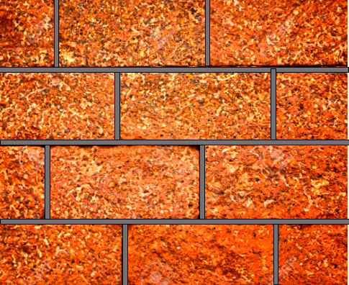
Interior
(unstressed)
Outside (stressed)
Figure 1: Physical model of the considered wall

  - Mathematical model
The physical phenomena taken into account in the mathematical model are:
- conduction,
- convection,
- radiation,
- phase change.
The equations governing heat and mass transfers used in this work are based on the Luikov model [12]. The energy and mass conservation equations are given respectively by:
$∇q=-\left(C_{p,m}ρ_{m}+C_{p,l}ω\right)\left(\frac{∂T}{∂t}\right)$ (1)
$\frac{∂ω}{∂t}+∇\dot{m}=0$ (2)
By taking into account the assumptions mentioned above, equations (1) and (2) can be written respectively as follow:
$C_{T}\frac{∂T}{∂t}=∇.\left(C_{11}∇T+C_{12}∇φ\right)+v.(D_{11}∇T+D_{12}∇φ)$ (3)
$Ω\frac{∂φ}{∂t}=∇.\left(C_{21}∇T+C_{22}∇φ\right)+v.(D_{21}∇T+D_{22}∇φ)$ (4)
The expressions of coefficients $C_{T},$ $C_{ij}$, $Ω$ and $D_{ij}$ ($1≤i≤$ 2 and 1$≤$j$≤$2) are given in annex.
A matrix representation of equations (3) and (4) are shown below:
$d_{a}\left[\begin{matrix}\frac{∂T}{∂t} \\ \frac{∂φ}{∂t}\end{matrix}\right]=∇.\left(C∇\left[\begin{matrix}T \\ φ\end{matrix}\right]\right)+β.∇\left[\begin{matrix}T \\ φ\end{matrix}\right]$ (5)
with
$d_{a}=\left[\begin{matrix}C_{T} & 0 \\ 0 & Ω\end{matrix}\right]$ (6)
$C=\left[\begin{matrix}C_{11} & C_{12} \\ C_{21} & C_{22}\end{matrix}\right]$ (7)
$β=v.\left[\begin{matrix}D_{11} & D_{12} \\ D_{21} & D_{22}\end{matrix}\right]$ (8)
The capillary pressure p_{c} is function of the relative moisture and the relation is given by the low of Kelvin [14,15]:
$φ=\exp\left(\frac{-p_{c}}{ρ_{l}R_{v}T}\right)$ (9)
$p_{c}=-Klnφ$ (10)
with $K=ρ_{l}R_{v}T$ (11)
2.3. Finite elements model
In figure 2, the drawing the considered wall is shown. A volume meshing is applied on the wall by using the simulation tool COMSOL MultiPhysics ® version 5.2.

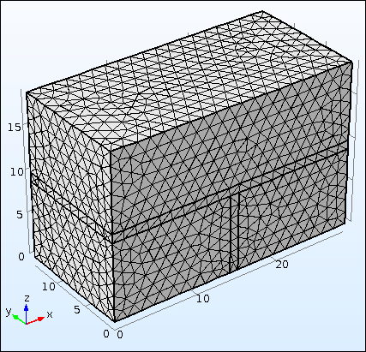
Figure 2: Considered physical model of the wall with volume meshing

2.4. Initial Conditions
At the initial time, we suppose that:
- the values ​​of the thermophysical parameters of the laterite bricks are those resulting from the measurements of Kabré et al. [9]
- the thermal conductivity depends on the outdoor environment relative moisture which also depends on the period of simulation
- air temperature and moisture rate data for the months of January, April and August are considered for the simulation. These three months represent the main season in Burkina Faso

2.5. Boundaries conditions
The exchanges are made following the normal to the contact surface. The other components of the flows are considered null. These conditions take into account the aforementioned physical phenomena and verify the following equations:
$\left[\begin{matrix}\left(g_{L}+g_{V}\right).n \\ \left(g_{T}-{L_{V}g}_{L}\right).n\end{matrix}\right]=\left[\begin{matrix}(β\left(p_{v}^{sat}\left(T_{ext}\right)φ_{ext}-p_{v}^{sat}\left(T_{in}\right)φ_{int}\right).n \\ \left(α\left(T_{ext}-T_{int}\right)\right).n\end{matrix}\right]$ (12)
$T_{ext}$, exterior ambient temperature and φ_{ext} , the exterior moisture rate which depends the period (season) during which the experience is curried out.

2.6. Data for mathematical model parameters
The values of the laterite bricks properties are necessary for use the mathematical model implemented in COMSOL. Thes values are obtained experimentally from the work of [9].
Air temperature and moisture rate data for the months of January, April and August were measured using MSR.5.28.32 type thermochips. The data for each month are mean values for the three main season in Burkina Faso as presented below:
- cold and non-rainy season: January;
- warm and non-rainy season: April;
- rainy season: August
Temperature, moisture content in different months and their modelling are given in the table below.
Table 1: Temperature and moisture content in different months modelling
Temperature and moisture content in different months | Modeled data
Sample of temperature for April (°C) | T(t)=-0,2672t²+7,2266t-10,694
Sample of moisture content for April (%) | Hr(t)= -0,0174t⁴+0,9017t³-16,582t²+125,52t-292,07
Sample of temperature for January (°C) | T(t)= 0,0042t⁴-0,2121t³+3,5764t²-22,637t+68,435
Sample of moisture content for January (%) | Hr(t)= -0,0049t⁴+0,2407t³-4,0962t²+27,245t-41,861
Sample of temperature for August (°C) | T(t)= -0,0981t²+2,655t+11,362
Sample of moisture rate for August (%) | Hr(t)= -0,0231t³+1,2827t²-21,387t+177,28

Remark: The unit of the time is hour. The data used for identifying the temperature and moisture models are measured from 6 am to 6 pm, therefore the equations given in table 1 above are only valid in the same range. The starting value of the time is t₀ = 6 h.
The instruments used to measure temperature and relative humidity are shown in figure 3.
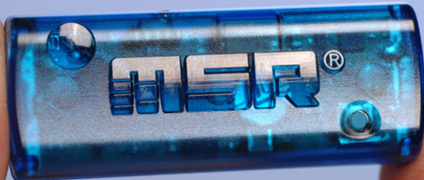 | 
Figure 3: MSR.5.28.32 type thermochips used to measure temperature and relative humidity

2.7. Assumptions
The following assumptions are considered:
- the wall is made with laterite bricks which have same properties,
- the mortar is made of sand-cement-water,
- the medium studied is made up of three phases: solid phase, liquid phase (water) and gas phase (water vapor and air),
- the solid phase is non-deformable,
- the properties of the gas phase are taken as those of an ideal gas,
- The driving forces for transfers are due to the outside (exterior) air temperature T and air humidity level φ,
- liquid water does not flow through the contact surface. Any water flowing to external surfaces is in vapor form.

- RESULTS AND DISCUSSION
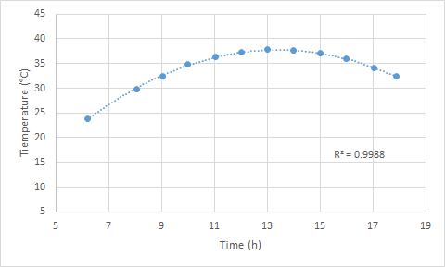  Figure 4a: Measurement data of temperature and model fitting for April | 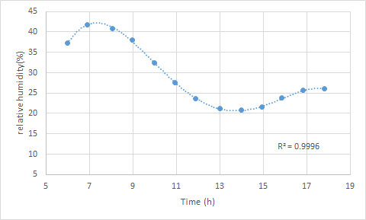  Figure 4b: Measurement data of moisture content and model fitting for April
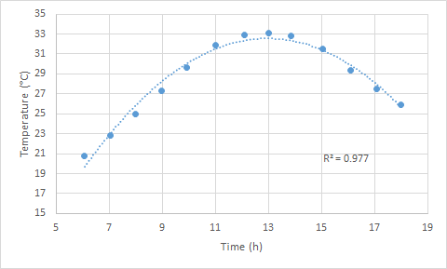  Figure 4c: Measurement data of temperature and model fitting for January | 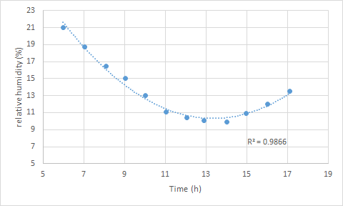  Figure 4d: Measurement data of moisture content and model fitting for January
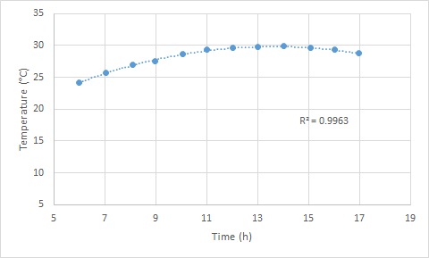  Figure 4e: Measurement data of temperature and model fitting for August | 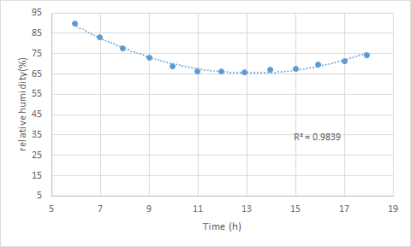  Figure 4f: Measurement data of moisture content and model fitting for August

Temperature and moisture content within different months and their fit with the considered model are given in Figures 2a to 2f. For each considered month, the corresponding models (see table 1) are used to represent temperature and moisture which are applied on the stressed side of the wall (exterior face). In other words, these models represent the weather conditions (in terms of temperature and moisture) which are applied on the stress side. For each month, the stressed side is exposed for 8 hours and 12 hours. It means that the exterior face is exposed to the sun for 8 hours and 12 hours before recording desired data.
After running the simulation, the temperature and moisture content profiles of the studied wall are plotted as function of the wall thickness and for different periods in Figures 3a to 3f. Theses plots represent the distribution of temperature and moisture content throughout the thickness of the wall (physical model). The exterior face of the wall corresponds to the coordinate x equals zero of the thickness. The interior face of the wall corresponds to the coordinate x equals to 14 cm, which is the laterite brick thickness. We can notice that the temperature and the moisture content decrease when we are moving away from the exterior face to the interior face. It suggests that the wall constitutes a shield against the propagation of heat and mass flow.
For the months of January and April, throughout the wall thickness, the plots of the temperature after 8 and 12 hours (Figures 3c and 3e) are superimposed. It is the same remark for the plots of the moisture, Figures 3d et 3f. It suggests that during these periods, for a given thickness, the temperature and the moisture reach their maximum values before 8 hours of exposure and thus, the wall acts as a shield against the transfer of heat and mass.
For the month of August, the temperature at each step of thickness after 8 hours of exposure is relatively lower than those after 12 hours of exposure, Figures 3a and 3b. On Figure 2e and 2f, we can notice that the variation of the temperature during the day in August is almost three times lower than the one in January and April. Due to the lower gradient of temperature applied on the stressed side on August, the temperature and the moisture rate at each step of thickness vary all along the duration of exposure. By comparing our results with those of [13] whose objective is to follow the evolution of the temperature profiles and the moisture content on the stress side as a function of the thickness, our results are in agreement.

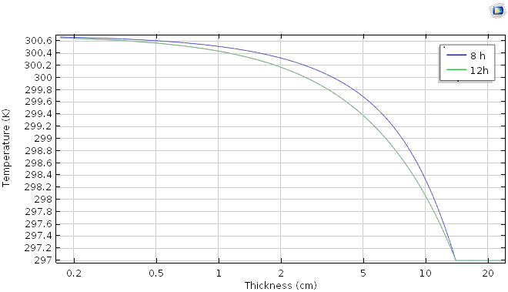  Figure 5a: Variation of the indoor temperature versus wall thickness - August | 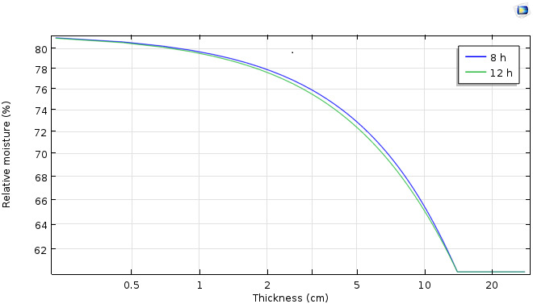  Figure 5b: Variation of relative indoor moisture content wall thickness – August
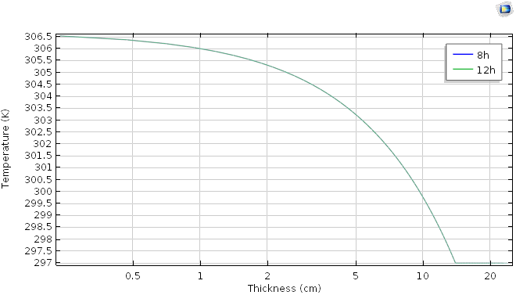  Figure 5c: Variation of the indoor temperature versus wall thickness - April | 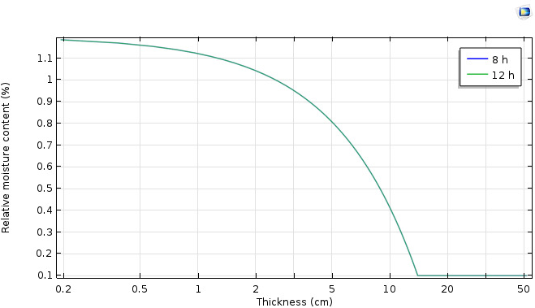  Figure 5d: Variation of relative indoor moisture content versus wall thickness – April
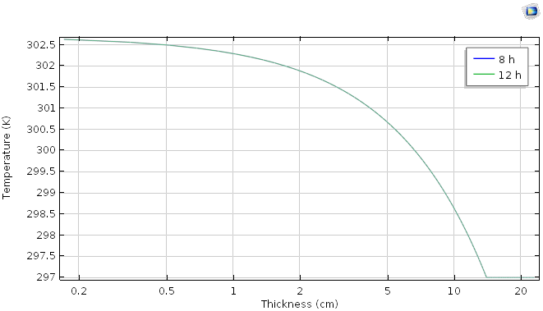  Figure 5e: Variation of the indoor temperature versus wall thickness - January | 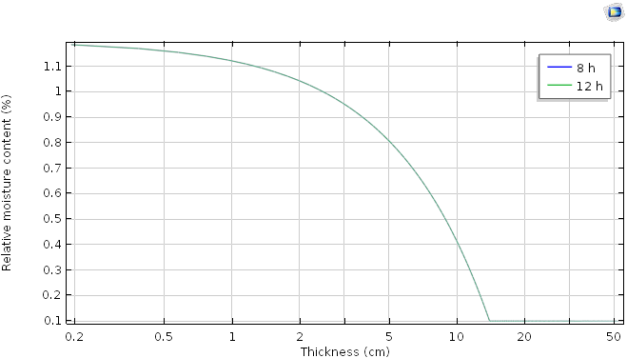  Figure 5f: Variation of relative indoor moisture content versus wall thickness – January

4.CONCLUSION
In this work, we used COMSOL software to model the heat and mass exchanges that take place in a wall made of cut laterite bricks. Firstly, the study reveals that a wall's response to thermohydric stress depends on its properties and thickness. Secondly, it shows that the thicker the wall, the more it absorbs temperature and moisture. The thickness of a building's wall is therefore a key parameter in guaranteeing its thermal inertia. Numerical results show temperature and moisture migration in the material. These results could be verified experimentally by thermography or magnetic resonance imaging within the wall.

Nomenclature:
Some notations used locally, are not mentioned in the list below. They are described as they appear in the text.
Latin characters:

$C_{p,a}$: specific heat of dry air [J/(kg.K)] ;
$C_{p,l}$: specific heat of liquid water [J/(kg.K)] ;
$C_{p,m}$: specific heat of the dry material [J/(kg.K)];
$L_{v}$: latent heat of state change (J/kg)
$C_{T}$ : total specific heat of the porous material [J/(kg.K)]
K : hydraulic conductivity [kg/(Pa.m.s)]
M : molar mass of water (kg/mol)
$\dot{m}$: flux density [kg/(m².s)] ;
n : normal vector to the exchange surface;
${\dot{m}}_{l}$: liquid flux density [kg/(m².s)] ;
${\dot{m}}_{v}$: steam flux density [kg/(m².s)];
$\dot{m_{T}}$: mass flux density under temperature gradient [kg/(m².s)];
$P_{v}^{sat}$: saturation steam pressure (Pa) ;
$P_{c}$: capillary pressure (Pa) ;
$P_{v}$: partial steam pressure
q : heat flux (W/m²) ;
R_{v} : water steam constant [J/(kg.K)]
$T_{ext}$: ambient temperature (K);
$T_{int}$: wall surface temperature (K);
t : time (s) ;
v : air speed (m/s)

Greek letters:

$φ_{ext}$: outdoor relative humidity (%);
$φ_{int}$: indoor relative humidity (%);
$β$: mass transfer coefficient [kg/(m².s.Pa)];
$δ_{p}$: wet material permeability to steam [kg/(m.s.Pa)];
$α$: heat transfer coefficient [W/(m².K)].
$ρ_{v}$: water steam density (kg/m³) ;
$ρ_{m}$: density of the material (kg/m³)
$ρ_{l}$: density of liquid water (kg/m³)
$ω$: mass water content (kg/m³) ;
$Ω$: moisture storage capacity [kg/(m³.Pa)] ;
$λ$: thermal conductivity of the material [W/(m.K)].

Indices:

a : air ;
c : capillary;
ext. : outdoor/external;
int. : indoor/internal
l : liquid;
m : environment;
p : permeability;
T : temperature;
v : steam/vapor.

COMPETING INTERESTS DISCLAIMER:
Authors have declared that they have no known competing financial interests OR non-financial interests OR personal relationships that could have appeared to influence the work reported in this paper.

References
[1] - D. SAMRI, Physical analysis and hygrothermal characterization of construction materials: experimental approach and numerical modeling, Doctoral thesis, civil engineering option, National Institute of Applied Sciences of Lyon, France, 2008.
[2] – J. R. PHILIP, D. A. DE VRIES, Moisture Movement in Porous Materials under Temperature Gradients, Transaction American Geophysical Union, Vol. 38, No. 2, April 1957.
[3] – P. CRAUSSE, G. BACON, S. BORIES, Fundamental Study of Coupled Heat-Mass Transfers in Porous Media, International Journal of Heat Mass Transfer, Vol. 24, No. 6, PP 991-1004, 1981.
[4] - K. ABAHRI, R. BELARBI, A. TRABELSI, Contribution to the analytical and numerical study of combined heat and moisture transfers in porous building materials, Building and Environment 46 (2011) 1354-1360,

[5] - M. SAIDI, A.S. CHERIF, B. ZEGHMATI, E. SEDIKI, Modeling of heat and mass transfers in a bio-sourced building material, The 9th Tunisian Conference on Flows and Transfers (JTET), 2016.
[6] – S.LARBI, A.AL-SARKHI, A. SZEKRENVES, Heat and Mass Transfer with condensation in capillary porous Bodies, Hindawi Publishing Corporation, http://dx.doi.org/10.1155/2014/194617.
[7] - F. MNASRI, Study of heat and mass transfer in complex media: application to fibrous media and building insulation, Doctoral thesis, Energy Engineering option, University of Lorraine, France, 2016.
[8] - J. E. AUBERT, Characterization of raw earth bricks from Midi-Pyrénées, Final report of the TERCRUSO project, April 2013.
[9] - S. KABRE, F. OUEDRAOGO, B. NAON, A. MESSAN, J.C. BENET, F. ZOUGMORE Evaluation of the thermo-hydro-mechanical properties of compressed earth bricks (CEB) from the Matourkou quarry, Burkina Faso, Afrique SCIENCE 15 (3) (2019)12-22, ISSN 1813 - 548X, http://www.afrique.science.net.
[10] - M. MALIKI, N. LAREDJ, K. BEDANI, H. MISSOUM, Two-Dimensional Transient Modeling of Energy and Mass Transfer in Porous Building Components using, Journal of Applied Fluid Mechanics, Vol.10, N°1, pp 319-328, 2017.
[11] - M. MALIKI, N. LAREDJ, K. BENDANI, H. MISSOUM, Numerical Study of coupled Heat and Mass Transfer in Building Envelopes Based on Temperature and Capillary Pressure Gradients, Proceedings of the 1st Thermal and Fluid Engineering Summer Conference, TFESC, August 9-12, 2015, New York City, USA.
[12] - A. V. LUIKOV, Systems of Differential Equations of Heat and Mass Transfer in Capillary-Porous Bodies, Review, International Journal Heat Mass Transfer, Vol. 18, pp. 1-14, 1975.
[13] – H. KAZEOUI, A. SEGHIR, F. BENNAI, N. SAIBI, A. TAHAKOUR, R. BELARBI, A. AIT-MOKHTAR, Modeling of heat and mass transfer in building walls, https://www.researchgate.net/publication/290748934.
[14] – S. MOISSETTE, M. BART, Validation of a heat and moisture transfer code in a wall according to EN 15026, 9th Interuniversity Franco-Quebec Conference on Thermal Systems, May 18-20, 2009, Lille, France.
[15] – J. F. DAÏAN, Equilibrium and Transfers in Porous Media, Manual, Hal-00452876, Version 4-21 October 2013, Joseph Fourier University, Grenoble, France.
[16] - I. TRAORE, Heat and Mass Transfers in the Walls of Timber-Framed Buildings, Doctoral Thesis in Mechanics and Energy, Henri Poincaré University – Nancy University, France, 2011.

