Original Research Article
Diversity and antimicrobial attributes of fungal endophytes from Argemone mexicana L.

ABSTRACT
Aims: The research on exploring endophytic fungal diversity of the medicinal herb Argemone mexicana L. and their pharmacological applications remains limited. This study aimed to investigate the diversity of endophytic fungi in A. mexicana and to determine their antimicrobial capacities.
Study design: The study design included isolation of endophytic fungi from the plant Argemone mexicana and determination of antimicrobial activities of these fungi against selected targets.
Place and Duration of Study: Department of Microbiology, Davangere University, Davangere, Karnataka, during August 2021 to February 2025.
Methodology:
The endophytic fungi of A. mexicana were isolated by plating apparently healthy tissues on Potato Dextrose Agar (PDA). Fungal morphological and microscopic features were used for identification. Different parameters such as Relative Abundance (RA%), Colonization Frequency (CF%), and Simpson diversity index were employed to assess fungal diversity. The evaluation of antimicrobial properties of these fungi was done through agar-well diffusion assay and conidial germination inhibition assay. The metabolites were extracted in ethyl acetate from the fungi that had shown antimicrobial activities in initial trials. The crude cellular and secretory extracts were analysed for antimicrobial potentials through disc-diffusion assay, conidial germination inhibition assay, bioautography, and TLC-bioautography methods.
Results: A total of 26 endophytic fungal isolates were recovered from stem, root, and leaf tissues. More diverse fungal assemblages were noticed in stem tissues. The Fusarium oxysporum was found as the dominant species with a Relative Abundance of 23.01%. Four isolates, Aspergillus luchuensis (DUMB 210 and DUMB 222), Penicillium dierckxii (DUMB 208) and Penicillium restrictum (DUMB 211) showed antifungal activity. The crude secretory extract of P. dierckxii was efficient against Gram-positive bacteria and all the target fungi. Only two TLC-separated fractions (F3 and F8) from the secretory extract of P. dierckxii showed antifungal activity.
Conclusion: The findings of the present study highlighted the association of fungi as endophytes in A. mexicana. The potential of these endophytic fungi to produce antimicrobial metabolites was realised.
Keywords: Endophyte; Aspergillus; Penicillium; Fusarium; TLC-bioautography.

- INTRODUCTION
Being eukaryotic organisms, the fungi exhibit a wide array of life cycle strategies. They have profound impacts on the environment. They are being exploited biotechnologically in various industries and in scientific research (Stajich et al., 2009; Rehman et al., 2022; Santra et al., 2022).
The fungi live within healthy tissues of plants through asymptomatic infections, are referred to as endophytic fungi. The majority of the plants in natural ecosystems host fungal endophytes (Suryanarayanan et al., 1998; Sarkar et al., 2021). They balance mutualistic, parasitic, or commensal symbiosis with their hosts. They shield their hosts from pathogenic agents and enable them to adapt to harsh climatic circumstances (Rodriguez et al., 2009; Nath et al., 2012).
The herb Argemone mexicana L. (Mexican Poppy), belonging to the plant family Papaveraceae, is a widely spread weed in many regions of the world. With its medicinal properties, the plant parts were used to treat skin diseases, inflammations, warts, piles, rheumatism, dysentery, edema, jaundice, ulcers, and asthma (Arcos-Martinez et al., 2016; Elizondo-Leuvano et al., 2018). The A. mexicana possesses significant pharmacological properties like anti-allergic, anticancer, antidiabetic, anti-inflammatory, antioxidant, antimicrobial, antipyretic, antiviral, cardioprotective, cytotoxic, hepatoprotective, and larvicidal activities (Magaji et al., 2019; Patocka et al., 2024). The potential medicinal value of this plant makes it ideal for metabolite extraction and use. There is scope for producing the bioactive metabolites of endophytic fungi derived from such medicinal plants (Caruso et al., 2020; Enyi et al., 2025).
The plant’s medicinal value may be imputed to the endophytes. In this context, only scanty reports were available on the diversity of fungi colonized as endophytes in A. mexicana (Sheshrao et al., 2012; Singh et al., 2020, 2023). It would be interesting to explore fungal endophytic diversity and determine their biological potential. This study comprises the isolation of fungi from the plant parts of A. mexicana, their diversity analysis, and elucidation of their antimicrobial potentials.

- MATERIALS AND METHODS
  - Isolation, identification, and diversity assessment of endophytic fungi from Argemone mexicana
Apparently healthy A. mexicana plants were collected from Chitradurga and Davangere districts of Karnataka state, India. A typical A. mexicana plant flower and fruit are represented in Fig. 1. The plants were processed for endophytic fungal isolation. Five-millimetre-long segments were made from the flower, fruit, leaf, stem, and root samples of the collected plants. The segments were washed in tap water and dried. For the endophytic fungal isolation, a modified surface disinfection protocol was followed (Schulz et al., 1993). The tissue segments were immersed in 70% ethanol (3 min) and transferred to 5% Sodium hypochlorite solution (5 min). The segments were rinsed in 70% ethanol (2 min) and washed in sterile water for four times. Further, they were dried on sterile blotters in aseptic conditions. Fifteen segments of each plant organ from each plant were imprinted on sterile Potato Dextrose Agar (PDA) surface in plates and then placed equidistantly on separate PDA plates (Schulz et al., 1998). A total of five segments were placed on each plate. Incubation was done at room temperature (25±5°C) and observed periodically. The fungi expressed were pure cultured in PDA slants and stored (4°C).
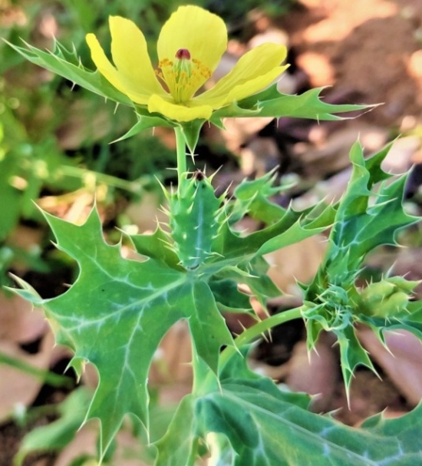

Fig. 1. Argemone mexicana plant with flower and fruit.

Among many endophytic fungi expressed on sample segments, only the morphologically distinct ones were selected. The fungi were identified by comparing their morphological and microscopic characteristics with standard fungal identification manuals and research reports (Thom and Raper, 1945; Raper and Thom, 1949; Sivanesan, 1987; Domsch et al., 1993; Leslie and Summerell, 2006; Bensch et al., 2012; Index Fungorum).
The endophytic fungal diversity in different organs of A. mexicana was assessed through different parameters. The percentage of plant segments colonized by fungal endophytes was analyzed by calculating the mean colonization density (CD%) with the following formula.
$$Mean colonization density \left(CD\%\right)= \frac{Total number of segments colonized by endophytes}{Total number of segments screened} x 100$$

(Fisher and Petrini, 1987)

The quantitative diversity measure of species of endophytic fungi was determined through the Simpson Diversity Index by using the following formula.
$$Simpson Diversity Index =1-\sum{{(ni/n)}^{2}}$$
ni - Number of isolates of a particular species
n - Total number of isolates of a particular plant
(Simpson, 1949)
The percent appearance of a particular fungal species in the total endophytic fungal population of different tissues of a plant was calculated as the Relative Abundance (RA%) using the following formula.
$$Relative Abundance \left(RA\%\right)= \frac{Number of isolates of each endophytic fungal species}{Total number of endophytic fungal isolates} x 100$$

(Li et al., 2007)

Using the Colonization Frequency (CF%) formula, the frequency of each fungal species colonized as an endophyte in A. mexicana parts was calculated.
$$Colonization Frequency \left(CF\%\right)=\frac{Number of isolates belonging to a particular fungal species}{Total number of segments of a plant part screened} x 100$$

(Suryanarayanan and Vijaykrishna, 2001)

A paired t-test was performed at p=0.05 using GraphPad Prism 10.4.2. to compare the endophytic fungal CF% in different tissues of A. mexicana.
The comparison of fungal species present as endophytes in the host plant parts was studied by calculating Jaccard’s Similarity Coefficient (Sj) using the following formula.
$$Jaccard^{'}s Similarity Coeffiient \left(Sj\right)=\frac{C}{(A+B-C)}$$

A- Total number of fungal species isolated from one plant part
B- Total number of fungal species isolated from another plant part
C- Number of fungal species found common in both plant parts

(Suryanarayanan and Kumaresan, 2000)

  - Antimicrobial activities of endophytic fungi
The endophytic isolate’s antimicrobial properties were assessed against different pathogenic bacteria and fungi. The Gram-positive bacterial pathogens like Bacillus subtilis (MCC 2511) and Staphylococcus aureus (MCC 2408), and Gram-negative bacterial pathogens like Escherichia coli (MCC 2246) and Salmonella enterica (MCC 3910) were used. The yeasts like Candida albicans (MCC 1151) and Cryptococcus sp. (MCC 1408), were used as targets. These pathogen pure cultures were procured from Microbial Culture Collection (MCC), National Centre for Microbial Resource, Pune, India. The plant pathogenic filamentous fungi Alternaria tenuissima, Cladosporium oxysporum, Curvularia lunata, and Fusarium oxysporum were isolated from sorghum grains and used as targets.

    - Antibacterial activity through agar well-diffusion assay
The endophytic fungi were cultured in Potato Dextrose Broth (PDB) for five days, and culture filtrates were collected by filtration. The culture supernatants were obtained by centrifugation (5000 rpm for 10 min) and used as test samples. The 24-hour-old bacterial cultures in Luria-Bertani Broth (LB Broth) were set to 0.5 McF standards (McFarland Standard, Dalynn Biologicals) and swab inoculated onto Mueller-Hinton Agar (MHA) plates. Using a sterile cork-borer (7 mm), the wells were made and filled with 100 µl of fungal culture filtrates. The positive control was Chloramphenicol solution (30 µg/well), and sterile PDB was the negative control. The plates were incubated at 37±2°C for 24 hours. Plates were observed for the appearance of inhibition zones and were noted in millimetres (Nath and Joshi, 2014).
    - Antifungal activities
      - Agar well-diffusion assay
The agar well-diffusion assay was performed on Sabouraud Dextrose Agar (SDA) plates as mentioned above using the pathogens Candida albicans (MCC 1151) and Cryptococcus sp. (MCC 1408) cultured in Sabouraud Dextrose Broth (SDB). The Fluconazole solution (30 µg/well) was used as positive control, and the sterile PDB as negative control.
      - Conidial germination inhibition assay
The antifungal activity was determined for the culture filtrates of endophytic fungi through conidial germination inhibition assay. The spore suspensions of target fungi Alternaria tenuissima, Cladosporium oxysporum, Curvularia lunata and Fusarium oxysporum were prepared in sterile water. The endophytic fungal culture filtrates (100 μl) were added to depression slides and air dried. The 100 μl of spore suspensions of each target fungus were added into the depressions. The control used was sterile water. The slides were incubated in a humid chamber for 12-15 h. (25±5°C) (Dhingra and Sinclair, 2019). The total number of spores and the number of spores germinated in the microscopic fields were noted. The percent inhibition of conidial germination over control was calculated using the formula.
$$\text{Conidial Germination Inhibition over Control (\%)}\text{= }\frac{\text{C-T}}{\text{C}}\text{×100 }$$
C- Conidial germination percentage in control. T- Conidial germination percentage in treatment.

  - Extraction of metabolites from selected endophytic fungi
The fungi that had exhibited antimicrobial activities in earlier trials were selected and cultured in 300 ml of PDB in Roux bottles and then extracted with solvent ethyl acetate (Chatterjee et al., 2019). The cellular metabolites from the mycelial mat were also extracted by soaking the mycelial mat overnight in ethyl acetate. The air-dried crude extracts of selected fungi were stored at 4°C until further use. The culture filtrate extracts were referred to as secretory extracts, while the mycelial mat extracts were considered as cellular extracts.
  - Antimicrobial activities of endophytic fungal crude extracts
    - Antibacterial activity by disc-diffusion assay
Antibacterial activity of crude extracts of endophytic fungi was determined by disc-diffusion assay according to the protocols of Kirby-Bauer (Hudzicki, 2009). Briefly, the 24-hour-old bacterial cultures in LB set to 0.5 McF were swab inoculated onto sterile MHA plates. The sterile 10 mm discs (HiMEDIA) were loaded with fungal crude extracts dissolved in ethyl acetate to get a final concentration of 1500 µg/disc and were used. Chloramphenicol (30 µg/disc) and the ethyl acetate were separately used as positive and negative controls, respectively. The plates were observed after 24 hours of incubation for the clear zone of inhibition and measured using an antibiotic zone measuring scale (HiMEDIA).
    - Antifungal activities
      - Disc-diffusion assay
The antifungal activity was also determined for the crude extracts using the disc-diffusion assay, by following standard protocols. The target fungi Candida albicans (MCC 1151) and Cryptococcus sp. (MCC 1408) were cultured in SDB and swab inoculated onto SDA plates using positive control Fluconazole (30 µg/disc). The negative control used was ethyl acetate.
      - Conidial germination inhibition assay
The performed conidial germination inhibition assay as described in the earlier section for the same target fungi. Crude fungal extracts in ethyl acetate (1 μg/μl) were used as test samples. The control used for each target fungus was ethyl acetate. The percent inhibition of conidial germination over the control was calculated.
      - Bioautography method
For bioautography, the glass plates (20x20 cm) were coated with Silica gel-G (particle size 40 µm), dried, and activated at 100°C for 45 min. The endophytic fungal crude extracts were spotted equidistantly. The positive and negative controls used were Fluconazole (0.75 mg) and ethyl acetate, respectively. The conidial suspensions of target pathogenic fungi, Alternaria tenuissima, Cladosporium oxysporum, and Curvularia lunata, prepared in PDB, were sprayed uniformly onto plates separately (Choma and Jesionek, 2015; Narendrababu and Shishupala, 2023). Incubation was done in a moist chamber (25±5°C) up to 48 h. The fungal growth inhibition zone diameters were measured.
      - Thin-Layer Chromatography-bioautography method
The crude extracts from selected endophytic fungi that had exhibited good activity in the bioautography method were selected for TLC-bioautography. The TLC was performed on activated Silica gel-G (particle size 40 µm) plates for crude extracts in the solvent system ethyl acetate:hexane (6:4 v/v) (Narendrababu and Shishupala, 2023). The TLC-bioautography was performed against the same fungal targets. The diameters of the zone of inhibition displayed by the TLC-fractions were measured.
Statistical analyses:
The experiments were conducted in triplicate. The standard errors (SE) with the mean values of conidial germination inhibition and the zone of inhibition were calculated. One-way ANOVA (p=0.05) and Duncan Multiple Range Test (DMRT) were performed for bioautography and TLC-bioautography using an online statistical tool, GRAPES 1.1.0. (https://www.kaugrapes.com/) (Gopinath et al., 2021).

- RESULTS AND DISCUSSION
  - Isolation, identification and diversity assessment of endophytic fungi from Argemone mexicana
By the fifth day of incubation, the mycelial growths emerged from the plant segments on the agar plates. The growth of various fungal forms was observed on the stem, root, and leaf segments of Argemone mexicana (Fig. 2). No fungal growth was found on the flower and fruit samples even after a prolonged period of incubation. No fungal growth was found on the imprint PDA plates ensuring the efficiency of surface disinfection procedures (Fig. 2.D.).
Among 375 plants segments processed from five individual A. mexicana plants, the endophytic fungi were expressed on 75 segments. Among them, 28 were from root segments, 30 were from stem segments, and 17 were from leaves. Among them, 26 fungal isolates were selected according to their differences in morphological appearance and pure cultured. Out of 26 fungal pure cultures, 11 each were isolated from root and stem segments. From the leaf tissues, four fungi were obtained. As more fungi were expressed in stem tissue, the mean colonization density (CD%) of endophytic fungi was also higher in stem (40%), and this was followed by root tissue with CD% of 37.33% (Table 1). The endophytic fungal colonization density is a quantitative measure of the extent of fungi inhabiting the internal tissues of the host plant. The higher density of endophytic fungal colonization leads to greater ecological significance and is correlated with the magnitude of the beneficial effects of endophytes on host. The higher density of colonization may accompany to the enhanced host plant fitness and ecological adaptability (Rodriguez et al., 2009).

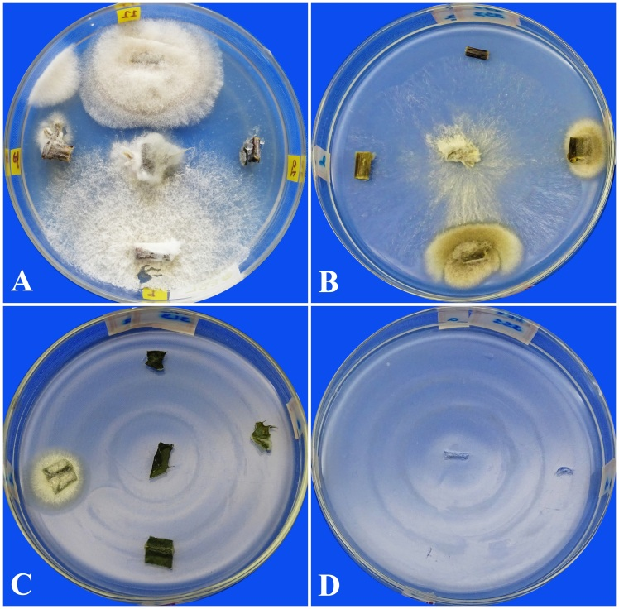

Fig. 2. Endophytic fungi grown on different parts of Argemone mexicana in Potato Dextrose Agar medium.
- Fungal growth on root segments B- Fungal growth on stem segments
- Fungal growth on leaf segments D- Imprint plate

The selected endophytes belonged to six different fungal genera: Aspergillus, Cladosporium, Curvularia, Fusarium, Phoma, and Penicillium. A total of eight species of fungi were found distributed in both root and stem tissues. The root and stem of A. mexicana had diverse endophytic fungal species as indicated by their higher Simpson diversity index (Table 1). The fungal colonization in the host tissues are influenced by a complex interplay of abiotic and biotic factors such as plant health, host tissue type and age, geographical location and climatic conditions, soil type and nutrient availability (Suryanarayanan et al., 2003; Murali et al., 2006).

Table 1. Endophytic fungal distribution in different parts of Argemone mexicana.
Data Analyses | Root | Stem | Leaf | Flower | Fruit | Total
Number of segments screened | 75 | 75 | 75 | 75 | 75 | 375
Number of segments colonized by fungi | 28 | 30 | 17 | 0 | 0 | 75
Total number of fungi isolated | 11 | 11 | 04 | 0 | 0 | 26
Total number of different fungal species obtained | 08 | 08 | 04 | 0 | 0 | 11
Mean colonization density (CD%) | 37.33 | 40 | 22.67 | 0 | 0 | 20
Simpson Diversity Index | 0.93 | 0.95 | 1.0 | 0 | 0 | -
$Mean density of colonization \left(CD\%\right)= \frac{Total number of segments colonized by endophytes}{Total number of segments screened} x 100$

$Simpson Diversity Index =1-\sum{{(ni/n)}^{2}}$ where, n- total number of isolates, ni- number of isolates of a particular species.

All the fungi belonged to Ascomycota and the fungal group Hyphomycetes. These fungi were further categorised under three different fungal classes and are Dothideomycetes, Eurotiomycetes, and Sordariomycetes (Table 2). Among these three fungal classes, the fungi falling under class Sordariomycetes were relatively abundant (38.39%). Among 11 different species of fungal endophytes, the Fusarium oxysporum exhibited higher relative abundance of 23.01% followed by F. solani with relative abundance of 15.38%. Calculating the relative abundance is fundamental to determining microbial ecology. Relative abundance assists in identifying dominant taxa and accessing community composition (Dai et al., 2016). Additionally, the findings of Chen et al. (2019) revealed the similar pattern of higher abundance of endophytic Sordariomycetes fungi associated with the wild tea plant Camellia taliensis. This evidences the abundant association of Sordariomycetes fungi as endophytes in different plant species, also concluding that they equally prefer an endophytic lifestyle.

Table 2. Relative abundance (RA%) of fungal endophytes in Argemone mexicana.

Endophytic fungal species | Total number of isolates | Fungal Class | Relative Abundance (RA%)
Cladosporium cladosporoides | 01 | Dothideomycetes | 03.85
Cladosporium oxysporum | 02 | Dothideomycetes | 07.69
Curvularia lunata | 03 | Dothideomycetes | 11.54
Phoma sp. | 02 | Dothideomycetes | 07.69
Aspergillus luchuensis | 02 | Eurotiomycetes | 07.69
Aspergillus sclerotiorum | 03 | Eurotiomycetes | 11.54
Aspergillus sydowii | 01 | Eurotiomycetes | 03.85
Penicillium dierckxii | 01 | Eurotiomycetes | 03.85
Penicillium restrictum | 01 | Eurotiomycetes | 03.85
Fusarium oxysporum | 06 | Sordariomycetes | 23.01
Fusarium solani | 04 | Sordariomycetes | 15.38
$$Relative Abundance \left(RA\%\right)= \frac{Number of isolates of each endophytic fungal species}{Total number of endophytic fungal isolates} x 100$$
The different fungal species isolated in the present study, exhibited varying colonisation frequencies (CF%) among root, stem, and leaf tissues of A. mexicana. All three plant tissues were frequently colonised by F. oxysporum followed by F. solani. The Aspergillus sydowii (DUMB 218), Cladosporium cladosporoides (DUMB 209), Penicillium dierckxii (DUMB 208) and P. restrictum (DUMB 211) were the least occurring in A. mexicana plant parts. Both the Penicillium species were restricted to root tissues. The Cl. cladosporoides (DUMB 209) was found only in root segment. The A. sydowii (DUMB 218) was found restricted to the stem tissues only (Table 3). The root tissue was more densely colonized by the endophytic fungal species compared to the stem by the total CF%. It is known that the species composition and colonization frequency of endophytic fungi differ with distinct host plant tissues, demonstrating that plant organs resemble diverse microhabitats regarding endophyte infection. (Suryanarayanan and Vijaykrishna, 2001).
Table 3. The Colonization Frequency (CF%) of endophytic fungal species in different parts of Argemone mexicana.

Endophytic Fungi | Endophytic fungal Colonization Frequency (CF%)
Endophytic Fungi | Host Plant Parts
Endophytic Fungi | Root | Stem | Leaf | Flower | Fruit
Aspergillus luchuensis | 1.33 | 1.33 | 0.0 | 0.0 | 0.0
Aspergillus sclerotiorum | 2.67 | 1.33 | 0.0 | 0.0 | 0.0
Aspergillus sydowii | 0.0 | 1.33 | 0.0 | 0.0 | 0.0
Cladosporium cladosporoides | 1.33 | 0.0 | 0.0 | 0.0 | 0.0
Cladosporium oxysporum | 0.0 | 1.33 | 1.33 | 0.0 | 0.0
Curvularia lunata | 0.0 | 2.67 | 1.33 | 0.0 | 0.0
Fusarium oxysporum | 4.0 | 2.67 | 1.33 | 0.0 | 0.0
Fusarium solani | 1.33 | 2.67 | 1.33 | 0.0 | 0.0
Phoma sp. | 1.33 | 1.33 | 0.0 | 0.0 | 0.0
Penicillium dierckxii | 1.33 | 0.0 | 0.0 | 0.0 | 0.0
Penicillium restrictum | 1.33 | 0.0 | 0.0 | 0.0 | 0.0
$$Colonization Frequency \left(CF\%\right)=\frac{Number of isolates belonging to a particular fungal species}{Total number of segments of a plant part screened} x 100$$

More similar endophytic fungal species distribution was noticed among the root-stem, when compared to the fungal species distribution among the stem-leaf and root-leaf. The root and leaf tissues share only a few similar species. These were noticed with their least Jaccard’s Similarity Coefficients (Root-Stem: 0.45, Stem-Leaf: 0.50, and Leaf-Root: 0.2). The endophytic fungal species community in root-stem (p=0.623), stem-leaf (p=0.058), and root-leaf (p=0.50) were not significantly different, as observed in paired t-test.
This study provides a comprehensive report on the endophytic fungal diversity in A. mexicana. The Cladosporium, Curvularia, Fusarium, and Phoma sp. were being reported as endophytes for the first time from this plant. In contrast, Acremonium and Emericella were previously documented by Singh et al. (2020). Stem tissues harboured the highest fungal diversity, while stem and root tissues shared greater similarity in community composition, reflecting patterns observed in other medicinal plants. For instance, in Butea monosperma, there was a significant difference in fungal species distribution between stem–petiole and stem–flower assemblages, but not among root–stem and stem–lamina (Tuppad and Shishupala, 2013). These findings underscore the tissue-specific nature of endophytic fungal colonization in medicinal plants. This trend of endophytic fungal tissue-specific nature was also evident in different plant hosts (Ananda and Sridhar, 2002; Sun et al., 2011).
Among the isolates, Fusarium oxysporum was the most dominant species, followed by F. solani, both colonizing all tissue types of A. mexicana. This contrasts with earlier reports where Aspergillus flavus and A. sydowii were more prevalent (Singh et al., 2020). Such variation in species dominance may arise from differences in host physiology, geographical location, and environmental conditions. The prevalence of F. oxysporum suggests its ecological adaptability and potential functional significance within the endophytic community of A. mexicana. Overall, this study expands the understanding of fungal endophyte diversity in A. mexicana and offers an essential foundation for subsequent inquiries of their ecological roles and biotechnological applications.
  - Antimicrobial activities of endophytic fungi
    - Agar well-diffusion assay
All the endophytic fungal culture filtrates were not able to display both antibacterial and antifungal activities in agar well-diffusion assay against both the target bacterial and fungal pathogens. These mycoendophytes may be producing metabolites in lower concentrations in the culture filtrates, and hence no visible antimicrobial activities were displayed by them in well-diffusion method. Most of the fungal endophytes from the leaves of Indigofera suffruticosa were not effective against the bacterial pathogen Pseudomonas aeruginosa (Santos et al., 2015). The antimicrobial properties of these fungi may provide competitive advantage for survival.
    - Conidial germination inhibition assay
Among the different endophytic fungal culture filtrates, the culture filtrates of 14 fungi displayed inhibition against some of the target fungi. All isolates exhibited inhibition of conidial germination of Alternaria tenuissima. Only eight different fungi exhibited inhibition remaining three target fungi. The two isolates of A. luchuensis (DUMB 210 and DUMB 222), P. dierckxii (DUMB 208) and P. restrictum (DUMB 211) displayed potential inhibition of all target fungi. The least antifungal activity was displayed by F. solani (DUMB 203) against A. tenuissima. The endophytic Cl. oxysporum (DUMB 219) exhibited least antifungal effect on the target Cl. oxysporum. Similarly, the endophytic A. sydowii (DUMB 218) and C. lunata (DUMB 223) were least effective on target C. lunata. The least inhibition of target F. oxysporum conidial germination was displayed by endophytic F. oxysporum (DUMB 202) and F. solani (DUMB 203) (Table 4). These findings imply significant degree of variability in the antifungal potential of different endophytic taxa from A. mexicana.
This study assessed the inhibitory capacity of fungal endophytes from A. mexicana on the conidial germination of pathogenic fungi. Similarly, no previous studies have assessed the antifungal activities of endophytes from A. mexicana against plant pathogenic Alternaria tenuissima, Cladosporium oxysporum, Curvularia lunata, and Fusarium oxysporum. Conversely, comparable findings have also been documented from other hosts. The cell-free culture filtrate of an endophytic Aureobasidium sp. isolated from the cactus Echinopsis chiloensis significantly inhibited conidial germination of Botrytis cinerea (Vidal et al., 2020). Such inhibitory activity is often linked to the secretion of lytic enzymes or secondary metabolites capable of interfering with early fungal developmental stages. The variability among isolates further highlights the species- and strain-specific nature of antifungal metabolite production in endophytic fungi.

Table 4. Efficacy of endophytic fungal culture filtrates from Argemone mexicana on conidial germination of plant pathogenic fungi.

Endophytic fungi | Conidial germination inhibition over control (%) ± SE
Endophytic fungi | Target fungi
Endophytic fungi | Alternaria tenuissima | Cladosporium oxysporum | Curvularia lunata | Fusarium oxysporum
Aspergillus luchuensis (DUMB 210) | 89.36±0.09 | 100±0.00 | 100±0.00 | 98.36±0.07
Aspergillus luchuensis (DUMB 222) | 97.87±0.04 | 100±0.00 | 100±0.00 | 100±0.00
Aspergillus sclerotiorum (DUMB 221) | 15.90±0.04 | 00±0.00 | 00±0.00 | 15.78±0.04
Aspergillus sydowii (DUMB 218) | 28.40±0.20 | 07.60±0.10 | 01.11±0.07 | 00±0.00
Cladosporium oxysporum (DUMB 219) | 11.36±0.09 | 04.34±0.01 | 00±0.00 | 00±0.00
Curvularia lunata (DUMB 214) | 17.04±0.03 | 00±0.00 | 00±0.00 | 00±0.00
Curvularia lunata (DUMB 223) | 31.81±0.10 | 00±0.00 | 02.22±0.01 | 31.57±0.02
Fusarium oxysporum (DUMB 202) | 26.53±0.33 | 00±0.00 | 21.21±0.02 | 02±0.01
Fusarium oxysporum (DUMB 212) | 20.45±0.33 | 00±0.00 | 00±0.00 | 00±0.00
Fusarium oxysporum (DUMB 215) | 28.40±0.07 | 06.52±0.04 | 00±0.00 | 00±0.00
Fusarium solani (DUMB 203) | 03.06±0.02 | 00±0.00 | 20.20±0.09 | 03±0.01
Fusarium solani (DUMB 213) | 10.22±0.08 | 13.04±0.20 | 00±0.00 | 00±0.00
Penicillium dierckxii (DUMB 208) | 95.74±0.09 | 97.91±0.02 | 88.42±0.07 | 85.24±0.09
Penicillium restrictum (DUMB 211) | 98.93±0.02 | 100±0.00 | 100±0.00 | 91.80±0.08
DUMB- Davangere University Microbial culture collection
$$\text{Conidial Germination Inhibition over Control (\%)= }\frac{\text{C-T}}{\text{C}}\text{×100}$$

  - Extraction of metabolites from selected endophytic fungi
The fungi A. luchuensis (DUMB 210 and DUMB 222), P. dierckxii (DUMB 208), and P. restrictum (DUMB 211) were selected due to their antifungal activity (Fig. 3). The cellular and secretory metabolites of these selected fungi were successfully extracted in ethyl acetate. The ethyl acetate being a moderately polar organic solvent, can dissolve wide classes of compounds, majorly natural products from plants and microorganisms. Hence, for the extraction of fungal metabolites, the ethyl acetate was being used widely as an effective solvent (Shawky et al., 2019; Narendrababu and Shishupala, 2023).

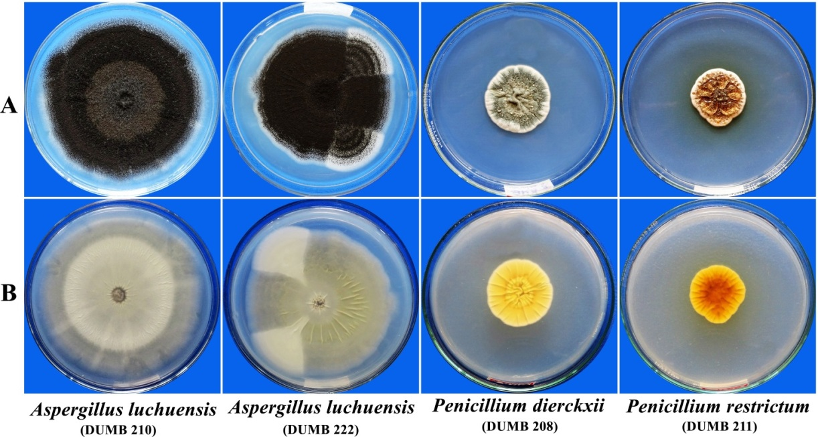
Fig. 3. Selected endophytic fungal species from Argemone mexicana cultured on Potato Dextrose Agar.

A- Obverse view of fungal colonies B- Reverse view of fungal colonies

  - Antimicrobial activities of selected endophytic fungal crude extracts
    - Antibacterial activity by disc-diffusion assay
Among the crude cellular and secretory extracts of endophytic fungi tested, only the crude secretory compounds of Penicillium dierckxii (DUMB 208) showed prominent inhibition of Bacillus subtilis and Staphylococcus aureus with the inhibition zone of 16±0.33 mm and 20±0.29 mm, respectively (Fig. 4). The secretory extracts from both the isolates of Aspergillus luchuensis (DUMB 210 and DUMB 222) inhibited only B. subtilis with inhibition zone measuring 12±0.00 mm and 14±0.00 mm, respectively. The positive control Chloramphenicol exhibited zone of inhibitions of 19±0.33 mm and 24±0.44 mm against B. subtilis and S. aureus respectively.
The present study recognizes the antibacterial potential of endophytic fungi from A. mexicana, with P. dierckxii (DUMB 208) extracellular compounds showing strong activities against both B. subtilis and S. aureus. The bioactive metabolites are predominantly secreted by the endophytic fungi, consistent with earlier reports on fungal endophytes (Sheshrao et al., 2012; Kumar et al., 2014). The activity of P. dierckxii was comparable to chloramphenicol indicating a true potential candidate for pharmaceutical relevance.
In contrast, A. luchuensis isolates (DUMB 210 and DUMB 222) displayed narrow-spectrum inhibition restricted to B. subtilis, reflecting the pathogen-specific nature of fungal metabolites. Similar selective inhibition capacity was observed in endophytic Aspergillus extracts from the same plant (Singh et al., 2023). These findings expand the current knowledge on A. mexicana endophytes and highlight P. dierckxii as a promising source of antibacterial compounds. Supporting reports on antibacterial activities of crude metabolites of host plant A. mexicana on both Gram-positive and Gram-negative pathogens were available (Bhattacharjee et al., 2006; More et al., 2017). This infers that the antibacterial activity of the host-associated fungal endophytes may be attributed to the host-endophyte interactions. Such compounds probably originate from the associated endophytic fungi.
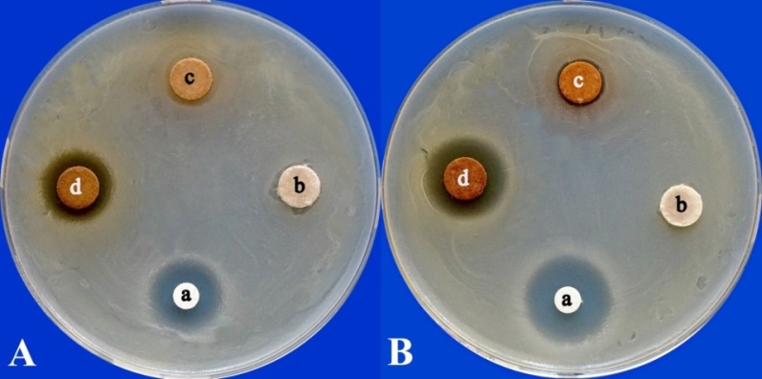
Fig. 4. Antibacterial activity of the ethyl acetate soluble crude secretory metabolites of Penicillium dierckxii (DUMB 208) against Bacillus subtilis (A) and Staphylococcus aureus (B) in disc-diffusion assay.

- Chloramphenicol b- Ethyl acetate c- Crude cellular extract of Penicillium dierckxii (DUMB 208)
d- Crude secretory extract of Penicillium dierckxii (DUMB 208)

    - Antifungal activities of metabolites from endophytic fungi
      - Disc-diffusion assay
Among the ethyl acetate soluble fungal crude extracts, only the secretory extract of Penicillium dierckxii (DUMB 208) exhibited potential inhibition of both Candida albicans and Cryptococcus sp. with inhibition zones of 25±0.88 mm and 27±0.88 mm, respectively (Fig. 5). The positive control Fluconazole displayed inhibition zones of 24±0.88 mm against C. albicans and 23±0.16 mm against Cryptococcus sp. Notably, the inhibition exhibited by secretory extract of P. dierckxii (DUMB 208) against Cryptococcus sp. was more than that of the positive control. The secretory extract of P. dierckxii (DUMB 208) exhibited similar effects on C. albicans as that of the Fluconazole. The negative control ethyl acetate, has not exhibited any antifungal activity.
In this study, the antifungal activity observed is in accordance with the previous reports that endophytic fungi synthesize a wide array of secondary metabolites with strong bioactivity. Sheshrao et al. (2012) reported antifungal properties of diethyl ether soluble compounds of Aspergillus fumigatus from the same host plant against C. albicans. The antifungal activity of methanolic leaf extracts of A. mexicana against C. albicans and C. tropicalis was evident (Bais et al., 2013). This property of production of antifungal compounds by the host plant may have imparted to the associated fungal endophytes, as evidenced in the current study.

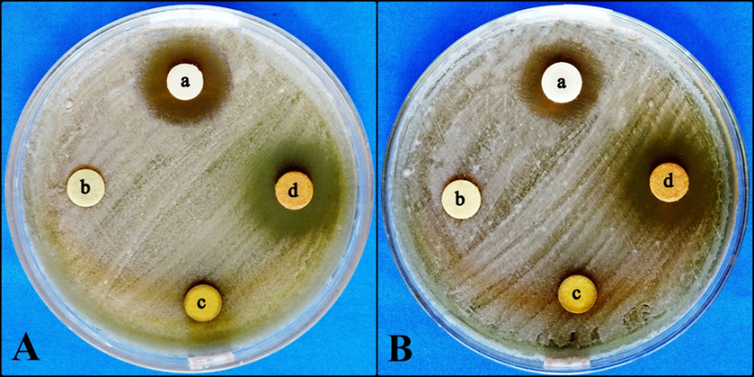
Fig. 5. Antifungal activity of ethyl acetate soluble crude secretory compounds of Penicillium dierckxii (DUMB 208) in disc-diffusion assay.
(A)-Candida albicans (B)-Cryptococcus sp.
a- Fluconazole b- Ethyl acetate c- Crude cellular extract of Penicillium dierckxii (DUMB 208)
d- Crude secretory extract of Penicillium dierckxii (DUMB 208)

      - Conidial germination inhibition assay
All the endophytic fungal compounds soluble in ethyl acetate demonstrated potential inhibition of conidial germination of all target fungi. These extracts exhibited 100% inhibition of target fungal conidial germination except the crude cellular extract of P. restrictum (DUMB 211), which displayed more than 80% inhibition of all the target fungal conidial germination. These results highlighted their potent antifungal activity. Endophytic fungal secondary metabolites are involved in conidial germination inhibition. Li et al. (2021) demonstrated that versicolorin B, a metabolite derived from the crude mycelial extract of Aspergillus versicolor isolated from Aphanamixis grandifolia, significantly inhibited the conidial germination of banana anthracnose pathogen Colletotrichum musae. In the life cycle of fungi, the conidial germination is a crucial step, hence the inhibition at this stage is a highly effective strategy to prevent disease onset (Osherov and May, 2001). The high degree of conidial germination inhibition observed in our study signifies the potential utility of these endophytic fungal extracts in biocontrol applications. The results also indicate solubility of these antifungal compounds in ethyl acetate.
      - Bioautography method
The tested ethyl acetate soluble crude endophytic fungal extracts exhibited varying levels of inhibition of target fungi in bioautography method. The secretory extract of Penicillium dierckxii (DUMB 208) displayed significantly higher antifungal activity on all the three target fungi with visible larger inhibition zone (Fig. 6). The crude cellular and secretory extracts of Aspergillus luchuensis (DUMB 210 and DUMB 222) exhibited moderate levels of antifungal activities against all tested fungi, but the differences found among these extracts in their inhibition zones were not significant. The cellular extract of Penicillium restrictum (DUMB 211) was least effective among the endophytic fungal crude extracts, against all the target fungi (Fig. 7).
In this study, the potential antifungal property of endophyte P. dierckxii (DUMB 208) was realised. The endophytes may be contributing to antifungal properties of the plant (Stierle et al., 1993). There are reports on antifungal activities of methanolic extracts of plant parts of A. mexicana against different species of Aspergillus, Penicillium and also on Mucor indicus (Bais et al., 2013; More and Kharat 2016). Hence, the antifungal nature of the host and its associated fungi may be because of the interaction of host-fungal metabolic pathways. The broad spectrum antifungal nature of P. dierckxii (DUMB 208) can find applications in multiple industries.

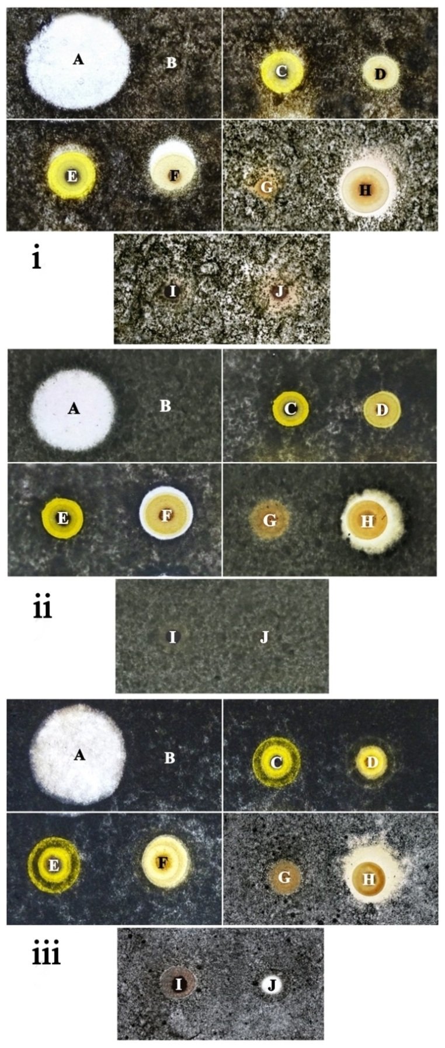

Fig. 6. Bioautogram of ethyl acetate soluble crude extracts of endophytic fungi from Argemone mexicana against (i) Alternaria tenuissima, (ii) Cladosporium oxysporum and (iii) Curvularia lunata.
- Fluconazole B- Ethyl acetate
- Cellular extract of Aspergillus luchuensis (DUMB 210)
- Secretory extract of Aspergillus luchuensis (DUMB 210)
- Cellular extract of Aspergillus luchuensis (DUMB 222)
- Secretory extract of Aspergillus luchuensis (DUMB 222)
- Cellular extract of Penicillium dierckxii (DUMB 208)
- Secretory extract of Penicillium dierckxii (DUMB 208)
- Cellular extract of Penicillium restrictum (DUMB 211)
- Secretory extract of Penicillium restrictum (DUMB 211)
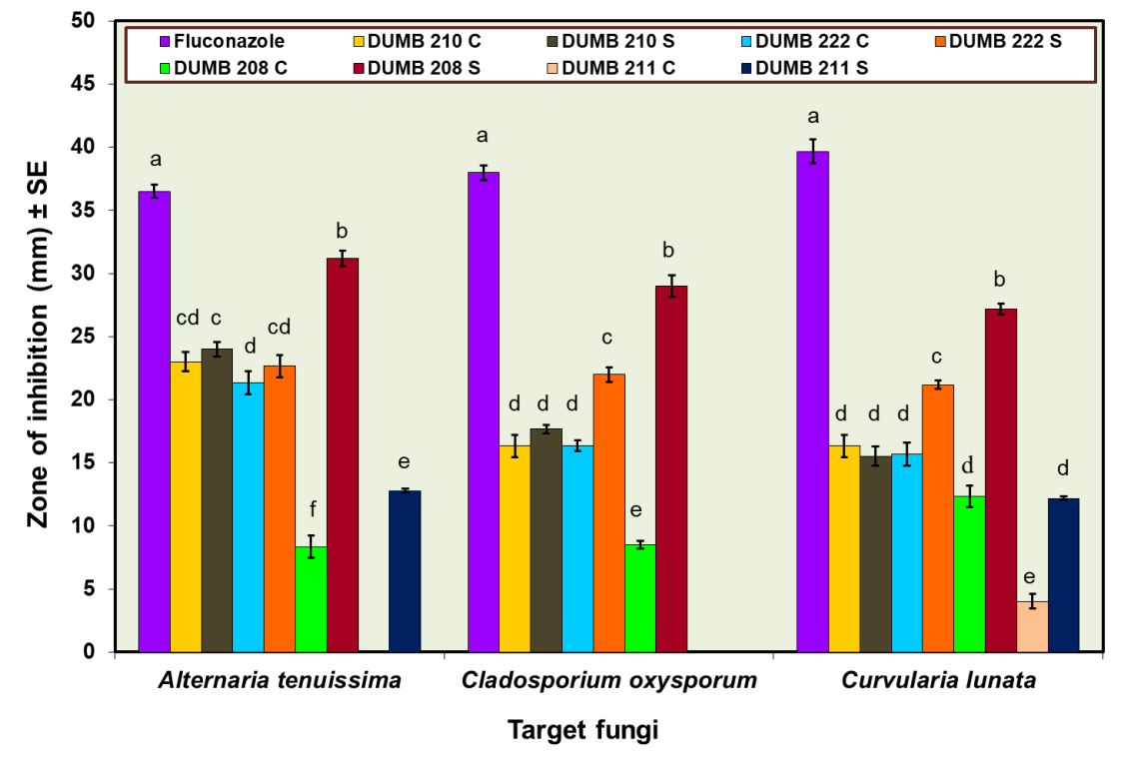

The graphical bars represent mean inhibition zone ± Standard Error of inhibition zone. Bars assigned with different letters are significantly different from each other with respect to each target fungus at p=0.05, based on Duncan Multiple Range Test.
Fig. 7. Antifungal activity of the endophytic fungal crude extracts in bioautography method.
- Cellular extract S- Secretory extract
DUMB 210: Aspergillus luchuensis DUMB 222: Aspergillus luchuensis
DUMB 208: Penicillium dierckxii DUMB 211: Penicillium restrictum

      - Thin-Layer Chromatography (TLC)-Bioautography method
The crude secretory extract from Penicillium dierckxii (DUMB 208) was further selected for TLC-Bioautography because of its good antifungal activity in bioautography method. Eight distinct fractions were separated from the crude extract with different R_{f} values when subjected to TLC (Fig. 8.A.). Only two fractions, Fraction three (F3) and Fraction eight (F8) with R_{f} values 0.46 and 0.97 respectively, displayed antifungal activity on all the target fungi tested. The prominent inhibition was exhibited by F3 (yellowish-brown) with inhibition zone of 25±0.86 mm against Alternaria tenuissima, 19±0.76 mm against Cladosporium oxysporum and 26±0.28 mm against Curvularia lunata. The F8 showed significantly lower inhibition, with less than 10 mm zone diameters, against all three fungi (Fig. 8). The antifungal nature exhibited by the fractions (F3 and F8) against all the tested fungi was significantly different according to DMRT.
The differential antifungal activities observed between F3 and F8 emphasize the utility of TLC-bioautography in identifying bioactive fractions within complex crude extracts. It is ideal method to detect endophytic fungal antifungal metabolites aiding subsequent isolation and characterization of bioactive compounds (Cheng and Wu 2013). Hence, among the other endophytic fungi of A. mexicana, the P. dierckxii was identified to be the potential producer of antifungal compounds secreted into the medium. This paves way for industrial applications. Many of such antifungal metabolites are secreted into the medium facilitating downstream processing. One such fungal metabolite is Griseofulvin, secondary metabolite produced by Penicillium griseofulvum. Griseofulvin is an antifungal antibiotic that is well studied and commercially available (Saykhedkar and Singhal, 2004).

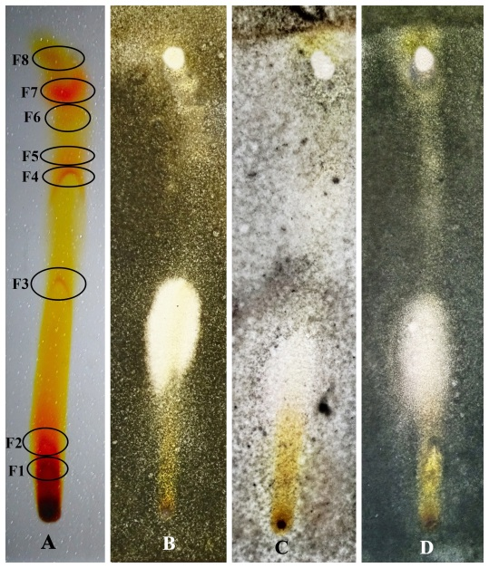

Fig. 8. TLC-Bioautogram of crude secretory extract of Penicillium dierckxii (DUMB 208).
- Thin-Layer chromatogram of crude secretory extract of Penicillium dierckxii (DUMB 208)
- Alternaria tenuissima C- Cladosporium oxysporum D- Curvularia lunata

- CONCLUSION
Endophytic fungal diversity in medicinal herb Argemone mexicana was assessed. Diverse species of fungal assemblages were found in stem tissues, indicated their differential colonization ability. The crude secretory extract of P. fellutanum demonstrated potential antimicrobial activities, suggesting it as a repository of bioactive compounds. It is crucial to investigate the medicinal values of endophytic fungi compared to the host plant.

Abbreviations: DUMB- Davangere University Microbial culture collection
CD%- Ccolonization density
RA%-Relative Abundance
CF%-Colonization Frequency

REFERENCES
- Ananda, K., & Sridhar, K. R. (2002). Diversity of endophytic fungi in the roots of mangrove species on the west coast of India. Canadian Journal of Microbiology, 48(10), 871-878. DOI: 10.1139/w02-080
- Arcos-Martinez, A. I., Munoz-Muniz, O. D., Dominguez-Ortiz, M. A., Saavedra-Velez, M. V., Vazquez-Hernandez, M., & Alcantara-Lopez, M. G. (2016). Anxiolytic-like effect of ethanolic extract of Argemone mexicana and its alkaloids in Wistar rats. Avicenna Journal of Phytomedicine, 6(4), 476-488. DOI: 10.22038/ajp.2016.6701
- Bais, Y., Chaudhari, S. B., Belani, S. & Umarkar, A. R. (2013). Evaluation of antimicrobial activity of plant leaf Argemone mexicana. International Journal of Pharmacy and Biological Sciences, 3(1), 41-45.
- Bensch, K., Braun, U., Groenewald, J. Z., & Crous, P. W. (2012). The genus Cladosporium. Studies in Mycology, 72, 1-401. DOI: 10.3114/sim0003
- Bhattacharjee, I., Chatterjee, S. K., Chatterjee, S. & Chandra, G. (2006). Antibacterial potentiality of Argemone mexicana solvent extracts against some pathogenic bacteria. Memórias do Instituto Oswaldo Cruz, 101(6), 645-648. DOI: 10.1590/S0074-02762006000600011
- Caruso, G., Abdelhamid, M. T., Kalisz, A., & Sekara, A. (2020). Linking endophytic fungi to medicinal plants therapeutic activity. A case study on Asteraceae. Agriculture, 10(7), 286-308. DOI: 10.3390/agriculture10070286
- Chatterjee, S., Ghosh, R. & Mandal, N. C. (2019). Production of bioactive compounds with bactericidal and antioxidant potential by endophytic fungus Alternaria alternata AE1 isolated from Azadirachta indica A. Juss. Plos One, 14(4), e0214744-e0214761. DOI: 10.1371/journal.pone.0214744
- Chen, X., Luo, X., Fan, M., Zeng, W., Yang, C., Wu, J., Zhao, C., Zhang, Y. & Zhao, P. (2019). Endophytic fungi from the branches of Camellia taliensis (WW Smith) Melchior, a widely distributed wild tea plant. World Journal of Microbiology and Biotechnology, 35(7), 113-127. DOI: 10.1007/s11274-019-2686-x
- Cheng, Z. & Wu, T. (2013). TLC bioautography: high throughput technique for screening of bioactive natural products. Combinatorial Chemistry & High Throughput Screening, 16(7), 531-549. DOI: 10.2174/1386207311316070004
- Choma, I. M., & Jesionek, W. (2015). TLC-direct bioautography as a high throughput method for detection of antimicrobials in plants. Chromatography, 2(2), 225-238. DOI: 10.3390/chromatography2020225
- Dai, T., Zhang, Y., Tang, Y., Bai, Y., Tao, Y., Huang, B. & Wen, D. (2016). Identifying the key taxonomic categories that characterize microbial community diversity using full-scale classification: a case study of microbial communities in the sediments of Hangzhou Bay. FEMS Microbiology Ecology, 92(10), 150-. DOI: 10.1093/femsec/fiw150
- Dhingra, O. D., & Sinclair, J. B. (2019). Basic plant pathology methods. (2nd ed.). CRC Press, Boca Raton.
- Domsch, K. H., Gams, W., & Anderson, T. (1993). Compendium of soil fungi. Academic Press, London.
- Elizondo-Luevano, J. H., Castro-Ríos, R., Sanchez-Garcia, E., Hernandez-Garcia, M. E., Vargas-Villarreal, J., Rodriguez-Luis, O. E., & Chavez-Montes, A. (2018). In Vitro Study of Antiamoebic Activity of methanol extracts of Argemone mexicana on Trophozoites of Entamoeba histolytica HM1‐IMSS. Canadian Journal of Infectious Diseases and Medical Microbiology, 2018(1), 7453787. DOI: 10.1155/2018/7453787
- Enyi, E. O., Chigozie, V. U., Okezie, U. M., Udeagbala, N. T., & Oko, A. O. (2025). A review of the pharmaceutical applications of endophytic fungal secondary metabolites. Natural Product Research, 39(11), 3295-3311. DOI: 10.1080/14786419.2024.2423036
- Fisher, P.J. & Petrini, O. (1987). Location of fungal endophytes in tissues of Suaeda fruticosa: a preliminary study. Transactions of the British Mycological Society, 89(2), 246-249. DOI: 10.1016/S0007-1536(87)80161-4
- Gopinath, P. P., Parsad, R., Joseph, B. & Adarsh V. S. (2021). grapesAgri1: collection of shiny apps for data analysis in agriculture. Journal of Open Source Software, 6(63), p.3437-3440. DOI: 10.21105/joss.03437
- Hudzicki, J. (2009). Kirby-Bauer disk diffusion susceptibility test protocol. American Society for Microbiology, 15(1), 1-23.
- Index Fungorum https://www.indexfungorum.org/names/names.asp
- Kumar, S., Aharwal, R. P., Kumar, S., & Sandhu, S. S. (2014). Isolation and detection of anti-bacterial activity of endophytic fungi from Bombex cebia and Argemone Mexicana. Journal of Chemical and Pharmaceutical Research, 6(11), 95-100.
- Leslie, J. F., & Summerell, B. A. (2006). The Fusarium laboratory manual. Black Well Publishing, USA.
- Li, L.F., Li, T. and Zhao, Z.W. (2007). Differences of arbuscular mycorrhizal fungal diversity and community between a cultivated land, an old field, and a never-cultivated field in a hot and arid ecosystem of southwest China. Mycorrhiza, 17(8), 655-665. DOI: 10.1007/s00572-007-0143-4
- Li, W.C., Zhou, J., Guo, S.Y., & Guo, L.D. (2007). Endophytic fungi associated with lichens in Baihua mountain of Beijing, China. Fungal Diversity, 25, 69-80.
- Li, X., Wu, Y., & Liu, Z. (2021). Antifungal activity of an endophytic fungus Aspergillus versicolor DYSJ3 from Aphanamixis grandifolia Blume against Colletotrichum musae. Mycobiology, 49(5), 498-506. DOI: 10.1080/12298093.2021.1976967
- Magaji, M. B., Haruna, Y., & Muhammad, A. (2019). Phytochemical screening and antioxidant activity of Argemone mexicana leaf methanol extract. Annals of Pharmacology and Pharmaceutics, 4(1), 1167-1172.
- McFarland Standard. 2002. Dalynn Biologicals. Catalogue No. TM50-TM60.
- More, N. V. and Kharat, A. S. (2016). Antifungal and anticancer potential of Argemone mexicana L. Medicines, 3(4), 28-37. DOI: 10.3390/medicines3040028
- More, N. V., Kharat, K. R. & Kharat, A. S. (2017). Berberine from Argemone mexicana L. exhibits broad spectrum antibacterial activity. Acta Biochimica Polonica, 64(4), 653-660. DOI: 10.18388/abp.2017_1621
- Narendrababu, B. N., & Shishupala, S. (2023). Bioprospecting of Talaromyces ruber pigments for antimicrobials. Biomedicine, 43(3), 963-971. DOI: 10.51248/.v43i3.2667
- Nath, A., & Joshi, S. R. (2014). Ultrastructural effect on mastitis pathogens by extract of endophytic fungi associated with ethnoveterinary plant, Hibiscus sabdariffa L. Journal of Microscopy and Ultrastructure, 3(1), 38-43. DOI: 10.1016/j.jmau.2014.10.001
- Nath, A., Raghunatha, P., & Joshi, S. R. (2012). Diversity and biological activities of endophytic fungi of Emblica officinalis, an ethnomedicinal plant of India. Mycobiology, 40(1), 8-13. DOI: 10.5941/MYCO.2012.40.1.008
- Osherov, N. & May, G. S. (2001). The molecular mechanisms of conidial germination. FEMS Microbiology Letters, 199(2), 153-160.
- Patocka, J., Ovando-Martinez, M., Navratilova, Z., Oleksak, P., Ogwu, M. C., Nepovimova, E., & Kuca, K. (2024). Argemone mexicana L. (Papaveraceae): chemistry, pharmacology, and toxicology. Phytochemistry Reviews, 23(4), 1167-1182. DOI: 10.1007/s11101-024-09918-y
- Raper, K. B., & Thom, C. (1949). A manual of the Penicillia. Williams & Wilkins Company, USA.
- Rehman, B., Khan, S. A., Hamayun, M., Iqbal, A., & Lee, I. J. (2022). Potent bioactivity of endophytic fungi isolated from Moringa oleifera leaves. BioMed Research International, 2022(1), 2461021-2461030. DOI: 10.1155/2022/2461021
- Rodriguez, R. J., White Jr, J. F., Arnold, A. E., & Redman, A. R. A. (2009). Fungal endophytes: diversity and functional roles. New Phytologist, 182(2), 314-330. DOI: 10.1111/j.1469-8137.2009.02773.x
- Santos, I. P. D., Silva, L. C. N. D., Silva, M. V. D., Araújo, J. M. D., Cavalcanti, M. D. S. & Lima, V. L. D. M. (2015). Antibacterial activity of endophytic fungi from leaves of Indigofera suffruticosa Miller (Fabaceae). Frontiers in Microbiology, 6, 350-356. DOI: 10.3389/fmicb.2015.00350
- Santra, H. K., Maity, S., & Banerjee, D. (2022). Production of bioactive compounds with broad spectrum bactericidal action, bio-film inhibition and antilarval potential by the secondary metabolites of the endophytic fungus Cochliobolus sp. APS1 isolated from the Indian medicinal herb Andrographis paniculata. Molecules, 27(5), 1459. DOI: 10.3390/molecules27051459
- Sarkar, S., Dey, A., Kumar, V., Batiha, G. E. S., El-Esawi, M. A., Tomczyk, M., & Ray, P. (2021). Fungal endophyte: an interactive endosymbiont with the capability of modulating host physiology in myriad ways. Frontiers in Plant Science, 12, 701800-701818. DOI: 10.3389/fpls.2021.701800
- Saykhedkar, S.S. and Singhal, R.S., 2004. Solid‐state fermentation for production of griseofulvin on rice bran using Penicillium griseofulvum. Biotechnology Progress, 20(4), 1280-1284. DOI: 10.1021/bp0343662
- Schulz, B., Guske, S., Dammann, U., & Boyle, C. (1998). Endophyte-host interactions. II. Defining symbiosis of the endophyte-host interaction. In Presented at the Second International Congress of Symbiosis, 25, 213- 227.
- Schulz, B., Wanke, U., Draeger, S., & Aust, H. J. (1993). Endophytes from herbaceous plants: effectiveness of surface sterilization methods. Mycological Research, 97(12), 1447-1450.
- Shawky, B. T., Nagah, M., Ghareeb, M. A., El-Sherbiny, G. M., Moghannem, S. A. & Abdel-Aziz, M. S. (2019). Evaluation of antioxidants, total phenolics and antimicrobial activities of ethyl acetate extracts from fungi grown on rice straw. Journal of Renewable Materials, 7(7), 662-677. DOI: 10.32604/jrm.2019.04524
- Sheshrao, D. U., Devidas, K. T., & Gyananath, G. (2012). Preliminary screening of endophytic fungi from Tridax procumbens Linn. and Argemone mexicana Linn. for their antimicrobial activity. International Journal of Current Research, 4(2), 93-96.
- Simpson, E. (1949). Measurement of Diversity. Nature 163, 688. DOI: 10.1038/163688a0
- Singh, P., Sharma, A., Bordoloi, M., & Nandi, S. P. (2020). Molecular identification of endophytic fungi isolated from medicinal plant. Biointerface Research in Applied Chemistry, 10(5), 6436-6443. DOI: 10.33263/BRIAC105.64366443
- Singh, P., Sharma, A., Bordoloi, M., & Nandi, S. P. (2023). Antimicrobial, antioxidant, GC-MS analysis and molecular docking analysis of bioactive compounds of endophyte Aspergillus flavus from Argemone mexicana. Journal of Microbiology, Biotechnology and Food sciences, 13(1), e9970-e9970. DOI: 10.55251/jmbfs.9970
- Sivanesan, A. (1987). Graminicolous species of Bipolaris, Curvularia, Drechslera, Exserohilum and their teleomorphs. C.A.B. International. UK.
- Stajich, J. E., Berbee, M. L., Blackwell, M., Hibbett, D. S., James, T. Y., Spatafora, J. W., & Taylor, J. W. (2009). The fungi. Current Biology, 19(18), R840-R845. DOI: 10.1016/j.cub.2009.07.004
- Stierle, A., Strobel, G. & Stierle, D. (1993). Taxol and taxane production by Taxomyces andreanae, an endophytic fungus of Pacific yew. Science, 260(5105), 214-216. DOI: 10.1126/science.8097061
- Sun, Y., Wang, Q., Lu, X.D., Okane, I. & Kakishima, M. (2011). Endophytic fungi associated with two Suaeda species growing in alkaline soil in China. Mycosphere, 2(3), 239-248.
- Suryanarayanan, T. S., & Kumaresan, V. (2000). Endophytic fungi of some halophytes from an estuarine mangrove forest. Mycological Research, 104(12), 1465-1467.
- Suryanarayanan, T. S., Kumaresan, V., & Johnson, J. A. (1998). Foliar fungal endophytes from two species of the mangrove Rhizophora. Canadian Journal of Microbiology, 44(10), 1003-1006.
- Suryanarayanan, T.S. & Vijaykrishna, D., 2001. Fungal endophytes of aerial roots of Ficus benghalensis. Fungal Diversity, 8, 155-161.
- Suryanarayanan, T.S., Venkatesan, G. & Murali, T. (2003). Endophytic fungal communities in leaves of tropical forest trees: diversity and distribution patterns. Current Science, 85(4), 489-493.
- Thom, C., & Raper, K. B. (1945). A Manual of the Aspergilli. Williams & Wilkins Company, USA.
- Tuppad, D. S., & Shishupala, S. (2013). Endophytic mycobiota of medicinal plant Butea monosperma. International Journal of Current Microbiology and Applied Sciences, 2(12), 615-627.
- Vidal, A., Parada, R., Mendoza, L., & Cotoras, M. (2020). Endophytic fungi isolated from plants growing in central andean precordillera of chile with antifungal activity against Botrytis cinerea. Journal of Fungi, 6(3), 149- 162. DOI: 10.3390/jof6030149

