VARIABILITY OF SURFACE AIR TEMPERATURE AND RELATIVE HUMIDITY AT A TROPICAL SITE IN OSOGBO, NIGERIA

ABSTRACT
The warmness experienced at the lowest strata of the earth’s atmosphere is largely caused by the increase in air temperature and relative humidity due to the greenhouse gases (GHGs). Consequently, this has significant impact on health conditions and detrimental to human fitness. However, changes in response to the climatic forcing within the boundary layer has substantial impacts on temporal trends of the atmospheric parameters. Therefore, this study utilized eight weeks (8) PurpleAir data (May 1 to June, 30, 2022) acquired from African Centre for Space Science and Technology Education (UN-ARCSSTE-E), NASRDA situated at the Osun State University, Campus, Osogbo, Osun-State to study the variation of surface air temperature, relative humidity and the nexus in the variability. The data collected were sampled at 2 s interval and the dataset were reduced to 30 minutes average for each day and the statistical analyses were carried out using Micro Cal Origin software and Open-Air project for R-statistics. The results showed that at night, the air temperature had similar relationship with relative humidity, it was still lower than the optimum temperature zone, say, (24-30°C). Additionally, two relative humidity peaks were observed in the early morning and at night, aligning with two low points (troughs) in surface temperature. These low temperatures were primarily due to nighttime cooling and loss of heat through long wave radiation. The relative humidity peaks observed in the early morning were attributed to intensified convective activities. Also, the atmosphere were noticed to be more stable at night with reduced turbulence. This stability impedes vertical mixing, allowing moisture to accumulate near the surface, thereby contributing to the higher relative humidity observed during nighttime hours. Correlation analysis between temperature and relative humidity showed that from week 1 to week 8, surface air temperature had a cumulative decrease of 1.32ºC while relative humidity had cumulative increase of 4.25% at Osogbo. On the average, 3.21% increase in relative humidity had a correlation of 1ºC decrease in surface air temperature at Osogbo.

1.0 INTRODUCTION
The continued buildup of greenhouse gases may force any number of changes to the climate system including the highly-popularized prediction for an increase in mean global temperatures [2]. However, changes in temperature variability are also important in determining the future temperature distributions. While the newer numerical models of climate predict less warming with realistic greenhouse changes than do earlier versions, predictions of temperature variability remain inconsistent [12]. The increase in the major greenhouse gases such as carbon dioxide, CFCs and so on has led to an increase in surface layer air temperature and relative humidity [5].
The fluctuation in climate influenced by meteorological variables has led into investigating changes in mean values of some important parameters such as temperature and relative humidity, both for short and long-terms [4]. Previous researches over the years have shown that there is climate change, unlike climate variability which is year-to-year deviation from the mean value. The variability in turn affects the society, bio ecosystem and agricultural yields [8]. Meteorological variables such as surface air temperature and relative humidity contribute immensely to global warming thereby resulting in fluctuations in weather patterns [33]. In addition, anthropogenic activities such as burning of fossil fuels, factory operations and deforestation resulted in the rapid increase in greenhouse gases which is responsible for the global warming [25].
The relative humidity constitutes the global atmospheric energy budget cycle due to wind transport which moves water around the earth atmosphere resulting in cloud and precipitation formation [18, 16]. However, water vapor increases due to the greenhouse gas (GHG) and has resulted in the reduction in the escape of longwave radiation and contributed to further warming [20, 28]. Previous researcher reported that an average of 0.7–0.8ºC increase in surface temperature were observed over the western Africa region [26, 11]. Also, the mean global surface temperature has increased approximately by 0.3-0.6°C in the last decade prior to the last one [21, 17]. This is the largest increase recorded in surface temperatures in the last 1,000 years and scientists predict an even greater increase over this century [29, 27]. This increase in surface layer air temperature also enhances rapidly and significantly contributes to global warming [19, 24]. Water vapor and relative humidity based on research, have the greatest positive feedback on global warming. Based on the projections by climate models, there is drastic vapor during the 21st century [22, 31].
In Nigeria, [9] reported that the changes in surface layer air temperature and relative humidity are observed that Kano which is under tropical Savannah climate is very hot while Port-Harcourt which is closer to the coast experienced flooding due to rise in sea level and erosion. Simmons, [30], also observed a decreasing trend in relative humidity (RH) over some regions in Europe. He attributed the decreasing trend in relative humidity and surface-air temperature to a lack of moisture from the oceanic region. Relative Humidity, on the other hand, shows significant positive trend across the U.S [32, 7]. Relative humidity increased by 0.5 to 2% per decade on a global scale, which was attributed to increases in surface-air temperature, low-level clouds, and specific humidity [34].
In characterization of land surface air temperature anomaly over Nigeria conducted by [1], seventeen gridded stations across the latitude over Nigeria were selected to determine and characterize land surface air temperature (LSAT) anomaly for both minimum and maximum values within a period 2008 – 2013. Long-term averages of minimum and maximum land surface air temperatures were obtained from National Aeronautics and Space Administration satellite meteorological dataset (1983 – 2007). The results showed that Jos had consistently experienced -10.8 and -4 percent decrease in minimum and maximum LSAT anomaly for the period under review. The implication is that Jos was getting colder than usual. The minimum LSAT anomaly declined by -2.8 percent in Lagos. Other stations across Nigeria showed a considerable percentage increase in minimum LSAT anomaly led by Yola (19.5%), Sokoto (18%) and Katsina (15.5%). Inland stations had percentage increase of minimum LSAT anomaly ranging between 5.8% and 10% except in Osogbo where the percentage increase was 1.8%. Osogbo is a less populated capital city of Osun state with active agricultural activities as heat sink. Percentage increase of minimum LSAT anomaly was not significant in Nigerian coastal areas most especially at Port Harcourt (0.5%). The spatial distribution of maximum LSAT anomaly across Nigerian latitudinal belt, unlike minimum LSAT anomaly, reduced in trend except in Lagos, Makurdi, Abuja, Bida, Minna and Kano. The minimum and maximum anomaly for maximum LSAT was observed at Jos and Makurdi respectively. There are 2 stations to be watched in terms of getting colder in the years ahead namely Jos and Osogbo while Makurdi and Yola were gradually becoming hotspots.
Previous studies showed the surface-air temperature and relative humidity vary with space and time, and is affected by topological factors [6]. More importantly, radiative conditions and the local energy balance regime influence the magnitude distribution of Surface-Air temperature [23]. On the other hand, the magnitude of local surface energy budget balance is determined by the instability of atmospheric conditions as well as Earth surface characteristics [15]. Surface layer air temperature decreases as the topographic elevation increases. But despite the series of researches conducted in Nigeria on the variability of air temperature and relative humidity, the study conducted by [1] pointed out that Osogbo is a station to watch out for, hence, there is need to carry out more intensive study of meteorological variation beyond annual mean values. Thus, this study investigates the variation in the surface air temperature and relative humidity at Osogbo to provide more detailed information on the interactions between temperature and relative humidity.

2.0 MATERIALS AND METHODS
2.1 Description of the Study Area
The study location is situated at UN-ARCSSTE-E laboratory in Osun State University, Osogbo Campus supervised by NASRDA. Osogbo is the capital territory of Osun State in the southwestern geopolitical zone of Nigeria. The study area is in a tropical climate with two prevailing seasons (Wet and Dry). The wet season is characterized by warm, oppressive and overcast spanning from April to October while the dry season is usually hot, muggy and partly cloudy which is from November to March. The average annual rainfall amount of the study area is 1361 millimeters (about 53.6 inches) with the relative humidity ranges from 46-88 % annually. Also, the annual mean temperature is about $25.5 ℃$ and the wind flow is relatively weak (about 3.0 m/s or less) at the surface. Figure 1 depicts the geographical map of the study location in Osogbo.

2.2 Sampling and Analysis of Meteorological Parameters
In this study, eight weeks (8) Purple Air data (May 1 to June, 30, 2022) were collected from UN-ARCSSTE-E laboratory at Osun State University, Osogbo campus. PurpleAir sensors generate high resolution of laser particle counters for real-time observation and measurement of particulate matter particularly PM1, PM2.5 and PM10 as well as other meteorological parameters. This was aided by CAR’s collaboration with Pennsylvania State University The data collected were sampled at 2 s interval and the dataset were reduced to 30 minutes average for each day. The 30 minutes average dataset were used in this study for data analysis on weekly basis and plotting of the time series of the meteorological parameters. Also, the statistical analyses were performed using Micro Cal Origin software and Open-Air project for R-statistics [10, 14, 3]. Diurnal variation and weekly statistics of surface temperature and relative humidity were obtained. Correlation between surface temperature and relative humidity was also analyzed.

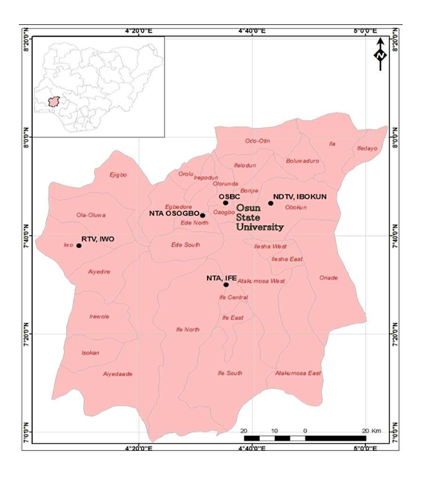
Figure 1: The Geographical Map of the Study Location in Osogbo.

3.0 RESULTS AND DISCUSSIONS: Variations of Air Temperature and Relative Humidity
Figure 2 depicts the diurnal variation of surface air temperature and relative humidity for week 1 to 4. It was observed that the air temperature increased at 7:00 hours during the daytime in response to solar heating activities, it reached the peak at 15:00 hours and decreased immediately after the sunset to reach the minimum in the night time. During the observation period, week 1 presented nearly uniform temperatures between 0:00 and 06:00 hours and later increased to a maximum temperature of 35.91⁰C at 16:00 hours and attained minimum temperature value of 27.01ºC at 6:00 hours. The diurnal estimated range was 8.9ºC with a mean value of 30.2ºC. Relative humidity had opposite trend compared to the air temperature variations with a minimum value of 43.16% at 16:00 hours while the highest value was 68.71% at 6:00 hours with a range value of 25.55%.
For week 2, It was noticed that the air temperature at the early hours had similar variations with what was observed in week 1 and later increased to reach its maximum value of 38.86^{O}C with a range value of 2.96^{O}C (Table 1). Also, an apparent decline in air temperature was observed around 18:00 hours to attain its minimum value of 27.93^{O}C. A temperature difference of 2.1^{O}C was observed between week 1 and week 2 temperature mean value which is an indication that there was more increase in solar heating in week 2. The relative humidity had minimum value of 36.82% at 16:00 hours while the maximum value of 65.76% at :00 hours was recorded. Week 3 Recorded a minimum temperature of 26.98⁰C at 6:00 hours while the highest temperature of 37.8⁰C at 16:00 hours was noticed with a range value of 10.82⁰C. The minimum relative humidity was 38.06% at 16:00 hours while the highest relative humidity was 66.96% at 6:00 hours with a mean value of 56.98%.
Week 4 had the lowest temperature of 26.09⁰C and the highest temperature was 36.71⁰C, the temperature range difference was 10.62⁰C while the minimum relative humidity of 39.18% and maximum relative humidity value of 68.44% was recorded with a mean value of 57.71%. Fig. 3 presented the diurnal variation of air temperature and relative humidity. It is observed in week 5 that the air temperature increases around 6:00 hours to reach its peak at 15:30 hours. As observed during the study period, week 5 temperature ranged from 26.9-38.6⁰C with a mean value of 31.20⁰C (Table 1). The lowest relative humidity value was 36.37% while the highest value was 69.11%. In week 6, the air temperature was noticed to be minimum around 6:00 hours and increase significantly to attain its peak (35.78%) around 15:30 hours and sharply dropped in values around 16:00 hours till the evening time. Relative humidity minimum value was 43.33% while its maximum value was found to be 67.63%. Week 7 had the minimum temperature value of 26.25⁰C while its maximum value was 34.82⁰C with a temperature range of 8.57⁰C. The minimum relative humidity was 44.33% while the maximum relative humidity was 69.14%. Week 7 was observed to be the most humid during the observation period. In week 8, Minimum temperature value was found to be 25.90⁰C while the maximum temperature value was noticed to be 33.84⁰C with range value of 7.94⁰C. The minimum relative humidity was 46.23%, while the maximum relative humidity was 69.44% with the range and mean values of 23.21 and 60.34% respectively.
It was generally observed in Figure 2 and 3 that relative humidity tends to lag behind the peak in surface air temperature during the periods of deep convection, which were most noticeable in the late afternoon and evening. This suggests that as surface air temperature rises, the air above the surface could hold more water vapor resulting in a noticeable drop in relative humidity and leading to relatively stable moisture content throughout the day. Additionally, two relative humidity peaks were observed in the early morning and at night, aligning with two low points (troughs) in surface temperature. These low temperatures were primarily due to nighttime cooling and loss of heat through long wave radiation. Moreover, relative humidity was observed to reach its lowest levels in Figure 2 and 3 during the afternoon, coinciding with the highest surface air temperatures. This inverse relationship occurred because relative humidity largely depends on how much moisture the surface air can hold, as such warmer air can hold more moisture than cooler air. As a result, relative humidity tends to drop during the day and higher during the night or cooler periods. The relative humidity peaks observed in the early morning were attributed to intensified convective activities and the results is in agreement with the findings of Moradi et al., (2016). More so, the atmosphere tends to be more stable at night with reduced turbulence. This stability impedes vertical mixing, allowing moisture to accumulate near the surface, thereby contributing to the higher relative humidity observed during nighttime hours.
The correlation plots presented in Figure 4 and 5 showed that the surface air temperature had a strong negative correlation with relative humidity. From week 1 to week 2, 2.10ºC increase in surface air temperature had 5.57% decrease in relative humidity; from week 2 to week 3, 1.49ºC decrease in surface air temperature had 3.26% increase in relative humidity; from week 3 to week 4, 0.84ºC decrease in surface air temperature had 0.73% increase in relative humidity; from week 4 to week 5, 1.23ºC increase in surface air temperature had 1.32% decrease in relative humidity; from week 5 to week 6, 1.13ºC decrease in surface air temperature had 2.28% increase in relative humidity; from week 6 to week 7, 0.99ºC decrease in surface air temperature had 2.27% increase in relative humidity; from week 7 to week 8, 0.20ºC decrease in surface air temperature had 0.60% decrease in relative humidity.

Table 1: Summary of the Statistical Analysis of Air temperature (T) and Relative Humidity (rh) at the Study Area.
Weeks | Parameters | Min. | SD | Max. | Range | Mean
Week 1 | T | 27.01 | 3.04 | 35.91 | 8.90 | 30.20
Week 1 | r h | 43.16 | 9.08 | 68.71 | 25.55 | 59.29
Week 2 | T | 27.93 | 3.84 | 38.86 | 10.93 | 32.30
Week 2 | r h | 36.82 | 10.38 | 65.76 | 28.94 | 53.72
Week 3 | T | 26.98 | 3.65 | 37.80 | 10.82 | 30.81
Week 3 | r h | 38.06 | 10.41 | 66.96 | 28.90 | 56.98
Week 4 | T | 26.09 | 3.62 | 36.71 | 10.62 | 29.97
Week 4 | r h | 39.18 | 10.09 | 68.44 | 29.26 | 57.71
Week 5 | T | 26.98 | 4.20 | 38.58 | 11.59 | 31.20
Week 5 | r h | 36.37 | 12.03 | 69.11 | 32.74 | 56.39
Week 6 | T | 26.99 | 3.01 | 35.78 | 8.79 | 30.07
Week 6 | r h | 43.33 | 9.08 | 67.63 | 24.30 | 58.67
Week 7 | T | 26.25 | 3.14 | 34.82 | 8.57 | 29.08
Week 7 | r h | 44.33 | 9.29 | 69.14 | 24.81 | 60.94
Week 8 | T | 25.90 | 2.83 | 33.84 | 7.94 | 28.88
Week 8 | r h | 46.23 | 8.67 | 69.44 | 23.21 | 60.34

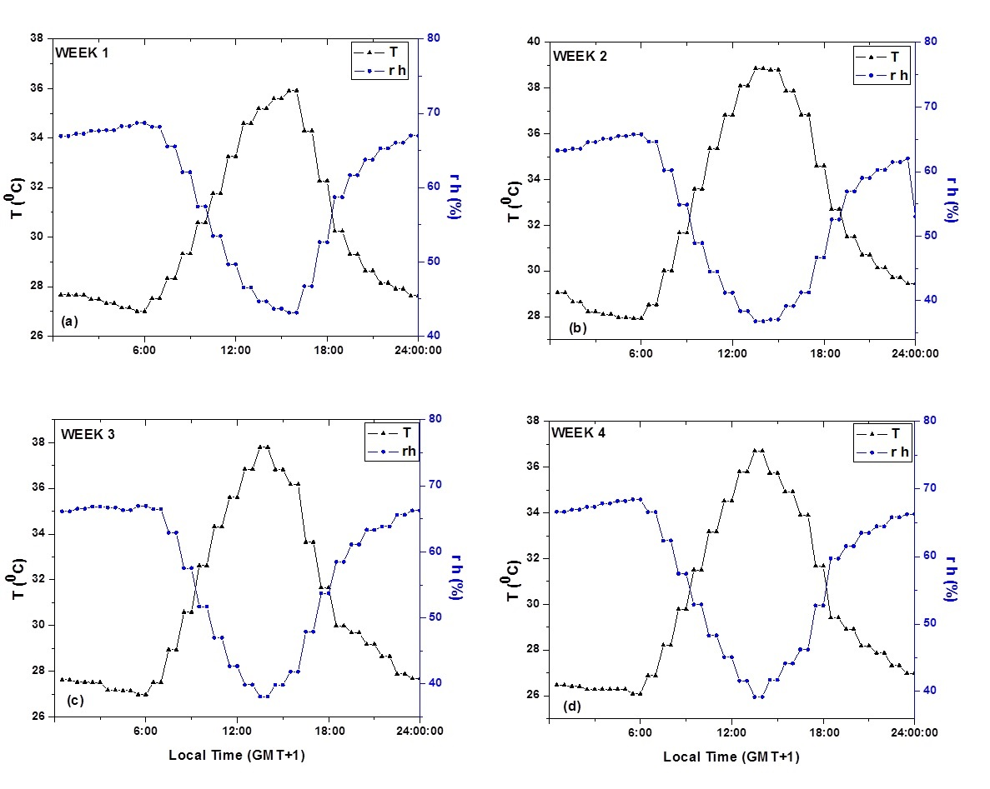
Figure 2: Diurnal Variations of the Air Temperature and Relative Humidity between Week 1 and Week 4 at the Study Site
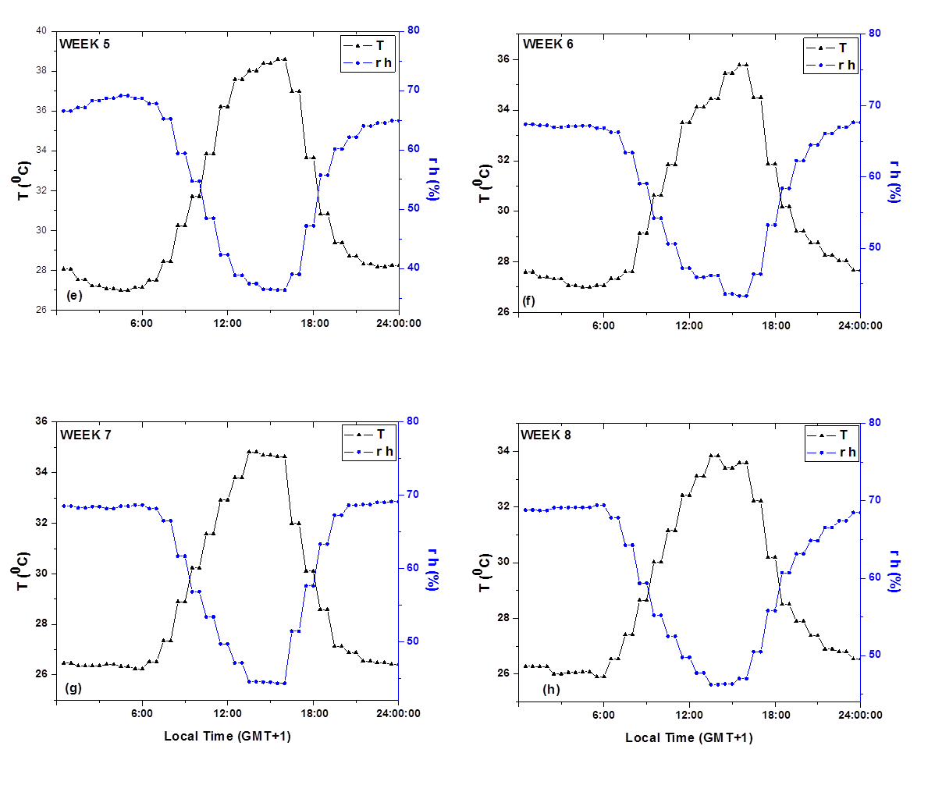
Figure 3: Diurnal Variations of the Air Temperature and Relative Humidity between Week 1 and Week 4 at the Study Site
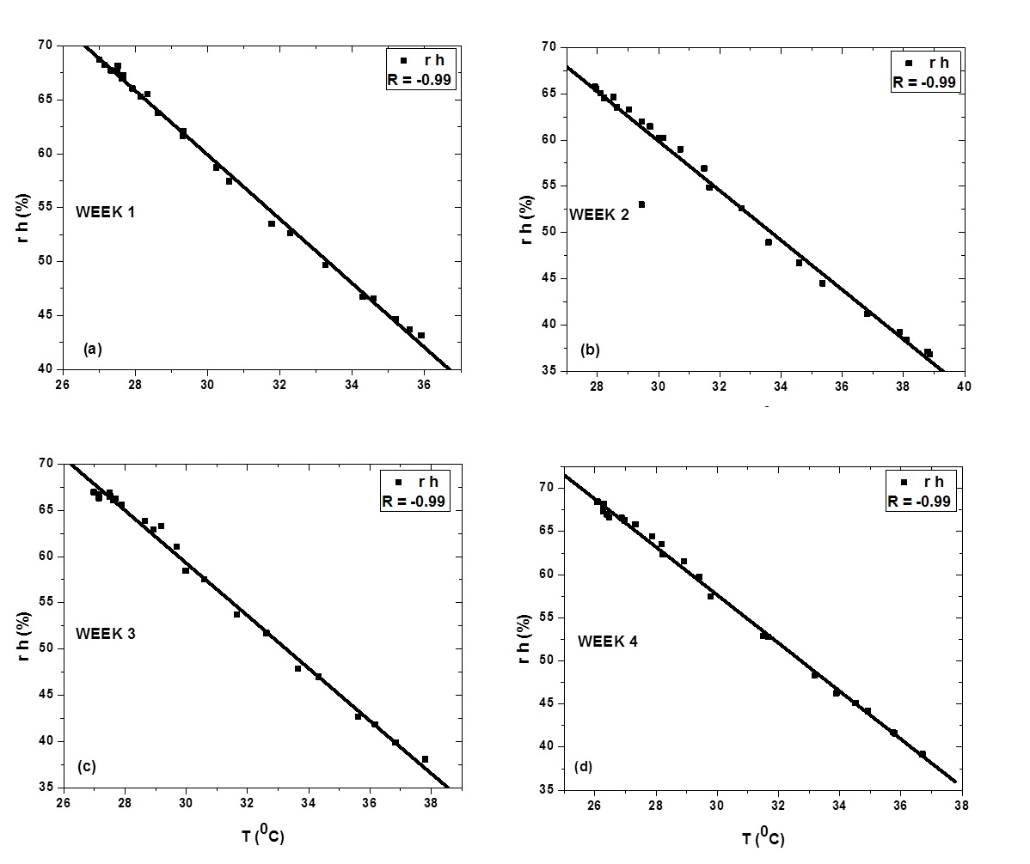
Figure 4: Correlation between Air Temperature and Relative Humidity for Week 1 to 4 at the Study Area
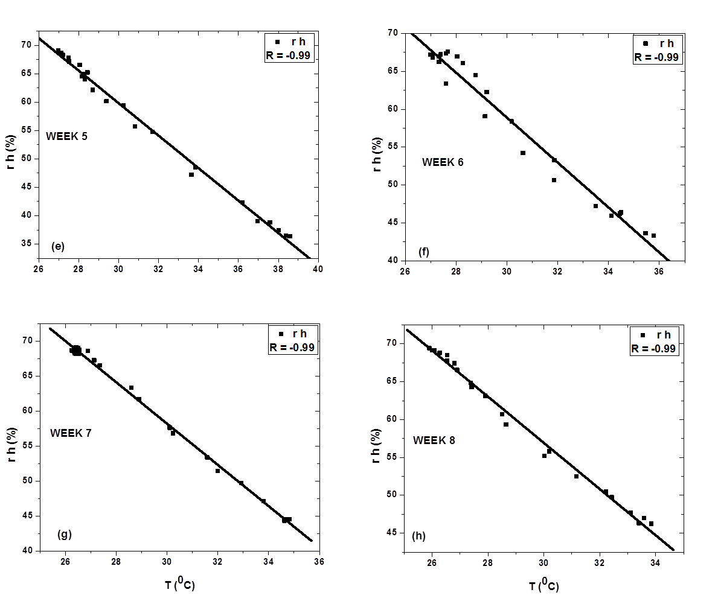
Figure 5: Correlation between Air Temperature and Relative Humidity for Week 5 to 8 at the Study Area.

4.0 CONCLUSION
Surface air temperature has a great influence on relative humidity. As a consequence, the effect is significant and greatly impact on human health and detrimental human fitness. However, changes in response to the climatic forcing within the atmospheric surface layer, the atmospheric parameters is greatly affected. This study employed eight weeks (8) Purple Air data (May 1 to June, 30, 2022) acquired from UN-ARCSSTE-E, NASRDA meteorological station situated at the premises of Osun State University, Osogbo Campus, Osun-State. The results showed that at the air temperature was in accordance with existing correlation with relative humidity, the temperature was lower than the optimum temperature zone, (24-30°C). During the period of observations, surface air temperature decreased while relative humidity increased cumulatively. Temporal analysis of the temperature pattern distribution showed that relative humidity pattern decreases more rapidly leading to the heat-surge scenarios. This was followed by a slower return to normal condition afterward. Correlation analysis between temperature and relative humidity showed that from week 1 to week 8, surface air temperature had a cumulative decrease of 1.32ºC while relative humidity had cumulative increase of 4.25% at Osogbo. On the average, 3.21% increase in relative humidity had a correlation of 1ºC decrease in surface air temperature at Osogbo.

5.0 REFERENCES
- Ajileye, O. O, Aladodo, S. S. and Rabiu, A. B. (2019). Spatio–Temporal Characterization of Land Surface Air Temperature Anomaly over Nigeria. Physical Science International Journal 21(3): 1-9, 2019; Article no. PSIJ.47878 ISSN: 2348-0130
- Akpabio. L.E, Etuk. S.E, (2012). Relationship between solar radiation and sunshine duration for Onne Nigeria, Turkish Journal of. Physics, Vol 27: pp 161-167.
- Anderson, D, Swanton, C, Hall, J. and Mersey, B. (2006). The influence of temperature and relative humidity on the efficacy of glufosinate‐ammonium. Journal of Weed Research. Vol 33. pp 139 - 147. 10.1111/j.1365-3180. 1993.tb01927.
- Ayegba, L. (2017). Impact of Climate Change on Epileptic Patients with Sex Stratifications: Variability of Temperature and Relative Humidity Effects, International Journal of Trend in Research and Development. Vol 4 (2). pp 786-791.
- Bakri, M. (2013). Using Ventilated Envelopes to Improve the Performance of Buildings in Hot Humid Climate, Journal of Geophysical Research. Vol 13(4): pp 40-51.
- Bolstad, P, Swift, L, Collins, F, and Régnière, J. (2018). Measured and Predicted Air Temperatures at basin to Regional Scales in the Southern Appalachian Mountains. Journal of Meteorology 91, 161–176. doi:10.1016/s0168-1923(98)00076-8.
- Brown et al, (2013). Physics of the Atmosphere and Climate.Cambridge University Press, pp. 127-146.
- Capparelli V, et al. (2013). A spatiotemporal analysis of U.S. station temperature trends over the last century. Journal of Geophysical Research. Vol 118: pp 1-8.
- Chiadikobi, K.C, et al. (2011). Flood Risk Assessment of Port Harcourt, River State, Nigeria. Advances in Applied Sciences Research., Vol 2(6): pp 287-298.
- Chow. W, (2013), Assessment of measured and perceived microclimates within a tropical urban forest, Journal of Atmospheric Research. Vol 16: pp 62–75.
- Etta, A.H. (2017). Extended Reconstructed Sea Surface Temperature Version 4 (ERSST.v4), Journal of Climatology. Vol 28: pp 911-930.
- Falayi. E.O, Rabiu. A.B, (2016). Modeling global solar radiation using sunshine duration data. Nigerian Journal of Physics. Vol 17: pp 181-186.
- Hargreaves. G.H, (2018). Defining and using reference evapotranspiration. Journal of Irrigational Drain Engineering. Vol 120(6): pp 1132–1139.
- Högström, R., Salminen, J., and Heinonen, M. (2016). Calibration of hygrometers at non-static conditions. Journal of Measurement Science and Technology, Vol 31(3), pp 34-40.
- Jin, et al. (2017). Regional variation trend of humidity in China in recent 50 years in the context of global climate change. Research on Soil Water Conservation Vol 20: pp 141−143.
- Khan. S, (2016). Temperature, Precipitation and Relative Humidity Fluctuation of Makkah Al Mukarramah, Kingdom of Saudi Arabia (1985-2016), TECS, vol. 6 (1), pp 42.
- Lau. M, (2019). Urban expansion and drying climate in an urban agglomeration of East China. Geophysical Research, Vol 46: pp 6868−6877.
- Li et al, (2020) Homogenized daily relative humidity series in China during 1960−2017, Journal of Advanced Atmospherical Sciences, Vol 37: pp 318−327.
- Liu Y.Y, and Zhang. L. J. (2016). Climate change characteristics of free atmospheric humidity and its relationship with temperature and precipitation in Northeast China, Journal of Atmospheric Environment. Vol 36: pp 628−636,
- Lu. A.G, (2013). Influence of global warming on the change of regional relative humidity in China, Journal of Atmospheric Environment. Vol 22: pp 1378−1380.
- Maleki, K., Hosseini, S.M. and Nasiri, P. (2010) The Effect of Pure and Mixed Plantations of Robinia pseudo acacia and Pinus El Darica on Traffic Noise Decrease. International Journal of Environmental Science, Vol 1: pp 213-224.
- Isaac Moradi, Philip Arkin, Ralph Ferraro, Patrick Eriksson, and Eric Fetzer, (2016). Diurnal variation of tropospheric relative humidity in tropical region. Atmos. Chem. Phys., 16, 6913–6929. doi:10.5194/acp-16-6913-2016
- Marshall et al. (2017). Climatic change in northern Ethiopia during the past 17,000 years: a diatom and stable isotope record from Lake Asheng, Journal of Atmospheric Chemistry. Vol 34 (10); pp 367-388.
- Mutiibwa, D, Strachan, S and Albright, T. (2015). Land Surface Temperature and Surface Air Temperature in Complex Terrain. IEEE Journal of Selected Topics in Applied Earth Observations and Remote Sensing. Vol 8. pp 1-13 10.1109/JSTARS.2015.2468594
- Neftel A, Moor E, Oeschger H, and Stauffer B (2015). Evidence from polar ice cores for the increase in atmospheric CO2 in the past two centuries. Nature, Journal of Atmospheric Research. Vol 315 (20): pp 45–47.
- Nicholas, J. (2013). Estimating mean monthly incident solar radiation on horizontal and inclined slopes from mean monthly temperature extremes. International journal of biometeorology. Vol 44. pp 04-11. 10.1007/s004840000073.
- Ojo, O. (2014): Climate of West Africa. Heinemann, London. pp 219.
- Okonkwo W. I. and Echiegu E. A. (2011). Evaporative Cooling: A Postharvest Technology for Fruits and Vegetables Preservation. International Journal of Scientific and Engineering Research, Vol. 4(8), pp 2257–2266.
- Olusola. R., (2014). Aspects of the variation in some characteristics ofradiation budget within the urban canopy of Ibadan. Journal of Atmospheric Environment. Vol 24 (1), pp 9–17.
- Simmons et al. (2019). Low-frequency variations in surface atmospheric humidity, temperature, and precipitation: inferences from reanalyzes and monthly grided observational data sets. Journal of Geophysical Research. Vol 115: pp 24-42
- Udoakah, A, (2015). Global Warming and Air Temperature Anomalies in the Niger Delta Region of Nigeria, International Journal of Science and Research (IJSR), Vol 15(9): pp 1352-1355.
- Uko, D, Otugo, N, Sigalo, F, and Udonam, J. (2016). Investigating of the Effect of weather Condition on Solar Energy in River State University Port Harcourt, Nigeria, Journal of Atmospherics Physics. Vol 2(1), pp 2414-2484.
- World Meteorological Organization, (2015), Earth System and Environmental Sciences.
- Zhang. L. J, et al (2020). Effects of urban land expansion on decreasing atmospheric moisture in Guangdong, South China. Journal of Urban Climatology Vol 32: pp 100-117.

