Modelling Cropping Intensity of Kerala Using ARIMA with Exogenous Predictors

ABSTRACT
In order to comprehend long-term patterns and the impact of climatic variables, this study used linear time-series modeling approaches to analyze Kerala's cropping intensity over a 58-year period (1965–66 to 2022–23). The dependent variable was cropping intensity, and the exogenous predictors of yearly rainfall, maximum temperature, and lowest temperature were included to evaluate their possible influence. To find the most appropriate and reliable forecasting model, a variety of model configurations were assessed using common model selection criteria, such as the Bayesian Information Criterion (BIC) and the Akaike Information Criterion (AIC). The ARIMA with Exogenous Variables (ARIMAX) and Auto-Regressive Integrated Moving Average (ARIMA) models were both used and contrasted. Because it incorporates external factors, the ARIMAX model is especially good at capturing how climate variables affect cropping intensity. The ARIMAX(0,1,1) model consistently performed better than the ARIMA(0,1,1) model across all assessment measures among the many model combinations studied. Relative diagnostic tests were performed to verify that the residuals behaved like white noise and to make sure the selected model was adequate. These tests included checks for autocorrelation and non-linearity. These results demonstrate how important climate variables are in determining cropping intensity over time, particularly temperature trends. The findings provide valuable empirical information for creating evidence-based legislation, climate-resilient agricultural practices, and sustainable resource management that are suited to Kerala's changing agroclimatic environment..
Key words: ARIMAX, weather parameters, time Series, cropping intensity
INTRODUCTION
Kerala stands out among other Indian states due to its diverse agro-ecosystem and copious amounts of rainfall. Seasonal crops like rice and vegetables, annual crops like tapioca and bananas, and perennial crops like pepper, small cardamom, and rubber are among the many crops grown here. Increased food production and self-sufficiency are required to meet the state's growing food needs. Crop production can be raised by strengthening crop cultivation or by expanding the area under cultivation. The latter has a smaller scope because the net cultivated area makes up approximately 56% of the entire geographical area, or 38.86 lakh hectares. Therefore, increasing the number of crops planted on a given plot of land in a given year, that is, increasing cropping intensity, is one way to achieve agricultural intensification, which is one of the solutions we may conceive of.
The cropping intensity of Kerala over a long historical period is statistically modeled in the current study using the ARIMAX model, which is an enhanced version of the ARIMA (AutoRegressive Integrated Moving Average) framework. When modeling agricultural time series impacted by external meteorological or socioeconomic conditions, ARIMAX is very helpful since, in contrast to ARIMA, it takes into account exogenous variables that may have an impact on the target variable. To increase the precision and dependability of forecasts, this study employed exogenous factors such as annual rainfall, maximum temperature, and lowest temperature. SPSS version 25 and the open-source analytical platform R (version 4.2.1) were used for data analysis and model implementation, guaranteeing the results' reproducibility and robustness.
Previous research has extensively recorded the agricultural change in Kerala, providing important background information for evaluating the current study's findings. According to Nair (2012), commerce and land fragmentation led to a major change in land use, with many traditional home gardens being transformed into monoculture plantations like coconut or rubber or cropping systems with fewer crop variety. Cropping intensity and agricultural diversification in the state have been impacted for a long time by this trend.
Using data from 1995–96 to 2009–10, Viswanathan (2014) found that several crops had stagnant yield levels and that both area and output growth were trending downward. In line with more general structural changes in Kerala's farming landscape, his findings highlighted a change in agricultural performance and production. Likewise, Johnson (2018) recorded distinct land-use shifts in the state in a longitudinal study that spanned 1956–57 to 2016–17. In order to indicate a shift toward urbanization and other non-farm activities, he emphasized an increase in non-agricultural land use at the expense of net cultivated area.
The difficulties facing Kerala's agriculture industry were further examined by Kumar and Abraham (2021). They discovered that land-use decisions progressively shifted toward non-agricultural uses and that quick changes in cropping patterns favored cash crops over food crops. Overall cropping intensity decreased as a result of these changes, which also reduced net and gross cropped areas. According to Shilpa and Prema's (2024) research, the proportion of food crops to the gross cultivated area fell sharply from 56.85% in 1987–88 to 40.73% in 2019–20, while the proportion of non-food crops rose sharply from 43.14% in 1987–88 to 59.29% in 2019–20. Strong statistical evidence of notable regional economic changes within Kerala's agricultural sector was presented more recently by Ayyoob et al. (2025). Their research revealed a structural shift from food crops to high-value cash crops, driven by shifting consumer tastes as well as market conditions.
There seems to be a clear lack of research on the use of ARIMAX specifically to model cropping intensity in Kerala, despite the fact that a number of researchers, including Nath et al. (2020), Mahapatra et al. (2024), and Irshad et al. (2024), have employed comparable statistical modeling techniques to investigate agricultural trends across different regions and sectors. This analytical technique has not yet been used in any published study to comprehensively explore the dynamic link between cropping intensity and meteorological variables over such a long period of time.
Therefore, the current study closes this gap by providing a data-driven, statistically sound examination of Kerala's long-term cropping intensity patterns while specifically taking into account the impact of important climatic conditions. Its conclusions have consequences for climate adaptation, agricultural planning, and sustainable resource management in the area.

MATERIALS AND METHODS
Sources of Data
Data on Cropping Intensity in percentages was gathered annually for 58 years, from 1965–1966 to 2022–2023, from the Kerala State Planning Board’s Economic Review (https://spb.kerala.gov.in). Similarly, the India Meteorological Department's official website (https://mausam.imd.gov.in) was used to gather the following data: Annual Rainfall in mm, Maximum Temperature in Degree Celsius, and Minimum Temperature in Degree Celsius throughout the same period.
ARIMA Model
The ARIMA model, developed by George Box and Gwilym Jenkins in 1970, is a linear statistical framework used for analyzing and forecasting time series. It comprises three components: the autoregressive part, denoted as AR(p); the moving average part, denoted as MA(q); and the degree of differencing, represented by (d), which indicates the number of times the time series must be differenced to achieve stationarity. The model ARIMA (p, d, q) has the following mathematical equation:
$$Y_{t}=∅_{1}Y_{t-1}+…+∅_{p}Y_{t-p}+θ_{1}ε_{t-1}+…+θ_{p}ε_{t-q}+ε_{t}$$
where $Y_{t}$ is Target time series, $∅_{p}$are AR terms, $θ_{p}$are MA terms, $ε_{t}$ is White noise and d is the Differencing order to make the series stationary.
ARIMAX Model
An adaptation of the ARIMA model, the ARIMAX model (Box et al., 2015) adds external elements to increase forecasting accuracy. It incorporates influences from independent variables along with a time series' historical values and errors. Because of this, it is perfect for modelling time-dependent data that is impacted by outside variables. The equation for the ARIMAX model is:
$$Y_{t}=∅_{1}Y_{t-1}+…+∅_{p}Y_{t-p}+θ_{1}ε_{t-1}+…+θ_{p}ε_{t-q}+βX_{t}+ε_{t}$$
where $Y_{t}$ is Target time series, $X_{t}$ is Exogenous variables (one or more), $∅_{p}$are AR terms, $θ_{p}$are MA terms, β are Coefficients for exogenous variables, $ε_{t}$ is White noise and d is the Differencing order to make the series stationary.
A thorough stationarity examination of the series using the Augmented Dickey-Fuller (ADF) test is required to guarantee the robustness of the model (Dickey & Fuller, 1979). To obtain stationarity, which is necessary for accurate ARIMA and ARIMAX modelling, non-stationary series must be differenced. The next step in specifying the model is to choose the best arrangement for the autoregressive (AR) and moving average (MA) components. The Autocorrelation Function (ACF) and Partial Autocorrelation Function (PACF) analysis can be used to achieve this. Potential MA orders are suggested by ACF, which offers information on the overall correlation between the time series and its lags. On the other hand, by separating the correlation of each lag after correcting for earlier lags, PACF helps determine the AR order. In order to create clear ARIMA and ARIMAX model structure and enable efficient estimate and forecasting, these preparatory actions are essential.
Lower values of the Akaike Information Criterion (AIC), Bayesian Information Criterion (BIC) and Corrected Akaike Information Criterion (AICc) can be used to choose a better model. Improvements in important performance indicators like Mean Absolute Percentage Error (MAPE) and Root Mean Squared Errors (RMSE) further support the choice. Residual diagnostic tests i.e. Ljung-Box test for autocorrelation (Ljung & Box, 1978) and the BDS test for nonlinearity (Brock et al., 1996) was done for the selected model.
RESULTS AND DISCUSSION
The state of Kerala showed significant temporal variability in agricultural intensity and important meteorological indicators over the last 58 years, from 1965–1966 to 2022–2023. With a standard deviation of 3.97% and an average cropping intensity of 131.99% during this time, the data showed moderate variations across the decades. Cropping intensity showed both long-term trends and inter-annual variations, with the lowest cropping intensity occurring in 1965–1966 (123.59%) and the greatest occurring in 2005–2006 (139.86%).
Significant heterogeneity was also seen in rainfall patterns, which are a key element impacting agricultural productivity. During the studied period, the state received 2801.98 mm of rainfall on average annually, with a standard deviation of 414.68 mm. The monsoon's growing variability, which may be related to climate change and regional weather anomalies, is seen in the maximum annual rainfall of 3606.30 mm in 2021–22 and the lowest, 1870.90 mm, in 2016–17.
Important patterns were also found in the temperature data. Over the course of 58 years, the average maximum temperature was 30.76°C, with a standard deviation of 0.408°C. The 1971–72 season had the lowest recorded maximum temperature (29.65°C), while the 1998–99 season had the highest (31.60°C). Likewise, a slightly higher standard deviation of 0.416°C was reported for the average minimum temperature, which was 22.77°C. In 1974–75, the lowest minimum temperature was 21.71°C, while in 2016–17, the maximum was 23.51°C. The variables under investigation's descriptive statistics are shown in Table 1 below.

Table 1: Descriptive statistics of the variables
Variable | Mean | Std. Dev. | Min. | Max.
Cropping intensity (%) | 131.99 | 3.97 | 123.59 | 139.86
Annual Rainfall (mm) | 2801.98 | 414.68 | 1870.90 | 3606.30
Min. Temperature (⁰C) | 22.77 | 0.416 | 21.70 | 23.51
Max. Temperature (⁰C) | 30.76 | 0.408 | 29.65 | 31.60

Concerns regarding the possible effects of climate change on Keralan agriculture are raised by these figures, which show a slow but steady rise in both minimum and maximum temperatures. The intricate relationships between climatic conditions and agricultural practices are highlighted by the interannual variations in temperature and rainfall as well as the shifts in cropping intensity. A visual depiction of these long-term changes is given by Figures 1(a) through 1(d), which show the historical trends of Cropping Intensity, Annual Rainfall, Minimum Temperature, and Maximum Temperature, respectively. These figures also serve as a basis for time series modeling and additional analysis.
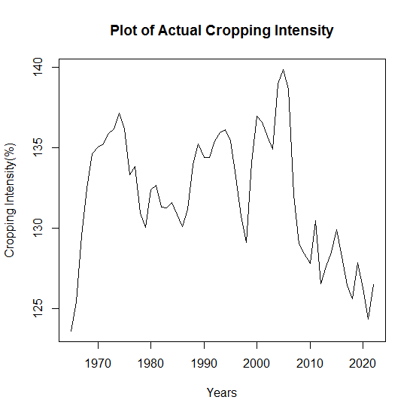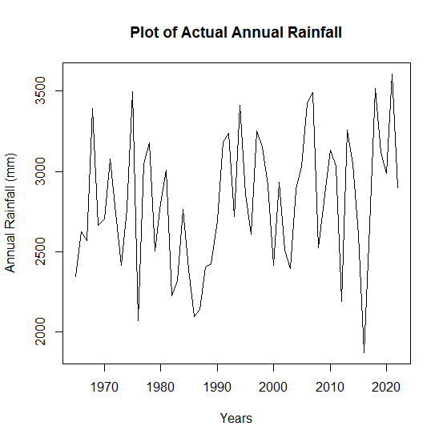
Fig. 1(a): Diagram of actual cropping intensity | Fig. 1(b): Diagram of actual annual rainfall
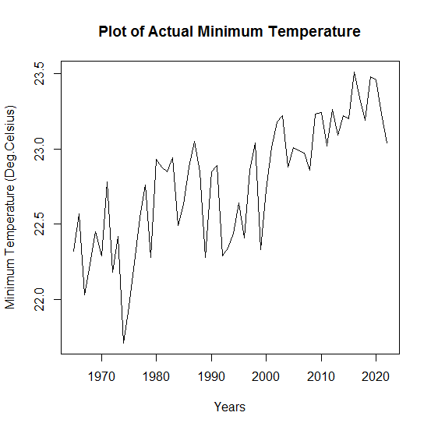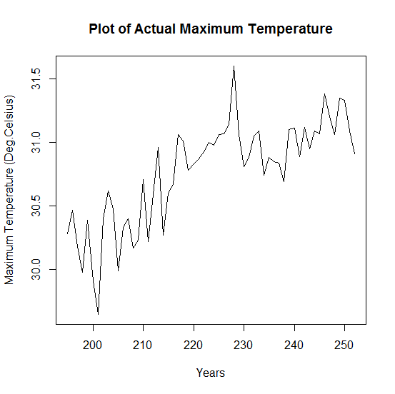
Fig.1(c): Diagram of actual minimum temperature | Fig. 1(d): Diagram of actual maximum temperature

The dataset included 10 years of testing from 2013–2014 to 2022–2023 and 48 years of training from 1965–1966 to 2012–2013. The non-stationary character of the Cropping Intensity data was evident from time series plots, which prompted additional statistical validation. This discovery was verified using the Augmented Dickey-Fuller (ADF) test, which was unable to rule out the null hypothesis of non-stationarity. Table 2 below provides the ADF Test results.
Table 2: Results of ADF Test
Variable | Cropping Intensity (%)
Test Statistic | -2.4134
p value | 0.4078
Max. lags | 3
Conclusion | Not stationary at 5% level

The necessity of data transformation prior to model construction was highlighted by this result. The autocorrelation function (ACF) and partial autocorrelation function (PACF) plots were shown in Figures 2(a) and 2(b), respectively. These plots reinforced the need for differencing in order to attain stationarity and further demonstrated the persistence of correlation across lags. In order to ensure accurate time series modeling utilizing ARIMA and ARIMAX techniques, minimize problems resulting from trends or seasonality, and ensure dependable forecasts, differencing became an essential step.
Fig. 2(a): ACF Plot of original Series | Fig. 2(b): PACF plot of original series

The Cropping Intensity time series was subjected to first-order differencing in order to attain stationarity. The previously noted non-stationary traits were resolved by this change. To help choose the best model, the resultant differenced series was further examined using Autocorrelation and Partial Autocorrelation plots, which are shown in Figures 3(a) and 3(b).
Fig. 3(a): ACF Plot of First differenced Series | Fig. 3(b): PACF plot of First differenced series

To find the best model, a number of tentative ARIMA models were evaluated on the training dataset after the differencing order was established as (d = 1). With lower Akaike Information Criterion (AIC), corrected AIC (AICc), and Bayesian Information Criterion (BIC) values than other configurations, ARIMA(0,1,1) was the best-fitting model among those assessed. A number of ARIMAX models were created, and exogenous factors such as annual rainfall, maximum temperature, and minimum temperature were added to improve the model's predictive power. The most suitable of these was determined to be ARIMAX(0,1,1), which also had the lowest AIC, AICc, and BIC values. When comparing ARIMA(0,1,1) and ARIMAX(0,1,1), the latter demonstrated superior performance based on model selection criteria. Because of its better match, ARIMAX(0,1,1) was selected as the final model for predicting. Table 3 below offers a comprehensive comparison of the model selection criteria for your reference.
Table 3: Model Selection Criteria
Model | AIC | AICc | BIC
ARIMA (1,1,0) | 208.42 | 209.35 | 215.91
ARIMA (0,1,1) | 203.28 | 203.56 | 209.34
ARIMA (1,1,1) | 203.79 | 204.35 | 209.98
ARIMAX (1,1,0) | 209.58 | 209.85 | 215.34
ARIMAX (0,1,1) | 200.72 | 202.19 | 209.97
ARIMAX (1,1,1) | 205.44 | 206.39 | 212.84

For the next ten years, forecasting was done using the ARIMA(0,1,1) and ARIMAX(0,1,1) models that were fitted to the training dataset. To verify model performance, the predicted values from both models were then contrasted with the test dataset's actual observations. Table 4 below displays the validation findings, together with important performance measures like Mean Absolute Percentage Error (MAPE) and Root Mean Square Error (RMSE).
Table 4. Results of Model Validation
Model | RMSE |  | MAPE
Model | Training data | Test data | Training data | Test data
ARIMA (0,1,1) | 1.9909 | 1.0775 | 1.1435 | 1.1654
ARIMAX (0,1,1) | 1.8177 | 1.4153 | 0.9794 | 1.1202

The comparison indicated that the ARIMAX(0,1,1) model outperformed the ARIMA(0,1,1) model, yielding lower RMSE and MAPE values. Based on these validation metrics, the ARIMAX(0,1,1) was selected as the more accurate and reliable model for forecasting Cropping Intensity in the given region. ARIMAX (0,1,1) was used to model the original data and the model coefficients were estimated as given in table 5. Rainfall was found to contribute very less to Cropping intensity while the maximum and minimum temperatures were found to have negative effect on cropping intensity in this model. A plot of the fitted values along with original data is given in figure 4.

Table 5: Model coefficients of ARIMAX (0,1,1)
Parameter | Value | SE | t statistic | p value | Significance
MA(1) | 0.3729 | 0.1361 | 2.739 | 0.0062 | Significant
Rainfall | 0.0005 | 0.0024 | 0.2083 | 0.8360 | Non-Significant
Min. Temp. | -1.1831 | 0.4890 | 2.419 | 0.0156 | Significant
Max. Temp. | -0.5579 | 0.2136 | 2.613 | 0.0090 | Significant

Fig. 4: Plot of fitted values using ARIMAX (0,1,1) and actual values

After the chosen model was fitted, residuals were taken out and examined to evaluate their characteristics and make sure the model was adequate. Using the BDS (Brock-Dechert-Scheinkman) test, it was possible to determine whether the residuals were non-linear. According to the BDS test findings, which are shown in Table 6, every standard normal value was less than 1.96. This suggests that there is no evidence of non-linear dependency in the residual series and that the residuals are linearly, independently, and identically distributed (i.i.d.).
Table 6: Results of BDS test
Embedding dimensions | Epsilon close points
Embedding dimensions | 0.9383 | 1.8766 | 2.8149 | 3.7532
2 | 0.2102 | -0.3789 | -0.2827 | -1.0155
3 | 0.0435 | -0.7752 | -0.4707 | -1.4953

In parallel, the residuals were examined for autocorrelation using the Ljung-Box test. The test produced a p-value of 0.862 and a Chi-Squared value of 0.030. The null hypothesis that there is no autocorrelation, could not be rejected since the p-value is significantly greater than the often accepted significance level of 0.05. This further demonstrated that there is no autocorrelation in the residuals, suggesting that the model has effectively accounted for the underlying structure in the data.
The statistical test results were also visually corroborated by the residuals' Autocorrelation Function (ACF) and Partial Autocorrelation Function (PACF) plots, which are displayed in Figures 5(a) and 5(b). These plots showed that the residuals resembled white noise.
Fig. 5(a) ACF Plot of residuals | Fig. 5(b) PACF plot of residuals

CONCLUSION
The current study used the ARIMAX framework, which includes meteorological factors as exogenous predictors, to successfully estimate the temporal dynamics of cropping intensity in Kerala over a 58-year period (1965–66 to 2022–23). A more thorough understanding of how climatic elements affect cropping patterns throughout time was made possible by this method. Based on a number of model selection and validation criteria, such as the Akaike Information Criterion (AIC), Bayesian Information Criterion (BIC), Root Mean Square Error (RMSE), and Mean Absolute Percentage Error (MAPE), ARIMAX(0,1,1) performed better than ARIMA(0,1,1). The ARIMAX model's enhanced performance emphasizes how crucial it is to incorporate pertinent external variables, especially those linked to climate, into forecasting models for agricultural indices.
Exogenous variable analysis showed that whereas maximum and lowest temperatures had large negative effects on cropping intensity, rainfall had a comparatively little influence. This implies that rising temperatures, possibly caused by climate change, may have a negative impact on the region's agricultural intensity. The chosen model was statistically sound, according to residual diagnostics such as the BDS and Ljung-Box tests, with residuals acting as white noise.
These results highlight how important climate variables are to agricultural forecasting and modeling. In order to create adaptable, climate-resilient strategies, they also emphasize how important it is to incorporate climate considerations into agricultural planning. In light of Kerala's changing agro-ecological conditions under climate variability, the study provides insightful empirical data that can help stakeholders, planners, and policymakers develop sustainable agricultural policies and enhance resource management techniques.

DISCLAIMER (ARTIFICIAL INTELLIGENCE)

Author(s) hereby declare that NO generative AI technologies such as Large Language Models (ChatGPT, COPILOT, etc.) and text-to-image generators have been used during the writing or editing of this manuscript.

REFERENCES
Ayyoob, K. C., Bhattacharya D., Sarkar, K. A., and Dhakre, D. S. (2025). Regional Economic Shifts in Kerala’s Agricultural Landscape. Journal of Scientific Research and Reports, 31(5), 1055-1064.
Box, G. E. P., & Jenkins, G. M. (1970). Time Series Analysis: Forecasting and Control. San Francisco: Holden-Day.
Box, G. E. P., Jenkins, G. M., Reinsel, G. C., & Ljung, G. M. (2015). Time Series Analysis: Forecasting and Control (5th ed.). John Wiley & Sons.
Brock, W. A., Dechert, W. D., Scheinkman, J. A., & LeBaron, B. (1996). A test for independence based on the correlation dimension. Econometric Reviews,15(3), 197–235.
Dickey, D. A., and Fuller, W. A. (1979). Distribution of the estimators for autoregressive time series with a unit root. Journal of the American Statistical Association, 74(366), 427–431.
Irshad M., Sarkar, K. A., Dhakre, D. S., and Bhattacharya, D. (2024). Forecasting of Coconut Price Using Time Series Modelling Technique, 34(2), 223-231.
Johnson, D. (2018). Cropping Pattern Changes in Kerala, 1956–57 to 2016–17. Review of Agrarian Studies, 8(1):65-99
Kumar, P., and Abraham, M, P. (2021). Leading Issues and challenges in the Agriculture Sector of Kerala. Munich Personal RePEc Archive. Paper No. 108759.
Ljung, G. M., & Box, G. E. P. (1978). On a measure of lack of fit in time series models. Biometrika, 65(2), 297–303.
Mahapatra, S.K., Dhakre, D. S., Bhattacharya, D., and Sarkar, K. A. (2024) Forecasting of finger millet production in Odisha by ARIMA & ANN model: A comparative study, 9(1), 276-281.
Nair, K, N. (2012). Agriculture and rural development; Decentralizes and local level development.
Nath, B., Dhakre, D. S., Sarkar, K. A., and Bhattacharya, D. (2020). The challenge of selecting the best forecasting model for a time series data. Journal of Food, Agriculture & Environment 18 (2), 97-102 .
Shilpa, Mathew., A, Prema., & M, Hema. (2024). Cropping pattern and crop diversification in Kerala, India – a spatio-temporal analysis. Current Science, 126(4), 470-477.
Viswanathan, P, K. (2014). The Rationalisation of Agriculture in Kerala: Implications for the Natural Environment, Agro-ecosystems, and Livelihoods. Agrarian South: Journal of Political Economy, 3(1)

