Original Research Article

Elemental analysis of the proboscis hooks of Metacanthocephalus (Bimuscularis) rennicki inflatus (Acanthocephala: Rhadinorhynchidae) from Notothenia coriiceps off Galindez Island, West Antarctica

ABSTRACT
Aims: Specimens of Metacanthocephalus (Bimuscularis) rennicki inflatus Amin, Chaudhary, Caracciolo, Rubtsova, Singh, de Souza, 2025 (Acanthocephala: Rhadinorhynchidae) from Notothenia coriiceps Richardson collected off Galindez Island, West Antarctica were studied for metal analysis of hooks. We report on the Energy Dispersive X-ray Analysis (EDXA) for this acanthocephalan or any member of the same genus for the first time.
History: We have described the mineral distribution in the margins and center of the anterior, middle, and posterior proboscis hooks of cystacanths of many acanthocephaln species. Our studies included X-ray scans (EDXA) of FIB-sectioned hooks and spines of these acanthocephalan worms. The chemical composition of the hooks is characteristic of acanthocephalans.
Study design: We report here a new aspect of elemental analysis of hooks demonstrating the differential distribution of sulfur, phosphorous, calcium, and magnesium at the tip, middle, and base of anterior, middle and posterior hooks. SEM data maps were created, marking spectra from the edge and middle of hook tips, middle, and roots. These were followed by color-coded spectra showing magnesium, calcium, phosphorous, and sulfur element overlays. Then, graphs and tables were created for each spectrum of anterior, middle hooks, and posterior.
Place and duration of study: The study too over one year between collecting data in Antarctica processing specimens in Ukraine and the United States and laboratory work in Brazil.
Methodology: The fixed samples were dehydrated through a graded ethanol series and subsequently were critical point dryied using a Tousimis Autosamdri-815 (Tousimis Research Corporation, Rockville, MD, USA). Samples were mounted on aluminum stubs and coated with a 20 nm layer of carbon using a Balzers MED 010 sputter coater (Balzers Union Ltd., Balzers, Liechtenstein).
Results and conclusions: We demonstrated highest levels of calcium in all hooks especially middle hook tips (56.0%) compared to somewhat lower levels of phosphorus also in all hooks. The lowest level of both these two elements was found in the base of anterior hooks (15% and 9.2%). Sulfur and magnesium were also found in all hooks but at negligible levels. Calcium was found to be the most prevalent element in the middle hooks. Phosphorous was highest in the tip of posterior hooks (23.7%). Sulfur was most negligible (0.3%) in anterior hook tip but most pronounced (1.1%) in anterior hook base and middle of posterior hook. Magnesium was somewhat more prevelant reaching 2.9% at the anterior hook tip.
Importance: The biological importance of this pattern is discussed in terms relevance to hook strength and flexibility, species identity and comparative systematics. This EDXA profile of Metacanthocephalus (Bimuscularis) rennicki inflatus was distinctly differentiated from that of morphologically related species especially those that co-infected the same host species.
Keywords Metacanthocephalus (Bimuscularis) rennicki inflatus, Corynosoma paraevae West Antarctica, EDXA, localization of minerals, hooks, taxonomic implications.

1.INTRODUCTION
Specimens of Corynosoma pseudohamanni Zdzitowiecki, 1984 and Metacanthocephalus (Bimuscularis) rennicki inflatus Amin, Chaudhary, Caracciola, Rubtsova, Singh, de Souza, 2025 (Polymorphidae) coinfected the same host individuals Notothenia coriiceps Richardson at the same time (Table 1) (Amin et al. 2025a) and hence were exposed to the same biochemical environment as the recently described Metacanthocephalus (Bimuscularis) rennicki inflatus Amin, Chaudhary, Caracciolo, Rubtsova, Singh, de Souza, 2025 (see Amin et al., 2025b). The results of the Energy Dispersive X-ray analysis (EDXA) of hooks of Corynosoma pseudohamanni Zdzitowiecki, 1984 (Polymorphidae) show predominance of calcium (11.5–47.0%) and to some extent phosphorus (2.0–19.6%) in all analyzed hooks followed by lower levels of sulfur (0.0–7.1%) (Amin et al. 2025b). Calcium levels reached the highest levels in the roots of the anterior (50.6%), middle (67.9%), and posterior (51.9%) hooks. Sulfur reached higher levels at the edges of all hooks; however, we only detected the highest concentration of this element at the tip of the middle hook (7.1%). Magnesium exhibited the lowest levels or was mostly undetectable (0.0–1.2%). Notably, in the anterior hook, magnesium was only detected in hook roots (1.5%). In the present study of M. rennicki inflatus, the relative prevalence of calcium, phosphorous, sulfur and magnesium were not similar to those of C. pseudohamanni documenting the species specificity of EDXA as a useful tool for distinguishing acanthocephalan species apart diagnostically even though both species shared the same host biochemical environment and locality.
Cystacanths and juveniles of five other species of acanthocephalans were studied by EDXA for elemental composition. These are (1) Southwellina hispida (Van Cleave, 1925) Witenberg, 1932 (Polymorphidae) from the long jaw mudsucker Gillichthys mirabilis Cooper (Gobiidae) off the California coast (Amin et al., 2022); (2) cystacanths of Profilicollis rancoensis Amin, Rodríguez, Farrer, Fierro, Garcés, Rivera, D’Elía, 2023 (Polymorphidae) from the freshwater crab Aegla abtao Schmitt (Crustacea: Decapoda) in Ranchi Lake, North Patagonia, Chile (Amin et al., 2023b); (3) cystacanths of Neoandracantha peruensis Amin, Heckmann, 2017 from the ghost crab Ocypode guadichaudi Milne-Edwards and Lucas in Peru (Amin and Heckmann, 2017); (4) cystacanths of Sphaerirostris picae (Rudolphi, 1819) Golvan, 1956 from lizards and hedgehogs in Ukraine (Amin et al. 2022); and (5) Cystacanths of Moniliformis kalahariensis Meyer, 1931 from Blatella germanica Linn. in India (Amin et al., 2022). We describe herein, the mineral distribution in the margins and center of the anterior, middle and posterior proboscis hooks and hook roots of cystacanths of C. paraevae for the first time.
2. MATERIALS AND METHODS
2.1 COLLECTIONS
A total of 88 specimens of M. rennicki inflatus were collected from cysts in the body cavity of 5 individuals of the Atlantic black rockcod Notothenia coriiceps Richardson between November 2022 and March 2023 off Galindez Island, Argentine Islands, West Antarctica (65°15′ S, 64°15′ W). This collection was part of a long-term parasitological monitoring studies carried out since 2014–2015 by the Ukrainian Antarctic expeditions at the Ukrainian Antarctic station (UAS) “Akademik Vernadsky” on Galindez Island, West Antarctica. Acanthocephalan cysts were collected manually from fish body cavity sites, washed in saline after excystation, and then kept for a few hours in saline for proboscis evagination before fixing in 70% ethanol. We have processed 10 specimens of each sex for SEM and Energy Dispersive x-ray analysis (EDXA).
2.2 DEPOSITS
Voucher specimens were deposited in Harold W. Manter Laboratory (HWML) collection of the University of Nebraska’s State Museum’s in Lincoln, Nebraska, USA; collection no. HWML 217885 from Notothenia coriiceps on 23 Oct., 2024. Additional specimens are kept in 70% ethanol in the OMA collection.
2.3 ENERGY DISPERSIVE X-RAY ANALYSIS (EDXA)
EDXA is an analytical technique associated with electron microscopy, used for the elemental analysis or chemical characterization of a sample. It relies on the interaction between an X-ray excitation source and the sample. Its characterization capabilities are due in large part to the fundamental principle that each element has a unique atomic structure allowing a unique set of peaks on its electromagnetic emission spectrum (Goldstein, 2003; Scimeca et al., 2018) which is the main principle of spectroscopy). A similar methodology to study the hooks Moniliformis kalahariensis Meyer, 1931 (Moniliformidae Van Cleave, 1924) was combined with TEAM (Texture and Elemental Analytical Microscopy) which is a technique that combines both crystallographic texture analysis (using Electron Backscatter Diffraction - EBSD) and elemental analysis (using Energy Dispersive X-ray Spectroscopy - EDS) on a single electron microscope platform (Tan, 2024) was used. This technique allowed us to simultaneously study the microstructure and chemical composition of the M. kalahariensis material at the micro-scale level (Amin et al., 2025b).
Quantitative EDS analysis, especially on non-flat surfaces or those with significant topography—such as these hooks—can exhibit uncertainties on the order of 10–20% in mass percentage values. The results presented here should not be considered absolute, as they may vary depending on the equipment and analysis conditions (e.g., beam current, accelerating voltage, detector angle, conductive coating, etc.).
2.4 SAMPLES PREPARATION
2.4.1 Scanning Electron Microscopy and Focused Ion Beam Preparation

Specimens were dehydrated through a graded ethanol series and critical-point dried using a Tousimis Autosamdri-815 (Tousimis Research Corporation, Rockville, MD, USA). Dried samples were mounted on aluminum stubs and coated with a 20 nm carbon layer in a Balzers MED 010 sputter coater (Balzers Union Ltd., Balzers, Liechtenstein) to enhance surface conductivity during electron imaging.
Focused ion beam milling of the acanthocephalan hooks was performed using a dual-beam focused ion beam–scanning electron microscope (FIB-SEM; Nanolab 600, FEI Company, Hillsboro, OR, USA). Longitudinal sections were generated under an accelerating voltage of 30 kV. An initial coarse trenching step was conducted at a beam current of 20 nA to remove bulk material, followed by progressive polishing using beam currents of 7 and 5 nA to refine the cut surface. The total milling duration depended on the morphological dimensions and volume of each targeted hook.
2.5 Energy Dispersive X-ray Analysis (EDXA)
Energy-dispersive X-ray spectroscopy analysis was performed using a Thermo Fisher Pathfinder™ system (version 1.2; Thermo Fisher Scientific Inc., Waltham, MA, USA) equipped with an UltraDry silicon drift detector (SDD) and integrated into a Magellan 400 scanning electron microscope (FEI Company, Hillsboro, OR, USA). Measurements were conducted at an accelerating voltage of 10 kV and a probe current of 6.3 nA. A standardless quantitative method was applied, employing peak fitting with the filter-fit algorithm and Proza (Phi–Rho–Z) correction to improve the accuracy of elemental quantification.

3. RESULTS
EDXA analysis of elements in anterior, middle and posterior hooks is depicted in figures 1-3, 4-6, and 7-9, respectively. Our results are reported as weight % for calcium, phosphorous, sulfur and magnesium in the tip, middle, and basal regions of apical, middle, and posterior hooks. Common elements in living cells (H, O, N) and cutting elements (Ga) are also listed in all tables and spectra but not discussed. Calcium was the most prevalent element in all regions of all 3 hooks reaching 34.9%, 56.0% and 40,6% at the tip of the anterior, middle, and posterior hooks, in the same order. Phosphorus was equally common but not as prevalent as calcium and was highest at the tips of all three hooks at 20.5%, 19.3%, and 23.7, respectively. Interestingly, calcium and phosphorous were present in all hooks but was progressively lower in most posterior locations being 15.9% and 9.2%, respectively. Sulfur had smallest levels in all regions of all three hooks but most prominent (1.1%) at base of anterior hook and at middle of posterior hook. The percentage of magnesium was also very low but slightly higher than that of sulfur in all regions in all hooks reaching highest levels of only 2.9% at the tip of anterior hooks (Table 2).
4. DISCUSSION
Energy Dispersive X-ray Analysis (EDXA)
Our studies of acanthocephalan worms have usually involved X-ray scans (EDXA) of FIB-sectioned hooks and spines. The chemical elements present in the hooks are typical for acanthocephalans. Hooks were evaluated for chemical ions, with sulfur (s), calcium (ca) and phosphorus (p) being the prominent elements. Calcium and phosphorus are major ions at the base and middle of the hooks that play a prominent role in host tissue attachment (Heckmann et al. 2007, 2012; Standing and Heckmann 2014; Amin and Heckmann, 2017). Sulfur is usually high especially at the outer edge of large hooks and hook tips. These elements are critical for the mineralization of the hook which creates the hardened outer layer, an apatite, similar to tooth enamel of mammals. Magnesium probably plays a role in the mineralization of hooks similar to the disulfide bonds formed by sulfur in the protein apatite (Amin and Heckmann, 2017). Sodium, a rarely prominent metal, was found in scans of whole hooks of Microsentis wardae Martin and Multani, 1966 (Table 2, fig. 12 in Amin et al., 2022a). It was also prominent in whole hooks of Pallisentis nandai Sarkar, 1953 (see Amin et al. 2021, tables 3-6 & figs. 9-12) as well as in egg shells of Neoechinorhynchus qatarensis Amin, Saoud, Alkuwari, 2002 (see Heckmann et al. 2007, table 3).

5. COMPARATIVE FINDINGS
Our results support the above findings and are related to those of the closely related Corynosoma paraevae (Amin et al., 2025c) also co-infecting the same host species N. coriiceps individuals in the same location at Galindez Island, West Antractica. The morphological and molecular distinctions between specimens of these two species, C. paraevae and Metacanthocephalus (Bimuscularis) rennicki inflatus are further supported by the unique EDXA profile of each species comparatively summarized in Table 2. Differences in the level of sulfur are particularly of paramount importance. Distinctions are also noted among cystacanths of 5 other species highlighted in the Introduction.
6. BIOLOGICAL SIGNIFICANCE
EDXA, as a diagnostic tool, supports the observation that populations of an acanthocephalan species will consistently have similar EDXA spectra irrespective of host species or geography. The taxonomic identity of species is deep-seated at the genetic level manifesting the organism’s morphology and biochemistry as revealed, in part, by its elemental spectra (Amin et al., 2022).
The results of large and small gallium (Ga) cut anterior hooks (Figs. 1-3), middle hooks (Figs. 4-6), and posterior hooks (Figs. 7-9) are given. The elements necessary for the mineralization and hardening of the hooks especially calcium and phosphorus are present with sulfur in smaller amounts. In contrast, the percent of sulfur was highest in hook tips and hook edges of Cavisoma magnum (Southwell, 1927) Van Cleave, 1931 from Mugil cephalus in the Arabian Sea reaching 43.51 wt. % and 27.46 wt. %, respectively (Amin et al. 2018).
7. CONCLUSIONS
Metal analysis of hooks has become a diagnostic standard since hooks have the highest level of elements compared to the mid- and posterior trunk regions of the acanthocephalan body (Heckmann et al. 2012). Specifically, the sulfur content in the proboscis is paramount in the composition of disulfide bonds in the thiol groups for cysteine and cystine of the polymerized protein molecules. Protein synthesis occurs in two stages, transcription and translation (Stegman, 2005). The formed disulfide bonds are direct by-products of the DNA-based process of protein synthesis which makes up the identity of a biological species. Accordingly, the level of sulfur, in our EDXA profiles, will indicate the number of sulfur bonds that along with the levels of calcium phosphates, will characterize the identity of a species based on its nuclear DNA personality (Amin et al., 2022). Diversity in the species-specific EDXA profiles will further substantiate its taxonomic relevance in both the cystacanth and adult stages, when such information becomes available.
AVAILABILITY OF DATA AND MATERIAL
All samples used in this study have been deposited in the relevant curated, internationally recognized museum collection as outlined in this paper.
ETHICAL APPROVAL
All applicable institutional, national, and international guidelines for the care and use of animals were followed.
DISCLAIMER (ARTIFICIAL INTELLIGENCE) Author(s) hereby declare that NO generative AI technologies such as Large Language Models (ChatGPT, COPILOT, etc.) and text-to-image generators have been used during the writing or editing of this manuscript.

REFERENCES
Amin, O. M., Chaudhary, A., Caracciolo, M. E., Rubtsova, N. Yu., Wendt, C., Lisitsyna, O., Kuzmina, T. A., de Souza, W., & Singh H. S. (2025a). Redescription and molecular analysis of Corynosoma pseudohamanni Zdzitowiecki, 1984 (Acanthocephala: Polymorphidae) juveniles from Notothenia coriiceps Richardson in the water area of Argentine Islands, West Antarctica. Systematic Parasitolology, 102,16 https://doi.org/10.1007/s11230-024-10212-w
Amin, O. M., Chaudhary, A., Caracciola, M. E., Rubtsova, N. YU., Singh, H. S., & de Souza, W. (2025b) The description of Metacanthocephalus (Bimuscularis) rennicki inflatus n. subgen., n. subsp. (Acanthocephala: Rhadinorhynchidae) from Notothenia coriiceps off Galindez Island, West Antarctica, with the erection of two new subgenera and subspecies. Systematic Parasitology (submitted/revised).
Amin, O. M., Chaudhary, A., & Singh, H. S. (2022a). New perspectives of Microsentis wardae Martin & Multani, 1966 (Acanthocephala: Neoechinorhynchidae) from Gillichthys mirabilis Cooper in California, with scanning electron microscopy images and energy dispersive X-ray analysis. Journal of Helminthology 96, e42,1–12. https://doi.org/ 10.1017/S0022149X22000347
Amin, O. M., Chaudhary, A., & Singh, H. S. (2022). Morphological and molecular description of immature Southwellina hispida (Van Cleave, 1925) Witenberg, 1932 (Acanthocephala: Polymorphidae) from the body cavity of the paratenic host Gillichthys mirabilis Cooper (Gobiidae) in California, with analyses of the chemical composition of hooks and spines. Acta Parasitologica, 67, 1107-1125. https://doi.org/10.1007/s11686-022-00552-2
Amin, O. M., Chaudhary, A., Caracciolo, M. E., Rubtsova, N. Yu., Wendt, C., Kuzmina, T. A., de Souza, W., & Singh, H. S. (2025c). Morphological and molecular description of Corynosoma paraevae n. sp. (Acanthocephala: Polymorphidae) juveniles from Notothenia coriiceps Richardson in Argentine Islands, West Antarctica. Systematic Parasitology 102:43 https://doi.org/10.1007/s11230-025-10238-8
Amin, O. M., & Heckmann, R. A. (2017). Neoandracantha peruensis n. gen. n. sp. (Acanthocephala: Polymorphidae) described from cystacanths infecting the ghost crab Ocypode gaudichaudii on the Peruvian coast. Parasite, 24, 40. DOI:10.1051/parasite/2017038
Amin, O. M., Heckmann, R. A., & Bannai, M. A. (2018). Cavisoma magnum (Cavisomidae), a unique Pacific acanthocephalan redescribed from an unusual host, Mugil cephalus (Mugilidae), in the Arabian Gulf, with notes on histopathology and metal analysis. Parasite 25, 5.
Amin, O M., Heckmann, R. A., Chaudhary, A., Rubtsova, N. Y., & Singh, H. S. (2021). Redescription and molecular analysis of Pallisentis (Pallisentis) nandai Sarkar, 1953 (Acanthocephala: Quadrigyridae) in India. Journal of Helminthology 95, e3,1–20. https:// doi.org/10.1017/S0022149X20001005
Amin, O. M., Lisitsyna, O., Heckmann, R. A. (2022.) Evaluating energy dispersive X-ray analysis (EDXA) as a diagnostic tool in acanthocephalan taxonomy as evidenced in Palaeacanthocephala and Archiacanthocephala. Systematic Parasitology, 100, 43–57. https://doi.org/10.1007/ s11230-022-10069-x
Amin, O. M., Rodríguez, S. M., Farrer, S., Fierro, P., Garcés C., Rivera, F., & D’Elía, G. (2023b.) Review of the concept of Profilicollis Meyer, 1931 with a description of Profilicollis rancoensis n. sp. (Acanthocephala: Polymorphidae) from the freshwater crab, Aegla abtao Schmitt, 1942 (Decapoda: Anomura) in Chile, with a key to congeneric species. Parasite, 30, 42. https://doi. org/10.1051/parasite/2023042
Goldstein, J. (2003). Scanning Electron Microscopy and X-Ray Microanalysis. Springer. ISBN 978-0-306-47292-3. Retrieved 26 May 2012.
Heckmann, R. A., Amin, O. M. & Standing, M. D. 2007. Chemical analysis of metals in Acanthocephalans using energy dispersive X-ray analysis (EDXA, XEDS) in conjunction with a scanning electron microscope (SEM). Comparative Parasitolology, 74, 388–391.
Heckmann, R. A., Amin, O. M., Radwan, N. A. E., Standing, M. D., Eggett, D. L, & El Naggar, A. M. 2012. Fine structure and energy dispersive X-ray analysis (EDXA) of the proboscis hooks of Rhadinorynchus ornatus, Van Cleave 1918 (Rhadinorynchidae: Acanthocephala). Scientia Parasitologica 13, 37–43.
Standing, M. D., & Heckmann, R. A. (2014). Features of Acanthocephalan hooks using dual beam preparation and XEDS phase maps. Microscopy and Microanalysis Meeting, Hartford, Connecticut, USA. No. 0383–00501.
Scimeca, M., Bischetti, S., Lamsira, H. K., Bonfiglio, R., & Bonanno, E. (2018) Energy Dispersive X-ray (EDX) microanalysis: A powerful tool in biomedical research and diagnosis. European Journal of Histochemistry, 62, 2841. https://doi.org/10.4081/ejh.2018.2841.
Stegman, J. K. (2005). Stedman’s Medical Dictionary for the Health Professions and Nursing. 5th Ed. Lippincott, Williams and Wilkins, Baltimore, Maryland, USA.
Tan, S. (2024). Guide to operate FEI Scios FIB/SEM equipped with EDAX EDS/EBSD-Elemental and texture analysis using EDS/EBSD. https://www.nano.pitt.edu.files.Equipment-SOP.

Figures
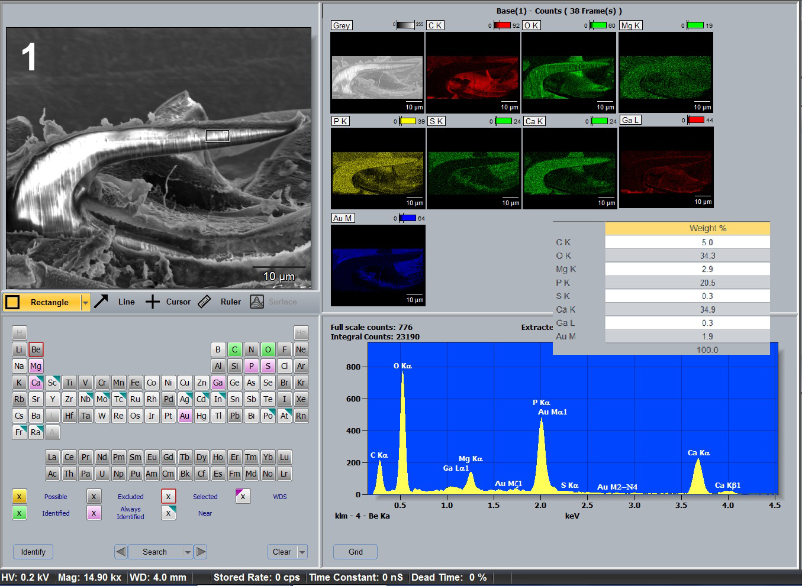
Fig. 1. Elemental analysis of anterior proboscis hook tip of Metacanthocephalus (Bimuscularis) rennicki inflatus collected from Notothenia coriiceps off Galindez Island, Argentine Islands, West Antarctica. Gallium cut-marked SEM section of anterior hook and color-coded graphic element distribution. Tabulated levels of elements analyzed by weight % from the anterior hook tip with corresponding spectrum are also shown.
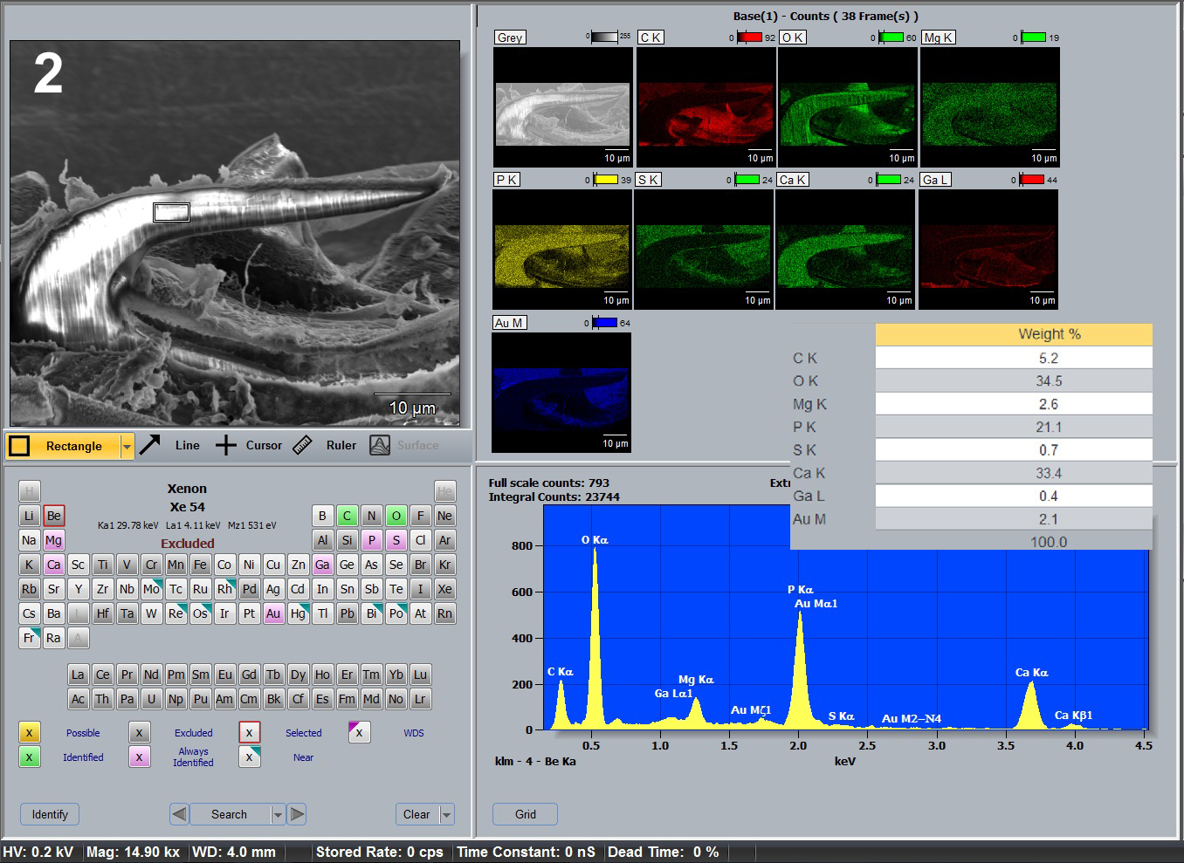
Fig. 2. Elemental analysis of anterior proboscis hook middle of Metacanthocephalus (Bimuscularis) rennicki inflatus collected from Notothenia coriiceps off Galindez Island, Argentine Islands, West Antarctica. Gallium cut-marked SEM section of anterior hook and color-coded graphic element distribution. Tabulated levels of elements analyzed by weight % from the anterior hook middle with corresponding spectrum are also shown.
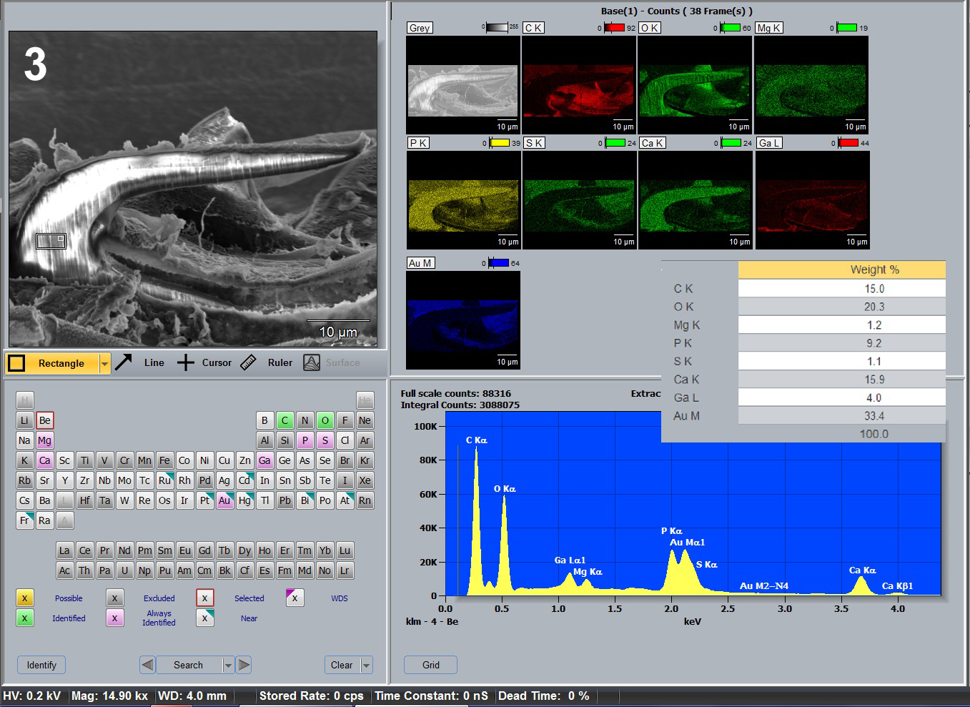
Fig. 3. Elemental analysis of anterior proboscis hook base of Metacanthocephalus (Bimuscularis) rennicki inflatus collected from Notothenia coriiceps off Galindez Island, Argentine Islands, West Antarctica. Gallium cut-marked SEM section of anterior hook and color-coded graphic element distribution. Tabulated levels of elements analyzed by weight % from the anterior hook base with corresponding spectrum are also shown.
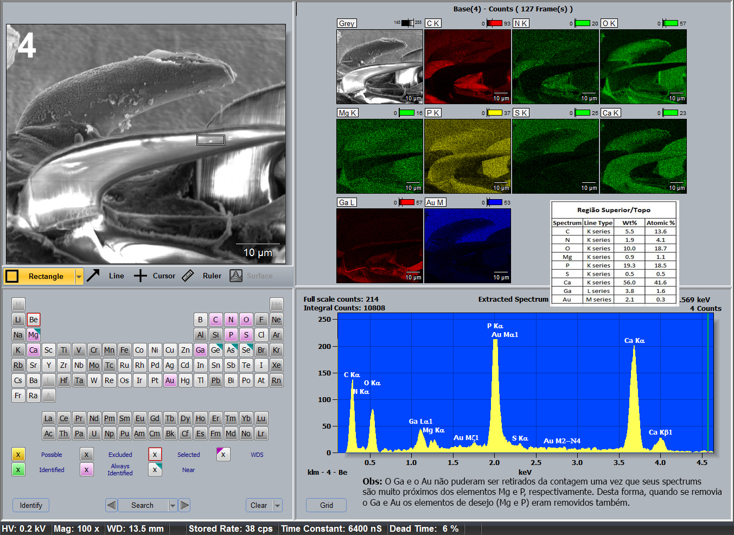
Fig. 4. Elemental analysis of middle proboscis hook tip of Metacanthocephalus (Bimuscularis) rennicki inflatus collected from Notothenia coriiceps off Galindez Island, Argentine Islands, West Antarctica. Gallium cut-marked SEM section of middle hook and color-coded graphic element distribution. Tabulated levels of elements analyzed by weight % from the middle hook tip with corresponding spectrum are also shown.
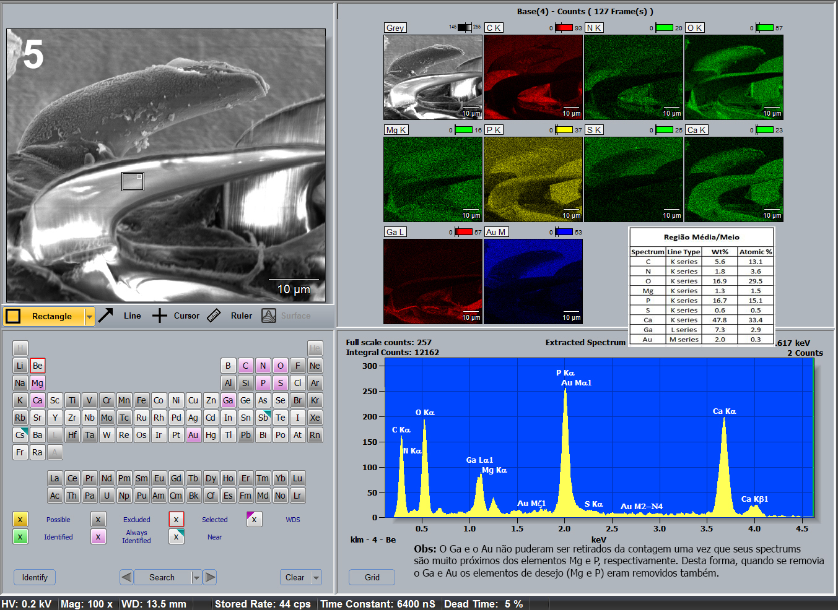
Fig. 5. Elemental analysis of middle proboscis hook middle of Metacanthocephalus (Bimuscularis) rennicki inflatus collected from Notothenia coriiceps off Galindez Island, Argentine Islands, West Antarctica. Gallium cut-marked SEM section of middle hook and color-coded graphic element distribution. Tabulated levels of elements analyzed by weight % from the middle hook middle with corresponding spectrum are also shown.
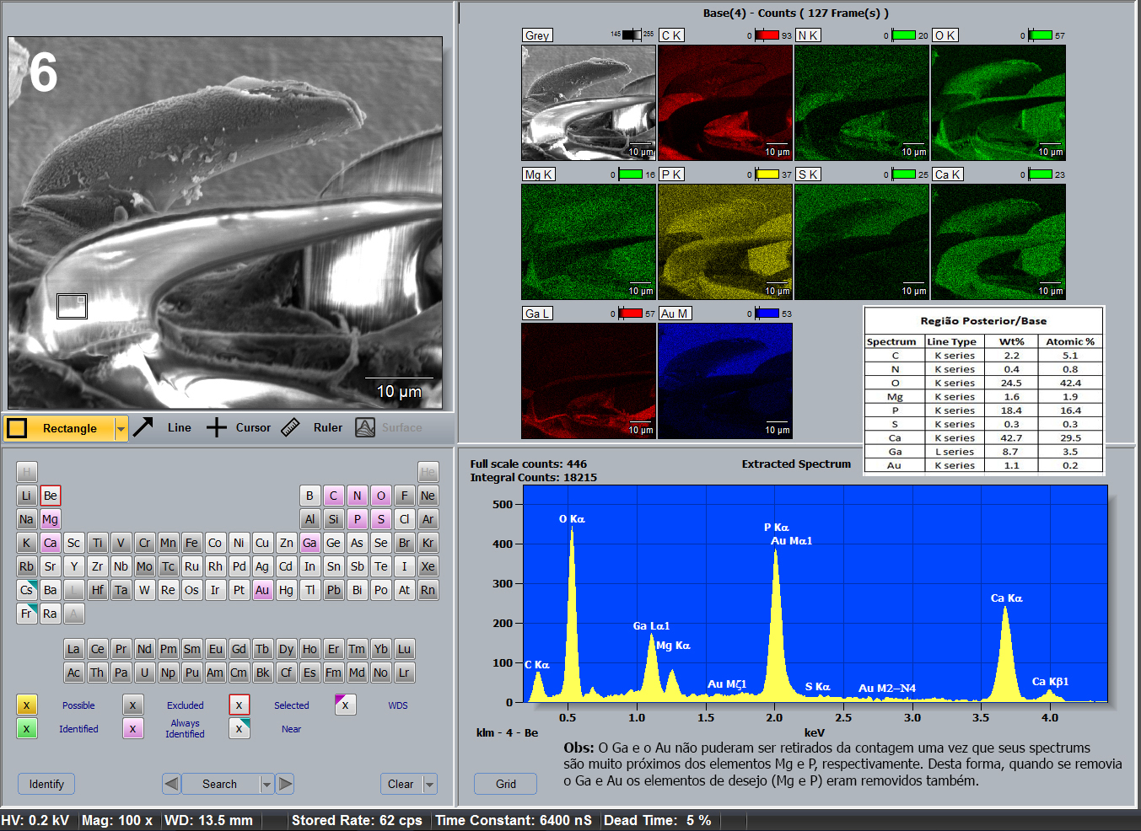
Fig. 6. Elemental analysis of middle proboscis hook base of Metacanthocephalus (Bimuscularis) rennicki inflatus collected from Notothenia coriiceps off Galindez Island, Argentine Islands, West Antarctica. Gallium cut-marked SEM section of middle hook and color-coded graphic element distribution. Tabulated levels of elements analyzed by weight % from the middle hook base with corresponding spectrum are also shown.
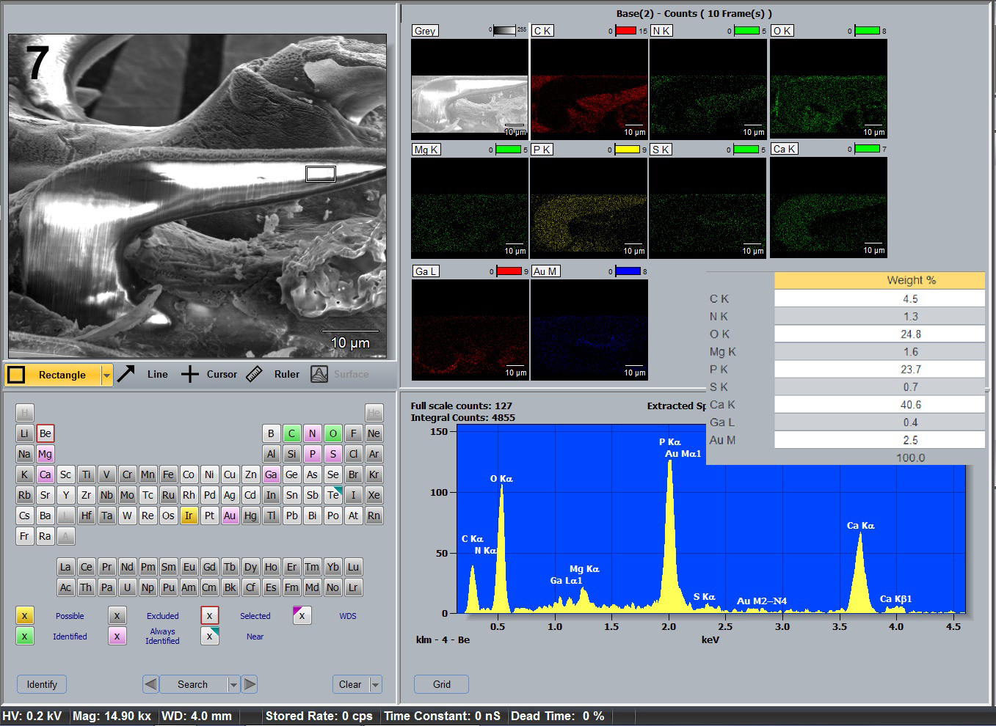
Fig. 7. Elemental analysis of posterior proboscis hook tip of Metacanthocephalus (Bimuscularis) rennicki inflatus collected from Notothenia coriiceps off Galindez Island, Argentine Islands, West Antarctica. Gallium cut-marked SEM section of posterior hook and color-coded graphic element distribution. Tabulated levels of elements analyzed by weight % from the posterior hook tip with corresponding spectrum are also shown.
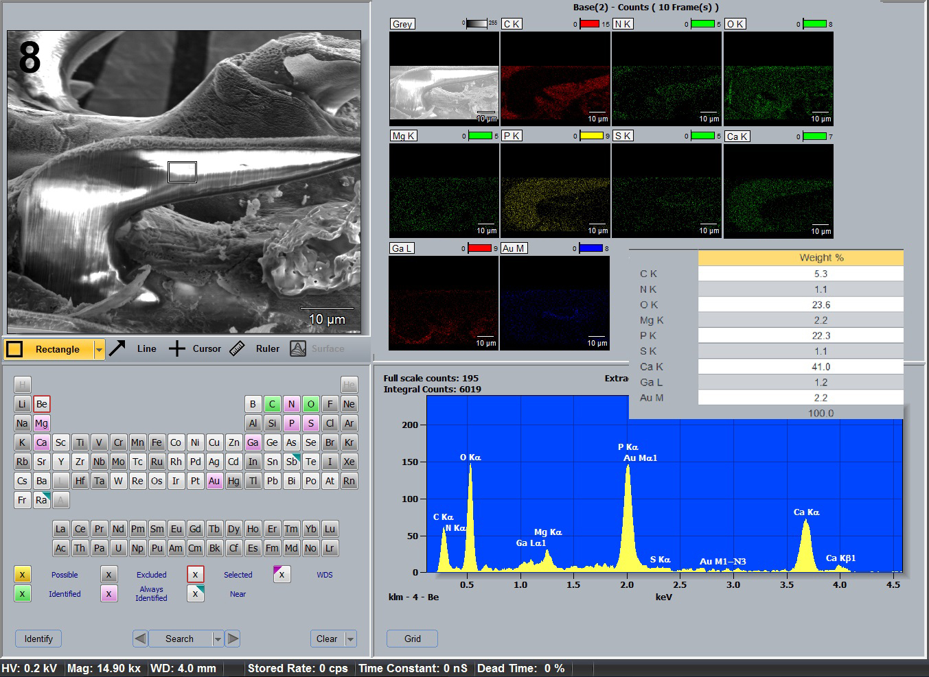
Fig. 8. Elemental analysis of posterior proboscis hook middle of Metacanthocephalus (Bimuscularis) rennicki inflatus collected from Notothenia coriiceps off Galindez Island, Argentine Islands, West Antarctica. Gallium cut-marked SEM section of posterior hook and color-coded graphic element distribution. Tabulated levels of elements analyzed by weight % from the posterior hook middle with corresponding spectrum are also shown.
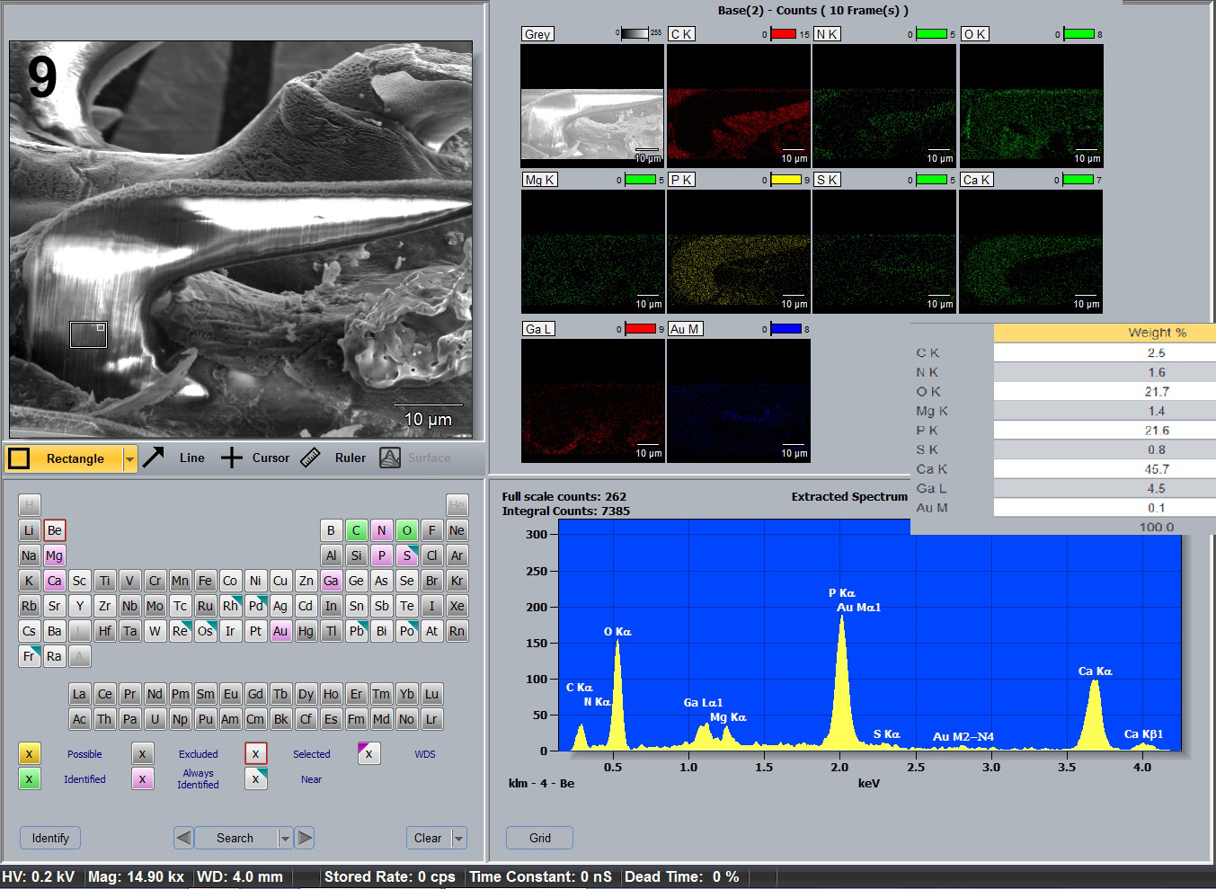
Fig. 9. Elemental analysis of posterior proboscis hook base of Metacanthocephalus (Bimuscularis) rennicki inflatus collected from Notothenia coriiceps off Galindez Island, Argentine Islands, West Antarctica. Gallium cut-marked SEM section of posterior hook and color-coded graphic element distribution. Tabulated levels of elements analyzed by weight % from the posterior hook base with corresponding spectrum are also shown.

Table 1. Initial identification of acanthocephalans collected from the body cavity of the paratenic host Notothenia coriiceps off Galindez Island, Argentine islands, West Antarctic in 2022 and 2023.
Host Weight (g)  & length (cm), date | Juvenile acanthocephalans
Host Weight (g)  & length (cm), date | Corynosoma evae | Corynosoma pseudohamanni | Metacanthocephalus campbelli | Metacanthocephalus rennicki
640 g; 31 cm  10 Nov., 2022* | 11 | 77 | 0 | 44
841 g; 37 cm  10 Nov., 2022** | 19 | 125 | 0 | 8
287 g; 27 cm  16 March, 2023 | 1 | 159 | 0 | 3
568 g; 35 cm  16 March, 2023 | 3 | 78 | 4 | 4
705 g; 38 cm  16 March, 2023 | 0 | 155 | 4 | 29
Total | 34 | 594*** | 8 | 88

*3 Specimens of Corynosoma hamanni and 1 of Corynosoma shackletoni were also collected from this host.
**1 specimen of Corynosoma bullosum was collected from this host.
*** The numbers in this table represent a drastic underestimate of the number of Corynosoma cysts’ infections as only up to 13% of cysts get to be collected, excysted, and identified.

Table 2. Summary of chemical composition of Gallium (Ga) cuts of anterior, middle, and posterior hooks of Metacanthocephalus (Bimuscularis) rennicki inflatus compared to Corynosoma paraevae collected from the same host individuals, Notothenia coriiceps in the same geography off Galindez Island, Argentine Islands, West Antarctica.

Position of Ga cuts | Calcium (Ca) | Phosphorus (P) | Sulfur (S) | Magnesium (Mg)
 | Anterior hooks
Hook tip | 34.9* | 20.5 | 0.3 | 2.9
Hook middle | 33.4 | 21.1 | 0.7 | 2.6
Hook base | 15.9 | 9.2 | 1.1 | 1.2
 | Middle hooks
Hook tip | 56.0 | 19.3 | 0.5 | 0.9
Hook middle | 47.8 | 16.7 | 0.6 | 1.3
Hook base | 42.7 | 18.4 | 0.3 | 1.6
 | Posterior hooks
Hook tip | 40.6 | 23.7 | 0.7 | 1.6
Hook middle | 41.0 | 22.3 | 1.1 | 2.2
Hook base | 45.7 | 21.6 | 0.8 | 1.4

Corynosoma paraevae n. sp. (modified from Amin et al. 2025)
Hook cuts | Calcium (Ca) | Phosphorus  (P) | Sulfur (S) | Magnesium  (Mg)
Ant. hook tip | 35.06 | 17.87 | ND** | 1.36
Middle hook tip | 34.66 | 17.80 | 1.53 | 1.36
Post. hook tip | 25.78 | 14.56 | 3.99 | 1.27
Ant. hook edge | 15.14 | 9.83 | 2.68 | 1.11
Middle hook edge | 17.05 | 10.06 | 4.14 | 1.15
Post. hook edge | 15.11 | 9.64 | 3.37 | 1.19
Ant. hook middle | 21.67 | 12.89 | 1.34 | ND
Middle hook middle | 45.78 | 20.30 | ND | 1.35
Post. hook middle | 50.55 | 23.69 | ND | 1.30

*All elements are listed in weight (WT%). Common protoplasmic elements (C, O, N) are not listed.
** Not detectable.

