KINEMATIC ANALYSIS OF DISC ASSISTED TRANSPLANTING MECHANISM FOR ROOTWASHED PADDY SEEDLINGS USING SOLIDWORKS

ABSTRACT
The kinematic analysis of a planting mechanism is essential for understanding its operational behavior, as it enables the prediction of the mechanism’s motion at any point in its cycle and provides a basis for further design improvements. Kinematic analysis can be carried out using analytical, graphical, or numerical methods. Analytical methods involve the formulation and solution of equations of motion, whereas graphical methods use diagrams to visualize the movement of various links. Numerical methods, on the other hand, employ iterative techniques and computer simulations to handle complex motions more efficiently. By using computer-assisted analytical methods, a complete rotation analysis can be performed quickly and accurately, avoiding the time-consuming steps required in traditional graphical approaches. In this study, SolidWorks Motion Analysis was utilized to determine key kinematic parameters such as linear displacement, angular velocities and accelerations of a disc-assisted planting mechanism developed for transplanting root-washed paddy seedlings.
1. Introduction
Kinematic analysis is fundamental for gaining insight into the functional characteristics and overall performance of a mechanism. It provides detailed insights into the motion characteristics of individual components throughout the working cycle, enabling designers to identify inefficiencies, optimize motion transmission, and improve overall mechanism performance. Such analysis can be conducted using analytical, graphical, or numerical methods (Wang et al., 2022; Avilés et al., 2008; Gallardo-Alvarado & Gallardo-Razo, 2022; Shete et al., 2017; Vareed Thomas, 2002; Guo & Zhang, 2001). Analytical methods involve deriving equations of motion based on kinematic relations, while graphical methods rely on scaled diagrams to visualize the movement of links. Numerical methods, on the other hand, employ iterative techniques and computer simulations to handle complex geometries and motions that are difficult to solve analytically. Among these, computer-assisted analytical methods are particularly advantageous, as they allow complete cycle analysis to be performed efficiently, eliminating the time-consuming steps associated with traditional graphical methods. Modern CAD software such as SolidWorks Motion Analysis offers powerful tools to simulate and analyze mechanisms in real time, providing precise values for kinematic parameters such as linear displacement, linear and angular velocities, and accelerations of different components. These parameters are essential for evaluating the functional efficiency, ensuring proper timing between components, and avoiding undesirable vibrations or shocks during operation. In this study, kinematic analysis is carried out for a disc-assisted planting mechanism designed for transplanting root-washed paddy seedlings. This analysis aims to predict the motion behavior of the mechanism throughout its cycle, thereby supporting design refinement and ensuring reliable and synchronized transplanting operations in field conditions
2. METHODOLOGY
2.1 Design of the transplanting mechanism
The transplanting unit used a crank rocker mechanism for picking and planting as shown in Fig. 1. It is a four bar mechanism where the fixed link AB is inclined at an angle $θ$ from the horizontal. When the disc (AB) rotates, the coupler (BC) which is eccentrically connected to the disc, reciprocates the follower (CD), which in turn moves the planting finger in the desired path. The dimensions of the link satisfed the Grashof’s law (Soriano-Heras et al., 2025). The length of the transplanting finger was designed to provide an appropriate lift to pick seedlings effectively from a tray positioned at 160 mm above the ground. Also the finger should move 50 mm deep into the soil for proper planting. Additionally, it was important for the transplanting finger to fit within a compact space. Considering the requirements, a planting mechanism with a disc (diameter -140 mm, length of coupler-250 mm, eccentricity of coupler – 55 mm), length of follower - 68 mm, finger arm (length-250 mm, radius of curvature- 95 mm from center) and finger was designed using SolidWorks premium software - 2023 as shown in Fig.2.

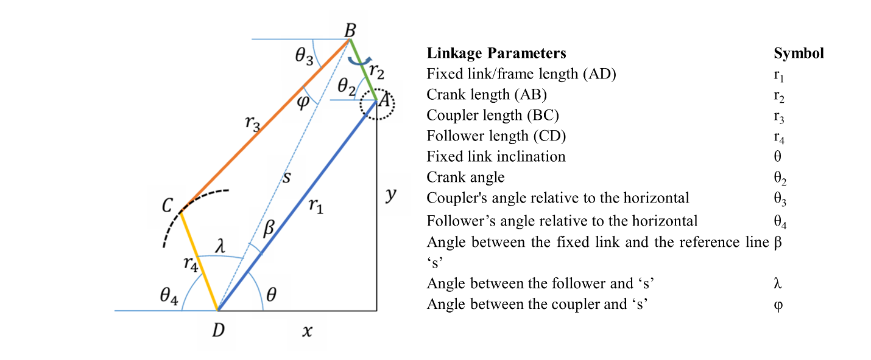
Fig.1 Sketch diagram of the crank and rocker mechanism for the transplanting unit
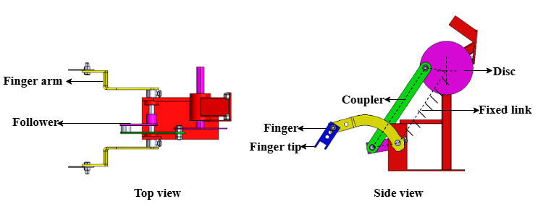
Fig.2 Top view and side view of the transplanting unit modeled in SolidWorks premium software -2023
2.2 Kinematic Analysis
The analytical method uses Eqn.1-10 for kinematic analysis of four bar mechanism in 2D plane (Marzuki et al., 2019). But it is a time consuming process. In this study, motion analysis was done in SolidWorks premium software-2023 to obtain linear displacement, velocity and acceleration of the Fingertip in 3D plane. Although SolidWorks does not directly apply the analytical equations (Eq. 1–10) used for 2D kinematic analysis of four-bar mechanisms, it is based on the same fundamental kinematic and dynamic principles. The software employs numerical solvers to handle vector loop and constraint equations in three dimensions, using multibody dynamics formulations derived from Newton–Euler equations and D’Alembert’s principle. This allows it to compute displacement, velocity, and acceleration parameters efficiently for complex geometries without the need for explicit manual calculations. In simple planar cases, the results obtained from SolidWorks closely match those derived analytically, while for spatial mechanisms, the numerical approach provides a more practical and comprehensive solution.
Displacement analysis
$$s=\sqrt{r_{1}^{2}+r_{2}^{2}-2r_{1}r_{2}\cos{{(θ}_{2}+θ)}}$$ | (1)
$$β= \sin^{-1}{\frac{r_{2}sin({θ_{2}+θ)}}{s}}$$ | (2)
$$φ=\cos^{-1}({\frac{s^{2}+r_{3}^{2}-r_{4}^{2}}{2r_{1}r_{2}})}$$ | (3)
$$λ=\cos^{-1}{(\frac{s^{2}+r_{4}^{2}-r_{3}^{2}}{2sr_{4}}})$$ | (4)
$$θ_{3}=β+θ-φ$$ | (5)
$${ θ}_{4}=π-(θ+β+λ)$$ | (6)

Angular velocity analysis ($ω$)
$$Angular velocity of coupler, ω_{3}=\frac{{-ω}_{2}r_{2}\sin{{(θ}_{4}-θ_{2})}}{r_{3}\sin{{(θ}_{4}-θ_{3})}}$$ | (7)
$${Angular velocity of follower, ω}_{4}=\frac{ω_{2}r_{2}\sin{{(θ}_{3}-θ_{2})}}{r_{3}\sin{{(θ}_{3}-θ_{4})}}$$ | (8)
Angular acceleration analysis ($α$)
$${Angular acceleration of coupler, α}_{3}$$  $$=\frac{r_{2}α_{2}\sin{{(θ}_{4}-θ_{2})-r_{2}ω_{2}^{2 }\cos{{(θ}_{4}-θ_{2})+r_{4}ω_{4}^{2 }-r_{3}ω_{3}^{2 }\cos{{(θ}_{4}-θ_{3})}}}}{r_{3}\sin{{(θ}_{3}-θ_{4})}}$$ | (9)
$${Angular acceleration of follwer,α}_{4}=\frac{r_{2}α_{2}\sin{{(θ}_{3}-θ_{2})-r_{2}ω_{2}^{2 }\cos{{(θ}_{3}-θ_{2})-r_{3}ω_{2}^{2 }+r_{4}ω_{4}^{2 }\cos{{(θ}_{3}-θ_{4})}}}}{r_{4}\sin{{(θ}_{3}-θ_{4})}}$$ | (10)

In the developed model, the two extreme limits in the trajectory of the follower decided the maximum lifting height and planting depth. The optimal angle of the planting arm relative to the follower was analyzed in SolidWorks software. The upper limit of the follower corresponded to the finger's starting position for picking the seedlings. As the follower reached its lower limit, the finger became perpendicular to the horizontal surface, allowing the seedlings to be released into the soil. The crank angles at the two extreme limits of the follower were obtained through SolidWorks analysis and were subsequently used to calculate the remaining link parameters using Eqn. 1-6. This data provided critical insights for determining the precise motion and configuration of the mechanism. The forward speed of paddy transplanters for root-washed seedlings ranged between 0.5 and 1.5 km/h (Gaikwad et al., 2018). The forward speed of the transplanter and the rotational speed of the planting unit determine the plant-to-plant spacing. To get a plant-to-plant spacing of 15 cm, with an effective diameter of 440 mm, the calculated the crank speed were found in the range of 90 to 128 rpm. Hence the angular velocity and acceleration of the links were analyzed at minimum speed of 90 rpm using motion analysis tool in SolidWorks software for validating the mechanism. The steps in motion analysis is given in Fig.3.
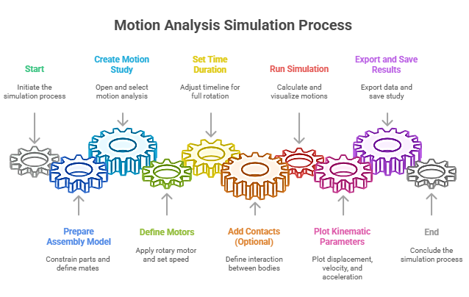
Fig.3 Steps in motion analysis simulation process
3. Results and Discussion
3.1 Kinematic Analysis
From motion analysis of the planting mechanism in SoildWorks premium software 2023 the crank angle at the upper limit of follower was determined as 126.6ᵒ (Fig.4a) and at the lower limit was 53.39ᵒ (Fig.4b). The values of different kinematic parameters at the upper and lower limit of the fingertip is given in Table. 1. These parameters were critical in developing the prototype of the planting mechanism. It provided idea regarding the connection between the links to achieve the desired finger lift, planting depth, the total space requirement, and position of tray placement.
Table.1 kinematic parameters of developed planting mechanism at extreme limits of fingertip
Fingertip position | $$θ_{2}$$ | $$s$$ | $$β$$ | $$φ$$ | $$λ$$ | $$θ_{3}$$ | $$θ_{4}$$
Start (upper limit) | 126.6 | 298.37 | -0.93 | 10.04 | 39.86 | 53.39 | 82.64
End (lower limit) | -53.39 | 188.8 | -1.47 | 7.83 | 149.94 | 53.44 | -29.83

*angles measured below the horizontal line are considered as negative
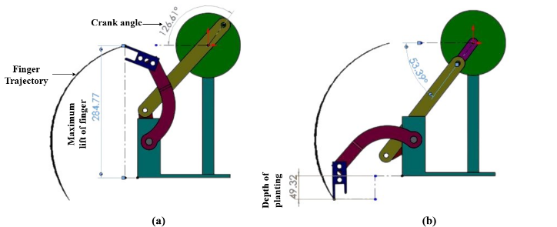
Fig.4 Motion analysis of developed mechanism using SolidWorks premium software 2023 (a) upper limit of fingertip, (b) lower limit of fingertip
a. Linear Displacement
The linear displacement analysis of the fingertip provided insights into the optimal placement of the picking point of the tray relative to the fingertip in the transplanting mechanism. At 90 rpm, the crank required 0.68 seconds to complete one revolution (Fig. 5a). The time interval from 0 to 0.32 s corresponded to the forward stroke, while the interval from 0.32 to 0.68 s represented the return stroke. The linear displacement of the finger was analyzed along the X and Y directions with center of disc as origin. The finger was able to pick the seedlings from the tray at X equals to 320 mm which indicated that the horizontal distance of picking area in the tray should be at this position. The corresponding Y component 182 mm indicated the vertical position of the picking area from the center of disc. The upper limit of Y component (335 mm) at the end of return stroke indicated a sufficient lift of fingertip above the tray and a proper planting depth of 49.5 mm as shown in Fig. 4b. Similar study was conducted by (Marzuki et al., 2019) in SolidWorks software to optimize the dimension of a four bar mechanism. The obtained data was compared with the mathematical equations using Microsoft Excel software. The motion analysis tool provided data similar to the excel model. The optimized dimensions of the four-bar mechanism links were determined to be L₁ = 230.87 mm, L₂ = 87 mm, L₃ = 117.85 mm, and L₄ = 225.57 mm. Simulation results of the developed prototype showed that the mechanism achieves a total vertical displacement of 634.22 mm during the return stroke (Y-direction) and a total horizontal displacement of 322.41 mm in the forward stroke (X-direction) of the finger. Additionally, the mechanism travels 371.56 mm to reach the lower end of the hopper, 484.95 mm to reach the soil surface, and places the seedlings at an approximate depth of 100 mm in the soil
b. Angular velocity
The angular velocity of the follower increased from 58.9 – 443 deg s⁻¹ as the finger moved from its initial point to halfway of the forward stroke and decreased towards the end of forward stroke (133.7 deg s⁻¹) (Fig.5b). This behavior occurred because the follower started from a position where the mechanical advantage allowed it to rotate faster. As the follower links moved towards the end of the forward stroke, the distance between the links decreased leading a reduction in the angular velocity due to changes in relative velocity of the links. The finger exhibited same trend during the return stroke though the magnitude of angular velocity was high compared to the forward stroke. This was likely due to more power requirement for lifting the finger during the return stroke. The non-uniform velocity profile of the follower due to the constrained link lengths caused continuous shifting of the instantaneous center of rotation and relative angular velocities throughout the stroke (Khurmi, R. S., & Gupta, 2005). Although the motion of the follower link was directly driven by the input link, the motion of coupler was influenced by the relative movement of both input and follower link. The angular velocity of the coupler decelerated when the follower velocity accelerated as the motion of input and output link no longer provided sufficient mechanical advantage to the coupler in that position.
c. Angular Acceleration
The angular acceleration of the follower decreased when the angular velocity was high (Fig.4c). This may have occurred because the system velocity was approaching a constant value due to inertia, requiring less acceleration to maintain that high speed. Since the couplers motion was influenced by both the follower and driver, the combined forces from these links could lead to increase in angular acceleration with increase in angular velocity (Khurmi, R. S., & Gupta, 2005). At higher angular velocity, the system demanded a greater change in angular velocity for the coupler to continue its motion.
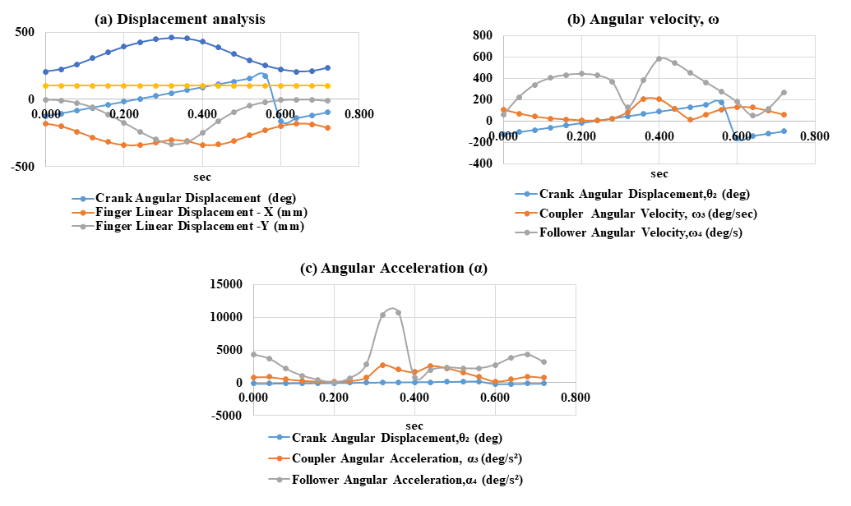

Fig. 5 Kinematic analysis of planting mechanism using SolidWorks premium Software-2023, (a) Displacement analysis, (b) Angular velocity, (c) Angular acceleration
Conclusion
The kinematic analysis of the developed disc-assisted planting mechanism demonstrated that the designed link dimensions and motion characteristics are well-suited for accurate and synchronized seedling picking, lifting, and placement operations. The use of SolidWorks motion analysis enabled detailed evaluation of displacement, velocity, and acceleration parameters, which would be difficult to achieve through graphical methods alone. The mechanism exhibited appropriate fingertip trajectory, adequate planting depth, and smooth motion transmission across the operating cycle. These results provided a strong foundation for prototype development, ensuring reliable performance under field conditions and supporting future refinements for increased efficiency and precision in mechanical rice transplanting.
Reference
Avilés, R., Hernández, A., Amezua, E., & Altuzarra, O. (2008). Kinematic analysis of linkages based in finite elements and the geometric stiffness matrix. Mechanism and Machine Theory, 43(8), 964–983. https://doi.org/10.1016/J.MECHMACHTHEORY.2007.07.007
Gaikwad, P. B., Shahare, P. U., & Pathak, S. V. (2018). Performance of Four Row Self Propelled. 36(1), 72–75.
Gallardo-Alvarado, J., & Gallardo-Razo, J. (2022). Analytical method. Mechanisms, 279–309. https://doi.org/10.1016/B978-0-32-395348-1.00027-2
Guo, L. S., & Zhang, W. J. (2001). Kinematic analysis of a rice transplanting mechanism with eccentric planetary gear trains. Mechanism and Machine Theory, 36(11–12), 1175–1188. https://doi.org/10.1016/S0094-114X(01)00052-0
Khurmi, R. S., & Gupta, J. K. (2005). Theory of machines. S. Chand Publishing. https://books.google.co.in/books?id=RWWgwVoSBWwC&lpg=PA3&ots=yfQTwHBLOy&dq=khurmi book theory of machines&lr&pg=PA15#v=onepage&q=khurmi book theory of machines&f=false
Marzuki, Syukran, & Azwinur. (2019). Design and Development of Four Link Bar Mechanism for Transplanting Wet Rice Seedlings. IOP Conference Series: Materials Science and Engineering, 536(1). https://doi.org/10.1088/1757-899X/536/1/012027
Shete, S., Kumar, N., Nalawade, P., & Tripathi, P. (2017). Review of Synthesis of Four BAR Mechanism. International Research Journal of Engineering and Technology(IRJET), 4(5), 1521–1524. https://www.irjet.net/archives/V4/i5/IRJET-V4I5297.pdf
Soriano-Heras, E., Pérez-Carrera, C., & Rubio, H. (2025). Mathematical Dimensional Synthesis of Four-Bar Linkages Based on Cognate Mechanisms. Mathematics, 13(1), 1–24. https://doi.org/10.3390/math13010011
Vareed Thomas, E. (2002). Development of a mechanism for transplanting rice seedlings. Mechanism and Machine Theory, 37(4), 395–410. https://doi.org/10.1016/S0094-114X(01)00071-4
Wang, Y., Zhang, Q., Zhang, X., Cai, J., Jiang, C., Xu, Y., & Feng, J. (2022). Analytical and numerical analysis of mobility and kinematic bifurcation of planar linkages. International Journal of Non-Linear Mechanics, 145, 104110. https://doi.org/10.1016/J.IJNONLINMEC.2022.104110

