Morphological Characterization of Colletotrichum truncatum from Diverse Agro-Climatic Zones of Madhya Pradesh

ABSTRACT: Anthracnose caused by Colletotrichum truncatum is a major constraint in soybean production, affecting leaves, stems, pods, and seeds. In the present study, ten isolates of C. truncatum were collected from ten locations across nine districts and seven agro-climatic zones of Madhya Pradesh. Their cultural and morphological characteristics were evaluated on five different media: Potato Dextrose Agar (PDA), Oatmeal Agar (OMA), Corn Meal Agar (CMA), Czapek’s Dox Agar (CDA), and Richard’s Agar (RA). Colony morphology, mycelial density, sporulation, and radial growth were recorded at 2nd, 5th, 8th, and 11th days post-inoculation. Significant variability was observed among isolates and media in terms of colony texture, colour, mycelial density, and sporulation. PDA supported the fastest early growth and maximum final radial expansion, while OMA and CDA promoted vigorous sporulation. Corn Meal Agar also supported good growth and sporulation for most isolates. Richard’s Agar consistently exhibited the lowest radial growth and sparse sporulation. These findings indicate that PDA, OMA, and CMA are the most suitable media for studying growth and reproductive potential of C. truncatum, and the observed isolate-specific differences highlight considerable intraspecific variability, which may have implications for disease management and inoculum production.

KEYWORDS: Soybean anthracnose, Colletotrichum truncatum, cultural variability, morphological characterization, growth media, sporulation.

INTRODUCTION: Soybean (Glycine max L.) is one of the world’s most important oilseed crops, valued for its high protein, oil content, and bioactive compounds (Masuda and Goldsmith, 2009; Guzeler and Yildirim, 2016). Introduced to India in the 1960s, large-scale cultivation began in the early 1970s, with Madhya Pradesh now being the leading soybean-producing state. However, soybean is highly susceptible to fungal diseases, among which anthracnose, caused by Colletotrichum truncatum (Schw.) Andrus and Moore, is particularly destructive (Backman et al., 1982; Dias et al., 2016). The pathogen infects plants at nearly all growth stages, with pod blight being the most damaging, leading to shriveled or mold-infested seeds and significant yield losses. Symptoms include dark necrotic lesions on leaves, leaf curling, premature defoliation, and irregular brown spots on pods, with warm and humid conditions favoring disease development. The fungus survives in crop residues and infected seeds, contributing to its persistence (Yang and Hartman, 2015; Sharma et al., 2019). Colletotrichum species rank among the world’s top ten most impactful fungal pathogens, affecting a wide range of hosts globally (Latunde, 2001; Dean et al., 2012). In India, soybean anthracnose was first reported in 1971, and C. truncatum is now recognized as the primary causal agent (Nene and Srivastava, 1971; Dias et al., 2018). Although fungicides are commonly used for control, sustainable management requires identifying resistant cultivars and understanding pathogen biology. Cultural and morphological characterization of C. truncatum is essential for studying pathogen variability and inoculum production, as previous studies have shown that colony growth, pigmentation, and sporulation vary with isolate and culture medium (Wong et al., 1983; Shirshikar, 1995; Kumar and Dubey, 2007; Smita and Dhutraj, 2017). However, systematic evaluation of isolates from diverse agro-climatic zones of Madhya Pradesh remains limited. Therefore, the present study investigates ten C. truncatum isolates collected from nine districts and seven agro-climatic zones of Madhya Pradesh to assess their colony morphology, mycelial density, sporulation, and radial growth on five commonly used culture media, providing insights into intraspecific variability and optimal growth conditions

MATERIALS AND METHODS

COLLECTION OF ISOLATES
During the Kharif season of 2024, soybean plants showing typical anthracnose symptoms were collected from ten locations across nine soybean-growing districts of Madhya Pradesh, India. The surveyed districts included Betul, Damoh, Dindori, Jabalpur, Mandsaur, Narsinghpur, Rajgarh, Sagar, and Tikamgarh. From each district, one representative sample was collected, except for Dindori where two samples were obtained from different locations.
A total of ten isolates of Colletotrichum truncatum were successfully obtained from infected soybean leaf tissues, representing seven major agro-climatic zones of the state. Region-wise, isolates from the Central Narmada Valley included Jabalpur (CT5_soy_jbl) and Narsinghpur (CT7_soy_nrg); the Vindhya Plateau contributed Damoh (CT2_soy_dmh) and Sagar (CT9_soy_sgr); the Malwa Plateau yielded Mandsaur (CT6_soy_mnd) and Rajgarh (CT8_soy_raj); the Kymore Plateau and Satpura Hills were represented by Betul (CT1_soy_btl) and Dindori (CT3_soy_dnd1, CT4_soy_dnd2); while the Bundelkhand region contributed Tikamgarh (CT10_soy_tkm).

PREPARATION OF MEDIA
Five culture media were evaluated for their suitability in supporting growth and sporulation: Potato Dextrose Agar (PDA), Oatmeal Agar (OMA), Corn Meal Agar (CMA), Czapek’s Dox Agar (CDA), and Richard’s Agar (RA). All media were sterilized at 15 psi for 20 minutes prior to inoculation. Actively growing mycelial discs of 5 mm diameter were aseptically excised from the margins of seven day old cultures and transferred to Petri plates containing the respective media. Cultures were incubated at 27 ± 1°C, and observations were recorded on the 2nd, 5th, 8th, and 11th day post-inoculation.
DATA PROCESSING AND HEATMAP CONSTRUCTION
The mean radial growth values of isolates across different media and incubation periods were compiled. Data were normalized and used to generate a clustered heatmap using hierarchical clustering (Euclidean distance and complete linkage method). Both isolate–medium combinations and incubation periods were subjected to clustering to reveal patterns of similarity. Heatmap construction and clustering were carried out using the statistical software R with the packages heatmap and stats. The heatmap was visually inspected to determine clustering trends across isolates, media, and time points. Groupings were interpreted in terms of nutrient richness of media, temporal phases of growth, and isolate-specific variability.

PARAMETERS RECORDED
The following parameters were evaluated for each isolate on each medium: colony morphology including texture, colour, and pigmentation; mycelial density, visually graded as thin, moderate, or dense; sporulation, scored qualitatively as poor (+), fair (++), good (+++), or excellent (++++); and radial growth, measured as the mean colony diameter in millimeters along two perpendicular axes.

RESULTS AND DISCUSSION
Media-wise assessment revealed that PDA supported the most rapid early growth, with isolates CT3_soy_dnd1 and CT7_soy_nrg exceeding 19 mm radial expansion by the second day, while RA consistently restricted growth, recording the lowest values (8.45 mm in CT10_soy_tkm). By the fifth day, PDA and CMA facilitated extensive colonization (>54 mm), whereas RA remained limiting (23.94 mm). On the eighth day, most isolates surpassed 70 mm on PDA, OMA, and CMA, reaching near-complete colonization (>85 mm) by the eleventh day. In contrast, RA maintained the lowest mean growth (53.12 mm). The overall growth trend followed: PDA (80.55 mm) > CMA (78.22 mm) > OMA (76.35 mm) > CDA (68.68 mm) > RA (53.12 mm). These results confirm PDA as the most suitable medium for rapid mycelial expansion, while OMA and CDA favored sporulation, consistent with earlier reports emphasizing the role of nutrient composition in Colletotrichum growth (Dias et al., 2019; Sinclair & Backman, 1989).
Colony morphology and sporulation varied notably among isolates (Table 1). PDA supported velvety to fluffy colonies, with CT4_soy_dnd2 and CT6_soy_mnd appearing cottony, while CT9_soy_sgr and CT10_soy_tkm produced smooth colonies. OMA enhanced pigmentation and prolific sporulation in CT2_soy_dmh and CT5_soy_jbl, whereas CDA induced colored colonies (pinkish-grey to olive green) with profuse sporulation in CT1_soy_btl and CT4_soy_dnd2. RA produced thin, smooth colonies with sparse sporulation. These patterns align with previous studies showing that sporulation depends on carbon source complexity (Dennis & Webster, 1971; Di Pietro et al., 2001).
Zone-wise clustering revealed ecological adaptation among isolates. The Central Narmada Valley isolates (CT2_soy_dmh, CT5_soy_jbl, CT7_soy_nrg, CT9_soy_sgr) formed a fast-growing, highly sporulating cluster with dense mycelium and dark colonies. Dindori isolates (CT3_soy_dnd1, CT4_soy_dnd2) displayed cottony, rapidly growing colonies with abundant sporulation. Malwa Plateau isolates (CT6_soy_mnd, CT8_soy_raj) exhibited moderately fast growth and uniform margins, while CT1_soy_btl (Betul) and CT10_soy_tkm (Tikamgarh) showed slower growth and sparse sporulation.
Such variability reflects ecological and genetic adaptation to local environments, supporting earlier observations of high pathogenic and physiological diversity within C. truncatum populations (Backman et al., 1982; Dias et al., 2016). The hierarchical and isolate-wise heatmaps (Figures 2–3) further corroborate these findings by illustrating consistent clustering patterns across media and incubation periods.
Clustered Heatmap
Hierarchical clustering of isolate–medium combinations and incubation periods (Figure 3) revealed distinct biological patterns reflecting the combined influence of media composition, incubation duration, and isolate-specific variability.
Clustering of isolate–medium combinations showed that isolates grown on PDA and OMA consistently exhibited vigorous mycelial growth, attaining near-maximal colony diameters during later incubation periods. These nutrient-rich substrates repeatedly grouped within high-growth clusters, confirming their suitability for rapid hyphal expansion. In contrast, CMA and CDA consistently appeared in low-growth clusters, indicating restricted development due to limited nutrient availability, while RA exhibited intermediate behavior with moderate growth. These results corroborate earlier findings that carbohydrate- and nitrogen-rich substrates enhance mycelial proliferation and sporulation in Colletotrichum species (Kaur et al., 2020; Meena et al., 2019).
Temporal clustering differentiated two distinct growth phases: the early incubation intervals (2–5 days) represented the lag phase with limited radial expansion, while the later periods (8–11 days) formed a high-growth cluster corresponding to the exponential and stationary phases. This temporal separation reflects the typical fungal growth curve and supports earlier observations of phase-specific metabolic activity in Colletotrichum spp. (Sharma et al., 2021; Homer et al., 2025).
Although medium composition was the major determinant of growth, isolate-level differences were also evident. Isolates CT7_soy_nrg, CT10_soy_tkm, and CT6_soy_mnd exhibited broad adaptability and vigorous growth across multiple media, particularly on PDA and OMA, whereas CT1_soy_btl and CT4_soy_dnd2 showed delayed or selective responses, performing poorly on CMA and CDA. Such variation likely reflects inherent physiological and genetic diversity within C. truncatum populations (Bankoliya et al., 2022; Finoto et al., 2021).
Overall, the heatmap analysis clearly demonstrates that radial growth of C. truncatum isolates is strongly influenced by nutrient composition and incubation time. PDA and OMA emerged as the most favorable media, RA provided moderate support, and CMA and CDA were comparatively restrictive. These results suggest that nutrient-rich media not only promote rapid mycelial expansion but also minimize isolate-level variability, making PDA and OMA suitable for standardizing future pathogenicity and biochemical assays.
Conclusion
Significant morphological and cultural variability was observed among Colletotrichum truncatum isolates from Madhya Pradesh. PDA and OMA supported the fastest growth and highest sporulation, while CMA, CDA, and RA were less favorable. Growth patterns were influenced by medium composition, incubation time, and isolate-specific traits, providing key insights for inoculum production and management of soybean anthracnose.
REFERENCES
Backman, P. A., Willams, J. C., & Craw Ford, M. A. (1982). Yield losses in soybean from anthracnose caused by Colletotrichum truncatum. Plant Disease, 66(11), 1032–1034.
Bankoliya, M., Yadav, V. K., Kumar, A., Amrate, P., & Bhatt, J. (2022). The resistance screening and morphological variability of Colletotrichum species in soybean. Journal of Mycology and Plant Pathology, 52(3), 215–225.
Dean, R., Van Kan, J. A., Pretorius, Z. A., Hammond‐Kosack, K. E., Di Pietro, A., Spanu, P. D., ... & Foster, G. D. (2012). The top 10 fungal pathogens in molecular plant pathology. Molecular Plant Pathology, 13(4), 414–430.
Dennis, C., & Webster, J. (1971). Antagonistic properties of species-groups of Trichoderma. I. Production of non-volatile antibiotics. Transactions of the British Mycological Society, 57(1), 25–39.
Di Pietro, A., García‐Maceira, F. I., Méglecz, E., & Roncero, M. I. G. (2001). A MAP kinase of the vascular wilt fungus Fusarium oxysporum is essential for root penetration and pathogenesis. Molecular Microbiology, 39(5), 1140–1152.
Dias, B. R., Fonseca, M. E., & Hartman, G. L. (2016). Anthracnose of soybean caused by Colletotrichum truncatum: biology and management. Crop Protection, 90, 43–50.
Dias, M. D., Dias-Neto, J. J., Santos, M. D., Formento, A. N., Bizerra, L. V., Fonseca, M. E. N., & Café-Filho, A. C. (2019). Current status of soybean anthracnose associated with Colletotrichum truncatum in Brazil and Argentina. Plants, 8(459), 1–13.
Dias, M. D., Fonseca, M. E. N., Dias-Neto, J. J., Santos, M. D., Pandolfo, G. M., Boiteux, L. S., & Café-Filho, A. C. (2018). Biology, pathogenicity, and haplotype analyses of Colletotrichum cliviae: A novel soybean anthracnose agent in warm tropical areas. Tropical Plant Pathology, 43(5), 439–451.
Guzeler, N., & Yildirim, M. (2016). Soybean: nutritional composition and health benefits. Journal of Food Science and Technology, 53(2), 1451–1460.
Jain, A.K., Kumar, A., Chouhan, S.S. and Tripathi, S.K., 2017. Cultural characteristics and evaluation of Trichoderma isolates against Rhizoctonia solani Kühn causing banded leaf and sheath blight of Little Millet. Annals of Plant Protection Sciences, 25(1), pp.140-143.
Kumar, A., Jain, A. K., Kumar, A., & Sharma, R. L. (2017). Agro-morphological characters of little millet (Panicum sumatrense) associated with grain smut incidence. Journal of Entomology and Zoology Studies, 5(5), 356–359.
Kumar, A., Jain, A. K., Singh, J. S., Tripathi, S. H., & Tiwari, R. K. (2016). In-vitro studies on cultural characterization of a repository of local isolates of Trichoderma spp. from Madhya Pradesh. Indian Phytopathology, 69(4a), 462–485.
Kumar, A., Sahu, T.K., Bhalla, A. and Jain, A.K., 2014. Morphological characterization of Trichoderma harzianum from Madhya Pradesh. Annals of Plant Protection Sciences, 22(1), pp.228-229.
Kumar, A., Singh, T. K., Kumar, P., Bose, U. S., & Tiwari, R. K. (2017). Pathological and cultural variability in Colletotrichum gloeosporioides (Penz. and Sacc.) inciting anthracnose of mango. International Journal of Current Microbiology and Applied Sciences, 6(10), 190–200.
Kumar, B., & Dubey, K. S. (2007). Effect of media, temperature and pH on growth and sporulation of Colletotrichum truncatum. Journal of Mycology and Plant Pathology, 37(2), 274–276.
Latunde‐Dada, A. O. (2001). Colletotrichum: Tales of forcible entry, stealth, transient confinement and breakout. Molecular Plant Pathology, 2(4), 187–198.
Masuda, T., & Goldsmith, P. D. (2009). World soybean production: Area harvested, yield, and long-term projections. International Food and Agribusiness Management Review, 12(4), 143–162.
Meena, M., et al. (2019). Nutrient composition influences mycelial growth and sporulation of Colletotrichum truncatum. Mycology, 10(3), 151–160.
Nene, Y. L., & Srivastava, S. S. L. (1971). Outbreaks and new records. Plant Protection Bulletin (FAO), 19(2), 66–73.
Sharma, S. (2021). Growth dynamics of Colletotrichum spp. on synthetic media. Mycological Progress, 20(7), 897–908.
Sharma, S., Kour, D., Rana, K. L., Dhiman, A., Thakur, S., Thakur, P., & Singh, K. (2019). Trichoderma: Biodiversity, ecological significances, and industrial applications. In V. K. Gupta, M. Schmoll, A. Herrera-Estrella, R. S. Upadhyay, I. Druzhinina, & M. G. Tuohy (Eds.), Recent advancement in white biotechnology through fungi: Volume 1: Diversity and enzymes perspectives (pp. 85–120). Springer.
Shirshikar, S. P. (1995). Studies on seed borne nature and cultural aspects of Colletotrichum truncatum (Schw.) Andrus and Moore incitant of anthracnose disease of soybean (Glycine max) (Doctoral dissertation, University of Agricultural Sciences, Bangalore, India).
Sinclair, J., & Backman, P. A. (1989). Compendium of soybean diseases (3rd ed.). St. Paul, MN: American Phytopathological Society.
Smita, S., & Dhutraj, D. N. (2017). Effect of cultural media and temperature on growth and sporulation of Colletotrichum truncatum of soybean in vitro. International Journal of Applied and Pure Science and Agriculture, 3(6), 25–30.
Wong, C. F. J., Nik, W. Z., & Lim, T. K. (1983). Studies of Colletotrichum dematium f. sp. truncatum on soybean. Pertanika, 6(1), 28–33.
Yang, H. C., & Hartman, G. L. (2015). Methods and evaluation of soybean genotypes for resistance to Colletotrichum truncatum. Plant Disease, 99(1), 143–148.

Media | Isolate Code  Oveservation | CT1_soy  _btl | CT2_soy  _dmh | CT3_soy  _dnd1 | CT4_soy  _dnd2 | CT5_soy  _jbl | CT6_soy  _mnd | CT7_soy  _nrg | CT8_soy  _raj | CT9_soy  _sgr | CT10_soy  _tkm
PDA | Colony Texture | Velvety | Fluffy | Fluffy | Cottony | Velvety | Fluffy | Cottony | Velvety | Smooth | Smooth
PDA | Colony Colour | Grey | Grey | Dark Grey | Olive Green | Dark Grey | Dark Grey | Dark Grey | Pinkish Grey | Grey | White
PDA | Mycelial Density | Dense | Moderate | Moderate | Dense | Thin | Moderate | Moderate | Thin | Dense | Dense
PDA | Sporulation | + | +++ | ++ | + | + | ++ | +++ | + | + | +
OMA | Colony Texture | Fluffy | Smooth | Cottony | Smooth | Cottony | Cottony | Cottony | Cottony | Smooth | Velvety
OMA | Colony Colour | White | Dark Grey | Grey | Olive Green | Grey | Grey | Dark Grey | Olive Green | Pinkish Grey | Pinkish Grey
OMA | Mycelial Density | Dense | Moderate | Moderate | Dense | Dense | Moderate | Dense | Thin | Dense | Thin
OMA | Sporulation | ++++ | ++++ | +++ | ++++ | ++ | + | + | +++ | +++ | ++
CDA | Colony Texture | Cottony | Cottony | Fluffy | Fluffy | Velvety | Smooth | Cottony | Fluffy | Velvety | Cottony
CDA | Colony Colour | Pinkish Grey | Dark Grey | Pinkish Grey | Olive Green | Grey | Dark Grey | Olive Green | White | Olive Green | Pinkish Grey
CDA | Mycelial Density | Dense | Moderate | Thin | Dense | Moderate | Moderate | Thin | Dense | Dense | Thin
CDA | Sporulation | ++ | ++ | +++ | ++++ | ++++ | +++ | ++++ | ++++ | + | +++
CMA | Colony Texture | Cottony | Cottony | Cottony | Cottony | Cottony | Velvety | Smooth | Cottony | Velvety | Cottony
CMA | Colony Colour | White | Olive Green | Pinkish Grey | Pinkish Grey | Olive Green | Grey | Dark Grey | Pinkish Grey | White | White
CMA | Mycelial Density | Dense | Moderate | Thin | Thin | Moderate | Dense | Thin | Moderate | Dense | Dense
CMA | Sporulation | ++ | + | + | ++ | +++ | +++ | +++ | +++ | + | +++
RA | Colony Texture | Smooth | Fluffy | Fluffy | Velvety | Velvety | Fluffy | Smooth | Cottony | Smooth | Fluffy
RA | Colony Colour | Pinkish Grey | Dark Grey | White | White | Grey | Dark Grey | Grey | Olive Green | White | Dark Grey
RA | Mycelial Density | Dense | Moderate | Moderate | Dense | Thin | Thin | Thin | Dense | Thin | Thin
RA | Sporulation | ++ | + | +++ | + | +++ | ++ | ++ | +++ | ++ | ++
Table 1: Morphological characteristics of different isolates of Colletotrichum truncatum on different media
++++ = Excellent +++ = Good ++ = Fair + = Poor

Table 2: Mycelial growth of different isolates of Colletotrichum after 2 days of incubation on different media
Treatment no. | Treatment detail | Radial growth (in mm) after 2days
Treatment no. | Treatment detail | CT1_soy_btl | CT2_soy_dmh | CT3_soy_dnd1 | CT4_soy_dnd2 | CT5_soy_jbl | CT6_soy_mnd | CT7_soy_nrg | CT8_soy_raj | CT9_soy_sgr | CT10_soy_tkm
T₁ | PDA | 16.603 | 18.435 | 19.071 | 16.864 | 16.864 | 18.809 | 19.071 | 19.071 | 17.65 | 18.958
T₂ | OMA | 18.622 | 18.622 | 15.967 | 16.229 | 19.071 | 18.734 | 14.696 | 15.182 | 15.406 | 18.771
T₃ | CDA | 14.284 | 16.49 | 15.817 | 15.144 | 12.302 | 18.36 | 13.723 | 16.453 | 14.359 | 17.163
T₄ | CMA | 15.929 | 19.071 | 18.51 | 16.715 | 16.752 | 16.79 | 18.51 | 18.36 | 18.734 | 16.116
T₅ | RA | 11.33 | 12.901 | 11.442 | 14.135 | 12.601 | 11.106 | 11.33 | 13.088 | 12.19 | 8.451
 | CD at 5% | 0.325 | 0.385 | 0.447 | 0.256 | 0.338 | 0.606 | 0.447 | 0.338 | 0.562 | 0.277
 | SE (m) | 0.102 | 0.121 | 0.14 | 0.08 | 0.106 | 0.19 | 0.14 | 0.106 | 0.176 | 0.087
Table 3: Mycelial growth of different isolates of Colletotrichum after 5 days of incubation on different media
Treatment no. | Treatment detail | Radial growth (in mm) after 5days
Treatment no. | Treatment detail | CT1_soy_btl | CT2_soy_dmh | CT3_soy_dnd1 | CT4_soy_dnd2 | CT5_soy_jbl | CT6_soy_mnd | CT7_soy_nrg | CT8_soy_raj | CT9_soy_sgr | CT10_soy_tkm
T₁ | PDA | 47.252 | 52.656 | 54.033 | 47.782 | 48.206 | 53.291 | 54.033 | 54.033 | 49.583 | 53.927
T₂ | OMA | 52.762 | 52.762 | 45.239 | 45.981 | 54.033 | 53.08 | 41.637 | 43.015 | 43.65 | 53.186
T₃ | CDA | 40.26 | 47.147 | 45.239 | 43.332 | 34.645 | 51.384 | 38.671 | 45.981 | 40.896 | 48.63
T₄ | CMA | 44.922 | 54.033 | 53.291 | 47.147 | 47.676 | 48.206 | 53.291 | 52.02 | 53.08 | 45.451
T₅ | RA | 32.102 | 36.552 | 32.42 | 40.048 | 35.704 | 31.466 | 32.102 | 37.082 | 34.539 | 23.944
 | CD at 5% | 0.869 | 1.247 | 1.229 | 1.059 | 0.565 | 1.458 | 1.132 | 1.091 | 1.411 | 0.786
 | SE (m) | 0.272 | 0.391 | 0.385 | 0.332 | 0.177 | 0.457 | 0.355 | 0.342 | 0.442 | 0.246
Table 4: Mycelial growth of different isolates of Colletotrichum after 8 days of incubation on different media
Treatment no. | Treatment detail | Radial growth (in mm) after 8days
Treatment no. | Treatment detail | CT1_soy_btl | CT2_soy_dmh | CT3_soy_dnd1 | CT4_soy_dnd2 | CT5_soy_jbl | CT6_soy_mnd | CT7_soy_nrg | CT8_soy_raj | CT9_soy_sgr | CT10_soy_tkm
T₁ | PDA | 64.803 | 72.214 | 74.103 | 65.53 | 66.111 | 73.085 | 74.103 | 74.103 | 68 | 73.957
T₂ | OMA | 72.359 | 72.359 | 62.043 | 63.06 | 74.103 | 72.795 | 57.103 | 58.991 | 59.863 | 72.94
T₃ | CDA | 55.504 | 64.077 | 61.462 | 58.846 | 47.803 | 71.342 | 53.325 | 63.932 | 55.795 | 66.692
T₄ | CMA | 61.897 | 74.103 | 71.923 | 64.949 | 65.094 | 65.239 | 71.923 | 71.342 | 72.795 | 62.624
T₅ | RA | 44.026 | 50.419 | 44.752 | 55.214 | 48.675 | 43.735 | 44.026 | 50.564 | 48.821 | 32.838
 | CD at 5% | 1.117 | 1.924 | 1.784 | 1.078 | 1.21 | 2.392 | 1.735 | 1.245 | 2.744 | 1.036
 | SE (m) | 0.35 | 0.603 | 0.559 | 0.338 | 0.379 | 0.749 | 0.544 | 0.39 | 0.86 | 0.325
Table 5: Mycelial growth of different isolates of Colletotrichum after 11 days of incubation on different media
Treatment no. | Treatment detail | Radial growth (in mm) after 11days
Treatment no. | Treatment detail | CT1_soy_btl | CT2_soy_dmh | CT3_soy_dnd1 | CT4_soy_dnd2 | CT5_soy_jbl | CT6_soy_mnd | CT7_soy_nrg | CT8_soy_raj | CT9_soy_sgr | CT10_soy_tkm
T₁ | PDA | 74.333 | 82.833 | 85 | 75.167 | 71.5 | 83.833 | 85 | 85 | 78 | 84.833
T₂ | OMA | 83 | 83 | 71.167 | 72.333 | 85 | 83.5 | 65.5 | 67.667 | 68.667 | 83.667
T₃ | CDA | 63.667 | 73.5 | 70.5 | 67.5 | 54.833 | 81.833 | 61.167 | 73.333 | 64 | 76.5
T₄ | CMA | 71 | 85 | 82.5 | 74.5 | 74.667 | 74.833 | 82.5 | 81.833 | 83.5 | 71.833
T₅ | RA | 50.5 | 57.833 | 51.333 | 63.333 | 55.833 | 50.167 | 50.5 | 58 | 56 | 37.667
 | CD at 5% | 1.281 | 2.206 | 2.047 | 1.236 | 3.86 | 2.744 | 1.99 | 1.427 | 3.147 | 1.19
 | SE (m) | 0.401 | 0.691 | 0.641 | 0.387 | 1.209 | 0.86 | 0.624 | 0.447 | 0.986 | 0.373

Table 6: Mean radial growth of different isolates of Colletotrichum on different media up to 11 days incubation period
Treatment  number | Treatment  detail | Radial growth (in mm)
Treatment  number | Treatment  detail | 2nd day | 5th day | 8th day | 11th day
T1 | PDA | 18.14 | 51.48 | 64.75 | 80.55
T2 | OMA | 17.13 | 48.53 | 61.37 | 76.35
T3 | CDA | 15.41 | 43.62 | 54.79 | 68.68
T4 | CMA | 17.55 | 49.91 | 62.57 | 78.22
T5 | RA | 11.86 | 33.60 | 42.64 | 53.12
 | CD at 5% | 1.41 | 3.99 | 5.46 | 6.33
 | SE (m) | 0.49 | 1.39 | 1.90 | 2.20

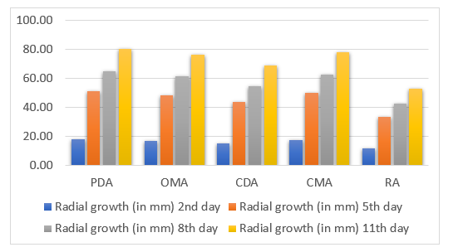

Figure 1: Graphical representation of mean radial growth of different isolated of C. truncatum up to 11 days incubation period
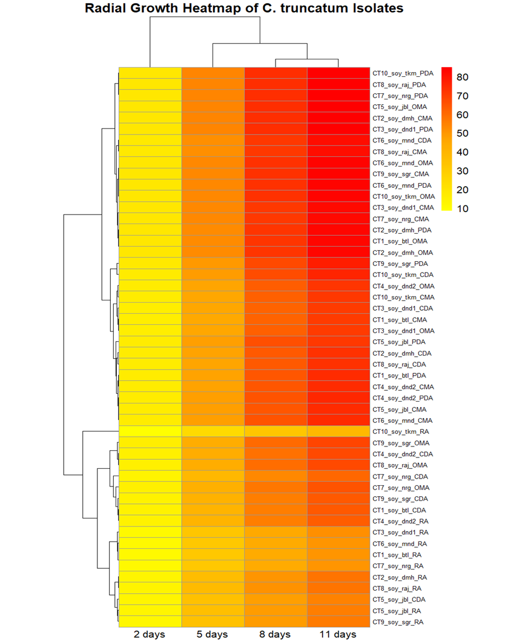
Figure 2: Hierarchical clustering based Heatmap showing the radial growth of C. truncatum isolates (CT1-CT10) cultured on five different media across four incubation periods [both rows (Isolate x Medium combinations) and columns (incubation period)]. The colour gradient (yellow-orange-red) represents increasing growth values, with yellow indicating minimal growth and red indicating maximum radial expansion.

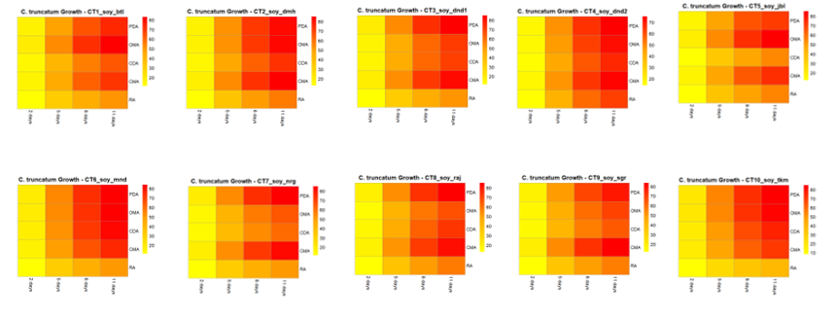
Figure 3: Isolate wise heatmaps showing radial growth (mm) of different isolates of C. truncatum cultured on five different media at four incubation intervals.

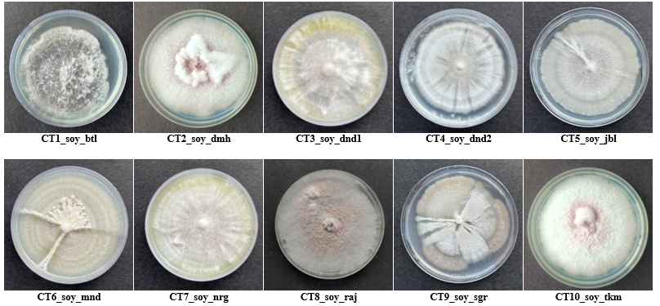

Plate 01: Mycelial growth of different isolates of Colletotrichum on Potato Dextrose Agar media

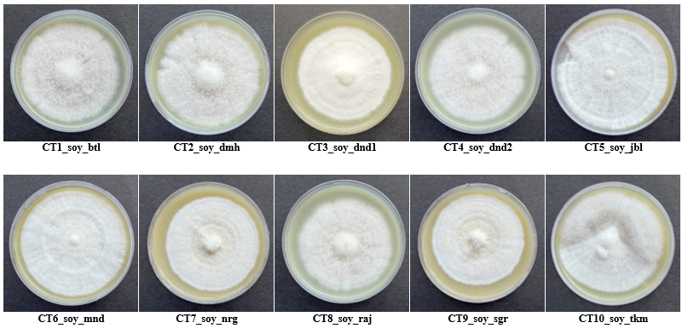
Plate 02: Mycelial growth of different isolates of Colletotrichum on Oat Meal Agar media

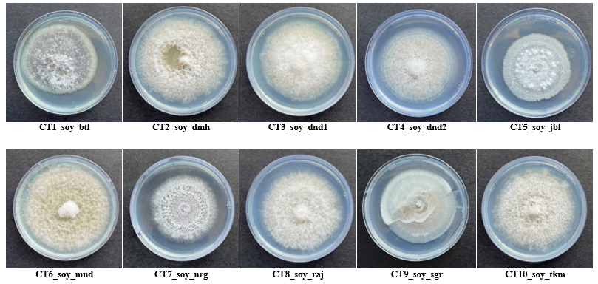
Plate 03: Mycelial growth of different isolates of Colletotrichum on Czapek’s Dox Agar media

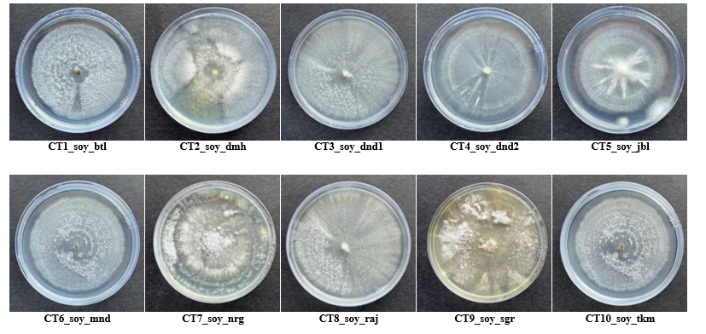
Plate 04: Mycelial growth of different isolates of Colletotrichum on Corn Meal Agar media

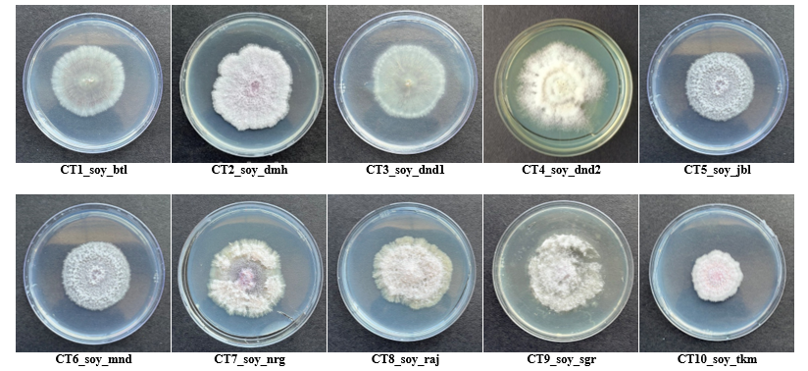
Plate 05: Mycelial growth of different isolates of Colletotrichum on Richard’s Agar media

