Review Article
Advances in Understanding Soil Microbial Diversity and Its Role in Ecosystem Functioning A Comprehensive Review

Abstract
Soil microbial diversity represents one of the most complex and essential components of terrestrial ecosystems, playing crucial roles in nutrient cycling, organic matter decomposition, and ecosystem stability. This comprehensive review examines recent advances in understanding soil microbial communities and their functional significance in ecosystem processes. Through analysis of contemporary molecular techniques including high-throughput sequencing, metagenomics, and metabolomics, we explore how technological innovations have revolutionized our understanding of microbial diversity patterns across various soil types and environmental gradients. The review synthesizes findings on key microbial groups including bacteria, archaea, fungi, and protists, examining their interactions and contributions to critical ecosystem services such as carbon sequestration, nitrogen fixation, and phosphorus mobilization. We discuss the impacts of anthropogenic activities, climate change, and land-use practices on soil microbial communities and their functional resilience. Special attention is given to the Indian subcontinent's diverse soil ecosystems, from the Indo-Gangetic plains to the Western Ghats, highlighting region-specific microbial adaptations and their agricultural implications. The review identifies current knowledge gaps and proposes future research directions, emphasizing the need for integrated approaches combining traditional and cutting-edge methodologies. Understanding soil microbial diversity is paramount for developing sustainable land management strategies, enhancing agricultural productivity, and mitigating climate change impacts through improved soil health management.
Keywords: Soil Microbiome, Ecosystem Functioning, Microbial Diversity, Nutrient Cycling, Metagenomics, Sustainable Agriculture
Introduction
Soil represents Earth's most biodiverse habitat, harboring an estimated 10⁹ to 10¹⁰ microorganisms per gram of soil, encompassing thousands of species that form complex ecological networks essential for terrestrial ecosystem functioning. The Indian subcontinent, with its diverse climatic zones ranging from the Himalayan mountains to coastal plains, presents unique opportunities for studying soil microbial diversity and its ecological implications. Understanding soil microbial communities has become increasingly critical as we face global challenges including food security, climate change, and environmental degradation.
The study of soil microbial diversity has evolved dramatically over the past decades, transitioning from culture-dependent methods that captured less than 1% of soil microorganisms to sophisticated molecular techniques that reveal the true extent of microbial complexity. This paradigm shift has unveiled the "unseen majority" of soil inhabitants, fundamentally changing our understanding of soil ecology and its role in supporting life on Earth. Indian researchers have contributed significantly to this field, particularly in understanding microbial diversity in unique ecosystems such as the Sundarbans mangroves, Thar Desert, and high-altitude Himalayan soils.
Soil microorganisms, including bacteria, archaea, fungi, protists, and viruses, form intricate networks that drive essential ecosystem processes. These microscopic organisms regulate nutrient cycles, decompose organic matter, suppress plant pathogens, enhance plant growth, and influence soil structure formation. The functional diversity of soil microbes extends far beyond their taxonomic diversity, with many species exhibiting functional redundancy that ensures ecosystem resilience. In agricultural contexts, particularly relevant to India's agrarian economy, soil microbes play crucial roles in maintaining soil fertility, crop productivity, and sustainable farming practices.
The Indian agricultural sector, which employs nearly half of the country's workforce, depends heavily on soil health and microbial diversity. Traditional farming practices in India, including organic farming and crop rotation systems, have long recognized the importance of soil biology. However, the Green Revolution's intensive agricultural practices have significantly impacted soil microbial communities, leading to reduced diversity and compromised ecosystem services. Understanding these impacts and developing strategies to restore soil microbial diversity has become a national priority.
Recent technological advances have revolutionized our ability to study soil microbial communities. High-throughput sequencing technologies, metagenomics, metatranscriptomics, and metabolomics approaches now enable comprehensive analysis of microbial community structure and function. These tools have revealed that soil microbial diversity follows distinct biogeographical patterns influenced by factors including pH, temperature, moisture, organic matter content, and land use. Indian soils, spanning from acidic lateritic soils of the Western Ghats to alkaline soils of the Indo-Gangetic plains, harbor unique microbial communities adapted to specific environmental conditions.
Climate change poses significant challenges to soil microbial diversity and functioning. Rising temperatures, altered precipitation patterns, and extreme weather events affect microbial community composition and activity. Indian soils are particularly vulnerable to climate change impacts, with predictions of increased drought stress in certain regions and flooding in others. Understanding how soil microbial communities respond to these changes is crucial for developing climate-resilient agricultural systems.
This comprehensive review aims to synthesize current knowledge on soil microbial diversity and its role in ecosystem functioning, with particular emphasis on Indian soil ecosystems. We examine recent methodological advances, discuss key findings on microbial community structure and function, analyze environmental and anthropogenic impacts, and identify research priorities for sustainable soil management. By integrating global perspectives with region-specific insights, this review provides a holistic understanding of soil microbial ecology relevant to researchers, policymakers, and practitioners working towards sustainable land management and agricultural development.
Table 1: Major Soil Microbial Groups and Functions
Microbial Group | Estimated Abundance (cells/g soil) | Primary Functions | Key Ecosystem Services
Bacteria | 10⁸-10⁹ | Decomposition, Nutrient cycling | Carbon mineralization, Nitrogen fixation
Archaea | 10⁷-10⁸ | Ammonia oxidation, Methanogenesis | Nitrogen cycling, Greenhouse gas regulation
Fungi | 10⁵-10⁶ | Organic matter decomposition | Nutrient mobilization, Soil aggregation
Actinomycetes | 10⁶-10⁷ | Antibiotic production, Decomposition | Disease suppression, Humus formation
Protists | 10⁴-10⁵ | Bacterial grazing, Nutrient release | Microbial loop regulation, Nutrient turnover
Algae | 10³-10⁴ | Photosynthesis, Nitrogen fixation | Soil crust formation, Carbon fixation
Viruses | 10⁸-10⁹ | Gene transfer, Population control | Microbial diversity maintenance, Evolution
Historical Perspective and Evolution
Early Discoveries in Soil Microbiology
The foundation of soil microbiology was laid in the late 19th century when pioneering scientists began recognizing the importance of microorganisms in soil processes. Sergei Winogradsky's discovery of chemolithotrophic bacteria and Martinus Beijerinck's enrichment culture techniques revolutionized our understanding of soil microbial diversity. In India, early soil microbiological research began in the 1920s with studies on nitrogen-fixing bacteria in agricultural soils, particularly focusing on Rhizobium species associated with leguminous crops.
Development of Cultivation Techniques
Traditional cultivation methods dominated soil microbiology research throughout much of the 20th century. Indian scientists made significant contributions to understanding culturable soil microorganisms, particularly those relevant to agriculture. The establishment of the Indian Agricultural Research Institute (IARI) in 1905 marked the beginning of systematic soil microbiological research in India. Researchers developed selective media for isolating beneficial microorganisms including Azotobacter, Azospirillum, and phosphate-solubilizing bacteria, laying the groundwork for biofertilizer development.
Molecular Revolution in Soil Microbiology
The advent of molecular techniques in the 1990s transformed soil microbiology from a cultivation-dependent to a molecular-based science. The application of 16S rRNA gene sequencing revealed that cultivation methods captured less than 1% of soil microbial diversity. This "great plate count anomaly" led to the development of cultivation-independent methods including denaturing gradient gel electrophoresis (DGGE), terminal restriction fragment length polymorphism (T-RFLP), and eventually high-throughput sequencing technologies.
Table 2: Evolution of Soil Microbial Study Methods
Time Period | Dominant Methods | Key Discoveries | Limitations Identified
1880-1920 | Direct microscopy, Cultivation | Nitrogen fixation, Decomposition | Limited morphological diversity
1920-1960 | Selective media, Enrichment | Functional groups, Biogeochemical cycles | Cultivation bias
1960-1990 | Biochemical assays, Activity measurements | Enzyme activities, Metabolic pathways | Limited phylogenetic resolution
1990-2000 | DGGE, T-RFLP, Clone libraries | Uncultured diversity, Community fingerprinting | Low throughput, PCR bias
2000-2010 | 454 Pyrosequencing, Microarrays | Deep diversity, Rare biosphere | Short read lengths
2010-2020 | Illumina sequencing, Metagenomics | Functional potential, Community assembly | Assembly challenges
2020-Present | Long-read sequencing, Multi-omics | Complete genomes, Active functions | Integration complexity
Figure 1: Timeline of Major Advances in Soil Microbiology
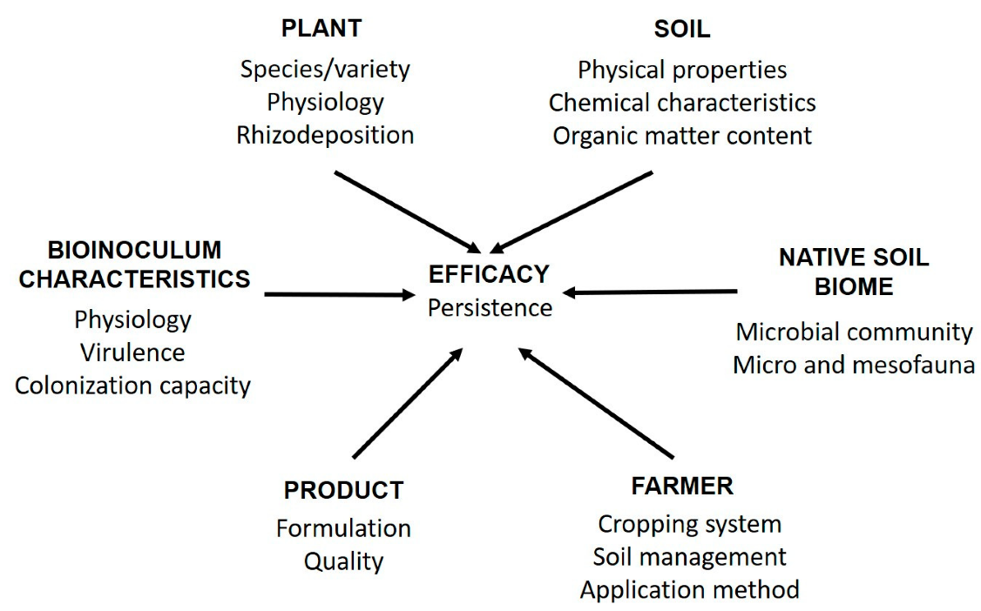
Soil Microbial Diversity: Current Understanding
Bacterial Diversity in Soil Ecosystems
Soil bacteria represent the most abundant and diverse group of soil microorganisms, with estimates suggesting 10⁴ to 10⁶ species per gram of soil. Proteobacteria, Acidobacteria, Actinobacteria, Bacteroidetes, and Firmicutes typically dominate soil bacterial communities, though their relative abundances vary significantly across soil types and environmental conditions. Indian soils exhibit unique bacterial diversity patterns influenced by monsoon cycles, temperature extremes, and diverse geological formations.
Archaeal Communities and Their Ecological Roles
Archaea, once thought to be extremophiles, are now recognized as ubiquitous soil inhabitants playing crucial roles in nitrogen and carbon cycling. Ammonia-oxidizing archaea (AOA) of the phylum Thaumarchaeota often outnumber ammonia-oxidizing bacteria in many soils, particularly in acidic and nutrient-poor conditions. Indian agricultural soils show distinct archaeal community patterns, with Nitrososphaera species dominating in rice paddies and contributing significantly to nitrification processes.
Fungal Diversity and Functional Significance
Soil fungi, though less abundant than bacteria in terms of cell numbers, contribute substantially to soil biomass and ecosystem functioning. Mycorrhizal fungi, including arbuscular mycorrhizal fungi (AMF) and ectomycorrhizal fungi (EMF), form symbiotic associations with over 80% of plant species. In Indian forest ecosystems, particularly in the Western Ghats biodiversity hotspot, fungal diversity reaches exceptional levels with numerous endemic species adapted to specific host plants and environmental conditions.
Table 3: Dominant Microbial Phyla in Different Soil Types
Soil Type | pH Range | Dominant Bacteria | Dominant Fungi | Unique Features
Alfisols | 6.0-7.5 | Proteobacteria, Actinobacteria | Ascomycota, Basidiomycota | High enzyme activity
Vertisols | 7.5-8.5 | Firmicutes, Bacteroidetes | Glomeromycota | Clay-associated communities
Ultisols | 4.5-5.5 | Acidobacteria, Verrucomicrobia | Ascomycota | Acid-tolerant species
Aridisols | 7.0-8.5 | Actinobacteria, Chloroflexi | Dothideomycetes | Drought-adapted taxa
Histosols | 3.5-6.0 | Acidobacteria, Proteobacteria | Basidiomycota | High organic matter degraders
Inceptisols | 5.5-7.0 | Proteobacteria, Planctomycetes | Glomeromycota | Diverse functional groups
Entisols | 6.0-7.5 | Bacteroidetes, Gemmatimonadetes | Ascomycota | Pioneer communities
Methodological Advances in Studying Soil Microbiomes
High-Throughput Sequencing Technologies
The revolution in DNA sequencing technologies has transformed our ability to characterize soil microbial communities comprehensively. Next-generation sequencing (NGS) platforms, particularly Illumina sequencing, have become the standard for amplicon-based community profiling. The transition from 454 pyrosequencing to Illumina MiSeq and HiSeq platforms has increased sequencing depth while reducing costs, enabling large-scale soil microbiome studies across environmental gradients.
Metagenomics and Functional Gene Analysis
Shotgun metagenomics provides insights into both taxonomic composition and functional potential of soil microbial communities. This approach has revealed the vast functional diversity of soil microbiomes, identifying novel enzymes, metabolic pathways, and biogeochemical cycles. Indian researchers have utilized metagenomics to discover novel antimicrobial compounds, cellulases, and other industrially relevant enzymes from diverse soil environments including hot springs, mangroves, and high-altitude soils.
Figure 2: Soil Microbial Diversity Across Indian Biomes
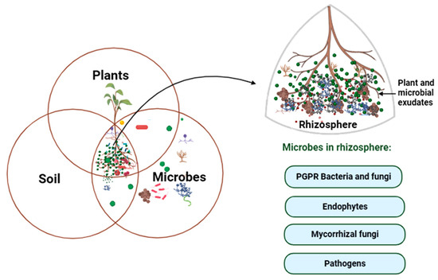
Multi-Omics Integration
The integration of metagenomics with metatranscriptomics, metaproteomics, and metabolomics provides a holistic view of soil microbial community structure and function. Metatranscriptomics reveals active community members and expressed functions, while metaproteomics identifies translated proteins and metabolomics characterizes metabolic products. These multi-omics approaches have been particularly valuable in understanding microbial responses to environmental perturbations and agricultural management practices.
Table 4: Comparison of Molecular Methods for Soil Analysis
Method | Target | Resolution | Advantages | Limitations
16S/18S/ITS Amplicon | Taxonomic markers | Genus/Species | Cost-effective, Standardized | PCR bias, Limited function
Shotgun Metagenomics | Total DNA | Species/Strain | Functional insight, Unbiased | Expensive, Complex analysis
Metatranscriptomics | RNA/cDNA | Active taxa | Real-time activity | RNA instability, Technical challenges
Metaproteomics | Proteins | Functional groups | Direct function | Limited coverage, Database dependency
Metabolomics | Metabolites | Metabolic pathways | End products, Biomarkers | Complex matrices, Standard absence
Single-cell genomics | Individual cells | Single cell | Rare taxa, Genome completion | Technical difficulty, Cost
Stable isotope probing | Active incorporators | Functional groups | Links identity-function | Labor intensive, Limited substrates
Figure 3: Multi-Omics Workflow for Soil Studies
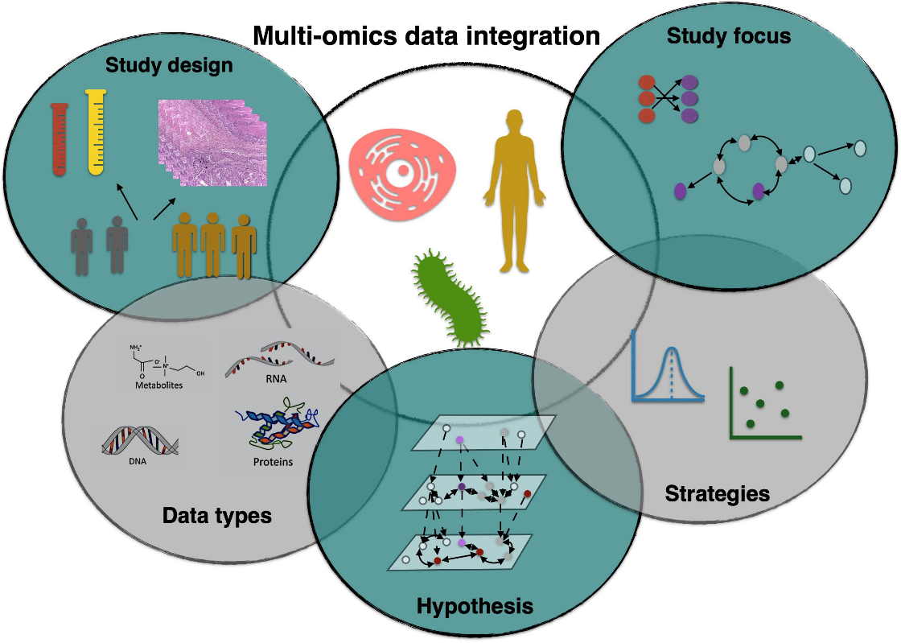
Ecosystem Functions of Soil Microorganisms
Carbon Cycling and Sequestration
Soil microorganisms play pivotal roles in global carbon cycling, decomposing organic matter and influencing carbon sequestration. Fungi, particularly saprotrophic species, possess unique enzymatic capabilities for degrading complex polymers like lignin and cellulose. Bacterial communities contribute to carbon cycling through diverse metabolic pathways, from aerobic respiration to anaerobic fermentation. In Indian agricultural systems, understanding microbial carbon cycling is crucial for enhancing soil carbon sequestration and mitigating climate change impacts.
Nitrogen Transformations
The nitrogen cycle represents one of the most complex biogeochemical cycles mediated by soil microorganisms. Biological nitrogen fixation by diazotrophs, including symbiotic Rhizobium species and free-living Azotobacter, contributes significantly to soil nitrogen inputs. Nitrification by ammonia-oxidizing bacteria and archaea, followed by denitrification by diverse bacterial groups, completes the nitrogen cycle. Indian soils, particularly in rice-wheat cropping systems, exhibit unique nitrogen cycling patterns influenced by alternate wetting and drying cycles.
Phosphorus Mobilization
Phosphorus availability often limits plant growth in tropical and subtropical soils. Phosphate-solubilizing microorganisms (PSMs), including bacteria like Pseudomonas and Bacillus species and fungi like Aspergillus and Penicillium, enhance phosphorus availability through organic acid production and phosphatase enzyme secretion. Indian researchers have isolated numerous efficient PSMs from diverse soil environments, contributing to biofertilizer development for sustainable agriculture.
Table 5: Microbial Contributions to Nutrient Cycling
Nutrient Cycle | Process | Key Microorganisms | Environmental Factors | Agricultural Importance
Carbon | Decomposition | Fungi, Actinomycetes | Temperature, Moisture | Soil organic matter maintenance
Carbon | Methanogenesis | Methanogens | Anaerobic conditions | Greenhouse gas emission
Nitrogen | N₂ fixation | Rhizobium, Azotobacter | Mo availability, pH | Reduced fertilizer need
Nitrogen | Nitrification | Nitrosomonas, AOA | Oxygen, pH | Nitrogen availability
Nitrogen | Denitrification | Pseudomonas, Paracoccus | Low oxygen, NO₃⁻ | Nitrogen loss prevention
Phosphorus | Solubilization | Bacillus, Pseudomonas | pH, Organic acids | Enhanced P availability
Sulfur | Oxidation | Thiobacillus | Oxygen, pH | Sulfate production
Environmental Factors Influencing Microbial Diversity
Soil Physical and Chemical Properties
Soil pH emerges as the master variable controlling microbial community composition, with bacterial diversity typically peaking at neutral pH and declining in acidic or alkaline conditions. Soil texture influences water retention, aeration, and nutrient availability, creating distinct microbial habitats. Clay particles provide protective microsites for microorganisms, while sandy soils support different communities adapted to lower water and nutrient availability. Indian soils spanning diverse pH ranges from acidic lateritic soils to alkaline black soils harbor distinctly adapted microbial communities.

Figure 4: Integrated Nutrient Cycling by Soil Microbes
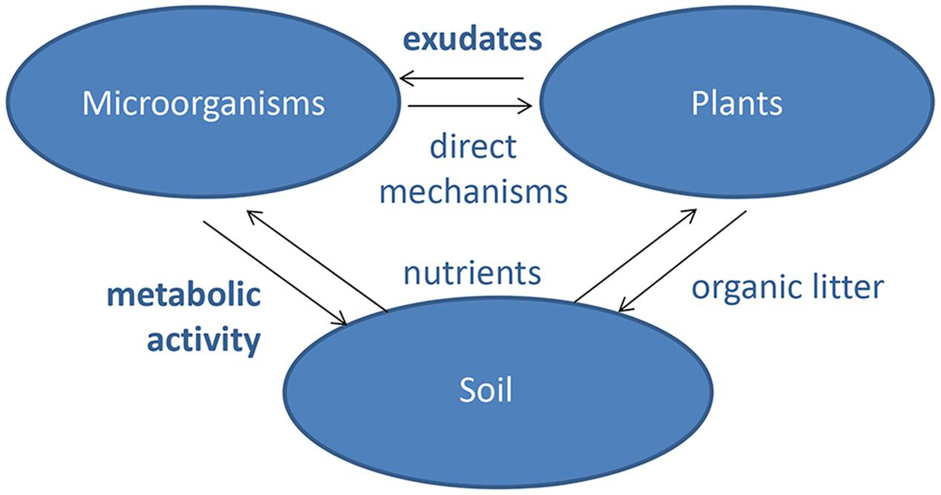
Climate and Seasonal Variations
Temperature and moisture represent critical factors shaping soil microbial communities. Monsoon-driven seasonality in India creates unique temporal dynamics in soil microbial communities, with distinct wet and dry season assemblages. Climate change-induced temperature increases and altered precipitation patterns significantly impact microbial diversity and activity. High-altitude Himalayan soils experience extreme temperature fluctuations, supporting psychrophilic and psychrotolerant microorganisms adapted to cold conditions.
Figure 5: Environmental Drivers of Microbial Diversity
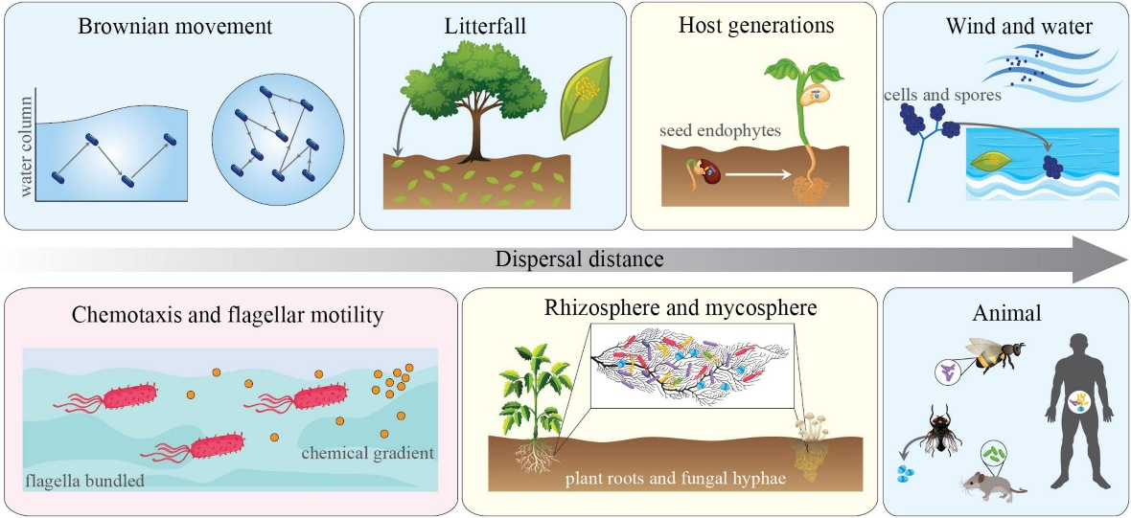
Vegetation and Plant-Microbe Interactions
Plant species identity strongly influences soil microbial community composition through root exudates, litter quality, and symbiotic associations. The rhizosphere effect creates hotspots of microbial activity and diversity. Indian forest ecosystems, from tropical evergreen forests to alpine meadows, demonstrate strong plant-microbe associations. Agricultural crop rotations and intercropping systems practiced in India create temporal and spatial heterogeneity in soil microbial communities.
Human Impacts on Soil Microbial Communities
Agricultural Intensification Effects
Intensive agricultural practices including excessive fertilizer application, pesticide use, and monoculture cropping significantly impact soil microbial diversity. Long-term fertilization studies in India reveal shifts in microbial community composition, often reducing diversity and altering functional capabilities. Continuous rice-wheat cropping in the Indo-Gangetic plains has led to declining soil health and microbial diversity, necessitating sustainable intensification approaches.
Land Use Change Consequences
Conversion of natural ecosystems to agricultural land represents one of the most significant drivers of soil microbial diversity loss. Deforestation in the Western Ghats and Northeast India has resulted in substantial changes to soil microbial communities, affecting ecosystem services. Urban expansion and industrialization create novel soil environments with altered microbial communities adapted to pollution and disturbance.
Climate Change Impacts
Rising temperatures, altered precipitation patterns, and increased frequency of extreme weather events pose significant challenges to soil microbial communities. Drought stress reduces microbial activity and alters community composition, while flooding creates anaerobic conditions favoring different microbial groups. Indian soils face particular vulnerability to climate change impacts, with predictions of increased drought stress in certain regions and intensified monsoons in others.
Table 6: Agricultural Practices and Microbial Responses
Practice | Impact on Diversity | Functional Changes | Recovery Potential | Sustainable Alternatives
Tillage | Decreased fungal biomass | Reduced aggregation | Moderate | No-till, Reduced tillage
Synthetic fertilizers | Altered community structure | Enhanced nitrification | High | Integrated nutrient management
Pesticides | Selective toxicity | Reduced beneficial microbes | Variable | Biopesticides, IPM
Monoculture | Reduced diversity | Pathogen buildup | High | Crop rotation, Intercropping
Organic amendments | Increased diversity | Enhanced cycling | Not applicable | Continue practice
Cover crops | Increased diversity | Improved soil structure | Not applicable | Promote adoption
Biochar application | Modified habitat | Carbon sequestration | Not applicable | Site-specific use
Figure 6: Impact Gradient on Soil Microbiomes
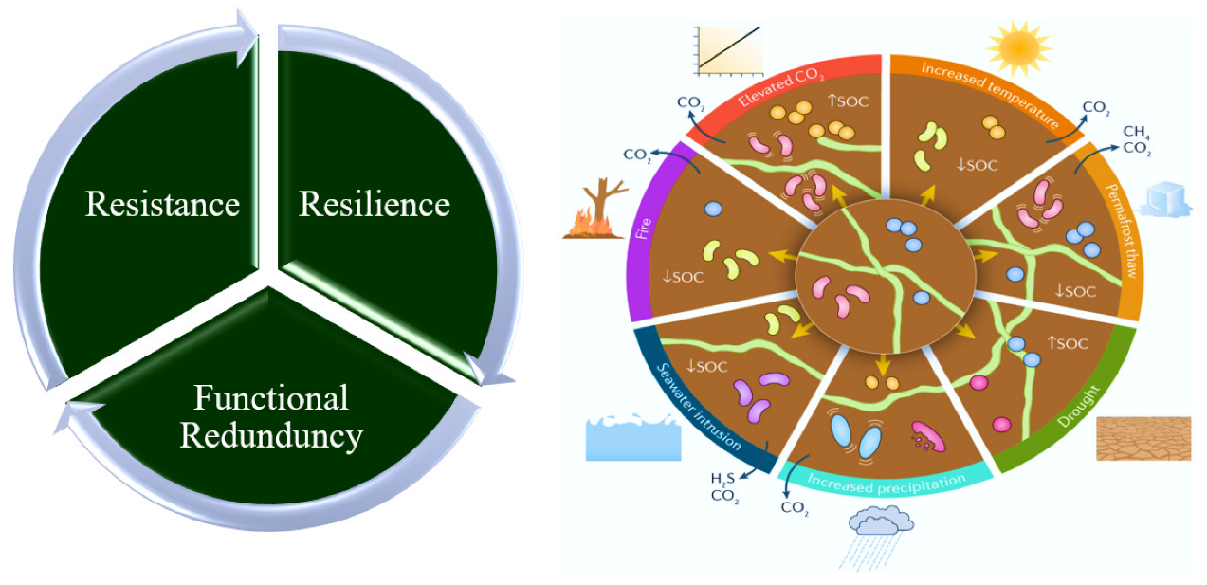
Soil Microbiomes in Indian Agroecosystems
Rice Ecosystem Microbiomes
Rice cultivation occupies over 44 million hectares in India, creating unique soil conditions through flooding and drainage cycles. Anaerobic conditions during flooding support methanogenic archaea, contributing to greenhouse gas emissions. Methanosarcina and Methanosaeta species dominate flooded rice soils, while aerobic periods support nitrifying bacteria. The rice rhizosphere harbors diverse plant growth-promoting bacteria including Azospirillum, Pseudomonas, and Bacillus species that enhance nutrient availability and stress tolerance.
Dryland Agricultural Systems
Dryland agriculture covering over 60% of India's cultivated area faces unique challenges of water limitation and nutrient stress. Soil microbial communities in these systems show adaptations to drought stress including production of extracellular polysaccharides, osmolytes, and stress proteins. Arbuscular mycorrhizal fungi play crucial roles in dryland crops, enhancing water and nutrient uptake. Indigenous drought-tolerant strains of Bacillus, Pseudomonas, and Rhizobium from Indian drylands show promise for developing bioinoculants.
Organic Farming Systems
Organic farming practices in India support higher soil microbial diversity compared to conventional systems. Regular organic matter additions through farmyard manure, vermicompost, and green manures enhance microbial biomass and activity. Studies from certified organic farms across India demonstrate increased abundance of beneficial microorganisms including nitrogen fixers, phosphate solubilizers, and biocontrol agents. The absence of synthetic pesticides allows natural microbial communities to flourish, contributing to disease suppression and nutrient cycling.
Table 7: Microbial Indicators of Soil Health
Indicator | Measurement Method | Healthy Range | Interpretation | Management Response
Microbial biomass C | Fumigation-extraction | 200-500 mg/kg | Energy reservoir | Organic matter addition
Respiration rate | CO₂ evolution | 50-150 mg/kg/day | Microbial activity | Optimize moisture
Enzyme activities | Substrate assays | Variable | Functional potential | Diverse crop rotation
PLFA diversity | Lipid extraction | >25 biomarkers | Community structure | Reduce disturbance
AMF colonization | Root staining | >40% | Symbiotic health | Reduce P fertilization
N mineralization | Incubation | >30 mg/kg/month | N availability | Adjust fertilization
Disease suppression | Bioassays | >50% reduction | Beneficial microbes | Maintain diversity
Figure 7: Soil Food Web in Agroecosystems
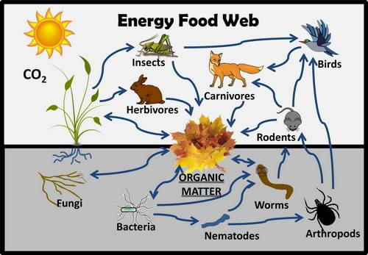
Emerging Technologies and Future Directions
CRISPR and Microbiome Engineering
CRISPR-Cas systems offer unprecedented opportunities for engineering soil microbial communities. Targeted manipulation of specific microbial functions could enhance nutrient cycling, disease suppression, or stress tolerance. However, ecological and regulatory considerations necessitate careful evaluation before field applications. Indian research institutions are exploring CRISPR applications for developing enhanced biofertilizers and biocontrol agents.
Artificial Intelligence in Microbiome Analysis
Machine learning and artificial intelligence approaches increasingly support soil microbiome research. AI algorithms predict microbial community assembly, identify keystone species, and forecast responses to environmental changes. Deep learning models trained on Indian soil microbiome datasets could guide site-specific management recommendations for sustainable agriculture.
Synthetic Microbial Communities
Designing synthetic microbial communities (SynComs) with desired functional properties represents a frontier in soil microbiome research. Combining compatible microorganisms with complementary functions could create powerful bioinoculants. Indian researchers are developing region-specific SynComs adapted to local soil conditions and crop requirements.
Figure 8: Future Technologies in Soil Microbiome Research
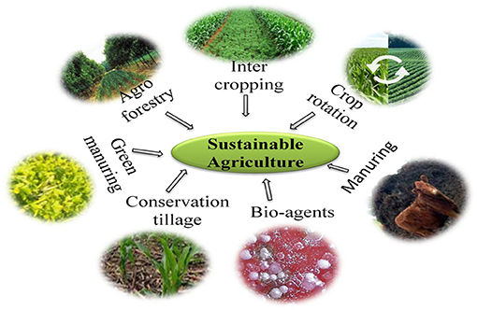
Conservation and Management Strategies
Soil Microbiome Conservation Approaches
Preserving soil microbial diversity requires integrated conservation strategies. In-situ conservation through sustainable land management practices maintains natural microbial communities. Ex-situ conservation in culture collections and biobanks preserves microbial resources for future use. India's microbial culture collections house thousands of agriculturally important strains requiring systematic characterization and preservation.
Microbiome-Based Sustainable Agriculture
Harnessing soil microbiomes for sustainable agriculture involves multiple approaches including biofertilizers, biopesticides, and microbial consortia. Precision microbiome management using real-time monitoring and targeted interventions could optimize agricultural productivity while maintaining ecological balance. Integration of traditional knowledge with modern microbiome science offers unique opportunities for developing sustainable agricultural practices suited to Indian conditions.
Policy and Implementation Frameworks
Translating soil microbiome research into practical applications requires supportive policy frameworks. Regulations for microbial inoculants, quality standards, and efficacy testing need updating based on current scientific understanding. Farmer education and extension services play crucial roles in promoting microbiome-friendly agricultural practices. Government initiatives supporting organic farming and natural farming practices in India create opportunities for enhancing soil microbial diversity at landscape scales.
Figure 9: Integrated Soil Microbiome Management
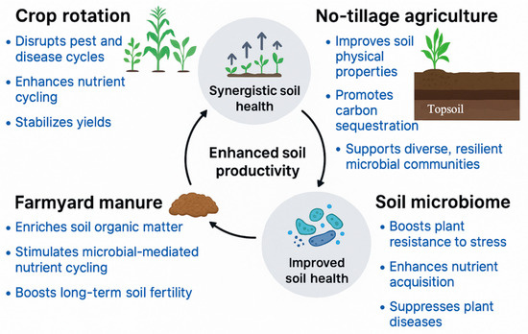
Research Gaps and Future Priorities
Understanding Microbial Dark Matter
Despite technological advances, substantial portions of soil microbial diversity remain uncharacterized. Novel cultivation techniques, single-cell genomics, and improved bioinformatics pipelines are needed to explore this "microbial dark matter." Focusing on understudied Indian ecosystems including caves, sacred groves, and extreme environments could reveal novel microbial diversity.
Functional Redundancy and Resilience
Understanding relationships between microbial taxonomic diversity, functional redundancy, and ecosystem resilience represents a critical research priority. Long-term studies across environmental gradients are needed to identify core microbiomes and keystone species. Indian long-term agricultural experiments provide valuable platforms for studying microbial community dynamics and resilience.
Microbiome-Climate Feedbacks
Soil microbiome responses to climate change and their feedbacks on greenhouse gas emissions require urgent attention. Developing region-specific models incorporating microbial processes could improve climate change predictions. Indian researchers must prioritize understanding microbiome-climate interactions in diverse ecosystems from coastal wetlands to mountain soils.
Figure 10: Research Priority Framework

Conclusion
Soil microbial diversity represents a fundamental component of ecosystem functioning, driving essential biogeochemical cycles and supporting terrestrial life. This comprehensive review highlights remarkable advances in understanding soil microbiomes through technological innovations and interdisciplinary research approaches. Indian soil ecosystems harbor exceptional microbial diversity adapted to diverse environmental conditions, offering unique opportunities for discovery and application. Future research must integrate multiple approaches from molecular biology to ecosystem ecology, addressing critical knowledge gaps while developing practical solutions for sustainable land management. Conservation of soil microbial diversity emerges as an urgent priority for maintaining ecosystem services, agricultural productivity, and environmental sustainability in an era of global change.
References
- Bardgett, R. D., & van der Putten, W. H. (2014). Belowground biodiversity and ecosystem functioning. Nature, 515(7528), 505-511.
- Bhattacharyya, P. N., & Jha, D. K. (2012). Plant growth-promoting rhizobacteria (PGPR): Emergence in agriculture. World Journal of Microbiology and Biotechnology, 28(4), 1327-1350.
- Delgado-Baquerizo, M., Oliverio, A. M., Brewer, T. E., Benavent-González, A., Eldridge, D. J., Bardgett, R. D., Maestre, F. T., Singh, B. K., & Fierer, N. (2018). A global atlas of the dominant bacteria found in soil. Science, 359(6373), 320-325.
- Fierer, N. (2017). Embracing the unknown: Disentangling the complexities of the soil microbiome. Nature Reviews Microbiology, 15(10), 579-590.
- Gupta, V. V. S. R., & Germida, J. J. (2015). Soil aggregation: Influence on microbial biomass and implications for biological processes. Soil Biology and Biochemistry, 80, A3-A9.
- Jansson, J. K., & Hofmockel, K. S. (2020). Soil microbiomes and climate change. Nature Reviews Microbiology, 18(1), 35-46.
- Kumar, A., & Dubey, A. (2020). Rhizosphere microbiome: Engineering bacterial competitiveness for enhancing crop production. Journal of Advanced Research, 24, 337-352.
- Lal, R. (2016). Soil health and carbon management. Food and Energy Security, 5(4), 212-222.
- Lehmann, J., Bossio, D. A., Kögel-Knabner, I., & Rillig, M. C. (2020). The concept and future prospects of soil health. Nature Reviews Earth & Environment, 1(10), 544-553.
- Nannipieri, P., Ascher-Jenull, J., Ceccherini, M. T., Landi, L., Pietramellara, G., Renella, G., & Schloter, M. (2020). Beyond microbial diversity for predicting soil functions: A mini review. Pedosphere, 30(1), 5-17.
- Prasad, R., Kumar, M., & Varma, A. (2015). Role of PGPR in soil fertility and plant health. In D. Egamberdieva, S. Shrivastava, & A. Varma (Eds.), Plant-growth-promoting rhizobacteria (PGPR) and medicinal plants (pp. 247-260). Springer.
- Rillig, M. C., Ryo, M., Lehmann, A., Aguilar-Trigueros, C. A., Buchert, S., Wulf, A., Iwasaki, A., Roy, J., & Yang, G. (2019). The role of multiple global change factors in driving soil functions and microbial biodiversity. Science, 366(6467), 886-890.
- Sahu, P. K., Singh, D. P., Prabha, R., Meena, K. K., & Abhilash, P. C. (2019). Connecting microbial capabilities with the soil and plant health: Options for agricultural sustainability. Ecological Indicators, 105, 601-612.
- Saxena, A. K., Kumar, M., Chakdar, H., Anuroopa, N., & Bagyaraj, D. J. (2020). Bacillus species in soil as a natural resource for plant health and nutrition. Journal of Applied Microbiology, 128(6), 1583-1594.
- Sergaki, C., Lagunas, B., Lidbury, I., Gifford, M. L., & Schäfer, P. (2018). Challenges and approaches in microbiome research: From fundamental to applied. Frontiers in Plant Science, 9, 1205.
- Sharma, S. K., Ramesh, A., Sharma, M. P., Joshi, O. P., Govaerts, B., Steenwerth, K. L., & Karlen, D. L. (2011). Microbial community structure and diversity as indicators for evaluating soil quality. In E. Lichtfouse (Ed.), Biodiversity, biofuels, agroforestry and conservation agriculture (pp. 317-358). Springer.
- Singh, B. K., Bardgett, R. D., Smith, P., & Reay, D. S. (2010). Microorganisms and climate change: Terrestrial feedbacks and mitigation options. Nature Reviews Microbiology, 8(11), 779-790.
- Singh, B. K., & Trivedi, P. (2017). Microbiome and the future for food and nutrient security. Microbial Biotechnology, 10(1), 50-53.
- Singh, J. S., Pandey, V. C., & Singh, D. P. (2011). Efficient soil microorganisms: A new dimension for sustainable agriculture and environmental development. Agriculture, Ecosystems & Environment, 140(3-4), 339-353.
- Tiedje, J. M., Bruns, M. A., Casadevall, A., Criddle, C. S., Eloe-Fadrosh, E., Karl, D. M., Nguyen, N. K., & Zhou, J. (2022). Microbes and climate change: A research prospectus for the future. mBio, 13(3), e00800-22.
- Trivedi, P., Delgado-Baquerizo, M., Trivedi, C., Hu, H., Anderson, I. C., Jeffries, T. C., Zhou, J., & Singh, B. K. (2016). Microbial regulation of the soil carbon cycle: Evidence from gene-enzyme relationships. The ISME Journal, 10(11), 2593-2604.
- Trivedi, P., Leach, J. E., Tringe, S. G., Sa, T., & Singh, B. K. (2020). Plant-microbiome interactions: From community assembly to plant health. Nature Reviews Microbiology, 18(11), 607-621.
- van der Heijden, M. G. A., Bardgett, R. D., & van Straalen, N. M. (2008). The unseen majority: Soil microbes as drivers of plant diversity and productivity in terrestrial ecosystems. Ecology Letters, 11(3), 296-310.
- Wagg, C., Schlaeppi, K., Banerjee, S., Kuramae, E. E., & van der Heijden, M. G. A. (2019). Fungal-bacterial diversity and microbiome complexity predict ecosystem functioning. Nature Communications, 10(1), 4841.
- Wall, D. H., Nielsen, U. N., & Six, J. (2015). Soil biodiversity and human health. Nature, 528(7580), 69-76.
- Wang, F., Chen, S., Wang, Y., Zhang, Y., Hu, C., & Liu, B. (2018). Long-term nitrogen fertilization elevates the activity and abundance of nitrifying and denitrifying microbial communities in an upland soil: Implications for nitrogen loss from intensive agricultural systems. Frontiers in Microbiology, 9, 2424.
- Yadav, A. N., Verma, P., Kumar, S., Kumar, V., Kumar, M., Singh, B. P., Saxena, A. K., & Dhaliwal, H. S. (2018). Actinobacteria from rhizosphere: Molecular diversity, distributions, and potential biotechnological applications. In B. K. Singh, R. Bardgett, P. Smith, & D. Reay (Eds.), New and future developments in microbial biotechnology and bioengineering (pp. 13-41). Elsevier.
- Zhang, Y., Li, Q., Chen, Y., Dai, Q., & Hu, J. (2019). Dynamic change in enzyme activity and microbial community structure during biodegradation of petroleum compounds: A laboratory experiment. Journal of Environmental Sciences, 76, 361-373.
- Zhou, J., Deng, Y., Shen, L., Wen, C., Yan, Q., Ning, D., Qin, Y., Xue, K., Wu, L., He, Z., Voordeckers, J. W., Nostrand, J. D. V., Buzzard, V., Michaletz, S. T., Enquist, B. J., Weiser, M. D., Kaspari, M., Waide, R., Yang, Y., & Brown, J. H. (2016). Temperature mediates continental-scale diversity of microbes in forest soils. Nature Communications, 7, 12083.

