Original Research Article

Performance Evaluation of Tractor Operated Boom Sprayer on Tomato Crop

ABSTRACT

Efficient pesticide application is essential for sustainable agriculture, especially in large-scale farms where manual spraying is labor-intensive and inconsistent. This study evaluates the performance of a tractor-operated boom sprayer under laboratory and field conditions. Key operational parameters such as nozzle discharge rate, spray uniformity, field capacity, efficiency, and fuel consumption were analyzed. Laboratory tests indicated nozzle discharge increased with pressure, with uniform spray coverage achieved at 3-4 kg/cm². Field evaluations on tomato crops revealed an effective field capacity of 1.27 – 1.84 ha/hr, field efficiency between 78–85%, and a fuel consumption rate of 2.24–2.4 l/hr. The estimated operational cost ranged between ₹ 265 – 384 per hectare, significantly lower than manual spraying costs. Results demonstrate that the boom sprayer ensures uniform pesticide application, reduces labor requirements, and enhances operational efficiency, making it suitable for medium- to large-scale farms.

Keywords: Boom sprayer; Pesticide application, Field efficiency, Operational cost, Agricultural mechanization.

1. INTRODUCTION

Agriculture has always been the backbone of human civilization, providing food, feed, and raw materials to sustain life and industry. In many developing countries, agriculture plays an important role in the economy and employs large number of rural populations, reducing poverty and support sustainable developments (Praburaj, 2018). Increasing the agricultural productivity is very essential to meet the food demands of a growing and urbanizing population, especially as expanding cultivated land is no longer feasible. However, modern agriculture faces significant challenges, including declining arable land, water scarcity, climate variability, and pest and disease pressures (Calicioglu et al., 2019; Das et al., 2020). Among these, biotic stresses such as insect pests, weeds, and plant pathogens are particularly devastating, accounting for 20–40% yield losses annually in major crops worldwide (Food and Agriculture Organization of the United Nations, 2017; Pandey et al., 2017). Chemical crop protection using pesticides and herbicides remains one of the most widely adopted strategies to control pests and diseases. However, the efficiency of chemical application is heavily dependent on timely and precise plant protection measures (Bobrovskiy et al., 2021; Dorokhov, 2022). Traditional tools such as hand-operated knapsack sprayers, rocker sprayers, and foot-operated pumps are still commonly used in small-scale farming due to their low initial cost and ease of handling (Bhatt et al., 2021; P et al., 2022). While these devices allow farmers to directly target crops, they have several limitations including low field capacity, high labor demand, operator fatigue, inconsistent spray patterns, and increased health risks due to direct chemical exposure (Karthikeyan et al., 2009; P et al., 2022). Moreover, uneven pesticide application from manual sprayers often leads to under-dosing or overdosing, resulting in poor pest control, pesticide resistance, and environmental contamination (An et al., 2020).
To overcome these limitations, mechanization in pesticide application has led to the development of tractor-mounted and tractor-operated sprayers. Among these, the tractor-operated boom sprayer has become an essential tool in modern, mechanized agriculture. Equipped with a horizontal boom carrying multiple nozzles, it ensures uniform and simultaneous application of agrochemicals across wide swaths of farmland (Gholap & Kushwah, 2015). Power to operate the sprayer’s pump is typically taken from the tractor’s Power Take-Off (PTO) shaft, enabling consistent operating pressure and uniform spray distribution. Compared to manual and motorized knapsack sprayers, boom sprayers significantly increase field capacity (up to 1–2 ha/hr), reduce labor and chemical costs, and improve precision in application (Lal et al., 2024).
The performance of a boom sprayer, however, depends on multiple interrelated factors such as nozzle type, spray pressure, boom height, forward speed, and droplet size. Previous studies have shown that nozzle discharge characteristics and spray distribution directly influence canopy coverage, drift potential, and overall pesticide use efficiency (Pan et al., 2025; Pramod et al., 2023). Uniform spray deposition not only maximizes crop protection but also minimizes chemical wastage and reduces environmental pollution. Evaluating the field performance of boom sprayers under specific crop and regional conditions is therefore necessary to ensure their adaptability and cost-effectiveness for farmers.
Considering all these points, the study was taken to evaluate the performance of the widely available tractor operated boom type sprayer. The study aims to evaluate the operational efficiency, spray uniformity, and cost economics of a tractor-operated boom sprayer procured and tested for tomato crop under varying field conditions in Parbhani, India. The detailed objectives of the study were:
- To evaluate the field performance of a tractor-operated boom sprayer on tomato crop.
- To assess the uniformity and adequacy of chemical application under laboratory and field conditions.
- To analyze the operational cost and fuel consumption of the sprayer for economic feasibility.

2. material and methods

This study was conducted to evaluate the technical performance, spray characteristics, and cost economics of a tractor-operated boom sprayer. The methodology included laboratory calibration, field trials on tomato crops, and cost analysis based on standard procedures.

2.1 Experimental Site

The field evaluation was carried out at the Vegetable Farm, College of Agricultural Engineering & Technology (CAET), VNMKV, Parbhani (Maharashtra, India). The experimental plot size was 40 m × 50 m (0.2 ha). The farm soil was Black cotton soil, clayey in texture medium, weak subangular blocky to medium, strong, angular blocky in structure with moderate fertility, and tomato (Solanum lycopersicum) was selected as the test crop. The crop was planted under plastic mulch with a row-to-row spacing of 1.5 m and plant-to-plant spacing of 0.5 m. The average plant height at the time of testing was approximately 0.4 - 0.60 m, with an average canopy width of 0.6 m. Weather parameters such as temperature, relative humidity, and wind speed were recorded during the trials.

2.2 Sprayer Specifications

The boom sprayer consisted of a stainless steel (304 grade) boom, mounted on a fabricated frame, equipped with multiple hydraulic nozzles, a chemical tank, pump, and pressure control system. The detailed specifications are represented in Table 1.

Table 1: Specification of Tractor Mounted Boom sprayer
S. No. | Parts Name | Specification
 | Sprayer Boom
 | Material | Cast iron
 | Type | Foldable
 | Boom length | 518 cm
 | Boom height | Adjustable (20-210 cm), interval - 10 cm
 | Sprayer Tank
 | Shape | Cylindrical
 | Capacity | 200 liters
 | Length | 890 mm
 | Outer diameter | 600 mm
 | Main Frame
 | Material | Cast iron, L angle Shape
 | Size (L×W×H) | 650×300×1420, mm
 | Sprayer Pump
 | Type | Piston pump (HTP)
 | No. of plunger | 3
 | Pump revolution | 800-1000 RPM
 | Suction Volume | 45-55 liter/min.
 | Operation pressure | 20-45 kg/cm²
 | Power required | 3-5 HP
 | Nozzle
 | Type | Flat fan
 | Discharge per nozzle | 757-1893 ml/min. at 2.07 bar pressure
 | No. of nozzle | 12
 | Nozzle spacing | Adjustable (15-45 cm), interval – 15 cm

2.3 Laboratory Tests

Under laboratory setting, the tractor mounted boom sprayer was tested to assess its performance under several circumstances. The experiment was carried out under various parameters including nozzle discharge, nozzle spray distribution, and pump performance under several operating pressures. The laboratory calibration of sprayers was conducted according to the BIS Code of IS: 11429 (1985): Methods for calibration of sprayers.

2.3.1 Nozzle Discharge

The method of volume-time measurement was used to assess boom type sprayer's discharge. The spray volume collected in a measuring cylinder for one minute duration of each nozzle at all levels of operating pressure. The total nozzle discharge on each boom provides the spray boom's discharge.

2.3.2 Nozzle Spray Angle

The spray angle hinted at the spread of the spray. Observing a functioning rear nozzle helped to define it. The angles differ significantly in several nozzles. With the technique described in IS 3652:1995 section F-9, the spray angle was determined.

2.3.3 Pump Performance

The performance of pump was determined as per the procedure given in test code IS: 8548:1977. The discharge capacity and power required for operating pump was determined. At four different pressures, the pump was run; bypass flow and discharge capability were noted at each pressure. The power needed to operate the pump was also calculated and documented.

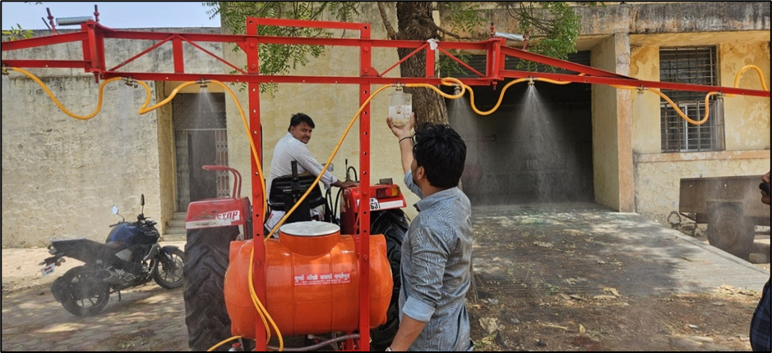
Fig. 1: Laboratory testing of tractor operated boom sprayer

2.4 Field Evaluation

The tractor operated boom sprayer was also tested in the field condition and various parameters were measured as follows:

2.4.1 Forward Speed

Before each experiment was carried out, the travel speed of tractor was calibrated for specified forward speed. In order to prevent mistakes, a test trial carried out in the same field condition for spraying operations on the same day is used for speed of operation calibration. Speed was calculated based on the time taken for travelling 50 m.

$$Forward speed( kmph)= \frac{Distance (50 m)}{Time taken to travel the given distance (s)}×3.6$$
………. (1)

2.4.2 Nozzle Pressure

Nozzle pressure is the amount of pressure needed at the nozzle to create an efficient spray stream. The pressure gauge fitted on the sprayer was used to measure the nozzle pressure.

2.4.3 Fuel Consumption

Before the beginning of each trial, the tractor's fuel tank was filled completely; after the trial, the tank was refilled again. The amount of fuel required to fill the tank up to the previous mark was considered as fuel consumption.

$$Fuel consumption \left(l/{hr}\right)= \frac{Amount of fuel required to fill the tank (litre)}{Time taken during the trial (hour)}$$
………. (2)

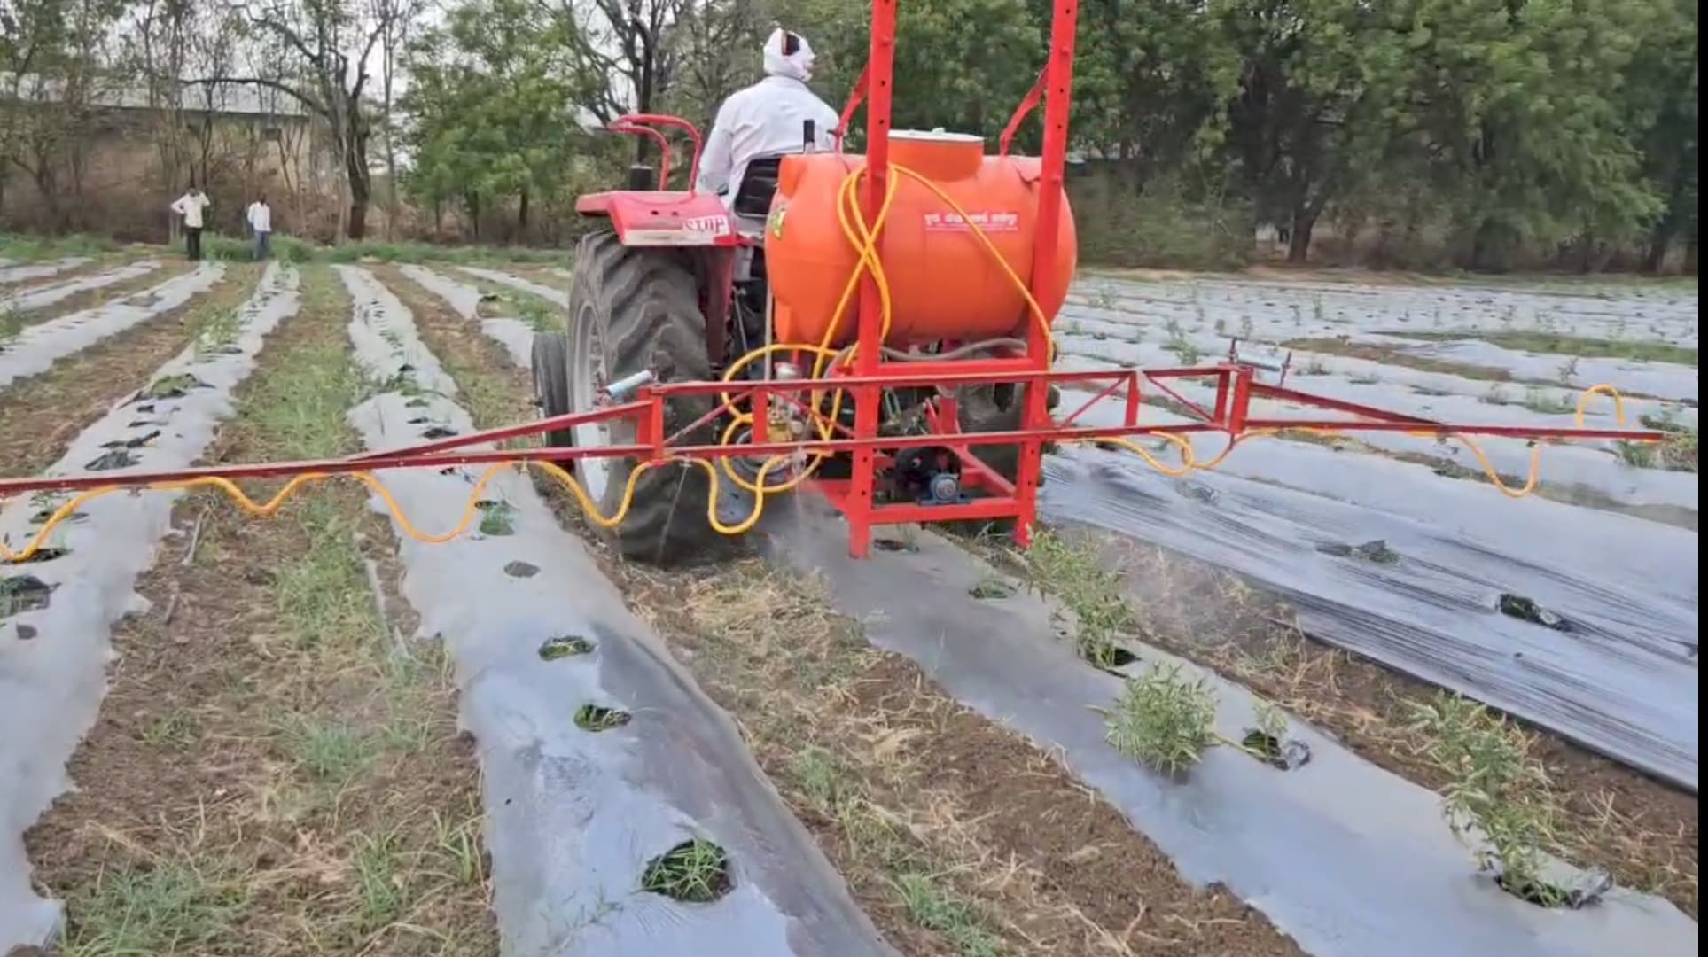
Fig. 2: Performance evaluation of tractor operated boom sprayer at field condition

2.4.4 Theoretical Field Capacity

It is the maximum possible rate at which any machine can cover the field if it operates at 100% efficiency, without any overlaps in operation, any interruption or any time losses in between.

$$Theoretical field cpacity \left({ha}/{hr}\right)=\frac{Machine width \left(m\right)×Speed (kmph)}{10}$$
………. (3)

2.4.5 Actual Field Capacity

It is the real rate at which a machine covers the field, taking into account all the field losses including headlands, overlaps, fuel refilling, repairs and operator delays.

$$Actual field capacity ({ha}/{hr})=\frac{Actual area covered (ha)}{Total time taken (hr)}$$ | ………. (4)

2.4.6 Field Efficiency

It’s a parameter used to compare the actual field performance with the ideal performance.

$$Field effiiency \left(\%\right)=\frac{Actual field capacity}{Theoretical field capacity}×100$$ | ………. (5)

2.5 Cost Economics

Cost economics of the tractor operated boom sprayer was assessed in accordance with IS 9164:1979. It involved the calculation of fixed cost and variable cost. The fixed costs include depreciation, interest, taxes, shelter and insurance. While the variable costs consist of cost viz. repair and maintenance costs, fuel and, oil or lubrication costs, and labour costs. The following formulae were used for calculating these expenditures.

$$Depreciation(D)=\frac{P-S}{L×h}$$ | ………. (6)
$$Interest\left(I\right)=\frac{P+S}{2}×\frac{i}{100}$$ | ………. (7)

Where,
P = purchase price of sprayer
S = salvage value (considered 10% of the purchase price)
L = Life span of sprayer in year
H = Annual working hours of the sprayer

The insurance and shelter costs together were estimated as 2% of the purchase price per year. The variable costs were calculated by calculating the labour and fuel costs based on actual market price. The cost of the lubrication oil was considered as 20% of the fuel cost. While, costs for repair and maintenance were estimated as 10% of the purchase price per year. The total operating cost per hour was calculated by adding up fixed and variable costs.
3. results and discussion

The performance evaluation of the tractor-operated boom sprayer was carried out under laboratory and field conditions. The result showed that the nozzle discharge during laboratory testing increased with increase in operating pressure. At 2.0 kg/cm² pressure, the average nozzle discharge was 1.82 l/min, which increased to 2.15 l/min at 2.5 kg/cm², and 2.46 l/min at 3.0 kg/cm². These findings of linear increase in discharge are consistent with hydraulic nozzle principles, reported by other researchers (Ghafoor et al., 2022; Jassowal et al., 2016). The results also indicated that the operating pressure of 3.0 kg/cm² provided optimum discharge without causing excessive drift. These findings align with various researchers, who reported better spray coverage at medium pressure levels.
During field testing, for a tomato with plastic mulching, decrease pressures was preferred to reduce with the flow onto the mulch while ensuring adequate coverage of the tomato plants. The sprayer tested on pressure of 1 bar, 2 bar and 3 bar which fall inside the endorsed vary of 1.03 to 2.76 bar for flat fan nozzles in this context. The discharge from single nozzle as well as from complete boom is enlisted in Table 2. This trend is consistent with the hydraulic principle where nozzle flow rate increases with the square root of pressure. It confirms that the sprayer was properly calibrated and able to deliver sufficient spray volume across operating pressures. However, at lower pressure (1.0 kg/cm²), the discharge was not sufficient enough for large scale spraying operations, though it could be used for delicate crops like Spinach, Lettuce and coriander which requires fine application. At higher pressure (2.0–3.0 kg/cm²), the sprayer achieved optimum discharge rates, ensuring adequate canopy coverage while minimizing potential drift. The spray angle for flat fan nozzle used in this study was recorded to be 110-120 degree.

Table 2: Discharge from spray boom in horizontal orientation at different pressure
S. No | Pressure  (kg/cm²) | Single Nozzle Discharge (ml/min) | Total Boom Discharge  (ml/min)
1. | 1 | 669.17 | 8030
2. | 2 | 946.67 | 11360
3. | 3 | 1160 | 13920
Speed of operation: 3 - 4 kmph

The swath width was measured as 5.4 m at the boom height of 0.6 m from ground. The application rate of the boom sprayer having swath width of 5.4 m was reported as 385 - 515 l/ha at an operation speed of 3-4 kmph. The theoretical field capacity of the sprayer was estimated as 1.62 – 2.16 ha/hr and effective field capacity as 1.27 – 1.84 ha/hr with field efficiency ranges from 78 to 85%.

Fig. 3: Variation in single nozzle discharge at different operating pressure

The fuel consumption of the tractor while operating the boom sprayer on a mulched tomato field was measured under actual field conditions as per the methodology described. The average fuel consumption of the tractor during spraying operations was recorded as 2.24 – 2.4 liters per hour. This consumption includes the fuel used for maintaining engine speed, PTO engagement for powering the sprayer pump, and traction during movement across the field. The value is considered efficient for boom sprayers in small- to medium-sized field operations and is in line with standard fuel usage rates for similar tractor-mounted equipment.

3.1 Cost analysis

The cost of operation of the tractor-operated boom sprayer was calculated as per the procedure outlined in IS:9164–1979, taking into account both fixed and variable costs. Fixed costs included depreciation, interest, housing, and insurance, while variable costs comprised fuel, lubrication, repair and maintenance, and labor charges. The total fixed cost of the sprayer was estimated at ₹ 77.13 per hour, while the variable cost was ₹ 410.29 per hour, giving a total operating cost of ₹ 487.42 per hour. Considering the measured effective field capacity of 1.27–1.84 ha/hr, the cost of spraying per hectare was calculated to be in the range of ₹ 265 – 384. This operational cost is considerably lower than that of manual spraying using knapsack sprayers, which typically ranges from ₹2000 to ₹2500 per hectare due to higher labor requirements and longer operating times.

S. No. | Particulars | Value | Calculation basis
 | Fixed costs
 | Cost of boom sprayer | ₹ 68,000 | Market price
 | Life span | 8 years | Standard value
 | Working hours per year | 150 hours | Standard value
 | Salvage value | ₹ 6,800 | 10% of initial cost
 | Interest rate per year | 10% | Standard value
 | Housing and insurance | 2% of (a) | Standard value
 | Depreciation cost per hour | ₹ 51 | Equation (6)
 | Interest cost per hour | ₹ 25 | Equation (7)
 | Housing and insurance cost per hour | ₹ 1.133 | 2% of purchase price
 | Total Fixed cost per hour | ₹ 77.133 | -
 | Variable costs
 | Fuel Price per liter | ₹ 92 | Market price
 | Lubrication | 20% of fuel price | Standard value
 | Repair and maintenance | 10% of (a) per year | Standard value
 | Operator wage | ₹ 100 per hour | Market price
 | Fuel cost per hour | ₹ 220.8 | Fuel consumption - 2.4 l/hr
 | Lubrication cost per hour | ₹ 44.16
 | Repair and maintenance cost per hour | ₹ 45.33
 | Operator cost per hour | ₹ 100
 | Total variable cost per hour | ₹ 410.29
 | Total cost of operation per hour | ₹ 487.42 | Sum of total fixed and variable cost per hour

4. Conclusion

The performance evaluation of the tractor-operated boom sprayer demonstrated that the machine is both technically efficient and economically viable for crop protection operations. Laboratory tests confirmed that nozzle discharge increased proportionally with pressure and produced droplet sizes within the recommended range for foliar spraying, ensuring effective coverage. Field trials on tomato crops revealed an effective field capacity of 1.27 - 1.84 ha/hr with a field efficiency of 78 - 85%, coupled with a moderate fuel consumption of 2.24 - 2.40 l/hr. The sprayer achieved uniform pesticide deposition across the canopy, reducing labor requirements and operating time compared to manual spraying. Cost economics analysis further established that the operational cost of ₹ 265 - 384 per hectare is significantly lower than that of conventional knapsack sprayers, highlighting its economic advantage. This study confirms that tractor-operated boom sprayers can enhance efficiency, reduce labor dependency, and ensure sustainable crop protection. Future work may integrate smart technologies such as variable rate nozzles and IoT-enabled monitoring for precision agriculture applications.

References

An, Q., Li, D., Wu, Y., & Pan, C. (2020). Deposition and distribution of myclobutanil and tebuconazole in a semi-dwarf apple orchard by hand-held gun and air-assisted sprayers application. Pest Management Science, 76, 4123–4130. https://doi.org/10.1002/ps.5968

Bhatt, G., Singh, M., Bharti, A., & Rana, D. (2021). Traditional and Modern Agricultural Implements Used in Agro Sciences – A Case Study in the Part of National Capital Region of Uttar Pradesh, India. Springer Proceedings in Earth and Environmental Sciences. https://doi.org/10.1007/978-3-030-79065-3_12

Bobrovskiy, A. V., Kryuchkov, A. A., Kozulina, N. S., Vasilenko, A. V., & Mikhailets, M. A. (2021). Research on the efficiency of plant protection products in sowing spring wheat. IOP Conference Series: Earth and Environmental Science, 839(4), 042015. https://doi.org/10.1088/1755-1315/839/4/042015

Calicioglu, O., Flammini, A., Bracco, S., Bellù, L., & Sims, R. (2019). The Future Challenges of Food and Agriculture: An Integrated Analysis of Trends and Solutions. Sustainability, 11(1), 222. https://doi.org/10.3390/su11010222

Das, J., Jha, S., Goyal, M., & Surampalli, R. (2020). Challenges of Sustainability in Agricultural Management. Sustainability, 339–356. https://doi.org/10.1002/9781119434016.ch16

Dorokhov, A. (2022). TECHNICAL MEANS FOR CHEMICAL PROTECTION OF PLANTS: CURRENT STATE AND DEVELOPMENT PROSPECTS. Agricultural Engineering, 24(3), 12–18. https://doi.org/10.26897/2687-1149-2022-3-12-18

Food and Agriculture Organization of the United Nations (Ed.). (2017). The future of food and agriculture: Trends and challenges. Food and Agriculture Organization of the United Nations.

Ghafoor, A., Khan, F. A., Khorsandi, F., Khan, M. A., Nauman, H. M., & Farid, M. U. (2022). Development and Evaluation of a Prototype Self-Propelled Crop Sprayer for Agricultural Sustainability in Small Farms. Sustainability, 14(15), 9204. https://doi.org/10.3390/su14159204

Gholap, B., & Kushwah, O. S. (2015). Comparative performance of tractor operated boom type field sprayers on cotton crop. INTERNATIONAL JOURNAL OF AGRICULTURAL ENGINEERING, 8(1), 85–91. https://doi.org/10.15740/HAS/IJAE/8.1/85-91

Jassowal, N. S., Singh, S., Dixit, A., & Khurana, R. (2016). Field Evaluation of a Tractor Operated Trailed type Boom Sprayer. Agricultural Engineering Today, 40, 41–52.

Karthikeyan, C., Veeraragavathatham, D., Karpagam, D., & Firdouse, S. (2009). Traditional tools in agricultural practices. Indian Journal of Traditional Knowledge, 8, 212–217.

Lal, S., Meena, S. S., Koumary, N. K., Lahre, J., & Adile, S. S. (2024). Empowering Vegetable Farmers: Energy Analysis and Evaluating the Impact of a Battery-operated Boom Sprayer. Journal of Scientific Research and Reports, 30(9), 825–836. https://doi.org/10.9734/jsrr/2024/v30i92409

P, P., B, N., S, L., & R, S. (2022). Analysis of traditional agricultural tools used by the farm women in Southern district of Tamil Nadu. International Journal of Agriculture Extension and Social Development, 5(1), 01–06. https://doi.org/10.33545/26180723.2022.v5.i1a.115

Pan, X., Yang, S., Gao, Y., Wang, Z., Zhai, C., & Qiu, W. (2025). Evaluation of Spray Drift from an Electric Boom Sprayer: Impact of Boom Height and Nozzle Type. Agronomy, 15(1), 160. https://doi.org/10.3390/agronomy15010160

Pandey, P., Irulappan, V., Bagavathiannan, M. V., & Senthil-Kumar, M. (2017). Impact of Combined Abiotic and Biotic Stresses on Plant Growth and Avenues for Crop Improvement by Exploiting Physio-morphological Traits. Frontiers in Plant Science, 8. https://doi.org/10.3389/fpls.2017.00537

Praburaj, L. (2018). Role of Agriculture in the Economic Development of a Country. Shanlax International Journal of Commerce, 6(3), 1–5. https://doi.org/10.5281/zenodo.1323056

Pramod, P. P., Raosaheb, G. N., Kashinath, K. J., & Madhukar, N. S. (2023). Performance evaluation of tractor mounted boom sprayer on chilly crop. Environment Conservation Journal, 24(2), 61–69. https://doi.org/10.36953/ECJ.13582406

