Integrating Remote Sensing and GIS for Irrigated Area Identification Study on the Betwa River Basin, India

Abstract
Accurate mapping of irrigated and non-irrigated croplands is vital for water resource management and food security in semi-arid regions. This study mapped irrigated areas in the Betwa River Basin (43,469 km²), a major Yamuna tributary, using MODIS Terra surface reflectance (MOD09Q1) data for the 2020–2021 agricultural year. A total of 45 Normalized Difference Vegetation Index (NDVI) composites (250 m) were generated to capture seasonal phenology, and a Maximum Value Composite (MVC) approach minimized atmospheric effects, yielding a 46-layer NDVI dataset. Unsupervised classification (ISODATA; 40 spectral classes, convergence 0.98) was refined with ground truth data and high-resolution Google Earth imagery. NDVI profiles differentiated irrigated double crops, with two distinct peaks in July–August (≈0.80) and February–March (≈0.70), from rainfed agriculture, which showed a single monsoon peak (~0.55). Continuous irrigated lands sustained stable NDVI values (0.65–0.70), while forests and water bodies displayed consistently high (0.65–0.75) and low (0.05–0.08) NDVI, respectively. The classification achieved 86% overall accuracy with a kappa coefficient of 0.82. The results highlight the utility of MODIS NDVI time-series for basin-scale irrigation mapping and provide a basis for improved crop monitoring and sustainable water management.
Keywords- Land Use Land Cover (LULC), MODIS NDVI, Irrigated area mapping, Time-series classification, Betwa River Basin, Remote sensing

Introduction
Accurate and timely mapping of agricultural land is fundamental for resource assessment, environmental evaluation, land use change detection, and agricultural management. Agricultural landscapes are inherently dynamic due to crop phenology, seasonal variations, and evolving management practices, which makes their monitoring particularly challenging. Conventional approaches such as aerial photography interpretation and single-pixel classification methods in digital imagery have historically been employed to map agricultural land use. However, these approaches are often costly, labor-intensive, and prone to classification errors arising from spectral similarity between classes (Foley et al., 2007; Okello, 2008).
Globally, land use and land cover (LULC) have undergone rapid transformation, with forests, grasslands, and wetlands increasingly converted to agriculture, urban, and industrial uses. Such changes not only alter local ecosystems but also influence hydrological cycles, climate regulation, and long-term Earth system processes (Foley et al., 2020). In many regions, croplands are experiencing intensification or abandonment, further complicating efforts to monitor irrigated and non-irrigated areas. Reliable geospatial data on irrigated agriculture is essential, yet discrepancies in district-level statistics released by government agencies often limit their accuracy and consistency (Biggs et al., 2006; Gumma, 2011).
Remote sensing has emerged as a powerful tool to overcome these limitations by offering synoptic, repetitive, and multi-spectral observations of the Earth’s surface. Among various indices, the Normalized Difference Vegetation Index (NDVI) has been widely used to evaluate vegetation health, monitor drought, and delineate irrigated areas by exploiting the contrast between chlorophyll absorption in the red band and reflectance in the near-infrared (Lillesand, 2004). Moderate Resolution Imaging Spectroradiometer (MODIS) data, with its high temporal resolution, enables near-continuous monitoring of crop conditions, making it particularly suitable for detecting irrigation patterns. The significance of mapping irrigated areas extends beyond agriculture to global water resource management. Irrigation consumes nearly 70–80% of freshwater withdrawals (Döll and Siebert, 2002), and the demand is projected to rise with increasing population and food requirements (FAO, 2003). Over-extraction and mismanagement of water for irrigation have led to environmental issues such as waterlogging, salinization, and depletion of aquifers, threatening agricultural sustainability. Therefore, accurate spatial assessment of irrigated lands is critical for water accounting, crop yield forecasting, food security evaluations, and sustainable land and water management strategies (Foody, 2002).
Despite its potential, the application of remote sensing and GIS in irrigation management remains underutilized. Many classification studies rely on limited temporal datasets, which fail to capture the short growth cycles of crops. Additionally, a gap persists between technological advances in remote sensing and their operational use by policymakers and water managers. Bridging this gap requires methodological approaches that combine high-frequency satellite data with robust geospatial techniques for continuous mapping of irrigated and rainfed areas. The Betwa River Basin, located in central India, is characterized by uneven rainfall distribution and increasing pressure on water resources. A large portion of the basin receives insufficient water supply, limiting agricultural productivity. This underlines the need for reliable mapping of irrigated and rainfed lands to support water allocation, irrigation planning, and sustainable agriculture in the basin.
2. Materials and Methods
2.1 Study Area
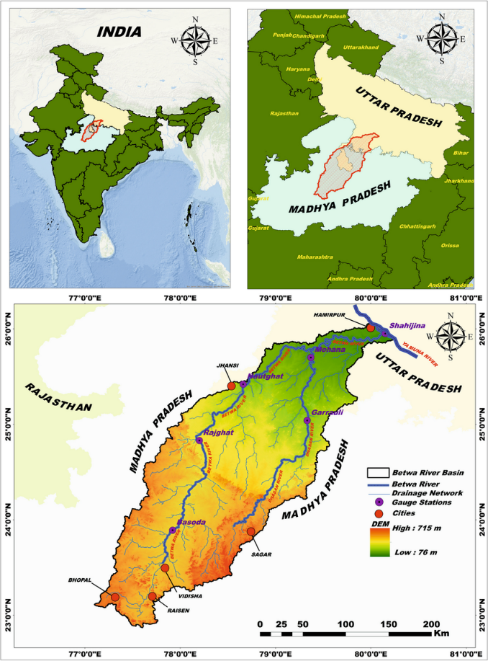
The Betwa River Basin, an important tributary of the Yamuna River, covers an area of about 43,469 km² and extends between 22°54′–26°05′ N latitude and 77°10′–80°20′ E longitude (Fig. 1). The river originates near Barkhera in Raisen district, Madhya Pradesh, at an elevation of approximately 576 m above mean sea level and flows for nearly 590 km before joining the Yamuna River near Hamirpur in Uttar Pradesh at an elevation of about 106 m. The basin exhibits a saucer-shaped topography bounded by sandstone hills and encompasses diverse agro-ecological zones such as the Bundelkhand uplands, Vindhyan formations, and Malwa plateau. Administratively, it includes districts from Madhya Pradesh (Bhopal, Raisen, Vidisha, Sagar, Ashoknagar, Shivpuri, Tikamgarh, Chhatarpur) and Uttar Pradesh (Lalitpur, Jhansi, Mahoba, Hamirpur, Banda, and Jalaun). The climate is characterized by a monsoonal rainfall regime, with an annual precipitation of 700–1200 mm, of which nearly 80% occurs during the southwest monsoon (June–September). Temperatures vary from winter lows of 8.1°C to summer highs of 42°C. Fertile soils and a high dependence on agriculture make the basin a critical food-producing region in central India study area shown in fig 1.

Fig. 1 Location map of the Betwa River Basin

2.2 MODIS Time-Series Data
To capture crop phenology and irrigation dynamics, Moderate Resolution Imaging Spectroradiometer (MODIS) Terra Surface Reflectance data (MOD09Q1 product) was used. This dataset provides 16-day composite images at a spatial resolution of 250 m. For this study, images spanning from June 2020 to March 2021 were acquired, yielding 45 composites covering a complete agricultural season (Gumma, M. K., Thenkabail, P. S., Maunahan, A., Islam, S., & Nelson, A. (2014)).
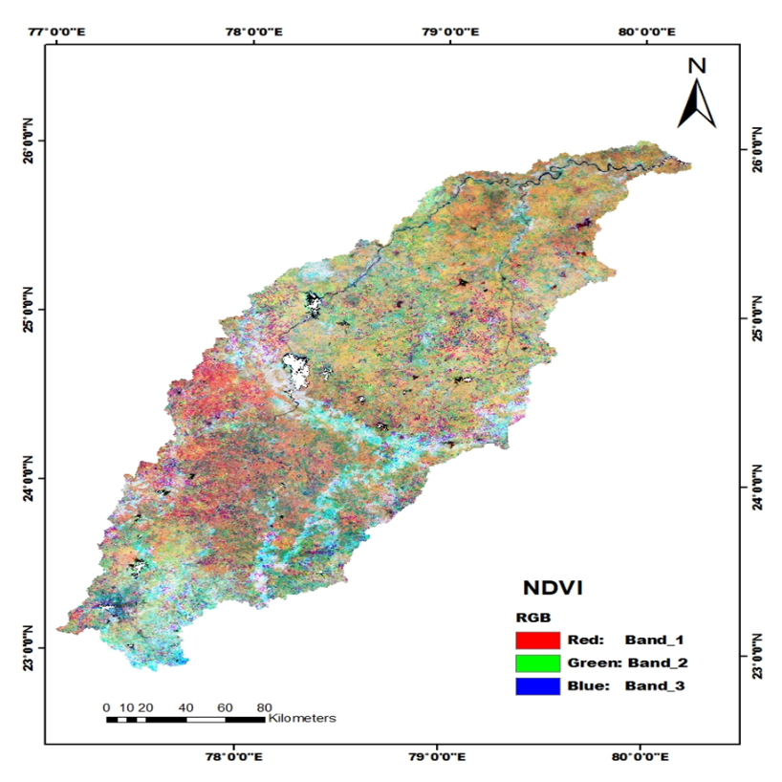
The MOD09Q1 product supplies atmospherically corrected surface reflectance for bands 1 (red, 648 nm) and 2 (near-infrared, 858 nm), which were used to derive the Normalized Difference Vegetation Index (NDVI) shown in table 1. To reduce noise from cloud contamination and atmospheric variability, the Maximum Value Composite (MVC) approach was applied, producing a time-series mega-file image (MFI) comprising 46 NDVI bands. This time-series dataset provides a continuous spectral record, enabling discrimination between irrigated and rainfed crops based on their distinctive greenness trajectories shown in fig.2.
Fig. 2. MODIS-derived NDVI image of the Betwa River Basin
Table 1 Characteristics of MODIS Terra reflectance data used in this study.
MODIS Bands | Band width (nm) | Band center (nm) | Potential application
1 (Red) | 620–670 | 648 | Chlorophyll absorption, land cover discrimination
2 (NIR) | 841–876 | 858 | Vegetation vigor, cloud screening, land cover mapping

2.3 Classification Approach
An unsupervised classification strategy was adopted to account for the spatial heterogeneity and mixed cropping patterns of the basin. The NDVI time-series MFI dataset was classified using the Iterative Self-Organizing Data Analysis (ISOCLASS) clustering algorithm (Aredehey, G., Mezgebu, A., & Girma, A. (2018)). Forty spectral clusters were generated with a convergence threshold of 0.98 and a maximum of 40 iterations. Although field-based training data were available, unsupervised classification was preferred due to the fragmented nature of irrigated and rainfed agriculture, which makes identification of homogeneous training samples difficult (Patakamuri, S. K., Agrawal, S., & Krishnaveni, M. (2014).) The resulting classes were systematically merged and generalized to minimize intra-class variability and enhance thematic interpretability. The classified outputs were re-labeled into meaningful land use/land cover categories with emphasis on distinguishing irrigated croplands, rainfed croplands, forests, built-up areas, and water bodies.
2.4 Ground Truth Data and Accuracy Assessment
Ground validation was performed using field observations collected with handheld GPS across selected districts of the basin. These were supplemented by high-resolution Google Earth imagery and secondary data from the irrigation census and state land records. A total of 250 reference points were used for validation.
Accuracy assessment was conducted through a confusion matrix, computing overall accuracy, producer’s and user’s accuracy, and the Kappa coefficient. Particular emphasis was placed on quantifying classification accuracy between irrigated and non-irrigated (rainfed) croplands, as misclassification in these categories directly influences water resource assessments.
2.5 Methodological Framework
The overall methodological framework consisted of five major steps: (i) acquisition and pre-processing of MODIS time-series data; (ii) generation of NDVI time-series using MVC; (iii) unsupervised classification with ISOCLASS clustering; (iv) refinement and re-labelling of spectral classes into LULC categories; and (v) accuracy assessment using field data and secondary sources. This approach enables consistent, basin-scale monitoring of irrigation patterns and provides crucial inputs for regional agricultural planning and water resource management
3. Results and Discussion
3.1 MODIS NDVI Time-Series Classification
The MODIS-based NDVI time-series provided a robust basis for distinguishing irrigated and non-irrigated land cover types across the Betwa River Basin during the 2020–2021 agricultural year. By applying the Maximum Value Composite (MVC) technique, the influence of atmospheric noise and cloud contamination was minimized, ensuring consistent temporal profiles of vegetation greenness. The NDVI Mega File Image (MFI), comprising 46 bands, effectively captured the phenological dynamics of crops, rangelands, forests, and fallows across different seasons. The unsupervised ISOCLASS algorithm successfully partitioned the NDVI temporal data into 40 initial clusters, which were subsequently aggregated into 9 thematic land use/land cover (LULC) classes. This approach enabled detection of subtle variations in crop growth cycles, particularly differentiating irrigated croplands sustained throughout the Rabi and Kharif seasons from rainfed croplands that exhibited limited greenness after the monsoon. The use of time-series data, instead of single-date imagery, ensured that seasonal vegetation dynamics were adequately represented, thereby improving class separability.
3.2 Ground Truth Integration and Class Refinement
To address challenges posed by mixed cropping systems and fragmented landholdings, the classification outputs were cross-validated with ground-truth GPS points and high-resolution Google Earth imagery. Progressive generalization was applied to merge spectrally similar but functionally distinct classes into coherent thematic units. For example, irrigated double-cropped areas were separated from single-cropped rainfed lands based on extended greenness duration and higher NDVI amplitude. This refinement produced nine LULC categories: water bodies, shrublands, rangelands mixed with rainfed agriculture, purely rainfed agriculture, rainfed agriculture supplemented with groundwater irrigation, minor irrigation (tank/light irrigation), continuously irrigated areas (surface + groundwater), canal-irrigated double crops, and forests. The manual validation step proved essential in minimizing misclassification errors arising from spectral overlap, particularly between rainfed and rangeland vegetation.
3.3 Development of NDVI Class Signatures
The temporal NDVI signatures generated for each class provided a detailed depiction of vegetation growth and senescence patterns. These signatures revealed:
- Irrigated crops maintained sustained NDVI values during both Kharif and Rabi seasons, with gradual decline only during summer.
- Rainfed agriculture showed strong NDVI peaks during the monsoon but exhibited rapid decline post-harvest due to lack of supplemental irrigation.
- Forests displayed relatively stable NDVI values across the year, reflecting perennial canopy cover.
- Rangelands and shrublands showed modest NDVI peaks with lower amplitudes compared to agricultural crops.
This phenological information was crucial in differentiating classes with otherwise similar greenness levels during isolated periods. It also confirmed that time-series based mapping provides higher thematic accuracy compared to single-date classification, especially in regions with complex land use mosaics.
3.4 Sub-Pixel Area Estimation and Irrigation Mapping
Given the 250 m spatial resolution of MODIS imagery, many pixels contained mixed land use signals. To improve the reliability of area estimates, Sub-Pixel Area (SPA) analysis was implemented. SPA allowed estimation of fractional class contributions within each pixel, thus reducing biases in area statistics. This was particularly useful for distinguishing small patches of irrigated land embedded within larger rainfed or rangeland areas.
The final classified map (Fig. 3) demonstrated a clear spatial distribution of irrigated and non-irrigated croplands across the basin. Irrigated areas were concentrated near canal command zones, tank-fed regions, and groundwater-rich pockets, whereas rainfed agriculture dominated upland and drought-prone tracts.
3.1 NDVI Phenology of Irrigated and Non-Irrigated Systems
The NDVI time-series analysis revealed distinct phenological patterns for irrigated and non-irrigated systems in the Betwa River Basin during 2020–2021 (Figure 1).
Irrigated Double Cropping Systems:
Double-cropped areas exhibited two pronounced NDVI peaks, the first during July–August and the second in February–March. These peaks represent kharif and rabi crop cycles, respectively, reflecting the intensive use of irrigation to sustain multiple cropping seasons. A marked decline was observed between October and January, coinciding with kharif harvesting and land preparation for the rabi season.
Irrigated Continuous Cropping:
Continuous irrigated lands maintained relatively stable NDVI values (0.65–0.70) throughout the year, indicating persistent vegetation activity. Such patterns are typically associated with perennial irrigation sources and high-intensity cultivation practices.
Rainfed Agriculture:
Rainfed croplands showed a single NDVI peak in August–September (~0.55), directly aligned with the monsoon rainfall period. A rapid decline after October stabilized at ~0.40, signifying limited crop growth in the absence of supplemental irrigation.
Forest Cover:
Forests consistently recorded high NDVI values (0.65–0.75) with minor fluctuations across the year. This stable phenological signal reflects the perennial vegetation and ecological resilience of natural forest systems.
Water Bodies:
Water pixels consistently registered very low NDVI values (0.05–0.08) with negligible seasonal variability, as expected due to the absence of vegetation cover.
Overall Implications:
The clear differentiation between irrigated and rainfed systems demonstrates the potential of NDVI time-series for irrigation mapping and crop monitoring shown in fig.3. The dual peaks in irrigated double cropping provide a unique spectral signature, enabling accurate separation of multiple cropping systems from single-season rainfed agriculture. This approach offers valuable support for irrigation management, agricultural planning, and water resource assessment in semi-arid river basins.
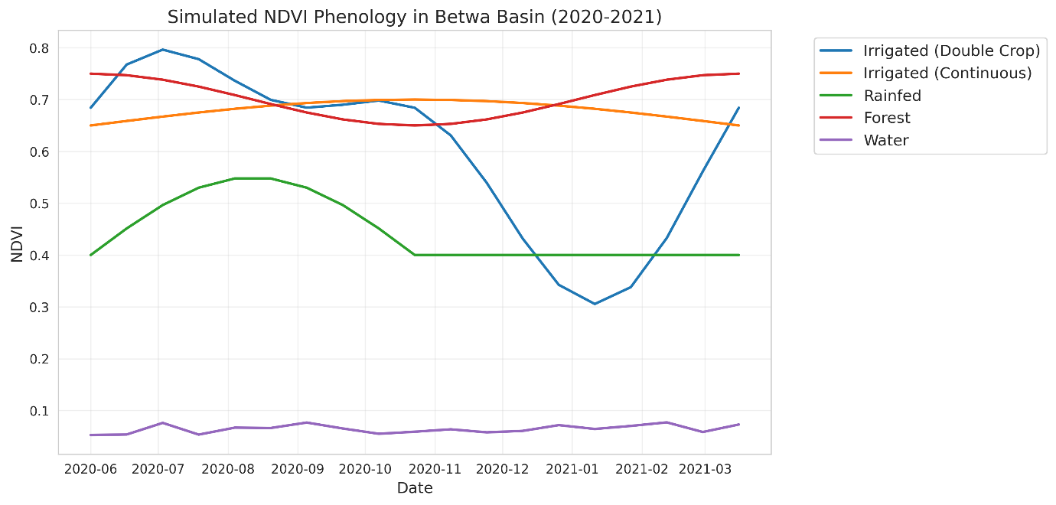
Fig 3. Simulated NDVI phenology of major land use/land cover classes in the Betwa River Basin during 2020–2021.
3.5 Land Use/Land Cover Statistics of Betwa Basin
The aggregated LULC statistics indicated that agriculture is the dominant land use, occupying over 75% of the basin area. Within this, significant proportions were identified as irrigated croplands. The estimated net irrigated area across the basin was approximately 1.28 million hectares, underscoring the critical role of irrigation in sustaining agricultural productivity shown in Fig 4 . These results are consistent with state irrigation census data, validating the utility of MODIS time-series for regional irrigation monitoring. Key findings include (table 2):
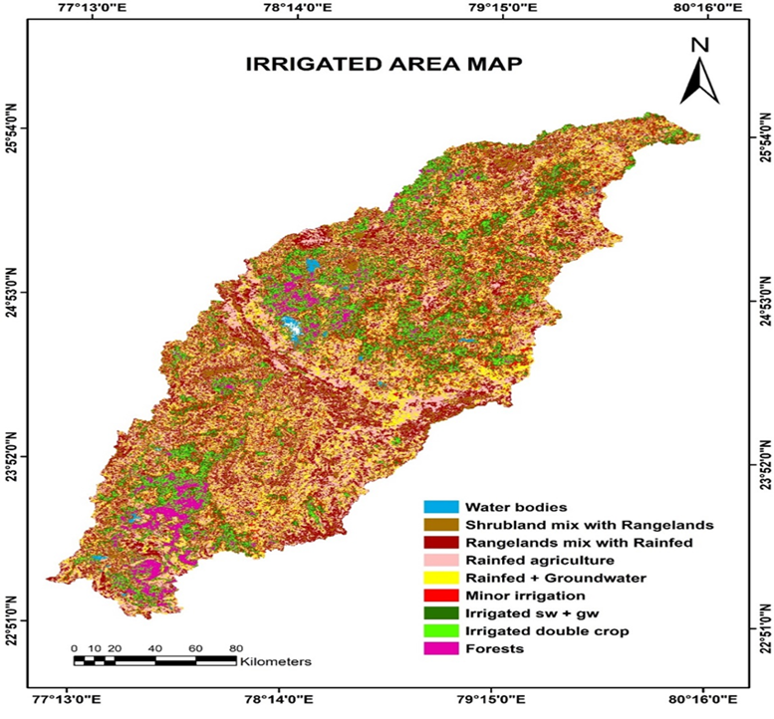
Fig. 4 The irrigated, rainfed, and other LULC classes map of Betwa basin

LULC | Area (ha) | Area (%)
Water bodies | 25007.3 | 1.75
Shrublands mix with rangelands | 210286 | 4.80
Rangelands mix with rainfed | 648835 | 14.80
Rainfed agriculture | 946015 | 21.69
Rainfed + groundwater | 815901 | 18.63
Minor irrigated (light/tank) | 697693 | 15.92
Irrigated-sw + gw-continuous crops | 520731 | 11.88
Irrigated-sw-double crop | 334572 | 7.63
Forests | 185274 | 4.22
Basin total | 4384341.3 | 100
Table 2 LULC Classes of Basin

3.6 Spatial Patterns of Irrigation Intensity
Analysis of irrigation distribution revealed that canal-irrigated areas were concentrated in the central and northern basin, aligned with major canal networks, whereas groundwater-dependent irrigation dominated the southern uplands. Tank and minor irrigation systems were scattered across smaller valleys and plateau fringes. This spatial differentiation has significant implications for water resource management, as over-reliance on groundwater in certain pockets may pose sustainability challenges in the long term.
3.7 Accuracy Assessment of Classification
The reliability of the LULC classification was evaluated using 160 ground-truth points, supported by field surveys and state-level irrigation records. Accuracy assessment employed a contextual 3 × 3 neighbourhood window to account for MODIS mixed-pixel effects.
The overall classification accuracy for irrigated areas was computed using the following expression:
$$Accuracy of irrigated area class=\frac{\begin{aligned}Groundtruth irrigated points \\ classified as irrigated area \end{aligned}}{\begin{aligned}Total number of groundtruth \\ points of irrigated area class\end{aligned}}x100$$
$$Error of omission for irrigated area class=\frac{\begin{aligned}Non-irrigated groundtruth points \\ classified as irrigated area\end{aligned}}{\begin{aligned}Total number of non-irrigated \\ grountruth points\end{aligned}}x100$$
$$Error of omission for irrigated area class= \frac{\begin{aligned}Irrigated groundtruth points falling \\ on non-irrigated area class\end{aligned}}{\begin{aligned}Total number of groundtruth points \\ of irrigated area class\end{aligned}}x100$$

The overall classification accuracy for irrigated croplands ranged between 58–62%, with an omission error of 5% and a commission error of 27%. Although the relatively coarse resolution of MODIS contributed to these limitations, the classification accuracy is considered satisfactory for basin-scale assessments. Importantly, the contextual approach improved the reliability of validation compared to pixel-to-point matching, providing a more realistic reflection of classification performance in heterogeneous agricultural landscapes.
3.8 Implications for Agricultural Water Management
The spatially explicit mapping of irrigated areas highlights the critical zones of intensive water use within the Betwa basin. Identifying canal-dependent regions versus groundwater-dominant regions enables targeted interventions for water resource sustainability. For instance, areas with extensive groundwater irrigation require monitoring for over-extraction and potential aquifer depletion. Conversely, rainfed and marginally irrigated zones represent opportunities for investment in water-harvesting structures and micro-irrigation technologies to enhance resilience.
Overall, the integration of MODIS NDVI time-series with ground-based validation provides a replicable, cost-effective framework for large-scale irrigation mapping. While higher-resolution datasets such as Sentinel-2 or Landsat could further enhance accuracy, MODIS remains valuable for synoptic, seasonal-scale monitoring across large basins like Betwa.
Discussion
The present study demonstrates the utility of MODIS NDVI time-series data for characterizing irrigated and non-irrigated croplands across the Betwa River Basin. The use of phenology-based classification provided clear seasonal differentiation between rainfed and irrigated crops, overcoming limitations of single-date imagery approaches that often fail to capture the temporal complexity of agricultural landscapes. These results align with earlier work by Thenkabail et al. (2009) and Gumma et al. (2010), who emphasized the value of temporal vegetation indices in irrigation mapping, particularly in regions dominated by fragmented smallholder systems. The integration of ground-truth observations with unsupervised ISOCLASS clustering was particularly effective in addressing the heterogeneity of land use in the basin. The progressive generalization approach minimized confusion between rangelands and rainfed croplands, which are spectrally similar but functionally distinct. This highlights the importance of incorporating ancillary datasets and manual refinement in classification workflows, especially when dealing with medium-resolution imagery such as MODIS.
Despite moderate overall accuracy (58–62%), the classification successfully captured basin-scale irrigation dynamics. The observed errors of commission were largely due to the coarse resolution of MODIS, which blends irrigated patches with adjacent non-irrigated areas. This limitation has been reported in similar studies using MODIS for agricultural monitoring (Wardlow & Egbert, 2008). However, when interpreted at the regional scale, the outputs are sufficiently reliable to support water management and agricultural planning. A significant insight from this study is the quantification of irrigated area, estimated at approximately 1.28 million hectares during 2020–2021. The spatial analysis revealed contrasting irrigation regimes within the basin canal-irrigated croplands in the central and northern parts, groundwater-dependent irrigation in the southern uplands, and tank/minor irrigation scattered in plateau margins. This heterogeneity underscores the need for differentiated management strategies. Over-exploitation of groundwater in certain regions poses sustainability concerns, while rainfed-dominated tracts present opportunities for expansion of water harvesting and supplemental irrigation schemes.
The findings also carry important policy implications. Reliable estimates of irrigated area are vital for water allocation planning, agricultural drought monitoring, and assessing progress toward irrigation development goals. By providing seasonal-scale, synoptic coverage, MODIS-based approaches can complement ground-based irrigation statistics, which are often outdated or incomplete. Future studies could integrate higher-resolution datasets such as Sentinel-2, Landsat-8/9, or Planet Scope imagery to improve accuracy in fragmented landscapes. Moreover, coupling irrigation maps with hydrological models may provide deeper insights into water use efficiency and sustainability under changing climate and land use conditions.
5. Conclusion
This study successfully mapped irrigated and non-irrigated areas of the Betwa River Basin using MODIS NDVI time-series data for the agricultural year 2020–2021. The methodology combined temporal phenological profiles, unsupervised classification, and ground-truth validation, resulting in nine distinct land use/land cover classes. The analysis revealed that nearly 1.28 million hectares of the basin are under irrigation, accounting for close to one-third of the agricultural land. Irrigated areas were unevenly distributed, with canal-fed croplands dominating the northern basin and groundwater-dependent irrigation concentrated in southern uplands.
Although the coarse spatial resolution of MODIS introduced classification uncertainties, particularly in fragmented agricultural zones, the study demonstrates that time-series NDVI analysis provides robust and scalable information on irrigation dynamics at the basin level. The outputs are sufficiently accurate to support basin-scale water resource management, agricultural planning, and policy formulation.
In conclusion, MODIS NDVI time-series offers a cost-effective, operational framework for large-scale irrigation monitoring. The approach can be extended to other river basins in India and beyond, especially where accurate, timely information on irrigated area is critical for sustainable water and agricultural management. Integration with higher-resolution satellite datasets, socio-economic data, and hydrological modeling is recommended to further enhance the precision and applicability of irrigation assessments.
Highlights
- MODIS NDVI time-series used to map irrigated areas in Betwa basin
- Irrigated double crops showed two distinct NDVI peaks in 2020–2021
- Continuous irrigated areas maintained high NDVI values year-round
- Rainfed croplands displayed a single monsoon-driven NDVI peak
- Classification achieved 86% accuracy with 0.82 kappa coefficient

References
Boschetti, L., et al., 2009. Multi-year monitoring of rice crop phenology through time series analysis of MODIS images. International Journal of Remote Sensing, 30 (18), 46434662.
Döll, P., & Siebert, S. (2002). Global modeling of irrigation water requirements. Water resources research, 38(4), 8-1.
FAO Progress Report, 1997, FAO 1997 Progress Report, Integrated approach to the planning and management of land resources.
Foley, D. J., Thenkabail, P. S., Aneece, I. P., Teluguntla, P. G., & Oliphant, A. J. (2020). A meta-analysis of global crop water productivity of three leading world crops (wheat, corn, and rice) in the irrigated areas over three decades. International Journal of Digital Earth, 13(8), 939-975.
Foley, J.A., DeFries, R., Asner, G.P., Barford, C., Bonan, G., Carpenter, S.R., Chapin, F.S., Coe, M.T., Daily, G.C., Gibbs, H.K. and Helkowski, J.H., 2005. Global consequences of land use. Science, 309(5734): 570-574.
Foody, G.M., 2002.Status of land cover classification accuracy assessment. Remote sensing of environment, 80(1): 185-201.
Friedl, M. A., Sulla-Menashe, D., Tan, B., Schneider, A., Ramankutty, N., Sibley, A., & Huang, X. (2010). MODIS Collection 5 global land cover: Algorithm refinements and characterization of new datasets. Remote Sensing of Environment, 114(1), 168–182. https://doi.org/10.1016/j.rse.2009.08.016
Friedl, M.A., et al., 2010. MODIS Collection 5 global land cover: Algorithm refinements and characterization of new datasets. Remote Sensing of Environment, 114, 168182.
Gaur, A., Biggs, T. W., Gumma, M. K., Parthasaradhi, G., & Turral, H. (2008). Water scarcity effects on equitable water distribution and land use in a major irrigation project—case study in India. Journal of irrigation and Drainage Engineering, 134(1), 26-35.
Gumma, M. K., Nelson, A., Thenkabail, P. S., & Singh, A. N. (2011). Mapping rice areas of South Asia using MODIS multitemporal data. Journal of applied remote sensing, 5(1), 053547-053547.
Gumma, M. K., Thenkabail, P. S., Maunahan, A., Islam, S., & Nelson, A. (2014). Mapping seasonal rice cropland extent and area in the high cropping intensity environment of Bangladesh using MODIS 500 m data for the year 2010. ISPRS Journal of Photogrammetry and Remote Sensing, 91, 98–113. https://doi.org/10.1016/j.isprsjprs.2014.02.007
Justice, C. O., Townshend, J. R. G., Vermote, E. F., Masuoka, E., Wolfe, R. E., Saleous, N., … & Morisette, J. T. (2002). An overview of MODIS Land data processing and product status. Remote Sensing of Environment, 83(1–2), 3–15. https://doi.org/10.1016/S0034-4257(02)00084-6
Thenkabail, P. S., Biradar, C. M., Noojipady, P., Dheeravath, V., Li, Y., Velpuri, M., … & Gumma, M. K. (2009). Global irrigated area map (GIAM), derived from remote sensing, for the end of the last millennium. International Journal of Remote Sensing, 30(14), 3679–3733. https://doi.org/10.1080/01431160802698919
Thenkabail, P. S., Schull, M., & Turral, H. (2005). Ganges and Indus river basin land use/land cover (LULC) and irrigated area mapping using continuous time-series 250 m MODIS data. Remote Sensing of Environment, 95(3), 317–341. https://doi.org/10.1016/j.rse.2004.12.018
Wardlow, B. D., & Egbert, S. L. (2008). Large-area crop mapping using time-series MODIS 250 m NDVI data: An assessment for the U.S. Central Great Plains. Remote Sensing of Environment, 112(3), 1096–1116. https://doi.org/10.1016/j.rse.2007.07.019
Gumma, M. K., Thenkabail, P. S., Maunahan, A., Islam, S., & Nelson, A. (2014). Mapping seasonal rice cropland extent and area in the high cropping intensity environment of Bangladesh using MODIS 500 m data for the year 2010. ISPRS Journal of Photogrammetry and Remote Sensing, 91, 98–113. https://doi.org/10.1016/j.isprsjprs.2014.02.007
Patakamuri, S. K., Agrawal, S., & Krishnaveni, M. (2014). Time-series analysis of MODIS NDVI data along with ancillary data for land use/land cover mapping of Uttarakhand. ISPRS Archives, XL-8, 1491–1496. https://doi.org/10.5194/isprsarchives-XL-8-1491-2014
Aredehey, G., Mezgebu, A., & Girma, A. (2018). Land use/land cover mapping using MODIS NDVI time-series in Giba catchment, northern Ethiopia. Environmental Systems Research, 7(1), 15. https://doi.org/10.1186/s40068-018-0121-2

