Review Article

E-NOSE technology: An eminent tool for early detection of plant diseases

Abstract
Plant pathogens and pests pose a critical threat to global food security, necessitating early, accurate and cost-effective diagnostic tools. Conventional methods such as visual inspection, microscopy and molecular assays, while accurate, are often labor-intensive, expensive and unsuitable for large-scale field deployment. Recent advances in volatile organic compound (VOC) profiling have enabled the development of electronic nose (E-Nose) technology, which replicates the mammalian olfactory system through arrays of chemical sensors and pattern recognition algorithms. E-Noses offer rapid, non-invasive and non-destructive detection of plant stress and disease at pre-symptomatic stages, providing an essential advantage for timely intervention. Beyond disease diagnostics, E-Noses are increasingly applied in pest detection, crop quality monitoring, fertilizer and pesticide management and environmental surveillance, aligning closely with the objectives of precision agriculture. The integration of artificial intelligence, nanotechnology and machine learning has enhanced system accuracy and robustness, while challenges such as sensor drift, standardization and field-level validation remain. Overall, E-Nose technology holds significant promise as a practical and sustainable tool for advancing plant health management, promoting environmental sustainability and strengthening the resilience of modern agricultural systems.
Keywords: Deep learning, Electronic nose, Plant disease detection, Precision agriculture, Sensor arrays, VOCs

1.Introduction

The progressive decline in biodiversity within agricultural systems increases the vulnerability of crops to pests, diseases and yield reductions. Plant pathogens, in particular, represent a considerable threat to agricultural productivity and global food security. Consequently, the implementation of effective disease management strategies is imperative to mitigate these risks. Promoting sustainable agricultural practices, coupled with accurate and timely disease detection, is crucial for minimizing economic losses (Gaya & Gursoy, 2023). Conventional disease assessment primarily relies on visual inspection, a method that, while diagnostic, is often labor-intensive and time-consuming (Palma et al., 2022). Alternatively, advanced diagnostic approaches such as light and transmission electron microscopy, virus bioassays and polymerase chain reaction (PCR) techniques provide greater accuracy; however, these methods are costly, laborious and dependent upon specialized expertise (Dastgir et al., 2022; Vunsh, Rosner, & Stein, 2010). When a plant becomes infected, both the composition and concentration of volatile organic compounds (VOCs) are altered (Jansen et al., 2011). This shift has led to advancements in gas monitoring technologies, enabling the detection of plant stress and disease through VOC profiling.

The development of sensor technologies has marked a significant advancement in the early diagnosis of plant diseases (Maiolo & Polese, 2021). Differentiation of specific chemical signatures requires consideration of the plant’s physiological state as well as its interactions with pests and pathogens. These volatile signatures frequently include compounds such as terpenoids, essential oils, ethylene, jasmonic acid, insect pheromones and metabolites associated with cellular stress or damage (Dudareva et al., 2006). For diagnostic applications to be feasible in field conditions, however, a balance must be achieved between sensitivity, target specificity, timeliness, operational simplicity and cost-effectiveness.

The emergence of electronic nose (e-nose) sensor technology has significantly contributed to agriculture and forestry by enabling the rapid detection of volatile organic compounds (VOCs) released by infected plants. This capability facilitates accurate monitoring of disease progression and supports the development of effective control strategies to limit further spread. Over the past few decades, progress in e-nose and sensor technologies has been driven by the miniaturization of sensing devices, advancements in materials science and the integration of sophisticated information processing techniques, including pattern recognition. Collectively, these innovations have enhanced the efficiency and resilience of agricultural systems through improved plant health monitoring.

2. Volatile Organic Compounds (VOC) Based Plant Disease Detection

Plant-derived volatile organic compounds (VOCs) are low molecular weight biomolecules and metabolites characterized by high volatility and low boiling points. These compounds are continuously emitted by plants and play essential roles in growth, defense, survival and inter-organismal signaling (Baldwin et al., 2006). Structurally, VOCs encompass diverse classes, including hydrocarbons, alcohols, aldehydes and organic acids. Beyond their internal regulatory functions, VOCs also act as mediators of ecological interactions at higher trophic levels, influencing herbivores, pollinators and natural enemies.

The emission of volatile organic compounds (VOCs) reflects underlying biochemical and metabolic processes governed by hundreds of genes, thereby serving as indicators of a plant’s physiological state. Within complex signaling networks, VOCs act as primary mediators through which plants and their neighbors perceive and respond to potential threats. These volatiles include green leaf volatiles (GLVs), diverse terpenes, methanol and key signaling phytohormones such as ethylene, methyl jasmonate (MeJA) and methyl salicylate (MeSA), all of which are integral to inter and intra-plant communication (Hazaika et al., 2020). Under conditions of stress, whether from pathogen infection or physical injury, plants emit distinct VOC profiles that differ significantly from those of healthy individuals (Sharifi et al., 2018). Such stress-induced alterations hold promise as biomarkers for early disease detection, allowing diagnosis at stages much earlier than conventional methods typically permit (Cellini et al., 2016).

3. E-NOSE

The concept of the electronic nose (E-Nose) was first introduced by Persaud and Dodd in 1982, who described it as “an invention which replicates the sense of smell through the use of an integrated system of chemical sensors and a pattern recognition system.” This pioneering definition marked the initial step in the development of artificial olfaction technologies, demonstrating the feasibility of replicating the biological function of smell through technological means. Building upon this foundation, Gardner and Bartlett (1994) provided a more comprehensive characterization, defining the E-Nose as “a system that implements several chemical sensors of varying degrees of specificity and applies sophisticated pattern recognition techniques to analyze a spectrum of olfactory stimuli ranging from simple to multi-layered.” These early contributions laid the groundwork for subsequent research and technological advancements that continue to shape the field of artificial olfaction.

Contemporary electronic noses (e-noses) are engineered to detect, classify and identify complex mixtures that often pose challenges for conventional analytical techniques. In contrast to traditional chemical analyses, which emphasize the separation and identification of individual compounds, the e-nose is designed to capture the overall essence of an odor by analyzing the collective response patterns of multiple sensors. This approach employs an array of broadly responsive, non-specific sensors that operate in concert to generate distinctive “fingerprints” for different volatile organic compound (VOC) mixtures (Jiarpinijnun et al., 2020; Santos et al., 2019). The resulting sensor data are subsequently processed using computational algorithms that integrate statistical methods and machine learning techniques to interpret responses and classify odors. This principle closely parallels the biological olfactory system (Figure 1), wherein odor discrimination arises from the combined activity of numerous receptors, producing a composite pattern of chemical information rather than a signal from a single receptor (Sun et al., 2019; Zhong, 2019).

Electronic noses (E-Noses) provide considerable advantages by saving time and resources while enabling the real-time identification and classification of odors—an ability not afforded by most conventional techniques. Although methods such as gas chromatography and mass spectrometry (GC-MS) deliver high analytical accuracy, they are costly, time-consuming and require specialized expertise. In contrast, E-Noses represent a more cost-effective, rapid and user-friendly approach, particularly in non-destructive applications. Their efficiency in analyzing volatile organic compound (VOC) emissions plays a crucial role in agriculture, where they facilitate the detection of plant infections, stress and other physiological disturbances before visible symptoms appear. By supporting early and affordable disease management. E-Noses contribute to improved crop health and a reduction in economic losses. Moreover, recent advancements in artificial intelligence (AI) and nanotechnology have further enhanced the reliability, sensitivity and accuracy of E-Nose systems, reinforcing their potential for widespread use in agricultural monitoring and management.

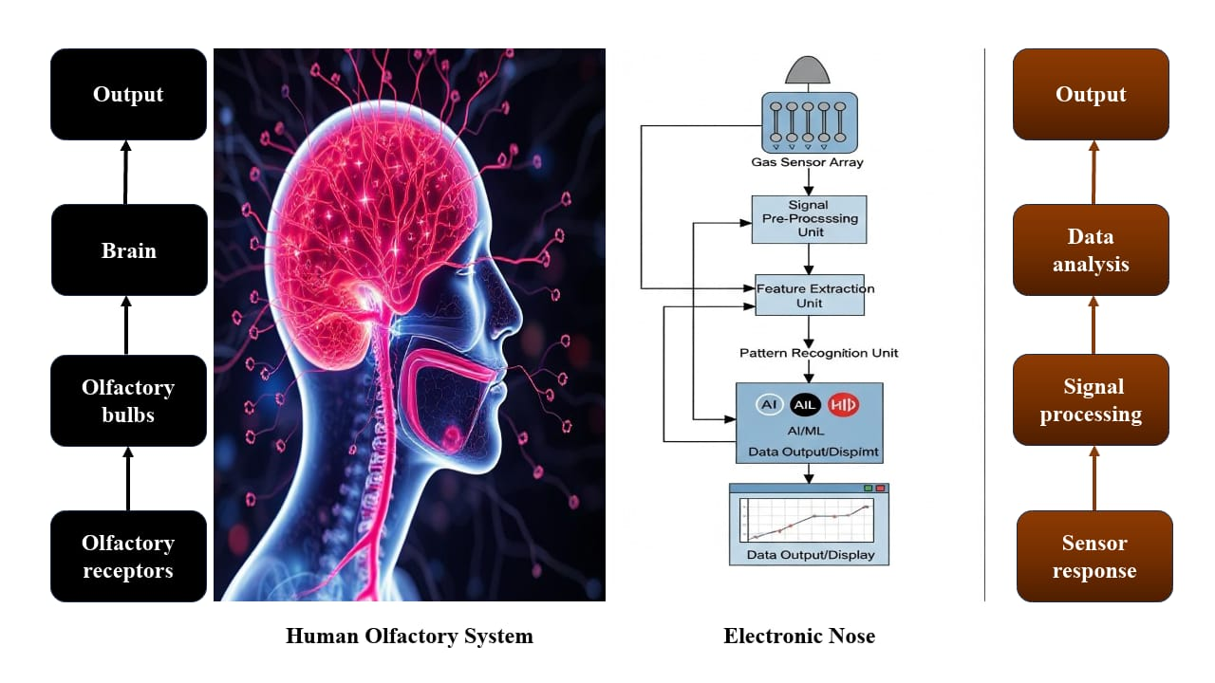

Figure 1. A schematic illustration showing the comparison between the human olfactory system and an electronic nose (E-NOSE)

4. Working principle of E-NOSE

The fundamental principle of an electronic nose (EN) system lies in the use of a sensor array to mimic the mammalian olfactory process by detecting changes in odor and aroma caused by volatile metabolites (Suchorab et al., 2019). An EN system typically comprises multiple sensors, each designed with varying sensitivities to different volatile compounds released from a sample. For instance, the PAN 3 electronic nose developed by Pan et al. (2014) incorporated ten sensors (S1–S10), each exhibiting distinct specificity. Sensor S1 was responsive to aromatic gases, while S2 detected nitrogen oxides. Sensor S3 exhibited sensitivity to both ammonia and aromatic gases, whereas S4 specifically detected hydrogen. Sensor S5 responded to alkenes and aromatic volatiles, and S6 was selective for methane. Sensor S7 demonstrated sensitivity to sulfur-containing compounds, alcohols and certain aromatic volatiles, while S8 was responsive to both aromatic and sulfur-organic volatiles. Sensor S9 detected nitrogen oxides and sulfides and S10 was sensitive to alkanes. In environmental monitoring, EN systems frequently employ sealed vials containing measured quantities of liquid or solid samples. The volatile compounds present in the headspace—sometimes enhanced through incubation—interact with the sensors, inducing changes in their physical or chemical properties, such as electrical resistance or optical characteristics. These changes are then transduced into electrical signals. When analyzed collectively, the outputs from all sensors form a multidimensional dataset that characterizes the sample’s odor profile (Licen et al., 2018; Yakubu et al., 2021), as illustrated in Figure 2.

These sensors exhibit high sensitivity to subtle variations in volatile metabolites, making them well suited for applications in early and highly sensitive detection processes (Lou et al., 2018). The ability of electronic nose (EN) technology to discriminate among complex odors relies on arrays of gas sensors with varying selectivity (Ali et al., 2020; Lioutas et al., 2021). By employing sensors with different response profiles, EN systems can differentiate and separate volatile fingerprints, thereby enhancing identification accuracy (Ali et al., 2020). Depending on the analytical objective, EN configurations may consist of a single sensor unit or a cluster of multiple sensing units, calibrated to detect the specific volatiles of interest. Both the type and number of sensors are critical determinants of detection efficacy, with larger sensor arrays generally improving analytical performance. Consequently, most research has focused on multi-sensor configurations to maximize effectiveness. This approach enables real-time detection by distinguishing unique volatile fingerprints with high precision (Shi et al., 2019).

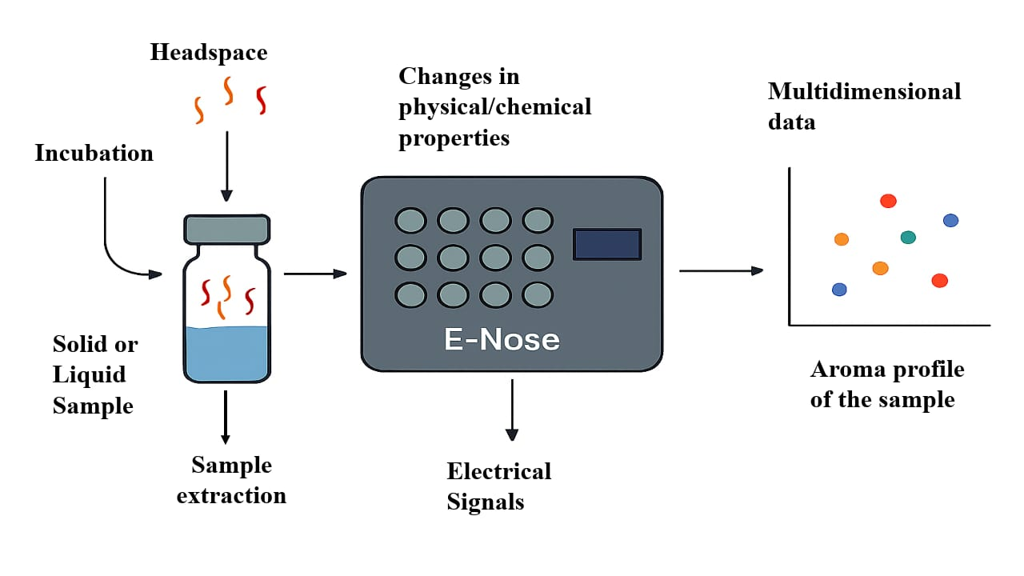

Figure 2. Schematic representation of the working principle of E-NOSE

5. Components of E-NOSE
Electronic noses consist of a sample dispersion system, sensing system and processing system (Karami et al., 2020)(Figure 3). The characterization of volatile metabolite profiling is a three-step process: (1) sampling of odours, (2) identification of disease based upon analysis of sensory array, and (3) capturing of data together with recognition of patterns (Ali et al., 2023).

5.1. Odour sampling

In analytical applications involving diseased samples, efficient sampling procedures are essential to ensure that volatile metabolites are accurately directed to the sensor array. The use of rapid sampling techniques that cause minimal or no mechanical damage during testing is particularly important, as it helps preserve product quality and maintain consumer acceptance (Adedeji et al., 2020). Classical methods employed in such applications include static headspace analysis, pre-concentration techniques and solid-phase microextraction (SPME), each of which is designed to enable precise and reliable detection of volatile compounds (Dong et al., 2019).
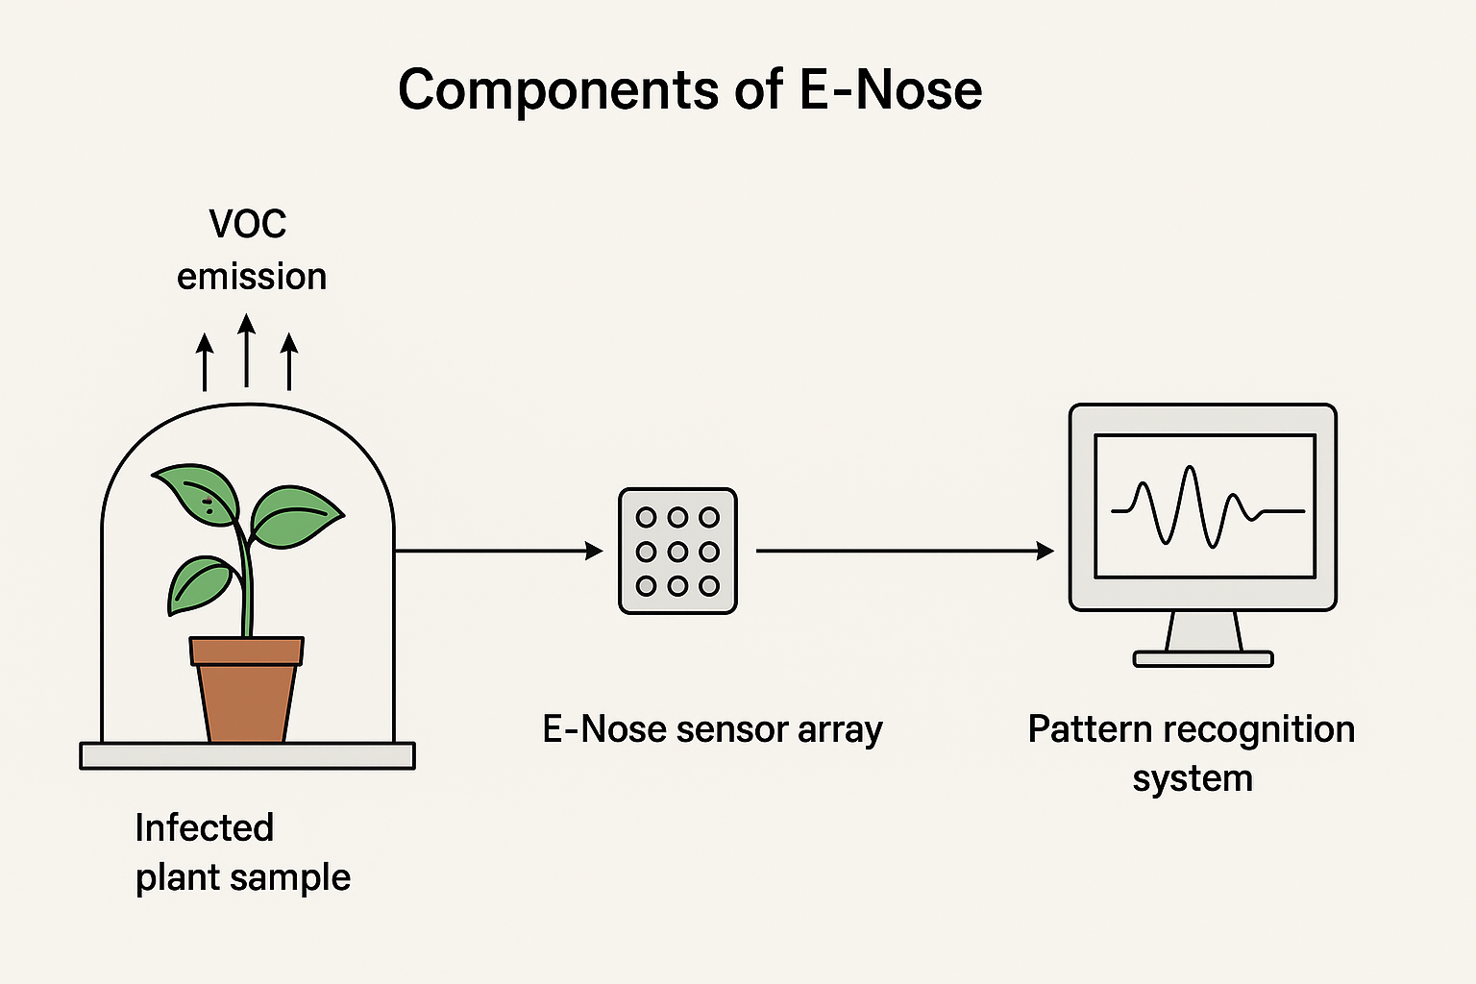

Figure 3. Schematic illustration showing the main components of an electronic nose (E-NOSE)

The static headspace technique requires that samples be securely sealed in vials, allowing equilibrium to be established prior to analysis of the volatiles by the sensor array, as illustrated in Figure 5 (Pascale et al., 2018). To ensure reproducibility, parameters such as equilibration time, temperature, and sample volume must be carefully optimized. Another widely employed approach, the pre-concentrator or “purge and trap” method, involves transferring volatile metabolites toward the detector via an inert gas stream, as shown in Figure 6. While effective, this technique is limited by the substantial loss of certain volatile compounds during the purging stage, which represents a significant drawback (Bruno & Harries, 2019).
Solid-phase microextraction (SPME) has gained widespread use in volatile metabolite research due to its simplicity and efficiency. The technique employs an adsorbent-coated fiber capable of selectively capturing volatile molecules, which are subsequently released into a detection system through thermal desorption (Peris & Escuder-Gilabert, 2009). Owing to its reliability and efficiency in isolating odorants from fresh produce, SPME is considered one of the most suitable methods for analytical applications.

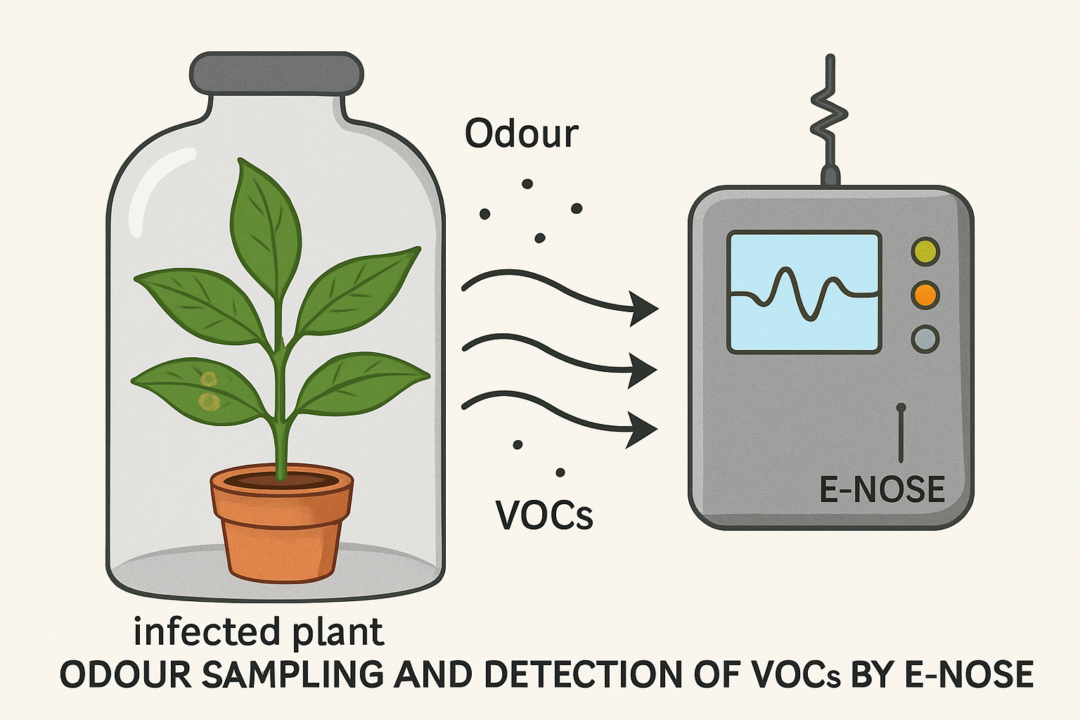

Figure 4. Diagrammatic illustration of odor sampling for the collection of volatile organic compounds (VOCs) from a diseased sample
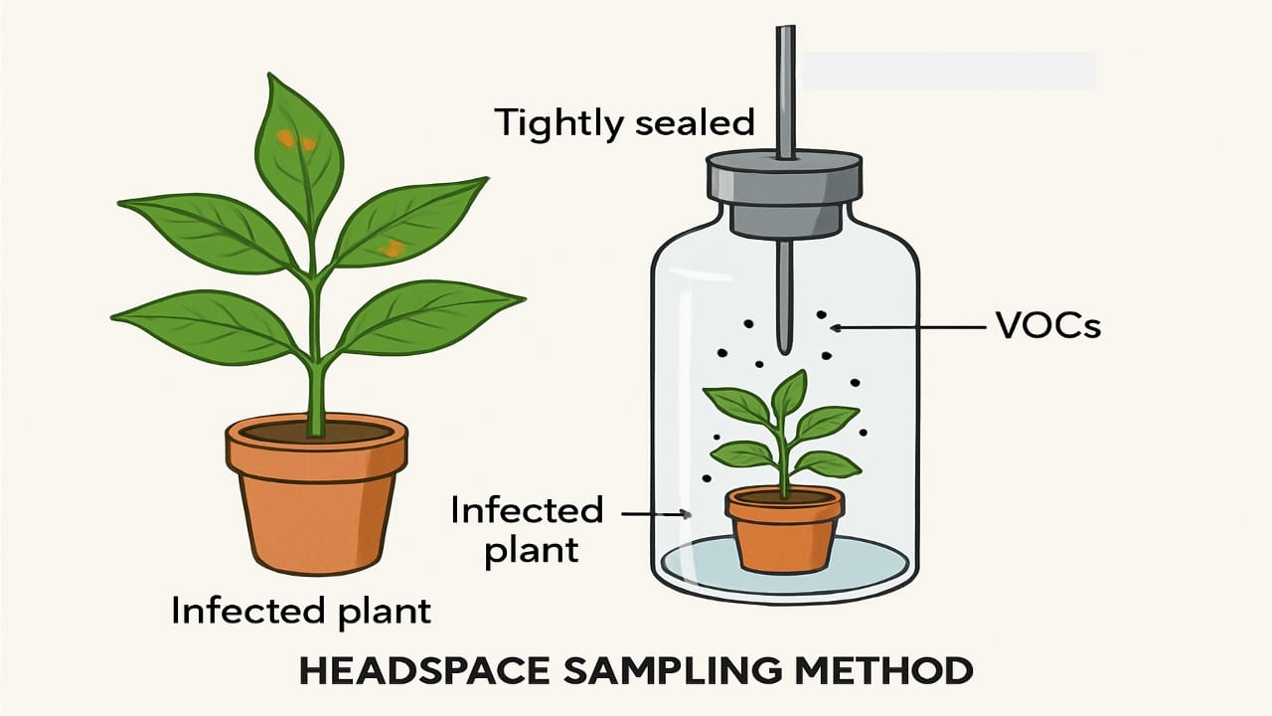
Figure 5. Schematic illustration of the static headspace method used for extracting samples from a diseased specimen
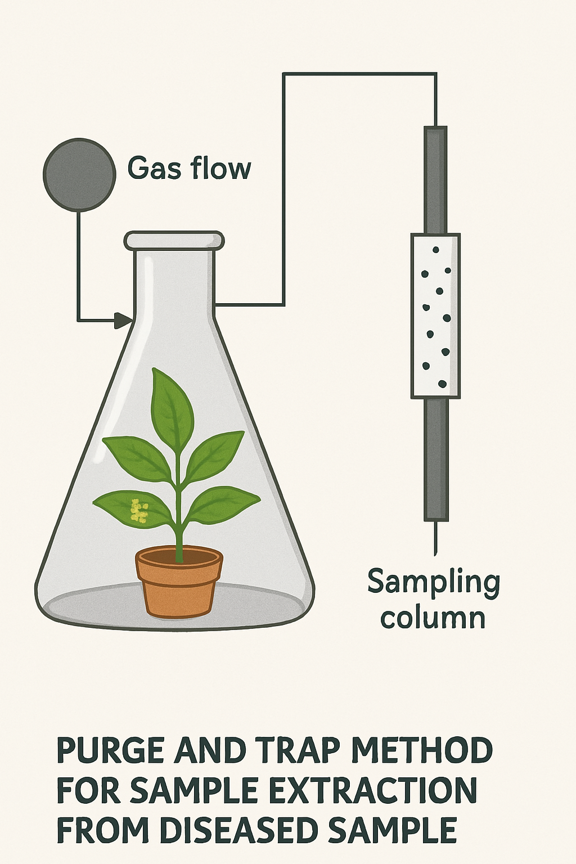
Figure 6. Schematic illustration of the purge-and-trap method for extracting samples from a diseased specimen

5.2. Sensor array/detection system
The detection system, typically composed of several sensors, functions as the reactive component of the electronic nose (Figure 7). Upon exposure to volatile compounds, these sensors undergo measurable changes in their electrical properties. Although each sensor is responsive to a range of volatile molecules, their distinct response patterns enable effective differentiation. Most electronic nose devices employ sensor arrays in which the adsorption of volatile molecules onto the sensor surface induces a physical change that is subsequently transduced into a quantifiable signal. This signal is processed through the electronic interface, converted into digital values, and analyzed to generate an interpretable odor profile.
A variety of sensor technologies are employed in electronic nose (EN) systems, including metal oxide semiconductors (MOS) (Nunes et al., 2019), metal oxide semiconductor field-effect transistors (MOSFET) (Loutfi et al., 2015), piezoelectric crystals (PC) (Pohanka, 2018), quartz crystal microbalances (QCM) (Wang, 2020), electrochemical sensors (Xiao et al., 2020), and surface acoustic wave (SAW) sensors (Kus et al., 2021), as summarized in Table 1. Among these, MOS sensors are particularly prominent in postharvest applications due to their effectiveness in early detection and quality monitoring. Their operating principle is based on changes in the properties of a thin layer of metal oxide when exposed to a target gas. Interactions between gaseous molecules and the sensor surface alter the availability of free electrons, resulting in measurable variations in electrical resistance that correlate with gas concentration. MOS sensors have gained popularity because they are inexpensive, robust, highly sensitive and capable of detecting a wide range of gaseous compounds.
Other sensor types also offer distinct advantages. For example, in plant disease detection, QCM biosensors utilize pathogen-specific antibodies immobilized on a quartz crystal surface. When an electric field is applied, the resulting piezoelectric effect generates acoustic wave resonance, where variations in surface mass lead to measurable shifts in resonance frequency. SAW sensors operate on a similar principle, though the propagation of their acoustic waves differs during detection (Kus et al., 2021). Both QCM and SAW sensors demonstrate high sensitivity and can detect a wide range of volatile compounds; however, their use is often constrained by higher costs and significant power requirements.

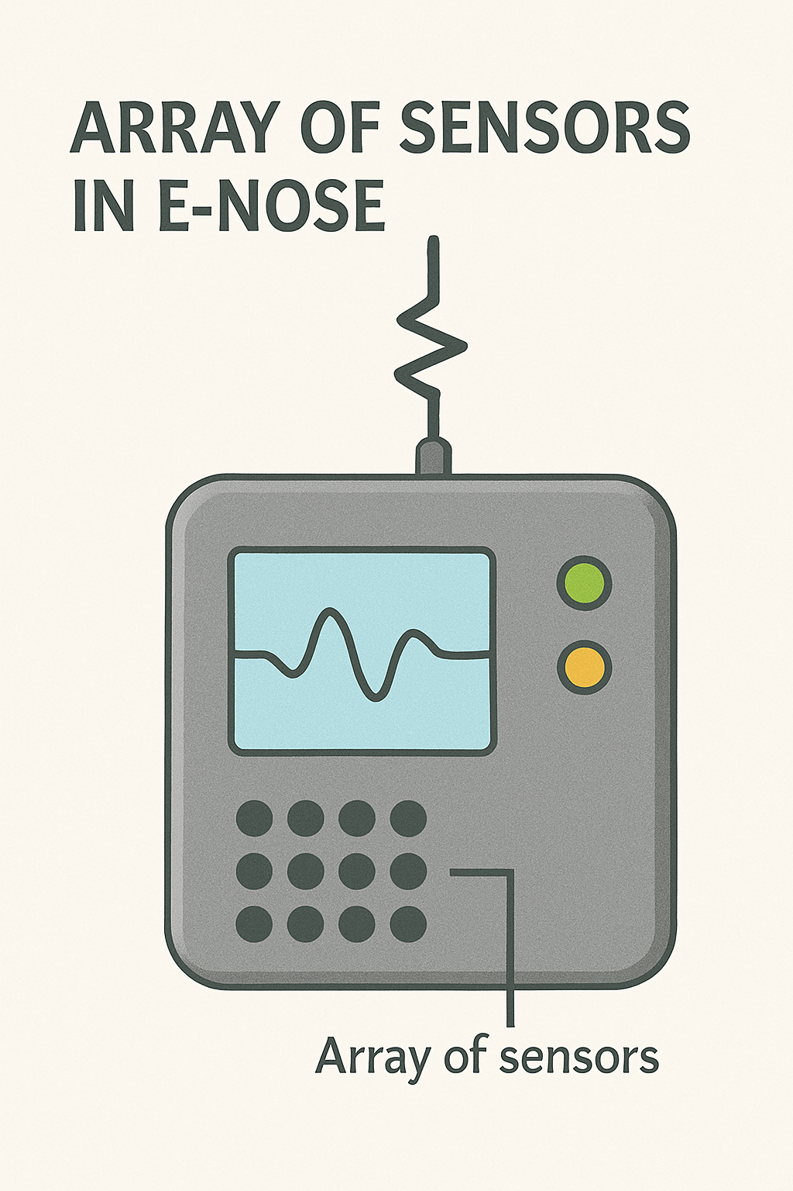
Figure 7. Diagrammatic illustration of the sensor array, functioning as the reactive component of the electronic nose (E-NOSE) system
Table 1. Overview of common sensor types employed in electronic nose (E-NOSE) systems for the detection of odors and volatile compounds. [Source: Ali et al., 2023]

Sensor type | Measurement | Advantages | Disadvantages | References
Metal oxide semiconductor (MOS) | Conductivity | The capability of detecting a greater range of chemicals, coupled with high reproducibility and rapid response times, represents a lower-cost, more convenient alternative. | High operating temperatures, high power consumption, susceptibility to sulfur poisoning and humidity, and a limited selection of available coatings are main concerns. | Nunes et al. (2019)
Metal oxide semiconductor field-effect transistors (MOSFET) | Threshold voltage change | Small, inexpensive sensors have a very fast response time and are very selective. | Baseline drift, high power consumption, controlled environmental conditions, and reduced sensitivity to ammonia and carbon dioxide | Loutfi et al. (2015)
Piezoelectric crystal (PC) | Piezoelectricity | High sensitivity, prompt time of response, capability to work at room temperature, easy synthesis, and low cost are impressive. | High sensor drift, unsatisfactory durability, sensitive to temperature and moisture, hard to produce | Pohanka (2018)
Quartz crystal microbalance(QCM) | Piezoelectricity | Wide range of coatings, batch-to-batch reproducibility, and enhanced sensitivity. | High cost, temperature- and moisture-sensitive, poor signal-to-noise ratio | Wang (2020)
Surface acoustic wave (SAW) | Piezoelectricity | The system has a rapid response time and is extremely sensitive, along with a broad selection of various coatings specifically created for a full range of detection analysis of gases. | The connected expenses are expensive, and there is a sensitivity of materials to variations in moisture and temperature, such that there is a suboptimal signal-to-noise ratio | Kus et al. (2021)
Electrochemical sensor | Conductivity | The fast processing, reduced cost, excellent chemical stability, and large ratio of surface to noise are of particular importance. | The product has a very limited shelf life, and it is cross-sensitive to other gases. Further, it is temperature- as well as moisture-sensitive | Xiao et al., 2020
Optical based | Intensity/spectrum | The sensor is highly sensitive, offers a high signal-to-noise ratio, and is immune to electromagnetic interference. Additionally, it is fast in its response, inexpensive, lightweight, as well as possessing a higher operational lifetime | High-cost, complex construction with advanced devices, experience photo-bleaching, advanced interface circuitry, few light sources, and poor portability | Ruan et al. (2018)
MS based | Chromatogram/ spectrum | This is a very sensitive, fast-response system, able to provide qualitative as well as quantitative results. The system is a universal detector, usable in a wide variety of different applications. | The factors concerning higher costs, heavy power consumption, and poor portability are significant points of consideration. | Zhang et al. (2018)

5.3. Data acquisition and Pattern recognition
Algorithm-driven data analysis is essential for both qualitative classification and quantitative prediction. With advancements in pattern recognition, several sophisticated algorithms have been developed specifically for electronic nose (E-Nose) applications. These analytical approaches are generally grouped into three main categories: graphical techniques, multivariate statistical analysis, and machine learning methods.
The simplest graphical techniques function by reducing data dimensionality, which enables comparison of samples or volatile organic compounds (VOCs) within databases. Commonly applied methods include Sammon mapping, bar charts, polar plots and hierarchical cluster analysis (HCA). While these approaches help minimize data preprocessing, datasets with extremely high dimensionality or diversity can sometimes lead to ambiguous outcomes. In contrast, multivariate data analysis relies on statistical methods and is particularly suited for datasets with numerous variables. By condensing complex data structures into two or three dimensions, these techniques make interpretation easier. Well-known examples include principal component analysis (PCA), linear discriminant analysis (LDA) and cluster analysis (CA).
In electronic nose (E-Nose) systems, pattern recognition methods are generally categorized as either supervised or unsupervised. Supervised approaches, such as artificial neural networks (ANNs), rely on predefined datasets or training samples to predict unknown feature categories based on established characteristics. Conversely, unsupervised methods—such as cluster analysis—organize input data into groups by identifying similarities among their features (Wu et al., 2016). Within unsupervised approaches, principal component analysis (PCA), also known as the Karhunen–Loève transform, is one of the most widely applied techniques. By reducing dimensionality while retaining the essential information, PCA proves especially effective for cluster analysis.
Artificial neural networks (ANNs) have proven highly effective in processing complex datasets and extracting hidden patterns. Recent research has increasingly explored their application in chemical vapor recognition. When integrated with sensor arrays, ANNs can potentially identify as many chemical compounds as there are sensors available (Hoffheins et al., 1989). This capability allows the use of less selective and more cost-effective sensors. Once trained, ANNs process sensor signals through vector–matrix multiplications, enabling rapid identification of unknown vapors in real-world scenarios. Various network architectures and training strategies have been implemented in E-Nose studies. For example, feed-forward networks combined with backpropagation remain widely used. Shakaff et al. (2014) demonstrated the effectiveness of an ANN-based E-Nose for detecting basal stem rot in oil palm plantations, achieving 100% classification accuracy with multilayer perceptron and probabilistic neural networks, and 97.5% accuracy with the radial basis function (RBF) model.
Random Forest (RF) is another widely applied supervised learning method, commonly used for both classification and regression tasks. Due to its strong performance in analyzing E-Nose data, RF has gained prominence across a variety of analytical domains. The method operates by constructing an ensemble of decision trees, where each tree’s prediction is based on randomly selected variables, and the collective output of the ensemble determines the final result. For instance, RF was successfully employed to distinguish between healthy maize plants and those showing early symptoms of Phaeosphaeria leaf spot, achieving 88% accuracy with a kappa coefficient of 0.75 (Adam et al., 2017). Likewise, Knauer et al. (2017) applied an RF model to predict the severity of powdery mildew in Chardonnay grape clusters, reporting a classification accuracy of 0.87 in differentiating healthy, infected, and severely infected samples.

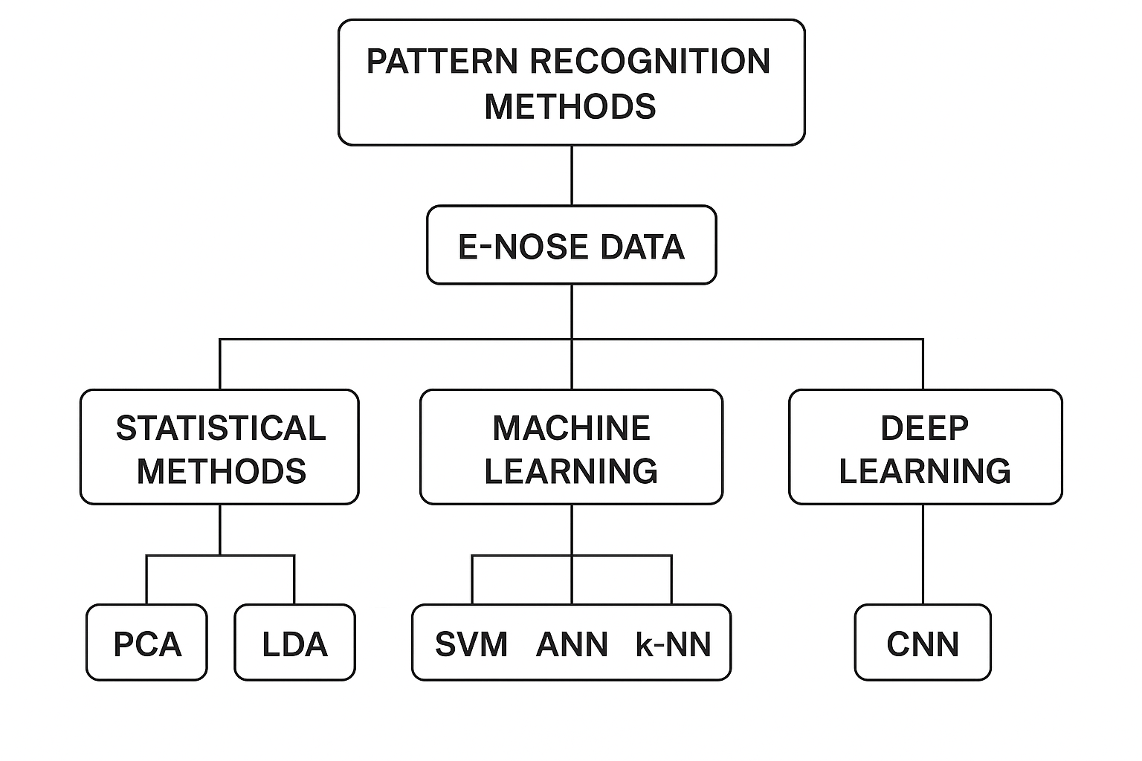
Figure 8. Common pattern recognition methods applied in electronic nose (E-NOSE) system

6. E-NOSE in plant disease detection

Electronic noses (E-Noses) have emerged as valuable tools for the early detection of plant diseases, offering rapid, non-destructive and highly sensitive diagnostics even before visible symptoms appear. Unlike conventional diagnostic methods that rely on morphological, molecular, or serological analyses, E-Noses function by detecting volatile organic compounds (VOCs) emitted by plants under stress or infection. This capability highlights their potential for early intervention, reduction of crop losses, and promotion of sustainable disease management practices.

For example, the Cyranose 320 E-Nose, using nitrogen as the reference gas, successfully differentiated Fulvifomes siamensis cultures, fruiting bodies and decayed wood from control samples (Tan et al., 2023). In another study, Wang et al. (2023) examined changes in VOCs associated with kiwifruit soft rot infection and storage conditions. By combining E-Nose measurements with chemometric analyses, they were able to clearly distinguish between medium- and late-rot stages, although differentiating latent infections from healthy samples proved more difficult. Their results further demonstrated that a multilayer perceptron neural network (MLPNN) provided the best performance for early detection of soft rot.

In a related study, Borowik et al. (2021) utilized a cost-effective E-Nose to detect odors produced by the forest pathogens Pythium intermedium and Phytophthora plurivora. Their results confirmed that E-Noses can successfully differentiate pathogen-derived odors under in vitro conditions. Among the sensors tested, TGS 2602 demonstrated particularly high sensitivity to VOCs, ammonia and hydrogen sulfide (H₂S), achieving the highest classification accuracy when used within a minimized sensor array.

Oates et al. (2020) employed a low-cost E-Nose system equipped with eight Taguchi-type (MQ) sensors (MQ135, MQ2, MQ3, MQ4, MQ5, MQ9, MQ7, and MQ8) to detect fatal bronzing disease in cabbage. More recently, Ratnayake et al. (2024) compared the diagnostic performance of three commercially available E-Nose devices—Cyranose 320, PEN 3 and MSEM 160—for identifying mango twig tip dieback (MTTD) and banana Panama disease (TR4). The Cyranose 320 achieved 54% accuracy in distinguishing healthy leaves from those infected with MTTD, and 75% accuracy in differentiating healthy pseudostems from TR4-infected ones. PEN 3 performed more effectively, with 86.06% accuracy for MTTD classification and 84.96% for TR4 detection. Among the three, MSEM 160, the most advanced system, demonstrated the highest capability in accurately separating samples into their respective disease categories.

Laboratory-developed systems have also demonstrated strong diagnostic capabilities. For instance, a custom-built E-Nose incorporating eight MOS gas sensors (Taguchi TGS series) combined with Support Vector Machine (SVM) analysis achieved 99.64% accuracy in differentiating Ganoderma boninense CSB, Ganoderma boninense “Rejosari” and Ganoderma lucidum in oil palm, with a clear distinction between infected and healthy samples. In another comparative study, Borowik et al. (2021) evaluated two low-cost systems, PW4 and PW6, against Fusarium oxysporum and Rhizoctonia solani. The PW4 system, equipped with six TGS sensors, exhibited a broad response spectrum, while PW6, which incorporated only two carefully chosen sensors, achieved higher classification accuracy—highlighting the importance of strategic sensor selection in optimizing system performance.

The integration of machine learning has significantly improved the performance of E-Nose systems. Wu et al. (2022) demonstrated that combining E-Nose data with the K-nearest neighbors (KNN) algorithm enabled early detection of Ceratocystis fimbriata in sweet potatoes, even during the asymptomatic phase. Similarly, Haghbin et al. (2022) utilized an E-Nose equipped with thirteen MOS gas sensors to identify Botrytis cinerea-infected kiwifruits. By applying correlation-based feature selection (CFS) alongside a multilayer perceptron neural network (MLPNN), they achieved classification accuracies of 99.9% in training and 100% in testing. In another application, the gas feature neural network (GFNN) model reached 98.76% accuracy in assessing wheat bunt severity, effectively detecting trimethylamine (TMA) as a key VOC biomarker.

Finally, Wang et al. (2020) developed a bioelectronic nose incorporating single-stranded DNA and single-walled carbon nanotubes to detect VOCs released by strawberries infected with Phytophthora cactorum, further expanding the technological frontier of plant disease diagnostics.

7. Applications of E-NOSE technology in agriculture

The electronic nose (E-Nose) has found wide-ranging applications in agriculture, spanning disease detection, crop quality management and environmental monitoring. Among its most critical functions is the early detection of plant diseases through the analysis of volatile organic compounds (VOCs) emitted by plants before the onset of visible symptoms. This rapid and non-destructive diagnostic capability also extends to food safety, where E-Noses are employed to monitor pesticide residues in crops. Additionally, they assist in fertilizer management by estimating nutrient residues in fruits and vegetables, based on VOC emissions linked to soil fertilizer applications. E-Noses are equally valuable for crop quality assessment, providing insights into freshness, ripeness, and post-harvest conditions. Beyond crop-focused applications, they also serve an important role in environmental surveillance by detecting soil and air pollutants, thereby supporting safer and more sustainable agricultural practices.

In plant health diagnostics, electronic noses (E-Noses) are typically applied through two main strategies: the direct method, which detects VOCs released by isolated microbial pathogens, and the indirect method, which analyzes plant-emitted VOC changes following pathogen inoculation. Together, these approaches provide a comprehensive assessment of infection status and plant stress responses. Notable examples include the successful early detection of fire blight (Erwinia amylovora) and blossom blight (Pseudomonas syringae pv. syringae) in apple orchards, demonstrated under both laboratory and field conditions (Fuentes et al., 2018; Spinelli et al., 2010).

Electronic noses (E-Noses) have also shown strong potential in detecting insect infestations and monitoring pest population dynamics. For example, tomato plants infested with spider mites (Tetranychus urticae), a significant greenhouse pest, produce distinct VOC profiles that can be accurately identified through E-Nose analysis (Zhang et al., 2011). Likewise, research has demonstrated that mechanical damage triggers defense-related alterations in plant VOC emissions, with the specific composition varying according to the type of stress or injury (Ghaffari et al., 2011).

Beyond their role in pathogen and pest detection, electronic noses (E-Noses) also contribute to resource management and food safety. For instance, VOC analysis of cucumber fruits has been employed to predict NPK fertilizer residues using statistical modeling, providing a rapid and non-destructive approach to fertilizer monitoring while helping to minimize excessive agrochemical use (Tatli et al., 2022). Similarly, E-Nose technology has shown strong potential in monitoring pesticide contamination in vegetables, offering a fast and effective tool for safeguarding food safety (Meng et al., 2025).

Electronic noses have also been applied in broader botanical research, such as detecting and monitoring floral scents and volatile biogenic gas emissions. These applications make it possible to analyze seasonal variations in plant VOC release, thereby enhancing our understanding of plant–environment interactions (Fujioka et al., 2012).
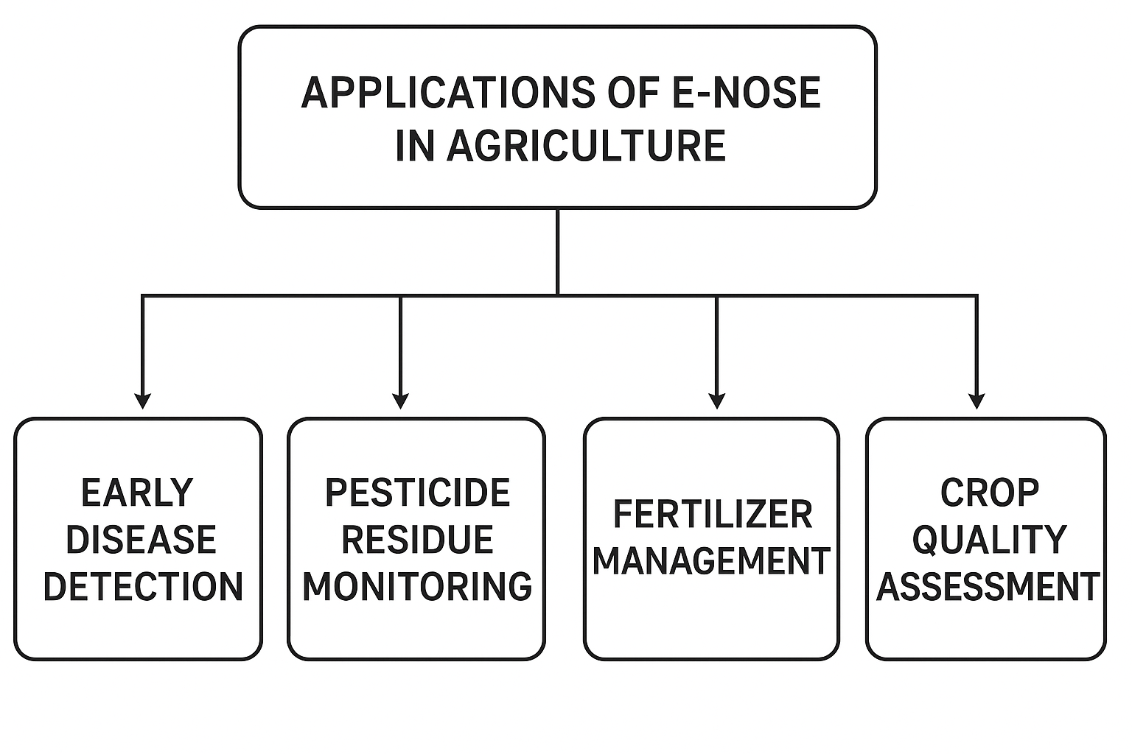

Figure 9. Applications of electronic nose (E-NOSE) technology in agriculture

8. Advantages of E-NOSE technology

The use of electronic nose (E-Nose) systems in plant disease diagnostics presents several notable advantages. These include: (1) non-invasive and non-destructive sampling, (2) the ability to detect infections within bulk host samples, (3) simultaneous identification of multiple diseases, (4) adjustable detection thresholds through customized training and discrimination settings, (5) sensor arrays that can be designed to target specific groups of disease-associated volatile organic compounds (VOCs), and (6) the capability to detect diverse pathogen classes using distinct reference databases while operating on a single device (Cellini et al., 2017).

Beyond these functional advantages, E-Nose devices are also valued for their portability, cost-effectiveness and ease of use, requiring only minimal operator training. Notably, they can detect, identify and classify complex mixtures of VOCs emitted from biological tissues without the need to isolate or characterize individual chemical compounds (Wilson, 2018). This capacity to transform chemical complexity into recognizable digital patterns highlights their practicality and efficiency as diagnostic tools in agriculture.

9. Conclusion

The electronic nose (E-Nose) represents a significant advancement in agricultural diagnostics, providing a rapid, non-invasive and cost-effective approach to detecting plant diseases at early stages. By analyzing volatile organic compounds (VOCs) released by plants, E-Noses bridge the gap between conventional laboratory-based methods and real-time field applications, allowing the detection of stress factors before visible symptoms emerge. The integration of advanced sensor technologies with machine learning and deep learning algorithms has further improved their sensitivity, specificity and predictive capabilities.

Beyond plant disease detection, electronic noses (E-Noses) have demonstrated broad applicability in agriculture, including crop quality assessment, fertilizer and pesticide monitoring, post-harvest management, and environmental surveillance. These functions align closely with the objectives of precision agriculture, where efficient resource use and timely interventions help reduce crop losses, limit excessive chemical application and enhance overall sustainability. However, challenges such as device standardization, sensor drift, miniaturization and field-level validation continue to hinder large-scale adoption. Overcoming these barriers through sustained research, technological innovation and interdisciplinary collaboration will be essential for realizing the full potential of E-Nose systems in modern agriculture.

In summary, E-Nose technology holds great promise as an indispensable tool in modern agriculture, contributing to food security, advancing environmental sustainability and strengthening the resilience of farming systems in response to growing global challenges.

References:

Abdullah, A.H., A.Y.M. Shakaff, A. Zakaria, F.S.A. Saad, S.A.A. Shukor and A. Mat (2014). Application specific electronic nose (ASEN) for Ganoderma boninense detection using artificial neural network. Proc. 2nd Int. Conf. on Electronic Design (ICED), Kuala Lumpur, Malaysia, pp. 19–21 August. IEEE.
Adam, E., H. Deng, J. Odindi, E.M.A. Rahman and O. Mutanga (2017). Detecting the early stage of Phaeosphaeria leaf spot infestations in maize crop using in situ hyperspectral data and guided regularized random forest algorithm. J. Spectrosc., 2017: 1–8.
Adedeji, A.A., N. Ekramirad, A. Rady, A. Hamidisepehr, K.D. Donohue, R.T. Villanueva and M. Li (2020). Non-destructive technologies for detecting insect infestation in fruit and vegetables under postharvest conditions. Crit. Rev. Food Sci. Nutr., 60(15): 927–945.
Ali, A., A.S. Mansol, A.A. Khan, K. Muthoosamy and Y. Siddiqui (2023). Electronic nose as a tool for early detection of diseases and quality monitoring in fresh postharvest produce: A comprehensive review. Compr. Rev. Food Sci. Food Saf., 22(3): 2408–2432.
Ali, M.M., N. Hashim, S.A. Aziz and O. Lasekan (2020). Principles and recent advances in electronic nose for quality inspection of agricultural and food products. Trends Food Sci. Technol., 99: 1–10.
Baldwin, I., R. Halitschke, A. Paschold, C. Dahl and C. Preston (2006). Volatile signaling in plant–plant interactions: “Talking trees” in the genomics era. Science, 311(5762): 812–815.
Borowik, P., L. Adamowicz, R. Tarakowski, P. Walclawik, T. Oszako, S. Ślusarski and M. Tkaczyk (2021). Development of a low-cost electronic nose for detection of pathogenic fungi and applying it to Pythium intermedium and Phytophthora plurivora. Sensors, 21(17): 5868.
Bruno, T.J. and M.E. Harries (2019). Encyclopedia of Analytical Science (3rd ed.). Elsevier, Amsterdam.
Cellini, A., S. Blasioli, E. Biondi, A. Bertaccini, I. Braschi and F. Spinelli (2017). Potential applications and limitations of electronic nose devices for plant disease diagnosis. Sensors, 17(11): 2596.
Cellini, A., E. Biondi, S. Blasioli, L. Rocchi, B. Farneti, I. Braschi, S. Savioli, M.T. Rodriguez-Estrada, F. Biasioli and F. Spinelli (2016). Early detection of bacterial diseases in apple plants by analysis of volatile organic compounds profiles and use of an electronic nose. Ann. Appl. Biol., 168(3): 409–420.
Dastgir, G., M.I. Majeed, H. Nawaz, N. Rashid, A. Raza, M.Z. Ali … A. Abdultaheem (2022). Surface-enhanced Raman spectroscopy of PCR products of rifampin resistant and susceptible tuberculosis patients. Photodiagn. Photodyn. Ther., 38: 102758.
Dong, W., R. Hu, Y. Long, H. Li, Y. Zhang, K. Zhu and Z. Chu (2019). Comparative evaluation of volatile profiles and taste properties of roasted coffee beans as affected by drying method and detected by electronic nose, electronic tongue, and HS-SPME-GC-MS. Food Chem., 272: 723–731.
Dudareva, N., F. Negre, D.A. Nagegowda and I. Orlova (2006). Plant volatiles: Recent advances and future perspectives. Crit. Rev. Plant Sci., 25(5): 417–440.
Fujioka, K., M. Shirasu, Y. Manome, N. Ito, S. Kakishima, T. Minami, T. Tominaga, F. Shimozono, T. Iwamoto, K. Ikeda, et al. (2012). Objective display and discrimination of floral odors from Amorphophallus titanum using an electronic nose. Sensors, 12(2): 2152–2161.
Fuentes, M.T., A. Lenardis and E.B. de la Fuente (2018). Insect assemblies related to volatile signals emitted by different soybean–weeds–herbivory combinations. Agric. Ecosyst. Environ., 255: 20–26.
Ghaffari, R., F. Zhang, D.D. Iliescu, E.L. Hines, M.S. Leeson and R. Napier (2011). Intelligent systems for machine olfaction: Tools and methodologies. In: Detection of Diseases by Volatile Discrimination in Plants (Eds.: D. Olivares, A.Y. Zain and K. Kamel). IGI Global, USA, pp. 145–166.
Huang, X., Y. Wang, H. Liang, Y. Xu, Y. Li and H. Zhang (2019). Discrimination of fungal infection in postharvest fruits using electronic nose and multivariate statistical analysis. Postharvest Biol. Technol., 150: 108–114.
Iseki, K., K. Ohnishi, J. Takabayashi and K. Takahashi (2007). Detection of cucumber green mottle mosaic virus infection in cucumber plants by gas chromatography-mass spectrometry and electronic nose. J. Agric. Food Chem., 55(21): 8579–8584.
Jain, S., S. Sharma and R. Kulshreshtha (2020). Electronic nose: A non-destructive tool for quality evaluation of food products. Food Anal. Methods, 13: 2221–2234.
Keshri, G., S. Voyron and R. Balestrini (2018). Potential of e-nose technology for monitoring plant–microbe interactions. Sens. Actuators B: Chem., 263: 76–84.
López, R., M. García and C. Orellana (2021). Recent advances in volatile analysis for disease detection in crops. Plant Sci. Today, 8(3): 547–555.
Martínez-García, H., M.C. Rodríguez-Molina and J. González (2017). Monitoring of tomato bacterial wilt through volatile organic compounds using electronic nose technology. Crop Prot., 100: 28–35.
Ncube, B., J.F. Finnie and J. Van Staden (2011). Quality from the field: The impact of environmental factors as quality determinants in medicinal plants. S. Afr. J. Bot., 77(3): 654–664.
Osborne, J., A. Turner and R. Clark (2016). Advances in artificial olfaction: E-nose development and application to agriculture. Biosyst. Eng., 151: 120–131.
Pereira, D.A., R. Silva and J. Costa (2019). Portable electronic nose for plant disease detection in the field. Comput. Electron. Agric., 162: 931–939.
Qiu, Z., Y. Zhao and Y. He (2015). Discrimination of fungal diseases in rice by electronic nose combined with feature selection and classifier. Sensors, 15(4): 8647–8660.
Ranjan, R., N. Verma and B. Gupta (2020). Application of machine learning in e-nose for detection of crop diseases: A review. Artif. Intell. Agric., 4: 81–90.
Sharma, R., D. Singh and R. Kaushik (2018). Early detection of plant pathogens using volatile profiling and electronic nose. Front. Plant Sci., 9: 1036.
Spinelli, F., A. Cellini, L. Marchetti, K. Mudigere and A. Bertaccini (2020). Emerging trends in electronic noses for plant disease detection. Phytopathol. Res., 2(1): 23.
Tóth, B., D. Virág and L. Kiss (2017). Volatile organic compounds in plant–pathogen interactions: Past, present, and future. J. Plant Pathol., 99: 11–18.
Usha, B., S. Meenakshi and C. Reddy (2019). Role of artificial olfaction in sustainable agriculture: A review. Curr. Sci., 116(9): 1515–1523.
Varma, A. and A. Dubey (2018). Plant–microbe interactions and volatile emissions: Diagnostic potential of e-nose. Appl. Microbiol. Biotechnol., 102(6): 2613–2624.
Wang, Y., H. Li, Y. Zhang and X. Chen (2020). Electronic nose detection of wheat fusarium head blight based on volatile fingerprints. Biosens. Bioelectron., 147: 111752.
Zhang, Q., J. Liu and Y. Xu (2016). Identification of rice blast disease using electronic nose and pattern recognition. Comput. Electron. Agric., 127: 760–768.

